This first piece of evidence shows Welsh literacy skills by using ‘Gwaith dosbath’ and the date in Welsh that I expect for every lesson to maintain an element of Welsh.

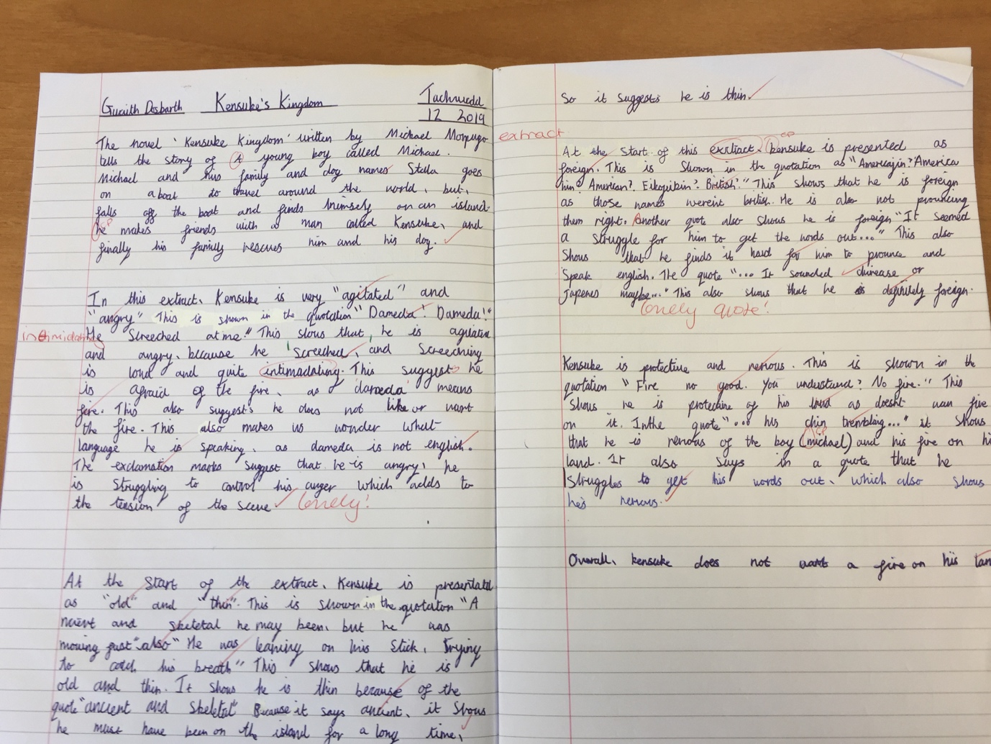

This second piece of evidence for the Welsh competency framework is the marking of a written assessment that I completed within PTE1. This shows my Welsh competency in marking learner’s work using Welsh phrases.

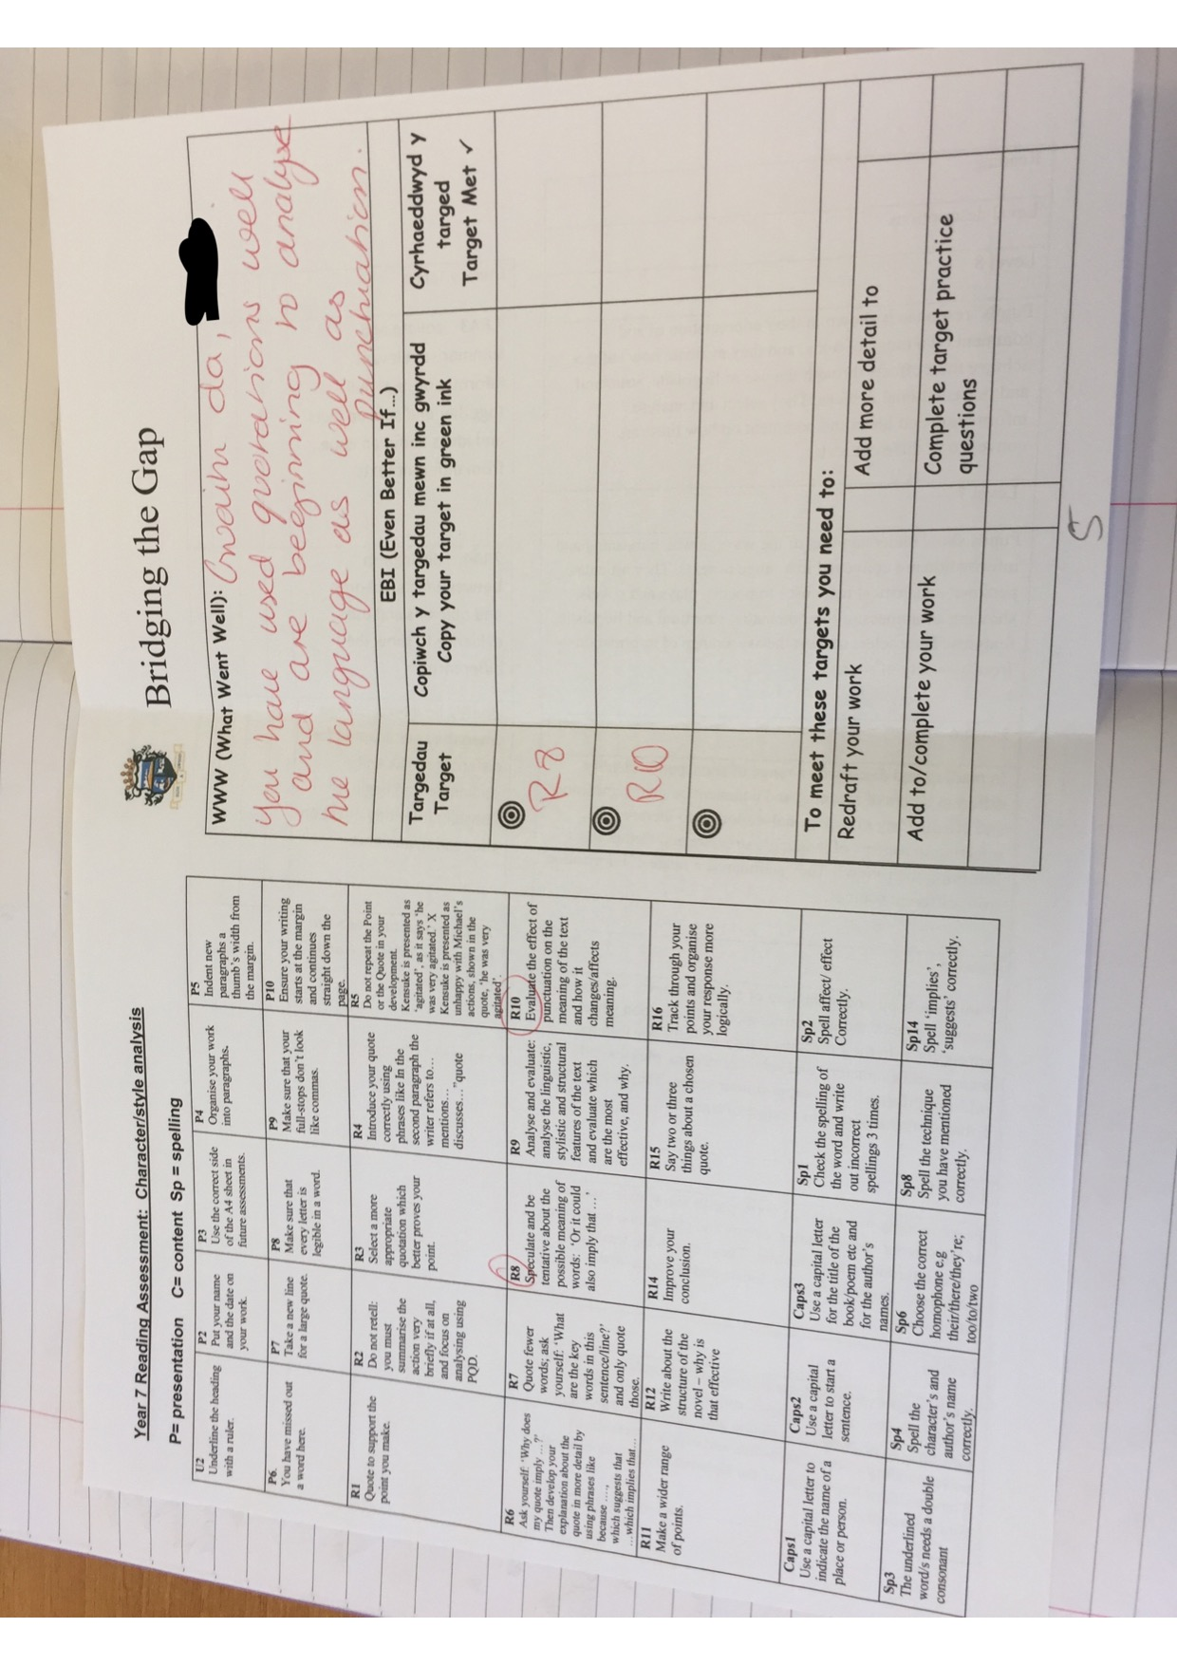

This third piece of evidence comes of the lesson that was formally observed by the lead and subject mentor at PTE1. This shows my Welsh competency by using Welsh language, date and learning objective within my powerpoint that I can use verbally within the classroom.

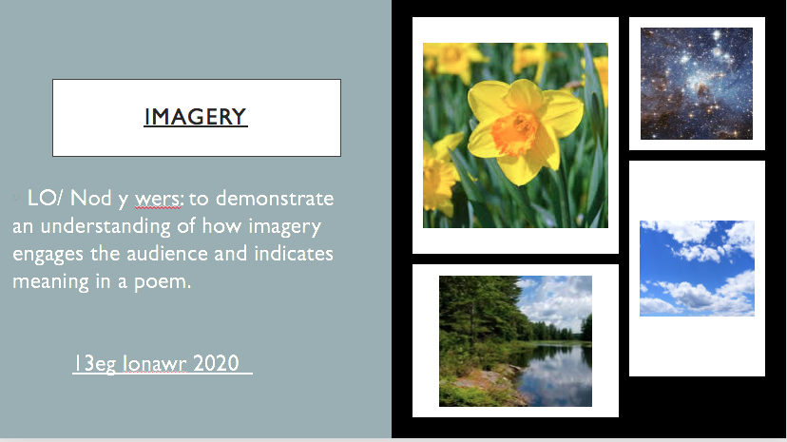

The next pieces for evidence come from my review that was performed within PTE1 from the subject teachers that I was placed with. It shows that I can use incidental Welsh within lesson even though it can be used further. It also shows that I use Welsh phrases when marking.

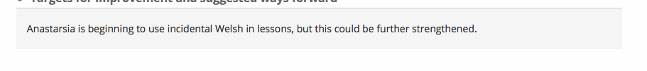

These worksheets show that I have engaged with the Welsh materials that were given to us during our Welsh lessons within university. They show that I have an awareness and are capable of using common phrases within the classroom environment.


