Video Presentation Assignment
Kathrine Williams-Kirby, 2204818, Learning in the digital Era, Animation and VFX

Table of Contents
Self-Evaluation 1
PDP 1
Unit 5 Section Summery 1
Video Presentation 1
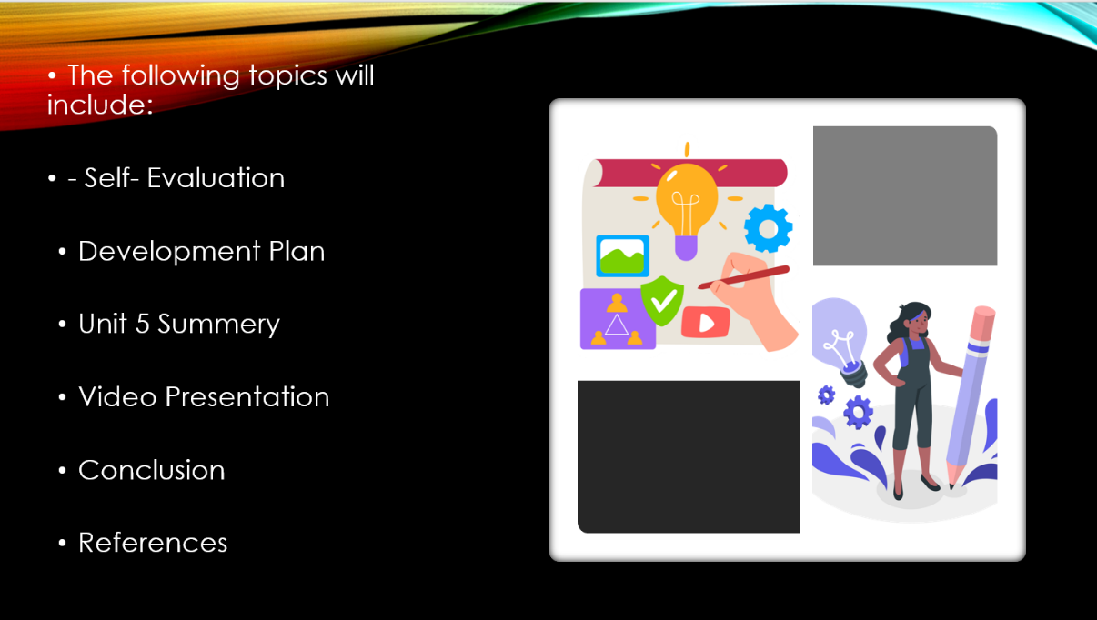
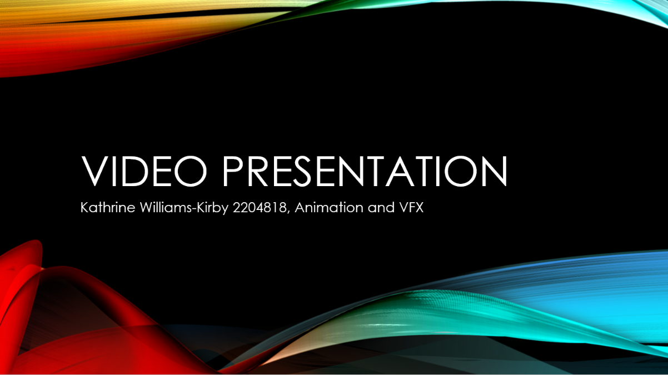

Self-Evaluation
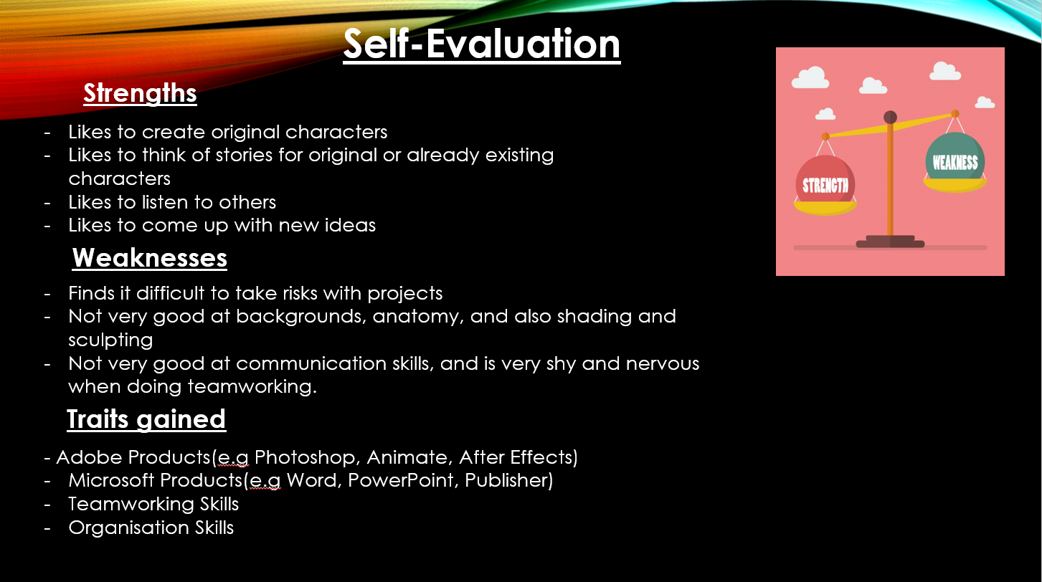

PDP
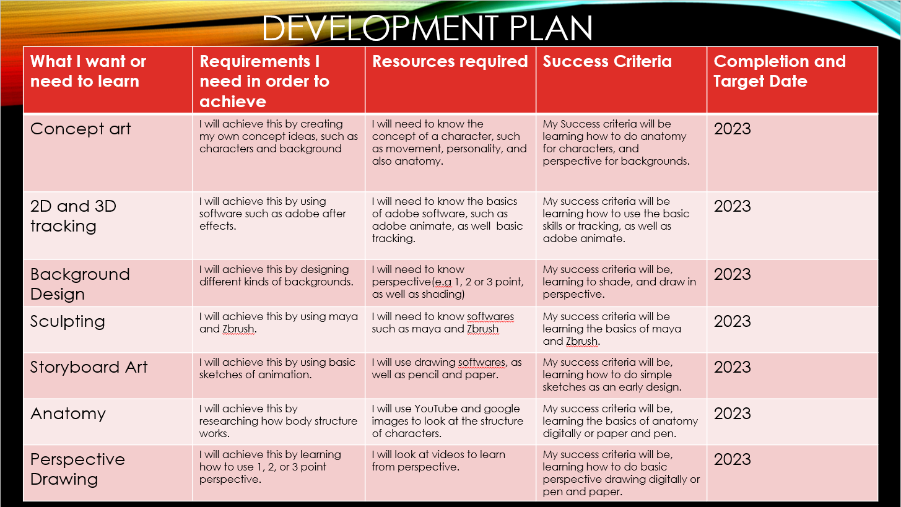

Unit 5 Section Summery

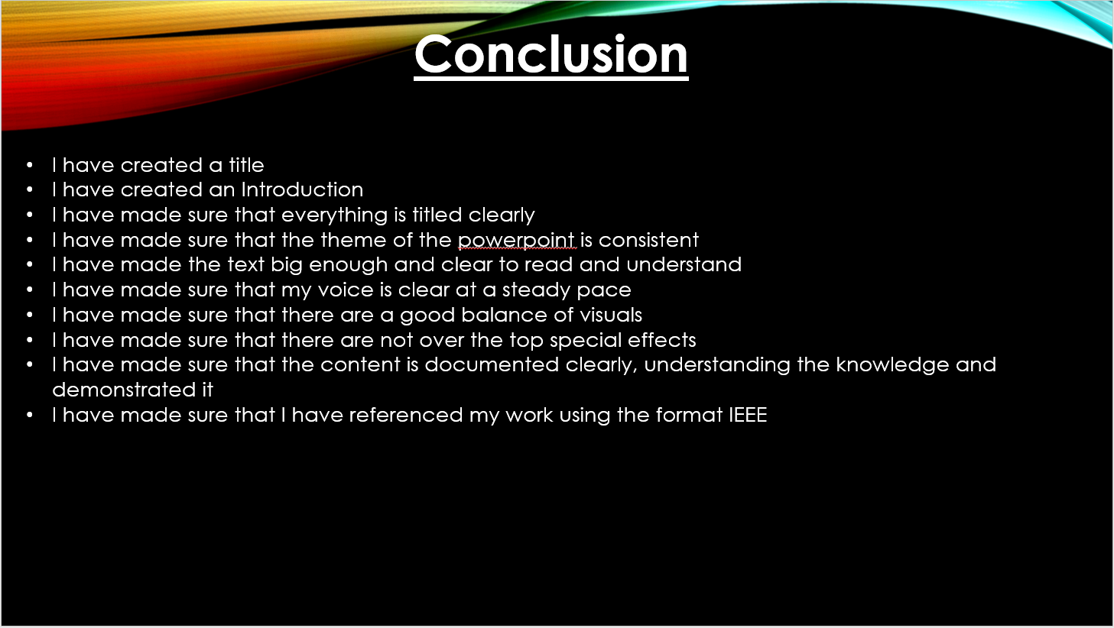
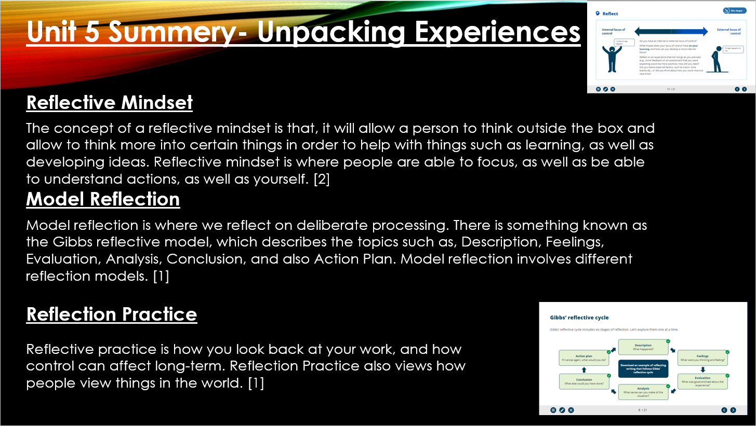

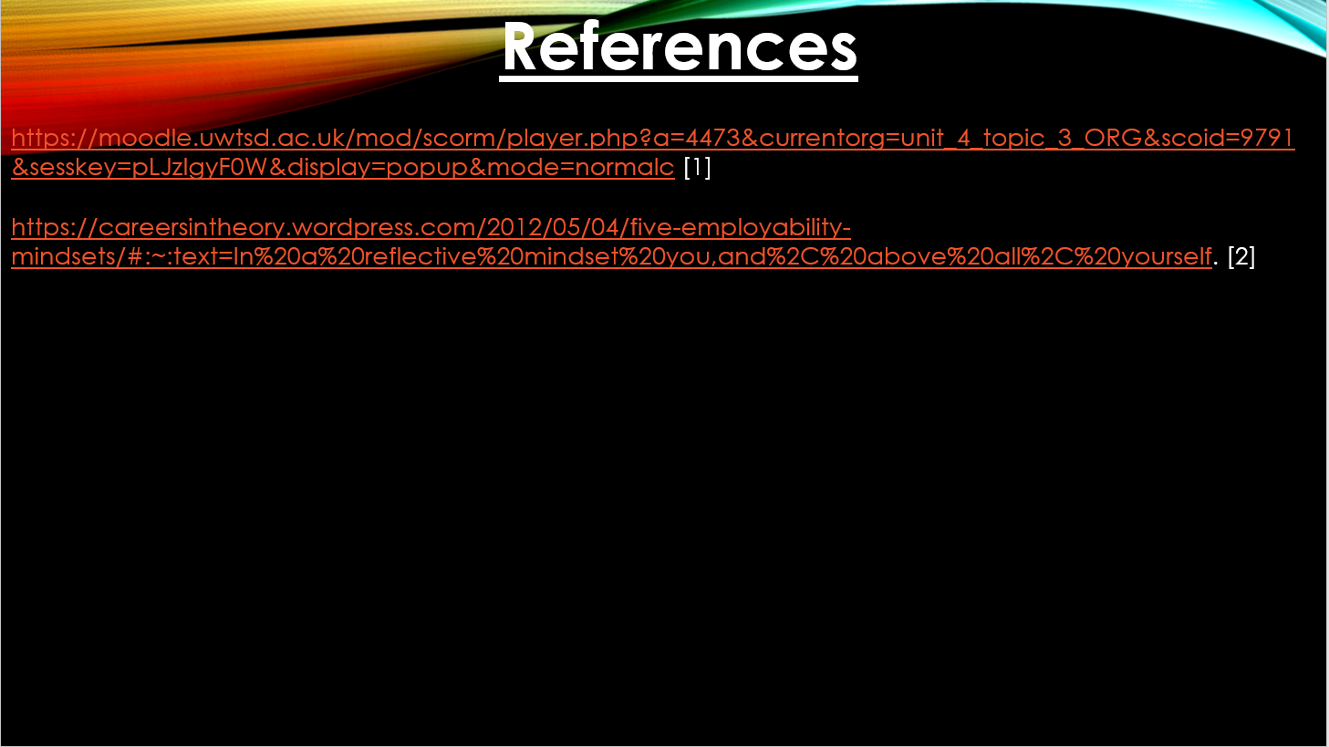
Video Presentation

https://uowtsd-my.sharepoint.com/personal/2204818_student_uwtsd_ac_uk/_layouts/15/onedrive.aspx?id=%2Fpersonal%2F2204818%5Fstudent%5Fuwtsd%5Fac%5Fuk%2FDocuments%2FLearning%20in%20the%20Digital%20Era%2D%20Adam%20Head%28Year%201%29%2FAssignments%2FAssignment%202%2DVideo%2FVideo%20Presentation%2Emp4&parent=%2Fpersonal%2F2204818%5Fstudent%5Fuwtsd%5Fac%5Fuk%2FDocuments%2FLearning%20in%20the%20Digital%20Era%2D%20Adam%20Head%28Year%201%29%2FAssignments%2FAssignment%202%2DVideo


