1922117@student.uwtsd.ac.uk
Term III.
Laszlo Gamsz

Problem Solving and Decision Making
Assignment

 | FACULTY:  Higher Education on the Workplace skills
Assessment Cover Sheet

Module Code:  BMSW4004 | Module Title:  Problem Solving and Decision Making | Module Lecturer:  Mr. Yajesh Kumar
Assessment Title and Tasks:  Problem Solving and Decision Making |  | Assessment No.  1
No. of pages submitted in total including this page: 14 |  | Word Count of submission  1914

Page: 2 Problem Definition,
Page: 3 Ishikawa fishbone diagram
Page: 4 Swot analysis
Page: 5 Data collection- What?
Page: 6 Cause analysis why? Solution planning and implementation-Why,
Page: 7 Evaluation of effects.
Page: 8 PESTLE analysis of changing the menu

Page: 9 PMI analysis

Page: 10 Standardisation, Evaluation of process

Page: 13 Conclusion

Page: 14 References

1. Problem Definition.

If the income of a restaurant is under an acceptable level, for even just a couple of months, it could be advisable to change the menu.
In my personal experience of managing a golf club, the ‘specials’ menu offered in the restaurant would change each week, while the a-la cart menu changed every two months. The menu allowed our guests to enjoy their favourites, or try something new each time they visited.
To identify which part of the menu needed to change, we would make an analysis of the sales figures from the previous months, looking for which items were the most popular and which were the least.
Based on this information, it was possible to create an improved menu that kept the items we knew to be successful and replace the ones that weren’t.

To identify the cause of our problem we can use the following steps:

- “Describe the Vision: We would state the most ideal solution for the problem and imagine how we want to business to look if the problem did not exist. Describe the problem: write a brief summary of the problem. Identify the key information by using a single phrase.
- Describe the financial consequences: Describe what would happen if we failed to correct the problem.
- The problem-definition process. (Visual Paradigm Online, 2021) To better understand the problem and the solution, we will create a SWOT analysis for this case:

Ishikawa fishbone diagram to understand the cause and effects through the menu changing process:

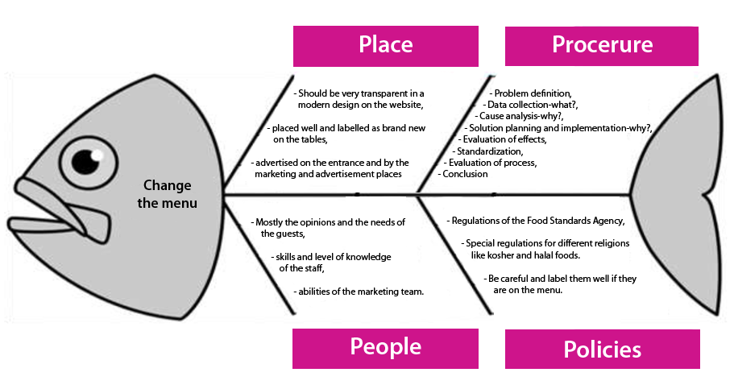

SWOT Analysis (New Menu)

Strengths  Improved variety of popular dishes.  Better selection, focused on popularity based on the previous sales database.  New specialities with wider range of ingredients.  Supplemented with an added calorie chart.  Separated section for local and international specialities and for wild and fish food.  Separate page with extra low calories for weight watchers.  Actual and modern design.  Still available the most popular foods.  Extended kid menu. | Weaknesses  Mostly not yet known specialities.  The good preparation and services need more time at the beginning, till the staff gets routine.  In advance hard to know, all food will be welcomed well.  New delivery and preparation ways should be introduced.  Many well-known foods will be missed.
Opportunities  New customers.  New marketing tool to advertise the new menu.  Refresh the staff to learn new ways and tools for higher and better hospitality service.  Surprise the usual guests.  Based on previous experiences and sale figures designed on the way to get higher revenue. | Threats.  Hard to calculate the new raw material orders.  Maybe more wasted raw material at the beginning.  How will be welcomed the new menu by regular costumer.  Will be enough new guests because of the new menu?  The staff will be trained well enough in a short time for the new foods?

2. Data collection - What?

Data collection of sales figures is important, as is customer feedback, but beyond what is popular we must also consider what is the profitability of the food items; we need to know which part of the menu makes the most income. In the restaurant business, this can be more deceptively difficult than it looks.

To understand the complexity of this problem, we must look at “costing margins”. Typically a restaurant works to a 30% “costing margin”. This means the raw ingredients must cost no more than 30% of the dish cost. (For example, a meal priced at £10 on the menu, first has the VAT removed to show a net cost of £8 total. 30% of £8 is £2.40, which is the maximum amount that can be spent on ingredients for a dish sold at £10.) What happens in reality, is a fish dish like a Dover Sole can be priced at a costing below 20%, whilst a Fillet Steak will be at the limit of affordability. On the surface this would give the impression that a fish dish is more profitable than steak, but there is a hidden factor in that good quality food is often matched with fine wines with advice from the sommelier. It could be the case that, the more profitable fish dish may be advised with a cheap white wine, whilst the fillet steak may be advised with a more expensive red wine. Therefore the ability to upsell wines with the food impacts on overall profitability. As wines are ordinarily separated from food items in menu analysis, and the upselling relies on the skill of the staff, these considerations would be missed if only an analysis of sold food items were made; therefore it is important to take a global approach to analysis, drawing as much human data as possible from front-line kitchen and serving staff.

From our collected data there are four main types of menu changing:
1. Full remodelling
2. New items.
3. Replacements
4. Redesign
Prange (2021)

3. Cause analysis why?

The case analysis should always include the fresh easily available raw materials, what we can buy easily and always fresh and high-quality? For example, are fishes or wild meats available easily?
If we implement the Five Whys of root analysis for all the actual food or drink on the menu what we decided to change, we will find it easier to identify successful changes. It is not enough to ask five questions beginning in “Why”, each question must be asked in context and lead to a conclusion.
Based on research, it has become important to customers that the calorie content and nutritional information be included on the menu. Therefore, our new menu should be planed and designed this way.
“A Meta-Analysis to Determine the Impact of Restaurant Menu Labelling on Calories and Nutrients (Ordered or Consumed) in U.S. Adults”
(Cantu-Jungles at. all 2017, p.1088)

4. Solution planning and implementation – Why?

Present the Vision with Enthusiasm

Even if we have a clear vision about the future menu of the restaurant and the sales figures shows us clearly the necessary changing point, it is important that we carefully consider the following points:

“We have a project, criteria for success, and a timeline for the project. Now, we have to communicate. From the initial announcement, we need to make four things clear:
What tools will change?
What processes will be updated?
How will the adoption of this technology help employees perform better?
What is the timeline employees and stakeholders can expect?”
Let (2020)

5. Evaluation of effects.

The effect evaluation must consider that special catering events and conference & banqueting menus should try to use the same ingredients as the main restaurant kitchen; for the purpose of operational management, it is important not to overcomplicate supply ordering, storage, or general kitchen management. If we change the menu in the right way and quite frequently (every two months) this will increase our sales as my personal experiences and official scientific sources suggest.
“Usually, customers go to a restaurant with distinct expectations. They expect that when they are in that place, have a desirable choice in terms of serving foods. According to this study finding, customers can change their behaviour under the influence of menu design. in the first hypothesis, we emphasized on the fact that in the time of choosing the food, the customer can ignore the price as the most critical element in marketing, and because the menu was designed in a descending order of price, the customer was most likely to spend time looking at the food at the top of the menu, thereby sales amount compared to the previous, has increased.”
(Amjadi and Rastad, 2015, p.93)

For precise and wide range evaluation of the effects I’ve prepared a PESTLE analysis:

 Laszlo Gamsz 1922117

PESTLE Analysis of a new menu

Political Factors

There are political factors that are able to influence our restaurant business in positive and negative ways. Health and safety guidelines, alcohol licensing and taxation changes can all impact on profitability. The menu has to be designed in the way that minimise the impact of changing regulations. Purchasing, cooking and packing are all the responsibility of our restaurant to take care with the food products. The United Kingdom has very strict food regulations.

Economic Factors

Price inflation affects our business and restaurants, the prices of the ingredients of course will increase on our menu prices than. Food delivery and takeaway services can help to survive the Covid pandemic lockdown situation. If the weather is good, families can enjoy dining outside.

Social Factors
In recent years, people have become increasingly health conscious; organic foods are much more popular than junk food. Indicated calorie chart is necessary labelled by each food. The busy lifestyle doesn’t give enough time to working people to prepare their foods based on their requirements, so they try to find the right solution online and mostly order them by delivery.

Technological Factors
This is the most dynamic factor of the PESTLE analysis. The quick change of the technology advancement can impact our restaurant business. Inevitable to install CCTV systems, for example. Almost all restaurants now use computerised ordering, billing and stock control systems such as Remanco and Micros, as well as restaurant management and accountant services such as Toast POS and QuickBooks Online with so many options and processes. If these software are used on the right way it can increase the flow of increase and profitability. Our menu should be downloadable by our restaurant application displayed on the table, to order food and drink online by smartphones what is an extra service and less personal contact when the restaurants can reopen again.

Legal Factors
Legal and local authorities can inflow our restaurant business. They regularly visit and supervise our business areas as kitchen and storing areas, the menu has to be constructed on that way as the raw materials storage and preparation procedure meets the legal requirements.

Environmental Factors

It is important to consider the internal and external environment of our restaurant in creating the right menu. Adequate sourcing of raw materials and proper food waste management policy can be implemented just by this way also. The impact of the environment is crucial for business expansion and a loyal customer base, should influence our weekly and standard a ’la carte offer on a symbiotic way.

To confirm we have chosen the right solution beside the PESTLE analysis the PMI analysis is a very useful device also:

Plus | Minus | Interesting
New interesting tastes: +5 | Many extra unprofitable work hours to learn the new menu to cook and to serve: -4 | People reaction unpredictable, hopefully good +2
New reason for brand new marketing: +3 | Have to change the shopping sources and routine: -3 | Something new interesting task: +2
New occasion to develop the staff team work: +2 | All the printed and physical menu have to be changed: -2 | Something new in the district for locals: +2
New experiences to learn: +2 | Many traditional offer from our old menu have to be missed: -3
New guests for new foods: +3

Plus: +15

Minus: -13

Interesting: +6

Final PMI evaluation: +8

6.- Standardisation.
The chosen menu must be always in the same high quality prepared by our chefs and served by the floor staff.
As we know standardisation is: “the creation of universality by the circulation of particulars.” (Grossman, 2002)
Standardisation is an inevitable process to running a successful restaurant. By putting policies, procedures, costings, operations manuals, recipe manuals and training modules in place, in case to get more positive customer and staff feedback, less employee turnover, and a successful venue. The standardisation of the menu is one of the most important part of our standardisation process.

7. Evaluation of process.

The evaluation process analyses the expected profit and turnover based on the new menu raw material prices. But the evaluation process includes not only the analysis of raw materials and price, but also measures the employee’s work and results based on their job responsibilities.
Based on the amount of value added by the employees in comparison to the standards of overall employees return on investment (ROI)
To evaluate employee performance regularly, it becomes very important to give them feedback about their job. They have the closest connection with guests they can evaluate how they like the new menu and how successful the changes, for future menu changes they can give us the best ideas based on they experiences with diners. They can also get ideas and inspiration from other restaurants they have visited about general new food trends. The aim of the process of performance evaluation is to improve the team organization functions, to realise higher levels of customer satisfaction. In order to improve competence and efficiency the manager should evaluate the team members regularly together with frequent employee training and skill development sessions. All team members must be able to present and serve the menu on a standard high quality. Regular performance evaluation can help determine the level of motivation on how they can contributes toward the success of regular menu changing.
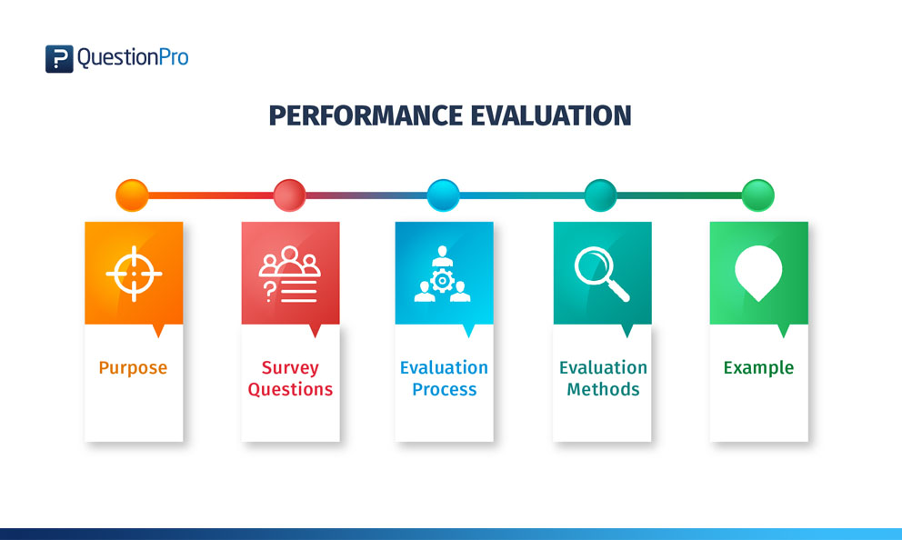

Performance evolution (Questionpro, 2021).

Another important part of our evaluation process is communication with stakeholders.
If the communication is good and regular, it is possible to get a greater understanding of their objectives and goals, and easier to support and deliver them.
One of the most important functions of the stakeholders is to provide resources to the business when it is needed; they are not an endless sources of money and capital, but they can offer them when the business is asking for their support, especially at times of growth.
Below you can see 6 effective ways to communicate with stakeholders,
- Schedule a meeting.
Meetings with stakeholders are the most usual method for communication in any corporations. To be in the same room with our stakeholders can avoid lots of misunderstanding. We can show them our new menu personally and answer any questions why we want to change the menu and why we chose these foods.
- Send out newsletter.
By the company’s collaboration platforms we can proactively define a newsletter. Including the reasons and the solutions for our new menu. Because e-mail is not a one way communication, we can answer any question from them.

- Online “screen to screen separate meetings.

Because of the time to travel for a meeting the best way to save time is the separate online face to face meetings with stakeholders. Not all of them responds for our presentation on the same way, so meet them separately, more detailed with greater control.
- Project summery report

Generally they are sent regular (weekly, monthly) reports. This is a regular form of communication, we can include here all the necessary information about the menu changing process and the results as they can see the situation in control.
- Schedule a conference call

Usually just when the issue is too urgent for a meeting, so not the best way for our menu changing project. This is a planned process.
- Lunch meetings

This is an informal communication category, but in case to introduce our new foods can be a brilliant way for the meetings with the stakeholders. And the best way to know our new menu is, to try it!

Jordev (2016)

8. Conclusion

As we can see to change the menu is one of the way to increase the profit and revenue of our restaurant. To define the problem on our sales and business results the SWOT analysis, Ishikawa Fishbone diagram, Pestle analysis are very useful and indispensable tools. It is much easier to solve any issues in our business if we can determine the issues. For any of them we can find the right solution, but just after than if the sources are identified correctly.
“First, we need to be clear about the six steps in the food-flow process: production, access, acquisition, preparation, presentation, and ingestion. Each of these are affected differently by structural, situational, and cultural variables.”
(Research Methods in Nutritional Anthropology, 1989)
Continuous observation of food-related behaviour is essential to understand the preparation rules and the recipe factors of different nations. How about the choices are made can be figured out also by observation, our menu have to help our customers to make their best choices without any complain or negative experiences.

Reference list:

Amjadi and Rastad (2015) EXAMINING CHANGES IN THE RESTAURANT MENU AND ITS IMPACT ON CONSUMER CHOICE BEHAVIOR. p.93

Cantu-Jungles. (2017) Nutrients. p.1088.

Grossman, (2002) ‘Standardisation’, The University of Chiago Press

Jordev, S (2016) 6 ways to effectively communicate with stakeholders.
Availabe at: https://www.celoxis.com/article/6-ways-to-effectively-communicate-with-stakeholders
(Accessed at: 09. February. 2016)
Prange Jackie (2021) Why your restaurant menu should always be changed.
Available at: https://www.touchbistro.com/blog/why-your-restaurant-menu-should-always-be-changing/
(Accessed: 2021)

Resarch Methods in Nutritional Anthropology. (1989) United Nations University

Lee Let (2017) 7 Vital Steps in a Successful Restaurant Technology Rollout
Availanble at: https://www.qsrautomations.com/blog/kitchen-automation/7-vital-steps-technology-rollout/
(Accessed: 01.May. 2017).

Questionpro (2021) Performane Evaluation
Available at: Performance Evaluation - Definition, Method, Survey and Example (questionpro.com)
(Accessed: (2021)

Visual Paradigm Online (2021)
The Problem-definition process
Available at: https://online.visual-paradigm.com/tabular/templates/the-problem-definition-process/

