8/17/2026
Code Link: https://github.com/crespo689/smart-home-device-manager-new

University of Wales Trinity Saint David
London campus
SPC Assignment on
Smart Home Device Manager System for Bright Minds Academy
Module Name: Scripting and Programming Concepts
Module Code: ACCA 5036

Student Name: Tania Crespo
Student ID: 2424748

Lecturer’s Name: Koushik Modak

Table of Contents
Introduction 3
Main Body 3
1.Analysis 3
2.Software Design and Development 7
Design: 7
Source Code 14
3.Testing and Debugging Report 17
4.Evolution 22
Conclusion 24
references 25
Appendices 26

Introduction
Bright Minds Academy is a private tutoring centre, currently trialling a smart classroom system with thermostats, projectors and smart lighting. The main problem is that these devices are currently managed manually. This makes it harder for staff to know the location and status of each device. This project develops a simple software system to allow Bright Minds Academy staff to record the location and connectivity status of smart devices. The aim of this project is to support staff in the management of devices through a more organized and user-friendly system.

Main Body

1.Analysis

Requirements Analysis
A simple computer-based solution is needed by Bright Minds Academy to facilitate the management of smart classroom devices. Thermostats, projectors and smart lighting are currently managed manually. This makes it harder for personnel to identify which devices are registered, their current status and their location. Requirements analysis is important because it helps to detect the expected functionality of the software before development begins [1]. The suggested Python program will help to solve this problem by using a Python dictionary and a list to store information about the devices. The system’s main purpose is to simplify, speed up and structure device management. The application does not control devices in real-time. Instead, it records and displays relevant information about each device.

Functional Requirements:

One of the main functions of the program is to register new devices. Staff enter a device name, such as "Smart Light A1" or "Projector B2", followed by the room where the equipment is located. The information is then stored in the system, giving Brith Minds Academy a more organized record of its smart classroom equipment.

The second functional requirement is to update device status. The device status should be updated by staff as needed. The available statuses are online, offline or maintenance. This is important as it allows personnel to quickly identify whether a device is working, offline or requires maintenance. To improve reliability and reduce ambiguity, it is important to monitor registered devices properly [2].

The third functional requirement is to view the device list. The application must display all devices that are stored in the system. Staff should be able to see the name, location and current status of each device. This will mean that staff will be able to monitor all devices from one place, instead of checking each classroom individually.

The fourth the fourth function allows staff to find a registered device by entering its name. When a matching record is found, the program displays the device location and current status. This feature reduces the time needed to find information, particularly when the academy has devices stored in several rooms.

The fifth functional requirement is a user-friendly interface. Bright Minds Academy staff will be the main users of the system. They might not have advanced technical knowledge therefore the program should be simple and user-friendly. A menu-based interface will be suitable, as it will allow the staff to select options, such as adding a device, updating its status, viewing the list of devices or searching for a device. This software solution will generally lead to more efficient management of smart classroom devices at Bright Minds Academy. This will give a clear record of where devices are and their current status, saving staff time and reducing confusion. Proper maintenance of asset inventory can assist in better monitoring, maintenance and decision-making [3].

Data Storage
The device information will be stored in a Python dictionary, because a database is not required for the project. Data should be stored in a dictionary because it stores information using key-value pairs. This allows the program to store relevant information such as the device name, location and current status [3]. This makes the software easier to understand and appropriate for a Python project designed for beginners. A dictionary and a list are suitable because the system is small and does not require a full database.

Non-Functional Requirements
In addition to performing its main functions, the system should meet several quality expectations. These requirements focus on how well the program operates rather than on the individual tasks it completes. For this project, the main areas considered are scalability, reliability, performance, security and accessibility.

Scalability: Scalability is the capacity of the system to grow in the future. This is a simple Python program that uses a dictionary and a list, but this program should allow staff to add more devices, as Bright Minds Academy expands its smart classroom system [4]. For example, if the academy adds more smart devices in the future, such as projectors, thermostats and lighting, the system should be able to store and display their information. This makes the program more useful, for both current devices, but also for future expansion.

Reliability: The system should provide accurate and consistent information. When staff add, update, view or search for a device, the information should remain correct. This is important because reliability is a key software quality characteristic [5].

Performance: The system should respond quickly when recording or retrieving device information. Since this is a simple Python program using a dictionary and a list, staff should be able to view or search for devices without noticeable delays. Performance efficiency is important because a system should complete tasks within an appropriate response time [5].

Security: The system should reduce the risk of incorrect or accidental changes to device information. Although this is a simple program, input validation and good coding practices are used to prevent invalid data from being entered [6].

Accessibility: The system should be easy to use and intuitive for staff. The menu options, instructions and information displayed should be simple and clear so that staff members without advanced technical skills and use the application without difficulty. This is important because the system is supposed to facilitate the management of smart classroom devices on a day-to-day basis at Bright Minds Academy [7].

2. Software Design and Development

This part explains how I planned and developed the Smart Home Device Manager for Bright Minds Academy. I created the program to help staff keep a clear record of classroom devices, including smart lights, projectors and thermostats. Using the main menu, staff can register a new device, change its status, view the saved device records, search for a device by name and close the program.

Design:

Flowchart The diagram below shows the steps followed by the Smart Home Device Manager. It begins with the main menu and shows what happens when the user chooses each option. Staff can add a new device, change its status, view stored device information, search for a device by name or close the program.

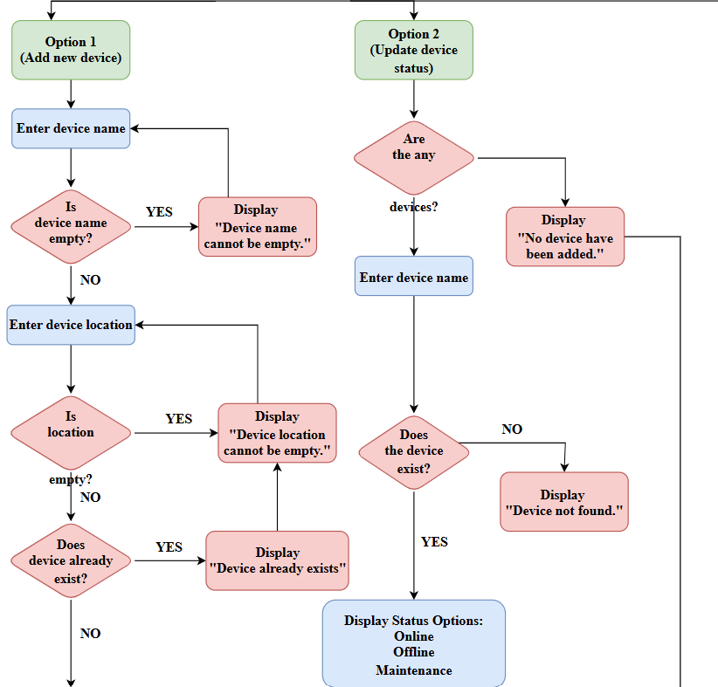
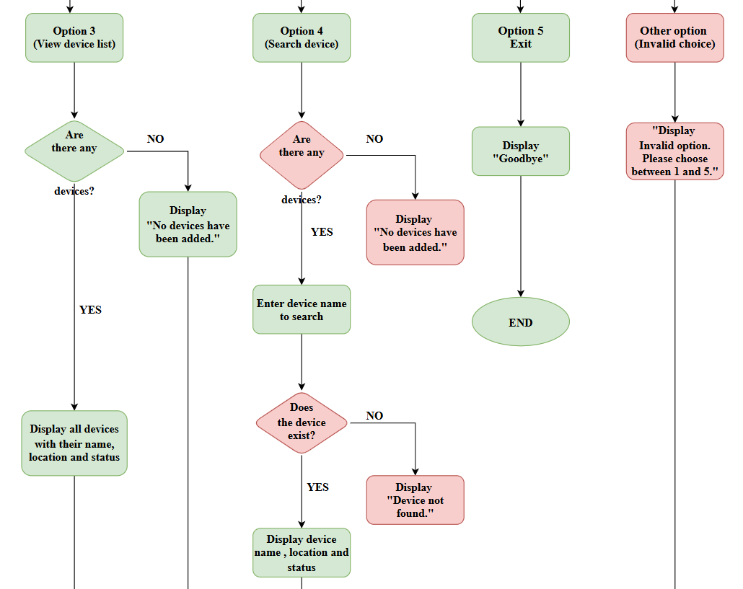
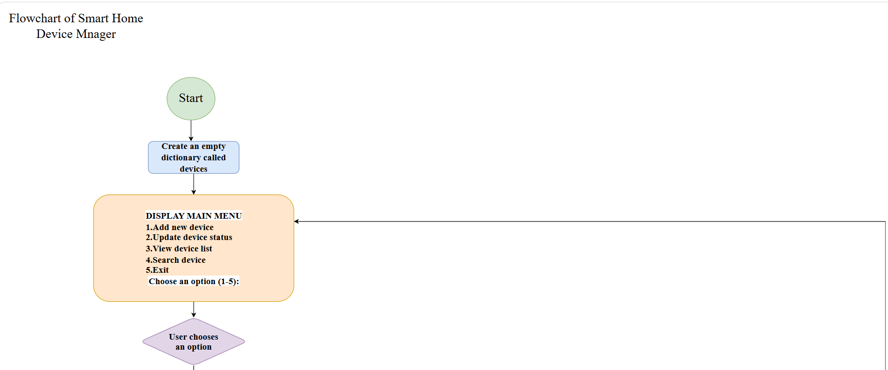
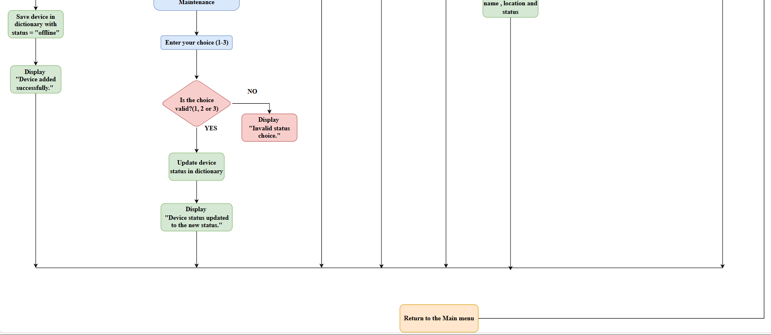

Figure 1: Flowchart of the Smart Device Management System.
Pseudocode
BEGIN

SET devices TO an empty dictionary

SET VALID_STATUSES TO:
"online"
"offline"
"maintenance"

FUNCTION display_menu()

DISPLAY "Smart Home Device Manager"
DISPLAY "1. Add Device"
DISPLAY "2. Update Device Status"
DISPLAY "3. View Devices"
DISPLAY "4. Search Device"
DISPLAY "5. Exit"

END FUNCTION

FUNCTION add_device()

INPUT device_name
REMOVE leading and trailing spaces from device_name

IF device_name is empty THEN
DISPLAY "Device name cannot be empty."
RETURN
END IF

INPUT location
REMOVE leading and trailing spaces from location

IF location is empty THEN
DISPLAY "Device location cannot be empty."
RETURN
END IF

IF device_name already exists in devices THEN
DISPLAY "Device already exists."
RETURN
END IF

STORE location and status "offline" under device_name in devices

DISPLAY "Device added successfully."

END FUNCTION

FUNCTION view_devices()

IF devices is empty THEN
DISPLAY "No devices have been added."
RETURN
END IF

DISPLAY "Device List"

FOR EACH device_name and information in devices

DISPLAY device_name
DISPLAY information["location"]
DISPLAY information["status"]

END FOR

END FUNCTION

FUNCTION update_status()

IF devices is empty THEN
DISPLAY "No devices have been added."
RETURN
END IF

INPUT device_name
REMOVE leading and trailing spaces from device_name

IF device_name does not exist in devices THEN
DISPLAY "Device not found."
RETURN
END IF

DISPLAY "Select the new status:"
DISPLAY "1. Online"
DISPLAY "2. Offline"
DISPLAY "3. Maintenance"

INPUT status_choice
REMOVE leading and trailing spaces from status_choice

IF status_choice equals "1" THEN
SET new_status TO VALID_STATUSES[0]

ELSE IF status_choice equals "2" THEN
SET new_status TO VALID_STATUSES[1]

ELSE IF status_choice equals "3" THEN
SET new_status TO VALID_STATUSES[2]

ELSE
DISPLAY "Invalid status choice."
RETURN
END IF

SET devices[device_name]["status"] TO new_status

DISPLAY "Device status updated to " followed by new_status and "."

END FUNCTION

FUNCTION search_device()

IF devices is empty THEN
DISPLAY "No devices have been added."
RETURN
END IF

INPUT device_name
REMOVE leading and trailing spaces from device_name

IF device_name exists in devices THEN

SET information TO devices[device_name]

DISPLAY "Device Found"
DISPLAY device_name
DISPLAY information["location"]
DISPLAY information["status"]

ELSE
DISPLAY "Device not found."
END IF

END FUNCTION

FUNCTION main()

WHILE TRUE

CALL display_menu()

INPUT choice
REMOVE leading and trailing spaces from choice

IF choice equals "1" THEN
CALL add_device()

ELSE IF choice equals "2" THEN
CALL update_status()

ELSE IF choice equals "3" THEN
CALL view_devices()

ELSE IF choice equals "4" THEN
CALL search_device()

ELSE IF choice equals "5" THEN
DISPLAY "Goodbye."
BREAK

ELSE
DISPLAY "Invalid option. Please choose between 1 and 5."
END IF

END WHILE

END FUNCTION

CALL main()
END

Figure 2: Pseudocode for the Smart Home Device Manager

Implementation decisions

Data Structures
To store the device records, I used a Python dictionary. Each device name is used as a key, while its location and status are stored as the related information. For example, “Smart Light A1” can be the key, with its room and current status saved under that name. I chose this structure because it allows the program to find a device directly by its name. A dictionary works well for this project because every key must be unique[8]. This means that one device name represents one record in the Smart Home Device Manager. It also allows the program to register devices, change their status, display the full device list and find a specific device.
The program also contains a list called VALID_STATUSES, which includes online, offline and maintenance. This list is used when the user chooses a new device status. When an option outside the accepted choices is entered, the program shows an error message instead of updating the device. This helps reduce incorrect information in the system.

Variables
The program uses different variables to store information entered or selected by the user. At the start of the program, devices is an empty dictionary. Each time a new device is added, its details are saved in this dictionary. The device_name variable stores the name entered by the user, while location stores the room where the device is kept. The new_status variable holds the new status selected during an update, which may be online, offline or maintenance.
The choice variable records the option selected from the main menu and helps the program decide which function to call. For example, option 1 runs add_device(), while option 2 runs update_status(). The status_choice variable records the number selected from the status menu. The information variable is used when the program needs to retrieve and display the location and status stored for a device.

Programming Constructs
The main menu is kept active using a while loop. This allows staff to complete several actions during the same session, such as adding a device, viewing the device list and changing a device status. After each action, the menu appears again. The loop ends only when the user selects option 5. The program uses if, elif and else statements to decide what should happen after the user enters an option. In Python, elif is useful when several conditions need to be checked
[9].In this program, these statements are used to process menu choices, check status selections and display error messages when an invalid option is entered. I divided the program into six user-defined functions: add_device(), update_status(), view_devices(), search_device(), display_menu() and main(). Each function is responsible for a different part of the program. For example, add_device() manages the process of registering a device, while search_device() looks for a device stored in the dictionary. Separating the program into smaller functions made the code easier to understand, test and correct. This is an example of problem decomposition because the complete task is divided into smaller sections.

Input validation is also an important part of the program. The system checks for an empty device name, an empty location, a duplicate device name, an invalid status choice and an invalid menu option. These checks reduce incorrect or incomplete information and help the program produce more reliable results. This is useful because some staff members may not have advanced technical knowledge

Python Modules and Libraries

This project does not require any external Python modules or libraries. The software was developed using simple Python features including dictionary, lists, functions, loops, conditional statements and input validation. The project only required Python’s built-in language features, even though Python has a standard library and built-in functions [10]. This decision keeps the program simple and easy to understand, making it suitable for a beginner-level Python project.

Also, the application is easier to run because no additional libraries need to be installed by the staff or the assessor. It uses only basic Python features to perform its main functions. This is in line with the project requirements as the solution is meant to be a simple smart device management program rather than a complex database system.

Source Code
Below in the source code you will see how the Smart Home Device Manager works. Functions are used to structure code, and input validation prevents users from inputting incomplete or incorrect data. You can also get the complete source code from the GitHub folder link on the title page.

Link: https://github.com/crespo689/smart-home-device-manager-new

The images below demonstrate elements of the Python source code that are important and explain their meaning. They explain how the system stores information about the device, validates human input and organizes the software using functions. Code that has clear spacing, variable names that clarify what they do, and comments is easier to read, maintain and fix issues in.

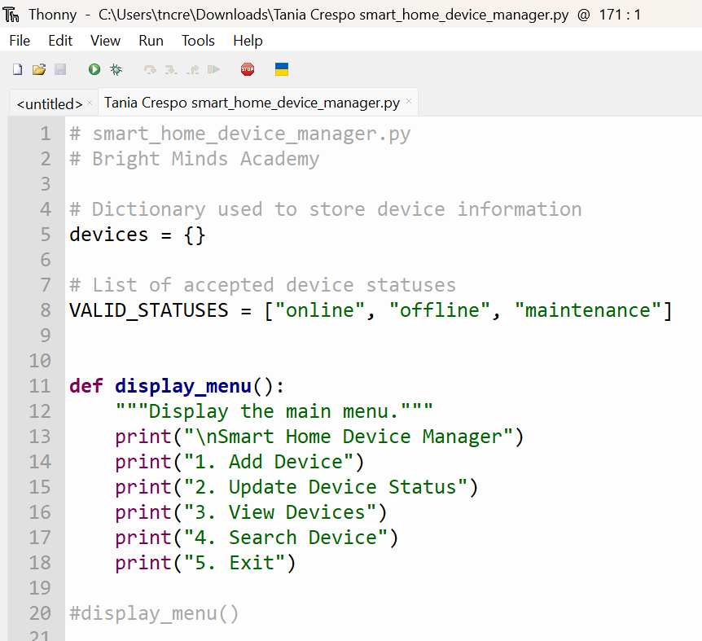

Figure 3: Data Structures and Display Menu Function
This screenshot shows the devices dictionary used to store device information and the VALID_STATUSES list containing the accepted status values. It also shows the display_menu() function, which presents the five options available to the user.

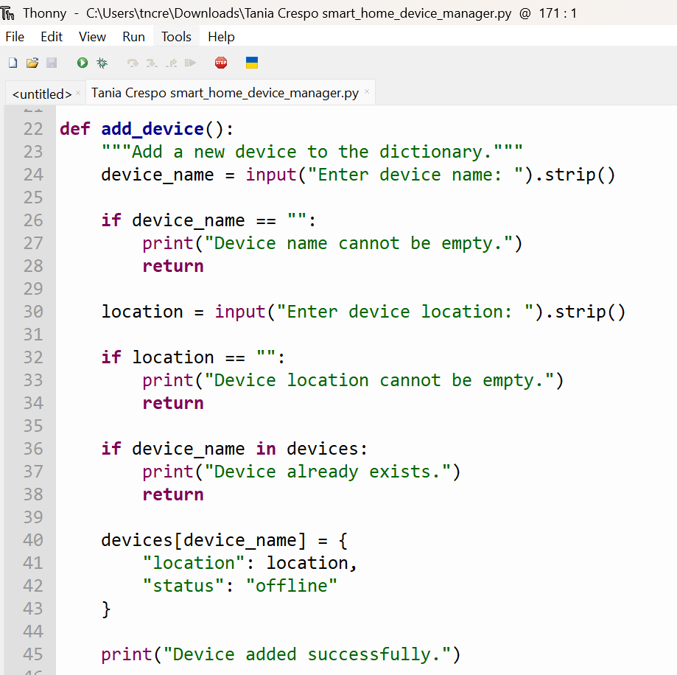

Figure 4: Add Device Function with Input Validation
This screenshot shows the add_device( ) function. It asks the user to enter a device name and location. The function checks for empty inputs and duplicate device names before storing the device with the default status of offline.
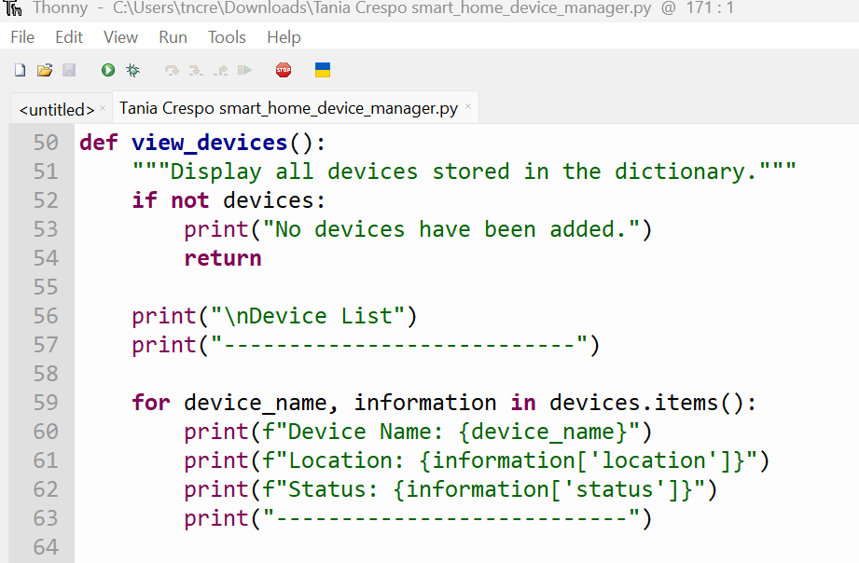
Figure 5: View Devices Function

This screenshot shows the view_devices( ) function. If no devices have been added, the program displays an appropriate message. Otherwise, it displays the name, location and status of every device stored in the dictionary.

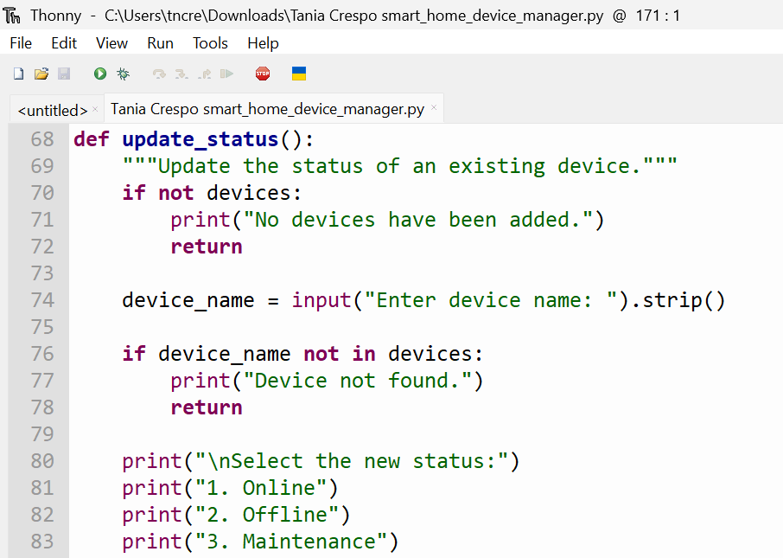

Figure 6: Status Selection and Device Status Update
This screenshot shows how the program processes the selected status option. It assigns online, offline or maintenance, rejects invalid choices and updates the device status in the dictionary.

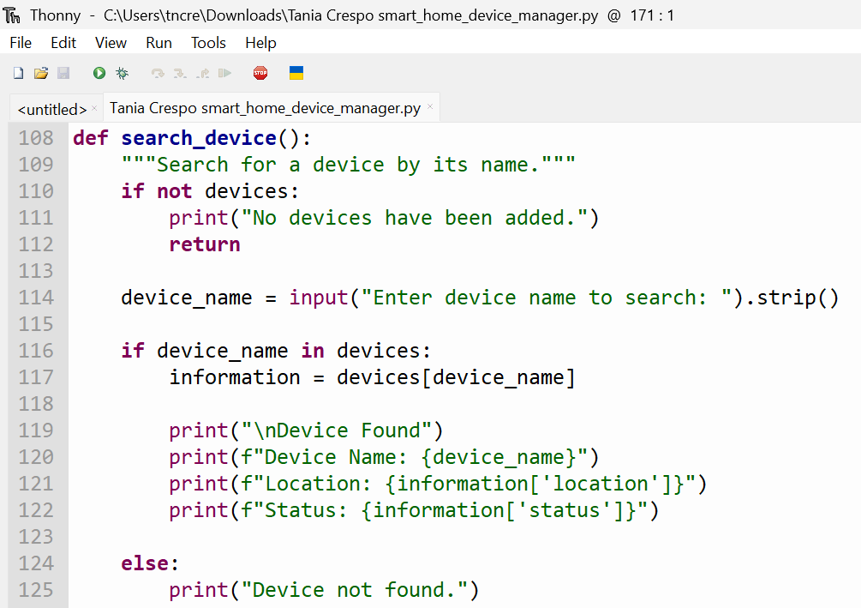

Figure 7: Search Device Function

This screenshot shows how the search feature works. The program first checks whether any devices are stored. The user then enters the name of the device they want to find. When a matching device exists, its name, location and current status are shown. If there is no matching record, the program displays “Device not found.”

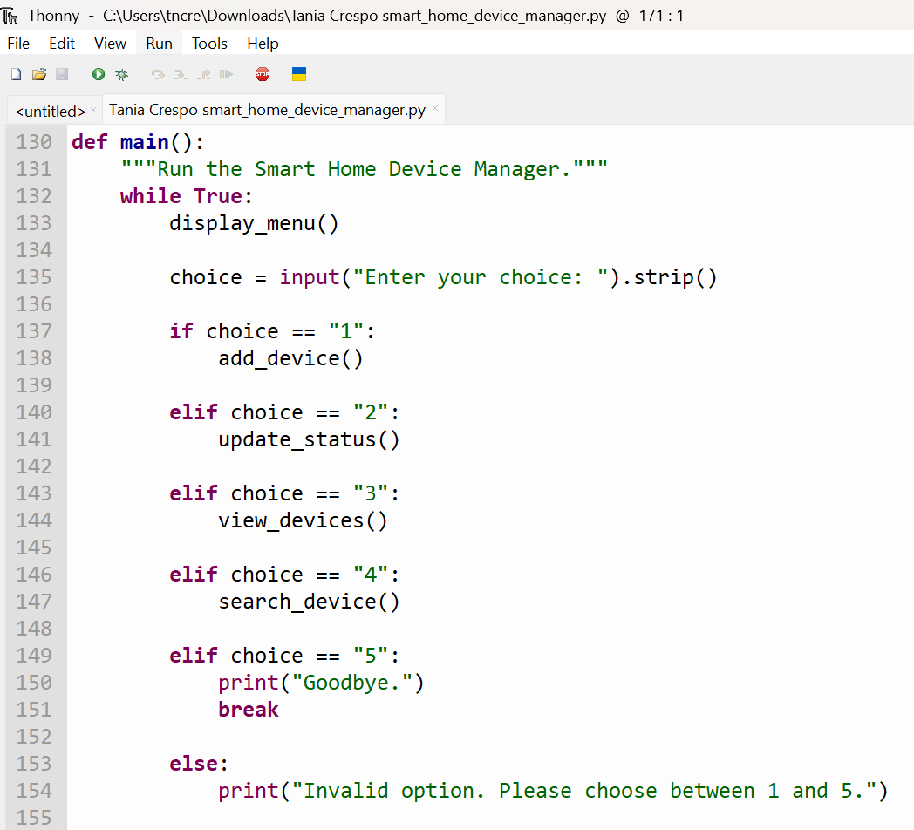

Figure 9: Main Function and Menu Selection Logic

This screenshot shows the main() function, which uses a while loop to keep the program running. The if, elif and else statements call the correct function according to the user’s menu choice. Option 5 displays a goodbye message and stops the program.

3. Testing and Debugging Report
Importance of Programme Testing
Testing helps me confirm that the program behaves correctly and produces the expected results.Testing is used to identify errors, confirm that requirements have been met and improve the quality of the final software. In this project, testing was important because the Smart Home Device Manager must allow staff to add devices, update the status of devices, view the device list and search for devices correctly. Software testing is also important because it helps developers evaluate software quality and identify possible failures before the system is used by real users [11].

Testing was also used to verify the input validation implemented in the program. For example, the system should not accept an invalid status choice, such as option 4 because the accepted statuses are only online, offline and maintenance. Testing correct and incorrect inputs helped to confirm that the system works under different conditions.

Types of Programming Errors

Syntax Errors
Programming mistakes can appear in different ways. A syntax error happens when Python cannot understand the structure of the code. During this project, I experienced this type of error when I used incorrect indentation or forgot symbols such as a colon or bracket.[12]. The message shown in the Python Shell helped me find the affected line and correct the code. Python documentation also explains how syntax errors are identified by the interpreter.

Logical Errors
A logical error is different because the program may run without showing an error, but the result is not what was expected. In this project, this could happen if the program changed the status of the wrong device or followed the wrong menu option. I looked for logical errors by testing the program with different inputs and checking the conditions used in the if, elif and else statements [13].

Runtime Errors
A runtime error appears after the program has started running. It may cause the program to stop or behave in an unexpected way. During this project, I reduced this risk by checking the user’s input before the program tried to use it. For example, the system checks for empty device names, empty locations, devices that do not exist, invalid status choices and menu options outside the range from 1 to 5.

Test Cases
The following tests were conducted to confirm the functionality of the Python program as shown in the table below. Each test includes the expected result , the actual result, the input used, and whether the test passed or failed. The tests include adding devices, viewing the device list, updating device status, searching for devices, rejecting invalid input and exiting the program.

Table 1: Testing results for the Bright Minds Academy Smart Home Device Manager

Test No. | Test Description | Input | Expected Result | Actual Result | Pass/Fail
1 | Register a new device | Option 1, Smart Light A1, Room 1 | The device record should be saved with offline as its starting status | “Device added successfully.” displayed | Pass
2 | Display the stored devices | Option 3 | The program should show the stored device name, location and status | Device name, location and status displayed correctly | Pass
3 | Change a device status to online | Option 2, Smart Light A1, choice 1 | The stored status of Smart Light A1 should change to online | “Device status updated to online.” displayed | Pass
4 | Find a device already stored | Option 4, Smart Light A1 | The program should return the stored details of Smart Light A1 | Device information displayed correctly | Pass
5 | Search for a device that is not stored | Option 4, Unknown Device | The program should inform the user that no matching device exists | “Device not found.” displayed | Pass
6 | Reject an unsupported status option | Option 2, Smart Light A1, choice 4 | The device should not be updated, and an error message should appear | “Invalid status choice.” displayed | Pass
7 | Reject an unsupported menu option | Option 9 | The program should display an error and return to the main menu | “Invalid option. Please choose between 1 and 5.” displayed | Pass
8 | Close the application | Option 5 | The program should display a goodbye message and stop running | “Goodbye.” displayed and the program ended | Pass

Testing Screenshots and Commentary

The following screenshots provide evidence of the tests carried out in Thonny Python Shell. Each screenshot shows the input entered by the user and the result produced by the Smart Home Device Manager. The tests include valid operations and invalid inputs to confirm that the program works correctly under different conditions.

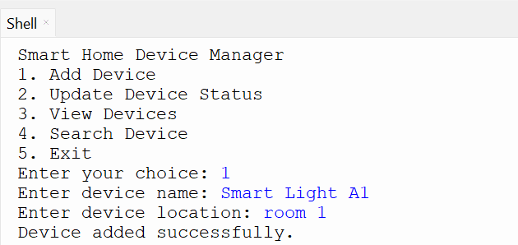

Figure 10: Testing the Addition of a New Device

This screenshot shows the successful addition of a new device. The user entered “Smart Light A1” as the device name and “Room 1” as its location. The program stored the device with the default status of offline and displayed the message “Device added successfully.”

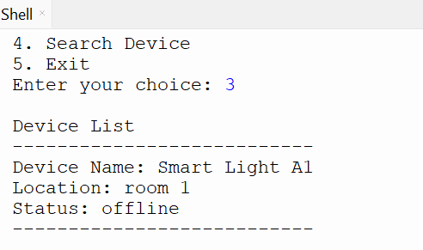

Figure 11: Testing the View Devices Function

This screenshot shows the view_devices() function working correctly. The program displays the name, location and current status of the device stored in the dictionary. Smart Light A1 is shown in Room 1 with the default status of offline.

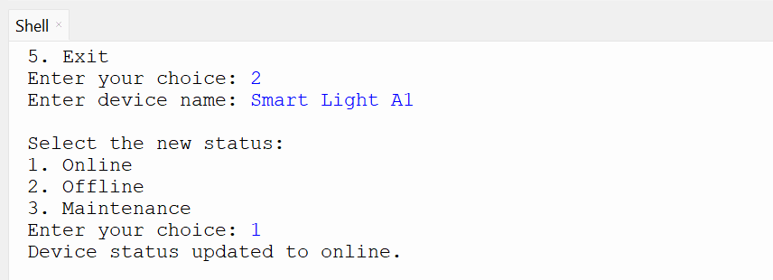

Figure 12: Testing the Device Status Update Function

This screenshot shows the successful update of a device status. The user selected Smart Light A1 and chose option 1 to change its status to online. The program confirmed the change by displaying “Device status updated to online.”

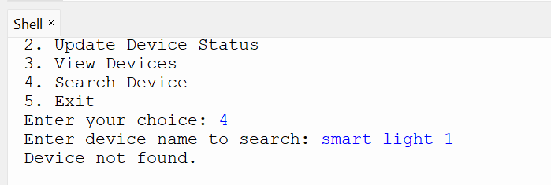

Figure 13: Testing the Search for an Existing Device

This screenshot shows the search function working with an existing device. The user searched for Smart Light A1, and the program displayed its name, location and current status. This confirms that the program can retrieve device information correctly.

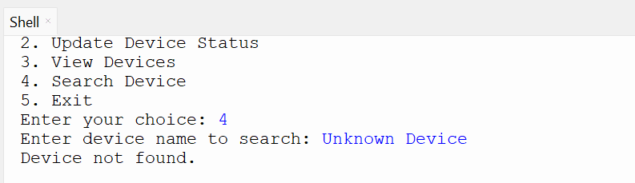

Figure 14: Testing the Search for a Non-Existing Device

This screenshot shows how the program responds when the user searches for a device that is not stored in the dictionary. The user entered “Unknown Device”, and the program displayed the message “Device not found.”

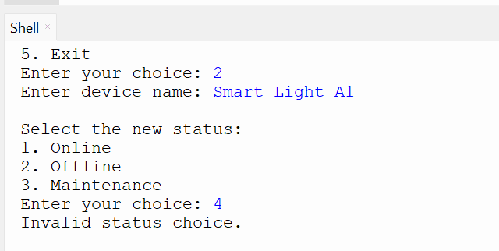

Figure 15: Testing an Invalid Status Choice

This screenshot shows the validation of an invalid status choice. The user selected option 4, although the available status options are 1, 2 and 3. The program rejected the input and displayed the message “Invalid status choice.”

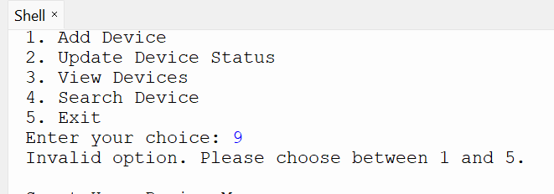

Figure 16: Testing an Invalid Menu Option
This test checks what happens when the user enters a number that is not available in the main menu. I entered option 9, and the program displayed “Invalid option. Please choose between 1 and 5.” The menu then appeared again so that another option could be selected.

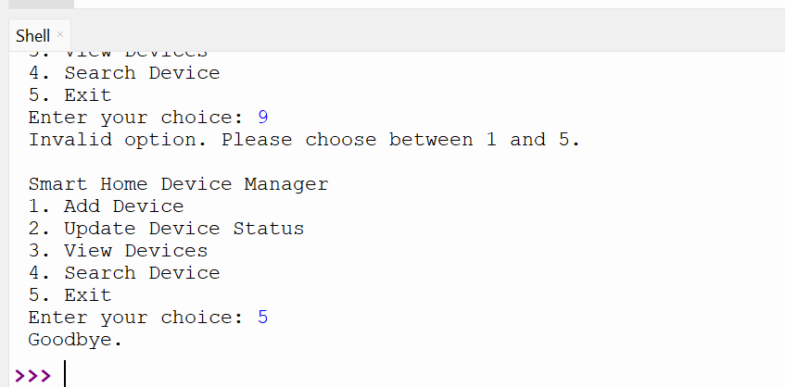

Figure 17: Testing the Exit Function
This screenshot shows the exit function. When the user selected option 5, the program displayed the message “Goodbye.” and stopped running.

4.Evalution

Challenges Faced
During this project, one challenge was in determining an efficient approach for storing device information. At first, the system had to keep the device name, location, and status. But it was also important to make sure that the system was easy to use in terms of updating and searching. This problem was solved with a Python dictionary that stores data in key-value pairs, allowing access to each device by name.

Another challenge was input validation. The system must be able to prevent staff from entering incorrect information, especially invalid statuses. This was solved by creating a list of allowed statuses including online, offline and maintenance. The application checks the user’s choice against this list before saving or modifying a device. This helped to improve the reliability of the system and reduced errors.

Another difficulty was the need to test the program with both valid and invalid inputs. This was important as the system was intended to operate in a variety of situations. The test helped me to identify small faults such as spelling errors in the device names and revealed that the system only locates a device when the name in the system matches the name you are looking for.

Future Improvements
In the future, the system could be improved to store the device information in a text file or database. Currently the software uses a dictionary. This means that the information is lost when the program is closed. If the data is stored permanently, the staff at Bright Minds Academy would benefit more from the system. Another improvement would be to add a “last used” date for each device. This would enable tracking of device usage and would allow staff to see when a device was last used. In addition, the system could also include a graphical user interface instead of acommand-line menu. That would make the program easier to use for non-technical staff. Furthermore, the system could be expanded in the future to include more device categories like interactive whiteboards, cameras or speakers. A further possible improvement is to provide user authentication to limit the ability to edit device information to approved staff.

Self-Reflection
During this project, I learned how the different stages are connected between analysis, design, implementation and testing. I’ve learned it’s important to understand the problem clearly before you start writing code. The flowchart and pseudocode helped me understand the logic of the software, but the analysis helped me understand the needs of the system. I also improved my understanding of Python programming. During a practical project I learned how to use dictionaries, lists, functions, while loops, if statements and input validation. Using functions enabled me to divide the code into smaller parts, which made the software easier to read and test. Overall, this work has helped me develop as a novice developer. One lesson I learned from this project is that testing should be done throughout development, because it helped me find mistakes and confirm that each function produced the expected result. Besides that, I also discovered that small issues like spelling differences in device names could affect how the program works. This experience helped me become more confident in designing, implementing and testing a simple Python application.

Conclusion

Finally, the Smart Home Device Manager is an easy-to-use software that can help Bright Minds Academy. Hand control of smart classroom equipment can be an issue, but this solution helps overcome that problem. Our staff may add devices, update the status of devices, view a list of all the devices we store and look up specific device information. The handling of devices has become easier, faster and more structured. The software was developed using Python dictionaries, lists, functions, loops and input checks. These qualities allowed the development of a menu-based system that is straightforward to use even for personnel who are not highly computer-savvy. Tests indicated that the system performs as expected for both valid and invalid inputs. For example, it will not allow invalid status selections or invalid menu selections.

references

[1] R. Chen, H. Zhu, W. Zhang, Z. Zhou and L. Wei, "Characterizing Tests in IoT Software: Practices, Challenges and Opportunities," IEEE Trans.Software Eng., 2026,
[2] S. Gowrishankar and A. Veena, Introduction to Python programming, Chapman and Hall/CRC, 2018.
[3] H. Washizaki, "Guide to the Software Engineering Body of Knowledge," 2024,
[4] J. M. Wulcan et al., "Classification performance and reproducibility of GPT-4 omni for information extraction from veterinary electronic health records," vol. 11, pp.1490030, 2025,
[5] G. Van Rossum, "Python programming language.", in USENIX ATC,
[6] D. G. Quevedo and J. Kuri, "AI for Qualitative Research," 2026,
[7] S. L. Henry, "Introduction to Web accessibility," 2005,
[8] K. Turpin and J. Gadsden, "Owasp secure coding practices-quick reference guide," vol. 20, pp.2019, 2010,
[9] K. Shivashankar, G. Al Hajj and A. Martini, "Maintainability and scalability in machine learning: challenges and solutions," vol. 57, no. 12, pp.1–36, 2025,
[10] D. J. Edwards, "Inventory and Control of Enterprise (Hardware) Assets," in Critical Security Controls for Effective Cyber Defense: A Comprehensive Guide to CIS 18 Controls, Springer, 2024. pp. 1–28.
[11] D. G. Quevedo and J. Kuri, "AI for Qualitative Research," 2026,
[12] M. Fagan, M. Fagan, K. N. Megas, K. Scarfone and M. Smith, "IoT device cybersecurity capability core baseline," 2020,
[13] S. Almeyda and A. Dávila, "Process improvement in software requirements engineering: A systematic mapping study," vol. 48, no. 8, pp.513–533, 2022,

Appendices

Appendix A: Project Links

The source code, flowchart and README file for the Smart Home Device Manager are available through the GitHub repository below:
GitHub Repository Link: https://github.com/crespo689/smart-home-device-manager-new

Appendix B: Program Files
The main Python file used for this project is:
smart_home_device_manager.py

This file contains the complete Python code for the Smart Home Device Manager. It includes the functions used to register devices, change their status, display stored device records, search for a device and close the program.

Appendix C: Additional Notes

The program was developed and tested using Python in Thonny. The system uses a Python dictionary to store device information, including the device name, location and status accepted status. The accepted statuses are online, offline and maintenance.

The program does not use databases or permanent data storage because the assessment required a simple Python solution using lists or dictionaries. Future improvements could include permanent data storage, a graphical user interface and a last-used date for each device.

