Title Page

University of Wales Trinity Saint David
Name: Riccardo Sterling
Student ID: 2334990
Programme: BA (Hons) Leadership and Management Skills for the Workplace
Module Code: LCLM 5002
Module Title: Developing and Managing Individuals and Teams
Assignment Title: Component 2 – Individual Report
Lecturers:
- Doreen Nyaa Amundam
- Nishi Ramsurran

Individual Report

1. Introduction
This report provides a focused overview of Darktrace’s organisational context and structure. Darktrace Holdings Ltd, founded in 2013 in Cambridge, UK, is an AI-driven cybersecurity organisation employing approximately 2,400 staff and serving 10,000 customers across over 100 countries. The company develops self-learning systems that detect and respond to cyber threats in real time, supported by continuous innovation and data-driven practices. Whilst these technological capabilities strengthen organisational performance, they create complex HR challenges for strategic management.
Consequently, effective management of technological advancement, talent acquisition and retention, and diversity and inclusion are important. This report analyses these three HR factors, evaluates contemporary HR practices, and critically assesses managerial implementation, supported by Figure 1 below (Darktrace, 2026).
Ultimately, strategic HR alignment enables Darktrace to sustain innovation, enhance workforce capability, and achieve long-term organisational success.

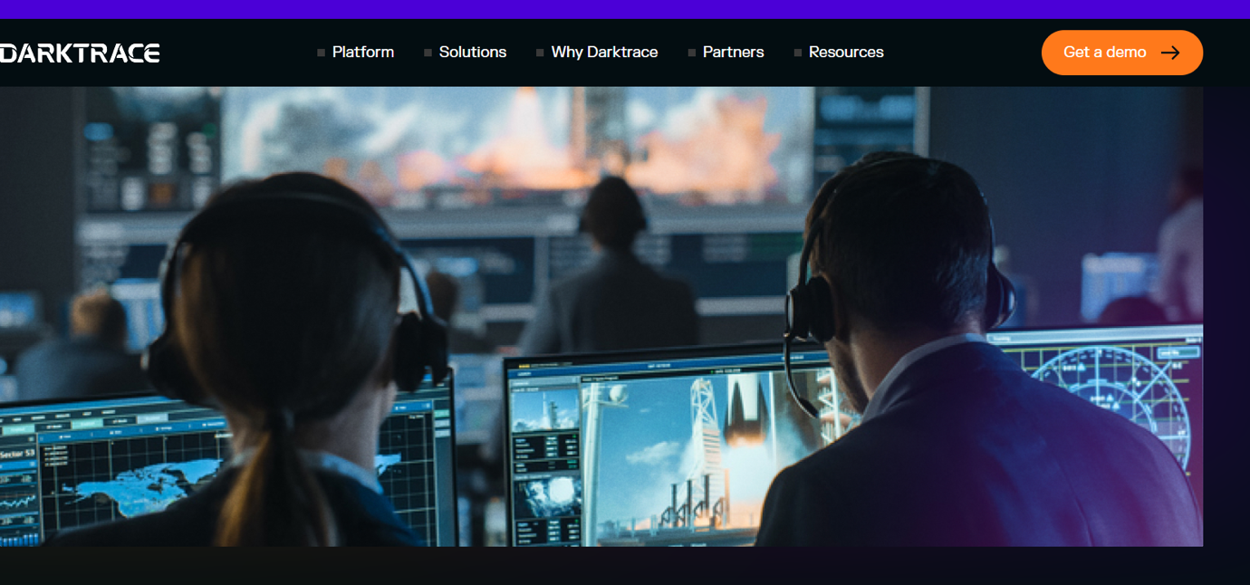

Figure 1 Darktrace (2026)

2. Explanation of Specific Factors

Technological Advancement

Technological advancement stands as a core element of organisational capability at Darktrace Holdings Ltd, as the company’s operations are based on artificial intelligence and machine learning systems. According to (Mullins and McLean, 2019), technological change requires organisations to adapt workforce skills and remain competitive internally. At Darktrace Ltd, rapid innovation in cybersecurity tools entails ongoing employee upskilling and digital capability development.
Research shows that AI-driven firms require employees to have advanced technical competencies, including data analysis, programming, and threat-detection skills. Consequently, HR supports continuous learning and development (L&D) initiatives to address emerging skills gaps. Furthermore, the integration of Human Resource Information Systems (HRIS) enhances workforce planning and performance monitoring (CIPD, 2023). To ensure technological capabilities lead to strategic success, Darktrace Ltd can implement the Balanced Scorecard framework as shown in Figure 2 below.

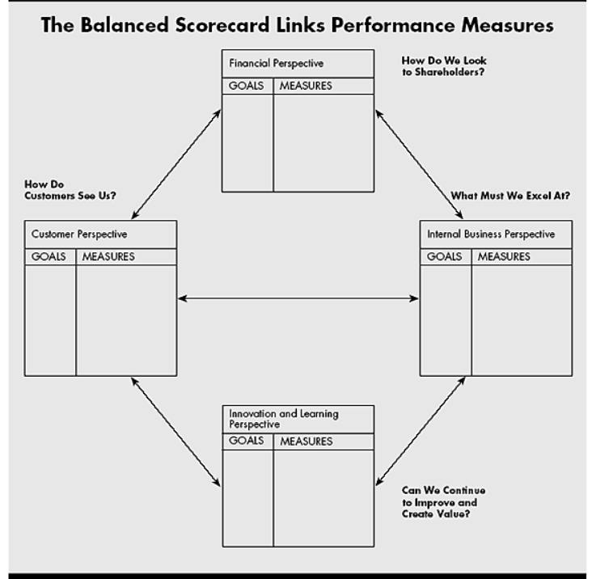
Figure 2: The Balanced Scorecard Framework Kaplan and Norton (1992).
The Balanced Scorecard is essential for ensuring that Darktrace’s investment in AI upskilling directly improves internal efficiency and long-term growth. By using this model, managers can track how employee development leads to better technical operations and, ultimately, a stronger competitive advantage in the cybersecurity market (Kaplan and Norton, 1992). However, technological advancement also presents challenges, including employee resistance to change and the risk of skills becoming obsolete. Organisations must therefore implement structured training and change management strategies.
Departmental managers must ensure urgent implementation by embedding continuous learning within operational routines. This requires task-specific digital learning and peer-to-peer knowledge exchange.

Talent Acquisition and Retention
Talent acquisition and retention remain significantly challenged within the cybersecurity sector, where demand for skilled professionals exceeds supply. A view is that organisations must develop strong employer value propositions to attract and keep high-quality candidates.
Effective recruitment strategies must focus on attracting individuals with specialised technical skills, while retention strategies should emphasise career development, rewards, and employee engagement. (Armstrong and Taylor,2014) argue that organisations investing in employee development are more likely to attract talent. Additionally, flexible working arrangements and wellbeing initiatives support employee satisfaction and reduce turnover.
Alternatively Individual Individual, high turnover rates in the technology sector suggest that traditional retention strategies may be insufficient. Therefore, organisations must adopt innovative approaches such as personalised career pathways and continuous learning (Deery and Jago, 2015). Such strategies are essential for sustaining Darktrace’s growth.
Managers play a critical role in ensuring urgent implementation by managing employee development and engagement. This includes career discussions and early identification of retention risks. Clear frameworks can support consistency while strengthening employee commitment and workforce stability.

Diversity, Equity, and Inclusion
Diversity, equity, and inclusion (DEI) have become a vital part of HR practice in technology-driven organisations, especially in sectors where workforce diversity is limited. According to (Shore et al,2018), inclusive workplaces boost employee engagement, innovation, and organisational performance. In the cybersecurity industry, the underrepresentation of women and minority groups poses a significant challenge for organisations such as Darktrace.
Inclusive recruitment practices, including anti-bias selection and skills-based hiring, are essential in addressing these differences. Furthermore, organisations must promote fair career progression and show psychologically safe environments where employees feel valued (ACAS, 2023). Whilst a wide range of organisations focus on equality, achieving clear inclusion requires a shift towards equity.
Figure 3: Comparison of Equality and Equity McKinsey & Company (2020).
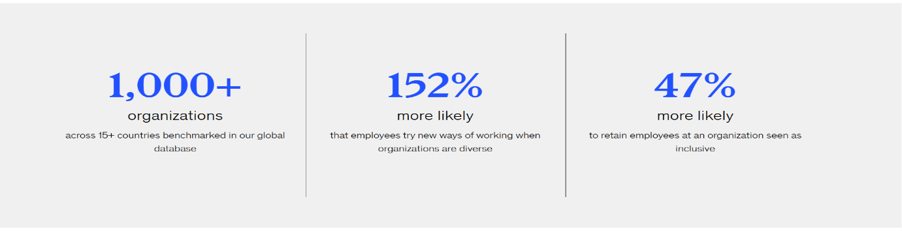
As illustrated above in Fig 3 (McKinsey and Company,2020), equality provides identical resources to everyone, while equity distributes support based on individual needs to ensure equal outcomes. For Darktrace, this means moving beyond generic policies to offer tailored support for minority groups, ensuring fair career progression (McKinsey & Company, 2020). Leadership is recognised as a key driver of DEI success, as managers shape organisational culture. However, challenges such as bias and structural barriers are prominent. Therefore, organisations must implement ongoing monitoring of DEI initiatives. To effectively implement diversity and equity practices, managers need to embed fair and transparent decision-making into daily processes, including recruitment and performance evaluation. A key limitation is that practices are often policy-driven rather than behaviour-based.

3. Evaluation of Contemporary HR Practices

Technological Practices
Contemporary HR practices, such as digital learning platforms and Human Resource Information System (HRIS) play a significant role in addressing technological advancement. These tools enhance efficiency, support real-time data analysis, and improve workforce planning. According to CIPD (2023), HR technology enables organisations to make informed decisions based on workforce analytics.
Furthermore, the successful integration of digital tools requires a structured transition through the stages of technological maturity, as illustrated in Figure 4. For Darktrace, moving from basic automation to advanced AI-driven HR analytics allows for predictive workforce planning, ensuring that technical skill gaps are specified and closed before they compromise operational security (CIPD, 2023).

However, while these practices improve operational capability, their effectiveness depends on employee engagement and digital readiness. A limitation is that over-reliance on technology may reduce human interaction and create resistance among employees. Therefore, organisations must balance technological investment with human approaches to ensure sustainable implementation.
In addition, performance management systems play a critical role in supporting technological integration by aligning employee goals with digital transformation goals. According to (Hutchinson ,2013), effective performance management enables organisations to check progress, skill gaps, and reinforce continuous improvement. This approach ensures that technological practices are not only adopted but also embedded within everyday organisational routines. Furthermore, structured feedback mechanisms can enhance employee understanding of digital expectations, reducing resistance and improving engagement. By integrating performance management with technological practices, organisations can create a more responsive and adaptable workforce capable of sustaining innovation.

Talent Practices
Current practices such as employer branding, flexible working, and career development programmes are widely used to address talent acquisition and retention challenges. The practices enhance employee satisfaction and support long-term engagement. (Armstrong and Taylor, 2014) suggest that data-driven HR strategies improve retention outcomes. However, these approaches may be costly and difficult to support consistently across departments.
A further limitation is that employee expectations continue to evolve, requiring continuous adaptation. Therefore, organisations must regularly review and update talent strategies to remain competitive in a dynamic labour market.
Structured recruitment and selection processes contribute significantly to the effectiveness of talent strategies. (Leatherbarrow and Fletcher,2019) Highlight that clear role definitions, competency frameworks, and fair selection methods improve candidate quality and organisational fit. This strengthens both short-term recruitment outcomes and long-term retention. Additionally, ongoing career development initiatives support employee progression and internal mobility, reducing reliance on external recruitment. By aligning recruitment, development, and retention within a cohesive framework, organisations can create a stable and committed workforce that supports sustainable organisational performance.

Diversity, Equity and Inclusion Practices
DEI practices include inclusive recruitment, diversity monitoring, and leadership development initiatives. These approaches aim to improve representation and create fair working environments. According to ACAS (2023), effective DEI practices contribute to employee engagement and organisational performance.
However, a key limitation is that such practices may become symbolic rather than meaningful if not fully embedded within organisational culture. Additionally, progress can be slow due to deep-rooted biases. Therefore, organisations must ensure that DEI initiatives are continuously evaluated and supported by leadership commitment.

Furthermore, effective communication strategies are essential in strengthening diversity and equity practices within organisations. Wellington (2011) emphasises that open communication fosters trust, encourages employee voice, and supports positive workplace relationships. This is particularly important in diverse environments where differing perspectives must be recognised and respected. Regular dialogue and feedback can help find potential issues early and promote a culture of fairness and respect. By embedding communication within DEI practices, organisations can move beyond policy-based approaches and create meaningful behavioural change that supports long-term organisational effectiveness.
4. Critical Evaluation of Management Practices
Departmental managers play a crucial role in ensuring that HR practices are linked within organisations. According to Rees (2015), managers function as the link between HR strategy and operational execution, making their role essential in achieving organisational aims. At Darktrace, managers must support technological adoption, talent development, and DEI initiatives.
However, a significant limitation of managerial practice is the lack of skills and training needed to implement HR strategies effectively. Managers may resist change due to increased workload or uncertainty, which can limit the adoption of innovative technologies and practices. Additionally, insufficient communication and a lack of clarity can lead to inconsistent implementation across departments.
A more effective approach would involve providing managers with training and development opportunities to enhance their leadership and decision-making skills. Wellington (2011) emphasises the importance of communication and employee engagement in successful implementation. Furthermore, organisations should set up clear performance indicators (KPIs) to check progress and ensure accountability.
To ensure urgency, organisations must adopt a structured approach to implementation, including regular monitoring, an evaluation process, and continuous improvement. Failure to implement HR practices effectively can result in reduced productivity, employee dissatisfaction, and loss of competitive advantage. Managerial capability is critical in operationalising HR practices and ensuring that organisational purposes are achieved. To further strengthen, departmental managers must adopt an initiative-taking and strategic approach that prioritises alignment between organisational goals and HR practices. This requires managers not only to understand HR policies but also to translate them into practical actions within their teams. Effective delegation, resource allocation, and time management are essential in ensuring that HR initiatives are implemented without disruption.
operational performance. By embedding HR responsibilities into daily managerial activities, organisations can ensure that practices are consistently applied across all departments.
Additionally, leadership capability plays a critical role in driving successful implementation. Managers should seek adaptability, emotional intelligence, and the ability to influence employee behaviour positively. According to Rees (2015), strong leadership enhances employee commitment and supports organisational change.
This is particularly important for Darktrace due to the fast-paced and technologically advanced environment, where employees must continuously adapt to new systems and processes. Managers who lead by example can reinforce organisational values and encourage employee engagement. Another important consideration is the use of data and performance metrics to support decision-making. By utilising HR analytics, managers can show trends, oversee employee performance, and evaluate the effectiveness of HR initiatives. This evidence-based approach enables more informed decisions and ensures resources are distributed effectively. Furthermore, regular performance reviews and feedback sessions provide insights into employee needs and organisational challenges, allowing managers to respond quickly and appropriately across teams in relation to practices. (Hutchinson, 2013)
Finally, fostering a culture of accountability is essential in ensuring that HR practices are implemented as a matter of urgency. Managers must take responsibility for outcomes and be held accountable for the success of HR initiatives within their teams. This can be achieved through clear expectations, measurable targets, and regular evaluation. By creating a culture where accountability is embedded, organisations can ensure that HR practices are not only implemented but sustained over time, supporting long-term organisational success and continuous improvement in dynamic organisational environments over time consistently across operations.
5. Recommendations
• It is recommended that Darktrace implement digital learning platforms to address technological skill gaps.
• A priority action is to introduce a measurable talent retention strategy, career development pathways and competitive reward systems.
•The organisation is to strengthen its DEI framework through inclusive recruitment and regular diversity monitoring.
•To ensure effectiveness, managers must receive training in leadership, communication, and HR
• A time-bound approach would involve quarterly performance reviews and KPI tracking to monitor progress.

6. Conclusion
In conclusion, this report has examined the key HR challenges affecting Darktrace, focusing on technological advancement, talent acquisition and retention, and DEI. It has been shown that these factors significantly influence organisational performance and require strategic HR intervention. Contemporary HR practices, including digital learning, data-driven recruitment, and inclusive policies, provide effective solutions; however, their success depends on proper implementation. The analysis highlights the critical role of departmental managers in ensuring that HR strategies are effective. Without strong leadership and clear accountability, even well-designed HR practices may not achieve desired outcomes. The findings show that organisations must integrate HR practices with strategic outcomes to support sustainable growth and competitive innovation.

REFERENCE LIST

ACAS (2023) Equality, diversity and inclusion guidance. Available at: https://www.acas.org.uk (Accessed: 5 April 2026).
Armstrong, M. and Taylor, S. (2014) Armstrong’s handbook of human resource management practice. 13th edn. London: Kogan Page.
CIPD (2023) People analytics and HR technology. Available at: https://www.cipd.co.uk (Accessed: 5 April 2026).
Darktrace (2026) Company overview and AI cybersecurity platform. Available at: https://www.darktrace.com (Accessed: 5 April 2026).
Deery, M. and Jago, L. (2015) ‘Revisiting employee turnover: theory and practice’, International Journal of Contemporary Hospitality Management, 27(3), pp. 453–472.
Hutchinson, S. (2013) Performance management. London: CIPD.
Kaplan, R.S. and Norton, D.P. (1992) ‘The balanced scorecard: measures that drive performance’, Harvard Business Review, 70(1), pp. 71–79.
Leatherbarrow, C. and Fletcher, J. (2019) Introduction to human resource management: a guide to HR in practice. 4th edn. London: Kogan Page.
McKinsey & Company (2020) Diversity wins: How inclusion matters. Available at: https://www.mckinsey.com (Accessed: 5 April 2026).
Mullins, L.J. and McLean, J.E. (2019) Organisational behaviour in the workplace. 12th edn. Harlow: Pearson.
Rees, W.D. (2015) Skills of management and leadership: managing people in organisations. London: Palgrave Macmillan.
Shore, L.M. et al. (2018) ‘Inclusion and diversity in work groups: a review and model’, Journal of Management, 44(1), pp. 189–222.
Wellington, P. (2011) Effective people management. London: Kogan Page.

