Student name:Luciana Dobra
Student ID 2019290
Teachers :Tristan Hawkins
Module Financial Management for the Hotel Industry BMIH5007

Comparison of Mandarin Oriental Hotel Group and Premier Inn

Introduction
The international hotel sector is characterized by its active and highly competitive nature, since numerous companies provide a diverse range of services. In today's contemporary and globally connected society, the Mandarin Oriental Hotel Group and the Premier Inn emerge as prominent hotel groups. Both of these prominent players in the hospitality industry have established themselves as dominant forces in the market, although they have adopted contrasting strategies in terms of financial management.
Mandarin Oriental Hotel Group International Limited is a global hospitality and management company that focuses on luxury hotels, resorts, and residences across 34 locations in 14 countries. In contrast, Premier Inn has established a reputation for accommodating a broader spectrum of cost-conscious individuals. Premier Inn Limited is the largest hotel chain in the United Kingdom, with over 72,000 rooms available across 800 locations. It competes with other hotel companies like Travelodge and Ibis by running hotels in a variety of locations. The comparison between high-end and low-cost alternatives illuminates the manner in which several market segments address their budgetary requirements.
The purpose of this report is to evaluate Mandarin Oriental Hotel Group and Premier Inn's financial management strategies and procedures. We will also provide recommendations for each of the selected organizations based on the specific areas assessed (e.g., development opportunities, outsourcing potential).

Revenue generated by each company
The Mandarin Oriental Hotel Group is well-known for providing high-end lodgings to affluent and cultured travellers. Premier Inn, on the other hand, is focused on accommodating a wide variety of budget-conscious travellers. Premier Inn offers cheaper rates as a result, while Mandarin Oriental is known for charging exorbitant prices for its accommodations and services.

Mandarin Oriental Hotel Group
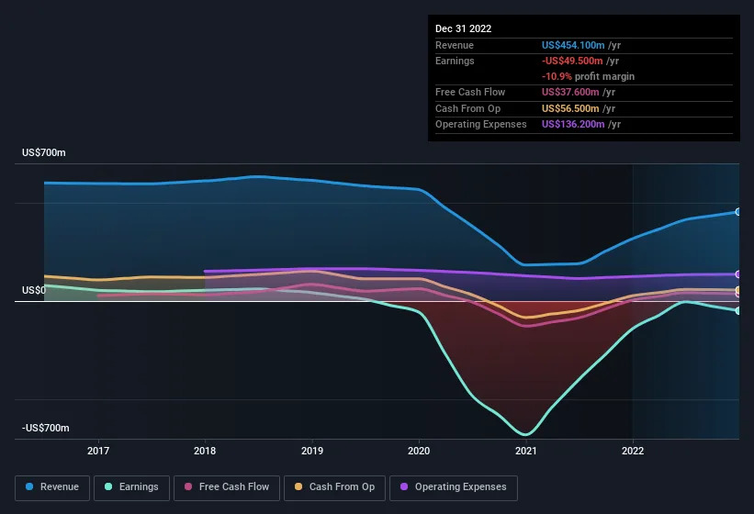
Source: https://finance.yahoo.com/
The entire income of Mandarin Oriental for the fiscal year 2022 has increased by 43% compared to the previous fiscal year, reaching a sum of US$454.1 million. Its income is mostly derived from accommodation reservations, dining in its restaurants, spa services, and events hosted there. Its revenue is primarily derived from its pricey rooms and exclusive services.
Due to its focus on providing opulent getaways for affluent travellers, the Mandarin Oriental Hotel Group lays significant importance on securing reservations in advance. The company generates additional income by offering services such as upscale dining and the provision of food and beverages. The incorporation of spa services and events contributes to the diversification of revenue streams (Prayag & Cellery d’Allens, 2019).
Mandarin Oriental's steady revenue growth can be attributed to the hotel's upscale positioning and enduring brand recognition. However, revenue trends are affected by economic cycles and global events such as the COVID-19 pandemic's influence on the high-end tourism industry.
Premier Inn:

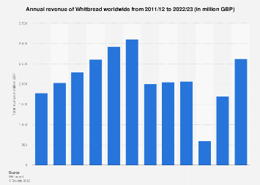
Source: https://www.statista.com/
For the fiscal year 2022-2023, Whitbread reported annual revenues of about 2.62 billion British pounds. Whitbread, a United Kingdom-based international leisure and hospitality corporation, is the owner of the Premier Inn hotel chain. Premier Inn's primary source of income is reservations due to the low pricing it offers. It's a good choice for budget-conscious business and vacation travellers.
The primary source of revenue for Premier Inn is derived from guest room reservations made across its broad network of hotels. When compared to the Mandarin Oriental, it has fewer diverse revenue streams despite having a smaller selection of inexpensive meals (Prayag & Cellery d’Allens, 2019).
The annual growth of Premier Inn's revenue can be attributed to its competitive pricing and convenient geographical positioning. Even during economic downturns, a consistent stream of customers is ensured by its low prices.
Factors Driving Revenue Growth or Decline
Both the Mandarin Oriental and the Premier Inn are impacted by the prevailing market conditions. Because of its emphasis on luxury, Mandarin Oriental is less resilient to downturns in the economy, whereas Premier Inn is more resilient because to its emphasis on affordability. Tourists with limited financial resources tend to opt for accommodations at Premier Inn as opposed to the comparatively pricier Mandarin Oriental. Although both serve affluent niche markets, Premier Inn additionally accepts leisure and business travellers. While both companies are expanding their product lines, Premier Inn is able to capture more of the market due to its lower prices and more convenient location. Premier Inn's thrifty strategy ensures both cost containment and consistent revenue growth, despite the fact that both lay a focus on operational effectiveness (Weerathunga et al., 2020).

Market Position
Mandarin Oriental Hotel Group
The Mandarin Oriental Hotel Group is a high-end hotel chain that provides luxurious accommodations and tailored service to affluent guests. By catering to a particular segment of affluent vacationers, it has carved out a niche for itself in the market. The brand's target market comprises individuals of high affluence, celebrities, accomplished entrepreneurs, and affluent individuals who priorities luxurious vacation experiences. In the hotel industry, "Mandarin Oriental" means luxury and excellent service. Mandarin Oriental hotels are noted for its luxury amenities, thought-provoking cultural programmes, and personalized service.
Premier Inn:
Premier Inn is a hotel chain that caters to both business and leisure travellers by offering comfortable rooms at affordable rates. The organization manages an extensive network of cost-effective and moderate hotels in the United Kingdom and other locations. User’s priorities dependability, cost, and convenience, but they come from different backgrounds and have distinct worries. Premier Inn is a well-known, trustworthy hotel chain that offers great rates without compromising on quality or convenience. It has a reputation for dependability, tidiness, and friendliness.
Comparison
The Premier Inn and the Mandarin Oriental both serve affluent travellers, but they do so in very different ways. Premier Inn attracts a diverse clientele in search of affordability and convenience, whereas Mandarin Oriental caters to affluent guests who value privacy. While Premier Inn and Mandarin Oriental both deploy premium pricing techniques, the former has a larger market share thanks to its extensive network and competitive rates. Mandarin Oriental is a name synonymous with luxury, privacy, and impeccable service.

Growth potential of each organization
Mandarin Oriental Hotel
The luxury hotel brand Mandarin Oriental has been expanding to developing countries like China to meet the rising demand for extravagant lodging. The company intends to develop hotels in highly sought-after worldwide destinations so as to capitalize on its luxury tourism and high-end travel visual. It frequently works with investors or real estate developers to fund and manage these buildings. The company has a strong reputation; therefore it attracts wealthy travellers who are looking for off-the-beaten-path adventures with a deep cultural impact. The addition of luxurious mansions, private estates, and unique adventure packages is one way to grow the business (Jones et al., 2016). However, growth may be hampered by factors like as high entrance and development costs, an uncertain economic climate, and intense rivalry from both established businesses and new entrants in the luxury hotel sector.
Premier Inn:
Premier Inn is expanding its business by constructing hotels in strategic locations such major city centers, airports, and popular tourist attractions. Because of its focus on convenience, quality, and pricing, the company is popular among budget-conscious vacationers. Premier Inn is frequently expanding new domestic and international markets. Emerging markets with growing middle classes, significant demand for affordable and moderate lodging, and the rising popularity of inexpensive and experiential vacationing all present excellent prospects for expansion (Brlečić Valčić & Bagarić, 2017). However, significant obstacles to growth include the difficulty of maintaining quality and consistency across a vast network, the fragility of the economy, and the saturation of the market. The increasing demand for vacations that don't break the bank bodes well for the company's future.
Comparison
- Growth opportunities for Mandarin Oriental can be found in the company's efforts to spread its upscale name in new markets and to increase the variety of its products. However, it presents a challenge because to its substantial development expenses and economic sensitivity.
- Premier Inn's development potential is primarily driven by the popularity of cost-conscious vacationing and the company's ambitious expansion plan. It can take advantage of growing markets and the demand for affordable lodging. Market saturation in some regions and the challenge of maintaining consistency over a large network are two considerations.

Financial Commitment to CSR (Corporate Social Responsibility)
Mandarin Oriental Hotel Group:
Sustainability Practices:
The Mandarin Oriental has demonstrated environmental responsibility by embracing sustainable practices including recycling and using less water and electricity. To invest in environmentally friendly technologies like LED lights and renewable energy sources, however, one may need to set aside a sizable sum of money.
Community Engagement:
Mandarin Oriental demonstrates a proactive commitment to cultural preservation initiatives by actively engaging in activities that provide support to local artists. This support is extended through a range of mechanisms, including financial funding, grants, sponsorships, and volunteer opportunities.
Ethical Business Practices:
When it comes to doing business, Mandarin Oriental places a premium on ethics, which may lead to additional costs for things like fair labour and ethical sourcing. In addition, their commitment to diversity and inclusion might lead to demands for financing for programmes that improve employee skills.
Premier Inn:
Sustainability Practices:
Premier Inn has set itself some challenging sustainability targets, such as reducing carbon emissions, water use, and waste. In addition to modern technologies, they have made significant investments in green construction methods (Pirani & Arafat, 2016).
Community Engagement:
Premier Inn shows its commitment to corporate social responsibility (CSR) by providing financial contributions and engaging in volunteer activities through the Premier Inn and Whitbread Foundation, in order to support local nonprofit organizations and civic initiatives.
Ethical Business Practices:
Premier Inn places a premium on responsible business practices and ethical sourcing, and it may even invest in supplier chain audits and certifications to ensure these standards are met. They also spend money on employee benefits, diversity initiatives, and training programmes.

Conclusion
For the fiscal year 2022, the luxury hotel operator Mandarin Oriental Hotel Group recorded revenue of US$454.1 million, up 43% over the previous year. Its premium positioning and recognizable brand are the major drivers of this growth. Meanwhile, Whitbread is the owner of Premier Inn, a budget hotel chain that caters to a wide range of guests for a fair price. Both businesses are vulnerable to market fluctuations, but Premier Inn can weather economic storms better than the more expensive Mandarin Oriental because of its focus on value. Both establishments strive to provide their customers with a pleasant and affordable stay.
The Mandarin Oriental and the Premier Inn both appeal to affluent travellers, but in different ways. Premier Inn is aimed towards budget-conscious vacationers who value comfort and solitude just as much as those who stay at the more expensive Mandarin Oriental. There is space for growth in these companies, but they may face challenges from rivalry, high development costs, and uncertain economic conditions. In contrast to Mandarin Oriental, whose growth potential is powered by its luxury name and aggressive expansion plans, Premier Inn's development potential is prompted by budget-conscious vacationing and market saturation. Both companies have made financial commitments to CSR, while the Mandarin Oriental is more focused on these areas of concern. As part of its corporate social responsibility (CSR) efforts, Premier Inn donates money and staff time to local organizations and civic projects through the Premier Inn and Whitbread Foundation.

Recommendation
Mandarin Oriental Hotel Group:
The Mandarin Oriental hotel chain should consider expanding its current portfolio of eco-friendly and culturally enriching programmes. Collaborations with local artists, cultural organizations, and environmental initiatives are all possible avenues here. A company can attract the type of discerning customers who are looking for genuine, environmentally friendly luxury by providing them with experiences that are both memorable and sustainable. Programmes like these can help sustain premium pricing and align with the growing demand for authentic and eco-friendly vacations (Bresciani et al., 2015).
Premier Inn:
Premier Inn could also consider speeding up its international expansion, particularly in developing nations with a growing middle class and a corresponding increase in demand for affordable, high-quality housing. Premier Inn is able to expand into new markets where there is a need for dependable and inexpensive travel options because of its well-established reputation for these very qualities. By expanding into these regions, a company can reduce its reliance on saturated mature markets and increase its revenue diversification (Kelly et al., 2017).

References
Abram, M. and Jarzabek, J. (2016) ‘Corporate Social Responsibility in hotel industry’, Ecocycles, 2(2). doi:10.19040/ecocycles.v2i2.51.
Alonso-Almeida, M.-M. et al. (2017) ‘Revisiting green practices in the hotel industry: A comparison between mature and emerging destinations’, Journal of Cleaner Production, 140, pp. 1415–1428. doi:10.1016/j.jclepro.2016.10.010.
Bresciani, S., Thrassou, A. and Vrontis, D. (2015) ‘Determinants of performance in the hotel industry - an empirical analysis of Italy’, Global Business and Economics Review, 17(1), p. 19. doi:10.1504/gber.2015.066531.
Brlečić Valčić, S. and Bagarić, L. (2017) ‘Return on strategic effectiveness – the need for synchronising growth and development strategies in the hotel industry using revenue management’, Economic Research-Ekonomska Istraživanja, 30(1), pp. 1631–1654. doi:10.1080/1331677x.2017.1383173.
Cram (2023) Premier Inn brand position, Cram. Available at:https://www.cram.com/essay/Premier-Inn-Brand-Position/PJNQCQH7GWM (Accessed:29 September 2023).
Ghandour, R., Bilal, J. and Mudassar, H. (1970) Relationship between service quality, customer retention and the role of Social Media- Case Study Premier Inn Hotel (UK), WestminsterResearch. Available at: https://westminsterresearch.westminster.ac.uk/item/v37qz/relationship-between-service-quality-customer-retention-and-the-role-of-social-media-case-study-premier-inn-hotel-uk (Accessed: 04 October 2023).
Jones, P., Hillier, D. and Comfort, D. (2016) ‘Sustainability in the hospitality industry’, International Journal of Contemporary Hospitality Management, 28(1), pp. 36–67. doi:10.1108/ijchm-11-2014-0572.
Kelly, P., Lawlor, J. and Mulvey, M. (2017) ‘Self-service technologies: Service failures and recovery.’, Service failures and recovery in tourism and hospitality: a practical manual, pp. 100–121. doi:10.1079/9781786390677.0100.
Kim, Y.H., Barber, N. and Kim, D.-K. (2018) ‘Sustainability Research in the hotel industry: Past, present, and future’, Journal of Hospitality Marketing &amp; Management, 28(5), pp. 576–620. doi:10.1080/19368623.2019.1533907.
Luo, Z., Marnburg, E. and Law, R. (2017) ‘Linking leadership and Justice to Organizational Commitment’, International Journal of Contemporary Hospitality Management, 29(4), pp. 1167–1184. doi:10.1108/ijchm-08-2015-0423.
Martin Roll (2020) Mandarin oriental - an iconic Asian luxury hotel brand, Martin Roll. Available at: https://martinroll.com/resources/articles/asia/mandarin-oriental-a-leading-asian-hospitality-brand/ (Accessed: 29 September 2023).
Moyeen, A., Kamal, S. and Yousuf, M. (2018) ‘A content analysis of CSR research in Hotel Industry, 2006–2017’, Responsibility and Governance, pp. 163–179. doi:10.1007/978-981-13-1047-8_10.
Pirani, S.I. and Arafat, H.A. (2016) ‘Reduction of food waste generation in the hospitality industry’, Journal of Cleaner Production, 132, pp. 129–145. doi:10.1016/j.jclepro.2015.07.146.
Prayag, G. and Cellery d’Allens, V. de (2019) ‘Celebrity chefs and luxury hotels’, The Routledge Handbook of Gastronomic Tourism, pp. 538–544. doi:10.4324/9781315147628-64.
Rahimi, R. and Gunlu, E. (2016) ‘Implementing customer relationship management (CRM) in hotel industry from Organizational Culture Perspective’, International Journal of Contemporary Hospitality Management, 28(1), pp. 89–112. doi:10.1108/ijchm-04-2014-0176.
Rahimi, R. et al. (2017) ‘Customer relationship management research in tourism and hospitality: A state-of-the-art’, Tourism Review, 72(2), pp. 209–220. doi:10.1108/tr-01-2017-0011.
Thomas, N. and Kumar, D.N.S. (2016) ‘Ethical beliefs and practices in hotel industry for value creation’, KIMI Hospitality Research Journal, 1(1). doi:10.21863/khrj/2016.1.1.001.
Weerathunga, P.R. et al. (2020) ‘The relative effect of growth of economy, industry expansion, and firm-specific factors on corporate hotel performance in Sri Lanka’, SAGE Open, 10(2), p. 215824402091463. doi:10.1177/2158244020914633.
Xu, S., Stienmetz, J. and Ashton, M. (2020) ‘How will service robots redefine leadership in hotel management? A Delphi Approach’, International Journal of Contemporary Hospitality Management, 32(6), pp. 2217–2237. doi:10.1108/ijchm-05-2019-0505.

