Assignment 2: Menu Engineering ( Practical Task)
Module:Food and Beverage Operations ( BMIH4002)
Ana-Maria Burada( 2233131)
Tutor name: Ffion Cumberpatch

Wordcount: 401 words



A restaurant concept defines the theme behind the restaurant, the type of service style, the cuisine, price point and menu design. The concept can define a personal experience, a family background or a mix of all other things like public interests or culture.
The name should express what kind of dishes you serve, the atmosphere of the restaurant and the theme of it to give the clients an idea of what to expect.
The décor as well should relate to the theme of the restaurant and the dishes that are served.
The menu design should be simple and easy to read and understand no matter what the concept of the restaurant is.
Also, the concept of the restaurant should be chosen based on the location of the restaurant, the community, the atmosphere and food you lean towards. A market study is a must, to see if your business and the theme of the restaurant would be a success. The concept of the restaurant should help you to be noticed among all the restaurants in the area.
The theme and the concept of the restaurant should be aligned with the food you are serving otherwise the guest will notice and the business won’t succeed.
The audience is a factor that you must consider when you must choose a restaurant concept.
When you think about setting up a restaurant you must establish a budget because building a restaurant that has an elegant concept will cost a lot more than a casual one.
The concept that I choose for the 4* Hotel Trinity Restaurant is an elegant one, for couples and business meetings. The theme is sleek and elegant, based on the stars that the hotel has. The interior in simple, the lightning is soft, not to bright just to give that intimacy that you need. The business meeting area is separated from the couple one.
The furnishings are quite simple and easy to clean. The tables are made from wood or stone from a local provider.
A precise system reservation is put into its place.
The menu is based on the variety of products that the Noel’s farm offers to us as the hotel is in a partnership with this local producer. The menu is suitable for vegetarians and people with different allergies to please everybody and to offer everyone a tasteful experience hard to forget and to make them to come back.

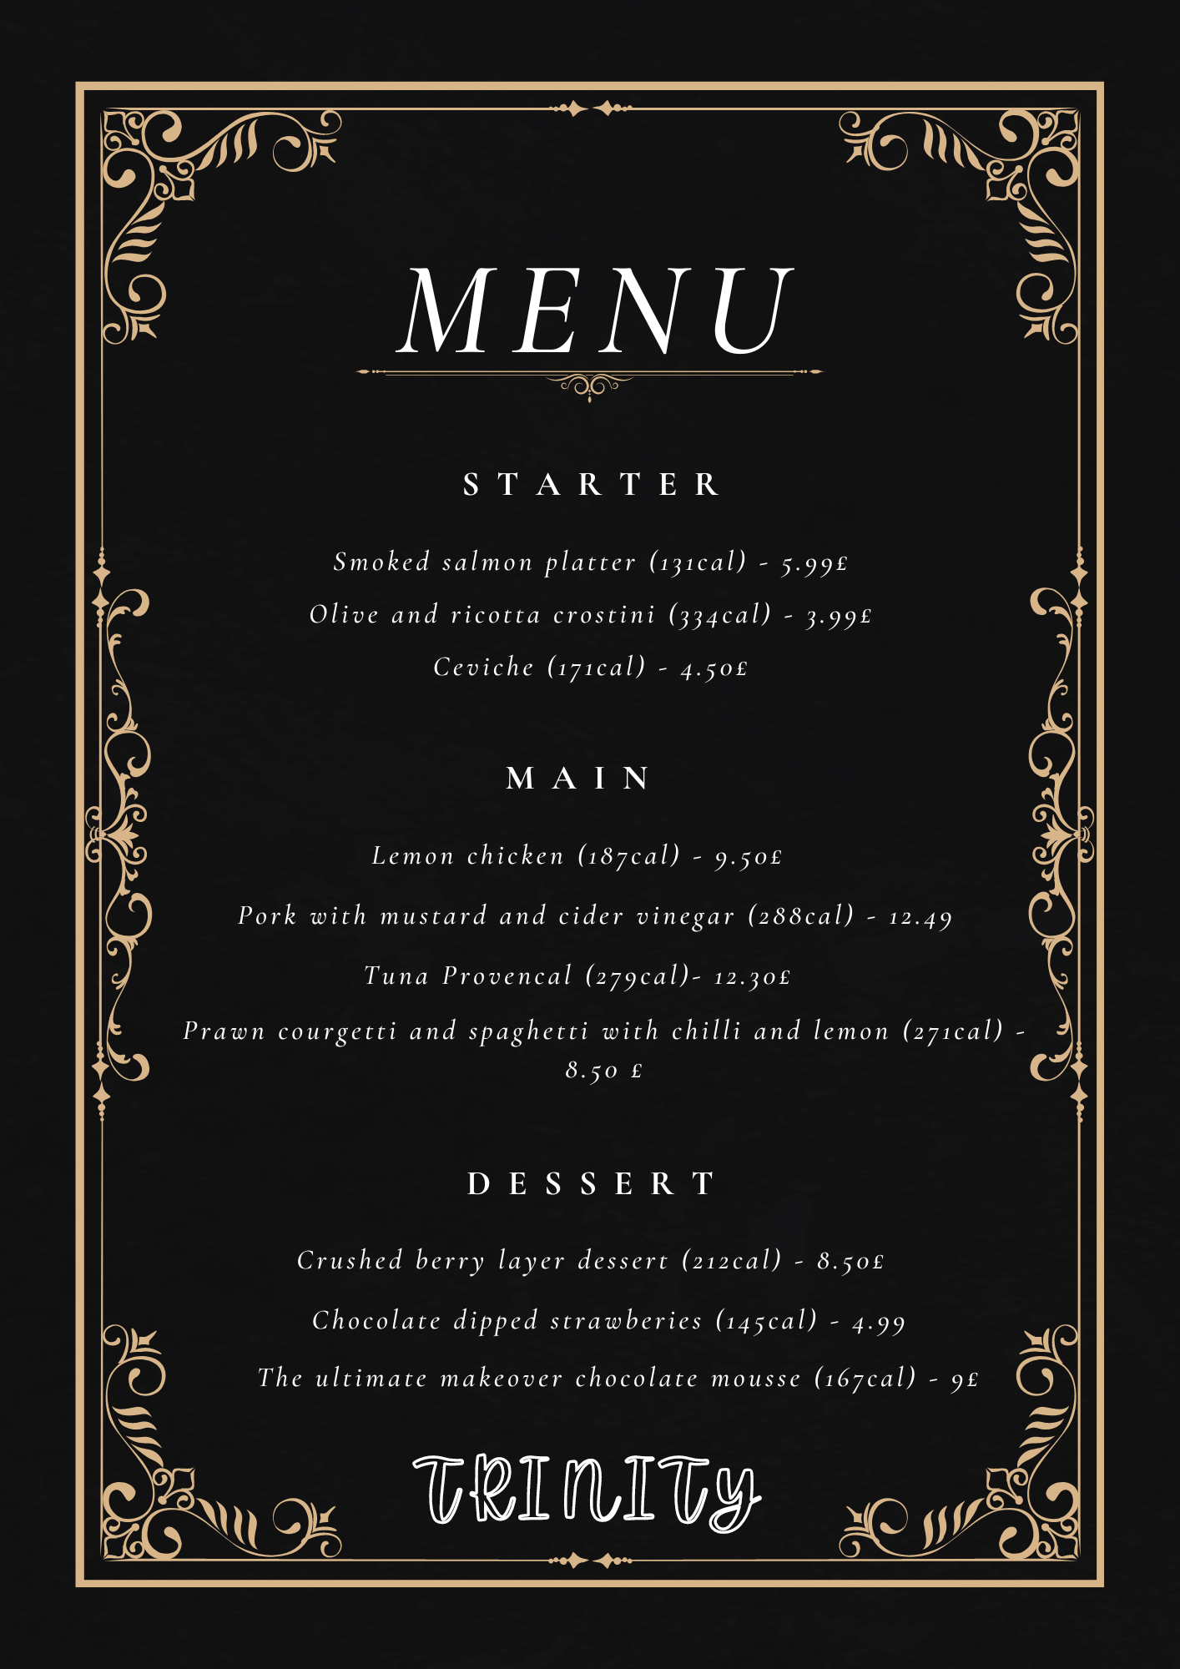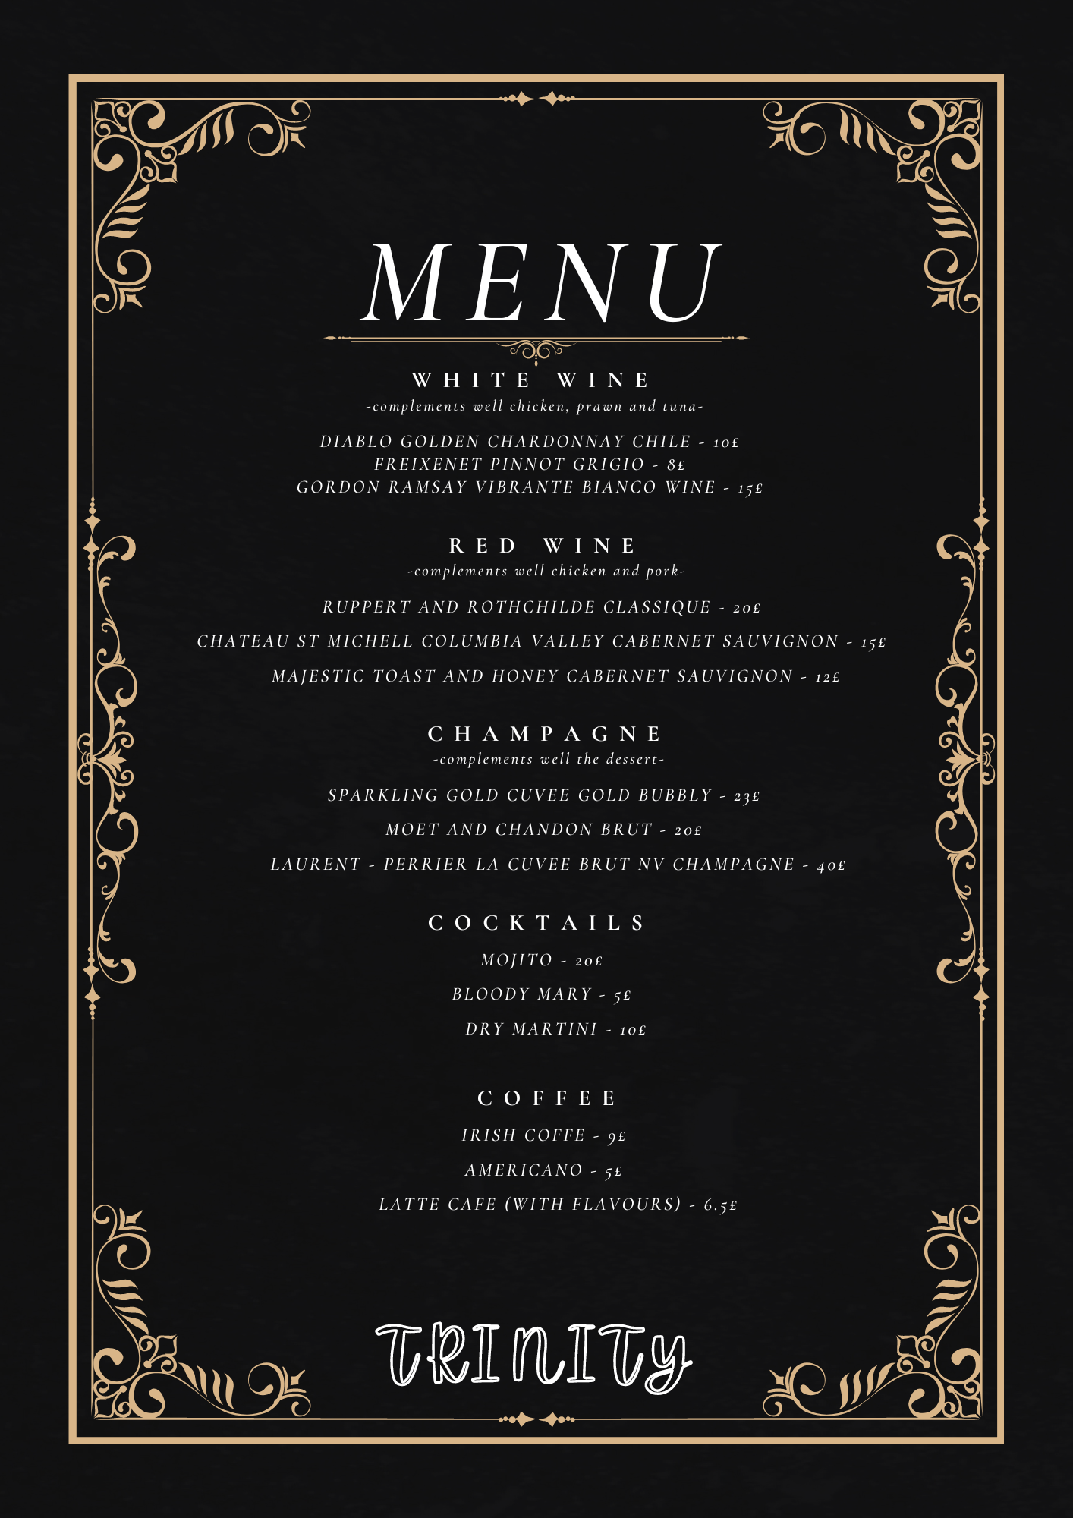

References
https://www.7shifts.com/blog/restaurant-concepts/
https://getsling.com/blog/restaurant-concepts/
https://joinposter.com/en/post/successful-restaurant-concepts
https://www.liveabout.com/what-is-the-best-type-of-restaurant-to-open-2888274
https://www.liveabout.com/classic-restaurant-menu-trends-2888574
https://www.liveabout.com/how-to-choose-restaurant-menu-items-2888581
https://www.liveabout.com/how-to-open-a-fine-dining-restaurant-2888696
https://www.noelsfarmshop.co.uk/
The fast 800 easy book
taste.com

