The Fairmont Monte Carlo
Organisational management issues
24 May 2024

Student name: Monica Roman
ID : 2128507
MONCONSULT LTD.
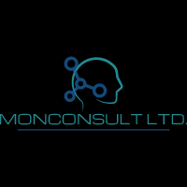

Contents
Executive Summary 3
Introduction: 5
Analysis: 7
PESTEL analysis: 7
SWOT analysis: 11
TOWS analysis: 13
Recommendations and Change Management 15
Recommendations for the hotel: 15
Change in leadership and policies in the management: 19
Key Performance Indicators in evaluating: 21
Action Plan: 23
Conclusion: 27
References: 28

Executive Summary
In today’s world, hotels face a tough competition. For this reason, in order to succeed it is important that they continuously assess the market to identify new trends in the industry and changes in consumer expectations. In order to build long-term competitive advantages and provide guests with a superior experience, hotel managers must now, more than ever, comprehend and recognise the needs and expectations of their visitors and strategically manage their resources (Zaman et al., 2022).
The famous Fairmont Monte Carlo hotel in the Principality of Monaco is facing a number of problems that could hurt its ability to perform in the high-end hotel market due to unsatisfactory guest reviews on social media and most popular booking platforms (Tripadvisor, 2024). The purpose of this report is to evaluate the damage done by poor organisational management of the establishment, identify major issues that need addressing immediately in order to avoid bad reputation, low customer satisfaction scores, damage to brand image and ultimately financial losses. The main issues that led to poor reviews were related to guest dissatisfaction as a result of inefficient management. Inadequate internal communication, lack of appropriate staff training and established protocols in delivering messages and certain information to guests, have caused unpleasant experiences for guests who had high expectations from such a reputable brand. Monte Carlo hosts annually several major events that attract millions of people. Many luxury hotels in Monte Carlo offer similar products and all compete to attract more customers (Buhalis, 2000). According to Chatain (2010) the value customers feel they are getting for their money “is a driver of relationship stability and supplier profitability”. Even though the Fairmont has a great name, lots of amenities and incredible views of the Mediterranean Sea, it has to adapt to meet the needs of its guests, deal with worries about sustainability, and follow the market changes in order to stay successful. The Fairmont Monte Carlo has hired a local consulting company, Monconsult LTD. that focuses on strategic management and organisational development to help them assess the current situation, identify the problems the hotel is facing and create a strategy to deal with this. Consulting firms are hired to help businesses solve specific business challenges, give specialised advice and implement change strategies (Management consulting, 2023). MonConsult has carefully looked at the hotel's internal and external settings using various theoretical frameworks and analytical tools, such as PESTEL: assessing the political, environmental, social, technological and legal factors that could influence the hotel’s activity and performance; SWOT to identify the Fairmont’s strengths, weaknesses, the opportunities that lay ahead, but also the threats that could negatively impact its business and TOWS. As Porter (1980) suggested, companies have to study the environment they compete in, decide on strategies to follow and obtain the necessary resources for implementing these strategies. This is where MonConsult stepped in to help Fairmont identify the issues and elaborate the strategic plan to go forward (Sekaran and Bougie, 2016). There are several things that could be done better: expanding digital transformation to become more agile, innovative and responsive to current trends (Chatterjee, Rana and Dwivedi, 2024), implementing sustainable projects (Buhalis, 2000), and finding new revenue streams, as research will show. To make the most of these opportunities, the consulting firm has created a strategic action plan with specific suggestions and actions to improve the experiences of guests, make operations more efficient, and raise income potential. This study shows Fairmont Monte Carlo how to deal with its current problems and take advantage of strategic opportunities as it is shown in the TOWS analysis. Applying theoretical frameworks, industry knowledge, and useful suggestions, MonConsult Ltd. will help Fairmont Monte Carlo implement the new strategies to keep its position as a top choice for high-class travellers, offer consistent exceptional service which is paramount for a high degree of guest satisfaction scores and ensure its financial growth and long-term success in the fast-paced hospitality industry.
Using Lewin’s model for change management (Burnes, 2020), Monconsult will try to implement the action plan to achieve the new strategic goals: enhance performance and increase revenue by keeping guest satisfaction levels high (Albayrak and Caber, 2015). The consultancy company will support the hotel and its staff throughout this journey and celebrate with them the achievements. Some suggestions are to make important changes to its digital presence, better internal communication through a performant software, committing more to sustainability for the good of the local communities and the environment, offer diverse wellness options, and improve relationship with brands. By following this action plan, Fairmont Monte Carlo can maintain its star status in the luxury segment, giving guests the best experiences possible and increase their ROI (Return on Investment). With the help of Monconsult, the hotel can handle the volatile hospitality landscape and ensure its long-term success by giving travellers around the world unforgettable experiences.

Introduction:
“Understanding fast changing markets requires identifying new market space, conducting strategic segmentation analysis, and determining customer value requirements” (Cravens, Piercy and Baldauf, 2009).
The Fairmont Monte Carlo, part of luxury segment in the Accor Group is a symbol of wealth and class in the hotel business. Located in the heart of the Principality of Monaco, the hotel offers incredible views of the Mediterranean Sea, luxurious rooms, and top-notch services and amenities (Fairmont Monte Carlo, 2024). Close by are two other landmarks, the famous Monte Carlo Casino and the legendary Salle Garnier or Monte Carlo Opera House built by French architect Charles Garnier in 1875.
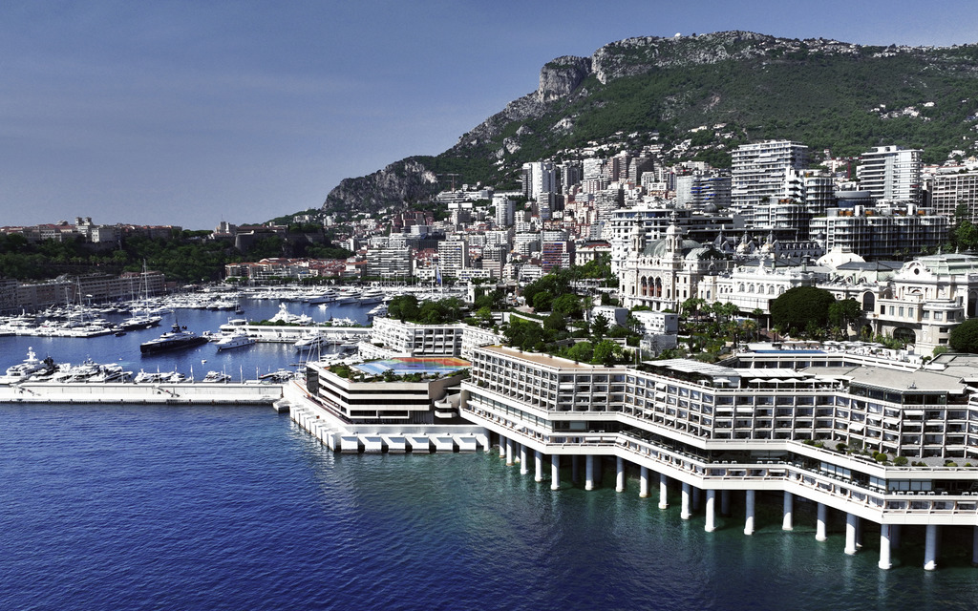
Fig.1 Fairmont Monte Carlo (Fairmont, 2024)
The Fairmont hotel has been associated with luxury and elegance since its inauguration in 1975, when princess Grace Kelly was the opening guest. Even though Fairmont Monte Carlo has a great name, the hotel has recently received a number of reviews (Tripadvisor, 2024) in which guests expressed their disappointment in certain services or experiences they had during their stay: cool welcome, bed sizes did not correspond to booking, guests were not informed that there were refurbishment works going on which disrupted their sleep and caused inconveniences, certain food products did not have the expected quality, pool was closed, etc. All these reviews could negatively impact its standing in the tough market for high-end hotels (Kirova and Vo-Thanh, 2019). Since its opening, Fairmont Monte Carlo has become a hot-spot of class, drawing celebrities and sophisticated travellers from all over the world (Lee & Jan, 2019). The hotel has 602 rooms and suites, including the luxurious Fairmont Gold rooms. It has stunning views of the coast of Monaco and the famous Monte Carlo Casino (Fairmont Monte Carlo, 2024). Its closeness to famed sites like the Prince's Palace and the Formula One Grand Prix track, mainly the Hairpin turn-one of the most dangerous turns in all Formula 1 tracks- which sits right in front of the hotel, makes it even more appealing to people who want to relax or have an exhilarating stay (Total Motorsport, 2024).
Even though Fairmont Monte Carlo has a great past and a strategic position, the recent unpleasant guest experiences need to be addressed and solved strategically. These problems are related mainly to guest experience, poor inter-departmental communication, lack of established protocols but also some issues of sustainability. All these suggest that the hotel’s operational management system does not support good guest service practices, and that staff are not sufficiently trained and empowered to deal with certain situations (LinkedIn, 2023). The Fairmont Hotel has hired a consulting company, MonConsult LTD, that specialises in strategy management and organisational development to help them deal with these problems and mitigate recent issues. MonConsult has worked with other hospitality companies to drive innovation, improve business efficiency, and give guests the best experiences possible. The firm has a team of experienced professionals who know both best practices, are up to date with industry trends and have developed cutting-edge methods in their field (Johnson, 2005). They can help Fairmont Monte Carlo solve current problems and reach its strategic goals to offer excellent guest service and continue exceeding expectations.
This study will use many different theoretical methods and analytical tools, such as PESTEL, SWOT, and TOWS analysis, to look at the problems that Fairmont Monte Carlo is having, assess the areas that need improvement and create strategies to be implemented to avoid the occurrence of such issues in the future. The main goal is to keep the high standards of excellence and quality of service the guests expect, continue to create unforgettable experiences which will benefit both the hotel’s reputation and financial stability and the guests by having memorable stays (Yavas and Babakus, 2005). These models will help the hotel get a full picture of the macro-environmental factors, its own strengths and flaws, and its strategy choices. Using these analytical tools, the study aims to give Fairmont Monte Carlo useful information and suggestions that will help them deal with the complicated world of high-end hotels and take advantage of new growth and diversifying possibilities.

Analysis:

PESTEL analysis:
A PESTEL analysis for Fairmont Monte Carlo has been provided in the section below and is important for understanding the dynamic nature of the industry that the hotel operates in.
Political factors:
Fairmont Monte Carlo is situated in Monaco, which is a parliamentary monarchy with a safe government. As Worthington and Britton (2009) point out, the activity of business organisations is influenced by the economic and political context they operate in, either in a positive or negative way. The political environment has two inter-related elements: internal and international, which both affect businesses in various ways. The government of the principality actively encourages travel, which makes it a good place for high-end hotels like Fairmont to operate (Gouvernment Princier, 2024). However, because Monaco is a small country, its neighbours and foreign groups can have an effect on its political choices. This can, in turn, affect policies related to tourism, taxes, and labour laws (Assaf & Josiassen, 2016). Changes in international ties and tensions in geopolitics can also have an effect on the hotel business in Monaco.
Economic factors:
Monaco's economy is strong, with low unemployment and a high income per person. The tourists, financial and insurance companies, wholesale trade and real estate industries all play a big role in this (Monaco Statistics, 2024). As Fig. 2 shows, Monaco’s Gross Domestic Product is in a continuous increase since 2013, registering an almost 50% growth in comparison to only 10% in neighbouring France (Monaco Statistics, 2024). Wealthy tourists, celebrities and business travellers visit Monaco every year, with a lot of Hallmark events that attract millions of people annually, bringing massive benefits for the hotel industry there, including the Fairmont Monte Carlo. But changes in customer buying habits, the level of spending, economic downturns in key source markets, and foreign exchange rates can all affect the hotel's ability to make money. It is also hard to stay competitive and increase revenue when running costs are going up (food, labour and energy).
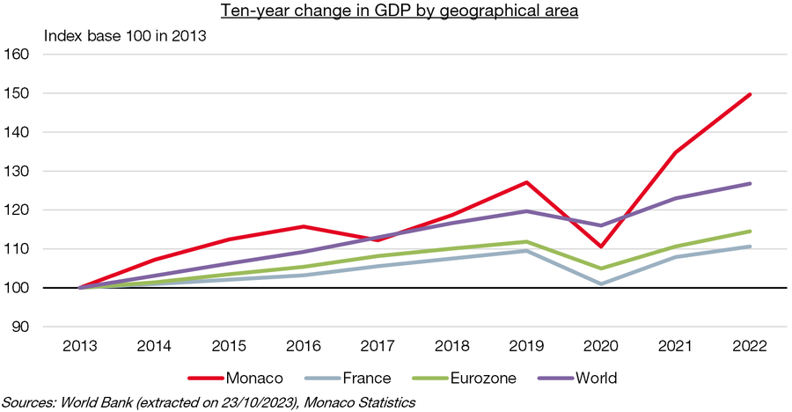
Fig.2 GDP increase in Monaco (Monaco Statistics, 2024)

Social factors:
Fairmont Monte Carlo serves a wide range of guests, from high-class travellers to business leaders and celebrities from all over the world. Trends in society, like the growing desire for experiencing luxury, wellness-focused features, and environmentally friendly practices, affect the hotel's marketing and service offers. Also, consumer tastes are constantly changing because of things like demographics, changes in lifestyle, and cultural norms. All these elements have major influence on the demand and supply in any business sector (Worthington and Britton, 2009). Businesses have to keep adapting to meet guest standards and improve customer satisfaction (MKG Consulting, 2023). Effective digital marketing and image management strategies are also needed because social media (Finances Online, 2023) has a big impact on how people think about brands and how loyal they are to those brands.
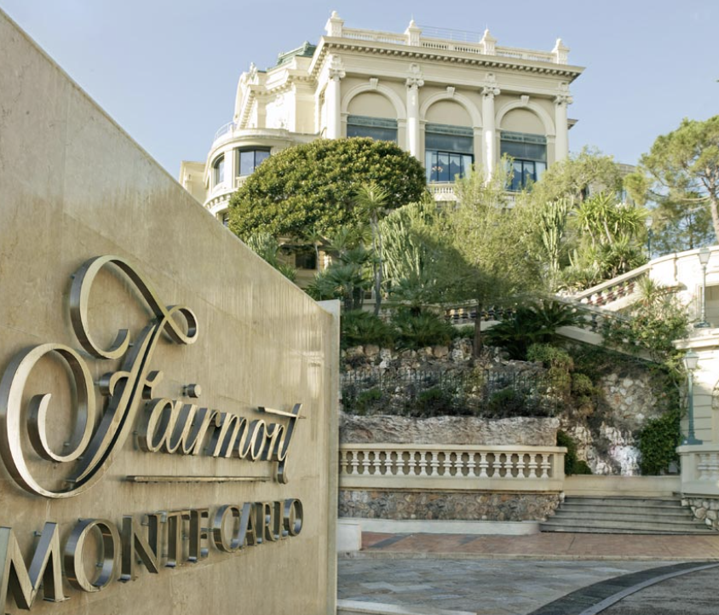
Fig. 3 Fairmont Monte Carlo frontage (Passion for luxury, 2014)
Technological Factors:
The hotel business depends on technology more and more to stay competitive, make operations run smoothly, and make the guest experience exceptional (Nicolau, Mellinas and Martin-Fuentes, 2020). Artificial intelligence has been used more recently even in hospitality and “is seen as a supporting tool, processing and analysing massive amounts of data with the aim of enhancing customer-oriented processes, with potential to increase organisational performance and reach strategic goals faster” (Citak, Owoc and Weichbroth, 2021). To make things easier and offer more personalised services, Fairmont Monte Carlo uses state-of-the-art tools as a customer relationship management software. Improvements in communication and connection have also made it possible for the hotel to interact with guests through a variety of digital methods, from messages sent before they arrive to comments sent after their stay. Fairmont has implemented Easyway, a digital platform that provides a complete solution for the hotel’s operational challenges on daily basis, but also enhances the service and guest experience (Hoteltechreport, 2024). The hotel can use Easyway to improve general guest engagement and experience from beginning to the end, share unique offers and loyalty programme benefits to their guests, creating a more streamlined guest lifecycle.

Environmental Factors:
As sustainability becomes more important to both customers, local communities and governments, the Fairmont Monte Carlo is under pressure to adopt green policies and prioritise environmental measures to reduce negative impact on local and global environment. According to Visit Monaco (2024) Monaco has one of the highest rates of certified rooms (88% of total capacity) and has been pioneering the use of heat pumps. The Fairmont has, since opening, a very sophisticated system that takes water from a 40 meter depth in the Mediterranean Sea and uses it to heat and air-condition its rooms (Fairmont Monte Carlo, 2024). Environmental rules and standards, like LEED (Leadership in Energy and Environmental Design), must be followed (Gupta & Bhatia, 2018). Fairmont Monte Carlo aims to obtain the Green Globe status this year (Fairmont Monte Carlo, 2024), which is a high sustainability commitment certification. The hotel has many other environmental-friendly services, offers e-bike rentals or electric car transfers to the airport, etc. This shows that the business is responsible and also appeals to travellers who care about the environment, which helps the brand's image and keeps guests coming back. But changes to operations and investments in sustainable infrastructure may have high costs and need to be made over a long period of time to show clear benefits.
Legal Factors:
The Legal environment of business is a key influence on the business organisation (Worthington and Britton, 2009) and this environment regulates and constrains the operations of a company. Laws control many aspects of hotel operations. These include labour laws, health and safety rules, licensing requirements, and taxation policies (Gouvernment Princier, 2024). Following both local and foreign laws (neighbouring France and Italy) is important to keep business running. Also, changes in the law, like new rules on data privacy or environmental standards, can have an effect on how the hotel works and require policy and procedure changes. Contracts with suppliers, partners, and workers must also be carefully discussed and managed to reduce legal risks and make sure that everyone follows regulations of the industry.

SWOT analysis:
The SWOT analysis for the hotel has been provided below for the readers to understand the underlying capabilities and weaknesses in the company.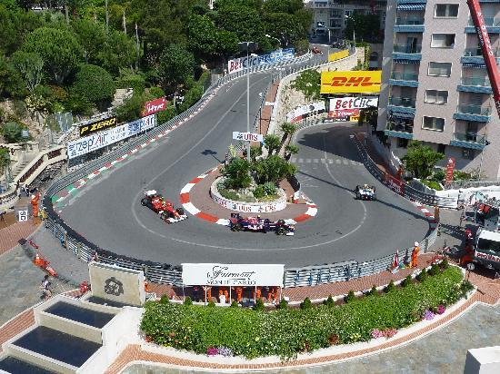
Fig.4 Famous Monaco F1 Grand Prix Hairpin turn (Fairmont Monte Carlo, 2024)
Strengths:
The Fairmont Monte Carlo has a number of strengths that offer a competitive edge (Barney, 2002) in the market for high-end hotels. Because of its perfect location in Monaco, the hotel is a tourist hot-spot and attracts celebrities and wealthy people from all over the world. There are over 600 beautifully decorated guest rooms and suites on site (Fairmont Monte Carlo, 2024), all of which have stunning views of the Mediterranean Sea or the famous Monaco Grand Prix track. The hotel also has world-class services, such as Nobu restaurant, bars, rooftop pool, spa facilities, night club, all allowing guests to choose from a variety of options and enhance their overall stay. The Fairmont Monte Carlo is dedicated to providing excellent service (Albayrak and Caber, 2015), and its staff is known for being professional and paying close attention to detail. They make sure that each guest has a unique and memorable stay.
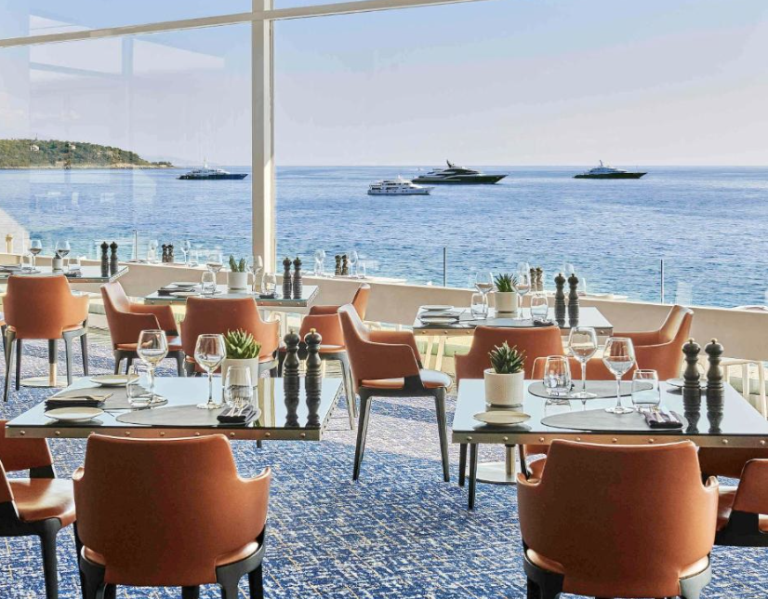
Fig.5 Lobby Lounge Restaurant and Bar (Fairmont Monte Carlo,2024)
Weaknesses:
Even though Fairmont Monte Carlo has many good points, it also faces problems that could affect its financial performance and guest satisfaction scores. The hotel is vulnerable to outside forces like changes in the economy and yearly tourist trends (MKG Consulting, 2023), levels of money spent, which can have an effect on occupancy rates and consequently on the hotel’s revenue. As a luxury property, Fairmont Monte Carlo also has to deal with "intense competition" from other high-end hotels and spas in Monaco and nearby places that target the same wealthy guests (Kang & Heo, 2018). Keeping the hotel's "historical charm" while also meeting modern guests' needs for services and technology is also hard. To stay competitive in the changing hospitality industry, the hotel needs to keep investing and reinventing itself and leveraging on its strengths.
Opportunities:
Fairmont Monte Carlo can use new market factors and trends to its advantage to encourage growth and new ideas. High-income guests looking for one-of-a-kind events can use the hotel's well-known name and famous position to their advantage (Yavas and Babakus, 2005). As wellness tourism grows in popularity, Fairmont Monte Carlo can add more specialised and tailored services to meet the needs of guests who want to rest, rejuvenate, and experience overall health benefits. The hotel can take advantage of the rising demand for "sustainable tourism" by promoting its pioneering heat-pump, implementing more eco-friendly solutions and supporting "responsible travel" programmes which involve guests’ participation. This will attract customers who care about the environment and raise its image for corporate social responsibility (Fairmont Monte Carlo, 2024). Strategic relationships with local businesses, event planners, and luxury brands can also create connections and cross-promotional opportunities that help the hotel's brand stand out and reach more customers (Buhalis, 2006).
Threats:
Fairmont Monte Carlo could be threatened by a number of things that might affect its business and finances. Uncertainties in the economy, like global recession or financial crisis, can make people less confident and less likely to spend extra money. This can lower the demand for high-end hotels and other leisure services (Altinay & Paraskevas, 2015). Geopolitical pressures, natural disasters, or public health problems like pandemics can also change travel plans and the flow of tourists, which can diminish occupancy rates and income streams. Alternative housing choices like holiday rentals and home-sharing platforms are also popular, creating competition for traditional hotels like the Fairmont. They need to come up with new strategies to stand out and stay relevant in the market. In addition, changes in regulations, like new tax policies or government rules, can affect the hotel's working costs and ability to make money.

TOWS analysis:
The TOWS analysis, developed by Heinz Weihrich is a strategic planning tool combining internal and external factors to generate strategic options (Zurich Networking Group, 2020). It is helpful for understanding the future strategic outlook of the business in the sense of decision making by identifying internal strengths and weaknesses and linking them to the external opportunities and threats. This way, organisations can capitalise on their strengths, seize opportunities, mitigate weaknesses and overcome threats.
Strengths-Opportunities (SO):
The Fairmont Monte Carlo can use its skills to take advantage of new opportunities in the luxury hotel segment. The hotel can improve its brand image and bring in wealthy travellers looking for unique experiences thanks to its great location and status as a high-class spot (Ritchie & Jiang, 2019). Fairmont Monte Carlo can set itself apart from rivals and meet the changing needs of high-end travellers by investing in high-end amenities and personalised services like custom butler services and private cooking classes with the distinguished Nobu restaurant chefs, organising tailored special celebrations in the hotel or on the yachts docked in Monte Carlo Marina. The hotel can also take advantage of the growing demand for environmentally friendly and wellness travel by creating eco-friendly programmes or special wellness packages. These offers will help the hotel meet the needs of travellers who want to have responsible vacations.
Strengths-Threats (ST):
Fairmont Monte Carlo can protect itself from possible threats by using the skills and resources it already has. As a well-known luxury establishment, the hotel can keep customers loyal and lessen the effect of rising competition from other places by giving regular guests special benefits and exclusive loyalty offers (Ritchie & Jiang, 2019). Implementing Easyway platform (Hoteltech report, 2023), The Fairmont is able to have real-time interaction with their members and guests, promote special offers and discounts and get their immediate feedback. By focusing on offering great service and keeping guests happy, Fairmont Monte Carlo can also lower the risk of bad reviews and damage to its image, protecting its brand in a market that is becoming more and more competitive (Cravens, Piercy and Baldauf, 2019). The hotel can also lessen the effects of economic downturns by reducing its reliance on traditional sources of income and increasing smart relationships with local businesses and event organisers (Buhalis, 2006).
Weaknesses-Opportunities (WO):
Fairmont Monte Carlo can improve the hotel's technology system, add new features like digital butler services (Kim & Kim, 2018), renovate some outdated amenities to help streamline operations and offer guests a better experience, creating more appeal to travellers. The hotel can also use its size and famous position to host more themed events, high-profile conferences, weddings, and social meetings. This will help the business increase its revenue stream and fill in empty rooms during slow times. The hotel can organise training sessions for staff (LinkedIn, 2023) to improve communication and customer service skills that are paramount for obtaining high guest satisfaction scores.
Weaknesses-Threats (WT):
Fairmont Monte Carlo needs to identify and implement a strategic plan to protect its long-term health and reduce the risk of danger. A major weakness is that it is easily affected by changes in the economy and the number of tourists during different times of the year. To lower this risk, Fairmont Monte Carlo can use revenue management techniques to make the most of price and product management. Using dynamic pricing during high-demand times the hotel can increase its revenue, and keep itself safe during low-season (Ko & Pastore, 2018). The hotel can also invest in training and development programs for staff and empower them to solve problems that might arise with service quality or operating efficiency as this type of problem has recently caused a series of negative reviews for the hotel (Tripadvisor, 2024). Fairmont Monte Carlo can also lessen the effect of outside risks on its finances by targeting a wider range of customers and focusing on specific areas through tailored marketing. This way, it can avoid being too dependent on a single market or source of business.

Recommendations and Change Management

Recommendations for the hotel:
The Fairmont Monte Carlo needs to make changes to keep up with changing guest tastes, market trends (Yavas and Babakus, 2005), and the way competition works in the high-end hotel business. The hotel can stay ahead of the competition, bring in wealthy guests, and ensure long-term success and profit by adopting new ideas, sustainability, and personalised experiences.
Improve digital presence and the experience of the guests:
The Fairmont Monte Carlo should invest to improve its digital infrastructure so that its guests have an enhanced experience and activities run more smoothly. Using digital butler services, personalised guest platforms, facial recognition and mobile check-in/out can make things easier, less stressful for guests, while cutting costs. According to a study by Deloitte, hotels with more advanced digital features have happier guests and have increased revenue (RevPAR) (Choi & Murray, 2018).

Create projects that will last:
Sustainability is becoming more important in the hotel business, so Fairmont Monte Carlo makes it a priority to use eco-friendly methods and start environmentally friendly projects (Hristov and Chirico, 2019). This could mean using green energy, lowering waste through recycling and composting programmes, and getting organic food for its restaurants from local producers. Sustainable practices not only appeal to travellers who care about the environment, but they also help businesses save money and be part of the circular economy trend.
Expand Wellness Offerings:
Wellness travel is a popular trend, so the Fairmont Monte Carlo should add wellness services and packages to meet the needs of guests who are looking for this type of experience. This could mean adding new fitness groups, health programmes, and spa services that focus on awareness, relaxation, and renewal. The Global health Institute states that health tourism market will grow to $919 billion by 2024 (Lee, Park & Yoo, 2016). This is a huge chance for hotels to embrace the trend and capitalise on it.
Diversify Income Streams:
The Fairmont Monte Carlo should look for ways to increase its income streams to be less reliant on traditional sources of income and better handle changes in the economy. This could mean adding more event hosting options: business meetings, wellness seminars, workshops, and leisure events all year long. The hotel could also look into forming relationships with local companies to give guests access to special deals and events, like food tours or boat charters.
Invest in Staff Training and Development:
The Fairmont Monte Carlo should put a high priority on staff training and development programmes to ensure high levels of guest service, because they know how important service quality is in the high-end hotel industry (Polo and Tweed, 2022). By empowering workers and giving them ongoing training in problem-solving, conversation, and cultural understanding, the hotel can provide guests an experience that sets it apart from competitors. A Cornell University study found that hotels with well-trained staff have happier guests and more return business (LinkedIn, 2023), emphasising how a hotel’s revenue, reputation and overall success is influenced by customer service and how staff deal with guest queries/issues.
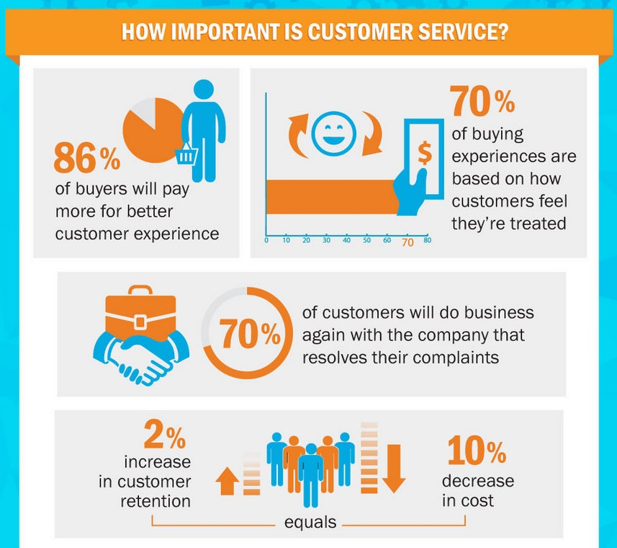
Fig.6 Customer service importance (Polo and Tweed, 2022)
Optimise Revenue Management Strategies:
The Fairmont Monte Carlo should use advanced revenue management strategies to make the most money possible and improve price and product control. Using tools for data analysis (Chatterjee, Rana and Dwivedi, 2022) and projections can help the hotel find trends in demand, change prices and make the best use of room assignments to get the highest revenue per available room (RevPAR). A study by McKinsey & Company found that hotels that use revenue management methods see a 2-5% rise in RevPAR compared to hotels that don't.
Strengthen brand partnerships and collaborations:
Working with local businesses and expensive brands can help the Fairmont Monte Carlo's brand stand out and bring in high-value guests. Partnerships with high-end stores, private clubs, yacht charters and tour companies can help promote each other and give guests unique experiences. The hotel could also look into co-branding opportunities with famous cooks, artists, or fashion designers to create unique eating experiences or events that wealthy travellers would enjoy.
Listen to and respond to guest feedback:
The Fairmont Monte Carlo should listen and respond to guest feedback through online reviews, polls, and social media, to find ways to improve and quickly solve guest concerns. A strong guest feedback management system can help the hotel keep track of performance data, find out how satisfied guests are, and spot trends over time. Fairmont Monte Carlo can improve its guests' trust and loyalty by listening to their concerns and taking action to fix problems. 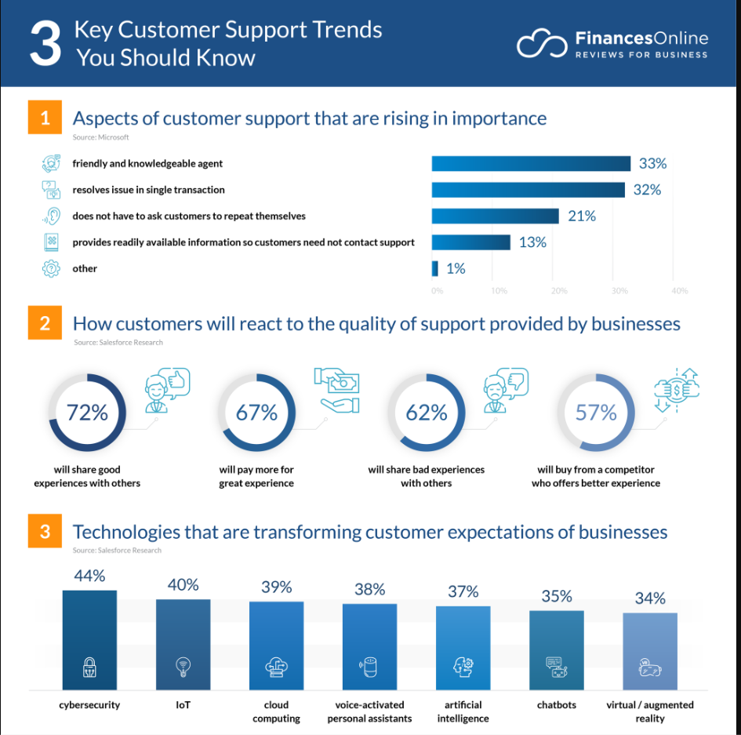
Fig. 7 Customer Support Trends (Finances Online, 2024)

Change in leadership and policies in the management:
In the upscale hotel field, Fairmont Monte Carlo, like all businesses, needs to be able to handle change well in order to keep up with changing market conditions, new technologies, and guest tastes. Strong change management practices and processes are needed to make sure that implementation goes smoothly, that pushback is kept to a minimum, and that efforts to make the hotel more competitive and improve guest experiences are fully realised. Using Lewin’s Change management model, new strategies will be implemented.
Setting Realistic Goals and a Grand Vision:
Before making any changes, Fairmont Monte Carlo needs to set clear goals and a convincing picture of how things should be in the future. This means explaining why things need to change, setting SMART goals that can be measured, and getting everyone on board. By communicating and giving workers a clear picture of the future, the company can build trust, get their support, and encourage them to take an active role in the change process.
Getting stakeholders involved and getting their support:
Key players at all stages of the organisation must be involved and on board for change management to work well. Early on in the change process, Fairmont Monte Carlo should involve all stakeholders from staff to suppliers and business partners, get their feedback, handle concerns, and build agreement. Setting up cross-functional teams and discussion groups can make it easier for people to work together, support different points of view, and make sure that change efforts take into account the wants and needs of all parties.
Figuring out readiness and impact:
Before making any changes, Fairmont Monte Carlo should do a full analysis of how ready the organisation is and how suggested changes might affect things. To do this, things like present skills, resource access, cultural relations, and possible risks need to be looked at. By being aware of possible problems and obstacles ahead of time, the hotel can create preventative plans to lower risks, deal with resistance, and make sure the implementation goes smoothly.
Knowing how to communicate well:
During the change management process, communication is paramount, keeping everyone involved, aware, and on track with the initiative's goals and objectives. The Fairmont Monte Carlo should have a full communication plan including monthly meetings and reports, training sessions, get feedback, and address issues. Open and honest communication increases trust, lowers doubt, and encourages people to work together and take responsibility.
Giving support and training:
Fairmont Monte Carlo should invest into regular training and development programs for its workers, making sure they can handle changes and that the hotel runs smoothly. This could include both professional training on new systems or processes, "soft skills" and personal development. Giving workers constant support can help them deal with problems, boost their confidence, and be more invested.
Giving employees power and encouraging new ideas:
The Fairmont Monte Carlo should give its workers the freedom to lead change projects and come up with ways to make things better. Fostering a culture of creativity and ongoing growth, the hotel can get its workers to look for ways of improving things, stimulating creativity and innovation. Employees who are rewarded for their contributions to change efforts are more likely to feel like they own the change and work hard to make it happen.
Keeping an eye on progress and making changes to plans:
Fairmont Monte Carlo should keep track of process, review results, and make changes to tactics as needed during the change process. Using measurements and key performance indicators (KPIs), the hotel can keep track of how well change efforts are working, find places to improve, and make decisions based on data. The organisation can respond to changing conditions, take advantage of opportunities, and stay flexible in a changing setting thanks to regular reviews and feedback loops. The Fairmont can ensure long-term success by applying the Total Quality Management philosophy (Corporate Finance Institute, 2024) and processes. TQM encourages teamwork and continuous learning, communication, staff engagement in pursuing customer satisfaction and excellence in all areas.

Key Performance Indicators in evaluating:
If Fairmont Monte Carlo follows the suggestions above, it should be able to reach a number of key performance indicators (KPIs) that show how well its change initiatives have been received. The KPIs cover many areas of the hotel's business, including guest satisfaction scores.
- Revenue Growth: Hotel is selling more rooms, giving customers a better experience, and getting a bigger share of the market.
- RevPAR Growth: Using dynamic pricing to make the most of busy periods with high demand and increasing occupancy rate.
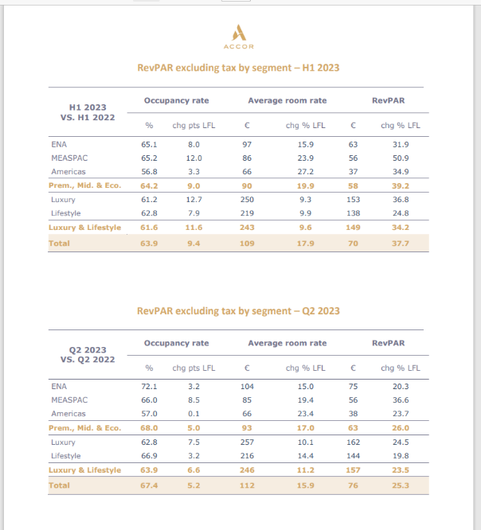
Fig.8 RevPar figures 2023 (Accor, 2024)
- Spa and Wellness Revenue: Spa services and wellness options can bring extra revenue. This will show how well new health programmes are working and how engaged guests are.
- Guest satisfaction rating: Review customer feedback to assess satisfaction scores, thank positive feedback and address negative reviews promptly.
- Repeat Guest Rate: Repeat guest percentage at the Fairmont Monte Carlo, to assess loyalty to the brand.
- Net Promoter Score (NPS): Find out how likely guests are to tell others about the hotel, which shows how satisfied and enthusiastic they are generally.
- Occupancy Rates: Keep an eye on rising room occupancy rates, which show that hotel services are being used more frequently.
- Average Length of Stay: Changes in the average length of stays of guests, which can show more engaged guests and better experiences.
- Energy, water consumption and waste reduction: Installing LED lights and other low consumption systems that use less energy and water. Apply principles of circular economy to reduce, reuse and recycle products and produce to reduce waste and carbon footprint.
- Green Certifications: Get certifications like LEED (Leadership in Energy and Environmental Design) or Green Key to show that the hotel meets strict sustainability standards and improve its environmental credentials (Lee and Jan, 2019).
- Employee engagement and productivity: Use internal polls and feedback systems to check employee satisfaction and engagement, to avoid staff turnover.
- Training Completion Rates: Keep track of completion rates of training and development programmes to improve staff performance.
- Market Share Growth: Asses Fairmont Monte Carlo's market share growth compared to its competitors in the high-end hotel area.
- Check brand awareness levels and changes through market research and polls.
- Social Media Engagement: Track the number of new social media fans, engagement measures (tags, likes, shares, and comments), and online mentions.

Action Plan:
For every issue that has been identified, this action plan provides detailed instructions, remedies, expected results, deadlines, and budgetary estimates. It gives Fairmont Monte Carlo a methodical way to organise and carry out the suggested solutions, guaranteeing that they are in line with company objectives and resource distribution.
Number | Problem | Solution | Desired Outcome | Time Scale | Completion Date | Planned Budget
1 | Need for Digital Transformation | Full digital update that includes digital butler services, personalised guest platforms, and mobile check-in/out. Upgrade Easyway. | Better guest experiences, more efficient operations, and increase in revenue. | 6 months | 01/01/2025 | €100,000
2 | Limited Sustainable Initiatives | Create and implement eco-friendly procedures: healthy food choices, waste reduction programmes, and green energy sources. | Less damage to the environment, better brand recognition, and appeal to people who care about the environment. | 12 months | 07/01/2026 | €50,000
3 | Expansion of Wellness Offerings | Additional wellness programs, personalised packages, and overall health experiences at the spa and leisure center. | Wellness services that bring additional revenue, make guests happier, and set the hotel apart from rivals. | 9 months | 04/01/2025 | €75,000
4 | Diversification of Revenue Streams | Establish relationship with local companies to offer special deals and hold events. | Added new sources of income, grow market share, and became less reliant on old sources of income. | 6 months | 01/01/2025 | €30,000
5 | Staff Training Program | Focus on training and development programs on service quality, leadership, and personal development. | Enhanced staff happiness, increased engagement, improved working effectiveness, all leads to higher guest satisfaction. | Ongoing | - | €60,000/annum
6 | Optimisation of Revenue Management | Use data analytics and projection tools to come up with improved strategies for managing income. | Maximising revenue per available room (RevPAR), making price and product control better, increase profitability. | 3 months | 01/01/2025 | €50,000
7 | Strengthening Brand Partnerships | Partnership with high-end brands, small businesses in the area, and event organisers to work together on exclusive projects and cross-promote each other. | Better company exposure, a bigger market reach, and standing out through unique encounters. | 9 months | 04/01/2025 | €40,000
8 | Implementation of Feedback Mechanisms | Set up strong ways for guests and employees to give feedback, improve and update constantly Easyway platform. | Continuous feedback and improvement lead to high guest satisfaction. | Ongoing | - | €20,000/annum

Conclusion:
The Fairmont Monte Carlo consulting report concludes with a thorough examination of the hotel's existing prospects and issues, along with strategic suggestions and a plan of action to successfully handle them. By means of identifying pivotal concerns like faults in the customer experience or lack of communication that could affect guest stay and future bookings (Kirova and Vo-Thanh, 2019), the want for digital transformation, restricted sustainable endeavours, and prospects for income diversification, the paper furnishes practical insights to augment the hotel's competitiveness within the upscale hospitality sector. In order to keep up with changing consumer trends and guest expectations (Zaman et al., 2022), the report's suggestions stress the need of consolidating staff training to offer impeccable customer service, empowering staff to take decisions and solve problems on the spot, embracing digital innovation, improving environmental initiatives, growing wellness programs, and fortifying brand alliances. By putting these suggestions into practice, Fairmont Monte Carlo can establish itself as a pioneer in the upscale hospitality industry, providing outstanding visitor experiences while optimising income potential and reducing environmental effects. The report's action plan gives Fairmont Monte Carlo a methodical way to organise and carry out the suggested tactics, complete with defined goals, deadlines, and financial allotments for every project. The hotel may measure progress, methodically handle obstacles, and achieve quantifiable results in line with its strategic objectives by adhering to this action plan. We would like to thank Fairmont Monte Carlo for the opportunity to work with them on this project. We are grateful for the confidence they have put in our abilities, and we're determined to help the hotel meet its goals and maintain its lead in the luxury lodging industry through its continuous pursuit of excellence in guest experiences, profitability, and sustainability. Finally, we would like to thank Fairmont for its cooperation and engagement throughout this consulting process. We have no doubt that the information and suggestions included in this study will help maintain Fairmont Monte Carlo's standing as a top luxury tourist destination for the long run. We appreciate the chance to work with them once again, and we hope to have the opportunity to do so in the future and wish them the best of luck!

References:
Accor (2024) Fairmont Monte Carlo https://all.accor.com/ssr/app/accor/rates/A598/index.en.shtml?compositions=1&dateIn=2024-04-29&nights=1&facets=fai&hideHotelDetails=false&hideWDR=false&destination=monte-carlo-98000-monaco&utm_campaign=ppc-ach-mafm-msn-uk-en-seu-mix-sear-&utm_content=uk-en-MC-V2645&utm_medium=cpc&utm_source=bing&utm_term=mafm (Accessed: 29 April 2024).
Accor (2023) Notes to Financial Statements [pdf]. Available at: file:///C:/Users/User/Downloads/Accor-2023-Notes-to-Financial-Statements-vPUB-amendee.pdf 01 May 2024 (Accessed: 01 May 2024).
Accor (2024) Why Invest [pdf]. Available at: file:///C:/Users/User/Downloads/01_EN_Why%20Invest%20in%20Fairmont_Accor%20Global%20Development_JUN2020%20(2).pdf (Accessed: 01 May 2024).
Albayrak, T., & Caber, M. (2015) Prioritisation of the hotel attributes according to their influence on satisfaction: A comparison of two techniques. Tourism Management, 46, 43–50. https://doi.org/https://doi.org/10.1016/j.tourman.2014.06.009 (Accessed: 27 May 2024).
Altinay, L., & Paraskevas, A. (2015) Planning research in hospitality and tourism. Annals of Tourism Research, 54, 1-13.
Assaf, A. G., & Josiassen, A. (2016) International hotel performance: A global benchmarking approach. International Journal of Hospitality Management, 53, 1-11.
Baron, A. and Armstrong, M. (2007) Human Capital Management. London: Kogan Page.
Barney, J. B. (2002) Gaining and sustaining competitive advantage. 2nd ed. NJ: Prentice-Hall.
Buhalis, D. (2000) Marketing the competitive destination of the future. Tourism management, 21(1), pp.97-116.
Burnes, B. (2020) The Origins of Lewin’s Three-Step Model of Change. The Journal of Applied Behavioral Science, 56(1), 32-59. https://doi.org/10.1177/0021886319892685 (Accessed: 27 May 2024).
Cameron, E. and Green, M. (2015) Making sense of change management: A complete guide to the models, tools and techniques of organizational change. Philadelphia: Kogan Page.
Chatain, O. (2011) Value creation, competition, and performance in buyer‐supplier relationships. Strategic Management Journal, 32(1), pp.76-102. Available at: https://citeseerx.ist.psu.edu/document?repid=rep1&type=pdf&doi=33410b7eb344901aa093ad7433cfe00e1cb31191 (Accessed: 21 May 2024).
Chatterjee, S., Rana, N. P., & Dwivedi, Y. K. (2021) How does business analytics contribute to organisational performance and business value? A resource-based view. Information Technology & People. https://doi.org/https://doi.org/10.1108/ITP-08-2020-0603 (Accessed: 26 May 2024).
Citak, J., Owoc, M.L. and Weichbroth, P. (2021) A note on the applications of artificial intelligence in the hospitality industry: preliminary results of a survey. Elsevier: Procedia Computer Science. Available at: https://doi.org/10.1016/j.procs.2021.09.233 (Accessed:17 May 2024).
Corporate Finance Institute (2024) Total Quality Management. Available at: https://corporatefinanceinstitute.com/resources/management/total-quality-management-tqm/ (Accessed:27 May2024).
Cravens, D., Piercy, N. and Baldauf, A. (2009) Management framework guiding strategic thinking in rapidly changing markets. Journal of Marketing Management, 25(1-2), 31-49.
Crouch, G. I. (2011) Destination Competitiveness: An Analysis of Determinant Attributes. Journal of Travel Research, 50(1), 27-45. https://doi.org/10.1177/0047287510362776 (Accessed: 20 May 2024).
Cummings, S., Bridgman, T., & Brown, K. G. (2016) Unfreezing change as three steps: Rethinking Kurt Lewin’s legacy for change management. Human Relations, 69(1), 33-60. https://doi.org/10.1177/0018726715577707 (Accessed: 19 May 2024).
Dawson-Shepherd, A., Kellner, K., & Neumann, J.E. (1997) Developing Organisational Consultancy (1st ed.). Routledge. https://doi.org/10.4324/9781315812465 (Accessed: 17 May 2024).
Fairmont Monte Carlo (2024) Luxury Hotel in Monaco. Available at: https://www.fairmont-montecarlo.com/en/ (Accessed: 29 April 2024).
Fairmont Monte Carlo (2024) Monaco Grand Prix 2024 Offers. Available at: https://www.fairmont.com/monte-carlo/offers/grand-prix/ (Accessed: 27 May 2024).
Fairmont Monte Carlo (2024) Social-environmental responsibility. Available at: https://www.fairmont-montecarlo.com/en/social-environmental-responsibility/#:~:text=The%20hotel%20also%20uses%20cutting,while%20offering%20guests%20unrivalled%20comfort. (Accessed:15 May 2024).
Finances Online (2024) Customer support trends. Available at: https://financesonline.com/customer-support-trends/ (Accessed: 27 May 2024).
Forbes (2022) The six best Change Management Models for your company. Available at: https://councils.forbes.com/blog/top-change-management-models (Accessed: 27 May 2024).
Free Logo Design (2024). Available at: https://www.freelogodesign.org/manager (Accessed: 08 May 2024).
Gouvernment Princier (2024) Employment/ Labour-Law. Available at: https://en.gouv.mc/Policy-Practice/Employment/Labour-Law (Accessed:16 May 2024).
Gupta, S. & Bhatia, S. (2018). Sustainable tourism: Drivers and challenges. Journal of Hospitality and Tourism Management, 35, 91-98.
Hair, J. F. et al. (2006) Multivariant data analysis. Pearson International Edition.
Hello Monaco (2022) The Fairmont Monte Carlo. Available at: https://www.hellomonaco.com/leisure-entertainment/hotels/the-fairmont-monte-carlo-a-unique-hotel-in-the-very-heart-of-monaco/ (Accessed:29 April 2024).
Hodges, J. (2017) Consultancy, Organizational Development and Change. Kogan Page.
Hotel Tech Report (2024) Guest experience: From email to instant communication. Available at: https://hoteltechreport.com/success-stories/guest-experience/easyway/fairmont-monte-carlo (Accessed: 28 April 2024).
Hristov, I. and Chirico, A. (2019) The role of sustainability key performance indicators (KPIs) in implementing sustainable strategies. Sustainability, 11(20), 5742. https://doi.org/10.3390/su11205742 (Accessed: 26 May 2024).
Johnson, M. (2005) The Independent Consultant’s Survival Guide. London: CIPD.
Kang, S. H., & Heo, C. Y. (2018) The impact of hotel website quality on users’ perception and booking intention. Journal of Hospitality Marketing & Management, 27(7), 726-747.
Kim, S. & Kim, M. (2017) The effect of green marketing on green commitment: Exploring the roles of green brand attitude and green brand image. Sustainability, 9(1), 13.
Kim, S. & Kim, M. (2018) The influence of luxury restaurant environments on guests’ emotions and loyalty intentions: The moderating role of destination image. International Journal of Hospitality Management, 72, 1-11.
Kirova, V. and Vo-Thanh, T. (2019) Smartphone use during the leisure theme park visit experience: The role of contextual factors. Information & Management, 56(5), 742–753. https://doi.org/https://doi.org/10.1016/j.im.2018.11.008 (Accessed: 27 May 2024).
Kotter, J. (2012) Leading change. Harvard Business Review Press.
Lee, H. A., Park, S., and Yoo, S. (2016) Does luxury consumption enhance psychological well-being? Luxury consumption, well-being, and the mediating role of psychological need satisfaction. Psychology & Marketing, 33(2), 103-114.
Lee, T. H., & Jan, F. H. (2019) Understanding the relationship between green hotel initiatives and guest satisfaction: A meta-analysis. Sustainability, 11(6), 1737.
Leiblein, M. J. (2011) What Do Resource- and Capability-Based Theories Propose? Journal of Management, 37(4), 909-932. https://doi.org/10.1177/0149206311408321 (Accessed: 21 May 2024).
LinkedIn (2023) The indispensable role of employee training in managing guest feedback. Available at: https://www.linkedin.com/pulse/indispensable-role-employee-training-managing-guest-feedback-khalil (Accessed: 27 May 2024).
Management Consultants Association (2024) AI and Digital technology to drive growth in consulting in 2024. Available at: https://www.mca.org.uk/press-releases/ai-and-digital-technology-expected-to-drive-growth-in-consulting-in-2024-according-to-independent-new-survey (Accessed: 13 May 2024)
Meeting and Incentive Travel (2022) Monaco leads the way on sustainable tourism. Available at: https://mitmagazine.co.uk/Sponsored-Content/Monaco-leads-the-way-on-sustainable-tourism
(Accessed: 15 May 2024).
MKG Consulting (2022) The French hotel industry still marked by the crisis in 2021. Available at: https://www.mkg-consulting.com/communique-de-presse/lhotellerie-francaise-encore-marquee-par-la-crise-en-2021-quelques-signaux-positifs-en-fin-dannee (Accessed:26 May 2024).
Monaco Statistics (2024) Economy and Finance. Available at: https://www.monacostatistics.mc/Economy-and-Finance/GDP#:~:text=In%202022%2C%20the%20Principality's%20GDP,in%20volume%2C%20adjusted%20for%20inflation.(Accessed: 17 May 2024).
Newton, R. (2009) The Project Manager: Mastering the art of delivery. Harlow: Pearson.
Nicolau, J. L., Mellinas, J. P., and Martín-Fuentes, E. (2020) Satisfaction measures with monetary and non-monetary components: Hotel’s overall scores. International Journal of Hospitality Management, 87, 102497. https://doi.org/https://doi.org/10.1016/j.ijhm.2020.102497 (Accessed:27 May 2024).
Oxford College of Marketing (2016) TOWS analysis guide. Available at: https://blog.oxfordcollegeofmarketing.com/2016/06/07/tows-analysis-guide/ (Accessed: 27 May 2024).
Passion for luxury (2014) Fairmont Monte Carlo. Available at: https://passion4luxury.blogspot.com/2014/03/fairmont-monte-carlo.html (Accessed: 15 May 2024).
Polo and Tweed (2022) Benefits of hotel staff training: increase guest satisfaction. Available at: https://poloandtweed.com/blog/benefits-of-hotel-staff-training-increase-guest-satisfaction (Accessed: 27 May 2024).
Porter, M. (1985) Competitive advantage. New York: Free Press.
Sekaran, U. and Bougie, R. (2016) Research methods for business: A skill building approach. 7th ed. John Wiley & Sons.
Sigala, M. (2018). Service intelligence in tourism and hospitality: Theory, research and practice. Journal of Service Management, 29(4), 639-655.
Teixeira, R., & Gomes, C. F. (2017) Drivers and outcomes of green tourism development: A systematic review. Sustainability, 9(10), 1865.
Total Motorsport (2024) F1 2024 Monaco GP Celebrities. Available at: F1 2024 Monaco GP celebrities: Emily Ratajkowski and Kylian Mbappe among the stars attending race - Total Motorsport (total-motorsport.com) (Accessed: 26 May 2024).
Tripadvisor (2024) Fairmont Monte Carlo Reviews. Available at: https://www.tripadvisor.com/Hotel_Review-g190409-d230423-Reviews-Fairmont_Monte_Carlo-Monte_Carlo.html 01 May 2024 (Accessed: 01 May 2024).
Vidgen, R., Shaw, S. and Grant, D. (2017) Management challenges in creating value from business analytics. European Journal of Operational Research.
Whittington, R. et al. (2020) Exploring strategy. Harlow: Pearson.
Worthington, I. and Britton, C. (2009) The business environment. Prentice Hall.
Yavas, U., & Babakus, E. (2005) Dimensions of hotel choice criteria: Congruence between business and leisure travelers. International Journal of Hospitality Management, 24(3), 359–367. https://doi.org/https://doi.org/10.1016/j.ijhm.2004.09.003 (Accessed: 27 May 2024).
Zaman, M. et al. (2022) How can hotels create sustainable competitive advantages? A resource-based view. Journal of Strategic Marketing, 1–16. https://doi.org/10.1080/0965254X.2022.2066558 (Accessed: 20 May 2024).
Zurich Networking Group (2020) The TOWS Matrix [pdf]. Available at: https://www.zurichnetworkinggroup.com/wp-content/uploads/2020/06/The-TOWS-Matrix.pdf (Accessed: 27 May 2024).

