Student Number – P121752
Module Title – Creating a strategic direction for school improvement
Module Code – M6X01440
Assignment Title –
Identify an initiative you are leading or an area of responsibility and present the following as a portfolio of evidence of your approach to strategic planning and school development
Section A – Strategic Planning

M6X01440 – Creating a strategic direction for school improvement
A continuous theme from the New Curriculum report, Successful Futures, (Donaldson, 2015), is the need to create a curriculum which inspires learners to tackle challenges and take independence in their learning. These characteristics will then help learners meet ‘the needs of today and the challenges of tomorrow’ (Donaldson, 2015, p.6). In an era where digital technology is becoming more dynamic and widespread, there is an obvious need to educate our learners in using these technologies, to equip them with skills for future industries, some of which may not even be invented yet. However, this should not be at the detriment to other areas of learning, particularly when the skills within the area promote the characteristics that will support learners in becoming ‘capable, well rounded individuals, who can thrive in the face of unknown challenges’ (Donaldson, 2015, p.5).
Section A
Detailed Analysis of the AOLE
As a member of my schools Senior Leadership Team (SLT), whilst we are at early stages of developing the New Curriculum to fit our school vision and values, one of the New Curriculum Areas of Learning Opportunities and Experiences (AOLE) that we decided to focus on during this academic year was Expressive Arts. This area is of interest to me on both a school developmental and personal level. With regards to a school priority, as leader of Key Stage 2 and English & Literacy Coordinator, there has been a decline in oracy levels and the school achieving the lowest percentage within the family of schools (see Figure 1 & 2) (All Wales Core Data Set, 2017). It is important that the name of school and learners remain confidential, following the guidelines published in Bera Guidance (2011). For confidentiality reasons, the school name and logo will be removed, and any pupil’s names will be anonymised with numbers (e.g Pupil 1, Pupil 2).
Figure 1: Pupils achieving L4+ in Oracy from 2010-2011 to 2016-2017
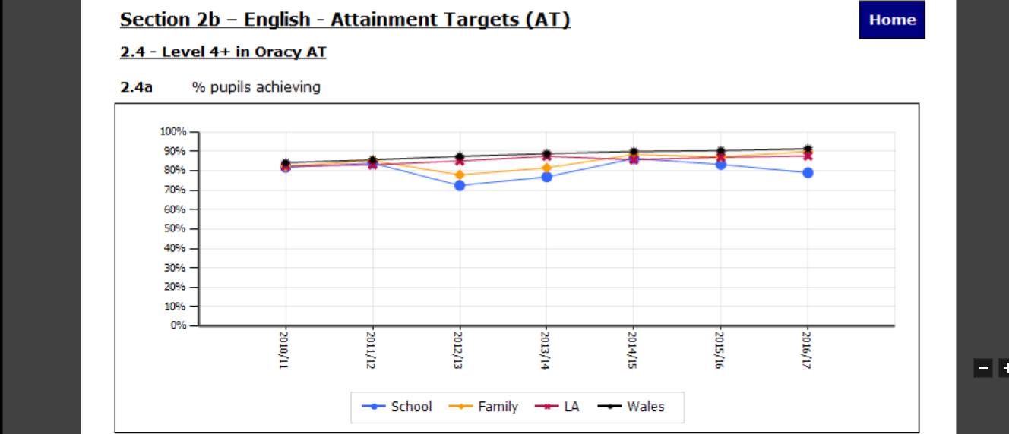

Figure 2: Percentage of pupils achieving L4+ within Family of Schools
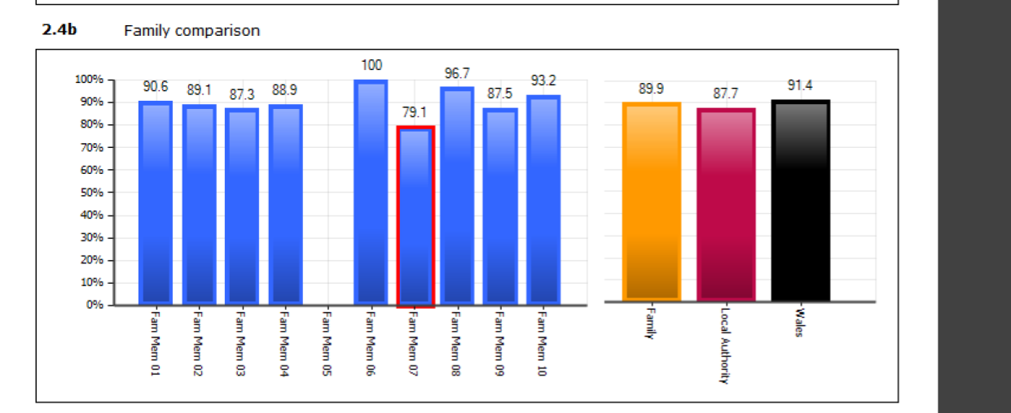
As a result, one of the targets in the current School Development Plan (SDP) is to ‘Develop Creativity across the School in readiness for the New Curriculum’ (see Appendix 1 for School Development Plan target). This is in line with the Welsh Government’s (2017) Curriculum Timeline, with the school ‘identifying areas of the curriculum to develop, and also identifying professional learning needs’ (p.20). The priority also includes links with outside partners, which is a principle that is advocated by in the Welsh Government’s (2015) Qualified for Life document. The school has been chosen as a Lead Creative School, a Welsh Government initiative that aims to support schools increase attainment by working closely with creative professionals.
In addition, improving the teaching and learning of oracy within the school was an area of personal interest as it was the subject of a recent research project I undertook. The research project was based on using film as a stimulus for literacy amongst lower ability boys, and the research did show improved levels (Down, E., (2015). One of the main outcomes was how the learners found it easier to understand the films, and the use of images, sounds and actions helped them to be more creative with their ideas. Despite the research project having a literacy focus, the film provided the opportunity for learners to engage with acting and expression, character and set design and soundtrack, all key areas of the Expressive Arts AoLE.
Successful Futures recommends that Expressive Arts include art, drama, dance, film, music and digital media. In recent years, it has been documented by various studies that the emphasis placed on more traditional art based subjects has reduced. Dai Smith’s report based on Art in Education in Wales (2013) cites The Henley Review (2012, cited in Smith, 2013:20) and Professor Robyn Ewing’s report (2010, cited in Smith, 2013:14) as identifying that the arts are becoming increasingly devalued and restricted, yet they have immense value upon both educational and social achievements. It is also my opinion that there is less emphasis placed on the arts, and having undergone a recent inspection, it also appears to be a less important feature on Estyn’s agenda. Although this may be due to the focus on the three national priorities, I believe that a focus on Expressive Arts will have a positive impact on the priorities, particularly with regards to literacy and reducing the gap between poverty and attainment.
Smith’s report identifies the importance of creativity in the curriculum, suggesting that ‘creativity…will shape our world like no force imaginable’ (p.6). Giving learners an opportunity to express themselves through art mediums is a powerful learning tool, as it promotes independent thinking, creativity and risk taking.
Teaching Strategies
Effective teaching and learning of art-based areas can be characterised by a Vygotskyian-style approach. Linking to Dewey’s (1933) earlier work on the role of society and social development in learning, Vygotsky’s (1978) belief that social interaction is crucial to a learner’s development. Areas of Expressive Arts such as drama and film study rely on social interaction, as the opportunity to collaborate with others allows learners to further their imagination, understanding and learning. Also, Vygotsky emphasises the importance of social collaboration and discussion amongst adults and younger learners, with the role of the adults as ‘scaffolding’ the knowledge in learners. The importance of the adult and learner social interaction is particularly prominent within areas of the Expressive Arts, such as music and art, as a skilled teacher can help ‘scaffold’ the learning with initial guidance and support, however it is the learner’s interpretation and ability that advances their learning. The Vygotskyian Social Constructivism theory also promotes the role of learner’s immediate society in their learning. As discussed previously, one of the most important factors in a well-developed and successful approach to the teaching of Expressive Arts is providing opportunities for learners to visit, and learn from, places and people linked to creative areas.
In addition to prominent learning theories, Donaldson (2015, p.9) identifies that ‘a curriculum is needed which promotes a high expectation for all’, and celebrating achievements within the arts is one way to achieve this. Throughout my teaching experiences, More Able and Talented (MAT) pupils have been identified and challenged in literacy and maths, however, less focus has been given to pupils that display talented in the arts and sports. My school is in an area of high deprivation, with 43% of pupils receiving Free School Meals (FSM). Although I will expand on this further in section B, identifying and targeting groups of pupils in other areas that literacy and maths may have a positive effect on their attitudes to learning, and see an increase in attainment in all areas. These themes were also explored in a Forest-Bank et al’s (2016) American-based study based on the effects of an expressive arts intervention in a low-income area. Whilst the study was not large enough to provide a definitive relationship between Expressive Arts and attitudes to learning, it did suggest that the relationship needs to be explored further.
Therefore, for the AoLE to be implemented successfully, it is important that all staff are aware of the importance of providing learning experiences that cover all areas of the Expressive Arts AoLE. As discussed previously, this is an area of learning which has been widely recognised as being undervalued, and as a result, teachers’ confidence in these areas may be lower. For this to be achieved, it is vital that the SLT within the school support, and facilitate opportunities for these learning styles to be developed, and opportunities for pupils to experience the AoLE to occur. Frost (2012: 207), cites Fullan’s (1998) findings that the most effective vehicle for change within education is the learning of new skills. Whilst I believe that this statement is valid, I also believe that the level of confidence in teaching the new skills to pupils is vital to ensuring that effective change is undertaken. This is an area that will be explored further in section B.
How will progression be observed?
As a Lead Creative School, the opportunity to participate in the scheme will hopefully show progression in the Expressive Arts areas. Currently, the school council is in the process of selecting the creative professional who will work closely with targeted classes. As stated in the Welsh Governments (2015) ‘Creative Learning through the Arts – An Action Plan for Wales’ document, the ‘teacher will be central to the learning process at all times’ (2015:8). Therefore, it is expected that through staff training, the skills and techniques learnt would be filtered to all members of teaching staff. This would be further developed by lesson observations based on the skills taught in the scheme, and opportunities for staff to observe each other based on areas of personal specialities and interest. The use of specialists to support teachers is supported in Bamford’s (2006) study, which promotes the strong partnership between schools and outside arts and community organisations. Expressive Arts is an area in which specialisms need to be developed (e.g music, drama, art), and teachers with these specialities may not always be available in primary schools.
In addition, the scheme also promises to ‘support schools to find creative approaches to literacy, numeracy and reducing the attainment gap’. Through participation as Creative Lead School, and as teaching of the Expressive Arts becomes a more prominent part of long and short-term planning, there would hopefully be progression in some areas of literacy and numeracy e.g English oracy and writing.
A pupil voice element will also demonstrate how much progression has been made. If the AoLE has been implemented successfully, due to the opportunities that Expressive Arts can provide, there should also be an increase in pupil participation in extra-curricular activities such as playing musical instruments, or attendance in art and drama clubs, both as an extra-curricular club and out-of-school activity. It is important to note that currently the after-school clubs are run by Learning Support Assistant’s (LSAs) with strengths in the areas of art and drama, however their extended hours are funded by the Pupil Deprivation Grant (PDG). A Joseph Rowntree Foundation study (2007) into education and poverty disadvantages advocates the benefits of extra-curricular, and out of school activities, suggesting ‘such activities can help children develop confidence in learning, to become active learners and to develop a different kind of relationship with adult instructors or supervisors than in a more formal school setting’ (2007:6). This is a factor that the school already sees as an important step towards bridging the gap between disadvantaged pupils and attainment, and this should be further developed if progress in the AoLE is made. However, it is important to note that as the school has a high percentage of FSM pupils, it is likely, but not certain, that funding will continue to be available, and this must be taken into account.
Ultimately, in accordance with the Education in Wales Action Plan (2017), successful implementation of the Expressive Arts AoLE, alongside the other five AoLEs as outlined in the New Curriculum (2015) would be a fully functioning curriculum which is delivered by confident, capable teachers and supported by strong leaders. All area of the AoLE’s will be underpinned by the four Main Purposes to ensure that learners given the best opportunity of being a successful member of a 21st Century Society

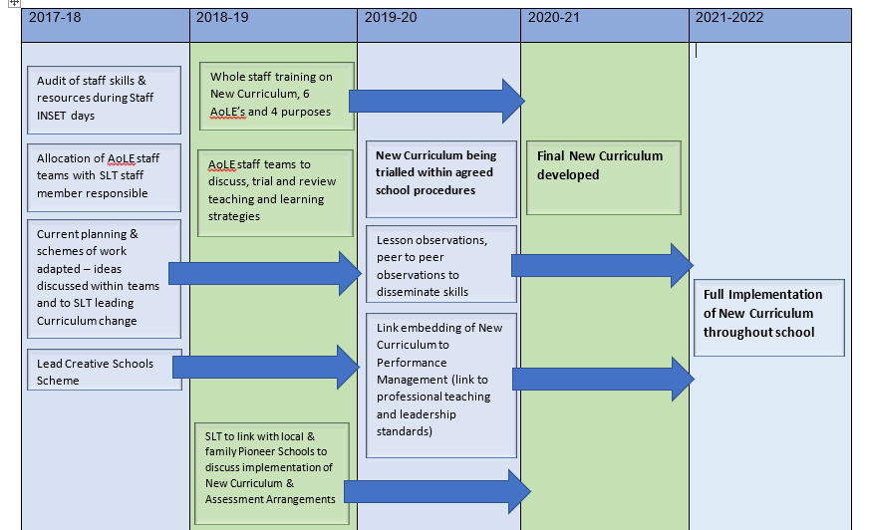
Five Year Strategic Plan for Implementation of the New Curriculum

Outline and Rationale for Targets
In a context wider than the delivery of the Expressive Arts AoLE, the 5 year Strategic Plan (SP) outlines the steps required to ensure the New Curriculum is implemented in an organised system, that is discussed, monitored and reflected upon regularly. The first 2-3 years of the SP are built upon a foundation of an evaluating, modifying, monitoring and reviewing cycle (see figure 3).
Figure 3 – Cycle used to implement effective changes

Not only does this cycle ensure that the final New Curriculum has been implemented as a result of of lengthy collaboration, discussion and reflection, but it also encompasses nearly all of the ‘seven dimensions of Welsh schools as learning organisations’ (as discussed in Education in Wales, Action Plan, 2017, p.12).
2017-2018
The main focus of the first year of the SP is to audit current practices and identify and establish focus groups to work on each AoLE, based on staff preferences and skills, for both teaching and non-teaching staff. This will ensure that the AoLE’s are developed by professionals with an interest and knowledge in the planning and implementation of the AoLE. Within these groups, there will be a member of SLT, or an aspiring middle leader with a coordinator role leading the groups. These groups will have opportunities in one staff training day, and three after-school training sessions to look at current schemes of work and/or teaching approaches and identify how these can be modified to the AoLE. The lead of each group will then work closely with the overall SLT lead for developing the New Curriculum, and the Headteacher, to map how the AoLE will be taught in the school. In accordance to the Education in Wales, Our National Mission Action Plan 2017-2021 document, the publication of the AoLE frameworks would also provide a guideline for the structure and content of each AoLE.
2018-2019
This academic year will see a further emphasis on collaboration within the AoLE focus groups, as the groups will continue with the cycle shown in Figure 4 to ensure the 6 AoLE’s are developed to ensure that the learners have the best learning opportunities available to them. As discussed previously, this can only be achieved by a process which allows professionals to trial new ideas and to reflect and revamp ideas. Also, there will be the opportunity for whole staff training on the New Curriculum, including the 6 AoLE’s, 4 main purposes and assessment arrangements. It is vital that both teaching and non-teaching staff have a detailed understanding of the purpose and organisation of the New Curriculum, and once again, it will allow opportunities for collaboration and discussion. In addition, the SLT will be given time to discuss, visit and collaborate with Pioneer Schools, both within the cluster and Family, to gain a further understanding on the implementation of the New Curriculum.
2019-2020
This academic year will see the New Curriculum being trialled in the school, based on the development of the 6 AoLE’s, and their aim to reflect the 4 main purposes for all learners. This will be the main priority in the school SDP, which in turn will allow opportunity for teacher observations both within, and out, of school. Allocating the delivery of an AoLE for a Performance Management Target will ensure the delivery of the New Curriculum is of prime importance amongst teaching staff, and it will allow practice, ideas and skills to be shared and disseminated amongst staff. This will also be in addition to triad lesson observations, phase-to-phase lesson observations and hopefully the opportunity to observe lessons from Pioneer Schools. As the 2017-2021 Action Plan outlines, the PDG grant will remain, and possibly increase from April 2017, which will allow funding for supply teachers to ensure that teaching staff have the opportunity to observe and learn from each other.
2020-2021
The main target for this academic year is to ensure that the final version of the New Curriculum is developed in school. As the SP demonstrates, there will still be a strong focus based on peer-to-peer lesson observations. Also, the New Curriculum will continue to be a main priority on the school SDP and performance management will be linked to the target. The development of the New Curriculum is the biggest change in education for many teachers currently working in the school, therefore it needs more than one academic year to ensure that all teaching staff are delivering it accordingly, and also planning lessons and managing support staff to their best potential. It will also provide opportunities for staff to continue to engage with the New Curriculum during Adds Sessions and whole staff INSET days, to ensure that it has been developed due to thorough discussions, trialled and tested strategies and opportunities for reflection. This would ensure that the curriculum has been developed through a series of thorough and carefully planned milestones. By following the SP, it is hoped that by this academic year, there will be a clear and coherent version of the New Curriculum being delivered in schools.
2021-2022
The New Curriculum will now be fully implemented throughout the school. This would ensure that; the curriculum’s aims are based on creating learners that strive to meet the 4 main purposes, the curriculum is taught through 6 Areas of Learning, and assessment is undertaken through the assessment procedures and milestones.

Word Count – 2,939

Appendix 1
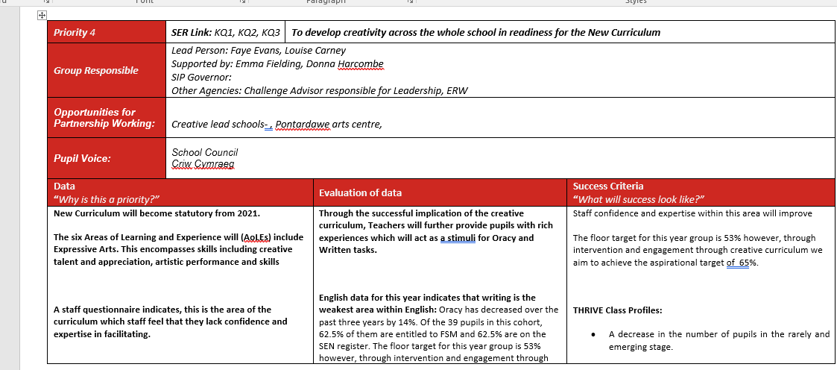
School Development Plan linked to development of creativity

Reference List
Bamford, A. (2006), The Wow Factor: Global research compendium on the impact of arts in education, Berlin: Waxmann Verlag.
BERA, (2011), BERA Ethical Guidelines, British Educational Research Association: London
Dewey, J., (1933), How we think, a restatement of the relation of reflective thinking to the educative process, Boston: Heath and Co.
Donaldson, G., (2015), Successful Futures, Cardiff: Welsh Assembly Government
Down, E., (2015), ‘How the use of film as a literacy stimulus has an impact on under-achieving boys’ attainment and engagement in literacy, with a focus on extended writing’, Masters in Educational Practice – Teacher Inquiry Project, Cardiff University, Cardiff, Unpublished Research Project
Estyn, (2015), Best practice teaching and learning in the Creative Arts at Key Stage 2, Cardiff:
Forrest-Bank, S., Nicotera, N. & Bassett Matera, D., (2016), ‘Effects of an Expressive Art Intervention with Urban Youth in Low-Income Neighbourhoods’, Child & Adolescent Social Work Journal, 2016, 33, pp.429-441
Frost, D., (2012), From professional development to system change:
teacher leadership and innovation, Professional Development in Education 38:2, pp.205-227
Green, L., Chedzoy, S., Harris, W., Mitchell, R., Naughton, C., Rolfe. L, and Stanton, W., (1998), ‘A Study of Student Teachers' Perceptions of Teaching the Arts in Primary Schools’, British Education Research Journal, 24:1, pp.95-107
Smith, D., (2013), An Independent Report for the Welsh Government into Arts in Education in the Schools in Wales, Cardiff: Welsh Assembly Government
Vygotsky, L.S (1978), Mind in Society: The Development of Higher Pyschological Processes, Cambridge: Harvard University Press
Welsh Government, (2015), A Curriculum for Wales, A Curriculum for Life, Cardiff: Welsh Assembly Government
Welsh Government, (2015), Creative Learning through the arts – an action plan for Wales, Cardiff: Welsh Assembly Government
Welsh Government, (2017), Education in Wales: Our National Mission Action Plan 2017-2020, Cardiff: Welsh Assembly Government
Welsh Government, (2017), Professional standards for teaching and leadership, Cardiff: Welsh Assembly Government

