

Assessment resit
Information engineering

Name: denis nagy
Student id:1920270

Contents
1.1 Entity Relationship Diagram 3
1.2 Use Case Diagram 4
1.3 Data Flow Diagram 5

Entity Relationship Diagram

A diagram of Entities' Relations (ER) is a kind of fluid diagram that shows how "entities" such as individuals, objects or concepts are related within a structure. ER Diagrams are most commonly used in the fields of software engineering, business information systems, education, and science to design or debug relational databases. They are also known as ERDs or ER Models, and they employ a predefined set of symbols. (SmartDraw)
In the following Erd I have three entities (Office Staff, Driver, Garage) and their relationship.
The relationship between office staff garage and driver are one to many because can have one or more drivers. The relationship between vehicle and the driver is one to many because a car can have one or more drivers.

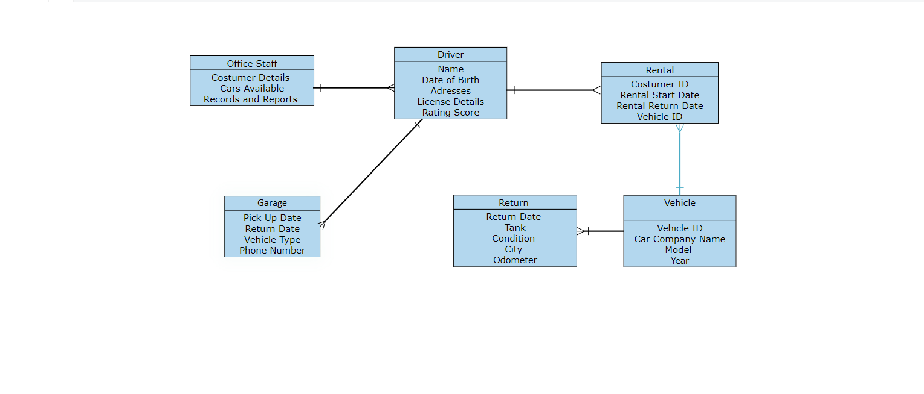

Use Case Diagram

A use case diagram shows the potential interactions between a user and a system. A use case diagram defines various use cases and user forms that exist in the system and is often followed by other types of diagrams. Both circles and ellipses reflect the use cases. (UCD)
The goal of Garage is to provide cars for the drivers in the easiest way, the driver must pay fees for renting their car and take care of the car, office staff generates bills make reports and send bills and invoices.
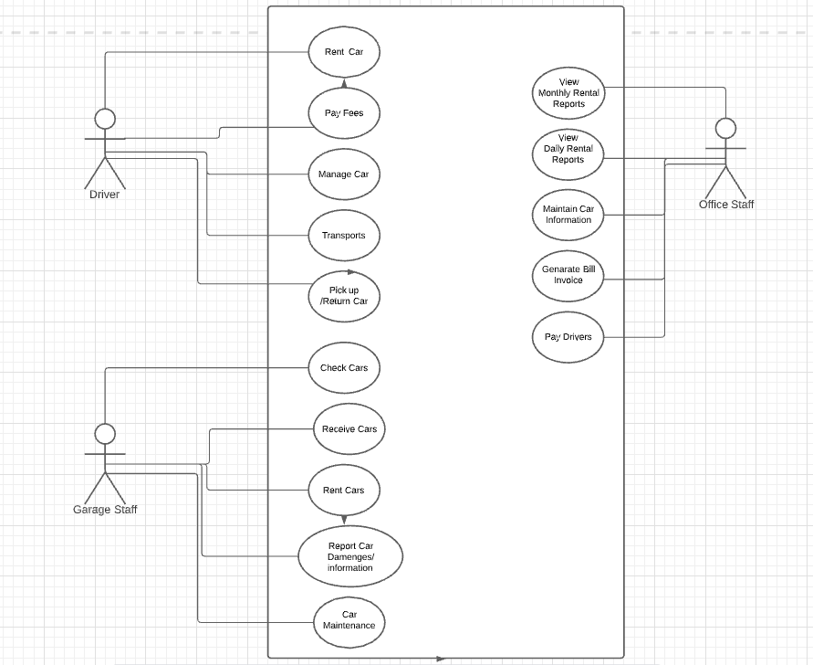

Data Flow Diagram

Data flow diagrams, also known as DFDs, are used to graphically represent the flow of data in a business information system. There are two types of data flow diagrams: logical and physical. The logical data flow diagram depicts the flow of data through a system to execute specific business functions. (Paradigm)
This Data Flow has four levels.
Level 1- Driver Information Checking
The driver sends his information to be checked so he is available for renting a car if he is available the system will forward the information.
Level 2- Car Available Checking
The system will check if there is any available car in the garage database. The garage updates his database in daily basis. Then the information is sent to Rental Processing Level 3.
Level 3- Rental Processing
Rental Processing deals with receiving and sending information to the entities if everything is good and on place to rent a car.
Level 4-Payment System
Payment System will send bill to the driver which he will need to pay for renting the car and also the system will give invoice and will let know the rental processing that the driver paid the fees.

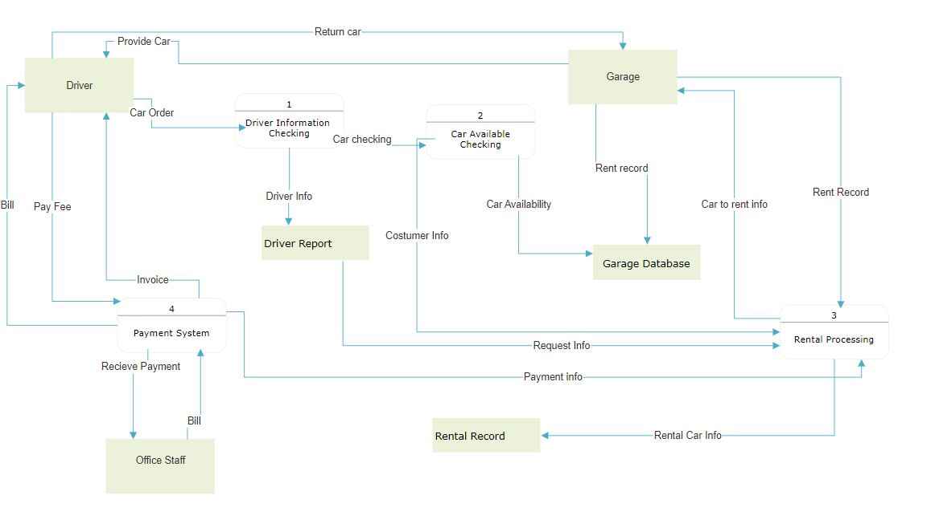

References
Paradigm, Visual. https://www.visual-paradigm.com/guide/data-flow-diagram/what-is-data-flow-diagram/. [Online]
SmartDraw. https://www.smartdraw.com/entity-relationship-diagram/. [Online]
UCD. https://en.wikipedia.org/wiki/Use_case_diagram. [Online]

