Strategic Management and Sustainability – LCBB6004

Diageo – strategic choices and capabilities of the company
ASSIGNMENT 1

Teodora Georgieva
Student ID: 2111818
Date of submission:16/04/24
Word Count: 3817 words
Tutor’s Name: Piyumika Gamage

University of Wales Trinity Saint David - London

Contents
1.Introduction 2
2. Business and Corporate Strategies of the company 2
2.1. Porter’s Generic strategies 2
2.2. Ansoff Matrix 4
3.Resources and Capability of the company 5
3.1. Value Chain Analysis 5
3.2. VRIO analysis 9
4. Diageo – Strategy in Action 12
5. Sustainability efforts evaluation 14
6. Conclusion 15
7. References 16

1.Introduction

In conditions of global competition, constantly changing consumer preferences and technological progress, the stability of the business built by the company's capabilities and the strategic approaches taken determines further development and success. This report examines the Diageo company, a significant representative of the alcoholic beverage industry, emphasizing current and future strategic planning and business strategies viewed through economic theory and the company's organizational capabilities.
Diageo is a British company founded in 1997 by merging Guinness and Grand Metropolitan. It is one of the leading producers and suppliers of alcoholic beverages in more than 180 countries, with over 130 production sites worldwide (Diageo,2024) and a staff of about 27.99 thousand people in 2022 (Statista, 2024). The portfolio of this conglomerate includes 200 brands, including Johnnie Walker, Smirnoff, Captain Morgan, Bailey's and Guinness. Operating profit for 2023 is approximately GBP 4.6 billion (Statista, 2023). Compared to previous years, it has grown, which speaks of a reasonable allocation of resources and successful strategies.

2. Business and Corporate Strategies of the company

Strategic planning guides the organization on the path to sustainability and competitive advantage. According to Michael Porter (1980), companies should aim to build a strategy in which the choice of a precisely defined market position, differentiation and creation of company value is of primary importance.
Diageo focuses on innovative solutions, differentiation, responding to changes in customer preferences, and expanding the market and its portfolio. The latter is confirmed by the acquisition of Casamigos Tequila and George Clooney's premium tequila brand (Diageo, 2024).

2.1. Porter’s Generic strategies

Three Porter's strategies would distinguish any company from the competition. Evaluating your capacity and strengths, the options for strategic development are:
Cost leadership, where the focus is on the lowest costs in the industry to obtain a competitive advantage (Porter, 1987);
Differentiation, where a company offers consumers unique services or products (Porter, 1987);
A focus strategy is one in which companies focus on a specific marketing niche serving a particular target group (Porter, 1996).
Diageo's approach to standing out in the spirits industry as a whole is focused on differentiation. With a portfolio of 200 internationally renowned brands, including Tanqueray, Guinness, Johnnie Walker, and Don Julio, Diageo (Fig 1.) embodies a methodical approach to brand development that connects with customers on a personal and social level.
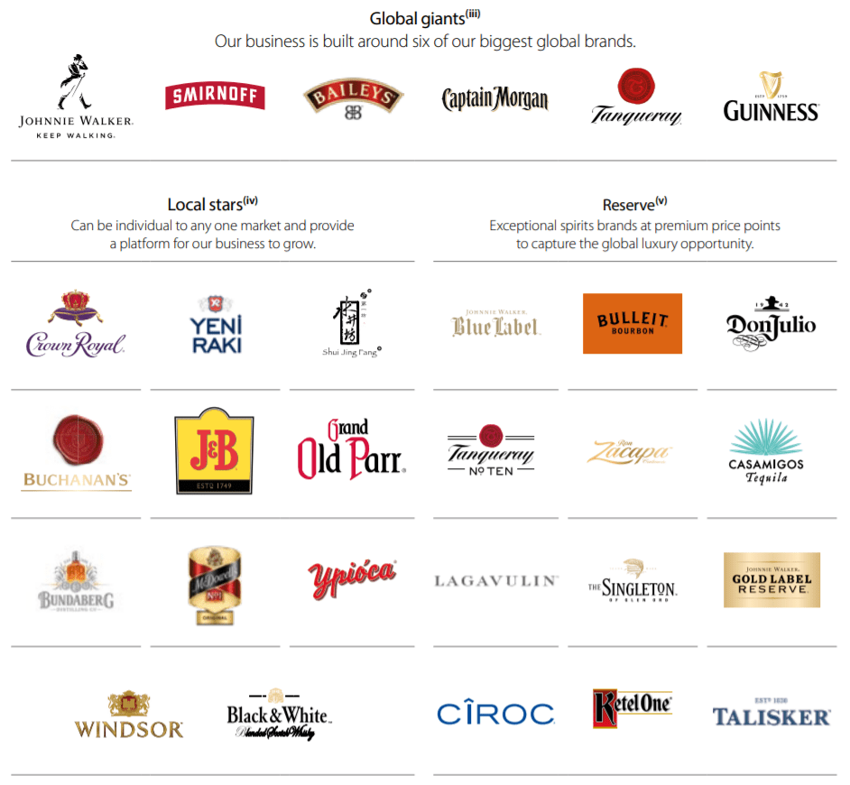
Fig 1. Some of Diageo’s top brands from its stable of more than 200 (UKValueInvestor, 2020)
This commitment goes beyond the calibre of products to include sustainability campaigns and responsible drinking, as demonstrated by the ESG Action Plan Society 2030 - The Spirit of Progress (Diageo, 2023). The company is hard at work improving supply chain skills, entrepreneurship, enabling culture and brand excellence.
Diageo's comprehensive understanding of consumer behaviour and preferences, enhanced by advanced technologies such as Catalyst, Sensor and Creative X, underpins its capacity to create and predict consumer trends. Diageo creates strategic alliances with suppliers in its wide supply chain in different geographies, using the name of its brand and the quality of the products offered. This saves money, which is then invested in brand image-building projects. An entrepreneurial attitude mixed with this culture of productivity and efficiency creates an atmosphere where new ideas are embraced, and market problems are solved quickly and nimbly.
Ultimately, Diageo's differentiating approach is underpinned by its unwavering focus on customers and trading partners, which drives sustainable growth and establishes the business as a global leader in consumer engagement and brand innovation.

2.2. Ansoff Matrix

Using Ansoff's matrix and four strategies can determine the feasible directions for the growth and development of a given company (Ansoff, 1980). From the analysis of Diageo Ltd, multiple strategies from the Ansoff matrix are visible. The company is taking these steps to maintain its strong position as a leader in the production of alcoholic beverages worldwide and to stimulate its growth further.
Market penetration
Market penetration means increasing market share in existing markets through existing products (Hussain, 2013). Diageo achieves this with an enhanced marketing strategy through advertising and promotional campaigns. According to the 2023 Annual Report (Diageo, 2023), the company invested in critical markets such as Europe and the United States and the "Join the Pact" campaign for Johnnie Walker, which aims to promote responsible alcohol consumption. In 2023, to increase the company's production capacity in Jalisco, Mexico, £160 million has been invested in constructing two distilleries, and the total budget for the development in the region is over £400 million (Diageo, 2023).
Product development
Product development involves introducing new products or variations of existing products into current markets. In this direction, Diageo is constantly updating its product portfolio. To the standard Smirnoff brand vodka option, the company added new flavoured options also and Captain Morgan rum (Diageo, 2024) to satisfy the preferences of, for example, women or younger consumers. In addition, the company also produces temporary limited bottles that differ from the standard design, which further attracts the attention of connoisseurs. Premium tequila brand Casamigos, which the company has been promoting for a while and is new to the brand, allows the company to tap into the fast-growing tequila market and target consumers looking for luxury spirits.
Market development
In Market Development, we have research into new markets and entering them with existing products (Whittington et al.,2019). Following this strategy, Diageo is currently the world leader in the sales of alcoholic beverages. For large companies, conquering new markets is a matter of necessity. A notable example is India, the vast growth market that the company targeted with localized products and tailored marketing strategies. Geographical expansion of companies requires extensive research into preferences and cultural differences but is an inevitable part of future development. Diageo is exploring emerging markets such as Africa and India. The company makes investments and already owns 21 facilities and trades in 16 countries on the African continent. In India, production is at 37 production bases (Diageo, 2024). The company's focus is to satisfy the needs of customers by emphasizing the production of mass-market spirits at affordable prices.
Diversification
Diversification involves entering new markets with new products. Diageo relies on the traditional spirits trade but should invest in new or adjacent industries through partnerships and acquisitions that would expand future consumer opportunities.

3.Resources and Capability of the company

The resources and their adequate management largely determine the company's adaptation and success in the industry dynamics. According to Teece, Pisano, and Shuen (1997), the company can arrange its policies and activities to distribute forces in building properly, integrating, and reconfiguring all resources. In addition, the assimilation and use of external information that Cohen and Levinthal (1990) share also contribute to management flexibility.

3.1. Value Chain Analysis

Porter described all activities, including the phases from the conception of a product or service through production, distribution, and its receipt by the end user, in 1985 under the name "value chain" (Dubey et al., 2020).
To establish Diageo's competitive advantages and core competencies, consider how the company carefully monitors and controls its value chain activities. They are divided into primary, which have a direct impact on value, as the firm transforms inputs into outputs, and other ancillary, which add value indirectly – Fig 2 (Medium, 2020)
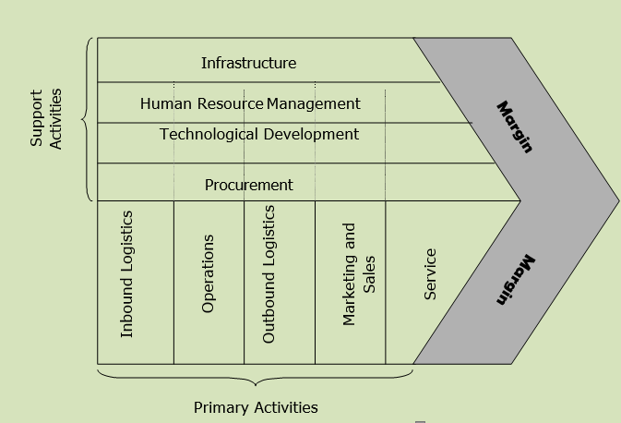
Fig 2. Porter’s Value chain 1985 (Medium, 2020)
3.1.1 Primary Activities
Inbound Logistics—To ensure the high quality of its final products, the company uses basic raw materials such as sugar, water, barley, corn, anise, and agave, which are supplied from over 100 countries (Diageo, 2022). These materials are of very good quality and sourced to sustainable and ethical standards (Diageo, 2024). Diageo maintains robust inbound logistics, ensuring the timely and efficient supply of raw materials.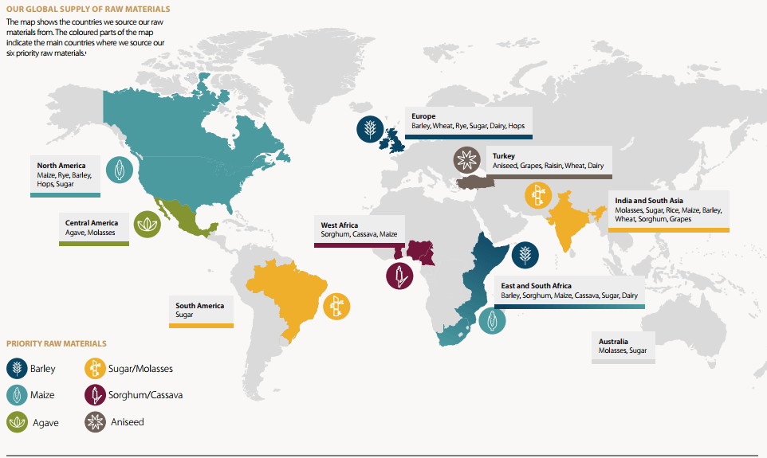
Fig 2. Source: (Diageo, 2024) Building Sustainable Supply Chains: Our Strategy for Sustainable Agriculture
Operations: As one of the leaders in producing alcoholic beverages, the company has built its production facilities on state-of-the-art technologies, enabling the production of a diverse product portfolio in the short term and on a large scale. Still, other facilities, such as those for making and ageing Scotch whiskey, adhere to strict standards of quality and tradition (Diageo, 2024). The company operates over 140 production sites, including distilleries, maturation warehouses, breweries, coopers, packaging plants, and distribution warehouses (Spirits Europe,2024). Most of Diageo's global shipping and supply chain operations are in Europe. There are manufacturing facilities in Italy, the United Kingdom and Ireland. The business owns 30 distilleries in Scotland, a distillery with maturation and packaging facilities in England, Scotland, Ireland, and Italy, and a brewery located in Dublin. Producing whisky, gin, vodka, beer, rum, liqueurs and other spirits sold in around 180 countries, the team is responsible for all European supply chain operations. (Diageo, 2024).
Outbound logistics: Diageo distinguishes itself from its competitors with an excellent distribution network worldwide. Partnerships with global distributors in 180 countries from Asia, Europe, Africa, Latin and North America, and the Caribbean ensure the wide availability of their products for many markets (Diageo, 2024). Diageo has five ways of distributing its products, all used in most countries: wholesalers and distributors, eMarketplace, modern trade, direct to consumer, and store (Diageo, 2023). In working with more than 40 carriers, the company uses a logistics platform, the Luminate Control Tower (LCT), through which it tracks all its operations in real-time, anticipates transportation challenges, and better plans its inventory levels (Diageo, 2022).
Marketing and Sales: In the UK, the products are marketed and sold through Diageo GB - for spirits and beer and through Justerini & Brooks Fine Wines for wines. Products are distributed through wholesalers to retailers and consumers. The Republic of Ireland and Northern Ireland sell directly to wholesalers and the mass market. In France, they are distributed through an agreement with Moët Hennessy. In Europe, they use their own companies and distributors, and in Turkey, the products reach the market through their subsidiary Mey İçki (Duarte, 2019).
Almost all of the company's products are recognizable worldwide. The company implements innovative promotional strategies and campaigns to increase its brand's commercial power. Partnership and sponsorship of famous events and sporting events are two strategies through which the brand gains consumer engagement and loyalty. Johnie Valker's advertisements are everywhere and emblematic of the brand. In addition, the company created a song and video with famous South Korean singer and actor SUHO, carrying the message of responsible alcohol consumption (Diageo, 2024).
Service: Diageo strongly advocates attention to customer service in its policy. They know that consumer loyalty is earned through price, quality, and, last but not least, satisfaction with the consumption or shopping process itself. For this reason, the company trains its sales representatives and bartenders to provide quality service to partners and customers (Diageo, 2024). Another strategy the company implements is Johnnie Walker My Edition, offering personal bottle customization (Duarte, 2019).
3.1.2. Support Activities
Company infrastructure: Management bodies maintain stability in the company's organizational structure in global operations worldwide. The company's decentralized organizational structure favours successful portfolio and brand growth management while allowing for flexibility and responsiveness to market conditions. The company's scale can be determined by the regions in which it operates actively and successfully, namely over 180 countries and over 30,000 employees (Duarte, 2019). In addition to a solid financial profile, Diageo is committed to corporate social responsibility and sustainability initiatives that further strengthen its reputation and the trust of its stakeholders.
Human resource management: To drive organizational performance, apart from financial incentives, the company promotes and prioritizes the development of the capabilities of its employees all over the world by organizing various initiatives and programs for innovation, flexible working, support for women working, inclusion, additional training (Diageo, 2023). According to the Diageo Careers company website, they offer presentations, people management development, and project management courses for their employees. (Diageo, 2024) Also, the company's management wants to create confidence, trust, and a sense of accessibility for the employees through their non-hierarchical structure (YouTube, 2014).
Technological development: Diageo is characterized by using cutting-edge technologies to improve production and develop new recipes through investment in research and development. Thus, the company turns to new packaging solutions—the grain-to-glass sustainability system, which reduces waste and cares for the environment (Diageo, 2024). Diageo has established an innovation team, and its innovations include the AI experience 'What's your whisky' and virtual AI concierge 'Elli', which provides guidance to consumers about the brand's products (Diageo, 2024).
Procurement: Diageo closely monitors its supply level, which ensures the reliability and quality of the raw materials required for its extensive portfolio. It also conducts preliminary analyses of problem areas to avoid unexpected situations (Fig.3).
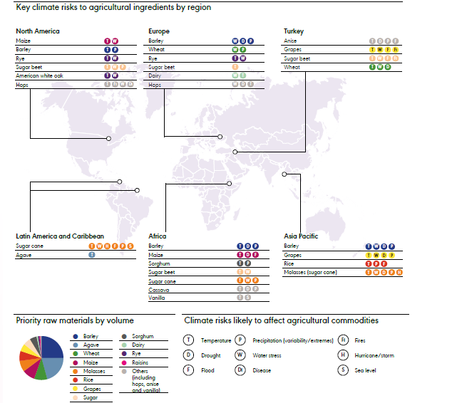
Fig 3. Key climate risk to agricultural ingredients by regions (Diageo, 2023)
To maintain good and stable relations with its suppliers from over 100 countries (Diageo, 2022), the company engages in strategic initiatives to maintain stable prices and protect against unexpected risks.

3.2. VRIO analysis

VRIO analysis clarifies an organization's strengths and weaknesses and identifies which resources or capabilities are particularly important for economic competitiveness and success (Wernerfelt, 1984).
According to Barney (1991), using the four criteria—valuable, rare, inimitable, and organized—would give the company an idea of what resources distinguish them from the competition and give them an advantage.
Recourse of Capability | Valuable | Rare | Inimitable | Organized | Impact on Competitive Advantage
Brand image and recognition | ✔️ | ✔️ | ✔️ | ✔️ | Sustainable competitive advantage
Effective distribution network | ✔️ | ❌ | ❌ | ✔️ | Competitive parity
leadership and innovative ability | ✔️ | ❌ | ❌ | ✔️ | Competitive parity
Relationship with suppliers | ✔️ | ❌ | ❌ | ✔️ | Competitive parity
Innovation | ✔️ | ❌ | ❌ | ✔️ | Competitive parity
Ability to raise capital | ✔️ | ❌ | ❌ | ✔️ | Competitive parity
International presence | ✔️ | ✔️ | ❌ | ✔️ | Temporary competitive advantage
Adaptability | ✔️ | ✔️ | ❌ | ✔️ | Temporary competitive advantage
Quality product offering | ✔️ | ❌ | ✔️ | ✔️ | Competitive parity
Marketing communications | ✔️ | ❌ | ❌ | ✔️ | Competitive parity
Trade patents | ✔️ | ✔️ | ✔️ | ✔️ | Sustainable competitive advantage
Customer experience | ✔️ | ❌ | ❌ | ✔️ | Competitive parity
Financial strength | ✔️ | ❌ | ❌ | ✔️ | Competitive parity
Technological integration and advancement | ✔️ | ❌ | ❌ | ✔️ | Competitive parity
Trademarks | ✔️ | ✔️ | ✔️ | ✔️ | Sustainable competitive advantage
Investment in research and development | ✔️ | ❌ | ❌ | ✔️ | Competitive parity
Production capacity | ✔️ | ❌ | ❌ | ✔️ | Competitive parity
Organizational culture | ✔️ | ✔️ | ❌ | ✔️ | Temporary competitive advantage

According to the analysis, it is clear that brand image and recognition, trademarks, secrets, and patents are the most vital points of the company and fall into the category of sustainable competitive advantages. The brand has been created for a long time. It symbolizes a stable and sustainable policy that includes a strategy for responsible drinking and protecting natural resources. The company's Trademarks are above 200, such as Johnnie Walker, Smirnoff, Captain Morgan, Bailey's and Guinness, which are recognizable, unique and protected by patents. The company has 1156 patents globally, and more than 34% of patents are active (Insights by Grayb,2023)- Fig 4.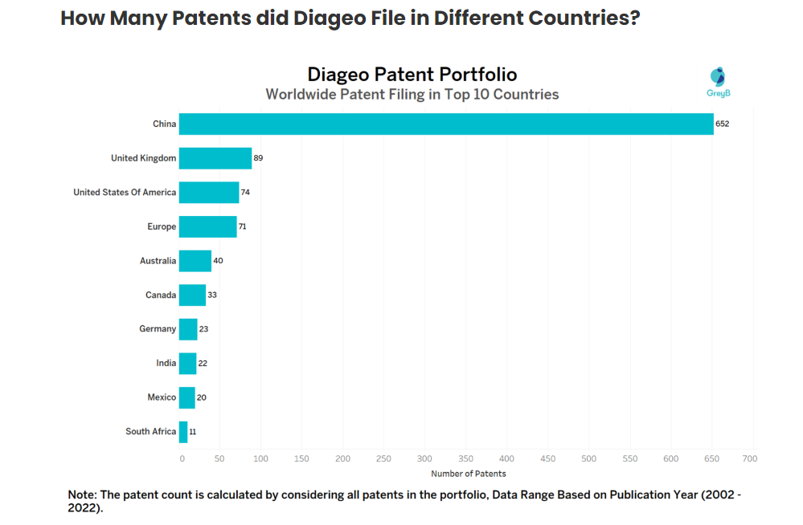
Fig 4. (Insights by Grayb, 2023)
The group of Temporary competitive advantages, which means the company has valuable and rare resources but is easy to imitate (Lynch, 2018), includes Adaptability due to the company's ability to respond to constantly changing customer preferences. This makes Diageo competitive through innovation, Unique Organizational culture, market knowledge and flexible management. At the same time, international presence also falls here due to over 180 countries from Asia, Europe, Africa, Latin and North America, and the Caribbean (Diageo, 2024). All the advantages listed are well-developed, but the company has additional potential to perfect them.
The remaining strengths listed above under Competitive parity, such as the quality of the products, are also advantages that the company holds and can rely on, strictly following the production processes and unique traditions. Leadership and innovative ability, relationship with suppliers, customer experience, investment in research and development, and production capacity should not be underestimated; they should be systematically monitored and improved to avoid potential risks of competitive interference and dominance.

4. Diageo – Strategy in Action

Diageo's core objectives of driving growth, fostering innovation and increasing shareholder value are based on its strategy, structure and systems. The company's decentralized organizational structure strongly emphasizes portfolio management and brand growth, allowing flexibility and responsiveness to market conditions. Diageo's corporate strategy includes supporting sustainable practices and responsible drinking. In addition, the company's investment in data-driven decision-making and digital skills improves efficiency and enables the implementation of marketing strategies that increase customer engagement and brand loyalty. Diageo's well-coordinated approach to strategy, structure and processes emphasizes the ability to adapt and thrive in a rapidly changing market environment.
SAF Framework:
Suitability: Diageo's initiatives appear appropriate in light of the company's
industry positioning, market dynamics and long-term growth prospects. Diageo's competitive advantage, market presence, and the company's emphasis on premiumization and innovation are in line with consumer trends and sector growth prospects. Diageo's focus on these two areas is in line with both consumer tastes for premium drinks and long-term sector developments. The company responded strategically by expanding into the ready-to-drink market and introducing limited editions. Diageo recorded robust growth in several key categories in FY23, illustrating its premiumization approach's effectiveness. For example, net sales of tequila increased by 19% and scotch by 12%. (Diageo Annual Report, 2023).
Also, Diageo has proactively expanded its portfolio by acquiring brands such as Balcones Distilling and Don Papa Rum to capitalize on new market trends and consumer preferences. In addition, the sale of non-core assets such as Archers and Guinness Cameroun S.A. demonstrates a systematic commitment to resource allocation and portfolio optimization. For example, the company's growth in the U.S. whiskey and rum categories were aided by the acquisition of Balcones Distilling and Don Papa Rum respectively, while Diageo was able to focus on more efficient models to support brand growth in Cameroon through the sale of Guinness Cameroun S.A.(Diageo Annual Report, 2023).
Acceptability: A wide range of stakeholders, including shareholders, employees and customers, find Diageo's plans acceptable. According to the company's 2023 annual report, a critical commitment drives growth and generates shareholder value, fending off headwinds such as inflationary pressures, geopolitical concerns and continued post-COVID-19 uncertainty. The company's commitment to sustainability, employee involvement and responsible drinking reflect its corporate social
responsibility and broader societal impact. The approval of both internal and
external stakeholders are demonstrated by a high level of staff engagement and a
positive brand attitude.
Feasibility: Given Diageo's assets, skills and operational efficiency, its plans appear feasible. The company's strong financial results, diverse portfolio and global presence, offer a solid platform to execute strategic plans and effectively address market obstacles. A commitment to long-term growth and value generation is evident through continued investment in technology, supply chain optimization and sustainability efforts. Diageo's fiscal 2023 results, which include growing organic net sales, higher earnings per share and a progressive dividend policy, demonstrate the effectiveness of the company's business and corporate initiatives. Despite short-term market swings, the company's emphasis on long-term shareholder wealth generation, careful capital allocation, and brand awareness investments has helped preserve shareholder returns. For example, Diageo increased its final dividend by 5% to recognize its sustained good performance and achieved organic net sales growth of 6.5%, with strong price/mix performance offsetting a slight decline in volume (Diageo Annual Report 2023).

5. Sustainability efforts evaluation

By implementing these specific programs and monitoring their progress, Diageo demonstrates a determined effort to mitigate climate risks, promote sustainability and effectively engage with local people.
Diageo's investments in solar and biomass energy, particularly in Africa, demonstrate the company's commitment to renewable energy initiatives across its business. To meet their target of net zero carbon emissions from operations by 2030, they plan to make a major spend of approximately £1 billion to promote environmental sustainability. By eliminating 141 million cardboard gift boxes and cutting them from the portfolio of premium scotch in the 23rd year, Diageo was able to save almost 5,520 tonnes of carbon emissions.
Restoring water in places where water is scarce is part of Diageo's 'Conserve Water for Life' policy. They completed water efficiency initiatives in FY23, including establishing or increasing the capacity of water recovery plants in Nigeria, Kenya and Uganda. With 22% of water use replaced in water-scarce areas, their initiatives have improved water efficiency by 51.1% since 2007.
Community involvement and partnership: Diageo works on water replenishment projects in close collaboration with regional authorities, NGOs and communities. They completed 35 replenishment projects in 11 different nations in FY23, adding to an annual volumetric water recharge capacity of 1,311,010 m3. These initiatives, which include programs to improve irrigation and provide small farming communities with access to water, demonstrate their commitment to sustainable development and community participation.
The company's concern is also for the customers. Through DRINKiQ's programs in Hungary and Internet campaigns in South Korea, they have had a significant impact such as 2.4 million page views in Korea in one month, proving the effectiveness of their efforts to educate customers around the world about safe drinking practices.
A modified online road safety program SMASHED in 2023 reached about 2 million people worldwide, resulting in 1,548,996 people reporting that their views against underage drinking had changed, demonstrating how well the program is working to address this important issue. Also, thanks to the collaboration with UNITAR and programs like Wrong Side of the Road, Diageo's efforts to stop drunk driving reached 230,000 people in India and a total of 706,000 people in FY23.
To promote diversity, Diageo has been able to expand its spending with minority-owned and disadvantaged companies because it has partnered with groups such as Disability: IN and WEConnect International. They invested £620m with 979 cross-owned and disabled providers in FY23.
For people from minority groups or on lower incomes, initiatives such as Learning for Life and the Diageo Bar Academy help progress, with 88% of respondents believing this. These initiatives help advance women in business and promote diversity and inclusion.

According to an article in the Guardian, the era of terms like 'green', 'carbon neutral', and other such imprecise terms are disappearing, and companies with large environmental footprints should be more heavily scrutinized by regulators in London and Brussels (The Guardian, 2023). The cases of discrepancies in the published information and the actual results of the environmental campaign of the respective company are becoming more frequent. Diageo's name was also involved in misleading consumers in 2008 when the Guardian mentioned a discrepancy in the information from the annual report, where a 60% reduction in harmful emissions was promised from the company, while 33.3% was achieved. Wastewater of 50% was only 45.3% completed (The Guardian, 2015).

6. Conclusion

In conclusion, Porter's Generic Strategy, the Ansoff Matrix, the VRIO framework, and value chain analysis are just a few of the analytical tools that Diageo strategically use to achieve success. The business ascertains its market positioning, resource optimisation, operational efficiency, and expansion strategies through its study. Furthermore, Diageo strongly emphasises the accountability of its business processes, as seen by its Sustainability Assessment Framework (SAF), which reflects its commitment to sustainability. By combining these strategies, Diageo guarantees innovation, long-term growth, and a favourable effect on all parties involved in the dynamic beverage market.

7.References

Ansoff, H.I. (1980) ‘Strategic issues management’, Strategic management journal, 1 (2), pp.131-148.
Barney, J. (1991) ‘Firm resources and sustained competitive advantage’, Journal of Management, 17(1), pp.99-120.
Cohen, W. M., and Levinthal, D. A. (1990) ‘Absorptive Capacity: A New Perspective on Learning and Innovation’. Administrative Science Quarterly, 35(1), pp. 128–152.
Diageo (2014) Celebrating our culture | Diageo Careers.
Available at: https://www.youtube.com/watch?v=BwRUxHiXkRE
(Accessed: 08 April 2014).
Diageo (2022) Partnering with suppliers.
Available at: https://media.diageocms.com/diageo-corporate-media/media/balpqe4e/partnering-with-suppliers-2022.pdf
(Accessed: 08 April 2024).
Diageo (2023) Annual Report.
Available at: https://www.diageo.com/en/investors/annual-report
(Accessed: 01 April 2024).
Diageo (2023) Empowering and Inspiring: A Journey Through Diverse Careers in Diageo Eastern Europe.
Available at: https://www.diageo.com/en/careers/life-at-diageo/2023/empowering-and-inspiring-a-journey-through-diverse-careers-in-diageo-eastern-europe
(Accessed: 31 March 2024).
Diageo (2024) Diagio - Our Business.
Available at: https://www.diageo.com/en/our-business
(Accessed: 01 April 2024).
Diageo (2023) Our global reach.
Available at: https://media.diageo.com/diageo-corporate-media/media/p1bljst1/diageo-annual-report-2023.pdf
(Accessed: 11 April 2024).
Diageo (2024) BUILDING SUSTAINABLE SUPPLY CHAINS.
Available at: https://horizonlives3.diageohorizon.com/PR1346/aws/media/1379/diageo_sustainable_agriculture_strategy_july2016.pdf
(Accessed: 08 April 2024).
Diageo (2024) Meet the people who make the magic.
Available at: https://www.diageo.com/en/careers/life-at-diageo
[Accessed 31 03 2024].
Diageo (2024) Positive drinking Savour Every moment.
Available at: https://www.diageo.com/en/news-and-media/stories/2024/diageo-partners-with-global-k-pop-star-suho-to-promote-responsible-drinking-across-asia-pacific
(Accessed: 09 April 2024).
Diageo (2024) Responsible sourcing.
Available at: https://www.diageo.com/en/esg/sustainability/responsible-sourcing
(Accessed: 31 March 2024).
Diageo (2024) Scotch whisky.
Available at: https://www.diageo.com/en/our-brands/scotch-whisky
(Accessed: 31 March 2024).
Diageo (2024) Supply operations.
Available at: https://www.diageo.com/en/our-business/where-we-operate/europe
(Accessed: 08 April 2024).
Diageo (2024) Water in our supply chain.
Available at: https://www.diageo.com/en/esg/sustainability/water-stewardship
(Accessed: 31 March 2024).
Diageo (2024) Where we operate.
Available at: https://www.diageo.com/en/our-business/where-we-operate
(Accessed: 31 March 2024).
Duarte, A.M.B. (2019). Equity Research: Diageo Plc. Doctoral dissertation. Universidad de Lisboa (Portugal)).
Available at: https://www.proquest.com/openview/f8beef3689270e961766c9b680988562/1?pq-origsite=gscholar&cbl=2026366&diss=y
(Accessed: 10 April 2024).
Dubey, S. et al. (2020) ‘A brief study of value chain and supply chain’, Agriculture Development and Economic Transformation in Global Scenario, pp.177-183.
Hussain, S.et al. (2013) ‘ANSOFF matrix, environment, and growth-an interactive triangle’. Management and Administrative Sciences Review, 2(2), pp.196-206.
Insights by Grayb (2023) Diageo Patents – Key Insights and Stats.
Available at: https://insights.greyb.com/diageo-patents/
(Accessed: 14 April 2024).
Lynch, R. (2018) Strategic Management. 8th edn. Harlow: Pearson Education
Medium (2020) How to perform a Value Chain Analysis (explained with example)?.
Available at: https://medium.com/dataseries/value-chain-7d02cbf22c4f
(Accessed: 31 March 2024).
Porter, M. E. (1980) Competitive Strategy: Techniques for Analysing Industries and Competitors. Free Press.
Porter, M. E. (1996) ‘What is Strategy?’. Harvard Business Review, 74(6), pp.61-78.
Porter, M. (1987) ‘From Competitive Advantage to Corporate Strategy’. Harvard Business Review, Macmillan Education UK, pp.43-59.
Spirits Europe (2024) A Spirit of Tradition.
Available at: https://spirits.eu/spirits/a-spirit-of-tradition/distillation-process
(Accessed: 09 April 2024).
Statista (2024) Number of employees of the company Diageo from 2017 to 2022.
Available at: https://www.statista.com/statistics/1429132/number-of-employees-diageo/
(Accessed: 01 April 2024).
Statista (2023) Operating profit of Diageo worldwide from 2013 to 2023 (in million GBP)*.
Available at: https://www.statista.com/statistics/398449/operating-profit-of-diageo-worldwide/
(Accessed: 01 April 2024).
Teece, D. J., Pisano, G., and Shuen, A. (1997) ‘Dynamic Capabilities and Strategic Management’, Strategic Management Journal, 18(7), pp.509–533.
The Guardian (2015) Sobering results for drinks giant Diageo reveal problems of sustainability targets.
Available at: https://www.theguardian.com/sustainable-business/2015/sep/03/diageo-results-drinks-multinational-sustainability-targets-corporate-commitments
(Accessed: 15 April 2024).
The Guardian (2023) Greenwashing era is over, say ad agencies, as regulators get tough.
Available at: https://www.theguardian.com/environment/2023/may/15/greenwashing-era-is-over-say-ad-agencies-as-regulators-get-tough
(Accessed: 15 April 2024).
UKValueInvestor (2020) Is Diageo’s share price too high?.
Available at: https://ukvalueinvestor.com/2020/02/diageo-share-price.html/
(Accessed: 14 April 2024).
Wernerfelt, B. (1984) ‘A resource‐based view of the firm’, Strategic Management Journal, 5(2), pp.171-180.
Whittington, R.et al. (2019) Exploring Strategy: Text and Cases. 12th edn. Harlow: Pearson.

