
Human Resource Management
LCMB700_HRM_A2

2021
Matthew Kelleher - 1710425
DR Gladius

Table of Contents
1.0 Introduction 3
2.0 Retention 3
2.1 Reason for employees leaving the company 3
2.2 HRM practices to improve retention 3
Training and development and Retention 4
Compensation and Retention 4
2.3 Theory 4
Social Exchange Theory 4
Maslow Hierarchy of Needs Theory 4
2.4 Recommended strategies for the company 5
Recognise and acknowledge with benefits 5
Provide monetary securities 5
Increase work socialisation and team spirit 6
Promote a healthy workforce 6
3.0 Reward Management 6
3.1 Components of rewards 6
Compensation 6
Benefits 6
3.2 Process of rewards 6
3.3 Type of rewards 7
Extrinsic Rewards 7
Intrinsic Rewards 7
3.4 Theory relating to reward management 7
Agency Theory 7
Expectancy Theory 7
4.0 Learning and development 8
4.1 Components of learning and development 8
E-Learning 9
Workplace Learning 9
4.2 Theories relating to Learning and Development 9
Kolb learning cycle 10
4.3 Recommended strategies for learning and development 10
Managerial interaction with Learning 10
Align Compensation Packages to learning and development 10
Receiving feedback 11
5.0 Conclusion 11
References 12

Introduction
Employees are the foundation of all organisations without employees’ organisations would be non-existent (Mehra, 2018). Therefore, organisations should not take Human Resources (HR) for granted. Several key functions relating to Human Resource Management (HRM) which include training HR, recruiting HR, motivating HR, performance appraisals, workplace safety, and more (Armstrong and Taylor, 2020). Humans have individual experiences, knowledge, skills, and personal qualities which are needed by the organisation. HR are the individuals, practices and policies that have influence on the human in the workplace. HRM is the management of humans and employee policies/practices which enable work to be conducted in the organisation. HR are affected by these elements from initial contact with the organisation from the job advertisement till departure from the organisation (Mehra, 2018). The importance of HRM is enable staff to excel personal qualities to fulfil position while contributing to missions and purpose of the organisation. Therefore, HRM need to retain while attracting new HR, if individuals acknowledge the organisation values HR more applicants will apply for roles and stay once recruited (Pak et al, 2019). Thus, emphasised by Taamneh et al (2018), who states HR are organisations most precious assets who are skilled and competent with retention of upmost importance for organisational success.

2.0 Retention
According to Mangal et al (2021), to retain employees and lower retention, money, time and many more resources need to be used. Employees leaving the company causes the companies procedure of recruiting and retaining talent to restart. This comes as an expense to the company not only in the loss of monetary but time, talent, and knowledge. Employee retention is considered when an employee remains at the company through the decision of their own and do not seek work elsewhere or with competitors. According to Winoto et al (2021), employee retention can be defined as a technique which managers use to retain employees for a long-term period. Companies have employees which all have different behaviours, employees are valuable assets for all companies. The key for all organisations is have employees retained for a long-term period due to the investment of time and money committed to the employee and recruitment process. Loss of talented employees mean new recruitment strategies will need to be developed alongside training schedules and schemes.

2.1 Reason for employees leaving the company
According to Savenah and Kamara (2019), the loss of talent can cause in excess of 300% of employee original pay to be replaced. Employee job dissatisfaction is one of many reasons’ employees leave the organisation. Employees become of demand when obtaining and possessing skills which are acquired. This can tempt employees to be poached by competitors or companies due to increased benefits, pay and potential opportunities which are offered. Thus, highlights the importance of identifying and understanding what the needs of employee are and if they are satisfied within the current situation and scenario. There are various influences which determine individuals to depart from the company which include managerial factors, fringe benefits, pay, clear job expectations, work environment and more.

2.2 HRM practices to improve retention
According to Azeez (2017), there are many HRM practices that can be used to improve job satisfaction through certain activities such as efficient leadership, rewards, pay, compensation, recognition, career development, training, and development and more. Improving employee job satisfaction through satisfying employee needs can improve employee motivation, performance, and commitment. Thus, can improve the company in key aspects such as increased retention of talent and knowledge, decreased turnover rates and less company costs.

Training and development and Retention
Training and Development is seen as the planning activities the company design to improve the performance of employees. Training develops and increases employee performance while committing employees to achieve company goals which have results such as decreased turnover, increased employee retention, performance, morale, satisfaction, and motivation (Malik et al, 2020).

Compensation and Retention
Compensation is a key activity that HRM can implement to retain talent (Bibi et al, 2018). Pay can be one issue of why talent leave the company. Compensation increases retention and decreases absenteeism. Employee opportunities are increasing due to compensations that offered by companies and the internationalisation of new markets.

2.3 Theory

Social Exchange Theory
According to Almaaith et al (2017), Social Exchange Theory (SET) insinuates individual’s connectivity is influenced through counteractions which are cost-benefits, which consists of three key aspects psychological, economic, and social. SET is the procedure between two parties when negotiating exchanges with both parties taking the responsibility for one another. Mangal et al (2021), identifies SET as social interactions between two parties which develops a psychological contract, which is built on trust. In the aspect of employee and employer, the employer should monitor and maintain the needs of the employee. Employers can cater for employees needs through HRM activities such as orientation and training, efficient leadership and career development/opportunities alongside alternative benefits such as work-life balance, job embeddedness, flexible working and more.

Maslow Hierarchy of Needs Theory

According to Dwivedi and Badge (2021), Maslow Hierarchy of Needs Theory (MHNT) is widely recognised and used by many companies as the model concentrates on the motivation of employees through the satisfaction of employee needs. The theory builds on the psychological and clinical experiences of the employee needs. There are five levels of needs which consist of physical, safety, social, esteem/achievement and self-actualisation.
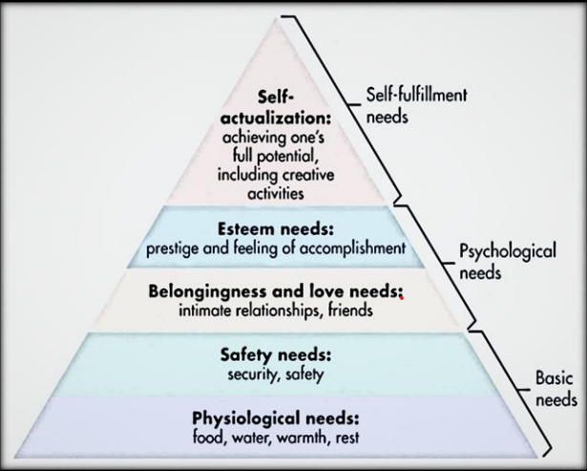
Maslow Hierarchy of Needs (Dwivedi and Badge, 2021).

Patricia and Asoba (2021), describe the five stages of MHNT as Physical needs consist of shelter, air, drink, and sleep. Safety needs consist of medical care, security, guaranteed job, and physical protection. Social needs consist of work, family, and friendship relations. Esteem/Achievement consists of recognition from employers and peers. Self-actualisation consists of employee’s personal growth and fulfilment.

2.4 Recommended strategies for the company
The recommended strategies are based on the above research gathered. The rationale behind this is employers should develop employees into fulfilling self-actualisation. This will increase employee motivation, job satisfaction and performance which can decrease companies’ turnover and increase retention of talent. The strategies are as mentioned below.

Recognise and acknowledge with benefits
Managers should recognise the accomplishment and achievement of employees as when mangers recognise employee progress, achievement and performance and offer praise and recognition, employees esteem needs can be fulfilled. The company can introduce rewards to employees to acknowledge their personal and work achievements. This can be done through introducing new reward systems such as targets that need to be attained to meet a level of reward. Other rewards and bonuses could be extra holidays, dinner with the CEO at interventions, hampers, and promotions to employees who perform with sufficient performances.

Provide monetary securities
Financial security for employees of most importance if an employee is feeling insecure, morale and performance will be low. The company should implement a profit-sharing strategy where employees are rewarded on enhancement of the company growth and increased performance and productivity. This will motivate and employees and increase job satisfaction. Other strategies can also be implemented such as offering employees stock of the company and retirement funding plans.

Increase work socialisation and team spirit
Socialisation is a key aspect to encourage and motivate employees, teams that work cohesive with high morale and spirit increase the performance of employees. The company can introduce upgraded hubs for employees to be able to relax and interact with peers. Hubs and staff rooms should have activities for employees to engage with one another such as snooker table, kettle for drinks, comfortable seating, and space to interact. Introducing an app for employees and managers to stay communicated with fun activities such as quiz nights, games nights, learning, chat rooms and feedback links. This will increase team morale and make employees bond like a family and increase attractiveness of the organisation.

Promote a healthy workforce
Employees mental and physical health is a key issue for employers as it impacts employee performance. The company should introduce counselling for employees who become stressed and burnt out, the organisation should look after staff well-bring. Also, dental, and medical healthcare programmes should be provided for employees as this will increase employee loyalty, morale, satisfaction, performance and more.

3.0 Reward Management
Reward Management (RM) consists of strategies and practices which reward and recognise the employee for contributions toward the organisational goals. Rewards potentially contributes towards employee retention, motivation organisational culture and structure which influences the organisations effectiveness (Shafagatova and Looy, 2020). Total rewards include all “financial, intrinsic, extrinsic and social benefits” employee can receive from their employer (Chinyio et al, 2018). The total reward approach plays a key role in ensuring willingness and organisational commitment remains amongst the employer (Alhmoud and Rjoub, 2019).

3.1 Components of rewards
According to Okoli et al (2020), the components of reword consists of three key aspects compensation (short and long-term incentives, base pay, etc), benefits (work-life balance, healthcare, etc) and career development (progression in the company, training, and development, etc).

Compensation
Compensation is considered as a “systematic approach” that delivers financial value to employee for their service in exchange. Compensation serves several HRM purposes such as recruitment, increasing job satisfaction and enhanced job performance (Badre et al, 2021).

Benefits
Benefits are seen as the non-financial incentives that employees receive from the company such as staff discount, healthcare, paid leave, employee wellness, retirement funds alongside other planned reductions over time periods (Bussin et al, 2019).

3.2 Process of rewards
Reward Management can be seen as the procedure for development and implementing policies, strategies and systems which support the success of the organisation regarding the objectives by maintaining and attracting individuals that are needed to increase commitment and motivation (Agbaeze et al, 2017).

3.3 Type of rewards
Generally, rewards are classified in to two selective categories extrinsic and intrinsic rewards. Tangible rewards are seen as tangible rewards which are physically given to the employee while intrinsic are tangible rewards (Okoli et al, 2020).

Extrinsic Rewards
Extrinsic Reward (ER) is regarded as a tangible reward which include allowances, pay, job security, bonuses, promotion, own office, and payments indirectly such as compensation and days off (Hussain and Batagoda, 2017). ER can be implanted to the organisation as it highlights the regards that employee is held through paying them for quality of their individual quality (Hariyanto and Haverina, 2021). According to Husain and Batagoda (2017), employee commitment increases if employee receive incentives such as additional pay and rewards for work accomplished.

Intrinsic Rewards
Intrinsic Reward (IR) relates to the task content which consists of elements such as task interests, challenges and variety which provides opportunities for employee to use their self-direction, innovation, creativity, ability, and skills. Feelings such as self-worth, accomplishments and self-esteem can develop through IR. Organisations today, compete based on employee growth and reward systems. Financial rewards are not the only way employees are committed and incentives should have influence and motivation to ensure employees value tasks performed (Khalid and Aftab, 2017).

3.4 Theory relating to reward management

Agency Theory
Agency theory insinuates employees will only produce the level of work which is equivalent to the pay received. Armstrong (2019) states that companies should implement compensation packages that will influence and change employee behaviour. According to Bussin and Thabethe (2018), Agency theory focuses attention on the company goals and interests of stakeholders alongside how remuneration can align with these goals and interests. Employer plays the role of principals and the employee adapts the role of agent. The compensation paid to employee is seen as the agency cost. The theory suggests that the employer should align rewards to the interest of employees and employer interests.

Expectancy Theory
According to Vrooms Expectancy Theory, individuals have available choices and make decisions regarding what is perceived as the best option to increase the individual outcome. There are three premises which Vroom Expectancy consists of which are “Expectancy, instrumentality and valance (Llyod and Mertens, 2018).
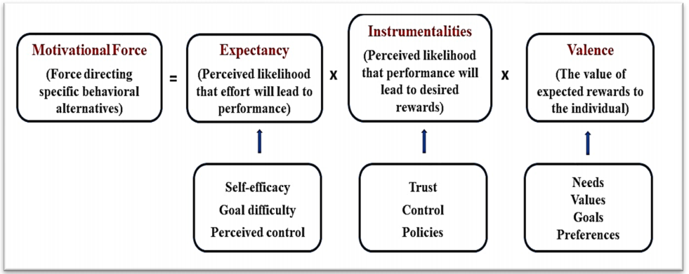
Motivation and Expectancy Model (Trang and Phuoc, 2021).

The three premises of Vroom Expectancy model will be described below by Trang and Phuoc (2021).
Expectancy relates to the individual believes that increased effect can result in better performance. Having the KSA, and support, individuals become more confident and engage within the workplace. Individuals are more likely to engage if tasks are attainable and are influence if attaining the ability.
Instrumentalities relates to the believe that if expectations are performed, rewards will be issued. Rewards are seen in a variety of form which include promotion, praise, increased pay, etc. developing and implementing reward policies provide employees what is expected and acceptable behaviour to receive rewards. Poor leadership and transparency can weaken instrumentalities.
Valence indicates if the employee values the received reward based on value, goals, needs and own preferences. A pay increase does not please all employees due to all individuals having different views and perspective. Therefore, the same reward is not as effective to all employees so various rewards should be offered.

4.0 Learning and development
According to CIPD (2021), Learning and Development (L&D) is a strategy that is used by organisations to develop workforce skills competencies and capabilities which are needed to ensure the organisation is successful and sustainable while implementing methods of developing capabilities and promote an effective organisation. The aim of L&D is to change or improve individual’s behaviour through sharing insights and knowledge which enable the individual to enhance performance or create new attitudes to enhance performances (Darling-Hammond et al, 2019).

4.1 Components of learning and development
According to Armstrong (2020) claims there are basic components of learning and development which are learning, development, training, and education. Learning is the process which an individual acquires, attains, and develops a new set of knowledge, behaviours, skills, and attitudes. Learning involves behaviours of the individual being modified through experience and learning inside/outside of the company (Hartikainen et al, 2019). Development is realisation and growth of an individual’s potential and abilities through the experiences of education and learning. According to () training is the systematic approach and formal process to assist individuals acquiring skills and knowledge which are necessary for the individual to perform tasks. Education can be seen as development of values, knowledge and understanding which is required as it relates to all aspects in life and not only areas such as skills and knowledge topics and activities.
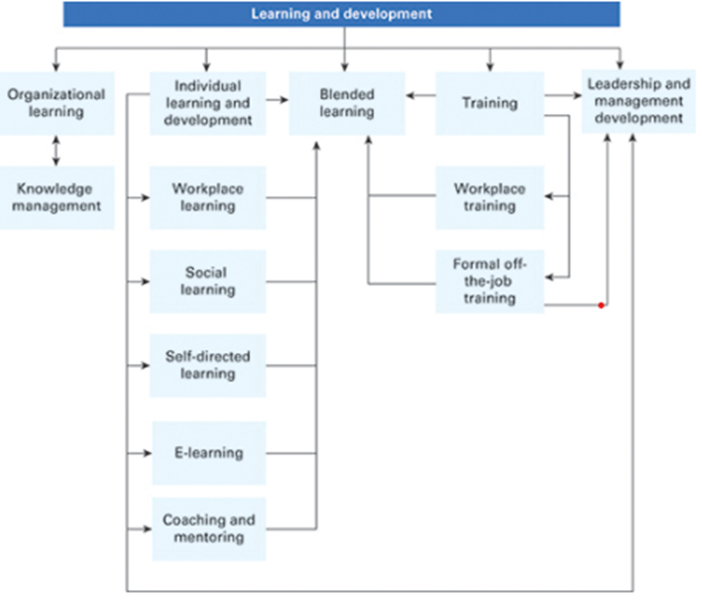
Learning and Development Components (Armstrong, 2020).

According to Armstrong (2020), Learning and Development consists of broader components such as “organisational learning, individual learning and development, blended learning, training and management development. Individual L&D includes elements such as blended learning, workplace learning, social learning, and E-learning. Training includes blended learning, off the job formal training and workplace training.

E-Learning
According to Marzo (2018), E- Learning is related to online learning which is flexible. Students choose the pace and are responsible for the learning. E-learning relates to E-appraisal which supports and motivates self-learning and informs student on progress receiving self-evaluation.

Workplace Learning
Workplace learning is programme which provides work experience and gives the student the opportunity to receive experience in the workplace in such activities as job shadowing, internships, and apprenticeships (Kim et al, 2018). According to Sims (2020), a key aspect about workplace training is that employers nurture employees to get an understanding of the workplace as well as job direction, career, and direction.

4.2 Theories relating to Learning and Development
According to Lim et al (2020), social cognitive theory (SCT) insinuates that the behaviour of human derives from interplay of the individual (outcome expectations, self-efficacy, and values), environmental (feedback or other individuals’ behaviour) and behavioural (past behaviours) factors. This is known as “triadic reciprocal causation” (Bandura, 1997). SCT imposes human behaviours is driven through the individuals own cognised aims and goals which regulate through the exercise of having control relating to internal cognitions/actions alongside the influences of external sources.

Kolb learning cycle
According to Bajaj and Sharma (2018), Kolb Learning cycle indicates four distinct and different styles of learning. The four stages of Kolb’s cycle consist of concrete experience, reflective observation, abstract observation, and active experimentation.
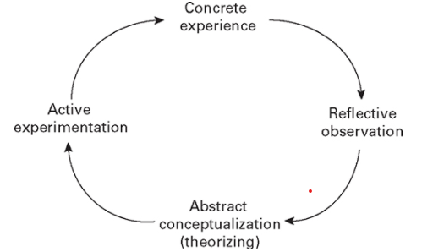
Kolb Learning cycle (Bajaj and Sharma, 2018)
Concrete experience can be accidental or planned. reflective observation includes thinking actively about previous experience and what the significance was. Abstract conceptualisation generates from individual experience when developing a variety of ideas and concepts which can be installed if situations similar occur or encountered. Active experience tests ideas and concepts within situations which are new (Fromm et al, 2021).

4.3 Recommended strategies for learning and development
Three recommended strategies on how to improve the learning and development for the future are explained below.

Managerial interaction with Learning
Managers and leaders should be included within the appraisal to ensure that knowledge and learning content is being delivered efficiently. An appraisal should be implemented alongside training to assess employee development regarding knowledge, skills and abilities obtained during the learning process. The process should be monitored and recorded to gather information on suitability regarding the quality of content and delivery of knowledge process.

Align Compensation Packages to learning and development
Aligning compensation packages to employee learning and development will promote learning and development programmes within the workplace. Employees are key aspects and attain talent through learning. Losing talent resolves in cost experience, extra jobs, and gaps in the workforce. Offering discount vouchers for equipment alongside career progression enhances performance, motivation, and well-being of employees.

Receiving feedback
Surveys can be issued amongst employees to gain feedback on learning methods. This allows new ideas to be innovated by employees and negative situations and activities to be improved. This allows employees to feel a sense of belonging in the company and will be motivated and increase performances. Surveys will be sent out through the company app, emails and be available to download and fill out online, to the employees who have participated in learning and development within the last year.

5.0 Conclusion
Retention is a problem to all organisations as a lost employee is a loss of talent, time, and cost. Employee departure can cost in access off 300% of employee original pay to replace. Through companies offering benefits and opportunities to develop within the organisation from the recruitment stage till departure to employees the organisation becomes more attractive to work, while employees become more motivated and satisfied. Thus, the organisation fulfils the needs of future and present employees. Implementing new strategies and being innovative with benefits decreasing turnover, improving retention while enhancing the organisations effectiveness.

References
Agbaeze, E. K. Agu, A. O. Onuocha, C. E. Etim, I. O. (2017) ‘Effects of reward management of Employee performance at selected oils and Gas industries. Evidence from South-South Nigeria, International Journal of Management, IT and Engineering, 7 (5), pp. 18-33.
Alhmoud, A. Rjoub, H. (2019) ‘Total rewards and employee retention in a Middle Eastern context’, Sage Journals, 9 (2), pp. 1-13.
Almaaith, M. F. Harada, Y. Sakdan, M. F. Almaaith, A. M. (2017) ‘Integrating Herzberg and social exchange theories to underpinned human resource practices, leadership style and employee retention in health sector’, World Journal of Business and Management,3 (1), pp. 16-34.
Armstrong, M (2019) Handbook of Reward Management Practice. 6th Ed, London: Kogan Page.
Armstrong, M. (2020) Armstrong’s Handbook of Human Resource Management Practice. 15th Ed, London: Kogan Page.
Azeez, S. A. (2017) ‘Human Resource Management practices and Employee Retention: A review of literature’, Journal of Economics, Management and Trade, 18 (2), pp. 1-10.
Badre, P. Taori, D. Gutane, M. (2021) ‘HRM practices and its impact on employee satisfaction’, Turkish Journal of Computer and Mathematics Education, 12 (10), pp. 1403-1414.
Bajaj, R. Sharma, V. (2018) ‘Smart education with artificial intelligence-based determination of learning styles’, Procedia Computer Science, 132, pp. 834-842.
Bandura, A. (1998) ‘Health promotion from the perspective of social cognitive theory’, Psychology and Health, 13, pp. 623–649
Bibi, P. Ahmad, A. Majid, A. H. A. (2018) ‘HRM practices and employee retention: The moderating effect of work environment’, Tourism and Hospitality Research, pp. 129-152.
Bussin, M. H. R. Thabethe, N. N. (2018) ‘Reward preferences in South Africa’s media industry’, SA Journal of Human Resource Management, 16, pp. 1-12.
Chinyio, E. Suresha, S. Salisu, J. B. (2018) ‘The impacts of monetary rewards on public sector employees in construction: A case of Jigawa state in Nigeria’, Journal of Engineering, Design and Technology, 16, pp. 125-142.
CIPD (2021) Learning and Development Strategy. Available at: https://www.cipd.co.uk/knowledge/strategy/development [Accessed: 4th May 2021].
Darling-Hammond, L. Flook, L. Cook-Harvey, C. Barron, B. Osher, D. (2020) ‘Implications for educational practice of the science of the learning and development’, Applied Development Science, 24 (2), pp. 97-140.
Dwivedi, P. Badge, J. (2021) ‘Maslow theory revisited – Covid-19- lockdown impact on consumer behaviour’, Turkish Journal of Computer and Mathematic Education, 12 (2), pp. 2445-2450.
Fromm, J. Radianti, J. Wehking, C. Stieglitz, S. Majchrzak, T. A. Brocke, J. V. (2021) ‘More than experience? – On the unique opportunities of virtual reality to afford a holistic experiential learning cycle’, The Internet and Higher Education, 0, pp. 1-14.
Hariyanto, O. I. B. Haverina, H. (2021) ‘The influence of leadership style, employee training, intrinsic reward, and bextrinsic reward on employee motivation’, Conference on Management, Business, Innovation, Education and Social Science, 1 (1), pp. 124-133.
HartiKainen, S. Rintala, H. Nokelainen, P. (2019) ‘The concept of active learning and the measurement of learning outcomes: A review of research in in engineering higher education’, Educations Sciences, 9 (276), pp. 1-19.
Husain, A. Batagoda, C. (2017) ‘impact of organisational rewards on employee motivation of operational level employees in the Sri Lankan large scale apparel industry in Colombo district’, HRM Scintilla Human Resource Management Journal, 5 (2), pp. 29-39.
Khalid, K. Aftab, S. (2017) ‘Employees intrinsic and extrinsic rewards as stimulus of increased organisational commitment: A study of higher education institution of Pakistan’, Internal Journal of Law, Humanities and Social Science, 1-4.
Kim, S. McLean, G. Park, S. (2018) ‘The cultural context of long working hours: workplace experiences in Korea’, New Horizons in Adult Education and Human Resource Development, 30 (2), pp. 36-51.
Lim, J. S. Choe, M-J. Zhang, J. Noh, G-Y. (2020) ‘The role of wishful identifications, emotional engagement, and parasocial relationships in repeated viewing of live-streaming games: a social cognitive theory perspective’, Computers in Human Behaviour’, 108, pp. 1-10.
Malik, E. Baig, S. A. Manzoor, U. (2020) ‘Effect of HR practices on employee retention: The role perceived supervisor support’, Journal of public value and administration insight, 3 (1), pp. 1-7.
Mangal, E. Lalwani, S. Dadhich, M. Chouhan, D. S. (2021) ‘A study of factors delivering competitive edge in employee retention’, Turkish Journal of Computer and Mathematics Education, 12 (7), pp. 2555 – 2571.
Marzo, R. R. (2018) ‘Role of medical education in cultivating lifelong learning skills for future doctors’, Education in Medicine Journal, 10 (3), pp. 63-66.
Mehra, R. (2018) ‘Human Resource Management and its importance for today’s organisations’, Journal of HR Organisational Behaviour Entrepreneurship Development, 2 (2), pp. 15-20.
Okoli, I. Okoli, D. Nuel-Okeli, C. (2020) ‘Reward management practices and employee performance of public universities in South-East Nigeria’, European Journal of Business and Management Research, 5 (8), pp. 1-9.
Pak, K. Kooij, D. T. A. M. Lange, A. H. D. Van- Veldhoven, M. J. P. M. (2018) ‘Human Resource Management and the ability, motivation, and opportunity to continue working: A review of quantitative studies’, Human Resource Management Review, 29 (3), pp. 336-352.
Patricia, N. M. Asoba, S. N. (2021) ‘Theories of job satisfaction in the higher education context’, Academy of Entrepreneurship Journal, 27 (2), pp. 1-16.
Sawaneh, I. A. Kamara, F. K. (2019) ‘An effective employee retention policies as a way to boost organizational performance’, Journal of Human Resource Management, 7 (2), pp. 41-48.
Shafagatova, A. Looy, A. V. (2020) ‘A conceptual framework for process-oriented employee appraisals and rewards’, Knowledge Process Management, 28, pp. 90-104.
Sims, S. (2020) ‘Modelling the relationships between teacher working conditions, job satisfaction and workplace mobility’, British Educational Research Journal, 46 (2), pp. 301-320.
Trang, N. T. Q. Phuoc, T. T. (2021) ‘Talent management in local government in Vietnam’, Internal Journal of Law, Humanities and Social Science,’ 1 (4), pp. 9-24.
Winoto, H. Tecoalu, M. Wijaya, S. (2021) ‘The Effect of Compensation and Supervisor Support Mediated by Job Satisfaction on Employee Retention (Case Study at PT Pradu)’, Jurnal Ekonomi Dan Bisnis, 19 (1), pp. 1-12.

