

Module: Organisational Consultancy
Module code: BMIH6005
Lecturer: Jaliya De-Silva

Student Name: Abdur Rahman
Student Number: 2212899

Consultancy Report
On
Mandarin Oriental, Bangkok - Managing Guest Experience in Light of Staffing Shortages Post-Pandemic
Consultancy Company Name: Elite Hospitality Solutions


Report Delivery Date: December 5, 2024
Table of Contents
Executive Summary 4
Purpose 4
The Issue at Hand 4
Key Findings and Data Points 4
Analysis and Strategic Recommendations 5
Concluding Remarks 6
Introduction 8
Background of the Consultancy Report 8
Hotel Overview 8
Consultancy Firm Background and Objectives 8
Issue Description 8
Frameworks for Analysis 9
Analysis 10
Detailed Issue Breakdown 10
PESTLE Analysis 10
SWOT Analysis 13
Strengths 13
Weaknesses 14
Opportunities 15
Threats 16
TOWS Analysis 17
Recommendations and Change Management 20
Recommendations 20
Change Management 22
Kotter’s 8-Step Model 22
Lewin’s Change Theory 24
Evaluation Metrics 26
Cost Analysis 27
Action Plan 29
Conclusion 31
Reference List 33
Appendices 40
Appendix – 1: PESTLE Analysis 40
Appendix – 2: SWOT Analysis 42
Appendix – 3: TOWS Analysis 44

Executive Summary

Purpose
The Mandarin Oriental, Bangkok consulting paper looks at how personnel shortages affect operational efficiency, guest experience, and reputation of the hotel in terms of The hotel industry has seen changes in employee expectations, labour availability, and operational expenses because the epidemic has impacted the labour market; these changes have made it difficult to keep service quality (Khan et al., 2021; Liu-Lastres, Huang, and Bao, 2023). This analysis looks at the causes of these staff issues, evaluates internal and external factors, and offers Mandarin Oriental a whole range of ideas to handle these problems while maintaining brand standards. Following the advice of this research will help Mandarin Oriental to solve manpower shortages, improve service quality, and follow industry trends for sustainable expansion.

The Issue at Hand
The COVID-19 epidemic and local and international labour market developments have presented personnel problems for Mandarin Oriental, Bangkok (Mandarin Group, 2023). Staff strain, higher running costs, and hampered hotel capacity to provide superior hotel-style service have all come from this shortfall. The brand's commitment to quality helps to explain these shortages' threat to the hotel's revenue and market position as well as visitor satisfaction and loyalty (Frost, 2020). The staff of Mandarin Oriental is already tired, and the business is under pressure to change and develop its operational strategies in reaction to the growing demand for sustainable and wellness-oriented services (Davies, 2020).

Key Findings and Data Points
Using PESTLE, SWOT, and TOWS, this study looks at Mandarin Oriental's operating environment and personnel challenges. The important conclusions show that the capacity of the hotel to provide high-quality service while controlling staff limitations is shaped by a complicated interaction of internal and external elements. Thai employment restrictions, immigration rules, and economic volatility affect both local and foreign workforce for Mandarin Oriental. Luxury hotels, according to Ari (2023), are more vulnerable to economic swings that affect staff retention, running expenses, and employment. This limited surroundings makes it difficult for the hotel to attract and keep experienced staff, so compromising the calibre of its offerings.
The epidemic has caused hotel employees to search for work-life balance, competitive pay, and professional progress as well as for Abdelazim (2023) notes that over highly sought-after, erratic hours, hospitality staff—especially those working in luxurious surroundings—prioritise career advancement and employment stability over These changes aggravate the staff problems at Mandarin Oriental when candidates choose less difficult fields of study. Though automation could help to ease load, premium hospitality calls for tailored service (Tuomi et al., 2021). Selective automation has to be carefully incorporated to improve output without sacrificing the individualised client experiences of the hotel (Bharwani and Mathews, 2021).
The resource-intensive nature of environmentally friendly projects complicates things since sustainability demands (Mondal and Palit, 2022). Thai employment regulations on wages, overtime, and benefits aggravate the operating expenses by limiting adaptability in handling workforce shortages (Caraway, 2023). Strategic planning is absolutely essential to handle issues of labour and sustainability.
Luxury consumers are drawn to Mandarin Oriental Bangkok by its brand reputation, strategic position along the Chao Phraya River, and customised service (Mandarin Oriental Bangkok, 2024). Notwithstanding these qualities, personnel restrictions aggravate shortcomings including reliance on trained workers and higher running costs. A balanced approach that takes use of strengths and solves basic shortcomings will help to retain the quality of service (Raciti et al., 2022).

Analysis and Strategic Recommendations
By means of focused service improvements, the study offers many strategic recommendations to improve Mandarin Oriental's operational effectiveness, visitor satisfaction, and recruitment and retention. Every recommendation comprises an implementation strategy, cost analysis, and assessment tools meant to gauge its effectiveness and advancement.
Mandarin Oriental should offer a competitive pay, a flexible schedule, and chances for professional development if it is to keep top personnel. These tactics, according to Strouse and Reed (2021), lower turnover and support a steady, committed workforce. Mandarin Oriental and other hotel companies can build loyalty, raise morale, and lower turnover costs by offering advantages that meet the changing needs of staff (Ghani et al., 2022).
Concierge service and check-in/check-out automation will free staff members to focus on valuable visitor contacts (Bharwani and Mathews, 2021). Automation, according to Tuomi et al. (2021), can maximise procedures without compromising first-rate quality. Mandarin Oriental can improve staff efficiency, service, and labour resource management by carefully automating monotonous processes.
By using sustainable materials, energy-saving techniques, and garbage reduction, the brand draws environmentally aware guests (Semwal et al., 2024). Luxury travellers are becoming ecologically sensitive and give things that are environmentally friendly top priority, citing Musau et al. (2024). By presenting itself as a sustainable luxury resort, Mandarin Oriental may draw a rising market segment and lower long-term running costs.
Mandarin Oriental can fit changing demand with a smaller workforce by cross-training staff members to handle a range of responsibilities (Shi et al., 2021). For luxury hotel managers, cross-training is helpful since it allows them to trade responsibilities to provide continuous service (Michael and Fotiadis, 2022). This method improves employee resilience and involvement by encouraging development of skills and growth (Strouse and Reed, 2021).
Organisations might expand their health programs and cultural activities to meet the growing need for wellness tourism and distinctive, location-specific experiences (Sangkakorn and Krajangchom, 2024). The strategic riverside position of the hotel presents the possibility to create unique experiences appealing to wellness-conscious visitors and lessen dependency on conventional services (Mandarin Group, 2023). This not only increases the value of guest experiences but also diversifies income sources, therefore shielding the company from labour restrictions in highly sought-after services.

Concluding Remarks
To reach premium service standards in this study, Mandarin Oriental, Bangkok, is given a thorough framework for maximising operations and handling labour shortages. Every recommendation has the projected money, schedule, and success KPIs incorporated in. Key performance indicators (KPIs) include operational efficiency, tourist satisfaction, employee retention, and environmental impact allow Mandarin Oriental to assess the success of every effort.
Given that it targets both urgent personnel needs and long-term growth potential, this study is strategic in character. Prioritising recruitment, selective automation, sustainability, cross-training, and visitor experiences would help Mandarin Oriental to maintain its luxury hospitality leadership while adjusting to changing market dynamics (Shi et al., 2021). The suggestions provide the hotel a competitive advantage in a challenging market since they improve operational resilience and fit eco-friendly travel, wellness tourism, and labour market trends.
All things considered, this consultation study offers Mandarin Oriental, Bangkok, answers to present problems and helps to build the hotel for long-term viability. EHS appreciate the chance to partner with Mandarin Oriental on this project. The suggestions improve the operational sustainability, guest satisfaction, and brand of the hotel. Mandarin Oriental can overcome staff restrictions, maintain its luxury service, and seize development possibilities to stay competitive by following this strategic plan.

Introduction

Background of the Consultancy Report

Hotel Overview
luxurious hotel in Thailand Renowned for its great hospitality and service since 1876, the Mandarin Oriental in Bangkok (Mandarin Oriental Bangkok, 2024) Considered as one of the best hotels worldwide, the Chao Phraya River-side hotel draws elite and discriminating guests. With a mix of modern Thai décor and colonial-style architecture, the hotel features 331 large rooms and 60 specially built to offer comfort and luxury in a setting that represents Thai culture and elegance (Mandarin Oriental Hotel Group, 2023). Renowned for its award-winning cuisine, tailored wellness programmes, first-rate facilities, Mandarin Oriental, 2023 The hotel's relationships with prestigious companies improve its amenities since they serve rich visitors who want unique services in unique cultural surroundings (Pang, 2020).

Consultancy Firm Background and Objectives
Elite Hospitality Solutions (EHS) helps upscale hotels and resorts improve guest experience, operational effectiveness, and market response. In the fields of strategic management, organisational transformation, and staff development in the hotel sector, EHS boasts a great deal of expertise. EHS offer practical analysis to help luxury hotels handle operational sustainability, tourist happiness, and manpower constraints. By using strategic analysis, sustainability, and innovation—our clients keep a competitive edge in a fast-changing sector. EHS uses evidence-based solutions based on industry trends and management systems to meet the needs of the clients. After evaluating the needs and expectations of the company and its customers, EHS creates solutions that combine the long-term goals of the company with the urgent need to raise visitor satisfaction, so enabling a complete client improvement plan.

Issue Description
Concerns over the post-pandemic personnel restrictions at Mandarin Oriental, Bangkok abound (Mandarin Oriental Limited, 2023). These shortages compromise almost every service department, from front-of-house to housekeeping, therefore compromising the Mandarin Oriental visitor experience. Hui, Tsui and Tavitiyaman (2021) found that shortages of staff at luxury hotels might lead to lower customer satisfaction, delayed services, and lower staff morale. The problem is exacerbated by patrons of Mandarin Oriental, Bangkok expecting flawless service in all contacts with the hotel. Staffing shortages could also cause fatigue, inefficiencies, and attrition, therefore aggravating the problem and raising running costs (Ghani et al., 2022).
Operations have suffered as the hotel tries to provide an outstanding client experience among limited human resources (Schalkx, 2020). The effects of housekeeping, concierge, and dining on longer wait times, lower service quality, and lower guest satisfaction are Mandarin Oriental, 2022. In competitive luxury hotel operations, where customer loyalty is vital, operational inefficiencies can compromise the hotel's reputation, brand loyalty, and income (Kim, Kim and Lee, 2022). As Abdelazim (2023) notes, motivated and sufficiently staffed employees define the level of first-rate hotel service. Mandarin Oriental, Bangkok, must thus fix its staffing problem if it is to stay competitive.

Frameworks for Analysis
Mandarin Oriental, Bangkok can handle workforce problems by means of an analysis of internal and external elements. Using PESTEL, SWOT, and TOWS analyses, this study finds hotel issues and suggests ways to handle manpower shortages while preserving service standards. The hotel can assess the political, economic, social, technological, environmental, legal, and political factors influencing its operations using PESTEL (Lynch, 2018). Changes in public opinions on hospitality, tourism economics, and government travel limitations (Gössling, Scott and Hall, 2020) raise staffing questions. Through analysis of these macro-environmental elements, hotel staff can identify outside influences. Mandarin Oriental will use a SWOT analysis to assess its prospects, shortcomings, advantages, and hazards. The hotel should maximise its loyal customers and strong brand while improving labour policies (Kordsofla and Sorourkhah, 2023). Following this, a TOWS study will link internal vulnerabilities and exterior threats as well as internal strengths and outside chances to make use of the hotel's brand power to minimise workforce shortages (Lynch, 2018). Al-Ababneh et al. (2021) claim that innovations in visitor loyalty and service delivery can help to balance personnel restrictions, hence improving operational resilience and tourist pleasure. In a cutthroat hotel market, EHS expects these rules to help Mandarin Oriental, Bangkok sustainably address personnel issues and improve its service quality.

Analysis

Detailed Issue Breakdown
Staffing shortages at Mandarin Oriental, Bangkok, lower employee morale, income, and reputation (Chanchomsri, 2023). Given visitors' high expectations, understaffing at luxury hotels could produce a service breach that could compromise their reputation. James (2020) emphasises how regular and high-quality service contacts cause luxury clients to enjoy themselves. The client satisfaction of Mandarin Oriental, Bangkok suffers from the longer wait times for housekeeping, concierge, and dining services resulting from inadequate manpower (Özdemir, Çolak and Shmilli, 2019). Consumers might thus choose rivals with a flawless experience, which would lower brand loyalty, reservations, and negative reviews (Chanchomsri, 2023).
Revenue consequences also worry me. Ari (2023) found that their later visits and extra income—spa and dining purchases, for example—have a detrimental effect on the pleasure of luxury hotel visitors. The income of the hotel might be lower, especially if high-paying guests leave because of inadequate staffing, therefore impeding the delivery of tailored services (Youngblood et al., 2021). The load on current workers aggravates the staffing problem by causing tiredness, poor morale, and higher turnover rates (Strouse and Reed, 2021). Underfunded resources and overworked staff create a negative feedback loop that hinders the upkeep of extraordinary hotel standards (Youngblood et al., 2021). These flaws have to be corrected if Mandarin Oriental's brand and financial stability are to remain. The hotel can improve visitor experiences, income sources, and staff morale by raising staff capacity or improving operations so guaranteeing long-term operational resilience (Brown et al., 2017).

PESTLE Analysis
When managing post-pandemic staffing shortages, Mandarin Oriental, Bangkok, faces a range of external events that affect the tourist experience, operational resilience, and consistency of service. Every PESTLE element shapes the hotel's capacity to maintain service standards and minimise personnel shortages.

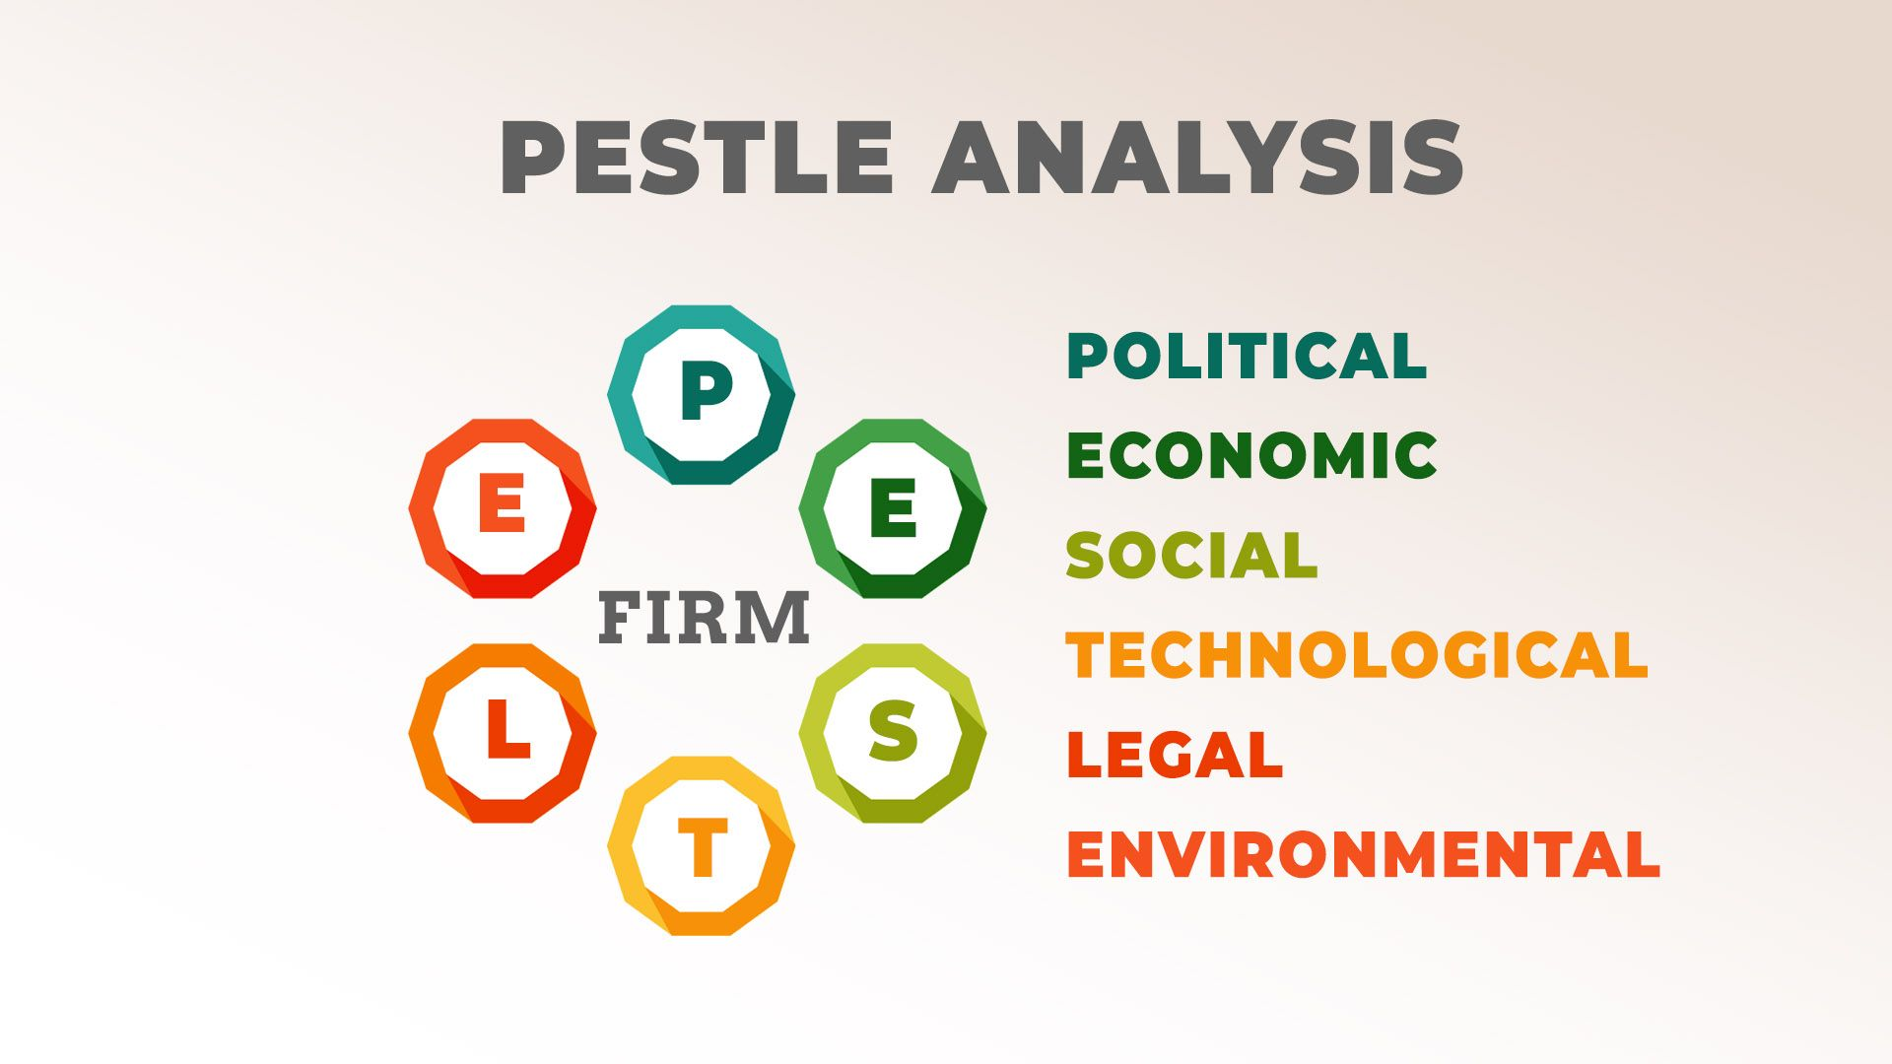
Pestle Analysis/Source: (Lynch, 2018)
- Political Factors: Politics, more especially Thai labour laws and international immigration restrictions, shapes Bangkok's recruitment approach, Mandarin Oriental Limited, 2023. Governments all across adopted tougher immigration laws during the outbreak, therefore limiting the mobility of foreign labour. This therefore affected hotels reliant on immigrant workforce (Dempster and Zimmer, 2020). The first-rate hospitality company Mandarin Oriental hires competent foreigners, hence government policies about labour migration in Thailand (IOM Thailand, 2024) are needed. The limited quantity of foreign labourers (Mandarin Oriental, 2022) could make it difficult for the hotel to attract people with the specific skills needed to provide upscale services. The hotel is obliged to rely mostly on local talent, which could cause a delay in service as staff members adjust to Mandarin Oriental's exacting standards. This limits also training costs and recruitment charges.
- Economic Factors: Financial difficulties brought on by the epidemic influence Mandarin Oriental's operational activities and staff (Chau et al., 2023). At Mandarin Oriental (Yu, Cui, and Hou, 2023), the worldwide economic crisis has caused changes in occupancy and income. A decline in tourism results in a smaller operational budget for the hotel, which calls for lower wages, perks, and training courses meant to attract and keep staff in a competitive labour market (Kataya, 2021). Economic unpredictability affects tourists' purchasing power, thereby justifying the premium price; hence, a constant and outstanding guest experience is needed (Chau et al., 2023.). Consequently, especially when fewer staff members are needed to satisfy the high standards essential to satisfy guests and promote repeat bookings, the hotel must combine cost control with high service expectations.
- Social Factors: The expectations and attitudes of post-pandemic employees towards the hotel sector aggravate the manpower problems of Mandarin Oriental. Per Hui, Tsui, and Tavitiyaman (2021), hospitality staff members are giving job security, work-life balance, and job contentment top priority over luxury hotel operations. This shift in staff expectations has made hospitality roles—especially those involving great pressure—less appealing, especially those at Mandarin Oriental. Thailand's reliance on local labour markets, where younger people want less demanding or more safe work, aggravates the staffing problem (Moroz, 2021). Mandarin Oriental might thus have to change its hiring practices to draw in and keep qualified staff members by offering contemporary perks and work flexibility.
- Technological Factors: Mandarin Oriental, Bangkok, faces possibilities as well as difficulties resolving personnel shortages brought on by artificial intelligence and automation (Bharwani and Mathews, 2020). Mustafa (2022) claims that technology might cut the human labour needed for daily tasks including check-ins, reservations, and maintenance. Digital technology may be adopted by Mandarin Oriental to improve operations and allow its small personnel to focus on more personalised, high-touch client interactions, which are a fundamental component of its luxury service offering. While technology can improve operational efficiency, luxury hotels usually give personalised touch—which technology cannot reproduce top priority (Pillai et al., 2021). The first investment in the integration of new technologies during the post-pandemic recovery period calls for the modification of visitor expectations, training, and cash, so perhaps stressing the already limited financial resources (Khan et al., 2021).
- Environmental Factors: The sustainability criteria of the premium sector complicate the operations and staff of Mandarin Oriental. Using sustainable solutions include waste reduction and energy-efficient operations could lead to more effort and the need of specialised knowledge (Modica, Perotti and Melacini, 2021). The extra care needed for trash management and environmentally responsible maintenance can weigh a small workforce. Notwithstanding the difficulties presented by its staff, Mandarin Oriental must strike a balance between environmental sustainability and customer service. Trying to apply sustainable practices with a small team could compromise the guest experience and damage the hotel's standing among ecologically minded visitors (Hameed, Hussain and Khan, 2022).
- Legal Factors: Thai labour rules about pay, overtime, and perks influence Mandarin Oriental's workforce management (IOM Thailand, 2024). Thai labour constraints, especially those related to pay and working hours, restrict the personnel flexibility of the hotel. Legal issues and more expenses could follow from more overtime resulting from a smaller workforce, especially if employee tiredness causes mistakes or complaints (Fastje et al., 2023). Should a luxury brand break employment laws, it can face legal fines and damage its name (Minor and Heys, 2022). Mandarin Oriental is so forced to balance operational needs with legal constraints, so complicating the management of lean staff.

SWOT Analysis
The SWOT study of Mandarin Oriental, Bangkok shows how staff shortages affect the guest experience. The capacity of the hotel to provide premium service in a labour-constrained market depends on its strengths, constraints, opportunities, and threats ( Lynch, 2018).
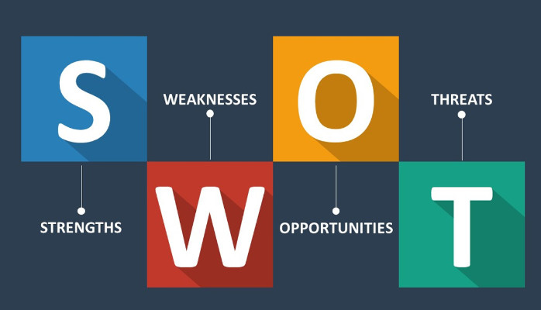
SWOT Analysis/Source: (Lynch, 2018)

Strengths
Particularly in the luxury sector, where brand loyalty and perceived value are critical, Mandarin Oriental's brand reputation is a great advantage (Mandarin Oriental, 2023). The hotel's stellar reputation attracts upscale visitors who value quality and would be more likely to understand service delays if they received tailored attention and communication (Pang, 2020). This reputation protects against personnel shortages since guests are more forgiving of well-known companies with a track record of outstanding service (Su, Jia, and Huang, 2022.). Careful management of guest interactions helps to minimise service lapses, thereby maintaining this reputation under operational pressure.
By offering individualised service, Mandarin Oriental sets itself out in a crowded market (Mandarin Oriental, 2022). Luxury customers expect to be valued and given personal attention, which will build loyalty (Shin and Jeong, 2022). This service approach meets their rather reasonable expectations. Nevertheless, the small staff members of this customised service approach could make it challenging to provide customised visitor experiences (Roberts and Maier, 2024). By momentarily putting quality over quantity in visitor encounters, Mandarin Oriental has the ability to use its brand and ensure that every contact, regardless of delay, satisfies the best criteria.
Foreign guests drawn in by the hotel's proximity to the Chao Phraya River are drawn in by local elegance and culture (Mandarin Oriental Bangkok, 2024). Without taxing the cleaning or concierge personnel, the hotel has the capacity to improve the visitor experience by providing special river-view dining or cultural events at this site (Mandarin Oriental Limited, 2023). By stressing distinctive location-based offers, the hotel can draw guests to labor-light events thereby addressing staff shortages (Khan et al., 2021).

Weaknesses
High-touch luxury service depends on experienced staff in hotel management, cultural sensitivity, and customer care; hence the hotel is vulnerable in these areas (Abdelazim, 2023). The lack of the workforce makes this reliance problematic since the hiring and training of new staff members takes time and expenses. While premium hotel firms like Mandarin Oriental demand a high degree of personal touch that technology cannot imitate, some mid-market hotels can use self-service technology to alleviate personnel limitations (Kataya, 2021). To keep service quality and lower hiring, the hotel has to give creative ideas including cross-training staff members top priority (Shi et al., 2021). This will help to perform a range of responsibilities.
The high operating costs connected with luxury service standards complicate the matter even more (Khan et al., 2021). Premium pay, large employee benefits, and extra expenses for training new workers aggravate financial restrictions in fluctuating tourism demand (Yu, Cui and Hou, 2023). This financial load limits the hotel's ability to execute compensation hikes meant to draw people or expensive training programs. The hotel has to use resources precisely if it wants to maintain service quality without running unnecessary costs. This could call for maximising labour schedules and raising production.
Furthermore, hampered by Mandarin Oriental's operating approach is its inability to include technology without sacrificing its luxury image (Mandarin Group, 2023). While automation could lower the demand for human work, it could also damage the brand's high-touch, customised service (Bharwani and Mathews, 2021). Although automated concierge services and self-check-in terminals are efficient, their expectations of human connection may not match them (James, 2020). Due to this limitation, the hotel depends on human capital since it cannot look at technological solutions for personnel shortages.

Opportunities
Mandarin Oriental might profit from the increased environmental consciousness of its premium guests by improving its methods (Hameed, Hussain and Khan, 2022). Luxury tourists that give sustainability top priority provide energy-efficient operations and waste minimising top priority (Modica, Perotti and Melacini, 2021). Through stressing these projects, the hotel can draw guests that give sustainability top priority, so offering a special value proposition that might help to reduce service delays. Environmental initiatives could also lead to partnerships with sustainability-minded companies, hence improving income and tourist involvement (Lynch, 2018).
For Mandarin Oriental, growing health travel presents a strategic possibility. Designed to meet the growing demand for vacation experiences that give health and well-being top priority following the epidemic, the hotel's wellness and spa programs Emphasising wellness will help the hotel draw guests since spa treatments and wellness resorts call for less staff than other offerings. This approach can improve income and help the hotel to control its labour resources by shifting demand from labour-intensive operations to experiences with a greater value-to-labour ratio.

Threats
Bangkok's luxury hotel market is quite competitive; new and boutique hotels fight for the same customer base. Visitor loyalty in this competitive environment depends on the quality and consistency of service since rivals quickly seize on mistakes (Yu, Cui, and Hou, 2023). Inadequate management of labour shortages could cause service differences, which would cause customers to choose other hotels providing a better experience (Wang, Ma, and Yu, 2021). Mandarin Oriental must thus improve its quality control and resource management if it is to help to offset these deficits. Changes in travel trends during times of economic uncertainty could compromise hotel income (Khan et al., 2021). Luxury travel is one of the first industry to suffer during economic downturns; this could affect occupancy and profitability if this trend continues. Notwithstanding manpower limitations, Mandarin Oriental faces the difficulty of keeping premium pricing and high standards in an unpredictable environment. This difficulty underlines how urgently Mandarin Oriental must properly control income projects and running expenses if it is to stay profitable.
Finally, Thai labour laws (IOM Thailand, 2024) limit the hotel's ability to supervise a minimum staff. The rigorous scheduling and resource allocation rules of working hours, salary, and overtime rules restrict the hotel's capacity to adjust to changing demand (Moroz, 2021). Being a well-known luxury brand, Mandarin Oriental's reputation and legal standing could suffer should these rules be broken. This legal threat emphasises Mandarin Oriental's need for fresh employees who meet operational and regulatory criteria.

TOWS Analysis
Mandarin Oriental, Bangkok, can use the TOWS study to make sure the visitor experience is kept even with limited staff by matching internal strengths and weaknesses with outside prospects and hazards (Lynch, 2018).
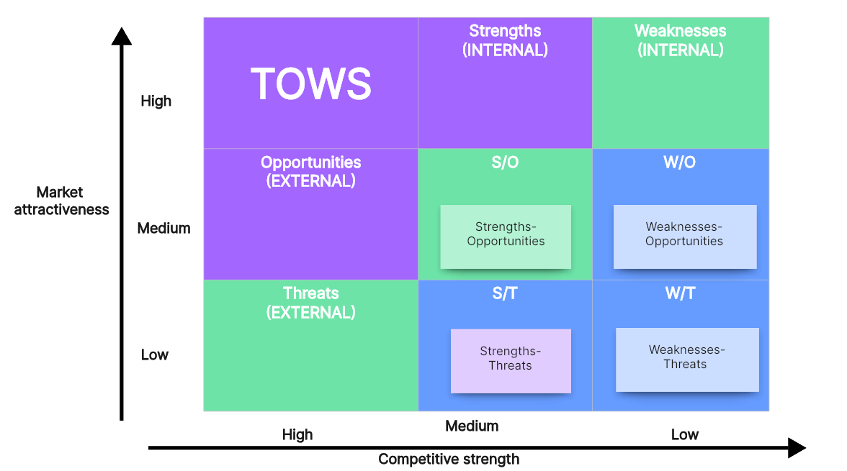
TOWS Analysis/Source: (Lynch, 2018)
- SO Strategies: Using Mandarin Oriental's strong brand recognition to support sustainability helps meet the growing demand for environmentally conscious luxury travel. Sustainable methods, according to Musau et al. (2024), can draw environmentally conscientious guests, therefore fostering brand loyalty and differentiating the hotel from rivals. By appealing to environmentally concerned guests who give sustainable practices first priority above luxurious amenities, Mandarin Oriental might be able to preserve high occupancy rates while controlling labour restrictions (Modica, Perotti, and Melacini, 2021). Following the epidemic, the wellness tourist industry has grown significantly; so, the hotel's expansion of wellness offers uses its assets (Mandarin Group, 2023). Though less staff than housekeeping or concierge services, spa treatments and wellness holidays are worthwhile services. Mandarin Oriental may be focussing these items on wellness-conscious guests, hence less reliance on areas experiencing the most severe staff shortages and better distribution of manpower throughout departments.
- ST Strategies: By providing distinctive location-based activities, such cultural tours or the Chao Phraya river-view experiences, which help to offset staffing shortages, Mandarin Oriental has the ability to improve the tourist experience (Pang, 2020). These services offer guests unique experiences that offset the typical service delays even though they require less effort. This approach maximises the riverfront position of the hotel to set it apart from its rivals and satisfies guest expectations without requiring large staff. Strong brand loyalty programs, which encourage repeat visits, help to reduce economic risks. If given special incentives or prizes, loyal consumers are more likely to ignore service problems (Yu, Cui, and Hou, 2023). By identifying its customers, Mandarin Oriental can maintain a solid occupancy base and a steady income despite labour problems.
- WO Strategies: Selective automation of visitor services, including virtual concierge systems or self-check-in kiosks (Bharwani and Mathews, 2021), can help to address staffing issues without sacrificing the standards of the luxury brand. The automation of mundane duties helps to maintain service quality, according to Tuomi et al. (2021), which releases staff members to interact personally with clients. Mandarin Oriental has to combine technology with human touch if it is to ensure that automation enhances tailored service. Apart from lowering running costs, corporate alliances with environmental organisations for sustainable activities exceed visitor expectations for eco-friendliness (Modica, Perotti, and Melacini, 2021). By using sustainable practices through partnerships, the hotel can lower its expenses and draw environmentally concerned guests (Hameed, Hussain, and Khan, 2022). This approach provides reasonably priced environmentally friendly solutions in line with strategic goals of Mandarin Oriental.
- WT Strategies: Cross-training employees to improve flexibility solves hotel shortcomings including Mandarin Oriental's over reliance on skilled personnel (Michael and Fotiadis, 20211). This strategy helps staff members to take on a range of responsibilities, therefore lowering the need for new hiring and guaranteeing that service standards are maintained in the face of manpower shortages (Strouse and Reed, 201). By giving employees new skills and changing their tasks, cross-training improves employee morale and engagement and hence increases their resilience (Shi et al., 2021). Clear policies and consistent internal audits help the hotel to protect its brand and legal position by lowering labour law violations (Moroz, 2021). By giving all staff members knowledge about labour rules, Mandarin Oriental has the ability to avoid fines and provide a good working environment in a hotel sector with high attrition rate.

Recommendations and Change Management

Recommendations
Mandarin Oriental, Bangkok keeps its premium standards despite staff constraints by using the following sustainable methods. These ideas strike a mix in service quality by tackling operational efficiency, tourist experience, technological integration, and recruiting and retention.
- Strengthen Recruitment and Retention Initiatives: Mandarin Oriental should improve its recruitment and retention plan to draw in and keep competent professionals (Wang, Ma, and Yu, 2021) so helping to offset personnel shortages. Competitive pay, work-life balance, and career growth prospects improve the stability of the labour market, which in turn lowers hotel turnover according to Ghani et al. (2022). Mandarin Oriental can build a staff that values service by improving pay, perks, and training (Singh et al., 2024). The pay of upscale service providers should reflect the splendour of the hotel and the hospitality industry of Bangkok. Competitive pay systems improve job satisfaction and retention in service-intensive companies (Abdelazim, 2023). In sectors like hospitality, which are recognised for their great degrees of stress, work-life balance is becoming more important. By providing wellness rewards and flexible scheduling to raise morale and loyalty, Mandarin Oriental could help to support this change (Baum et al., 2020). The hotel should offer cross-departmental training and career routes to help staff members grow and diversify. As Mustafa (2022) underlines, professional development is a crucial retention tool since it raises employee involvement.
- Integrate Selective Automation to Support Guest Services: By use of selective automation of mundane operations, Mandarin Oriental's luxurious image may be maintained while improving productivity and allowing staff members to focus on tailored interactions. This strategy helps the hotel to satisfy guest expectations while maximising staff and juggling operational needs with high-touch service. Using check-in/check-out kiosks improves front-desk efficiency and gives guests more autonomy, therefore lowering staff member workload. Self-service technology could help to lower wait times and improve visitor satisfaction in high-end environments, claims Pillai et al. (2021). Using a virtual concierge on a hotel website or smartphone app lets guests order housekeeping or room service without creating a backlog at the front desk. By allowing personnel to focus on the more complicated needs of guests, this automation helps to improve the client experience and control labour requirements.
- Enhance Brand Appeal through Sustainability and Wellness: By matching its brand with the tastes of consumers that give environmental and wellness-oriented travel first priority, Mandarin Oriental has the chance to improve its market position and reduce the demand on labour-intensive services. The hotel can draw environmentally aware guests and better control labour resources by supporting these values and using wellness programs (Singh et al., 2024). Among the sustainable practices that improve the attractiveness of hotel brands are eco-friendly facilities, energy saving, and trash reduction (Semwal et al., 2024). Luxury visitors support environmentally friendly labels, claims Modica, Perotti, and Melacini (2021). With leisure and wellness getaway packages in response to the growing popularity of wellness travel, Mandarin Oriental has the chance to set itself apart. Unlike high-traffic departments like housekeeping, these experiences require less daily operational resources, hence lowering staff workload and improving visitor experience (Wang, Ma, and Yu, 2021).
- Implement Cross-Training to Increase Labour Flexibility: Training staff in many roles helps businesses to maximise employment and change with the times (Michael and Fotiadis, 2022). In the luxury hotel sector, where service consistency is critical, this helps to produce a team that is flexible and strong. Cross-training exists for front desk, concierge, food service, and sanitation staff members. Cross-training, according to Strouse and Reed (2021), gives staff members vital abilities and adaptability they may use in times of great demand. Work with those who have gotten cross-training to help in areas of great demand. This structure ensures service quality without calling for significant staff development.
- Promote Location-Specific Guest Experiences: Mandarin Oriental may highlight its position by offering tailored experiences, such river-view dining or cultural tours along the Chao Phraya River, rather than labour-intensive services. These activities help the hotel to make use of its beautiful surroundings without sacrificing necessary services. The hotel might be able to offer special events with few personnel by working with nearby businesses and cultural organisations. Location-based products, according to Alzoubi et al. (2022), improve visitor happiness and lower operating costs. River-view meals and outdoor events suit visitors' tastes for unique, unforgettable experiences even while staff engagement is minimised (Schalkx, 2020).

Change Management
Effective change management is needed if the suggested improvements at Mandarin Oriental, Bangkok, with little opposition and long-term sustainability are to be properly carried out. Kotter's eight-step model guarantees that staff motivations line up with organisational goals, therefore facilitating change (Miller, 2021). Lewin's Change Theory helps to develop, apply, and validate these changes.

Kotter’s 8-Step Model
Since Kotter creates and preserves momentum for change, this approach is outstanding for Mandarin Oriental's new recruitment, automation, branding, and service strategies.
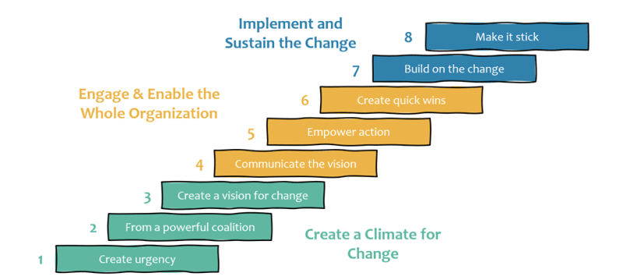
Kotter’s 8-Step Model of Change/Source: (Kotter and Cohen, 2012)
- Create Urgency: Change is dependent on generating urgency (Laig and Abocejo, 2021). Mandarin Oriental's leadership should stress how staff shortages effect tourist satisfaction, employee workloads, and service quality (Wang, Ma, and Yu, 2021). By emphasising the competitive restrictions and reputational risks associated with failing to adapt, leadership may persuade others that these changes are required to maintain Mandarin Oriental's standards and market position. According to research, urgency motivates change and facilitates stakeholder alignment.
- Build a Guiding Coalition: Department executives as well as a coalition of powerful guest services, HR, and operations staff should lead and assist in the transformation (Shulga, 2021). This team supports open communication and addresses departmental issues as it supports change projects. A unified leadership team shows a commitment to change and builds confidence among the employees, therefore improving buy-in. As per Kotter and Cohen (2012), a steering coalition provides constant support during the change and sets the tone and direction.
- Form a Strategic Vision and Initiatives: Improved recruitment, focused automation, and cross-training should all help to solve personnel issues and benefit guests as well as staff members. This vision should show how improvements will lower responsibilities, raise visitor pleasure, and forward careers. One vision might be "A workforce that is empowered and adaptable, providing exceptional guest experiences." When presented with a clear, aspirational goal, employees are more likely to see the benefits of fresh approaches (Kotter and Cohen, 2012).
- Communicate the Vision for Buy-In: Employee buy-in calls for consistent, multichannel communication (Laig and Abocejo, 2021). Department meetings, training, and instructional materials help to clarify the goal and how changes affect staff members and guests. Effective communication might highlight automation-reduced responsibilities and cross-training job advancement ( Michas and Fotiadis, 2022). According to Kotter and Cohen (2012), conveying the vision through relevant anecdotes and real-world examples will inspire and drive staff members.
- Empower Broad-Based Action: Mandarin Oriental needs to remove roadblocks to staff change if it is to encourage active involvement. Cross-training might call for extra time and help from qualified staff members. Training employees on virtual concierge systems and self-check-in terminals will also help automation to be successful (Khan, 2024). When employees are allowed to engage in change, they are more flexible, and this promotes ownership and motivation (Kotter and Cohen, 2012).
- Generate Short-Term Wins: Illustrating the immediate benefits of improvements requires short-term successes, which are absolutely essential (Laig and Abocejo, 201). Mandarin Oriental should celebrate its first achievements—better visitor comments, faster check-in, and streamlined housekeeping brought about by schedule—including the appreciation of these achievements helps to raise morale and confirm the success of the changes. Short-term achievements help to justify change, reduce staff opposition, and boost confidence (Kotter and Cohen, 2012).
- Sustain Acceleration: Mandarin Oriental has to grow from its first achievements by making more significant changes. After automating basic services and cross-training key workers (Hameed, Hussain and Khan, 2022), the hotel has the choice of including sophisticated automation or wellness and sustainability projects. Kotter and Cohen (2012) contend that creating new goals and extending the scope of change to use progress to enable more transformation will help to maintain momentum.
- Institute Change in the Culture: Mandarin Oriental should adopt fresh rules and recognise them if it is to include new habits into the hotel's culture. As basic values, leadership should give innovation, cooperation, and adaptability top priority; it should also honour those who give service and adaptability top priority (Shulga, 2021). Mandarin Oriental guarantees their sustainability by including these developments into the corporate culture (Kotter and Cohen, 2012).

Lewin’s Change Theory
Lewin's Change Theory streamlines preparation, execution, and consolidation of change therefore supporting Kotter's approach.
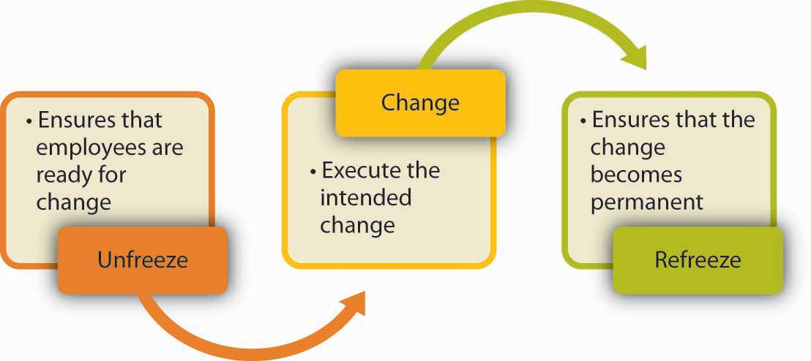
Lewin’s Change Theory/Source: (Kotter and Cohen, 2012)
- Unfreeze: Staff meetings and instructional seminars run Mandarin Oriental via which to explain the reasons of change. Knowing the staffing problems and service standards of the hotel helps employees to welcome change (Khan, 2024). Establishing a change-friendly atmosphere requires clarity and the elimination of first worries about employment insecurity or role changes (Chan et al., 2023).
- Change: Management helped Mandarin Oriental to apply the new ideas throughout this period. By means of training, cross-functional teamwork events, and technological demos, staff members gain understanding of their roles in novel procedures (Khan, 2024). Supervisors should be easily available to answer questions to help staff members adjust (Chan et al., 2023). Employees need practical tools and resources absolutely to be sure they can take on their new obligations.
- Refreeze: Mandarin Oriental uses the fresh approaches in its operations at the last stage. This means that regular operating policies should be changed, performance reviews should encourage cooperation and flexibility, and staff members who support and fit the changes should be recognised. Regular feedback sessions help to improve even if incentives and honours for adaption help the organisation to adopt new practices (Chan et al., 2023).
By using Kotter's 8-Step Model and Lewin's Change Theory to apply these operational changes, Mandarin Oriental, Bangkok, may address employee issues and lower resistance. While Lewin's theory develops, implements, and confirms these changes as organisational culture, Kotter's model drives people and creates momentum. Despite human problems, Mandarin Oriental's premium hotel leadership, staff engagement, and service standards are kept by means of these systematic processes.

Evaluation Metrics
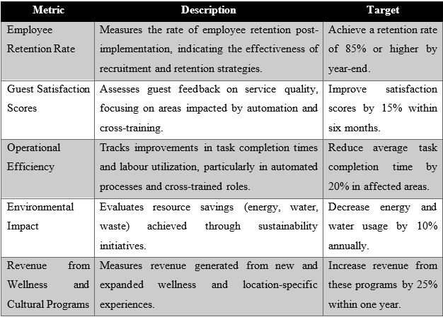

Cost Analysis
The Mandarin Oriental, Bangkok Cost Analysis assesses the costs involved in following the advice. These approximations line up with the size of the hotel, available resources, and expected profits.
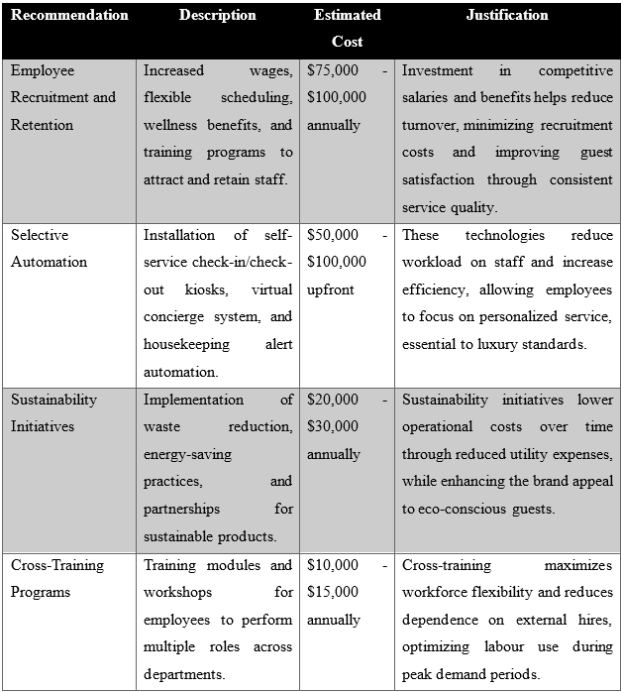
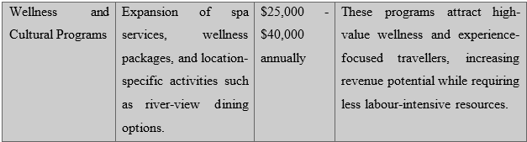

Action Plan
Mandarin Oriental, Bangkok's Action Plan is meant to improve operational effectiveness and solve personnel shortages.
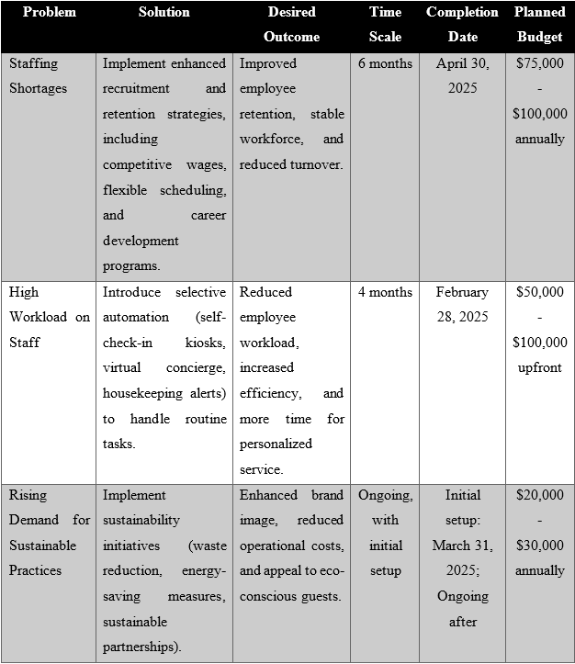
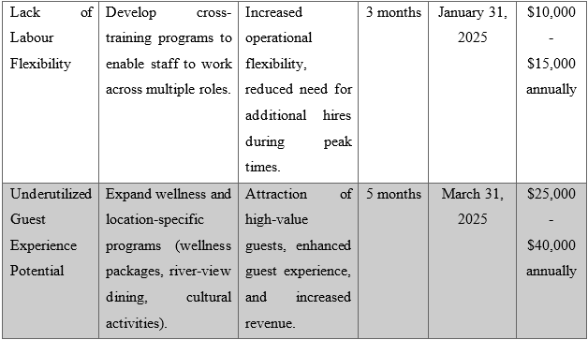

Conclusion
This study looked at how staffing shortages affected tourist happiness, reputation of Mandarin Oriental, and prestige service of Bangkok. The study found important internal and external elements impacting the operations of the hotel by means of PESTLE, SWOT, and TOWS studies. Important concerns include a great need for unique visitor experiences, difficulties with recruiting and retention, an increasing staff load, sustainable practices, and limited work flexibility. These solutions are meant to improve operational resilience and maintain Mandarin Oriental's extraordinary service quality.
Recommended are cross-training initiatives to improve labour flexibility, sustainable practices, better recruiting and retention methods, wellness and location-specific visitor experiences. Furthermore, advised is selective automation meant to cut staff labour. These operations connect Mandarin Oriental with the expectations of its visitors and help to alleviate personnel shortages. While appealing salary and career growth help to attract and retain talented employees, cross-training helps staff members to react to changing demand without becoming overburdened.
By means of selective automation, operational inefficiencies are reduced, thereby enabling staff to focus on tailored visitor experiences, which define the hotel brand. Automating routine tasks include housekeeping alerts and check-ins helps staff members to have less work and maintain quality of service. By encouraging sustainability and wellness, the hotel may draw environmentally concerned and wellness-minded visitors, therefore differentiating itself in a competitive market. Following tourist tastes and worldwide trends helps these hotels solve staffing shortages and improve their reputation.
By the action plan, the hotel management has a clear road for the activities, budget, and timeliness of every recommendation. Indicators of the success of every recommendation are employee retention rates, visitor satisfaction scores, operational efficiency enhancements, environmental impact, and wellness program income. Establishing these key performance indicators (KPIs) would help Mandarin Oriental evaluate its development and use data-driven changes to handle personnel issues.
Since it addresses human issues and improves operational resilience, this study is strategic in character. Following these suggestions will help Mandarin Oriental keep its luxury service standards, draw fresh business, and cut labour-intensive activities. These projects will strengthen Mandarin Oriental's financial stability and market posture, therefore ensuring its leadership in the exclusive hotel industry.
EHS appreciate Mandarin Oriental, Bangkok, letting the EHS team on this important project. Offering ideas and solutions unique to hotels has been a delight. The EHS team confident that by following these suggestions Mandarin Oriental will be able to strengthen its commitment to hospitality and fix its personnel problems. These steps will help the hotel to survive the crisis and provide a basis for sustained development in line with industry trends and expectations of luxury guests.

Reference List
Abdelazim, A. (2023). Causes of High Employee Turnover in the Jobs of the Hospitality Industry. In Proceedings International Conference on Business, Economics & Management (No. 1, pp. 690-714).
Al-Ababneh, M.M., Masadeh, M.A., Al-Sabi, S.M. and Al-Badarneh, M.B. (2021). Achieving Service Recovery Through Service Innovation: The Critical Role Of Employee Empowerment. Enlightening Tourism. A Pathmaking Journal, 11(1), pp.40-88.
Alzoubi, H., Alshurideh, M., Kurdi, B., Akour, I. and Aziz, R. (2022). Does BLE technology contribute towards improving marketing strategies, customers’ satisfaction and loyalty? The role of open innovation. International Journal of Data and Network Science, 6(2), pp.449-460.
Ari, E. (2023). Human resource risk challenges in the hotel industry. Journal of Hospitality and Tourism Insights, 6(5), pp.2073-2092.
Bharwani, S. and Mathews, D. (2021). Post-pandemic pressures to pivot: tech transformations in luxury hotels. Worldwide Hospitality and Tourism Themes, 13(5), pp.569-583.
Brown, N.A., Rovins, J.E., Feldmann-Jensen, S., Orchiston, C. and Johnston, D. (2017). Exploring disaster resilience within the hotel sector: A systematic review of literature. International Journal of Disaster Risk Reduction, 22, pp.362-370.
Caraway, T.L. (2023). Labor Standards and Labor Market Flexibility in East Asia. In Global Labour in Distress, Volume II: Earnings,(In) decent Work and Institutions (pp. 437-469). Cham: Springer International Publishing.
Chan, X.W., Shang, S., Brough, P., Wilkinson, A. and Lu, C.Q. (2023). Work, life and COVID‐19: a rapid review and practical recommendations for the post‐pandemic workplace. Asia Pacific journal of human resources, 61(2), pp.257-276.
Chanchomsri, K. (2023). Factors influencing customers loyalty toward luxury hotels: A case study of foreign tourists in Bangkok (Doctoral Dissertation, Bangkok University).
Chau, K.Y., Zheng, J., Yang, D., Shen, H. and Liu, T. (2023). Contingency Approach for Tourism Industry: The application of China model in crisis management during the outbreak and pandemic of COVID-19. Journal of China Tourism Research, 19(2), pp.133-154.
Davies , P. (2020). Mandarin Oriental faces ‘significant impact’ from coronavirus. [online] Travel Weekly. Available at: https://travelweekly.co.uk/articles/360887/mandarin-oriental-faces-significant-impact-from-coronavirus [Accessed 28 Oct. 2024].
Dempster, H. and Zimmer, C. (2020). Migrant workers in the Tourism Industry: how has COVID-19 affected them, and what does the future hold?’. CGD Policy Paper, 173, pp.1-31.
Fastje, F., Mesmer-Magnus, J., Guidice, R. and Andrews, M.C. (2023). Employee burnout: the dark side of performance-driven work climates. Journal of Organizational Effectiveness: People and Performance, 10(1), pp.1-21.
Frost, R. (2020). Covid19 hotel development analysis: Mandarin Oriental Hotel Group [Infographic]. [online] TOPHOTELNEWS. Available at: https://tophotel.news/covid19-hotel-development-analysis-mandarin-oriental-hotel-group-infographic/ [Accessed 28 Oct. 2024].
Ghani, B., Zada, M., Memon, K.R., Ullah, R., Khattak, A., Han, H., Ariza-Montes, A. and Araya-Castillo, L. (2022). Challenges and strategies for employee retention in the hospitality industry: A review. Sustainability, 14(5), p.2885.
Gössling, S., Scott, D. and Hall, C.M. (2020). Pandemics, tourism and global change: a rapid assessment of COVID-19. Journal of sustainable tourism, 29(1), pp.1-20.
Hameed, I., Hussain, H. and Khan, K. (2022). The role of green practices toward the green word-of-mouth using stimulus-organism-response model. Journal of Hospitality and Tourism Insights, 5(5), pp.1046-1061.
Hui, R.T.Y., Tsui, B. and Tavitiyaman, P. (2021). Disability employment in the hotel industry: Evidence from the employees’ perspective. Journal of human resources in hospitality & tourism, 20(1), pp.127-145.
IOM Thailand (2024). Labour Mobility and Social Inclusion | IOM Thailand | IOM Thailand. [online] thailand.iom.int. Available at: https://thailand.iom.int/labour-mobility-and-social-inclusion [Accessed 29 Oct. 2024].
James, G. (2020). Relationship between intrinsic job satisfaction, extrinsic job satisfaction, and turnover intentions in luxury hotels (Doctoral dissertation, Walden University).
Kataya, A. (2021). Current Trends and Issues of Luxury Tourism. Empirical Research on Supply and Demand Effects of Covid-19 Pandemic. Annals of the University Dunarea de Jos of Galati: Fascicle: I, Economics & Applied Informatics, 27(2), pp.46-54.
Khan, H.A. (2024). Innovative Services, Processes and Product Design Crucial for Enhancing Customer Experience. In Marketing and Design in the Service Sector: Enhancing Customer Experience (pp. 63-81). Emerald Publishing Limited.
Khan, K.I., Niazi, A., Nasir, A., Hussain, M. and Khan, M.I. (2021). The Effect of COVID-19 on the Hospitality Industry: The Implication for Open Innovation. Journal of Open Innovation: Technology, Market, and Complexity, [online] 7(1), pp.30–47. doi:https://doi.org/10.3390/joitmc7010030.
Kim, J., Kim, S.I. and Lee, M. (2022). What to sell and how to sell matters: Focusing on luxury hotel properties’ business performance and efficiency. Cornell Hospitality Quarterly, 63(1), pp.78-95.
Kordsofla, M.M. and Sorourkhah, A. (2023). Strategic adaptation in travel agencies: Integrating MARA with SWOT for uncertainty navigation. Journal of operational and strategic analytics, 1(4), pp.173-189.
Kotter, J.P. and Cohen, D.S. (2012). The heart of change: Real-life stories of how people change their organizations. Harvard Business Press.
Kuo, F.I., Fang, W.T. and LePage, B.A. (2022). Proactive environmental strategies in the hotel industry: Eco-innovation, green competitive advantage, and green core competence. Journal of Sustainable Tourism, 30(6), pp.1240-1261.
Laig, R.B.D. and Abocejo, F.T. (2021). Change management process in a mining company: Kotter’s 8-step change model. Journal of Management, Economics, and Industrial Organization, 5(3), pp.31-50.
Liu-Lastres, B., Huang, W. and Bao, H. (2023). Exploring Hospitality Workers’ Career Choices in the Wake of COVID-19: Insights from A Phenomenological Inquiry. International Journal of Hospitality Management, 1(111), pp.1–12. doi:https://doi.org/10.1016/j.ijhm.2023.103485.
Lynch, R. (2018). Strategic Management. 8th ed. Harlow, United Kingdom ; New York: Pearson Education Limited.
Mandarin Group (2023). Sustainability Report 2023. [online] Available at: https://photos.mandarinoriental.com/is/content/MandarinOriental/_DMO/_Corporate/PDFs/mandarin-oriental-sustainability-report-2023.pdf [Accessed 28 Oct. 2024].
Mandarin Oriental (2022). Mandarin Oriental Sustainability Report 2022. [online] Madarin Oriental Hotel Group. Available at: https://photos.mandarinoriental.com/is/content/MandarinOriental/_Corporate/PDFs/mandarin-oriental-sustainability-report-2022.pdf [Accessed 29 Oct. 2024].
Mandarin Oriental (2023). Our Company - Overview. [online] Corporate Site. Available at: https://www.mandarinoriental.com/en/our-company [Accessed 29 Oct. 2024].
Mandarin Oriental Bangkok (2024). Luxury 5 Star Hotel | Chao Phraya River | Mandarin Oriental, Bangkok. [online] Corporate Site. Available at: https://www.mandarinoriental.com/en/bangkok/chao-phraya-river [Accessed 28 Oct. 2024].
Mandarin Oriental Hotel Group (2024). MANDARIN ORIENTAL, BANGKOK - FACT SHEET. [online] Available at: https://photos.mandarinoriental.com/is/content/MandarinOriental/MOBKK%20-%20Bangkok/PDFs/bangkok-fact-sheet.pdf [Accessed 29 Oct. 2024].
Mandarin Oriental Limited (2023). Corporate Governance Report 2023 . [online] Mandarin Oriental Hotel Group. Available at: https://photos.mandarinoriental.com/is/content/MandarinOriental/_Corporate/PDFs/Investors/Regulatory%20&%20Releases/corporate-2022-annual-results-2021.pdf [Accessed 29 Oct. 2024].
Michael, N. and Fotiadis, A. (2022). Employee turnover: The hotel industry perspective. Journal of Tourism, Heritage & Services Marketing, 8(1), pp.38-47.
Miller, A. (2021). Strategic Management. Boston, Mass.: Irwin/Mcgraw Hill.
Minor, K. and Heyes, A. (2022). 50 Shades of the Luxury Hospitality Industry. In The Emerald Handbook of Luxury Management for Hospitality and Tourism (pp. 425-442). Emerald Publishing Limited.
Modica, T., Perotti, S. and Melacini, M. (2021). Green warehousing: exploration of organisational variables fostering the adoption of energy-efficient material handling equipment. Sustainability, 13(23), p.1-15.
Mondal, S. and Palit, D. (2022). Challenges in natural resource management for ecological sustainability. In Natural Resources Conservation and Advances for Sustainability (pp. 29-59). Elsevier.
Moroz, H.E. (2021). Aging and the labor market in Thailand. [online] World Bank Blogs. Available at: https://blogs.worldbank.org/en/eastasiapacific/aging-and-labor-market-thailand [Accessed 29 Oct. 2024].
Musau, J., Mapelu, I. and Njeri, A.K. (2024). Sustainability Practices and Brand Identity in City Hotels: The Moderating Impact of Guests’ Length of Stay. African Journal of Tourism and Hospitality Management, 3(1), pp.155-171.
Mustafa, E. (2022). Technology in Hotel Sector. In Technology application in aviation, tourism and hospitality: Recent developments and emerging issues (pp. 73-87). Singapore: Springer Nature Singapore.
Ng, M.A., Naranjo, A., Schlotzhauer, A.E., Shoss, M.K., Kartvelishvili, N., Bartek, M., Ingraham, K., Rodriguez, A., Schneider, S.K., Silverlieb-Seltzer, L. and Silva, C. (2021). Has the COVID-19 pandemic accelerated the future of work or changed its course? Implications for research and practice. International Journal of Environmental Research and Public Health, 18(19), p.10199.
Özdemir, A.İ., Çolak, A. and Shmilli, J. (2019). Business process management in hotels: with a focus on delivering quality guest service. Quality & Quantity, 53(5), pp.2305-2322.
Pang, J.M. (2020). Adopting “East Asian” cultures and themes in hotel branding: a study of the M. Mandarin. Asia Pacific Journal of Tourism Research, 25(10), pp.1085-1097.
Pillai, S.G., Haldorai, K., Seo, W.S. and Kim, W.G. (2021). COVID-19 and hospitality 5.0: Redefining hospitality operations. International Journal of Hospitality Management, 94, p.1-12.
Raciti, M.M., Russell-Bennett, R. and Letheren, K. (2022). A strengths-based approach to eliciting deep insights from social marketing customers experiencing vulnerability. Journal of Marketing Management, 38(11-12), pp.1137-1177.
Roberts, C. and Maier, T. (2024). The evolution of service toward automated customer assistance: there is a difference. International Journal of Contemporary Hospitality Management, 36(6), pp.1914-1925.
Sangkakorn, K. and Krajangchom, S. (2024). A study of tourist behaviour for the development of Lanna wellness tourism in Thailand. International Journal of Spa and Wellness, pp.1-23.
Schalkx, C. (2020). Post-Lockdown Bangkok: Empty Temples, Nightclubs, and Hotels. [online] Condé Nast Traveler. Available at: https://www.cntraveler.com/story/post-lockdown-bangkok-empty-temples-nightclubs-and-hotels [Accessed 29 Oct. 2024].
Semwal, R., Tripathi, N., Kulshrestha, R. and Tyagi, P. (2024). Innovative Approaches to Sustainable Hospitality: Leveraging AI and Technology for Energy Efficiency, Waste Reduction, and Eco-Friendly Mobility. In Hotel and Travel Management in the AI Era (pp. 379-400). IGI Global.
Shi, F., Shi, D., Weaver, D. and Samaniego Chavez, C.E. (2021). Adapt to not just survive but thrive: resilience strategies of five-star hotels at difficult times. International Journal of Contemporary Hospitality Management, 33(9), pp.2886-2906.
Shin, H.H. and Jeong, M. (2022). Redefining luxury service with technology implementation: the impact of technology on guest satisfaction and loyalty in a luxury hotel. International Journal of Contemporary Hospitality Management, 34(4), pp.1491-1514.
Shulga, L.V. (2021). Change management communication: The role of meaningfulness, leadership brand authenticity, and gender. Cornell Hospitality Quarterly, 62(4), pp.498-515.
Singh, S.V., Ancheary, T., Mondal, A. and Rajauria, S. (2024). Enhancing Service Excellence in the Hospitality Industry Through Effective Service Recovery From Failures. In Innovative Technologies for Increasing Service Productivity (pp. 117-133). IGI Global.
Strouse, M.C. and Reed, F.D.D. (2021). Employee turnover and workforce stability. In Organizational Behavior Management Approaches for Intellectual and Developmental Disabilities (pp. 210-234). Routledge.
Su, L., Jia, B. and Huang, Y. (2022). How do destination negative events trigger tourists’ perceived betrayal and boycott? The moderating role of relationship quality. Tourism Management, 92, p.104536.
Tuomi, A., Tussyadiah, I.P. and Stienmetz, J. (2021). Applications and implications of service robots in hospitality. Cornell Hospitality Quarterly, 62(2), pp.232-247.
Wang, K.Y., Ma, M.L. and Yu, J. (2021). Understanding the perceived satisfaction and revisiting intentions of lodgers in a restricted service scenario: evidence from the hotel industry in quarantine. Service Business, 15(2), pp.335-368.
Youngblood, A.M., Nutta, J.W., Dickson, D.R. and Nutta, M.W. (2021). Learning English as a second language in the back-of-the-House: proficiency and employment from the perspective of hotel human resource directors. Journal of Human Resources in Hospitality & Tourism, 20(1), pp.24-47.
Yu, W., Cui, F. and Hou, Z. (2023). The evolution of consumers’ demand for hotels under the public health crisis: opinion mining from online reviews. Current Issues in Tourism, 26(12), pp.1974-1990.

Appendices

Appendix – 1: PESTLE Analysis
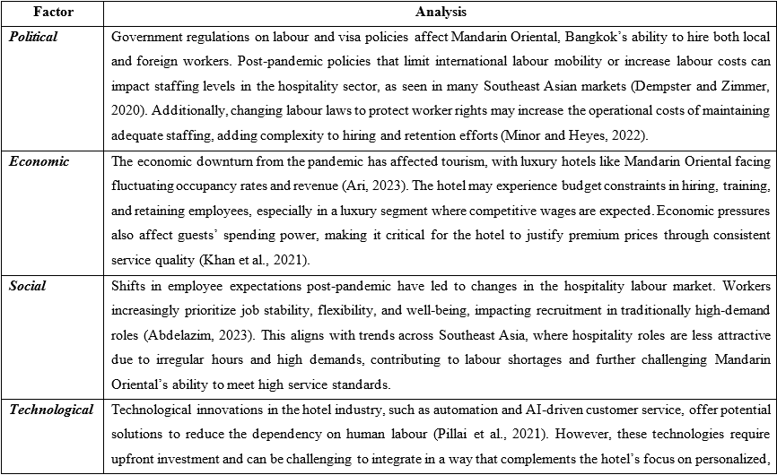
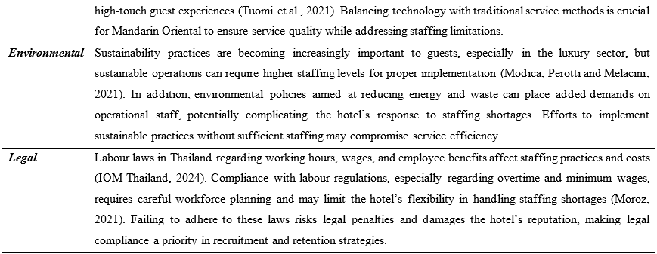

Appendix – 2: SWOT Analysis
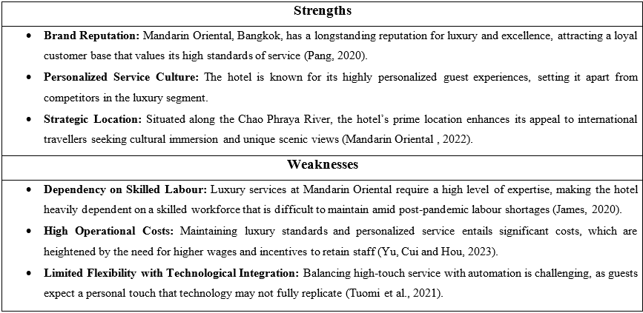
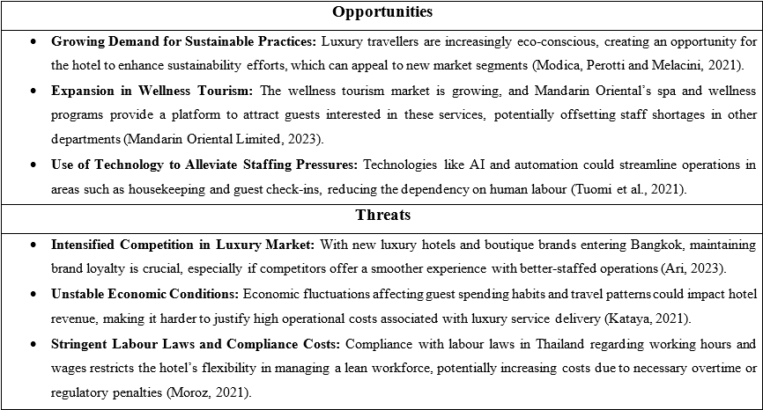

Appendix – 3: TOWS Analysis


