

Postgraduate/Distance Learning
Assignment coversheet & feedback form

THIS SHEET MUST BE THE FIRST PAGE OF THE ASSIGNMENT YOU ARE SUBMITTING (DO NOT SEND AS A SEPARATE FILE)

For completion by the student:
Student Name: Jiayi Zhu

Student University Email: 2126466@student.uwtsd.ac.uk
Module code: HPCA7014  Module title: Sacred Geography | Student ID number: 2126466 |  |  | Educational support needs:
Assignment title: Sacred Geography: The Dagu Glacier

Assignment due date: 5 Jan 2026
This assignment is for the 1st 2nd 3rd 4th 5th 6th module of the degree
Plagiarism declaration
I confirm that this is my original work and that I have adhered to the University policy on plagiarism.

Artificial Intelligence (AI) declaration
For this assessment, you can use Generative AI to check your own text/creation for grammatical and syntactical mistakes, including rephrasing of your own work within specific standards.*

*See separate guidance in the MA Writing Guidelines

I confirm that I have not used any AI tools in the research and creation of this assignment, except as permitted above. I confirm that I have not presented any AI generated materials as my own work. I confirm I have copies of my drafts, notes, and other resources I used, which I may be asked to provide in evidence.

Signed:

Assignment Mark
1st Marker’s Provisional mark
2nd Marker’s/Moderator’s provisional mark
External Examiner’s mark (if relevant)
Final Mark

NB. All marks are provisional until confirmed by the Final Examination Board.

For completion by Marker 1 :
Comments:

Marker’s signature: |  |  | Date:
For completion by Marker 2/Moderator:

Comments:

Marker’s Signature: |  | Date:
External Examiner’s comments (if relevant)

External Examiner’s Signature: |  | Date:

Abstract
The Dagü Glacier, situated in Aba Tibetan and Qiang Autonomous Prefecture, Sichuan Province, China, is not only a natural wonder but is also regarded as a sacred site within the Tibetan Buddhist belief system. This study examines how ‘sacred space’ gradually emerges through the interplay between natural manifestations and human experience. Taking the Dagū Glacier as a case study, it employs Mircea Eliade's (1959) theories of “theophany” and the ‘world axis’ to analyse how nature becomes a vessel for divine revelation. Concurrently, incorporating Tim Ingold's theories of dwelling and line, it explores how humans construct sacredness through spatial interaction. Furthermore, Beldon C. Lane's (2001) theological perspectives on narrative and spiritual geography enable this study to integrate nature, religion, and the divine within an ecological phenomenological framework.
Introduction
Glaciers constitute the most extensive freshwater reservoirs on the planet, containing 70% of the Earth's freshwater supply. Since the conclusion of the Little Ice Age in 1850, worldwide glaciers have been receding, a pattern that is consistent with regular climate variability. Recent worldwide data reveal that glaciers are melting at an unprecedented rate in an expanding range of regions. This trend intensified markedly in the 1990s. In 2010, the most recent evaluation by the World Glacier Monitoring Service indicated that the annual rate of glacial melt has increased twofold since 2000. This timeframe aligns with the hottest decade documented. Scientists identify chronic global warming as the principal driver of glacial melting, wherein substantial carbon emissions disturb ecological equilibrium and expedite glacial retreat. Prolonged arid winters and intense summers are expediting glacial thawing. As the pace of glacial retreat intensifies, millions of people face threats of flooding, drought, and reduced drinking water supplies. Against this backdrop of global glacial melt, it is our unshirkable responsibility and duty to adjust industrial structures and safeguard our beautiful Dagu Glacier (Zhang, 2020).
Sichuan Dagu Glacier Geopark is located in the central part of Aba Tibetan and Qiang Autonomous Prefecture, Sichuan Province, in the northern part of Heishui County, 25 kilometres from Heishui County town. The park consists of two zones: Dagu Glacier and Kalong Valley, covering a total area of approximately 138.8 square kilometres. The Dagu Glacier zone spans about 120 square kilometers, while the Kalong Valley zone covers approximately 18.8 square kilometers. The most representative geological relics within the Dagu Glacier zone are modern mountain glaciers, totaling 19 in number. The most concentrated area features 13 glaciers that connect end-to-end. Due to environmental changes, true large-scale glaciers no longer exist within the park. However, glacial geological relics formed during geological history—such as the massive whale-back rocks created by glacial movement—remain exceptionally rare worldwide. The core geological feature of the Kalong Gorge Park is travertine deposits formed under alpine karst conditions. The park boasts massive travertine accumulations and diverse travertine landscapes, earning it the reputation as “China's World of Moss and Travertine” (Wang, 2019).
The main question this study tries to answer is whether holy space is something made up by people or something that happens naturally. The relationship between the holy and the natural is at the heart of sacred geography, and this question touches on that. The purpose of this study is to look into how the interaction between people and nature creates the experience of "sacred space." For example, does the Dagü Glacier "manifest" its sacredness through its natural grandeur, or does its sacredness come mostly from its cultural meaning and religious rituals in the Tibetan belief system? By looking into this question, the study hopes to show that holy space doesn't come from a single source, but from a combination of natural features and human creation. It is a place where geography, the body, and belief are constantly creating new sacred experiences.
Literature Review
Introduction to Sacred Space and Sacred Geography
Places hold meaning for us because they bear “importance”. This importance must be preserved and remembered in some manner. Simon Schama's study of Landscape and Memory (Schama, 1995, cited in Trubshaw, 2012) explores in depth and breadth the complex process by which culture creates and commemorates meaning for significant sites. Yet this “memory” also exists at the most mundane, everyday level. For instance, the naming of places often encapsulates the “significance” of that location. No place name is arbitrary. Regardless of how much its original meaning is remembered, each designation is inextricably linked to a society's associations, figures, and narratives. Eighteenth-century linguists discovered the ruins of a Roman settlement named “Viernetum” – meaning “particularly sacred grove” – which is thought to have been a Late Iron Age ritual site. No visible remains of this settlement survive, nor have archaeologists unearthed them (Trubshaw, 2012).
Certain places acquire additional significance through their association with legends or myths. In the Nordic regions, narratives conferring sacred status upon a place seldom emphasise transcendent entities—namely, ‘local deities’. Even when these stories are based on old ideas—for example, Anglo-Saxon or prehistoric ditches being called "Devil's Dyke"—they give certain places symbolic meanings. Memories connected to the land are turned into myths through vivid stories. The way we see a place is shaped by both its physical features and the "landscape of the mind" that stories and legends create. Even if customs have "petrified" or are only remembered in place names and have lost their original meanings, stories or narratives must still be used to show how important a place is. Like other cultural aspects, a place only has value when it is given meaning through "narratives of significance (Trubshaw, 2012).
The connotations we give to locations have the power to both promote a feeling of social belonging and, whether on purpose or accidentally, keep others out of this "belonging." This process of creating meaning is intrinsically political. On the other hand, groups that are considered "outsiders," like the Romani and other nomadic peoples, have experienced generations of disdain from those who identify as "belongers." Women are required to leave their birthplace in order to follow their spouses in many non-Western countries. These women are more "rootless" than men, as several feminist authors have pointed out (Trubshaw, 2012) . Essentially, a location's significance comes more from the meanings we attach to it than from its actual topography. More precisely, the stories we tell about the location help to preserve and remember these meanings (Trubshaw, 2012) .
When it comes to religious studies, the most important spatial debate is where space and holiness meet (Knott, 2005). Chidester and Linenthal (1995), based on the work of Stallybrass and White (1986), make a distinction between the poetic and political aspects of sacred sites in the introduction to Sacred Places in America. They say that the poetic aspects have always been at the centre of religious studies. To explain this point of view, they don't use Eliade's "sacred centre" theory, which is often used as a general way to understand sacred space. Instead, they use Van der Leeuw’s (1993) systematic study of sacred places in Religion in Essence and Manifestation. His suggested order of analogous ideas—home, temple, settlement, pilgrimage site, and the human body—along with the metaphors that go with them—hearth, altar, sanctuary, shrine, and heart—forms the basic vocabulary of sacred poetics talk. Kidder and Lintner say that Van der Leeuw always agreed that "the positioning of sacred places is inherently a political act," no matter what his view on sacred presence was (Knott, 2005) . He went on to say that this position includes choosing a place, orienting it, drawing lines around it, or conquest (Chidester and Linenthal, 1995, cited in Knott, 2005) .
Chidester and Linenthal say that religious scholars mostly talk about Van der Leeuw’s phenomenological classification of sacred sites. However, they say that Van der Leeuw set the stage for later conversations on how these sites were built and how they are used politically. Their focus on a "controversial" way of looking at things—interpreting "overlapping and interwoven spatial sacredness" across natural, artificial, and mythical worlds, also comes from Van der Leeuw’s body of work (Knott, 2005) .
Chidester and Linenthal are aware that scholars who are only familiar with Mircea Eliade's work may find their focus on the contested nature of sacred place strange (Chidester and Linenthal, 1995, cited in Knott, 2005) . However, Eliade's poetics of sacred sites has always been the basis for all subsequent study in sacred geography, no matter whether scholars agree with it or disagree with it. Its main ideas—that sacred space is a separate realm from the secular, that it is a "centre" or world-axis that connects different dimensions, and that it is a physical vessel of the "real" (or divine) have become important ways for academics to think about how sacred and useful space-time is (Eliade, 1959). The later academic discussion on "sacred space" was shaped by these principles, which changed it from a basic idea based on sacred ontology to a critical examination of how people "sacralise" space. This is about how makers, owners, and followers see their own place of life, set of values, and way of thinking as unquestionable, special, and above the everyday (Knott, 2005) .
Eliade’s Phenomenology of the Sacred
Religious believers see space as having cracks and fissures; they do not regard it as existing consistently. "Do not approach," God warned Moses; "Take off your shoes, for the place where you are standing is holy ground" (Exodus 3:5, cited in Eliade, 1959) are two examples of geographical qualities that are essentially different from one another. Thus, while non-holy areas are chaotic and lack organization and coherence, sacred areas have significant symbolic meaning. Moreover, this spatial separation is seen by pious believers as a binary opposition between all other spaces and sacred space. Similar to the experience at the beginning of creation, this religious sense of spatial diversity is essential. Cosmic speculation is preceded by the religious basis rather than theoretical deduction. By exposing the fixed point—the core axis dictating all future directions—this spatial rupture creates the world. When the sacred appears in whatever way, it breaks the homogeneity of space and reveals absolute reality in sharp contrast to the unreality of the surrounding emptiness. The ontological basis of the world is established by the appearance of the sacred. The ultimate fixed point—the centre—is revealed by divine revelation within that homogeneous, infinite space that lacks any points of reference or guidance (Eliade, 1959) .
Therefore, the appearance of sacred space is of great existential importance to the religious person: without an initial orientation, nothing can begin its journey and success is impossible; however, the establishment of any orientation requires a fixed point of reference. This is the same reason why religious people have always tried to create homes at the "centre of the world." The world's foundations must be established in order to confirm its existence, yet no world can emerge in the chaotic homogeneity and relativity of secular space. It is equivalent to establishing the world to recognize or imagine a fixed point, the centre. We will now use specific instances to demonstrate the cosmogonic relevance of ritual orientation and the creation of hallowed spaces. On the other hand, space in secular experience is consistently undifferentiated, with no qualitative distinction at all among its constituent aspects. Although geometric space can be divided in any way, its fundamental structure lacks any fundamental variation and, therefore, orientational reference. A totally secular existence has never been realized, according to Eliade. Even individuals who choose to live an earthly life and are firmly enmeshed in secularization are unable to completely give up their religious behaviour. As the argument progresses, it becomes more and more clear that religious cosmology is present in even the most secular existence (Eliade, 1959) .
The manifestation of sacred space gives mankind steady points of reference when concentrating on experiences in both sacred and secular spheres. This makes it possible to navigate through a single chaos, reaching the "foundation of the world" and real life. On the other hand, secular experience preserves its relativity by maintaining spatial unity. As fixed points lose their intrinsic ontological importance and instead manifest or disappear in response to environmental demands, true orientation becomes impossible (Eliade, 1959) .
Each sacred area has a manifestation of the divine—a sudden surge of sacred energy that cuts off a sphere from the rest of the universe and changes its very nature. In Haran, Jacob had a dream about a ladder that went up and down in the sky, and he saw angels going up and down it. At the top of the ladder, Jacob heard the Lord say, "I am the Lord, the God of Abraham." When he woke up, he said, "This place is so awful!" Wasn't this where God lived and the way to heaven? As a tribute, he set up the stone he had used as a pillow and anointed it with oil. He then called the place Bethel, which means "House of God" (Genesis 28:12–19，cited in Eliade, 1959). The "heavenly gate" has a deep and heavy symbolic meaning. It is the holy place where God speaks to people and leads to the celestial realm, which is a strange place where heaven and earth meet. Soon, we'll see more vivid examples of sanctuaries that act as "gateways to the divine." In these situations, religiously important signs bring clarity and remove ambiguity and complexity. Transcendent presence shows up without a doubt, giving advice or setting rules for behavior (Eliade, 1959) .
Regardless of whether academics took a critical or supporting attitude, Eliade's poetics of sacred space set the foundation for all further research in sacred geography. Its assumptions evolved into fundamental ideas. More importantly, this theory covers the whole methodological development by which subsequent researchers moved the discussion of "sacred space" from a foundational ontological understanding to a critical analysis of the ways in which people "sacralise" locations (Knott, 2005, pp. 170–172) .
Phenomenological and Anthropological Approaches: Ingold and Tilley
What makes a place special is the experience it gives to people who stay there, including the sounds, sights, and even smells that make up its atmosphere. In turn, these rely on the kinds of things that the people who live there do. This relational context of how people connect with the world when they live there gives each place its own meaning. So, space is the act of giving the world meaning, and scenery is the act of getting meaning from the world. Obviously, different lines can be drawn in a landscape. These lines can be natural features like river courses or cliffs, or they can be man-made buildings like walls or fences. But these lines aren't necessary to the places they separate, and they don't even split the landscape, because the features that form those lines are natural parts of the scene. Importantly, no part of an environment is naturally a boundary. Something is only a boundary or a sign of a limit when people (or animals) know or experience it as one (Ingold, 2000).
By explaining what landscape is not, Ingold has slowly come closer to a positive description of it. Basically, scenery is how people who live in and travel through the world see it. Does this mean the same thing as what we usually call "the environment"? Obviously, there isn't a clear line between scenery and environment; in most cases, the two terms can be thought of as very similar. I clearly don't agree with Durand's suggested distinction, which is that the environment is "the given, the fragment of pure reality," while the landscape is "the achievement of the mature mind" (Tuan, 1979, cited in Ingold, 2000). This difference just reinforces the idea that nature and society are opposites. The environment is not "nature," and the scenery is not something made up. Ingold says that he has previously used the difference between the "physical world" and "reality" to show the difference between nature and environment: the "physical world" is "the reality of neutral objects visible only to detached observers," while "reality" is "the world constituted in relation to organisms or individuals as environmental subjects" (Ingold, 1992a, cited in Ingold, 2000). But this way of thinking about the environment puts its utility first—that is, the conditions it creates for organisms (human or nonhuman) with specific abilities and plans for what to do. On the other hand, to see these things as animals, you have to look at them through the lens of dynamic functional principles, that is, as organized systems (Pittendrigh, 1958, cited in Ingold, 2000). Lewontin wisely points out (1982) that the world is "nature organized by organisms" (Ingold, 2000) .
"By contrast, the concept of landscape emphasises form, much as the concept of the body emphasises the organism's shape rather than its function. If the body constitutes the organism's form of being in the world, then the realm of its existence manifests as landscape. Just as organism and environment, body and landscape, are complementary concepts: they mutually contain one another, alternately assuming the roles of subject and background. Yet the form of the landscape is not pre-prepared for the organism to occupy, just as the organism's bodily form does not exist independently within its genetic constitution. Both forms emerge from and are sustained by the ongoing unfolding of an integrative relational field—a field spanning the emerging interface between organism and environment (Goodwin, 1988, cited in Ingold, 2000). Given its formative nature, we may term this process “embodiment” (Ingold, 2000) .
Ingold has compared two ways to travel: getting around and exploring. The wanderer's path winds and curves, maybe stopping for a moment here and there, like the lines of a hike. But this path doesn't have a starting or an end. That person who is always moving is somewhere, but each "where" leads them to somewhere else. The world we live in is made up of these kinds of roads, which are knitted together all the time as life moves through them (Ingold, 1990, cited in Ingold, 2000). On the other hand, travel is very limited to certain places. The goal of each action is to move people and their things to a certain place. When travellers go from one place to another, they never really feel like they fit anywhere. Point-to-point networks form from transportation lines. During colonial rule, this network, which was first hidden in everyday life and limited by ways of living, slowly took over, covering whole areas and covering up the interwoven tracks of people who lived there. Additionally, I will explain that the main difference between walking and connecting is not just how the two types of movement work, but also how they integrate information. To begin, think about how directions are shown on maps (Ingold, 2000) .
On the other hand, people who overemphasize a place's independence or even magical traits to show how holy it is often forget about the social, economic, and political forces that will affect how it is used. Beldon C. Lane rethinks holy space as a story-based experience in holy Landscapes (Lane, 2002), saying that sacredness is always being made through stories, memories, and spiritual imagination. Lane doesn't see holy places as set representations of God. Instead, he sees them as texts made up of cultural, emotional, and theological parts—a conversation between people and places. In this "narrative turn," geography turns into religion because stories give the landscape meaning (Lane, 2002) .
Case study
Natural Landscapes and Sacredness
Glaciers are often seen as signs of global climate change because they represent a world that is being changed by people. Scientists generally agree that glaciers are melting around the world, but when they talk about this topic, they mostly talk about scientific methods. But because they are such important parts of the environment, glaciers have a lot more to do with people all over the world than just providing water. As a result, the way glaciers interact with people is affected by how people near and far think about them and what they think is important. So, as glaciers melt, they often become places where people from different levels connect with each other. Glaciers are being studied on a larger scale than just melting, from the local to the national to even the world. This change is especially clear when glaciers are given economic and artistic value. The way people in the area think about and experience changes in glaciers' shape, size, and water flow has an effect on the people who live there and on what communities, local groups, governments, and foreign organizations do. The main idea of this paper is that place-based research is important for studying world environmental events like glacial retreat (Gagné, Rasmussen and Orlove, 2014).
The Dagü Glacier lies on the southeastern edge of the Qinghai-Tibet Plateau (Zhang, Li and Wang, 2018, Fig. 1 a), within the central section of the Hengduan Mountains. It occupies a high-mountain gorge region where the northwestern mountainous fringe of the Sichuan Basin transitions into plateau hills. This area falls within a monsoon plateau climate zone, characterised by distinct dry and wet seasons, abundant sunshine, small annual temperature variations, and significant daily temperature fluctuations. Climate conditions vary considerably with altitude. By 2016, Dagü retained only 13 glaciers, covering a total area of just 1.70 km², representing a reduction of four glaciers since the second glacier inventory. Between 1975 and 2017, Dagü glaciers lost 5.094 km² of area, representing a shrinkage rate of 0.12 km²·a⁻¹. This retreat pattern aligns with changes observed in monsoon-influenced marine glaciers across southwest China (Wang et al., 2019). According to the Second Glacier Inventory, Dagü Glacier 17 lies at an elevation of 4,780–4,970 metres above sea level, with an ice volume of 3.38×10⁶ m³ and slopes predominantly between 30° and 50°. Between 1971 and 2016, the terminus of Dagü Glacier No. 17 retreated approximately 0.76 km, with its area decreasing by 0.78 km² (Wang and Zhou, 2019). As the largest glacier in the region, Dagü Glacier No. 17 exhibits pronounced melting trends and fragmented into three smaller glaciers around 2020 (Zhang, Li and Wang, 2018, Fig. 1 b). Therefore, considering factors such as glacier area, accessibility, and scenic appeal, the experimental site was established on the upper small glacier formed after the fragmentation of Dagü Glacier No. 17. This facilitates the transportation of experimental equipment to the destination by relevant personnel while significantly reducing manpower requirements, thereby providing favourable conditions for experimental investigation and research (Zhang, Li and Wang, 2018).
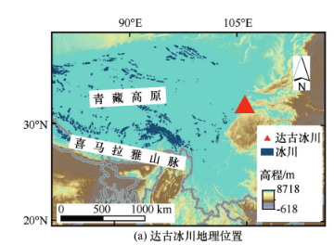

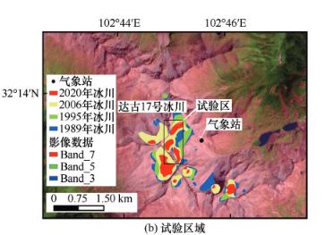

Fig. 1. Location of Dagu Glacier No. 17 in Sichuan Province: (a) regional map of Heishui County, and (b) detailed view of glacier topography and surrounding valleys (redrawn from Zhang, Li and Wang, 2018).

It is thus readily apparent that glaciers are not static entities, but rather dynamic systems in perpetual motion, undergoing both melting and refreezing. ‘From the perspective of glacial formation,’ the retreat and reduction in area of the flat-topped ice cap glaciers during the Quaternary glacial period, driven by the warming global climate of the Holocene, enabled the succession of alpine meadows and mountain forests to unfold within Dagugou. It was thus that Dagugou evolved into a habitable, ancient glacial U-shaped valley (Zhang et al., 2002). Upon reaching the summit via the scenic cable car, the immense glacier above silently sheds its icy radiance, while prayer flags flutter and chant in the wind, composing the most exquisitely moving tableau between heaven and earth. Approaching the ice that has slumbered for millennia, one discerns layer upon layer of azure deep within its core—as if the entire plateau's blue sky had been frozen within, pure and unblemished. In that moment, the divine no longer resides on distant mountain peaks, but dwells within the mutual reliance of humble creatures, reflected in those clear eyes that guard life's most primal essence (Li, 2021) .
Ritual, Belief, and Cultural Practice: The Axis Mundi of Glacial Devotion
During the Long March of the Chinese Communist Party's Red Army in 1935-1936, they paused within Aba Prefecture. Shangdagu Tibetan Village stands as a testament to the revolutionary era, and thus Sandagu Village has evolved into a distinctive ethnic cultural settlement infused with revolutionary heritage. Sandagu Village fully embodies the authentic Amdo Tibetan culture and rich folk traditions. The village's layout and architecture serve as repositories of the historical culture and traditional way of life of Tibetan residents, possessing local value. The unique Tibetan character and splendid natural scenery together form a harmonious whole. layout, and architecture serve as carriers of locally significant Tibetan residential history, culture, and traditional lifestyles. Its distinctive Tibetan character, combined with beautiful natural landscapes, constitutes the core value of the Dagu Glacier Scenic Area. The village holds significant importance for safeguarding the integrity of the scenic resource's value (Li, 2021).
In places where glaciers bear cultural beliefs, within the Tibetan worldview, snow-capped mountains are often the abodes of deities (Gagné, Rasmussen and Orlove, 2014) . Yet the ecological aesthetic underpinning Tibetan sacred mountain worship stems from lived experience. Since ancient times, Tibetan ancestors grasped ecosystems holistically: humanity cannot exist apart from nature. On special occasions, every household in Dagqu holds ceremonies honouring the sacred mountains, singing praises to their deities, and offering silent prayers for fewer calamities and greater blessings. These heartfelt rituals, praying for harmony between humanity and all creation, express not only gratitude to the sacred mountains but also an aesthetic recognition of nature's sanctity. Such ceremonies serve as channels for human-nature communication, primarily manifested through practices like hanging prayer flags, scattering prayer horses, circumambulating the mountains, and burning juniper. Walking around the sacred peaks embodies reverence and worship, while also embodying hopes for a harmonious and beautiful coexistence between humanity and nature (as shown in Figures 2–5). Humanity's perception of nature as otherworldly fosters a sense of its mystery and awe. These rituals thus serve to achieve self-satisfaction, alleviate anxieties about offending nature, and soothe the psyche through aesthetic appreciation. Primarily conducted at elevated locations, The wind serves as a messenger between humanity and nature. At such lofty heights, where winds blow fiercely, prayer flags, wind horses, and the incantations of the burning of juniper are carried aloft, conveying supplications to the sacred mountain. This act embodies profound reverence for the natural world, thereby fostering a corresponding sense of security at the psychological and spiritual levels. The burning of incense, or “sang”, is a cultural symbol of purification. Tibetans typically perform this ritual before significant life events – birth, ageing, illness, death – or when donning new garments, seeking cleansing. The billowing smoke rising ceaselessly towards the heavens signifies both the people's desire to welcome the deities and their profound reverence for nature. This ritual connects heaven and earth in supplication to the celestial deities. During these ceremonies, hymns expressing reverence for nature are recited to convey wishes for protection, peace, and bountiful harvests to the sacred mountain. Serving as a spiritual baptism, this practice remains deeply intertwined with Tibetan daily life, evolving into a widespread ritual of reverence for nature throughout Tibetan regions.
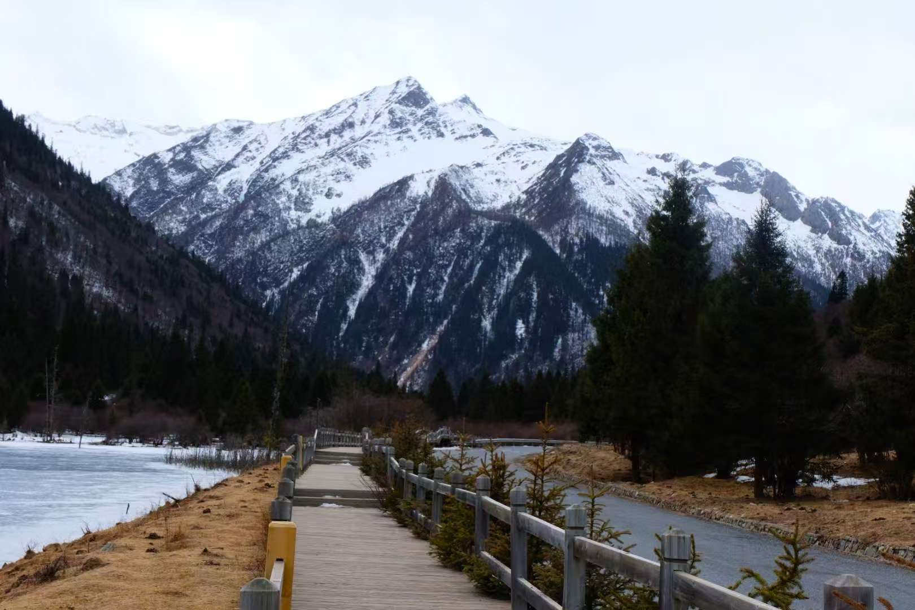
Fig. 2. Geographical overview of the Dagu Glacier scenic area. Photograph by the author, 2020
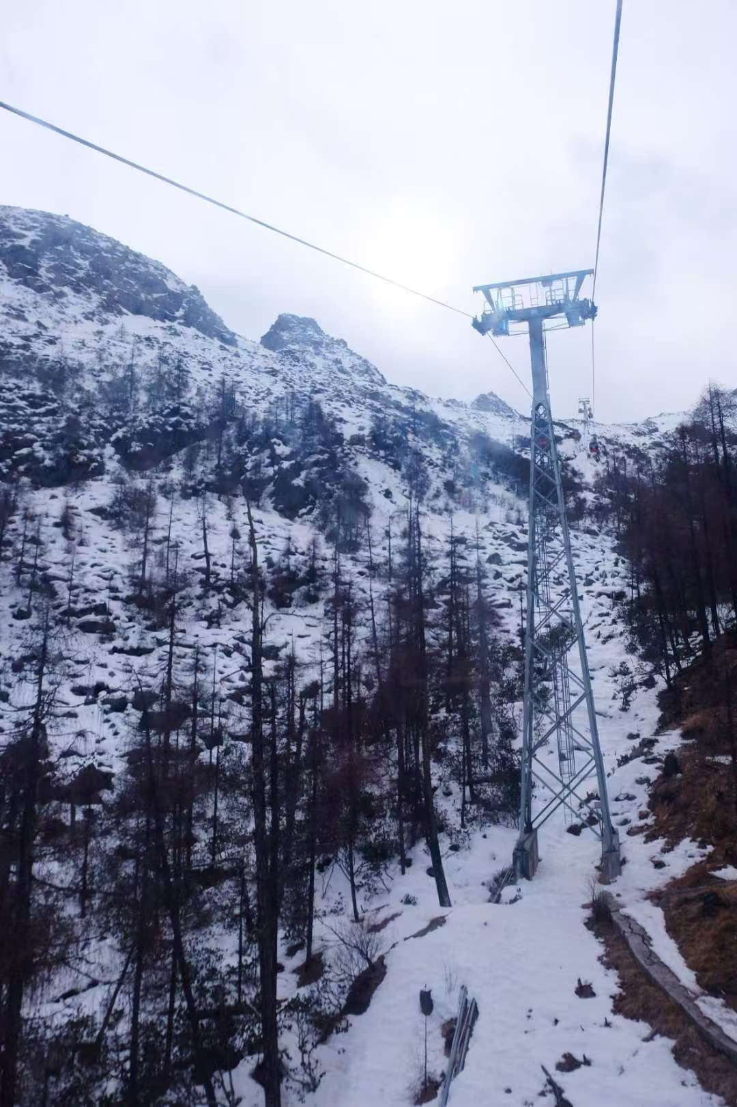
Fig. 3. Geographical overview of the Dagu Glacier scenic area. Photograph by the author, 2020

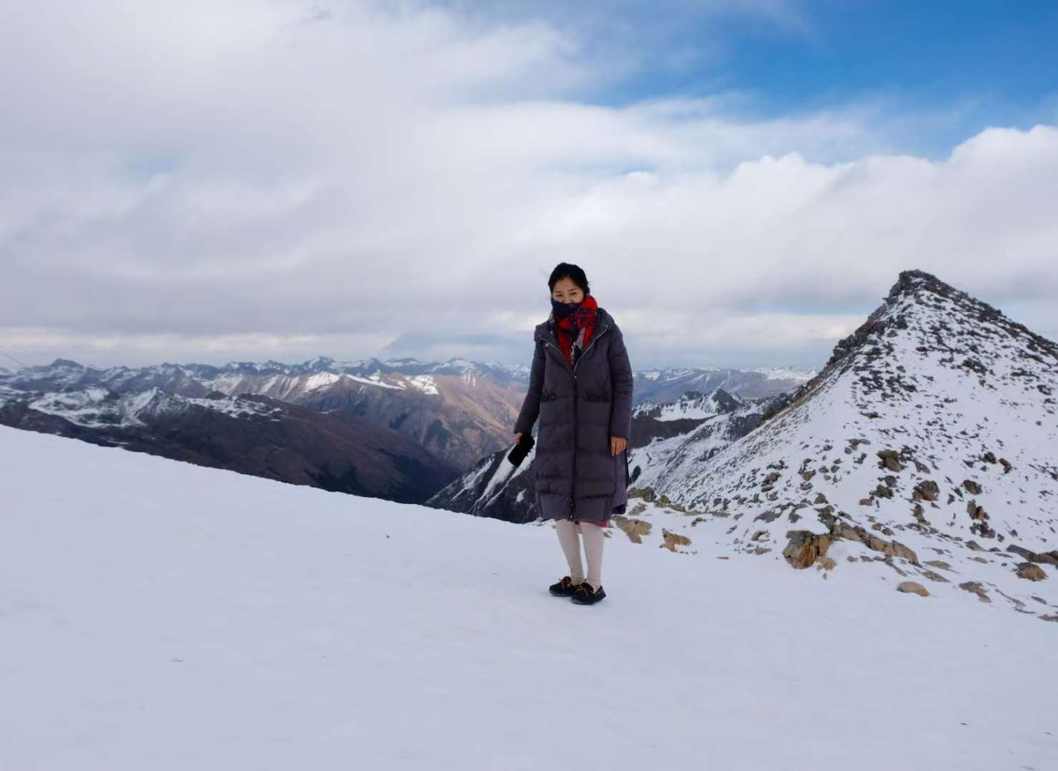
Fig. 4. Geographical overview of the Dagu Glacier scenic area. Photograph by the author, 2020

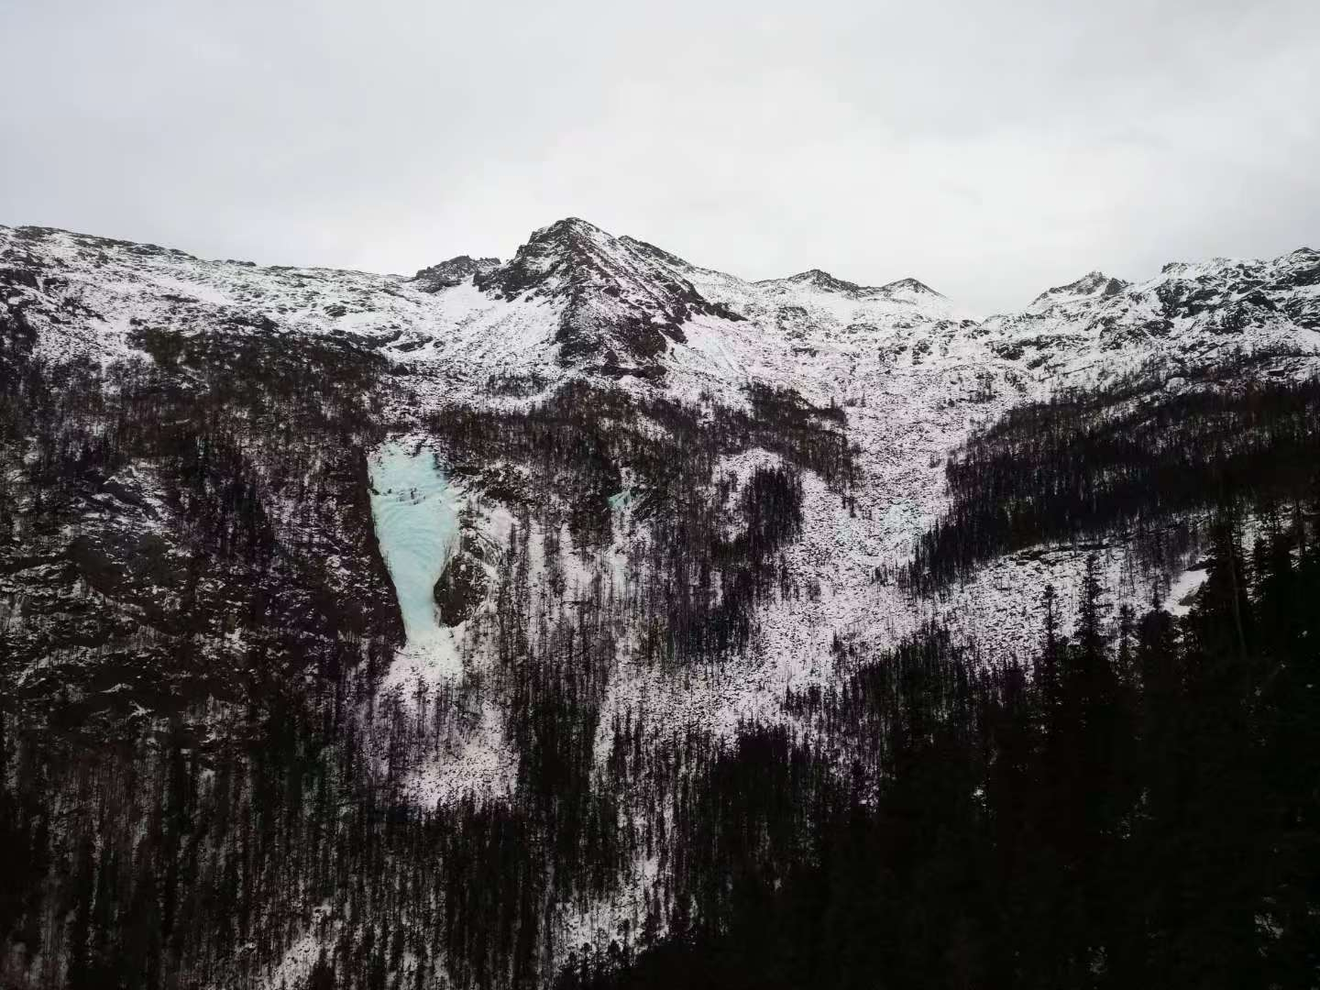
Fig. 5. Geographical overview of the Dagu Glacier scenic area. Photograph by the author, 2020
Burning Incense - Upon Tibetan mountain peaks, monasteries, and village entrances, one often beholds wisps of incense smoke curling upwards, passing through prayer flags and wind horses to blend with the azure sky and white clouds. This is the Tibetan ritual of burning incense, practised for millennia - an ancient rite where smoke converses with heaven and earth, and sincere devotion connects with all creation. The Tibetan term ‘bsang’ (煨桑) signifies ‘smoke offering ritual’. “Sang” (བསང་།) in Tibetan denotes ‘cleansing, expelling, purifying’, representing the most emblematic sacrificial rite in Tibetan Buddhism and folk belief (as shown in Figures 6–8). Tibetans hold that incense smoke ascends directly to the abodes of deities, conveying earthly supplications and offerings to the heavens. The ritual unfolds in three acts. The bsang altar is perpetually established in the ‘most pristine location’: the temple's mountain gate, rooftop, mountain pass, or sacred peak. Before ignition, participants first wipe the rim of the brazier with clear water or barley wine, chanting the Hundred-Syllable Mantra or the Six-Syllable Mantra to perform a ‘hand-washing rite’ for heaven and earth. Once the fire ignites, juniper branches are first cast in, followed by tsampa, roasted barley, tea leaves, sugar, and fruit. Finally, juniper branches dipped in purified water are sprinkled three times over the flames – ‘First sprinkle lightens sorrows, second sprinkle brings family prosperity, third sprinkle ensures all beings' peace.’ As smoke billows, the ritualist joins palms in supplication: praying for safe journeys, favourable weather, or the repose of the departed. When embers fade, ashes are scattered to the wind or river, signifying ‘merits returned to society, impurities carried away by water.’ During grand Buddhist assemblies, a straw effigy symbolising demonic obstacles is bound and set ablaze after a volley of arrows, signifying ‘the complete extinction of evil forces.’ Today, the burning of mulberry wood serves both as ‘folk ritual’ and ‘offering of smoke before the Buddha,’ seamlessly uniting the secular and sacred realms of the plateau. As the mulberry smoke rises, the distance between humans and the divine is but a breath of wind. Now, wherever you may be, light a Tibetan incense stick and let a wisp of sang smoke become our gentle reconciliation with the world. The wind carries your wishes to the snow-capped mountains, and brings back their blessings (Xinhua News, 2024)
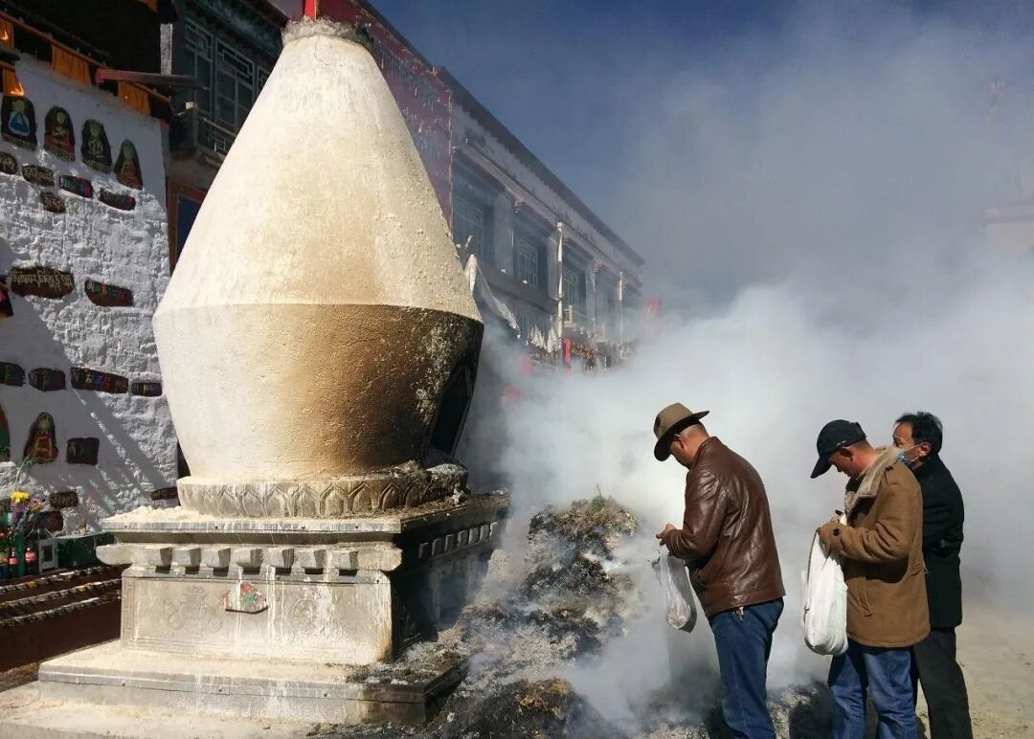
Fig. 6. Sang offering ritual in a Tibetan community near Dagu Glacier
Image source: WeChat Official Account (2024), “Dagu Glacier: A Sacred Landscape of Ice and Light”
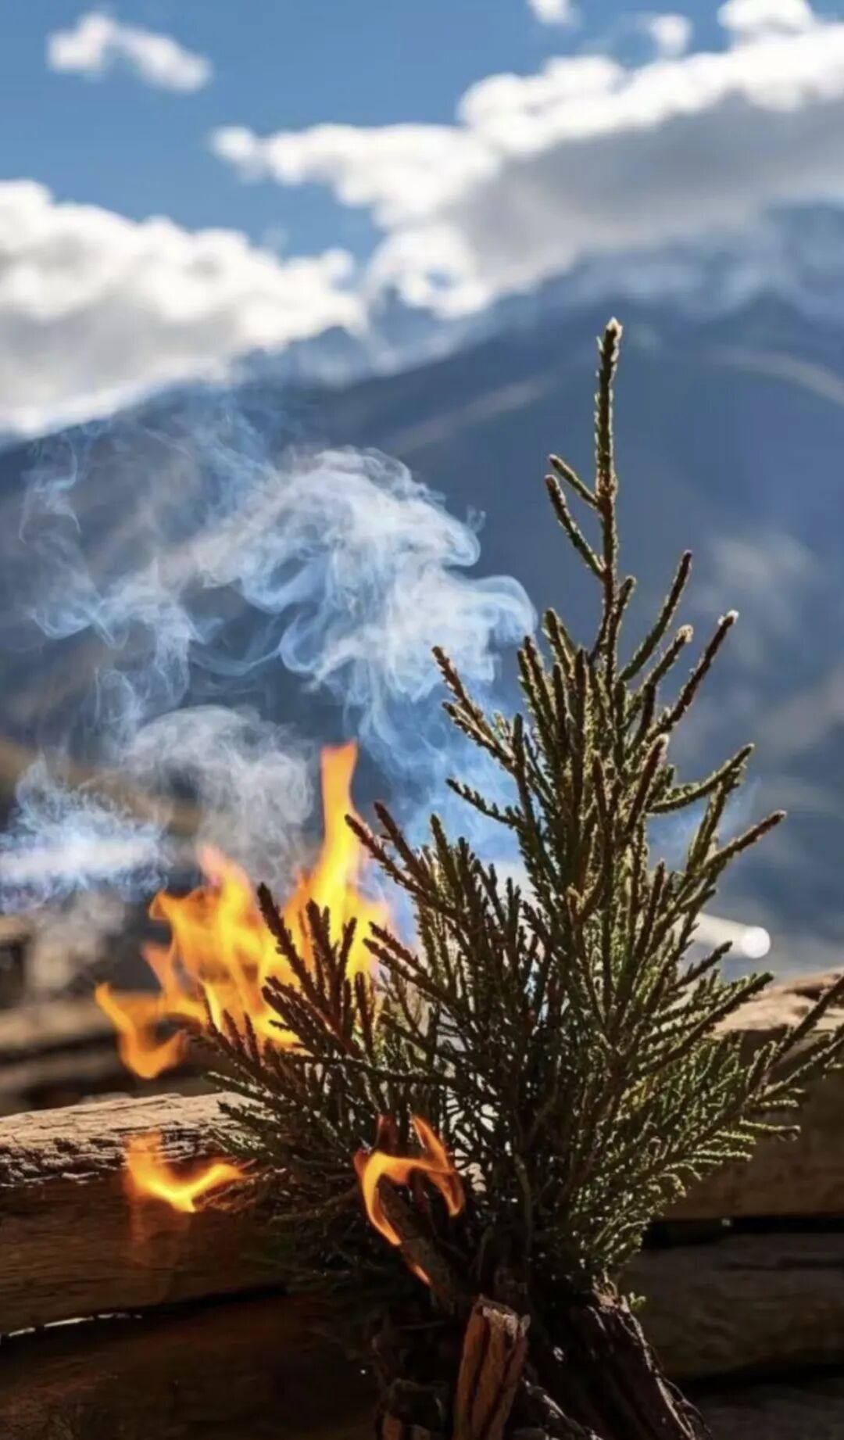
Fig. 7. Sang offering ritual in a Tibetan community near Dagu Glacier
Image source: WeChat Official Account (2024), “Dagu Glacier: A Sacred Landscape of Ice and Light”

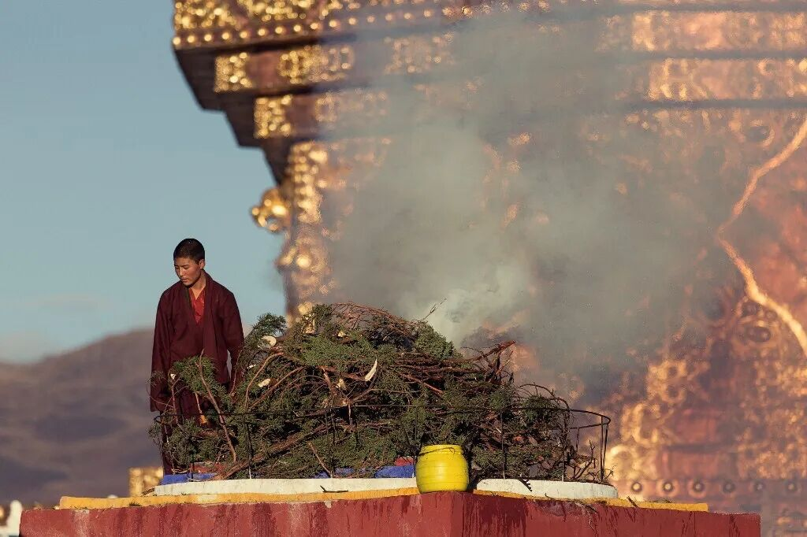
Fig. 8. Sang offering ritual in a Tibetan community near Dagu Glacier
Image source: WeChat Official Account (2024), “Dagu Glacier: A Sacred Landscape of Ice and Light”

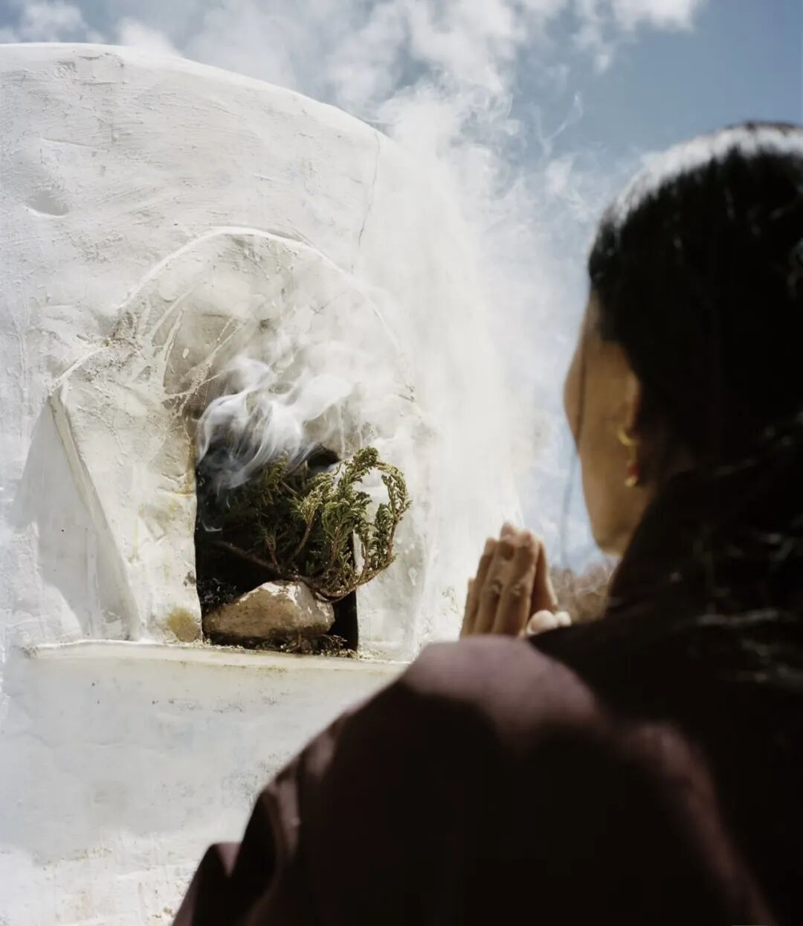
Fig. 9. Sang offering ritual in a Tibetan community near Dagu Glacier
Image source: WeChat Official Account (2024), “Dagu Glacier: A Sacred Landscape of Ice and Light”

Reference:
Chidester, D. and Linenthal, E. T. (eds.) (1995) American Sacred Space. Bloomington and Indianapolis: Indiana University Press. Cited in: Knott, K. (2005) ‘Spatial theory and method for the study of religion’, Temenos: Nordic Journal of Comparative Religion, 41(2), pp. 153–184.
Eliade, M. (1959 [1957]) The Sacred and the Profane: The Nature of Religion. San Diego, CA: Harcourt Brace Jovanovich.
Gagné, K., Rasmussen, M. B. and Orlove, B. (2014) ‘Glaciers and society: attributions, perceptions, and valuations’, WIREs Climate Change, 5(6), pp. 793–808. doi: 10.1002/wcc.315.
Goodwin, B. C. (1988) ‘Organisms and minds: the dialectics of the animal–human interface in biology’, in Ingold, T. (ed.) What Is an Animal? London: Unwin Hyman, pp. 73–101. Cited in: Ingold, T. (2000) The Perception of the Environment: Essays on Livelihood, Dwelling and Skill. London and New York: Routledge.
Knott, K. (2005) ‘Spatial theory and method for the study of religion’, Temenos: Nordic Journal of Comparative Religion, 41(2), pp. 153–184.
Ingold, T. (1990) ‘An anthropologist looks at biology’, Man (New Series), 25, pp. 208–229.
Cited in: Ingold, T. (2000) The Perception of the Environment: Essays on Livelihood, Dwelling and Skill. London and New York: Routledge.
Ingold, T. (1992a) ‘Culture and the perception of the environment’, in Croll, E. and Parkin, D. (eds.) Bush Base: Forest Farm. Culture, Environment and Development. London: Routledge, pp. 39–56. Cited in: Ingold, T. (2000) The Perception of the Environment: Essays on Livelihood, Dwelling and Skill. London and New York: Routledge.
Ingold, T. (2000) The Perception of the Environment: Essays on Livelihood, Dwelling and Skill. London and New York: Routledge.
Lane, B. C. (2001/2002) Landscapes of the Sacred: Geography and Narrative in American Spirituality. Expanded edition. Baltimore, MD and London: Johns Hopkins University Press.
Lewontin, R. C. (1982) ‘Organism and environment’, in Plotkin, H. C. (ed.) Learning, Development and Culture. Chichester: Wiley, pp. 151–170. Cited in: Ingold, T. (2000) The Perception of the Environment: Essays on Livelihood, Dwelling and Skill. London and New York: Routledge.
Li, Y. (2021) ‘Regeneration and development of Tibetan settlement landscapes based on the coordination of scenery and villages’, Journal of Landscape Research, 13(4), pp. 55–63.
Liu, P. (1998) ‘Ancient villages: a unique human settlement and cultural space’, Human Geography, (1), pp. 38–41. Cited in: Li, Y. (2021) ‘Regeneration and development of Tibetan settlement landscapes based on the coordination of scenery and villages’, Journal of Landscape Research, 13(4), pp. 55–63.
Pittendrigh, C. S. (1958) ‘Adaptation, natural selection and behavior’, in Roe, A. and Simpson, G. G. (eds.) Behavior and Evolution. New Haven, CT: Yale University Press, pp. 390–416. Cited in: Ingold, T. (2000) The Perception of the Environment: Essays on Livelihood, Dwelling and Skill. London and New York: Routledge.
Schama, S. (1995) Landscape and Memory. New York: Alfred A. Knopf. Cited in: Trubshaw, B. (2012) Thinking about Place: Themes in Place Studies. Wymeswold: Heart of Albion Press.
Stallybrass, P. and White, A. (1986) The Politics and Poetics of Transgression. London: Methuen. Cited in: Knott, K. (2005) ‘Spatial theory and method for the study of religion’, Temenos: Nordic Journal of Comparative Religion, 41(2), pp. 153–184.
The Holy Bible: New International Version (2011) Exodus 3:5. Grand Rapids, MI: Zondervan.
The Holy Bible: New International Version (2011) Genesis 28:12–19. Grand Rapids, MI: Zondervan. Cited in: Eliade, M. (1959 [1957]) The Sacred and the Profane: The Nature of Religion. San Diego, CA: Harcourt Brace Jovanovich.
Trubshaw, B. (2012) Thinking about Place: Themes in Place Studies. Wymeswold: Heart of Albion Press.
Tuan, Y.-F. (1979) ‘Thought and landscape: the eye and the mind’s eye’, in Meinig, D. W. (ed.) The Interpretation of Ordinary Landscapes. Oxford: Oxford University Press, pp. 89–102. Cited in: Ingold, T. (2000) The Perception of the Environment: Essays on Livelihood, Dwelling and Skill. London and New York: Routledge.
Van der Leeuw, G. (1986 [1933]) Religion in Essence and Manifestation. Princeton, NJ: Princeton University Press. Cited in: Knott, K. (2005) ‘Spatial theory and method for the study of religion’, Temenos: Nordic Journal of Comparative Religion, 41(2), pp. 153–184.
Wang, S. and Zhou, L. (2019) ‘Integrated impacts of climate change on glacier tourism’, Advances in Climate Change Research, 10(2), pp. 71–79. doi: 10.1016/j.accre.2019.03.005.
Wang, S., Qi, C., Zhou, L. et al. (2019) ‘The characteristics of the space-time structure, problem perspective and structural optimization of the tourist destination of Dagu Glacier’, Journal of Yunnan Normal University (Philosophy and Social Sciences Edition), 51(2), pp. 58–67.
Zhang, L. (2020) A Study on the Sustainable Development Strategies of Dagu Glacier. Journal of Glaciology and Geographical Research, 42(3), pp. 45–52.
Zhang, W., Li, M. and Wu, Z. et al. (2002) ‘Characteristics and evaluation of glacier water resources in Heishui County, Sichuan Province’, Journal of Mountain Science, 20(4), pp. 461–465.
Zhang, X., Li, H. and Wang, Y. (2018) ‘Experimental study on applying artificial intervention measures to mitigate glacier melting’, Journal of Glaciology and Geocryology, 40(3), pp. 512–520.

Eliade, M. (1959 [1957]) The Sacred and the Profane: The Nature of Religion. San Diego, CA: Harcourt Brace Jovanovich.
Lane, B. C. (2001/2002) Landscapes of the Sacred: Geography and Narrative in American Spirituality. Expanded edition. Baltimore, MD and London: Johns Hopkins University Press.
Zhang, L. (2020) A Study on the Sustainable Development Strategies of Dagu Glacier. Journal of Glaciology and Geographical Research, 42(3), pp. 45–52.
Wang, S. and Zhou, L. (2019) ‘Integrated impacts of climate change on glacier tourism’, Advances in Climate Change Research, 10(2), pp. 71–79. doi: 10.1016/j.accre.2019.03.005.
Schama, S. (1995) Landscape and Memory. New York: Alfred A. Knopf. Cited in: Trubshaw, B. (2012) Thinking about Place: Themes in Place Studies. Wymeswold: Heart of Albion Press.
Trubshaw, B. (2012) Thinking about Place: Themes in Place Studies. Wymeswold: Heart of Albion Press.
Trubshaw, B. (2012) Thinking about Place: Themes in Place Studies. Wymeswold: Heart of Albion Press.
Trubshaw, B. (2012) Thinking about Place: Themes in Place Studies. Wymeswold: Heart of Albion Press.
Trubshaw, B. (2012) Thinking about Place: Themes in Place Studies. Wymeswold: Heart of Albion Press.
Knott, K. (2005) ‘Spatial theory and method for the study of religion’, Temenos: Nordic Journal of Comparative Religion, 41(2), pp. 153–184.
Chidester, D. and Linenthal, E. T. (eds.) (1995) American Sacred Space. Bloomington and Indianapolis: Indiana University Press. Cited in: Knott, K. (2005) ‘Spatial theory and method for the study of religion’, Temenos: Nordic Journal of Comparative Religion, 41(2), pp. 153–184.
Stallybrass, P. and White, A. (1986) The Politics and Poetics of Transgression. London: Methuen. Cited in: Knott, K. (2005) ‘Spatial theory and method for the study of religion’, Temenos: Nordic Journal of Comparative Religion, 41(2), pp. 153–184.
Van der Leeuw, G. (1986 [1933]) Religion in Essence and Manifestation. Princeton, NJ: Princeton University Press. Cited in: Knott, K. (2005) ‘Spatial theory and method for the study of religion’, Temenos: Nordic Journal of Comparative Religion, 41(2), pp. 153–184.
Knott, K. (2005) ‘Spatial theory and method for the study of religion’, Temenos: Nordic Journal of Comparative Religion, 41(2), pp. 153–184.
Chidester, D. and Linenthal, E. T. (eds.) (1995) American Sacred Space. Bloomington and Indianapolis: Indiana University Press. Cited in: Knott, K. (2005) ‘Spatial theory and method for the study of religion’, Temenos: Nordic Journal of Comparative Religion, 41(2), pp. 153–184.
Knott, K. (2005) ‘Spatial theory and method for the study of religion’, Temenos: Nordic Journal of Comparative Religion, 41(2), pp. 153–184.
Chidester, D. and Linenthal, E. T. (eds.) (1995) American Sacred Space. Bloomington and Indianapolis: Indiana University Press. Cited in: Knott, K. (2005) ‘Spatial theory and method for the study of religion’, Temenos: Nordic Journal of Comparative Religion, 41(2), pp. 153–184.
Eliade, M. (1959 [1957]) The Sacred and the Profane: The Nature of Religion. San Diego, CA: Harcourt Brace Jovanovich.
Knott, K. (2005) ‘Spatial theory and method for the study of religion’, Temenos: Nordic Journal of Comparative Religion, 41(2), pp. 153–184.
The Holy Bible: New International Version (2011) Exodus 3:5. Grand Rapids, MI: Zondervan.
Eliade, M. (1959 [1957]) The Sacred and the Profane: The Nature of Religion. San Diego, CA: Harcourt Brace Jovanovich.
Eliade, M. (1959 [1957]) The Sacred and the Profane: The Nature of Religion. San Diego, CA: Harcourt Brace Jovanovich.
Eliade, M. (1959 [1957]) The Sacred and the Profane: The Nature of Religion. San Diego, CA: Harcourt Brace Jovanovich.
The Holy Bible: New International Version (2011) Genesis 28:12–19. Grand Rapids, MI: Zondervan. Cited in: Eliade, M. (1959 [1957]) The Sacred and the Profane: The Nature of Religion. San Diego, CA: Harcourt Brace Jovanovich.
Eliade, M. (1959 [1957]) The Sacred and the Profane: The Nature of Religion. San Diego, CA: Harcourt Brace Jovanovich.
Knott, K. (2005) ‘Spatial theory and method for the study of religion’, Temenos: Nordic Journal of Comparative Religion, 41(2), pp. 153–184.
Ingold, T. (2000) The Perception of the Environment: Essays on Livelihood, Dwelling and Skill. London and New York: Routledge.
Tuan, Y.-F. (1979) ‘Thought and landscape: the eye and the mind’s eye’, in Meinig, D. W. (ed.) The Interpretation of Ordinary Landscapes. Oxford: Oxford University Press, pp. 89–102. Cited in: Ingold, T. (2000) The Perception of the Environment: Essays on Livelihood, Dwelling and Skill. London and New York: Routledge.
Ingold, T. (1992a) ‘Culture and the perception of the environment’, in Croll, E. and Parkin, D. (eds.) Bush Base: Forest Farm. Culture, Environment and Development. London: Routledge, pp. 39–56. Cited in: Ingold, T. (2000) The Perception of the Environment: Essays on Livelihood, Dwelling and Skill. London and New York: Routledge.
Pittendrigh, C. S. (1958) ‘Adaptation, natural selection and behavior’, in Roe, A. and Simpson, G. G. (eds.) Behavior and Evolution. New Haven, CT: Yale University Press, pp. 390–416. Cited in: Ingold, T. (2000) The Perception of the Environment: Essays on Livelihood, Dwelling and Skill. London and New York: Routledge.
Ingold, T. (2000) The Perception of the Environment: Essays on Livelihood, Dwelling and Skill. London and New York: Routledge.
Goodwin, B. C. (1988) ‘Organisms and minds: the dialectics of the animal–human interface in biology’, in Ingold, T. (ed.) What Is an Animal? London: Unwin Hyman, pp. 73–101. Cited in: Ingold, T. (2000) The Perception of the Environment: Essays on Livelihood, Dwelling and Skill. London and New York: Routledge.
Ingold, T. (2000) The Perception of the Environment: Essays on Livelihood, Dwelling and Skill. London and New York: Routledge.
Ingold, T. (1990) ‘An anthropologist looks at biology’, Man (New Series), 25, pp. 208–229. Cited in: Ingold, T. (2000) The Perception of the Environment: Essays on Livelihood, Dwelling and Skill. London and New York: Routledge.
Ingold, T. (2000) The Perception of the Environment: Essays on Livelihood, Dwelling and Skill. London and New York: Routledge.
Lane, B. C. (2001/2002) Landscapes of the Sacred: Geography and Narrative in American Spirituality. Expanded edition. Baltimore, MD and London: Johns Hopkins University Press.
Lane, B. C. (2001/2002) Landscapes of the Sacred: Geography and Narrative in American Spirituality. Expanded edition. Baltimore, MD and London: Johns Hopkins University Press.
Gagné, K., Rasmussen, M. B. and Orlove, B. (2014) ‘Glaciers and society: attributions, perceptions, and valuations’, WIREs Climate Change, 5(6), pp. 793–808. doi: 10.1002/wcc.315.
Wang, S., Qi, C., Zhou, L. et al. (2019) ‘The characteristics of the space-time structure, problem perspective and structural optimization of the tourist destination of Dagu Glacier’, Journal of Yunnan Normal University (Philosophy and Social Sciences Edition), 51(2), pp. 58–67.
Wang, S. and Zhou, L. (2019) ‘Integrated impacts of climate change on glacier tourism’, Advances in Climate Change Research, 10(2), pp. 71–79. doi: 10.1016/j.accre.2019.03.005.
Zhang, X., Li, H. and Wang, Y. (2018) ‘Experimental study on applying artificial intervention measures to mitigate glacier melting’, Journal of Glaciology and Geocryology, 40(3), pp. 512–520.
Zhang, W., Li, M. and Wu, Z. et al. (2002) ‘Characteristics and evaluation of glacier water resources in Heishui County, Sichuan Province’, Journal of Mountain Science, 20(4), pp. 461–465.
Li, Y. (2021) ‘Regeneration and development of Tibetan settlement landscapes based on the coordination of scenery and villages’, Journal of Landscape Research, 13(4), pp. 55–63.
Li, Y. (2021) ‘Regeneration and development of Tibetan settlement landscapes based on the coordination of scenery and villages’, Journal of Landscape Research, 13(4), pp. 55–63.
Gagné, K., Rasmussen, M. B. and Orlove, B. (2014) ‘Glaciers and society: attributions, perceptions, and valuations’, WIREs Climate Change, 5(6), pp. 793–808. doi: 10.1002/wcc.315.

