

University of Wales
Trinity Saint David

Davis Gary Watkins
BSc Motorsport Engineering
Emissions Control & Diagnosis (M5X02202)
Emissions Assignment 2

1.0: Abstract
This report will focus on the many components and methods used to improve and remove some of the emissions produced by the engine, also explaining the Euro Emissions Standards from the past and a small amount into the future standards Euro 7. It will cover the components used to reduce emissions such as a catalytic converter, and the methods used such as SAIR (Secondary Air Injection). The report explains that a vehicle can be upgraded from an older emissions standard to a newer one and how this is achieved, also a more in depth look at one of the important emissions produced by the engine.

Contents
(1.0) Abstract (Page 2)
(1.1) Introduction (Page 3)
(1.2) Research of Emission Standards (Page 4)
……… 1.2.1: Euro 5
……… 1.2.2: Euro 6
(1.3) Research of Emission Controls (Page 6)
……… 1.3.1: Catalytic Converter, EVAP, EGR, SAIR, PCV, Air/Fuel ratio
(1.4) Upgrading to Euro 6 (Page 9)
(1.5) Conclusion (Page 9)
(1.6) Bibliography (Page 11)
(1.7) References (Page 14)

1.1: Introduction
Although the vehicles on the road have been using an engine for many years now, in the last decade a lot of people have been switching to electrical or hybrid cars because they’re better for the environment. Engines manage to produce a lot of emissions that are harmful to the environment and some are even hazardous to us, but over the years these emissions have been improved and adjusted by the Euro Emissions Standards. These standards give vehicle manufacturers a limit on how much of each emission their engine can produce, otherwise it wouldn’t meet the standards, and the amount of emissions produced has been declining every time so it’s difficult for manufacturers to achieve these required amounts.
Many vehicle manufacturers try to bypass these tests by adjusting the engine map before the testing to improve the emission outputs from the engine, then after testing the manufacturer would adjust the engine map back to the previous version which would produce increased amounts of emissions but may produce better engine power which may be preferred by the customer.
So, these vehicles would pass the emissions standards but when they’re sold and put onto the road, they manage to produce much higher values than what’s allowed to be produced by the engine, which is bad for the environment.
Manufacturers these days are trying everything they can to reduce the emissions outputted from their engines, but more and more manufacturers are slowly moving to the production of electrically powered vehicles which has benefits and downsides over an engine.
For example, the electrically powered vehicles wouldn’t produce the emissions that an engine does, but they need to be charged which can take a very long time, so in a rush this could be a very bad disadvantage over a few minutes to refill and engine with fuel to continue on the journey. However, the power output from the electrically powered vehicles are very high, but more sustainable power sources are always being researched and tested to improve them further.

1.2: Emissions Standards
Petrol and diesel engines both have different emissions standards that they must stick to, so they’d be similar but there are exceptions for each engine. For example, a diesel engine has strict Carbon Monoxide (CO) limits compared to a petrol engine but is allowed to produce slightly higher Nitrogen Oxide (NOx) than the petrol engine.
These emissions standards limit the amount of nitrogen oxides (NOx), total hydrocarbon (THC), non-methane hydrocarbons (NMHC), carbon monoxide (CO) and particulate matter (PM) of these engines in cars, trucks, lorries, locomotives, tractors and some machinery. However, each type has different emissions standards to follow and any not following these standards won’t be sold in the EU.

1.2.1: Euro 5
Euro 5 – from Euro 4 this has reduced the number of particulates produced from a diesel engine by up to 80%, but only having a small reduction in NOx produced from 250mg/km down to 180mg/km compared to the 70mg/km for petrol engines but Euro 5 also introduced a particulate limit for petrol engines that are using direct injection.

Euro 5 emission limits (petrol)
- CO – 1.0 g/km
- HC - 0.10 g/km
- NOx – 0.06 g/km
- PM – 0.005 g/km (direct injection only)

Euro 5 emission limits (diesel)
- CO – 0.50 g/km
- HC+ NOx – 0.23 g/km
- NOx – 0.18 g/km
Figure 1 – TheAA.com (2019)
- PM – 0.005 g/km
- PM – 6.0x10 ^11/km

1.2.2: Euro 6
From Euro 5 this emissions standard even further reduced the output of NOx by 67%, this can be helped by fitting an Exhaust Gas Recirculation (EGR) system by reburning the exhaust gases for a second time by reducing the amount of nitrogen available to be oxidised to produce NOx.
Diesel engines may also be fitted with extra equipment such as a NOx absorber which stores the NOx and uses a catalyst to reduce it to just nitrogen. Or Selective Catalytic Reduction (SCR) which uses and additive such as AdBlue, this is where a bit of urea is injected into the exhaust for converting the NOx into nitrogen and water. Or sometimes even the use of Cerium in the fuel tank can improve the emissions, it does this by assisting the DPF regeneration from lowering the temperature needed for it to work effectively.
Unfortunately for vehicle manufacturers, a more thorough set of tests have been introduced for Euro 6 to try and avoid any vehicle manufacturers being able to lie about the emissions output from their engines which is often the case by going through a test which doesn’t simulate real world driving, therefore producing a much lower value than if it were to be driven by a customer after purchase.
A new test called the Real Driving Emissions (RDE) test is being introduced in 2 stages, the first being applied to vehicles from September 2017 and then the second stage being applied to vehicles from January 2020.

Euro 6 emission limits (petrol)
- CO – 1.0 g/km
- HC – 0.10 g/km
- NOx – 0.06 g/km
- PM – 0.005 g/km (direct injection only)
- PM – 6.0x10 ^11/km (direct injection only)

Euro 6 emission limits (diesel)
- CO – 0.50 g/km
- HC+ NOx – 0.17 g/km
NOx – 0.08 g/km
- PM – 0.005 g/km
Figure 2 – TheAA.com (2019)
- PM – 6.0x10 ^11/km
1.3: Research of Emission Controls
Catalytic Converter – All petrol cars from 1993 onwards must be fitted with one. This reduces the amount of harmful pollutants by converting them into water vapour and less harmful gases using a chemical reaction. The catalytic converter includes ceramics which is filled with little pores less than 1mm thick, these pores are covered in metals such as platinum, palladium and rhodium which heat up and react chemically with the exhaust gases to reduce the harmful gases released into the atmosphere. For example, the Carbon Monoxide (CO) and Hydrocarbons (HC) are converted into Carbon Dioxide (CO2) and Water (H20) which are much less harmful. However, a catalytic converter has an ideal temperature range to maximise the efficiency so fitting it closer to the exhaust manifold will warm this us quicker and keep it at a higher temperature than fitting it further down the exhaust system. Too below or too high above this temperature will reduce the efficiency and therefore produce more emissions. Some cars will even have more than one catalytic converter installed on an exhaust system, the first would break down the exhaust gases as normal and then the second one further on would help as a filter for particles whilst also further reducing the harmful gases.
A catalytic converter is shown in the image below, but a more detailed image is shown by Figure 4 in the bibliography.
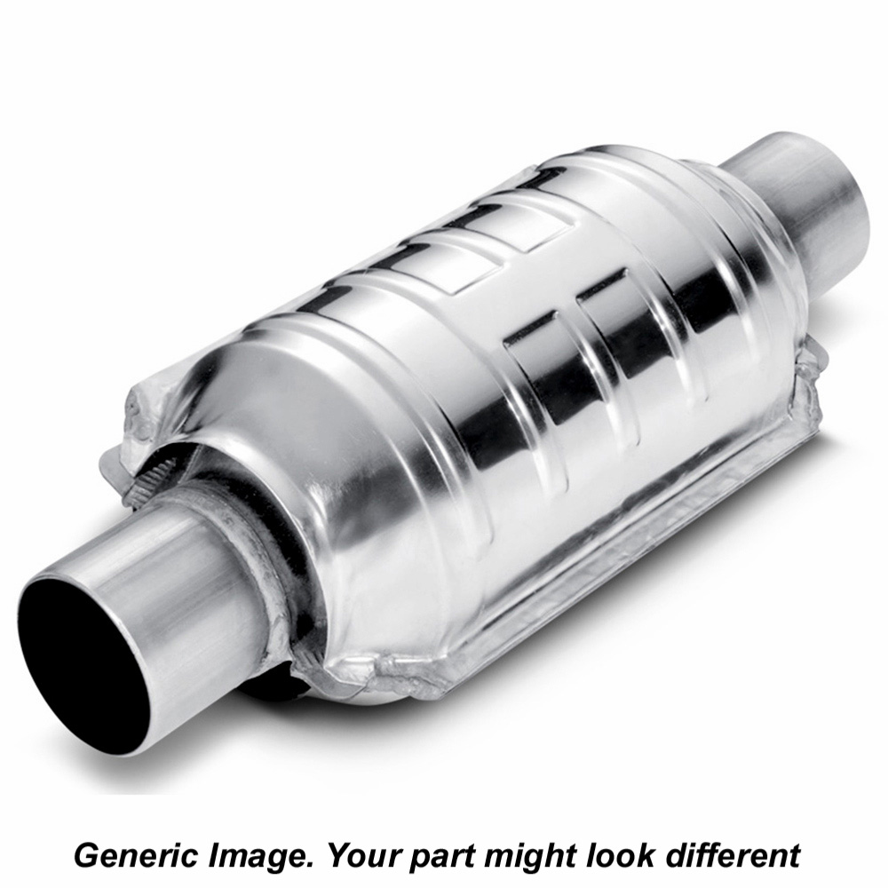
Figure 3 – Catalytic Converter, KwikFit.com (2019)

Evaporative Emission Control (EVAP) – The EVAP system would seal the vehicles fuel system to prevent any fuel vapours from escaping into the atmosphere, this would be bad as the fuel vapours contain a variety of hydrocarbons. The fuel evaporates quickly so if it were able to be released into the atmosphere then there would be pollution from the vehicle constantly, which these vapours would account for up to 20% of the pollution caused by a vehicle. An image of this system is shown by Figure 5 in the bibliography.

Exhaust Gas Recirculation (EGR) – The EGR system is very helpful in reducing the NOx produced by the engine. It uses the exhaust gases and reuses some in the cylinder to reduce the amount of oxygen being used and lowers the combustion temperatures, so therefore there’s less oxygen to combine with the nitrogen to produce less Nitrogen Oxide (NOx). An image of this system is shown by Figure 6 in the bibliography.

Secondary Air Injection (SAIR) – The SAIR system is used to help an engine to reduce the emissions produced during a cold start, this is where the engine hasn’t been run for a while, but the system will stop working once the engine has reached an acceptable temperature. It can do this by introducing some air into the exhaust system to mix with the gases flowing through, and this oxygen will mix with the gases to convert the HC and CO into less harmful CO2 and H2O. An image of this system is shown by Figure 7 in the bibliography.

Positive Crankcase Ventilation (PCV) – The PCV system helps to reuse any of the air/fuel mixture that was able to make its way past the piston rings and down into the crankcase to cause problems. It uses a valve to remove the mixture and add it back into the intake manifold to be used again. This system is mainly used for idling or slow speeds where the pressure is lower. An image of this system is shown by Figure 8 in the bibliography.
Air/Fuel ratio – This can be easily adjusted to achieve the most efficient combustion, which for petrol powered engines this efficient point is considered to be at a 'Stoichiometric' of 14.7:1, meaning it is combusting a mixture of 14.7 parts of air to one part of fuel for it to burn the highest percentage of the mixture in the cylinder, so to burn 1kg of fuel you would need 14.7kg of air. However, an engine can burn a mixture differently to 14.7:1, where anything above that value is considered as a lean mixture where it burns less fuel, and anything below that value is considered as a rich mixture where it burns more fuel.
Shown below is the ideal air/fuel ratio for many different fuels.
Fuel | Chemical formula | AFR
Methanol | CH₃OH | 6.47:1
Ethanol | C₂H₅OH | 9:1
Butanol | C₄H₉OH | 11.2:1
Diesel | C₁₂H₂₃ | 14.5:1
Gasoline | C₈H₁₈ | 14.7:1
Propane | C₃H₈ | 15.67:1
Methane | CH₄ | 17.19:1
Hydrogen | H₂ | 34.3:1
Running a leaner mixture (above stoichiometric) would improve the fuel consumption but it would also produce more emissions such as carbon monoxide as there’s more oxygen being introduced to the air/fuel mixture and burning less of the mixture and the lambda sensor would pick up on this difference. Running a richer mixture (below stoichiometric) would increase the power output but affect the fuel consumption whilst producing more emissions and a visible cloud of black smoke will appear from the exhaust under acceleration.

1.4: Upgrading to Euro 6
In order to upgrade an engine from Euro 5 to Euro 6, many stages of upgrades are required to achieve an official compliance of Euro 6. To start there are much stricter limits on the emissions produced from an engine with the higher emissions standards, so to become compliant with the next euro emissions standard the engine would need to follow these lower emission outputs. Certain methods would need to be taken for reducing the emissions low enough for compliance with Euro 6 standards, such as Selective Catalytic Reduction (SCR) where a liquid is injected into the exhaust system of a diesel vehicle. Or fitting an Exhaust Gas Recirculation (EGR) system to the vehicle to lower the combustion temperature and therefore lowering the emissions. If your vehicle is capable of producing the very low emission outputs of Euro 6 and with all the necessary equipment installed onto the system, then it can be compliant with the Euro 6 emissions standards.

1.5: Conclusion
From euro 1 in 1992 up to euro 6 in 2014, as the newer emissions standards have been implemented there has been a massive reduction in the harmful gases leaving the exhaust system of a fuel powered vehicle, but an increasing number of motorists have transferred to electrically powered cars or hybrids because they produce none or much less emissions than a fuel powered engine does. There have been discussions about manufacturers only producing electrically powered cars in the future, this will try to cut the emissions coming from vehicles especially in highly populated areas.
‘“By 2025, we will offer 25 electrified vehicles – 12 will be fully-electric,” Chief Executive Harald Krueger told journalists in Munich, adding the electric cars would have a range of up to 700 km (435 miles).’ (Taylor, 2017).
So, every year vehicle manufacturers are trying to develop new ways of reducing the emissions being produced by the engines, but many manufacturers are deciding to just move to hybrid or fully electrically powered vehicles to avoid these problems, but that could see a rise in vehicle sales prices due to the technology needed for these vehicles. The problem with electrically powered vehicles is the duration that they take to charge as this could take many hours, and many more charging points would need to be installed in most countries around the world which would cost a lot of money.
So many vehicle manufacturers believe that it’s the best idea to start focusing on methods to upgrade the electrically powered vehicles ready for the future, as it may be possible that without any major improvements the fuel powered engines may become almost impossible to produce the rapidly decreasing amounts of emissions that will be asked of them in the future.
‘As we move closer to 2040, “the majority of cars will be electrified in some way and the engine may no longer be the primary drive; its role would be to support an electric motor”, says Ricardo’s chief technical and innovation officer, Neville Jackson. In that case, the engine is likely to be smaller, highly boosted by turbocharger or an electrical boost system and redefine the idea of high efficiency.’ (Burt, 2016). So, this statement shows the fact Neville Jackson believes that the future will move to electrically powered cars instead of engines.
So, to conclude the future of engines, there is solid statements that believe the future includes mainly electrically powered vehicles instead of using an engine. Research shows that this would be the best idea for removing the emission outputs from the vehicles on the road, but it may not be the most cost effective method, possibly causing a decent rise in the vehicle sale prices thanks to the technology involved in these vehicles.
I am personally excited to see where the future takes the vehicle marketplace, but I’m hoping the technology arrives very soon that’s needed to help the fuel powered engines to stay around for a while longer. However, from the research it appears that this may not happen as the electrically powered vehicles are quickly taking over the marketplace.

1.6: Bibliography
- Figure 4 – Catalytic Converter internal components diagram
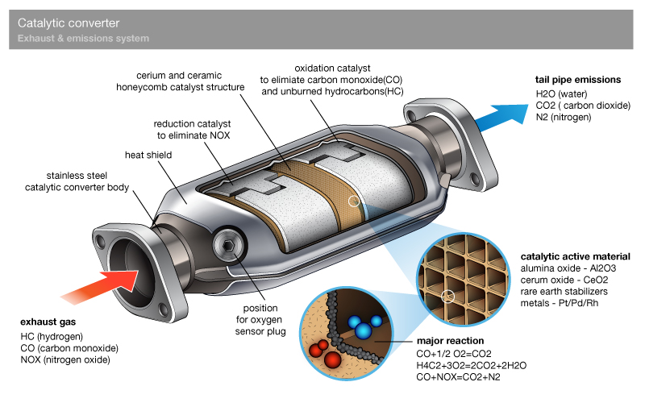
Figure 4 – Catalytic Converter, KwikFit.com (2019)

- Figure 5 – Engine EVAP system diagram
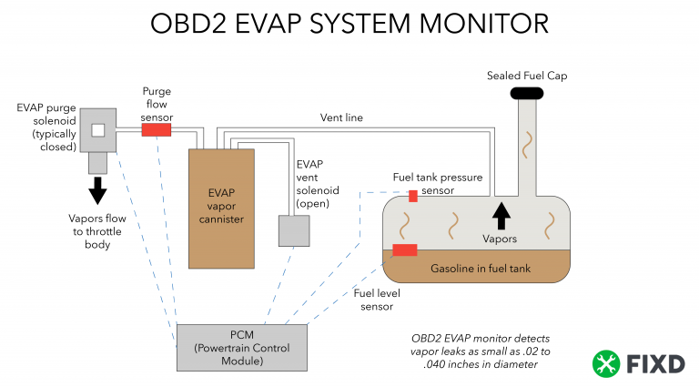
Figure 5 – Engine EVAP, Fixdapp.com (2019)

- Figure 6 – Engine EGR system diagram
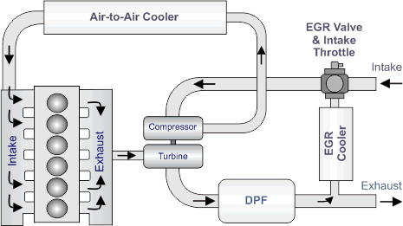
Figure 6 – Engine EGR, Fixdapp.com (2019)

- Figure 7 – Engine SAIR system diagram
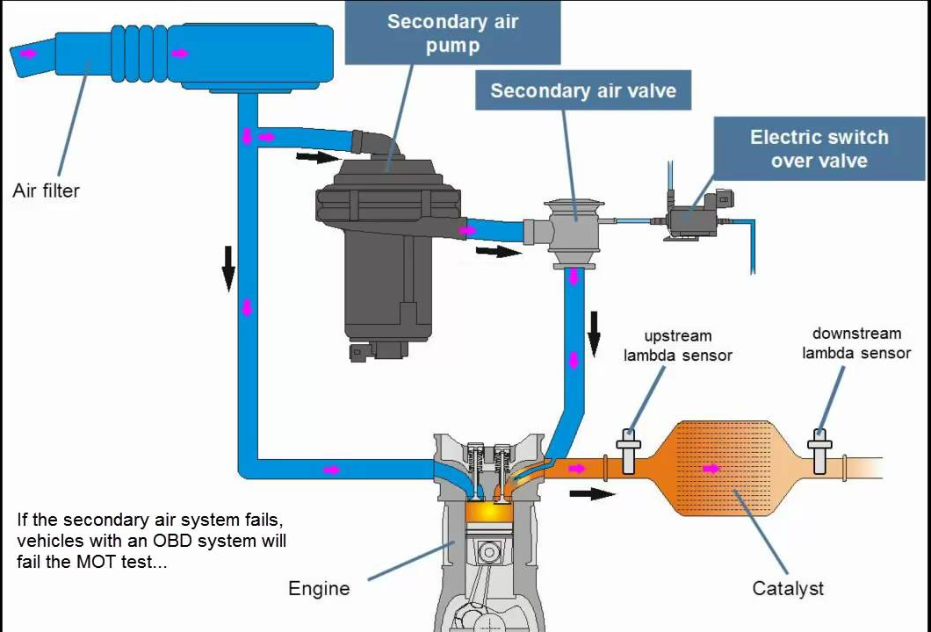
Figure 7 – Engine SAIR, Youtube.com (2019)

- Figure 8 – Engine PCV system diagram
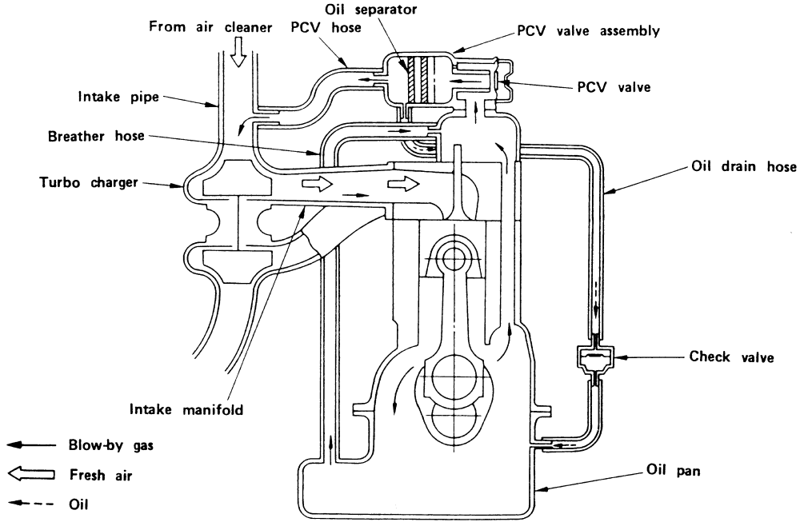
Figure 8 – Engine PCV, Autozone.com (2019)

1.7: References
- Euro Emissions Research – AA Authors, (2017), theaa.com, Limits to improve air quality and health, https://www.theaa.com/driving-advice/fuels-environment/euro-emissions-standards [Online]. [Accessed 14/03/19]

- Catalytic converter research – KwikFit Authors, kwikfit.com, What does a catalytic converter do?, https://www.kwik-fit.com/exhausts/information/catalytic-converters [Online]. [Accessed 14/03/19]

- EVAP research – Fixdapp Authors, (2018), fixdapp.com, Evaporative Emission Control (EVAP) System, https://www.fixdapp.com/blog/evap-system [Online]. [Accessed 14/03/19]

- EGR research – Perkins Authors, perkins.com, The benefits of exhaust gas recirculation (EGR), https://www.perkins.com/en_GB/products/emissions_technology/emissions-technology/exhaust-gas-recirculation.html [Online]. [Accessed 14/03/19]

- SAIR research – Hella Authors, hella.com, Secondary Air Injection System, https://www.hella.com/techworld/uk/Technical/Car-electronics-and-electrics/Secondary-air-injection-system-3296/ [Online]. [Accessed 15/03/19]

- PCV research – Christopher Lampton, (2012), howstuffworks.com, How does a positive crankcase ventilation (pcv) system work?, https://auto.howstuffworks.com/positive-crankcase-ventilation-system.htm [Online]. [Accessed 15/03/19]

- Air/Fuel Ratio research – Anthony Stark, X-Engineer.org, Air-fuel ratio, lambda and engine performance, https://x-engineer.org/automotive-engineering/internal-combustion-engines/performance/air-fuel-ratio-lambda-engine-performance/ [Online]. [Accessed 15/03/19]
- Edward Taylor, (2017), uk.reuters.com, BMW gears up to mass produce electric cars by 2020, https://uk.reuters.com/article/uk-autoshow-frankfurt/bmw-gears-up-to-mass-produce-electric-cars-by-2020-idUKKCN1BI1KN, [Online]. [Accessed 15/03/19]

- Matt Burt, (2016), autocar.co.uk, The future of motoring - what will cars be like in 25 years?, https://www.autocar.co.uk/car-news/new-cars/future-motoring-what-will-cars-be-25-years, [Online]. [Accessed 15/03/19]

