Using Theme Roller

A handy tool for creating the look of your jQuery Mobile site quickly is Theme Roller for jQuery Mobile. This can be found at: https://themeroller.jquerymobile.com/

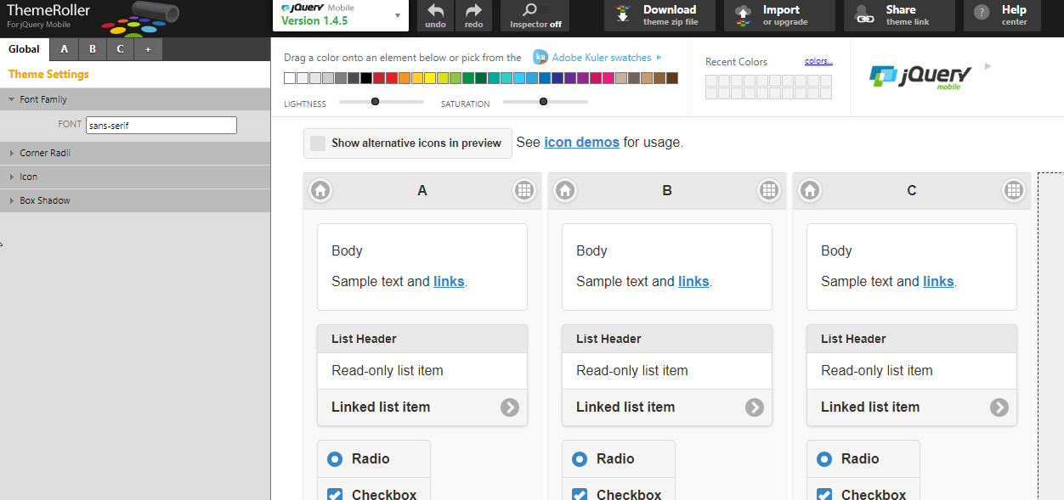

For example, here I have made the corners of elements square (Global) and changed the background colour of the heading:

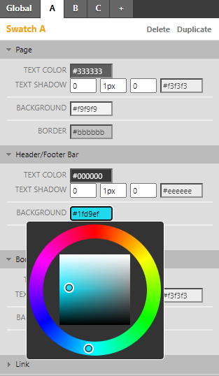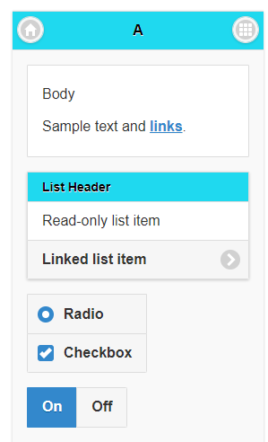

I can use Theme Roller to affect almost every element (there maybe still be times when we use CSS manually to get specific effects). Below, I have changed many of the elements, made the icons darker, changed the link colour, background colour of page, and colour of active state:

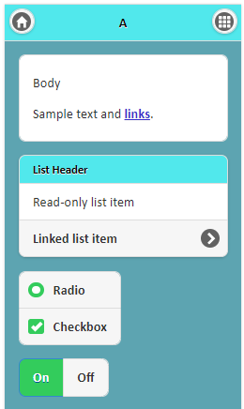

When I am happy with my colour/layout, I download the css files. Look at the top of the page for the link to do this:

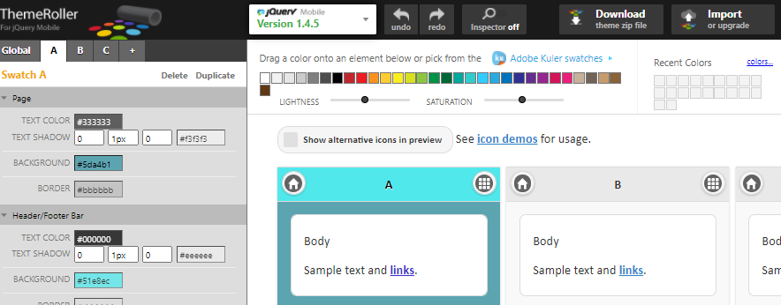

Click "Download theme zip file"

A screen will appear inviting you to give your theme a name. I've put my_turquoise_theme:

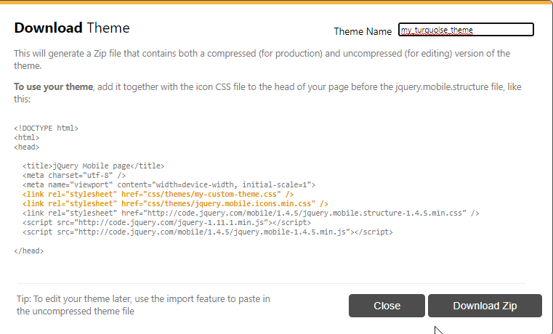

Click on "Download Zip" at the bottom, and it will download something like this:

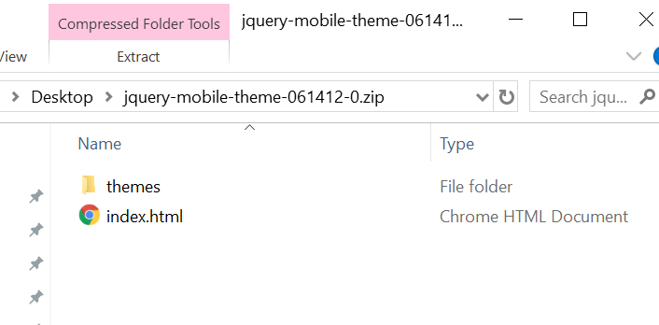

The themes folder contains the .css files for your new theme. Unzip, and move the whole folder into the location of your jQuery mobile file.

Open index.html and find the following two lines:

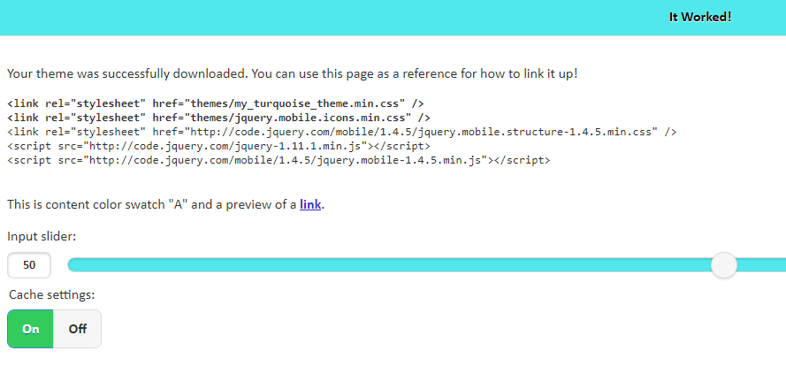

Copy and paste these two lines into your required file as follows (I've used my JQuery Mobile Panel demo file as an example here)

<head>

<script src="jquery.js"></script>
<script src="http://code.jquery.com/jquery-migrate-3.0.0.js"></script>
<link rel="stylesheet" href="jquery.mobile-1.4.5/jquery.mobile-1.4.5.css">

<link rel="stylesheet" href="themes/my_turquoise_theme.min.css" />
<link rel="stylesheet" href="themes/jquery.mobile.icons.min.css" />

<script src="jquery.mobile-1.4.5/jquery.mobile-1.4.5.js"></script>

</head>

Original:

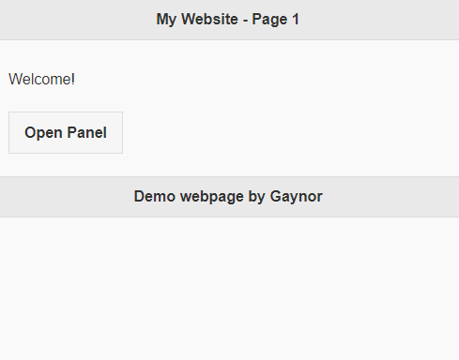

with ThemeRoller css file:



