

Toyota

Andrew Omoregie I.D 2317934
LCLM5005- Organisational Culture
Lecturer Name: Toyin Adisa
Contents
Abstract 2
1. Introduction 2
2. Organizational Culture of Toyota: Structure and Decision-Making 3
2.1. Company Structure of Toyota 3
3. Types of cultures in Toyota 3
3.1. Schein’s Three-Level Model 3
3.1.1 Artefacts (Visible Practices and Symbols) 4
3.1.2 Espoused Values 4
3.1.3 Underlying Assumptions 4
3.2. Hofstede’s Cultural Dimensions and Toyota 4
3.3. Handy’s Cultural Types 6
4. Toyota Organisational culture and external environment 6
5. Organisational Culture as a Barrier to Effective Functioning 7
6. Impact of Organisational Culture on Toyota’s Performance 8
7. Recommendations for Improvement 8
8. Conclusion 9
References 11

Abstract
This report provides a critical analysis of the role of organisational culture at automotive company- Toyota Japan, by addressing how some aspects of organisation culture have impact on its structure, decision-making and performance. Of the many available theoretical frameworks for understanding culture at companies (e.g.: Schein’s model, Hofstede’s dimensions of culture, Handy’s organisational cultures and Competing Values Framework), Mullins and Christy (2016) see culture as “the way things are done around here”, characteristic of an organisation. The results indicate that the Toyota culture- based on Toyota Way principles of continuous improvement (Kaizen) and respect for people—significantly influences its decentralised, team-based and consensus-oriented decision-making. The study also reveals how Toyota uses culture to learn, create, and perform in the face of changes in the external environment. Special ultimately struggles against straitjacketed cultural rigidity and consensus values that get in the way, especially when confronting crisis and bridging gaps or fissures between global cultures. Yet, despite these barriers, Toyota’s culture makes an appreciable positive difference in quality, productivity, and commitment to innovation among employees. The article concludes by providing suggestions for building flexibility, speeding up digitalisation, deepening the cross-cultural learning and enriching organisational agility in culture.

Introduction
Culture can be defined as a shared way of life, customs, values, behavior and artefacts, including beliefs that characterise a group or society. Culture is a complex system that includes everything from language, traditions, and arts to unconscious norms like bedrock with visible elements on top and deeper, harder to see values underneath.
Organisational culture is considered to be one of the most potent forces affecting how organisations operate, make decisions, and react to their environment. Culture has been defined by Mullins and Christy (2016) as “how things are done around here,” to stress that shared values and beliefs of people in an organisation shape various processes, including functioning, decision-making, structure, communication, group behaviour, and performance. Due to the fact that firms today face the need to operate in more global and culturally diverse environments, it is of great importance to understand organisational culture.

In this report, the culture of Toyota Motor Corporation, one of the world’s leading automotive companies and a global leader in lean manufacturing, innovation, and operational excellence, will be analysed. The company has a distinctive culture reflected in Toyota Way, which is focused on continuous improvement (Kaizen), respect for people, teamwork, problem-solving, and long-term thinking.
To that end, the following areas will be addressed:
- How the firm’s organisational culture affects its structure and decision-making;
- Identification of the company’s culture using various theoretical models and assessment of how well they represent the organisation;
- Factors of the firm’s culture that allow it to adapt to the external environment, and whether there are barriers to effective functioning due to culture;
- Culture’s impact on performance and recommendations for improvement.

Organizational Culture of Toyota: Structure and Decision-Making

Company Structure of Toyota
Toyota Motors is a hierarchical, formal team-based organization. The company operates in the down structure. Board of Directors and executive management hold authority, and control. The organization's divisional size consist of divisions like Toyota North America.The divisional organisation is based on product divisions such as Lexus and compact cars. The divisional structure allows the company to be more responsive to markets. A feature that makes Toyota’s structure unique is the degree to which it is built on teams, especially in its production process. The Toyota Production System (TPS) gives teams the authority to problem-solve and continuously improve (Kaizen), leading to both global integration and local innovation. Toyota’s decision-making process is based on a cultural phenomenon called Nemawashi (consensus-building). Nemawashi involves the need to consult all stakeholders before a decision is taken.
Some key characteristics:
- Slow but deliberate decision-making: Toyota takes the time to understand a problem (Genchi Genbutsu: “go and see”) before acting.
- Bottom-up influence: Employees have a sense of empowerment that allows them to raise an issue or stop the production line on the spot (Andon cord) if they notice a quality problem, which is an indication of high commitment within the culture.
- Long-term nature: Decision-making is based on a long-term sustainable approach (Liker, 2004)

In sum, values of respect, consensus and continuous improvement are directly translated to the point of decision making at Toyota.

Types of cultures in Toyota

Schein’s Three-Level Model
Schein's model of organisational culture consists of three levels: artefacts (observable), espoused values (aspiration and mission) and underlying assumptions (beliefs). Artefacts (observable but difficult to interpret) are basic assumptions not visible, have a high impact on behaviour and the most stable/immune to change (Schein, 2010).

3.1.1 Artefacts (Visible Practices and Symbols)
Toyota culture consists of the practices and tools used to direct work. Toyota has work charts. Toyota has pull cords to signal problems on the production line. Toyota holds Kaizen workshops to direct focus to continuous improvement. Toyota has visual management boards that show performance metrics and the status of workflow. Toyota also has rituals, such as morning reflections and team huddles. Toyota uses those rituals to build discipline and to keep communication steady. All of these things show the cultural values of Toyota: precision, teamwork, openness and ongoing improvement.

3.1.2 Espoused Values
Toyota values are spelt out in the Toyota Way. The Toyota Way says Toyota must keep improving respect, people work as a team, focus on the customer, stay humble and keep learning. Toyota's values guide how Toyota behaves. Toyota values shape how Toyota makes decisions, how Toyota employees talk and how Toyota sets up processes. Toyota values give everyone an idea of what matters in Toyota. Toyota values are the basis for Toyota's work.

3.1.3 Underlying Assumptions
At the deepest level of culture is a set of underlying assumptions that are taken for granted by organisation members. Here are some examples: Employees are trustworthy, competent and are a key ingredient in creating the best solutions to problems. Quality is everybody's business. Continuous improvement is a never-ending activity. Unconscious beliefs drive organisational behaviour and decision-making. They make up the invisible but mighty heart of Toyota's culture.

Hofstede’s Cultural Dimensions and Toyota

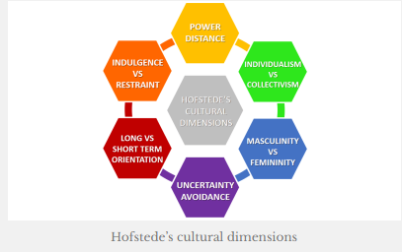 (Shohana, 2025)
The four elements in Hofstede’s cultural model that explain the significant behavioural patterns in Toyota’s national culture are Japan's relatively high score in power distance. The very low individualism score, Japan's relatively high uncertainty avoidance, the country's very high score in masculinity, and extremely high long-term orientation. In Japan, a "middle power distance" ranking has been documented, which characterises Toyota as a society with disciplined employees who function efficiently within a participative organisational system. The country's very low individualism index shows a highly collectivist society where the interdependent workforce is involved in teamwork, mutual adjustment, and shared responsibility, as in Toyota's just-in-time manufacturing system. Japan has a high uncertainty avoidance index. This is a society where people have an unconditional requirement to have exacting ways of getting things done. There is a significant amount of concern for written rules, procedures and standards in this society. Toyota's culture of continuous improvement and operational excellence could be further reinforced by the country's high masculinity index. The country's extremely high long-term orientation has also fostered long-term investments and sustained innovation efforts in Toyota and in long-term relationships with suppliers, employees, and customers.

Handy’s Cultural Types
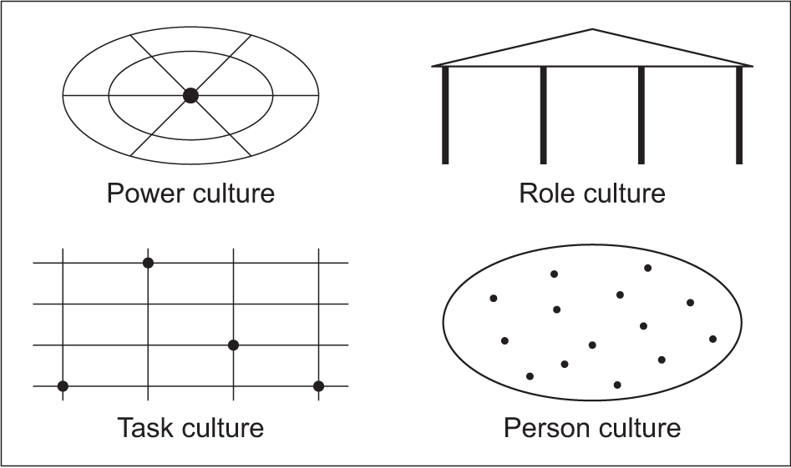
(Teaching guide: Handy's culture, 2025)
Handy’s (Handy, 1993) typology of culture groups is power culture, role culture, task culture, and person culture. The dominant culture type that seems to be present at Toyota is role culture and task culture. The strong presence of role culture at Toyota can be attributed to highly structured processes, extensive standardisation, and well-defined rules and procedures that guide employees’ actions and decisions. On the other hand, task culture is also prominent, especially when it comes to teamwork, Kaizen groups, and other collaborative problem-solving activities that focus on achieving specific tasks and objectives. Power culture is not significant in the organisation because the company is not strictly led by a single leader or a small group of people. Person culture is, to a large extent, absent due to Toyota being a collectivist company, which favours organisational goals over individual autonomy.

Toyota Organisational culture and external environment
Toyota Motor Corporation applies a combination of the divisional, team-based and hierarchical forms of organization to drive innovation and global integration. Governance Toyota Motor Corporation The position of the Board of Directors and executive management is a top-down structure, and corporate governance is exercised by this group. Toyota Motor Corporation has a divisional position structure by region as well, like North America and Europe, which includes Lexus and small cars. Toyota Motor Corporation has workgroups based such as quality circle, and product development team that facilitate department collaboration. We can use the PESTEL model to analyse the Toyota Way. The PESTEL model illustrates how the Toyota Way manifests characteristics and how the Toyota Way relates to influences. The PESTEL model helps see the link between the Toyota Way and the outside world. Toyota works in a car market that is heavily regulated. Toyota deals with the side of the car market by maintaining a culture that follows trade rules, safety rules, and emissions rules. Toyota's disciplined culture looks ahead to rule changes. Toyota, as a responsible company, sees the rules change before they actually happen, as they are always one step ahead. Toyota is a very disciplined company and ensures a waste reduction culture, which can increase productivity and guarantee competitiveness and resilience during economic downturns while upholding high standards globally.

Toyota puts respect and progress at the centre of its approach. That focus enables Toyota to answer customer calls about sustainable business practices. The result is that Toyota builds customer loyalty. Toyota builds technology by planning for the long term and innovating. That work brings ideas in manufacturing, battery technology and hybrid systems. Toyota cares about the environment. In today's eco and sustainability trends, Toyota invests in more environmentally friendly cars, lower emission vehicles, electric cars, and relies less on fossil fuel in its production and follows a safety culture worldwide. Besides, Toyota's organisational culture also helps to be robust and flexible in various PESTEL systems, thus Toyota can assure a sustainable competitiveness in a highly competitive global automobile market.

Organisational Culture as a Barrier to Effective Functioning
Toyota's organisational culture is often lauded for the degree to which it supports quality, efficiency and continuous improvement.Other parts of the culture, though, are undermining efficiency at the company. Specifically, the tradition of decision making process based on consensus building (Nemawashi) has been blamed as the reason why Toyota was not able to react quickly enough to crises like 2010 recall (Liker, 2004). The company has been less efficient in damages other aspects of the culture. For example, the decision making process being heavily dependent on consensus (Nemawashi) has been pinpointed as a reason for Toyota not being able to react efficiently to crises like in the 2010 recall (Liker, 2004). In particular, the cultural focus on "face-saving" behaviour and staying out of trouble made it hard for Toyota to act quickly when things went wrong in the company (Cusumano, 2010)
Toyota’s high standardisation and its dependence on well-entrenched routines (TPS) may become a constraint on creativity and risk-taking, and could thus limit the company’s ability to be radical and innovative (Steven Spear, 1999). In addition, particular cultural features of Japanese collectivism, embodied in Toyota organisational culture, may be “alien” for employees from the countries where individualism is emphasised, and people expect to have more autonomy and a faster pace of decision-making (Hofstede, 2001). Cultural values that stress hierarchy and seniority may also unintentionally make it harder for lower-level employees to talk to higher-ups or speak up about problems (Bhasin, 2012)This culture has helped Toyota become the best car company in the world, but it is important to recognise its limits when it comes to handling crises, integrating globally, and adapting to a world that is changing quickly.

Impact of Organisational Culture on Toyota’s Performance
Toyota’s company culture was also directly responsible for the level of performance achieved by the company. For one, there was the company’s culture of operational excellence and continual improvement informed by the Toyota Way. TPS is a culture that ichii, u.a. 3) Understood by TPS from the beginning of its genesis as being one upon which is based world-class levels of productivity, quality and low waste production, all which in turn enabled ultimate success (Liker, 2004) (Ōno, 1988). A “respect for people” culture fosters high employee engagement, great teamwork and low turnover. These have positive repercussion to the organisational stability and long run performance (Steven Spear, 1999), Toyota’s learning culture and long-term perspective also led to continued innovation, most notably in new technologies such as hybrid and environmentally responsive systems. This has enhanced its global competitiveness and leadership in sustainability (Cusumano, 2010). On the other hand, the strengths of the culture can also be sources of vulnerabilities. For example, the recall crisis in 2010 revealed that some aspects of culture that usually contribute to stability and positive performance, such as reaching decisions through consensus and respect for authority, may also lead to a lack of transparency and slowness when dealing with crises (Kersten, 2011). The Toyota culture, in general, can be considered to have a significant and direct impact on its competitive advantage and performance. For example, its cultural assets, including the Toyota Way and TPS, directly contribute to the operation, financial performance and reputation of the organisation (James P Womack, 1990). Finally, Toyota's organisational culture emerges more as a means to high-performance driving than as an outcome once it reaches the desired level through conformity and quantifiable trend data.

Recommendations for Improvement
Toyota has a strong organisational culture that has contributed to its success, but there are areas where the company can still improve to be better prepared for future challenges. One idea is to relax decision-making rules around certain things. Although Toyota, in general, has been known for adopting Nemawashi, a consensus-building system which is deeply rooted in Japanese culture, it has received criticism for being too slow, especially in the context of dynamic operations (Liker, 2004). A more hybrid way of making decisions – and continuing to strive for consensus when needed, along with giving leaders permission to make some faster decisions – will lead to greater agility within the organisation (Kersten, 2011). Second, Toyota should also seek to decrease the dependence on standardisation in innovation processes. Although the company’s strength lies in routines and practices around quality, efficiency, and robustness embedded in the Toyota Production System (and its accompanying processes), overly relying on standardisation can stifle experimentation and prevent breakthrough innovation: in new areas such as electric vehicles, or software-driven mobility services such as car-sharing, ride-hailing, etc (Steven Spear, 1999). According to (Cusumano, 2010), in order for Toyota to successfully adjust to fast technological innovations, it will create specialised teams, giving greater flexibility for them to operate more freely than other employees. The safety of the person should be a part of all enterprise operations. The employees in collectivist societies (e.g., Japanese) are more likely to respond with a conforming approach because of the social pressure from such a culture (Hofstede, 2001). Avoiding controversy and deferring to the lead might cause some employees not to challenge or make suggestions for decision-making among organisational heads. At its worst, this behaviour results in unethical activities within the institution. Toyota could address this by creating more open communication channels and leadership training that emphasise welcoming and acting upon upward voice (Bhasin, 2012). Fourth, there should be a stronger emphasis on cross-cultural management to help reduce potential tension between the headquarters and its many international subsidiaries. Such changes include the adoption of more locally sensitive leadership approaches, delivery of cross-cultural training and securing broader perspectives in decision-making in order to save the unity (Hoseus, 2008). Toyota should also be accelerating its digital transformation. Technological advances in artificial intelligence, digital platforms, autonomous technologies and so on are disrupting the automotive industry and encouraging a more experimental culture of adoption for new technologies that allow faster iteration (James P Womack, 1990). Finally, Toyota should further embed environmental sustainability into its organisational culture. While the company has made important efforts toward carbon neutrality. Further strengthening environmental values in daily work and training can help the company stay competitive as it faces increased regulatory and societal expectations in this area (Cusumano, 2010). In summary, while Toyota has a strong organisational culture, these changes will allow it to build on its current strengths and be more resilient in the face of future challenges.

Conclusion
Conclusion: Toyota’s organisational culture is certainly one of its predominant strengths and a key driver of its continued global leadership. The company’s culture — with a strong foundation in Toyota Way concepts of continuous improvement and respect for people — significantly shapes the company’s structure, decision-making practices, and overall organisational conduct. By applying models like Schein’s three-level framework, Hofstede’s cultural dimensions or Handy’s typology (1990; 2001), it can be shown that a culture at Toyota is working on different levels – establishing seen practices on the shop floor (“artefacts”), guiding shared values (or “norms of behaviour”) and supporting deep held assumptions regarding quality, teamwork and learning. This culture is one that has resulted in Toyota successfully adapting to external environmental pressures (such as those provided by a PESTEL analysis) sufficiently so as to remain resilient to regulatory change, technological progression, economic variability, and increasing demands for environmental sustainability.

At the same time, the analysis also reveals that Toyota’s culture is not problem-free. Consensus-based decision-making, extensive standardisation and strong hierarchical norms are among the features that can drag down an organisation’s responsiveness capabilities and stifle innovation when drastic change calls for it. This is what happens when culture becomes a problem (yes, I know you’re not supposed to call survivors of an accident problematic). This is 2010 coming back to haunt a company as its greatest strength mutates into its greatest liability. Despite an increasingly difficult market environment, the company culture still has a positive impact on performance as the company embraces operational excellence, drives innovation around hybrid and sustainable technologies and enhances workforce engagement.

As it looks to the future, Toyota will need to preserve some of the foundational elements of its culture whilst evolving others in response to the needs of an increasingly complicated and technical global world. Improving cross-cultural cooperation, promoting more safety and accelerating digital transformations will be key to maintaining the competitive edge. Toyota’s cultural legacy continues to be a remarkable strength for the company, but its future fortunes are ultimately tied to its capacity to shape or reinvent practices in line with future contexts and opportunities.

References
Bhasin, S. (2012). Promoting continuous improvement: Toyota’s approach. International Journal of Lean Six Sigma.
Cusumano, M. A. (2010). Staying Power Six Enduring Principles for Managing Strategy and Innovation in an Uncertain World. OUP Oxford.
Handy, C. (1993). Understanding Organizations. Penguin Adult.
Hofstede, G. (2001). Culture′s Consequences. SAGE Publications.
Hoseus, J. K. (2008). Toyota Culture: The Heart and Soul of the Toyota Way. New York: McGraw-Hill .
James P Womack, D. T. (1990). The Machine That Changed the World. New York: Rawson Associates.
Kersten, A. (2011). Crisis Communication and Reputation Management in the 2010 Toyota Recall. Journal of Business Ethics, 481–492.
Laurie J. Mullins, G. C. (2016). Management and organisational behaviour. Pearson.
Liker, J. K. (2004). The Toyota Way. McGraw-Hill.
Ōno, T. (1988). Toyota Production System. Taylor & Francis.
Schein, E. H. (2010). Organizational Culture and Leadership. Wiley.
Shohana. (2025, 12 6). Limit exists only in the mind. Retrieved from Understanding Hofstede Cultural Dimensions: https://shohanasite.wordpress.com/2018/05/07/understanding-hofstede-cultural-dimensions/
Steven Spear, K. B. (1999, 09). Decoding the DNA of the Toyota Production system. Hardvard Businnes review.
Teaching guide: Handy's culture. (2025, 12 6). Retrieved from https://www.aqa.org.uk/resources/business/as-and-a-level/business-7131-7132/teach/teaching-guide-handys-culture

