Marketing Fundamentals – LCBB4004

Name of the Student: Coordinator:
Maria-Loredana Dinculete(2023298) Hossein Shokri

Table of Contents
Introduction: 2
Discussion: 2
Effectivity of Marketing in Value Creation: 2
Impact of Stakeholders in Marketing Activities: 7
Conclusion: 9
References: 11
Appendices 13

Introduction:
The essence of marketing is felt by different individual organisations at every inch of their day today activities towards securing the institutional objectives and goals. Creation of values on behalf of the clients and the customers, are indeed very essential for any organisation to succeed in the market and gain the widespread desired reputation. Marketing develops values by building positive connections between products and people and various companies and their customer bases. To achieve that, the role played by marketing is indeed very essential. In order to guarantee the success of marketing initiatives undertaken by any specific institution, engagement of stakeholders is very important and the stakeholders indeed play a certain impact towards successful implementation of the marketing initiatives.
Both these components, when undertaken by any specific organisation in the best possible way, then automatically success flows towards such an entity and makes them one of the most trusted and reputed organisations within the market (Mahmoud et al. 2018). The purpose of presenting this research essay paper remains to highlight the importance of marketing towards building the values for the customer. Apart from these another important reason behind the development of this research essay paper is to figure out different external and internal stakeholders and judge their impact upon various marketing initiatives that are undertaken by any organisation.

Discussion:

Effectivity of Marketing in Value Creation:
Marketing may be described as the categorical process that is adopted to ensure acquisition of profitable customers and building positive relationships with them on a long-term basis in order to guarantee sales proceeds to run efficiently. The role played by marketing is not only to create values with respect to the customers but also to capture the values as a part of returning gifts by the customer (Grönroos, 2017). This give and take policy helps in positively instilling the marketing activities in a fruitful way and attain maximum opportunities available within the existing market. Marketing activities often acts as a bridge to build positive connection between
The commodities that are acquired by the individuals and the persons themselves.
The organisation from which the customers acquire any particular commodity and the person himself.
The role that marketing brings in developing a better value on behalf of the customers can be understood by the following stages that are described one by one.
Providing a better and satisfying experience during the time of acquisition of any particular commodity.
Getting acquainted with the products and meeting them.
Sustaining a very committed relationship
Initiating typical activities of marketing to build a relationship stage with the customers.
The process of marketing that involves: “Creation of values” related to customer
Better understanding of the market place needs and every want of the clients of the customer | Widening the scope of research about the marketplace keeping in mind the needs and preferences of the customers.  Managing to deliver relevant information regarding marketing and various types of customer data that are very essential to get their buying and selling process going on efficiently (Malone et al. 2018).
Designing better marketing strategies that are customer driven | Selecting all the customers that are ready to sign in on the basis of targeting and segmentation.  Designing the route to value proposition. The value proposition route is going to be prepared on the basis of positioning and differentiation.
Constructing a marketing program that is often integrated in nature | Both services or products are required to be designed in a way to guarantee development of strong branding relationships within the markets.  Pricing the products by keeping in mind the target customers and making the product very attractive.  The place of distribution of the product needs to be decided in advance and must be hassle-free  Promotion of the products needs to be communicated to the customers in advance and have the power to value the requirements of the customers in every possible way.
Developing relationships that are profitable and creating the delights within the minds of the customers. | CRM: Building and coordinating go to relationships with all the target customers  PRM: Developing good relations with all the marketing partners.

The initial step about the marketing process in order to create values for the customers remains in identifying the customer’s and the requirements made by them. Before any activity related to marketing is undertaken within the market it’s essential to grab a rough idea about the whole marketplace by doing ample amount of research. Simultaneously every information that is related to the marketplace or the details of the customer’s needs to be managed on a proactive basis.
The 2nd step speaks about the whole process that is undertaken to create the strategy of marketing that is driven towards the interests of the customers. In order to achieve such parameters every company gets involved in the idea of “market segmentation and targeting”. In this stage any organisation in order to create values regarding the customer’s first analyses the target customers and all the customers for which the organisation will mainly function. On the contrary, the organisation must focus on its available resources that they would Inkaar upon the customers in order to serve them in a better and more profitable way (Connor et al. 2018). The components targeting and segmentation are capable of determining the population for which the organisation will serve by keeping in mind the value propositions and would make them more valuable in front of the customer in comparison to their competitors. This total phenomenon can be also described as “marketing management orientation”.
After identifying the nature of marketing strategy that would be undertaken by any specific organisation comes the third step where the main focus remains upon constructing a marketing program that is integrated on the basis of marketing mix. In this stage the main purpose lies to transform different types of marketing strategies into real value creation for all the target customers. In this stage the 4p” s of marketing plays a very crucial role. Decisions are made about the price that would be kept regarding any particular service or product, the place where the product would get promoted, the way adopted to execute the distribution process, and managing the supply and demand chains.
The last stage or the fourth estate remains to be a part of the marketing process that renders its aim in creating high values for the customers and building a very profitable relationship with all such customers, especially the target customers (Zhang et al. 2017). The main aim in this stage remains to satisfy the customers by giving them the most desired product or service and by adopting proper orientation in delighting the customer (Tokai et al. 2017). The process that guarantees better customer relationships and maintenance lies under the category of CRM which is denoted as “customer relationship management”. Another stage that collaborates the strong relationships with different marketing partners lies under the category of PRM or “partner relationship management”.
Marketing process: “Capturing the values in return”
Capturing the values from the available target customers in order to create profit and equity of the customers is indeed an important task that needs to be undertaken by every organisation. This stage involves creating enough satisfaction among the minds of the customers and making them delighted about the service of the product that has been acquired by them. Capturing the customer on the basis of lifetime values and increasing the shares of the market in relation with the shares of the stakeholders are also regarded as one of the most effective processes to capture the “values in return”. The customers who repeatedly visit any particular store of any respective brand and every time during his visit purchase or sale takes place can be considered as an efficient example regarding “capturing the values in return”.

Impact of Stakeholders in Marketing Activities:
Stakeholders remain to be the most important part for every organisation and stand on behalf of the company in both their good and bad times. Being an organ of any specific organisation the stakeholder’s actions definitely determines the success or failure of an entity on a huge note (Chauhan et al. 2021). Especially when it comes to marketing strategies to be adopted by any specific organisation the role that stakeholders play is definitely not comparable at all to any other aspect of an organisation. Strategies of marketing refers to different game plans that are adopted by an overall business organisation to reach all the prospective consumers and make them the most relevant clients by offering different services and products in terms of their needs and requirements. Generally, the strategy of marketing contains different types of value propositions, customer data, brand messaging, and demographics related to target customer and many other high-level elements that are considered relevant for the success of an entity. This section of the research paper will deal with different prospects that are shown by both internal and external stakeholders of any said organisation towards the marketing initiatives undertaken by such an entity.
Stakeholders are often considered as those individuals who have relevant interests upon the activities undertaken by an organisation and have the power to affect different operations that are undertaken by any entity. Engagement shown by the stakeholders definitely impacts a lot upon the marketing activities for a said organisation either in a positive and negative way. Generally, there are two types of stakeholders that are found within any organisation which remain in the form of internal stakeholders consisting of the directors, the managers, the stakeholders who are connected, and the employees (Shinde et al. 2019). The other group of stakeholders remains in the form of external stakeholders. This category of stakeholders can be found in the form of government, news and media organisations, pressure and interest groups, and multiple local communities.
Internal stakeholders
Directors - This group of stakeholders enjoys the supreme power of any organisation and they are the persons who give the final consent about the adoption of any specific type of marketing strategy that would definitely fetch better profitable returns towards the organisation.
Managers - Managers are the persons who look after the employee’s performance and keeps them highly motivated so that every work of the organisation runs in a smooth way. This group of internal stakeholders' job is to look after every marketing activity that has been proposed by the management of the organisation and gets executed in an accurate manner.
Employees - Any marketing activity cannot be executed without the help of this group of internal stakeholders. These individuals are responsible for performing the fieldwork and carry out the marketing initiatives in their own hand (Yoo 2021). It’s the reliability, timeliness and accuracy of these individuals that makes the marketing activities of any organisation successful and definitely brings them better luck and profits in the coming future.
Connected stakeholders - This group of internal stakeholders’ responsibility is to extract the funds for the company by investing in different shares and debentures. They invest in any particular company and bring home the desired fund for undertaking different marketing activities on behalf of any said organisation.
External stakeholders
This group of stakeholders are not found within any organisation but they remain outside the organisation and have the power to affect the operations of any said organisation.
Governments - These types of stakeholders are responsible for influencing the regulations and different types of laws that concern any particular entity. In order to execute any marketing activity, permissions are required to be taken from these external stakeholders and necessary taxes are also required to be given in the absence of which the marketing activity might get banned and fines may be imposed upon the entity (Liu et al. 2017). Therefore, the government as an external stakeholder plays a very primitive role in overseeing the business activities of an organisation.
“Media and news organisations” - This group of external stakeholders realise the power to depict any marketing activity either in a positive and a negative way. The normal masses rely upon these types of external stakeholders to give positive feedback about the marketing initiatives taken by any organisation and thus the future of any entity definitely depends a lot upon the “media and news organisations'' type of external stakeholders and definitely be heavily impacted upon the marketing initiatives undertaken.
“Interest and pressure groups' ' - Such persons enjoy the power to divert the mind of the normal workers who are working within any organisation. The marketing activities that are planned to be executed in the stipulated deadline can get stopped suddenly. Having regulatory powers these types of organisations have the potential to stop the functioning of any organisation and hamper the marketing activities of such entities.

Conclusion:
The role that marketing activities play during the time of creation of values for the customers are indeed an essential learning process for an organisation to become successful in its business life. The marketing activities again depend upon the efficiency shown by the stakeholders of an organisation remaining in the form of both internal and external. The coordination between both these components kept under one single room in the form of an organisation remains the key procedure to acquire success by a particular organisation or the management that wishes to incorporate marketing activities in future. This individual research essay paper depicts different aspects of the marketing strategies and relevance of stakeholders upon implementation of those marketing activities within an organisation in the most appropriate way possible.

References:
Mahmoud, M.A., Hinson, R.E. and Anim, P.A., 2018. Service innovation and customer satisfaction: the role of customer value creation. European Journal of Innovation Management.
Grönroos, C., 2017. On value and value creation in service: a management perspective. Journal of creating value, 3(2), pp.125-141.
Fan, J. and Dong, L., 2021. A Study on Improving Customer Value Based on the Effect of Word of Mouth. Frontiers in Psychology, 12.
Zhang, M., Guo, L., Hu, M. and Liu, W., 2017. Influence of customer engagement with company social networks on stickiness: Mediating effect of customer value creation. International Journal of Information Management, 37(3), pp.229-240.
Malone, S., McKechnie, S. and Tynan, C., 2018. Tourists’ emotions as a resource for customer value creation, co creation, and destruction: A customer-grounded understanding. Journal of Travel Research, 57(7), pp.843-855.
Foroudi, P., Yu, Q., Gupta, S. and Foroudi, M.M., 2019. Enhancing university brand image and reputation through customer value co-creation behaviour. Technological Forecasting and Social Change, 138, pp.218-227.
Carlson, J., Wyllie, J., Rahman, M.M. and Voola, R., 2019. Enhancing brand relationship performance through customer participation and value creation in social media brand communities. Journal of Retailing and Consumer Services, 50, pp.333-341.
Rai, H.B., Verlinde, S. and Macharis, C., 2018. Shipping outside the box. Environmental impact and stakeholder analysis of a crowd logistics platform in Belgium. Journal of Cleaner Production, 202, pp.806-816.
Saha, M., Chauhan, D., Patil, S., Kangas, R., Heer, J. and Froehlich, J.E., 2021. Urban Accessibility as a Socio-Political Problem: A Multi-Stakeholder Analysis. Proceedings of the ACM on Human-Computer Interaction, 4(CSCW3), pp.1-26.
Connor, P.M., Axon, C.J., Xenias, D. and Balta-Ozkan, N., 2018. Sources of risk and uncertainty in UK smart grid deployment: An expert stakeholder analysis. Energy, 161, pp.1-9.
dos Muchangos, L.S., Tokai, A. and Hanashima, A., 2017. Stakeholder analysis and social network analysis to evaluate the stakeholders of a MSWM system–A pilot study of Maputo City. Environmental Development, 24, pp.124-135.
Roy, K., Shinde, S., Sarkar, B.K., Malik, K., Parikh, R. and Patel, V., 2019. India’s response to adolescent mental health: a policy review and stakeholder analysis. Social psychiatry and psychiatric epidemiology, 54(4), pp.405-414.
Yoo, D., 2021. Stakeholder Tokens: a constructive method for value sensitive design stakeholder analysis. Ethics and Information Technology, 23(1), pp.63-67.
Liu, P., Zhou, Y., Zhou, D.K. and Xue, L., 2017. Energy Performance Contract models for the diffusion of green-manufacturing technologies in China: A stakeholder analysis from SMEs’ perspective. Energy Policy, 106, pp.59-67.

Appendices
Appendix 1: Value Creation of Customers
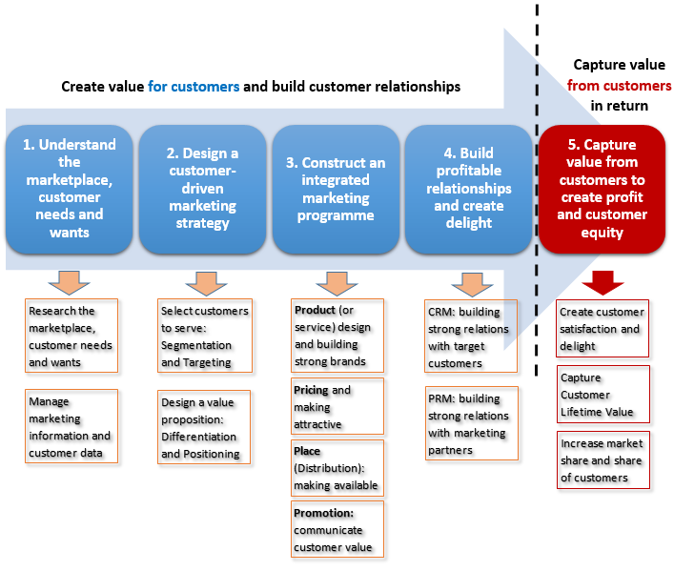
(Source: https://marketing-insider...value creation. Marketing-process/marketing-process/)

Appendix 2: Stakeholder’s role in marketing
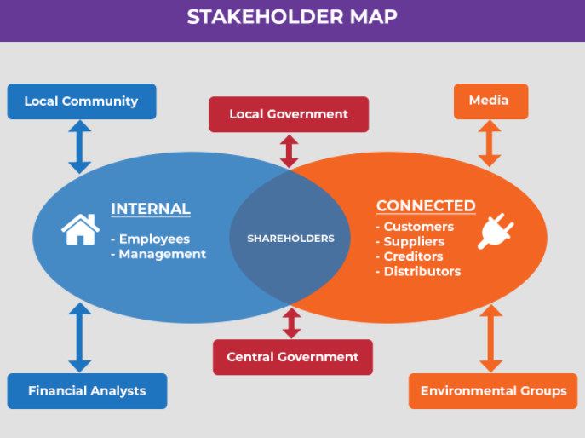
(Source: https://www.stakeholdersanalysis.in.12)

