Findings:
This section of the project will critically analyse and evaluate the data collected and present the results obtained. This section will also explore any issues encountered and analysis of these issues will be provided. Data from each method of collection will be critically analysed and evaluated.
Survey
The aim of the survey was to collect data in relation to preferred styles of leadership. The answers were prewritten multi choice enabling the researcher to gain quantitative data for analysis, mixed with free text options to gain further insights and qualitative data. Questions were varied and some questions were used to used hopefully get the participant thinking about leadership and their experiences. One of the questions written was not expected to achieve any new information, but more an opportunity for participants to think and divulge on their experiences with aim of achieving richer and more varied answers. Using these simple and easy questions in the research was to hopefully provoke thoughtful answers from participants. This was a strategic approach as I wanted the participant to be comfortable, confident and hopefully more likely to engage fully and provide more detailed responses as the survey progressed. I simply wanted to reduce cognitive load, encourage reflection and establish context of the research.
To gather as much information and to gain maximum participation, a link was sent to all staff via trust work emails for them to complete a survey. A ‘QR’ code was also designed, printed, and posted around multiple stations. The ‘QR’ code directed staff to the survey. There was reassurance on the form that all answers would be anonymous. The data has easily been analysed through ‘Microsoft Forms’ once received. The questions were themed around leadership and barriers to their performance when being lead at a higher acuity incident. There were also ‘free text’ options allowing participants to expand and rationalise their answers. The survey was relatively short, taking approximately 15 minutes to complete.
In total the survey was sent to 221 members of staff via their work emails, posters were displayed in all Cardiff and Vale stations and reminders were discussed during operational shifts with staff. In total there were 26 responses from staff resulting in a 11.7% participation rate. Kailash (2023) states that research has shown that the average survey response rate across organisations is 30-40%. The response rate is therefore lower than expected. There could be numerous reasons for this, one being survey fatigue. Working in an organisation where surveys are distributed almost weekly, staff can become overwhelmed by the number of surveys they are receiving, leading to a lack of interest and unwillingness to participate. Kailash (2023) further argues that poor survey design can lead to reduced participation numbers. Confusing questions, unclear instructions or long surveys can deter respondents. This was evident in this research as one respondent wrote:
“I found the questions difficult to fully understand”
Therefore, it could be argued that the questions were challenging. However no other respondents raised concerns with the questions. Furthermore, the same respondent wrote on their feedback:
“Unsure what 'high incidents of severity' referenced”
The phrase ‘high incidents of severity’ was not used during the survey, so it could be argued that the respondent was not reading the questions properly, had survey fatigue and therefore had a lack of interest in the subject and survey. Kailash (2023) also indicates that if there are inadequate incentives and insufficient motivation or rewards, staff might not see the value in taking the time to complete the survey. This could be a reason for low participation, as contribution was voluntary, and there was no option for incentives or rewards as there was zero budget.
Question 1 and 2 were worded as the following:
1.“During incidents of high severity, which of the below styles of leadership do you find most effective in eliciting a response from you?”
- Autocratic
- Laissez-faire
- Democratic
- Other
2. During incidents of high severity, which of the below styles of leadership do you find least effective in eliciting a response from you?”
- Autocratic
- Laissez-faire
- Democratic
- Other
The below graph clearly demonstrates the findings:

It is evident that there is a clear favourable leadership style that staff respond best to. However, in comparison to least favoured style, it was expected to almost be the complete opposite. The below graph illustrates the results:

Interestingly, 69% off staff found that Laissez-faire style least effective in eliciting a response from them during higher acuity incidents with 65% stating that a democratic style would be the most beneficial. This is an interesting comparison as it is almost direct opposite to least and most preferred style, with most staff agreeing that democratic is the most appropriate style to gain a response from staff and laissez-faire is the least appropriate. However, there seems to be a lack of agreement on an autocratic approach. With 6/26 stating they preferred this style and 8/26 stating it is the least effective.

As the above radar graph demonstrates there is a clear favoured and unfavoured leadership style. Granted the participation rate is small; however, it would be expected for the results to follow a similar pattern had the participation level been higher.
The survey then offered the participants an opportunity to discuss their preferred leadership style and why.
“5. Feel free to detail your preferred leadership style. For instance, explain why a particular style resonates with you or why you find a certain style of leadership unfavourable.”
This question yielded a good response rate with 57% of respondents using the word ‘democratic’ in their answer. There was an emerging theme from the free text option that staff favour democratic leadership to feel involved in the incident, but when the incident becomes more severe in nature, staff would welcome a more autocratic leadership from a member of staff providing clear concise instruction. Therefore, it could be stated that the staff members need strong direction or reassurance from more senior clinicians during higher acuity incidents to achieve the best results from staff.
It could be argued form the results of this question that the prehospital setting is a unique environment and a mix of both autocratic and democratic is needed. Faubion (2024) that democratic leadership is best utilised when team collaboration is needed. This style is effective when building new relationships or fostering teamwork. It encourages input from all team members, which can lead to improved morale. Faubion (2024) also stipulates that autocratic is best used in emergency situations. In high-pressure environments quick and decisive action is crucial. Autocratic leadership ensures that decisions are made swiftly and efficiently. Therefore, it could be reasoned that both these styles are required for higher acuity incidents and that a mix is beneficial for staff and patient outcomes.
Question 6 and 7 focused on personality traits that make a good and bad leader. The results were interesting, but both seemed to follow a pattern. The below images are a snap shot from the results section of the Microsoft form:
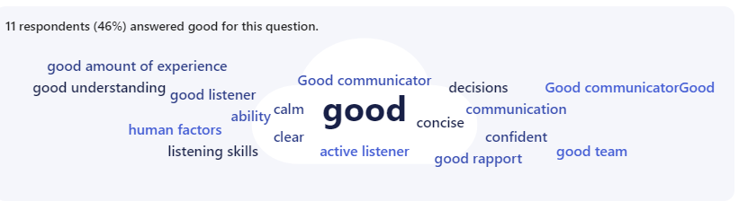
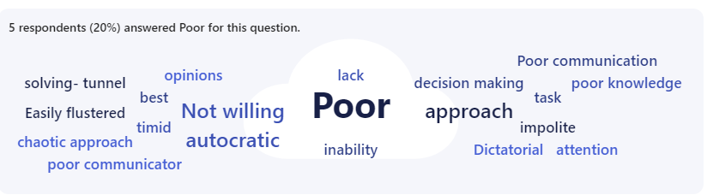
The ‘good’ leader traits focused mainly on having experience, knowledge, being calm and being a good listener. The ‘poor’ leader traits focused on arguably the opposite; easily flustered, poor communication and inability to perform job. On reflection, it could be argued that this question was not needed, and it is obvious what traits make a good and poor leader. There were no surprises with this result, but it confirmed the researcher’s knowledge of what makes a good leader and a poor leader.
The results for a ‘good’ leader echo what Wike (2024) states make a great leader. Wike (2024) states that active listening is a good trait of a leader, and effective leaders must be adept at both providing and accepting feedback from their team. Wike (2024) also describes effective communication as a good trait and states that effective communication involves both listening to others’ needs and expressing your own. Clear communication with your team helps them grasp your expectations and objectives. Moreover, fostering open communication encourages team members to feel at ease when discussing any difficulties in achieving goals (Wike, 2024).
Interestingly, Lundberg (2023) states that leaders with poor listening skills will make decisions without understanding concerns or insights from their team, which can lead to reduced commitment and potential misalignment from the end goal. This insight married with the results from the participants thoughts on poor leadership traits where the majority believed poor communication and poor listening is a negative leadership trait.
Intriguingly, one respondent has mentioned ‘human factors’ as a good trait when leading a higher acuity incident. Human factors refer to the study of how humans interact with various elements of a system, including other people, technology, and the environment (Jones, 2024). Incorporating human factors into leadership not only improves individual and team performance but also enhances overall safety and effectiveness during high-pressure incidents (Jones, 2024). Jones (2024) further argues that integrating human factors into incident management, leads to more resilient and adaptive teams, ultimately improving outcomes in high-stakes situations. Therefore, it could be argued or reasoned that being aware of human factors and having an understanding of how they affect our decisions and actions can have a positive or negative impact on patient outcomes.
Question 8 was designed to see directly if respondents responded better to preferred leadership styles. It was worded as follows:
“8. Do you believe that being receptive of a leadership style directly affects your performance during a higher acuity incident? For example, if you did not like the leadership style being used, do you believe it would decrease your performance? Would you be less willing to work harder?”
The below pie chart demonstrates the responses:

As is evidenced in the pie chart, over 50% of respondents felt like leadership style can directly affect their performance and their willingness to work harder for that leader. Just over a quarter of respondents were undecided and less than a quarter of respondents stated that a certain leadership style would not directly affect their performance.
Brown (2023) states that leadership styles significantly impact performance for several reasons. Different leadership styles can either boost or diminish your motivation. For example, democratic leaders who involve team members in decision-making can increase job satisfaction and morale, leading to higher productivity (Brown, 2023). This correlates with question 5, where respondents stated that democratic leadership was their preferred leadership style. And question 1, where respondents favoured democratic leadership as their preferred style.
Conversely, Brown (2023) states that autonomy and responsibility is a positive leadership trait that can generate positive staff performance. Brown (2023) states that Laissez-faire leaders give team members a lot of freedom to make decisions and manage their own work. This can be empowering for experienced and self-motivated individuals. This does not correlate with the authors findings as majority of respondents found that laissez-faire leadership was the least effective during high acuity incidents.
Darcy argues that leadership style profoundly influences performance by shaping the work environment and team dynamics. For instance, transformational leaders inspire and motivate their teams, fostering a culture of innovation and personal growth, which can lead to higher engagement and productivity (Darcy, 2020) In contrast, autocratic leaders provide clear, direct instructions, which can be effective in high-pressure situations but may stifle creativity and reduce morale over time. Democratic leaders, who involve team members in decision-making, often enhance job satisfaction and collaboration, leading to improved performance (Khajeh, 2018). Conversely, laissez-faire leaders offer significant autonomy, which can empower self-motivated individuals but may result in confusion and lack of direction for others. Ultimately, the alignment between leadership style and team needs is crucial for optimising performance and achieving goals (Darcy, 2020). These sentiments correspond to the responses where 53% believe that staff performance is directly affected by the leadership style being utilised.
Questions 9 and 10 sought to obtain more insight into the respondents experiences and gave them a free text option of when they have experienced effective and poor leadership during high acuity incidents.
“9. Could be provide an example of effective leadership you’ve experienced during a high-pressure situation?
10. Could you provide an example of experiencing poor leadership during a high-pressure situation?”
The opinions expressed in the responses form a qualitative response and require some interpretation from the author. The majority of respondents touched upon effective communication when providing their examples:
“Paediatric arrest, an EMRTS doctor displayed complete control of the situation in a calm, confident, decisive manner, allowing everyone to submit verbal input while communicating any decisions/treatments effectively to all on scene.”
And
“During a cardiac arrest, the leader calmly took on board all of the information available, communicated strongly with the team on scene, family members, other agencies on scene and other parties not on scene (CCC, EMRTS). Ensured that each team member was happy with their role and didn’t require any assistance/equipment. Hot debriefed after with the team and wider agency to ensure all parties were supported.”
It could be argued that regardless of the leadership style being used, effective communication is key to staff performance and leadership in general. This sentiment is echoed by Patel (2023) who states that communication is key to effective leadership because it ensures that everyone in the team understands the goals, expectations, and their roles in achieving them. Clear and open communication fosters trust and transparency, which are essential for building strong relationships and a cohesive team (Patel, 2023). Patel (2023) further argues that effective communication allows leaders to convey their vision, provide constructive feedback, and address any issues promptly, preventing misunderstandings and conflicts. Effective communication also encourages collaboration and innovation by creating an environment where team members feel valued and heard. Ultimately, leaders who communicate well can inspire and motivate their teams, driving better performance and achieving success, and therefore improving patient outcomes (Patel, 2023).
The response rate for question 10 was less than 9, with one person stating that they were not prepared to give a response. This could be for several reasons, such as survey fatigue, time constraints or even perceived irrelevance. However, more likely due to the sensitive nature. The respondent might have been hesitant to write their experiences due to specific details that may have been identifiable.
However, of the other respondents, autocratic leadership was mentioned on several occasions when discussing examples of poor leadership.
“During a medical arrest, the SP running it only used a autocratic approach…”
And
“An autocratic senior officer who would not listen to his experienced staff.”

Pizzolitto et al (2021) agree with the majority of respondents that autocratic leadership can be ineffective in high pressure situations. Pizzolitto et al (2021) state that Autocratic leadership, characterized by solo decision-making and strict control and is often ineffective in high-pressure situations due to its lack of flexibility and limited input from team members. Autocratic leaders may stifle creativity and hinder the flow of valuable insights from team members, leading to slower problem-solving and reduced morale (Pizzolitto et al, 2021). Additionally, the stress and pressure of high-stakes environments can exacerbate the negative effects of an autocratic approach, such as increased tension and decreased trust within the team. Pizzolitto et al (2021) go on to state that effective leadership in high-pressure situations typically requires a more collaborative and inclusive style, where diverse perspectives are valued and quick, informed decisions can be made collectively. This demonstrates a relationship with the majority of responses in question 9, where staff gave examples of inclusivity and good communication as effective traits.

Questions 11,12 and 13 focused on the respondents reactions to certain leadership styles. Authoritarian, democratic and Laisses-faire were chosen. The questions were worded as follows:
“11: What is the probability that you will react more positively to authoritarian leadership?”
“12: What is the probability that you will react more positively to democratic leadership?”
“13: What is the probability that you will react more positively to laissez-faire leadership?”
The respondents were given three options to click as answers:
- Promotors
- Passives
- Detractors
The purpose of this question was to obtain a quantitative result for how favourable or less favourable a certain leadership style was for the respondents.

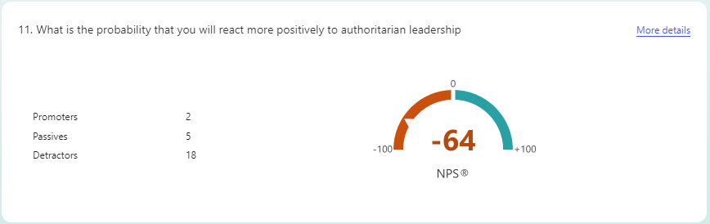
As demonstrated in the above image, there was a -64 negative swing for staff responding favourably to authoritarian leadership. This result suggests that authoritarian is not a good leadership style to employ during higher acuity incidents if the leader wanted to enhance employee performance.
Conversely and almost opposite to authoritarian leadership was the results for question 12
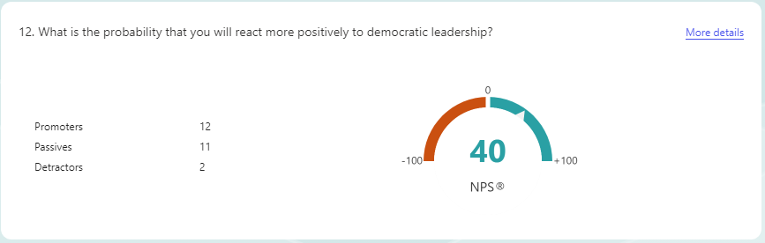
As exhibited in the above results, respondents voted for a +40 positive swing for promotors of democratic leadership as a style to enhance work performance.
It can be argued that leadership styles significantly impact staff performance, influencing motivation, productivity, and overall patient outcome. Two contrasting styles, democratic and autocratic leadership, offer distinct approaches with unique advantages and challenges. However, it is apparent that staff that responded to the survey favour a democratic leadership style.
Cherry, (2023) states that democratic leadership generally leads to higher employee engagement and satisfaction, which can translate into improved performance and productivity. Employees are more likely to be motivated and committed when they feel their contributions are valued. This could arguably improve patient outcomes. Furthermore, Cherry (2023) agrees with the results and states that whilst autocratic leadership can lead to efficient execution of tasks and quick decision-making, it often results in lower employee morale and job satisfaction. Over time, this can decrease overall performance and potentially affect patient outcomes.
Analysing the responses from these questions, it could be argued that both democratic and autocratic leadership styles have their place in healthcare settings relating to higher acuity incidents, but also considering and depending on the context and specific needs. The results suggest that democratic leadership is generally more effective in fostering a positive work environment, enhancing performance, and improving job satisfaction, which can lead to better patient outcomes. In contrast, autocratic leadership may be suitable for situations requiring quick decisions and clear directives, which is arguably higher acuity incidents, but can negatively impact employee morale and performance.
Ultimately, the choice between these leadership styles should be guided by the organisational goals, the nature of the tasks, and the dynamics of the team. A balanced approach, incorporating elements of both styles, may often be the most effective strategy for improving staff performance.
Question 13 yielded results that were expected and unsurprising. Nineteen out the twenty five respondents clicked that laissez-faire leadership was a detractor and was not a favoured style of leadership. This solidifies the results from question 3, where respondents found laissez-faire least effective during higher acuity incidents. Numerous studies support the notion that laissez-faire leadership is suboptimal during high-acuity incidents. For example, research has shown that crisis management is far more successful when leaders take an active role in directing teams (Mackay et al, 2015). In high-pressure medical environments, leaders who adopt a more directive or transformational style can provide the necessary support and structure to their teams, ensuring that patients receive timely care and resources are appropriately allocated (Mackat et al, 2015).
Avolio, et al (2002) state that whilst laissez-faire leadership can work well in environments where employees are highly experienced and self-motivated, in high acuity situations, it may undermine team morale. In these instances, teams often look to their leaders for assurance and confidence. A leader who is disengaged can create feelings of uncertainty and doubt, eroding the team's trust in the leadership and the overall effectiveness of the incident (Avolio et al, 2002). Effective leadership during high acuity situations provides not only guidance but also emotional support, helping to maintain team cohesion and morale.
These sentiments echo the results of the study, and it could be argued that while laissez-faire leadership can foster independence and creativity in stable, routine settings, it is a poor fit for high-acuity incidents where rapid response, clear guidance, and coordinated action are necessary. In such high-pressure environments, leaders must engage actively with their teams, providing clear direction, maintaining accountability, and ensuring that decisions are made swiftly. The absence of strong leadership during critical moments can result in confusion, delay, and suboptimal outcomes, reinforcing the need for more hands-on, directive leadership in these settings (Mackay, et al, 2015).
Question 14 gave the respondents the chance to rank their most to least preferred leadership styles.
“14. Please rank the following leadership styles, from most to least preferred.
Autocratic – Decide and dictate.
Laissez-Faire – Hands off approach and trust.
Democratic – Collaborate and involve.
Situational – Adaptive and flexible.
Coaching – Guide and mentor.
Charismatic – Persuade and unite.
Transactional - Reward and punishment.
Transformational – Inspire and innovate.”
The respondents were tasked with dragging their most preferred style to the top and least to the bottom. A couple of words were given after each style in case respondents had not heard of that particular style.
The below screen grab from the results section is a table that displays how respondents voted. It could be argued that the concise description of the leadership styles has influenced the voting. For example, styles with descriptive words such as dictate, persuade and punishment have returned near the bottom of the ranking. Leadership styles with descriptive words such as inspire, involve, collaborate returned higher in the ranking system. However, this does not detract from the results from this question that agree and relate to other questions. Democratic returned as he most preferred style, which coincided with every other question that mentioned democratic leadership.

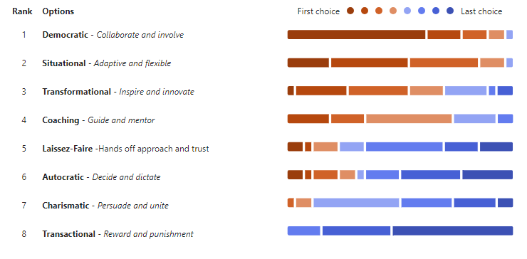
The below screen grab offers a simplified view of least to most preferred style. Again, as demonstrated with every other question, democratic comes out as favourite leadership style.
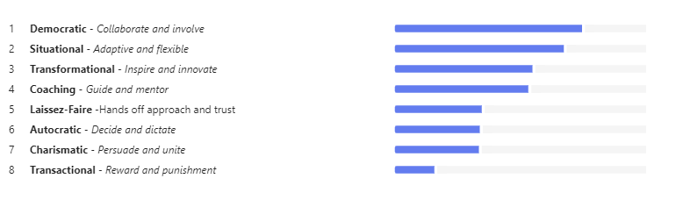
In high acuity incidents, where the stakes are high, and decisions must be made quickly and effectively, democratic leadership emerges as one of the most effective styles for managing complex, high-pressure situations and eliciting a response from staff. Unlike laissez-faire leadership, which can leave teams disoriented and without direction, democratic leadership combines the benefits of active participation and collective decision-making with clear coordination and direction (Northouse, 2018)
A democratic leader involves team members in decision-making processes, soliciting input from those closest to the situation, which fosters a sense of ownership, responsibility, and trust within the team. This collaborative approach ensures that the leader benefits from diverse perspectives and expertise, making it particularly valuable in high-acuity settings where rapid and informed decisions are critical (Bennett, et al 2014).
Additionally, democratic leadership balances the need for control with the flexibility required in crisis situations. Leaders who embrace this style can provide the guidance necessary for rapid decision-making while also empowering team members to take initiative, which is essential when every second counts. Democratic leadership creates a collaborative, transparent environment that fosters trust and team cohesion—key components when the team faces uncertainty and stress (Northouse, 2018).
In conclusion, during high acuity incidents, democratic leadership stands out because it allows for both structure and flexibility, integrates diverse perspectives, and promotes accountability and morale. This combination of factors ensures that teams can respond quickly and effectively to rapidly evolving challenges, leading to better outcomes in critical moments.

Interviews 2200
Interviews were conducted to gain further insight into preferred leadership styles and to offer a wealth of qualitative insights that would be difficult to capture using only quantitative methods. The hope was to collect detailed, context-rich data directly from individuals to help uncover the nuances and complexities that drive preferences for different leadership styles. The interview was designed and chosen to provide an opportunity for participants to share personal stories and experiences, which would hopefully enrich the understanding of how leadership is perceived and how it impacts team dynamics, performance, satisfaction, and ultimately patient outcomes.
Set questions were used and to avoid confusion and were similar to the survey. They were used in the hope they would provoke insightful answers. However, it is important to note that during all 4 interviews the answers strayed from leadership during higher acuity incidents to leadership in general in the ambulance service, from small decisions to high pressure situations. The questions were as follows:
- During incidents of high severity, which leadership style do you find most effective in eliciting a response from you and can you provide examples?”
- During incidents of high severity, which leadership do you find least effective in eliciting a response from you and can you provide examples?”
- What personality traits make a good leader during higher acuity incidents?
- What personality traits make a poor leader during higher acuity incidents?
- Could you provide an example of effective or poor leadership you’ve experienced during a high-pressure situation?
- Does leadership style affect your performance?
Out of the 221 staff members in the locality only 4 committed to the taking the interview, this is a 1.8% response rate. The invite was sent via outlook and teams. The small response to the interviews could be due to a variety of factors, including time constraints, lack of incentive, or concerns about confidentiality, among others.
Reasons for this low response rate could be lack of time or availability. Staff are incredibly busy and often don’t want to spend their time outside of work talking about work or the job. Saunders et al (2019) state that one of the most common reasons for low participation in interviews is that potential participants may simply not have the time or availability to engage. Interviews require a considerable time commitment, and many people may have busy schedules that prevent them from being able to allocate time for research, especially if they feel the study doesn’t directly benefit them or align with their immediate priorities.
A further reason for the low uptake may have been that the initial invitation or follow-up communication was not clear, engaging, or persuasive enough, staff may have overlooked or dismissed the request. Emails can often get lost in inboxes, and sometimes follow-up reminders are necessary to encourage participation. Working in an environment where email traffic is heavy, this is a feasible reason why uptake was low.
Guest (2013) states that if the interview invitation was too general or unclear, potential participants might have been unsure about the purpose of the research or how their participation would benefit the study. If the focus of your research is not communicated effectively, people may not see the relevance of the study to their role or expertise. Furthermore, leadership styles can be a sensitive topic, especially if participants are asked to discuss current leadership within their organisation. Employees may fear potential negative repercussions (e.g., from their leaders or peers) for sharing candid opinions or preferences, particularly in organisations where the leadership style is a contentious issue (Guest, 2013)
This arguably means that the research and data collected during the interview is not representative of the workforce and is therefore ineffective. Research that is non-representative and where ineffective data collection has occurred, can have profound negative effects on research outcomes. It compromises the validity and generalisability of findings, introduces bias, and limits the ability to draw accurate conclusions. Moreover, it can undermine the credibility of the research and even perpetuate ethical concerns about fairness and inclusivity (Kuar, 2011).
However, of the 4 that did complete the interview the data collected was interesting, relatable and offered insights that were not obtained in the data collected in the survey. The interviews conducted provided a rich and nuanced perspective on democratic leadership, particularly through the lens of real-life examples shared by staff members. These interviews not only illuminated how democratic leadership is understood and practiced in different settings and incidents but also offered valuable insights into its practical benefits and challenges. The respondents’ firsthand experiences enhanced the understanding of democratic leadership and how their real-life examples illustrated key themes such as collaboration, decision-making, and empowerment.
One of the defining features of democratic leadership is its emphasis on collaboration and collective decision-making (Northouse, 2019). In the interviews, one staff member shared examples of how their leaders actively involved them in decision-making processes, particularly when critical decisions had to be made.
For instance, one participant mentioned a situation where their Senior Paramedic (SP) involved all staff, irrespective of grade or experience, during a higher acuity incident and in particular the extrication of the patient. Rather than imposing a solution, the SP asked team members to contribute their ideas on how to best meet the solution and best patient outcome. This approach allowed for a variety of viewpoints to be considered, ultimately leading to a strategy that reflected both the expertise and concerns of the entire team. Staff members felt more empowered and motivated because they had a say in the process and could see how their contributions directly influenced the outcome. This real-life example demonstrated how democratic leaders can facilitate collaboration, ensuring that everyone’s voice is heard, which not only enhances decision quality but also strengthens team cohesion and commitment.
The interviews also highlighted how democratic leaders tend to prioritise open communication and transparency, which leads to more effective leadership within teams. All 4 staff members mentioned that their leaders often kept them well-informed about organisational changes and challenges. This transparent communication helped to build trust within the team, making it easier for employees to engage in open discussions about potential solutions or concerns.
One staff member provided an example of a time when a significant shift in company policy was introduced. Instead of simply enforcing the change, their leader took the time to explain the rationale behind the decision and encouraged feedback from the team. By doing so, the leader not only gained buy-in from the staff but also fostered an atmosphere of trust where employees felt comfortable voicing concerns and suggestions. This transparency and openness were crucial in maintaining morale and ensuring that everyone understood their role in the broader context. These real-life examples reinforce the importance of communication in democratic leadership, showing that when leaders engage with their teams in a transparent manner, it leads to more trust, smoother implementation of changes, and a greater sense of collective purpose.
When reflecting on the responses received regarding the traits of a leader during interviews about what personality traits make a good or bad leader, it's insightful to analyse the key qualities that emerged from the conversations. The traits discussed have provided a glimpse into the values and expectations that staff hold regarding effective leadership during higher acuity incidents.
Most respondents emphasised that empathy and emotional intelligence are crucial for good leadership. Leaders who understand their team members' emotions, motivations, and challenges can foster stronger relationships and build a supportive, inclusive environment. One respondent noted that a leader who listens actively and shows concern for others' well-being can inspire loyalty and trust. A common trait highlighted during the interviews for effective leadership was decisiveness. Good leaders are able to make decisions, often under pressure, and stick with them. Confidence was tied to the ability to take calculated risks, even in uncertain situations. Respondents valued leaders who could demonstrate conviction and clarity, instilling confidence in their team.
Two respondents mentioned a strong leadership trait as someone who has a clear vision and is able to communicate that vision effectively to their team. Respondents noted that leaders who inspire through a shared sense of purpose can help the group stay focused and motivated, especially when faced with challenges. Adaptability was another key trait that emerged. Leaders who can navigate change, manage uncertainty, and pivot when necessary were seen as being particularly effective. Problem-solving abilities, paired with the willingness to learn from mistakes, were also regarded as essential for leaders to foster continuous improvement.
Conversely, poor communication was frequently cited as a critical failing in bad leadership. Leaders who fail to communicate their expectations, vision, or feedback effectively tend to create confusion and disengagement (Northouse, 2019). The inability to listen to team members or to provide clarity leads to misunderstandings and misalignment on objectives.
Three respondents discussed a lack of vision or direction and mentioned that a leader without a clear vision or long-term plan often fails to provide a sense of purpose for their team. Respondents observed that bad leaders may not be able to clearly articulate goals or provide direction, leaving their team members feeling aimless or uninspired. Interestingly all respondents discussed micromanagement as a poor trait. When prompted to discuss this further, many expressed frustrations with leaders who are rigid or overly controlling. Micromanaging leaders undermine trust and autonomy within their teams, creating a stifling atmosphere where employees feel they cannot make decisions or take initiative (Northouse, 2019). Inflexibility, particularly in fast-paced or changing environments, can also cause leaders to miss opportunities to benefit the patient.
In summary from the interviews, it can be argued that the traits of good and bad leaders often reflect fundamental human qualities such as empathy, communication, integrity, and emotional intelligence. It is fair to reason from the results of the interviews that the most admired leaders are those who inspire trust and loyalty through empathy and decisiveness, while the least admired leaders tend to be those who lack transparency, communicate poorly, or fail to recognise the needs of their team. These responses underscore the importance of balance—effective leaders must be confident yet humble, decisive yet flexible, and always attuned to the needs of their people.

Observational data 2200
Observational data was chosen as a form of collecting data to gain the ability to study leadership in action during high-acuity incidents in their natural, high-pressure environments. This approach offered unique advantages, including capturing real-time behaviours, helped reduce recall bias, and aided in understanding implicit leadership skills. Observational research provides a rich, nuanced, and holistic understanding of leadership dynamics, making it an ideal method for exploring how leaders navigate complex and intense situations (Harrison et al, 2014). While observational data provides numerous advantages, it also has certain disadvantages that can limit its effectiveness, particularly when studying leadership in high-acuity incidents, with one interesting disadvantage being the ‘observer effect’.
Goldstein et al (2010) discuss the issue of the observer effect, where subjects' awareness of being observed can alter their natural behaviour, thereby affecting the authenticity of the data. Goldstein et al (2010) state that the presence of an observer can influence the behaviour of those being observed. Leaders and team members may alter their behaviour when they know they are being watched, potentially leading to data that doesn't accurately represent natural leadership behaviours. This can result in social desirability bias, where leaders or staff may act in ways they perceive as appropriate or expected, rather than reflecting their true leadership style. This is particularly problematic in studies where genuine, unaltered behaviour is critical to understanding real-time leadership dynamics (Goldstein et al, 2010).
The observational data was collected during ‘ride outs’ on an emergency ambulance where an SP works with a member of their team on an emergency ambulance for a shift providing clinical supervision and guidance. The researcher was also working as a paramedic during the ride outs, so to obtain data whilst treating patients was challenging. The shifts allocated to collecting data totalled 38., where some insight into preferred leadership was gained.
Nevertheless, due to several reasons it could be argued that the researcher has been unable to collect sufficient observational data to form meaningful conclusions. This could have stemmed from a combination of factors such as the rarity and unpredictability of high-acuity incidents, time and access constraints, ethical limitations, working and not just observing and the inherent challenges of observing in high-stress environments. These obstacles can limit the amount of data collected, the authenticity of the observed behaviours, and the overall representativeness of the sample (Yin,2018). Without enough incidents to observe or the ability to capture key leadership behaviours consistently, drawing robust conclusions from the data becomes challenging. It can be argued that practical constraints in high-acuity settings, such as limited time and the need for immediate action, often leave little opportunity for detailed note-taking or reflection during an incident. Observational data often relies on post-incident recall, which can lead to memory bias or the loss of important details in the heat of the moment. When the focus of a team is entirely on managing the incident, it becomes impractical, and perhaps even counterproductive, for researchers to expect a thorough and accurate record of the incident to be made (Yin,2018).
However, this does not negate or deflect from the data that has been collected that can be suggested is insightful, thought provoking and beneficial in influencing future practice.
During one shift, the researcher was able to observe a paramedics response to authoritarian leadership. A range of responses were encountered that could be influenced by several factors, including the nature of the incident, the personality of the leader, and the team dynamics. There was initial compliance from the staff member that was shortly followed by resentment. The staff member followed orders promptly because they recognised the need for swift action to manage the patient effectively. However, the leader’s approach was perceived as overly rigid or dismissive of input and the staff member felt frustrated and resentful, especially as they felt they had valuable insights or expertise that could have contributed to the decision-making process. Conversely the opportunity to observe other staff members presented itself and it was apparent on the other hand, this staff member appreciated the decisiveness of authoritarian leadership, especially as the leader remained calm and confident under pressure.
During the incident as a whole it was noted there was a breakdown in communication. Authoritarian leadership, while effective in certain contexts, can sometimes hinder open communication between leaders and staff. In high-acuity incidents, effective communication is crucial to ensure that everyone understands their roles and that decisions are made quickly and based on accurate, timely information (Darcy, 2020). Observing the staff member, it was noted that they appeared reluctant to speak up or offer suggestions, especially as the leader was not receptive to input. This suppressed the communication, and as a result, the leader arguably missed valuable insights or critical feedback from the team. According to Northouse (2018), clear and open communication is one of the key components of effective leadership. Poor communication undermines a leader’s ability to create a shared understanding among team members, leading to mistakes, misaligned efforts, and, ultimately, poor performance. Therefore, it can be argued that from observing the use of authoritarian leadership in a real-life setting, it has not benefited the staff member and has not had a positive effect on staff performance. These feelings are echoed by Goldman (2000) who states that whilst authoritarian leadership can be effective in moments requiring clear, rapid decision-making, it is crucial to balance this approach with efforts to maintain team morale, communication, and autonomy, particularly in the longer term. The ability to adapt leadership styles to the needs of the team and the specific nature of the incident can be key to maintaining high performance and overall team cohesion.
When observing staff members during high-acuity incidents, the researcher witnessed a particularly interesting and effective interaction when the leader employed a democratic leadership style. This leadership approach, which emphasises collaboration, team input, and shared decision-making, appeared to significantly enhance the performance of the team member observed, especially during the high-pressure nature of the incident. Democratic leadership fosters an environment where leaders encourage team participation, trust the expertise of their staff, and make collective decisions that draw on the input of all involved (Northouse, 2018)
One of the most notable effects of the democratic leadership style was the increased engagement this particular staff member. During this high-acuity incident, the leader made a conscious effort to ask for input from the team, including the staff member observed. The leader didn’t just give orders but rather consulted with the team, acknowledging their expertise and experience. The staff member responded with a heightened sense of responsibility and confidence. By being included in the decision-making process, the individual felt empowered to take ownership of their role, which in turn led to a more initiative-taking approach in carrying out their tasks. Their responses were quick, decisive, and thoughtful, as they no longer felt like a passive participant but rather an active contributor to the process.
This aligns with Bass’s (1990) concept of transformational leadership, which highlights that leaders who involve their teams in decision-making processes tend to inspire greater commitment, motivation, and responsibility among their followers. The observed staff member thrived in an environment where the leader employed a democratic leadership style during the high-acuity incident. Their engagement, confidence, and proactive behaviour were evident throughout the crisis, illustrating how a leader’s inclusive approach can enhance communication, boost morale, and improve decision-making in high-pressure situations. When leaders actively involve team members in the decision-making process, it not only empowers staff but also improves the collective capacity of the team to respond to complex challenges effectively. Bass’s (1990) concept of democratic leadership emphasises the importance of shared decision-making in improving the quality of outcomes. When staff members are empowered to contribute to decisions, they are more likely to be committed to the success of the plan and ensure its effective implementation and therefore improving staff performance.
Conversely during a different shift, it was observed and noted a significant example of ineffective functioning under a laissez-faire leadership style. The laissez-faire leadership had a negative impact on the staff performance and the overall effectiveness of the team. Whilst laissez-faire leadership can be effective in certain situations, where staff members are competent and self-motivated (Northouse, 2018), this particular scenario highlighted the challenges of implementing such a hands-off approach in a high-pressure incident. In the midst of the high-acuity incident, the leader demonstrated a hands-off, laissez-faire approach, refraining from providing clear instructions or guidance. While the team was left to manage the situation independently, the staff member in question appeared uncertain about the priorities and their specific role in the incident. The lack of clear direction led the staff member to hesitate in making decisions. They were unsure about the most appropriate course of action and were left without the support they needed to navigate the complexity of the situation. This indecision resulted in delays and missed opportunities to respond to urgent needs, which could have compromised the effectiveness of the overall team response.
According to Bass (1990), laissez-faire leadership often works when employees are highly competent and confident in their roles. However, in high-acuity situations where decisions need to be made quickly and with precision, this style can result in confusion and lack of clarity, particularly for less experienced team members or when tasks are complex and time-sensitive. Additionally, Northouse (2018) suggests that laissez-faire leadership can create a situation where team members lack direction and focus. When team members are left to make decisions without guidance, especially in high-stress situations, it can lead to poor prioritisation and the neglect of critical tasks. The absence of a strong leadership presence can overwhelm staff and reduce their ability to maintain focus on what is most important. It could be argued that this has occurred during this incident, therefore having a negative affect on staff performance.
The staff member observed struggled with indecision, poor prioritisation, and lack of accountability, all of which hindered their performance. The absence of clear direction and support from the leader resulted in confusion and stress, both of which exacerbated the staff member’s difficulties in managing the situation. This observation reinforces the idea that in high-acuity settings, where quick and decisive action is critical, a more directive leadership style may be more appropriate and conversely to what is preferred by staff, a more authoritarian style.
In conclusion, while observational data can offer valuable insights in certain research contexts, it is a poor tool for collecting data during high-acuity incidents. The inherent stress, the rapid pace of action, and the ethical and practical limitations of the observational method all make it an unreliable tool for capturing the full complexity of these situations (Patton, 2015).

.

