
APPENDIX GA36c

LEVEL 6 ASSESSMENT SPECIFICATION

Student name: | Sharlene Bernard | Student ID number: | 1902958
Programme: | PGCE Primary
Module: | The learner: who am I teaching?
Module code: | ECAD6007 | Contribution to Overall Module Assessment (%): | 100%
Lecturer: | Karl Jones/Ian Jones | Internal Verifier: | Dr S.V.Hughes
Assignment Title: | A critical evaluation and the identification of next teaching and learning steps focusing on a case study of an individual learner or a group of learners, based on an observed critical incident. | Word count (or equivalent):  4,008 (not including appendices) | Equivalent to 5000 words.
Submission deadline: | 07/11/22 (23:59) | Return date of provisional marks & written feedback: | 05/12/22
Submission method: | All written assessments, where practical and possible, must be submitted via Turnitin unless otherwise instructed by the Lecturer. (Please DO NOT put this assessment specification into Turnitin or it will match many similarities with other students’ submissions.)  Alternative submission method (if applicable):  Late submission of the assessment will result in a late penalty mark. Penalties for late submission: Up to one week late, maximum mark of 40%. Over one week late, 0%. Only the Extenuating Circumstances Panel may approve a change to submission dates.
Academic honesty / referencing: | Academic honesty is required. In the main body of your submission you must give credit to authors on whose research and ideas your work is based. Append to your submission a reference list that indicates the books, articles, etc. that you have used, cited or quoted in order to complete this assessment.
A critical evaluation and the identification of next teaching and learning steps focusing on a case study of an individual learner or a group of learners, based on an observed critical incident.

Introduction: (263 words)
Research within the classroom is essential for teachers and trainee teachers as it helps us evaluate the effectiveness of lessons and to see how we can become better practitioners and to see what we are already doing well and benefiting the pupils. In the text, Communicating in the Classroom, Clive Sutton wrote, ““Education is about the meanings each pupil takes away with him or her” (Clive, p.48, 1981). This shows us how much of an impact our practice has on each pupil. Therefore, doing research on critical incidents is imperative. A critical incident can be a big or small, positive, or negative incident; it can be anything that can influence or effect anyone in any way. It is something that can cause you to think, reflect and critically analyse to evaluate how you can become a better teacher, and what you can change for future use in your practice. This is essential for teachers and is one of the reasons as to why there is a lot of research around education, as there are always ways that something could be improved and there are always techniques that teachers may not have known about. One of these incidents can be the questioning techniques as it can help refresh pupils’ memory about what they had done the previous term or the previous lesson. It can also be about using a ‘think, pair, share’ (Plymouth Community School) technique as it could help pupils’ confidence and knowledge, but it could also mean that pupils may end up giving each other the answers if the teacher is not keeping track of the discussions happening.

The Role of Critical Reflection: (684 words)
The role of critical reflection is one of the most important aspects of a teaching career. It helps you evaluate yourself as a professional, and to share your ideas with your colleagues effectively as you can compare techniques and data, whilst thinking and responding in a critical way. Critical thinking is also important for teachers, as Mississippi College states, “They evaluate what they have, determine what they will need, and decide how and when to assess student progress.” (Mississippi College, 2019). This shows us that critical thinkers will evaluate what they have positively and negatively. Schools encourage their teachers to become more reflective and critical thinkers, as it has “consideration of teachers’ qualifications for in-depth reflection as well as the obstacles and challenges facing teachers and teacher educators” (Šarić and Šteh, 2017). This shows us that critical reflection and analysis is a personal thing for each teacher and can be adapted to anyone.
An important theorist of critical thinking is John Dewey. Dewey “introduced the term ‘critical thinking’ as the name of an educational goal, which he identified with a scientific attitude of mind. More commonly, he called the goal ‘reflective thought’, ‘reflective thinking’, ‘reflection’, or just ‘thought’ or ‘thinking’” (Stanford Encyclopeadia of Philosophy, 2022). Dewey created a model for his critical reflection, which stated that you must have concrete experience, then a reflective observation, an abstract conceptualisation and then an active experimentation (Iriss). This is a popular method of reflection as it is an easy, attainable guide for everyone to follow. Iriss also states that:
“Dewey suggests we consider professional development as a developmental spiral where the learning from one cycle stimulates the beginning of another and so on thereby providing us with a process that allows us to reconstruct our knowledge and skills in light of new experiences” (Iriss).
This shows us that this reflective model helps support our professional development, as it helps us process problems and figure out how to improve for our future. It also helps support positive incidents; figuring out why that particular question or task was effective and useful for the pupils, and thus remembering to include it for when you teach that lesson again. However, the problem with this reflective model is that it may take a lot of time, which teachers do not always have, which may mean that the reflective practice either won’t be completed or it won’t be completed to a high standard. Therefore, some teachers may have to find different models or purposely set time aside to complete this, which may prove to be difficult.
Another reflective model is by Donald Schon. Schon’s Reflective Practice Model shows us that there are three different strands of reflection; reflection in action, where you would consider what is happening in the situation, decide what to do and then act straight away (Edwards, 2007). The second strand is reflection on action, where you would think about the situation after it had happened, and critically reflect on how you would change things in future (Edwards, 2007). The third strand models ongoing reflections which would help shape your future lessons, actions and thought processes (Edwards, 2007). This is a very effective model as it provides many opportunities for reflection, and with the different strands it is similar to Assessment for Learning by self-assessing how things are, and how they can be improved. Edwards argues that this model “enables trainees to develop new forms of understanding and action” (Edwards, 2007). This shows us that this model is accessible and attainable for everyone and helps those who may not have a lot of experience within the educational profession become more confident and improves their practice. However, there may not be a lot of time to reflect in a lot of detail in-action, so there may be more effective reflections in the second and third strand.
Critical reflection can be done in many ways. Jackie Walkington and Hans Peter Christensen state, critical reflection is done “through both self-evaluation and […] collaborative strategies. It is no longer appropriate to focus solely on the 'what', but also on the 'how' and 'why'” (Walkington, Christensen, 2001). Here, we can see that there is support for teachers and that this is an essential part of collaboration within the schooling environment.
Observation: (252 words)
School X is a mixed, secondary community school for pupils aged 11-18 years. This is a Christian faith school which also accepts pupils of other faiths or who do not have a faith. It is very inclusive, with everyone being accepted and given the same opportunities. With 1,263 pupils on roll, including 295 in the sixth form, there are pupils from a wide variety of geographical locations, while the school is located in the city centre. There are 9% of pupils who are eligible for a free school meal and there are 18% of pupils come from minority ethnic backgrounds (Estyn). While it is an English medium based school, Welsh is encouraged to be used by teachers as incidental Welsh, and by pupils within their work and through incidental Welsh. School X follow their own ‘Five Principles of Excellence’ rules: high levels of challenge, development of high-quality skills, visible progress of learning, ‘quality’ feedback, and feedback for improvement. Both staff and pupils follow these rules, and they are used as both a guide and a motivator, that everyone can achieve highly and can do anything that they put their mind to. Another tool that helps support staff and pupils is that within each department are quotes relating to that subject on the stairs, floor, and walls e.g., in the science department there are equations, facts and famous female scientists all around the department. This is a very successful and supportive school, who ensure that the best is given to all staff and pupils.
Critical incident linked to Donaldson’s Four Purposes (538 words)
When observing the classroom for a critical incident, I observed through the method of participant observation and by doing this, I wrote a variety of things down as it happened (McLeod, 2015). I used this method as it allowed me to enter the classroom, looking for a critical incident with an unbiased, open mind. It gave me the freedom to look at anything and everything while not being focussing on one possible critical incident, that may not occur during the lesson. However, by using this method, while I had the freedom to observe, I did find it overwhelming that I did not have more guidance with what I could look for. Quoting social psychologist Kathy Sylvia, Saul McLeod wrote on his website, that this strategy “’gives the researcher the opportunity to study the total situation […] avenues of enquiry not thought of before’” (McLeod 2015). Evidently, Sylvia and McLeod agree that there is a lot more freedom and opportunities to explore ideas that could have otherwise been ignored or not known.
The observed critical incident was a very positive, engaging experience. It was in a Year 7 Science class where they studied cells (Appendices 1). For the plenary, the teacher had a game of ‘Splat’ – on the mention of this game, the pupils were engaged and excited. The game involved the teacher having possible answers on the whiteboard, and the pupils writing down questions that would go with those answers. After the pupils wrote two questions each, the teacher chose two pupils to go up to the whiteboard, gave them both a fly swatter and then the pupils would ask them a question. The questions and answers related to what the pupils had studied that lesson. The pupils would ‘splat’ what they thought the answer was, and the teacher would confirm whether they were right or wrong. The pupil who won could stay up and the pupil who did not, would swap with the pupil who asked the question, and so on. This plenary was very creative and lasted about five minutes. By doing this, the teacher was able to see in a discreet way which pupils were struggling, and whether each pupil was being challenged appropriately. This goes towards Donaldson’s Four Purposes as it creates Healthy, Confident Individuals and Ambitious, Capable Learners (Dauncey, 2021) as they are overcoming challenges and working together. They are also given the chance to learn from their mistake, which is seen as very positive. This task also allows pupils an opportunity to solve problems and ask questions, which also helps elevate pupil autonomy and independence.
During this task, all the pupils were involved and helped each other out with the answers if they got it wrong. However, not only did this task help their subject knowledge, but it also influenced their reading and speaking skills, and their confidence, as the teacher would encourage them to project their voices. This likely made the classroom feel like a safe environment. Thus, this aspect goes towards Healthy, Confident Individuals, Ambitious, Capable Learners and Enterprising, Creative Contributors (Dauncey, 2021) as their confidence is improving, they are taking risks and opportunities and are sharing ideas. What is seemingly just a fun and easy plenary activity is an incredibly positive and advantageous opportunity for all pupils.
LITERATURE REVIEW (1,697 words)
As shown in Appendices 1, The critical incident observed relates to Assessment for Learning (AFL), also known as Formative Assessment. Assessment for Learning is an increasingly popular method “of gathering information about students’ knowledge, skills and understanding in order to inform teaching” (Main). This gives teachers the opportunity to see how they can improve and to “help teachers plan their lessons so that they are more effective” (Main). Within this incident, the teacher used the game to inform him how well the pupils understood the role that cells have in our body, and whether to plan another lesson to support them if they did not understand. He did this in an effective way as the pupils were unaware that they were learning or teaching one another. It is of the upmost importance that teachers use Assessment for Learning within their lessons as there are many benefits, such as “ensuring the pupils achieve high standards, identifying areas where improvement is needed, monitoring attainment against national targets and to have the opportunity to improve teacher practice” (Main). It also allows for “supporting continuous professional development” and to “encourage self-reflection” (Main). In his article, Main states that Assessment for Learning helps provide opportunities for the enhancement of pupil learning. This also helps the teacher learn; it helps them see how effective they are being to their pupils, how they can improve their practice and it encourages reflection – not only to the teacher, but for the pupils. Whilst the pupils completed this task, the teacher stood at the back of the classroom, where he was able to observe all the pupils. The teacher also engaged with the pupils on their understanding of the topic as they were given the time to write their own questions. This allowed him to continuously identify any misconceptions and allow the pupils to have time to correct those mistakes, and to continuously reflect and plan how he can develop their knowledge further in future lessons. Assessment for Learning has been highly praised, as said on University of Greenwich’s website, it “can enable students to improve their self-regulatory skills so that they manage their education in a less haphazard fashion that is commonly found” (University of Greenwich). By giving his pupil’s a creative plenary like this, they are having fun while reflecting on their learning which can ease stress and allow them to be in control of their own learning and develop their self-regulatory skills. This makes it more organised for pupils as they can see how well they are understanding the topic – and that they are understanding their work correctly.
However, the University of Greenwich claims that students may not take it very seriously and may be discouraged with it as they do not receive a grade from it, meaning that there will not be any consequences from the result (University of Greenwich). This implies that Assessment for Learning tasks may not always be completely accurate with the results as there is no grade, therefore some pupils may perform better if it is more meaningful to them. However, there is not a lot of evidence to support this which could mean that it is simply a matter of opinion, and it could be argued the same for summative assessment, that pupils may not perform as well due to the pressure and stress, and therefore may perform better with formative assessments. Overall, formative assessment is generally highly praised. The teacher made this activity fun and engaging for the pupils, and there was no pressure placed on the pupils.
Not only does Assessment for Learning help build pupils’ knowledge, it also
“Builds students’ “learning to learn” skills by emphasising the process of teaching and learning and involving students as partners in that process. […] Builds students’ skills at peer-assessment and self-assessment and helps them develop a range of effective learning strategies” (Obsever OECD, 2005).
This shows us that Assessment for Learning helps build students’ communication, language skills and confidence. It also helps build on their teamwork skills, which the teacher successfully did within his plenary. This helps pupils become healthy, confident Individuals, Ambitious, Capable Learners and Enterprising, Creative Individuals (Dauncey, 2021). Each pupil will benefit in many ways from this activity.
Carol Dweck’s Growth Mindset Theory also relates to this activity. Carol Dweck is an American psychologist. Dweck coined the terms “fixed mindset and growth mindset to describe the underlying beliefs people have about learning and intelligence” (Mindset Works, 2017). This explains children’s attitudes towards failure and how the people around children can influence their mindset. If a child has a fixed mindset, they believe they can never learn something, but if they have a growth mindset, “they believe they can get smarter, they understand that effort makes them stronger. Therefore, they put in extra time and effort and that leads to higher achievement” (Mindset Works, 2017). This shows us that Growth Mindsets allow us to believe in ourselves more and to be resilient through any challenges or mistakes experienced by children. A Growth Mindset was evidently encouraged within this lesson, particularly this activity. School of Education Online Programmes states that to encourage a Growth Mindset within classrooms, it is important to “encourage students to work through problems” and “to be encouraged when they experience difficulty” (School of Education Online Programmes, 2020). Using encouragement, engagement, teamwork and building on prior and new knowledge, pupils are in a safe environment where they are supported. This was evident with using praise and telling pupils when they had a wrong answer that it was okay and that we all make mistakes when we are learning. By doing this, the pupils did not feel any shame when they made a mistake. However, this article goes on to state,
“Instead of giving students general praise or praising outcomes—an ineffective practice in Dweck’s view—teachers should focus on praising students’ efforts and the steps they take to overcome challenges and make progress. By doing so they reinforce the simple but powerful idea that ability can be improved” (School of Education Online Programmes, 2020).
Here, Dweck informs us that general praise will not encourage Growth Mindsets and that it is almost meaningless if you do just give children praise. Instead, you must praise their efforts and overcoming challenges; you must recognise the steps and hardships that they faced to get the right (or wrong) answer, and praise them for it, not just praising pupils when they get a correct answer. This will encourage them to keep trying as they will know that while they may not have the correct answer now, they will be able to get the correct answer soon. In her book, Dweck explains “we should keep away from a certain kind of praise – praise that judges their intelligence or talent” (Dweck, p.177, 2006). Again, this shows how important it is to praise their efforts rather than their intelligence or talent as it can create a pressure on them which can then create stress and possibly turn them toward a fixed mindset. It is also useful to talk to pupils about what a Growth Mindset is, as the article states that Dweck has stated that “students who were taught about developing intelligence went on to perform better in school and exhibit more motivation in the classroom” (School of Education Online Programmes, 2020). It appears the pupils in this incident are aware of what a Growth Mindset is as there were posters around the school and in the classroom with information about it. Pupils who know what a Growth Mindset is are more likely to have a Growth Mindset as they would know the steps that it takes to gain it. This helps encourage pupils that just because they may not understand something now, it does not mean that they never will.
While Dweck’s theory is highly praised and is increasingly popular, there have been some criticisms. For example, the article states that “sceptics point out that few researchers have been able to replicate Dweck’s results, and much of the corroborating research that’s been done has been done by Dweck and her colleagues” (School of Education Online Programmes, 2020). We can see that others who have tried to do the same research and experiments as Dweck have not achieved the same results. There could be many reasons for this; different factors influencing it such as not doing it the way that Dweck says to and possibly not doing it enough times to be able to see the results. However, there is an increasing amount of research that is happening this theory, “mindset research continues to advance, and evidence of the benefits of a growth mindset in education continues to mount” (School of Education Online Programmes, 2020). The more research we gain of this theory, the more effective all practitioners and educators can be with encouraging it and teaching children how to have a growth mindset. The teacher in my observation was very effective with it, which shows that it is something that everyone can learn how engage with and use in the classroom. The Growth Mindset also helps pupils become Healthy, Confident Individuals which is a crucial part of the curriculum and to a pupils’ view of themselves.
The teacher observed using a high engagement task that was enjoyable for all the pupils. University of Washington states that, “engaging student in the learning process increases their attention and focus and motivates them to engage in higher-level critical thinking” (University of Washington). This shows us that the learning is easier for pupils when the task has their attention and focus entirely. The critical incident showed that the pupils interpreted the task as a competition and they all wanted to win and have a turn, which motivated them, which in turn, helped assist their learning. High engagement activities include “interactive lecture […], hands on activities, and experiential learning” (University of Washington). These activities are what the teacher included in his teaching, which proved to be very effective. Upon discussion with the teacher, he said that it helped the pupils as it was a very popular game in his lessons and that they were always excited to play it (Appendices 1). This shows that another good aspect of this is that because it does not feel like learning, it captivates the pupils more as it is a game to them. They are simultaneously learning, gaining feedback on how well they understand the topic, are working with their peers and can view the school environment and learning as a safe and healthy place, which benefits the pupil’s well-being immensely.
Reflection/evaluation and next steps (731 words)
Upon reflection, I have learnt a lot about teaching, pedagogy, and techniques that I can use myself to help support pupils in both their learning and confidence in themselves. I have also learnt how important a positive relationship is between students and teachers as that can also influence pupils and their desire to learn. Through observations, I have also seen teachers who are incredibly passionate about their subjects and their roles, which was very inspiring and is something that I would like to emulate in my teaching. I found my critical incident very interesting and useful, as I am a trainee primary school teacher, so I would also be teaching science. The task that the teacher used can also be adapted to many lessons, such as learning nouns and verbs in English or learning the times tables or shapes in Maths. I can carry this forward within my own practise and show my colleagues and peers how they can use an extremely effective game like this in their own teaching to assess and assist learning. However, while this is an incredibly effective technique, I would have to ensure that I completely understand how to incorporate games within my teaching to make an effective lesson and teaching. This is because, while it can give pupils gratification through winning, there could be some misconceptions, and other drawbacks. As Prodigy Game states in an article, some drawbacks to game-based learning can include, “too much screentime, games aren’t always created equally [and] it is not always aligned to teaching or learning goals” (Prodigy Games, 2021). Here, there are suggestions that due to games not being created equally, it could cause arguments and jealousy among pupils if some pupils get to play more than others. Within the observed critical incident, this also suggests that it has potential to damage a pupil’s confidence or self-esteem if they happen to lose more than others and may feel left out. Therefore, it is crucial to ensure that there is an equal chance for everyone and to remind pupils of the safe atmosphere and Growth Mindset in the classroom. Prodigy Game goes on to say that if it is not “not implemented effectively, teachers and students can have a poor experience” (Prodigy Game, 2021). This emphasises the importance of ensuring that it is a fair game and that all of the pupils are supporting each other, and that the teacher is giving the pupils lots of encouragement. To ensure that I implement a game into my future lessons during my training and future classroom effectively, I will do research about how to do this. I will do this through reading textbooks and reading research about this. Talking to my colleagues and peers about this and finding out how they do this will also be effective. I will also research and trail how to implement this within different subjects. As a trainee primary school teacher there are lots of opportunities for creativeness and to use a variety of games within subjects to help assist with learning and to assess how well the pupils understand the topic. I will also research about more methods to captivate the pupils’ attention. In their research book, Allison and Tharby state that you should “aim to capture their essence, their spirit, rather than to apply them as hard-and-fast rules” (Allison and Tharby, p.10, 2015). This shows us how important it is that the lesson has the complete focus and attention of pupils. This can be done through game-based learning, but also through other aspects of the lesson such as manipulatives or an interesting question or fact on the board. This will intrigue the pupils and make their learning more fun and effective for them. It will also help build positive relationships within the classroom. A positive student-teacher relationship is extremely beneficial to student learning and well-being, as it “helps develop students self-worth and improves student mental health (Buffet, 2019)” (Coristine, S., Russo, S, et all, 2022). Therefore, by researching techniques to promote a positive student-teacher relationship, the classroom environment will thrive. By doing this assignment, I can also see the benefits of critically evaluating your practice consistently, which I plan to do a lot in future. Constructive criticism is essential in becoming the best teacher that you can be. I can also ask students and my colleagues what I can do better through conversations or anonymous questionnaires. This is part of the professional pedagogy standards and must be taken seriously to continuously develop professionally.
Conclusion (230 words)
In conclusion, I feel as though the observation was a very useful, important experience. Using the role of a participant observer, I was able to see a real classroom live. While watching the pedagogy and the students learning and reacting, I made notes. The approach to observation that I observed links to the role of the Reflective Practitioner in Wales as I had the opportunity to critically reflect and analyse what happened. This links to the new Professional Standards for Teaching and Leadership. Set up by the Welsh Government, these standards emphasise the clear expectations for effective practice, encourage teachers to reflect on their practice and giving support for teachers in finding ways to improve their professional development (Gov.wales). The Welsh Government stated that, “when individual practitioners are engaging in professional learning, they should be clear about how it supports their work in relation to the professional standards” (Gov.wales). This shows us that reflection is significant to becoming a good teacher, through always seeing what went well and what could be better and that there is a clear guideline for support. BERA, The British Education Research Association, also encourages practitioners to continuously reflect and research (BERA). There is an endless amount of research and theorists who support this, which shows us that it is essential, effective and that doing so is the key to becoming a better you. To becoming a better teacher.

Word count: 4,395

Appendices 1
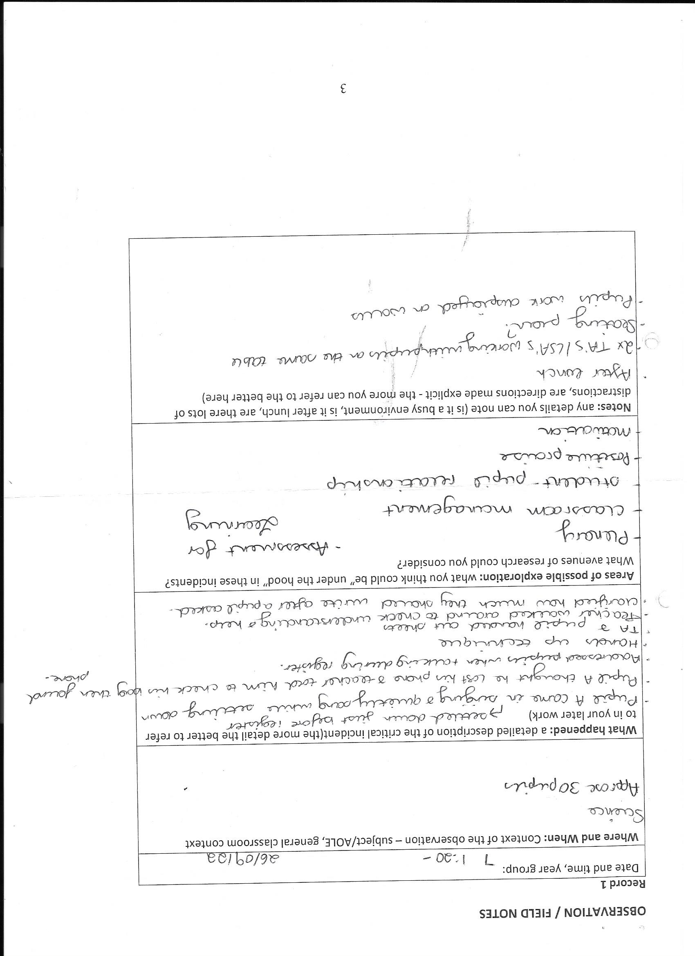
Appendices 2
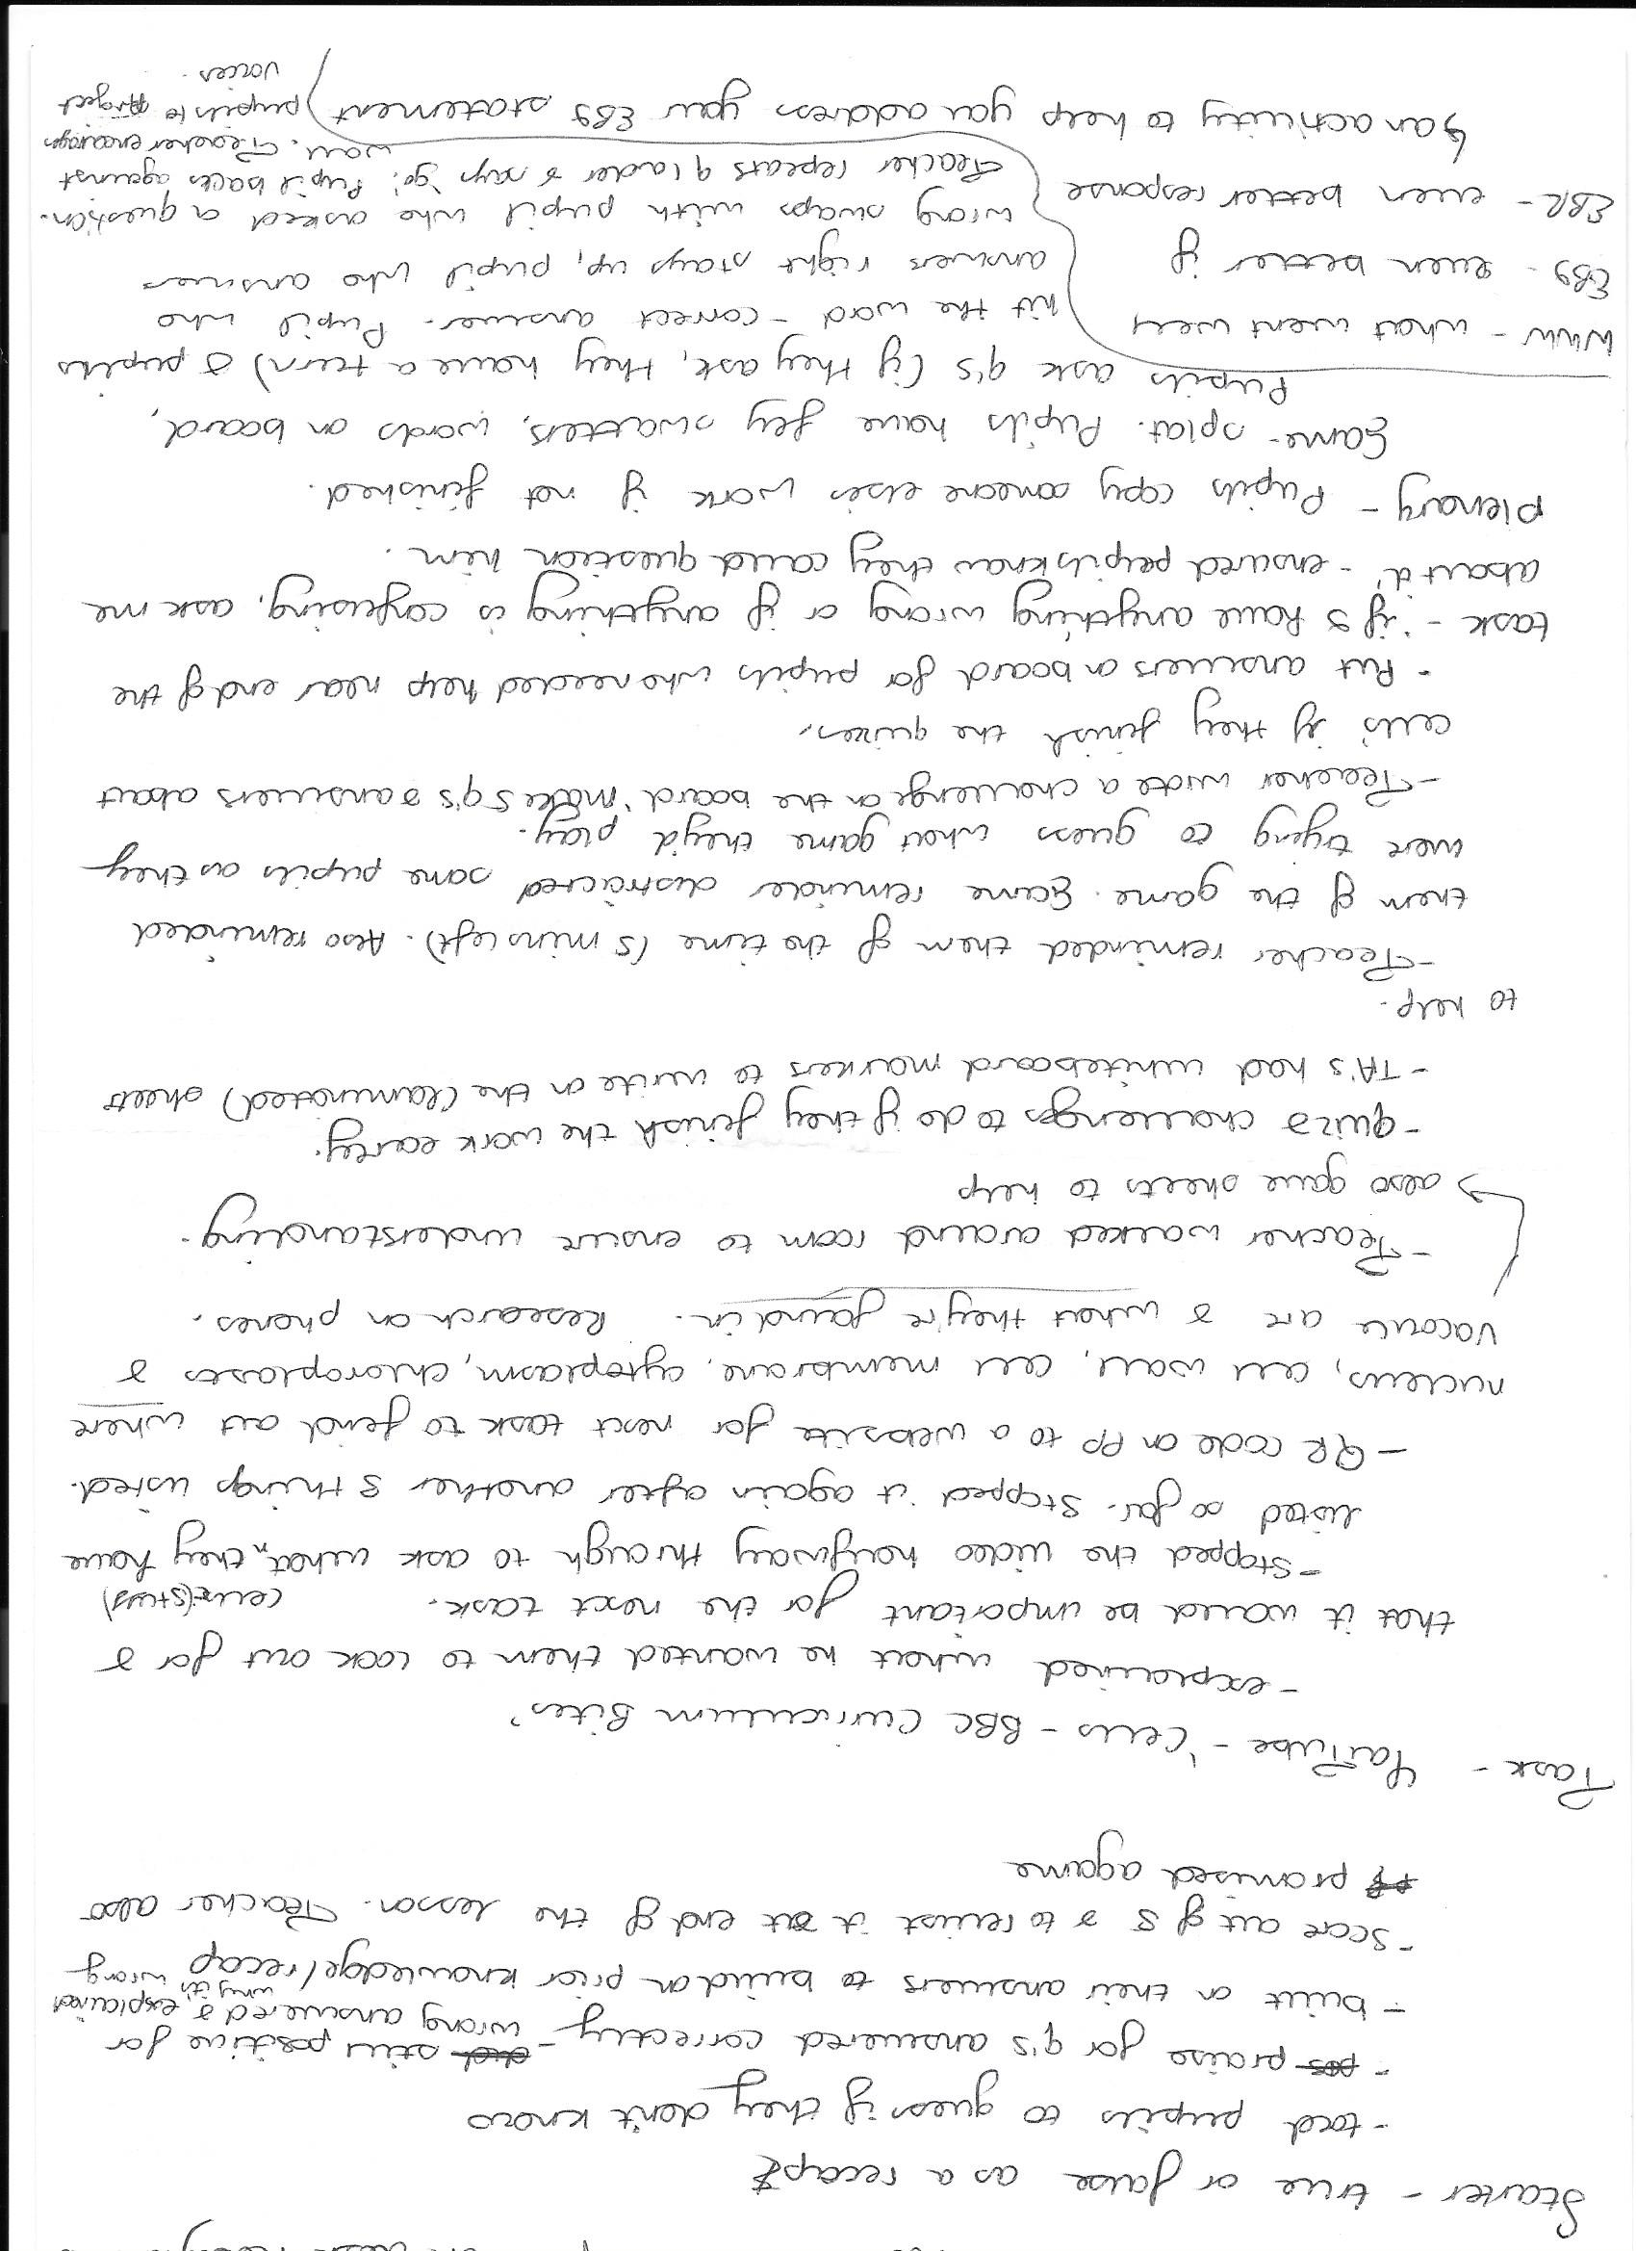
Appendices 3
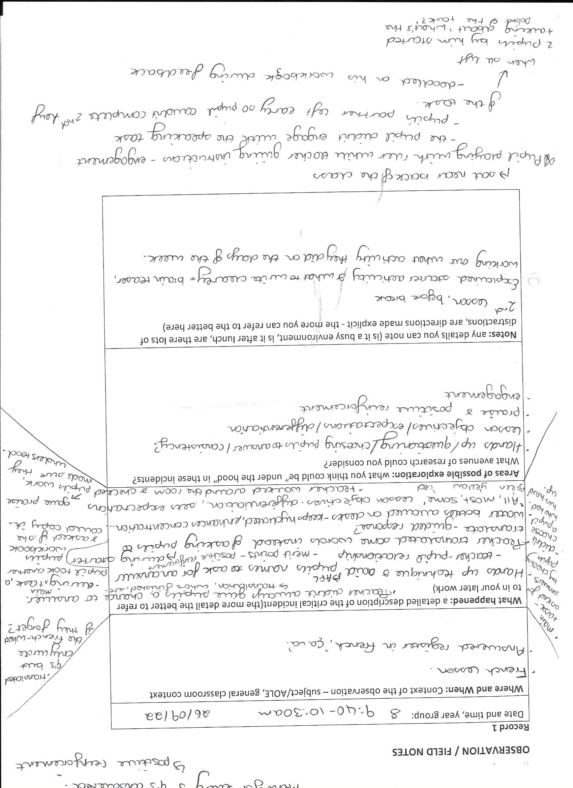
Appendices 4
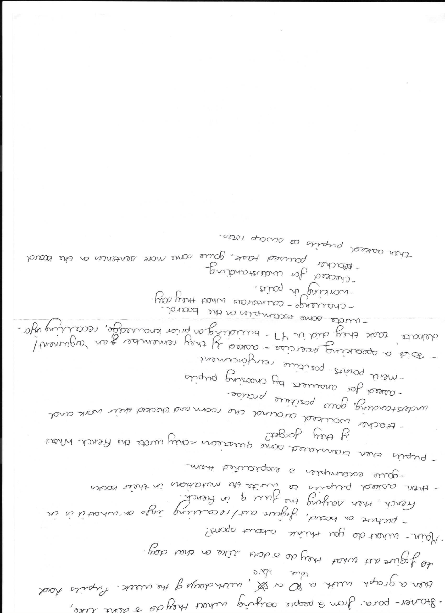
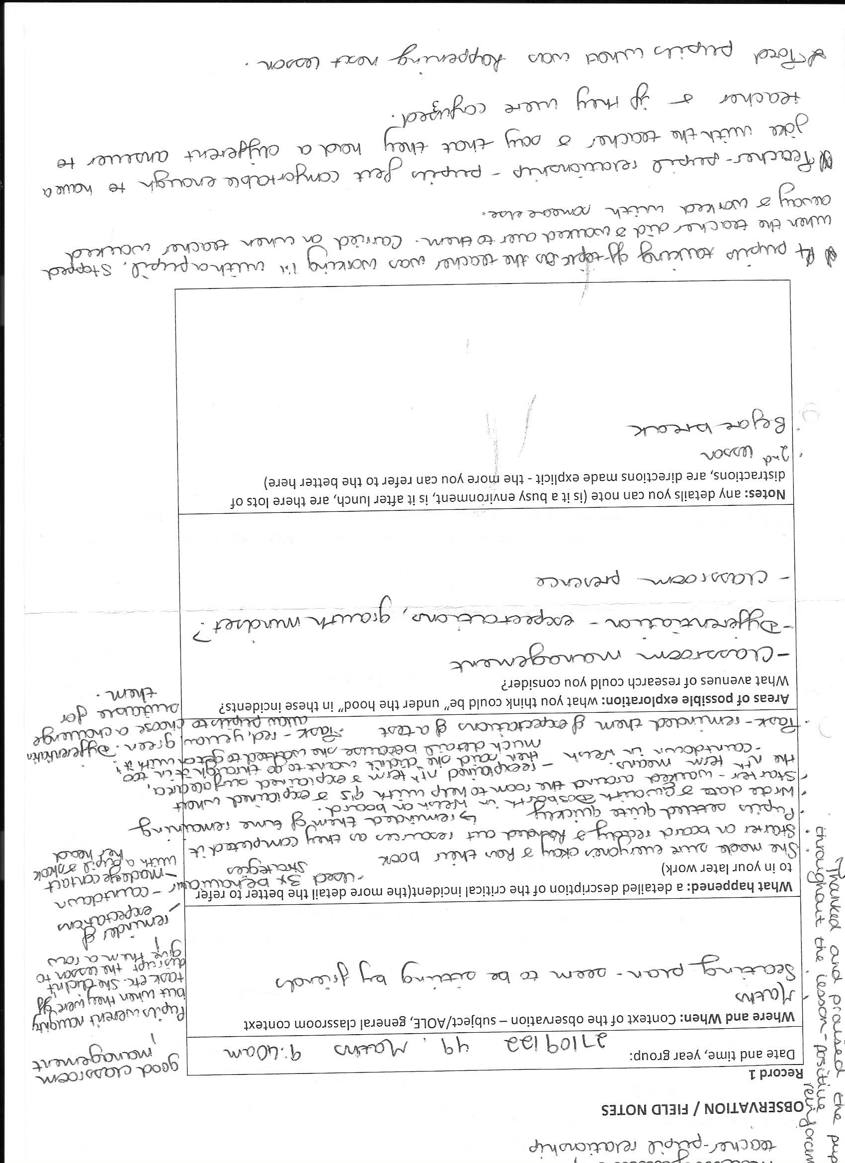
Appendices 5

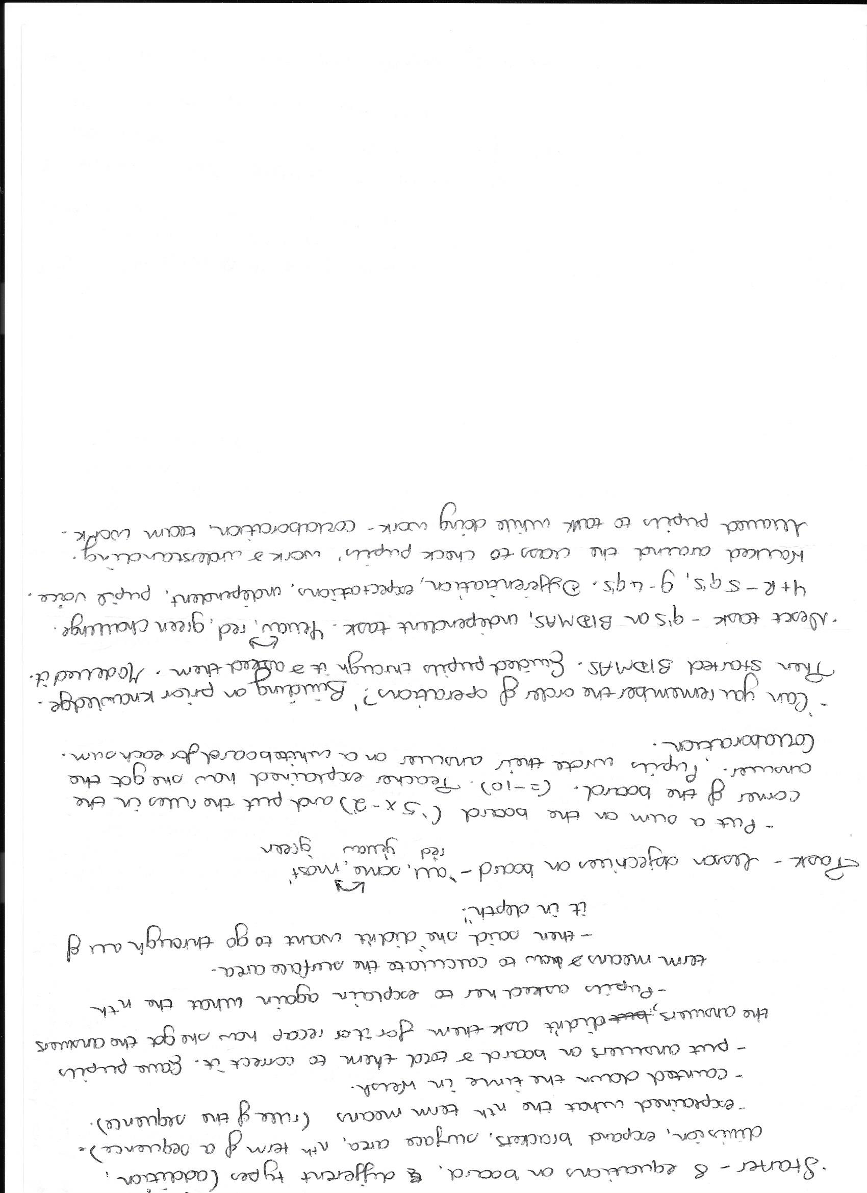
Appendices 6

Appendices 7
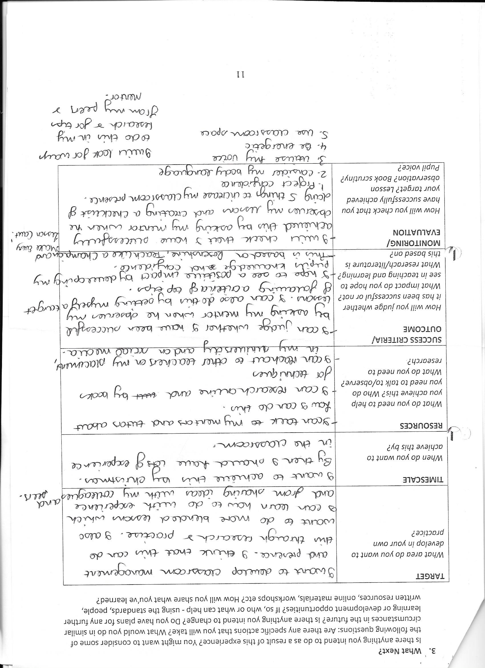

Reference List:
Appendices 1-7

Books:
Allison, Shaun and Andy Tharby. Making Every Lesson Count. 2015. Crown House Publishing Company. USA. 2019 Ed. Print.
Dweck, Carol S. 1999. Essays in Social Psychology: Self-Theories: Their Role in Motivation, Personality and Development. Edwards Brothers, Lillington. USA. Print.
Dweck, Carol S. Mindset: How You Can Fulfil Your Potential. 2006. US Random House, UK Robinson. London. 2007. Print.
Sutton, Clive. 1981. Communicating in the Classroom. Hodder and Stoughton Education, British Library Cataloguing. Great Britain. Print.
Websites:
British Education Research Association. ‘About’ Section. https://www.bera.ac.uk/. Accessed 1st November
Cambridge Assessment International Education. What is Assessment for Learning? N/A. https://cambridge-community.org.uk/professional-development/gswafl/index.html#:~:text=What%20is%20assessment%20for%20learning,learn%20and%20to%20what%20standard. Accessed 1st November 2022.
Coristine, S., Russo, S., Fitzmorris, R., Beninato, P., & Rivolta, G. (2022, April 1). The importance of student-teacher relationships. Classroom Practice in 2022. https://ecampusontario.pressbooks.pub/educ5202/chapter/the-importance-of-student-teacher-relationships/. Accessed 3rd November 2022.

Dauncey, Michael. Senedd Research. Donaldson Review: The ‘purposes’ and content of a Curriculum for Wales. 2021. https://research.senedd.wales/research-articles/donaldson-review-the-purposes-and-content-of-a-curriculum-for-wales/#:~:text=The%20four%20purposes%20are%20that,of%20Wales%20and%20the%20world.. Accessed 2nd November 2022.
Dr Karen Angus-Cole. Cambridge Assessment International Education. Education Brief: Teacher professional development. June 2021. https://www.cambridgeinternational.org/Images/621009-teacher-professional-development-facsheet.pdf. Accessed 1st November 2022.
Edwards, Julie-Ann. PRIMARY TRAINEES’ REFLECTION-IN-ACTION. 2007. https://www.cumbria.ac.uk/media/university-of-cumbria-website/content-assets/public/education/images/documents/research/escalatedocuments/ReflectionInAction.pdf. Accessed 1st November 2022.
Estyn Report. The XXX School. Estyn. 2018. https://www.estyn.gov.wales/system/files/2020-08/The%2520XXXXHigh%2520School_1.pdf. Accessed 1st November 2022.
Welsh Government. Professional Teaching and Leadership Standards: national approach to professional learning. Gov.wales. 2019. https://hwb.gov.wales/professional-development/national-approach-to-professional-learning/professional-teaching-and-leadership-standards-national-approach-to-professional-learning. Accessed 2nd November, 2022.
Main, Paul. Structural Learning. Strategies For Assessment For Learning. N/A. https://www.structural-learning.com/post/strategies-for-assessment-for-learning. Accessed 2nd November 2022.
McLeod, Saul. Observation Methods. 2015. https://www.simplypsychology.org/observation.html. Accessed 2nd November 2022.
Mindset Works. Decades of Scientific Research that Started a Growth Mindset Revolution. Dr. Dweck’s research into growth mindset changed education forever. 2017. https://www.mindsetworks.com/science/. Accessed 3rd November 2022.
Mississippi College: A Christian University. Importance of Critical Thinking in Curriculum Development. 21st October 2019. The Value of Critical Thinking in Curriculum Devleopment at MC. Accessed 1st November 2022.
NursingAnswers.net. November 2018. Schon's Reflective Model. [online]. Available from: https://nursinganswers.net/reflective-guides/schon-reflective-model.php?vref=1. Accessed 1 November 2022.
Observer (OECD). Policy Brief. Formative Assessment: Improving
Learning in Secondary Classrooms. 2005. https://www.oecd.org/education/ceri/35661078.pdf. Accessed 2nd November 2022.
Plymouth Community School Corporation. Think-Pair-Share. N/A. Https://www.plymouth.k12.in.us/formative/think-pair-share. Accessed 1st November 2022.
Prodigy Games. Understanding Game-Based Learning: Benefits, Potential Drawbacks and Where to Begin. June 2021. https://www.prodigygame.com/main-en/blog/game-based-learning/. Accessed 3rd November 2022.
Šarić, Marjeta and Šteh, Barbara. Critical Reflection in the Professional Development of Teachers: Challenges and Possibilities. 2017. https://files.eric.ed.gov/fulltext/EJ1156912.pdf. Accessed 1st November 2022.
School of Education Online Programmes. How to Foster a Growth Mindset in the Classroom. December 2020. https://soeonline.american.edu/blog/growth-mindset-in-the-classroom. Accessed 3rd November 2022.
Stanford Encyclopaedia of Philosophy. Supplement to Critical Thinking: History. 2022. https://plato.stanford.edu/entries/critical-thinking/history.html#:~:text=John%20Dewey%20(1910%3A%2074%2C,thought'%20or%20'thinking'. Accessed 1st November 2022.
University of Greenwich. Learning and Teaching: Formative vs Summative. N/A. https://www.gre.ac.uk/learning-teaching/assessment/assessment/design/formative-vs-summative#:~:text=Summative%20assessments%20often%20have%20high,and%20activities%20in%20subsequent%20courses.. Accessed 2nd November 2022.
University of Washington. CENTER FOR TEACHING AND LEARNING. Engaging students in learning. N/A. https://teaching.washington.edu/topics/engaging-students-in-learning/#:~:text=Strategies%20include%2C%20but%20are%20not,on%20activities%2C%20and%20experiential%20learning. Accessed 3rd November 2022.
Walkington, Jackie and Christensen, Hans Peter. Research Gate. Developing critical reflection as a part of teaching training and teaching practice. December 2001. https://www.researchgate.net/publication/245494046_Developing_critical_reflection_as_a_part_of_teaching_training_and_teaching_practice. Accessed 1st November 2022.

Iriss. What is Reflective Practice? N/A. https://content.iriss.org.uk/reflectivepractice/what.html. Accessed 1st November 2022.

Dweck, Carol. Mind Scholars Network. Carol Dweck Responds to Recent Criticisms of Growth Mindset Research. 2018. https://mindsetscholarsnetwork.org/carol-dweck-responds-recent-criticisms-growth-mindset-research/#. Accessed 10th October 2019.

