
NELSON ROLIHLAHLA MANDELA A Leadership case study
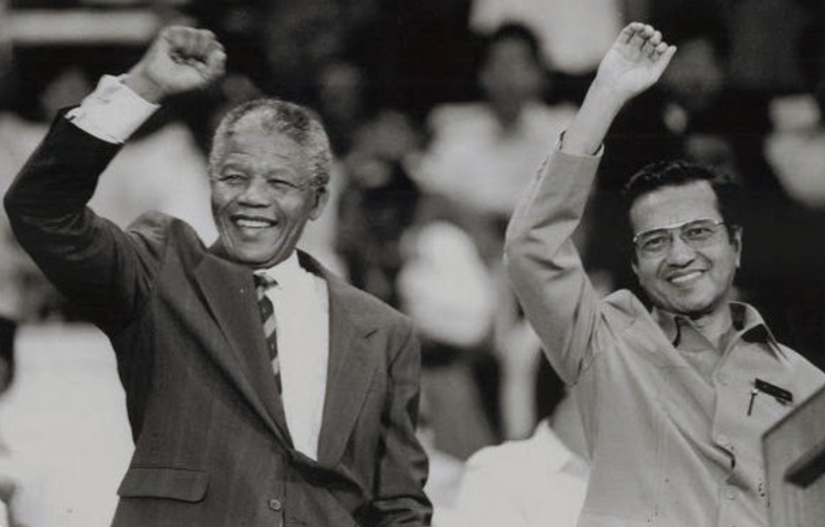

MODULE TITLE
Leading And Developing People
MODULE CODE
BMBM6012
MOHAMAD NUR AMIR BIN ISMAIL
2030311

Introduction
South African statesman and campaigner Nelson Rolihlahla Mandela passed away on December 5, 2013. The first democratically elected President of South Africa, he took office on April 27, 1994. The first black person to lead South Africa, he made history. Mandela was born into a Thembu royal family in Mvezo, South Africa. His administration worked to eradicate apartheid's lingering effects on South Africa by combating racism, poverty, and inequality and fostering more racial harmony. As President of the African National Congress (ANC) from 1991 to 1997, he championed the country's 1996 constitutional amendment outlawing discrimination on the basis of race, as well as language, religion, disability, and sexual orientation. From 1998 to 1999, Mandela served as the Secretary General of the Non-Aligned Movement on the international stage. Mandela received the Presidential Medal of Freedom, the Presidential Medal of Honour, the Soviet Order of Lenin, and the Nobel Peace Prize. His Xhosa clan name is Madiba, although he is also known as Tata (which literally means "Father"). What Mandela had done served as a source of motivation for many. Many years of Mandela's retirement were spent in bed due to illness. Hospitalisation was necessary for his prolonged lung disease in late summer of 2013. After a battle with a respiratory disease, Nelson Mandela died away on December 5th, 2013, at Houghton Estate in Johannesburg. He died at the age of 95 after a long life.
He and South African President F.W. de Klerk shared the 1993 Nobel Peace Prize for successfully transitioning South Africa from apartheid to multiracial democracy. One of South Africa's most famous leaders and politicians, Nelson Mandela transformed contemporary history with this feat. He was tireless, winning universal suffrage in South Africa. The ANC Youth League recruited Nelson Mandela in 1943 after he fled an arranged marriage and was banned from university for protesting bad dormitory conditions. He opposed apartheid legislation and compelled moderate ANC members to resign on his behalf. His ANC Youth League presidency advocated for strikes and boycotts to undermine apartheid. He led over 10,000 peaceful protesters in Durban in 1952. He captivated audiences with his charm and public speaking talents. The Suppression of Communism Act imprisoned him for nine months. He won the Nobel Peace Prize for his leadership for his anti-apartheid activism in 1993. After receiving the prize he said:

"We stand here today as nothing more than a representative of the millions of our people who dared to rise up against a social operation whose very essence is war, violence, racism, oppression, repression and the impoverishment of an entire people."
Origins and Early career

Nelson Mandela was born into the royal family of the Xhosa-speaking Tembu people, where his father was the Madiba clan chief. After Nelson's father died while he was young, the Tembu regent, Jongintaba, raised him. Nelson abandoned his proper position as tribal leader to enter the legal profession. He became an attorney after finishing his studies in law at South African Native College (now known as the University of Fort Hare). Joining the African National Congress (ANC) in 1944, he quickly rose through the ranks of the organization's Youth League to become a leader there. He also tied the knot with Evelyn Ntoko Mase that year. The African National Congress (ANC) was revitalized under Mandela's leadership, and he led the charge in the struggle against the National Party's apartheid policies.

In the year 1952, Nelson Mandela and his colleague Oliver Tambo established the first legal practice for Black individuals in Johannesburg, South Africa. This business primarily concentrated on addressing the legal obstacles stemming from the apartheid legislation enacted subsequent to 1948. Furthermore, during the aforementioned year, Mandela assumed a crucial role in initiating a defiance campaign aimed at challenging South Africa's pass laws. These laws mandated individuals of nonwhite ethnicity to possess official documents, commonly referred to as passes, pass books, or reference books, that granted them permission to be present in areas designated as "restricted" by the government, typically reserved for the white populace. As a component of the campaign, he traversed the whole country with the objective of mobilizing individuals in support of nonviolent opposition to the discriminatory law. In 1955, he provided assistance in the drafting of the Freedom Charter, a document that called for a social democracy in South Africa that transcended racial distinctions.

Mandela was often harassed by the police due to his anti-apartheid activity. He was barred (his movement, contact with others, and expression were all severely limited) on and off beginning in 1952. As part of a campaign to intimidate anti-apartheid campaigners, he and more than a hundred others were detained in December 1956 on treason allegations. The next year, in 1960, Mandela was put on trial and was found not guilty. Because of the lengthy legal case, he was able to marry his second wife, Nomzamo Winifred Madikizela (Winnie Madikizela-Mandela).

Subterranean Plotting and the Rivonia Trial

Following the banning of the African National Congress (ANC) subsequent to the 1960 massacre of unarmed Black South Africans by police forces, Nelson Mandela eschewed his previously nonviolent approach and began advocating for acts of sabotage against the South African regime. The individual in question played a pivotal role as one of the founding members of Umkhonto we Sizwe, the armed wing of the African National Congress (ANC). Subsequently, he assumed a clandestine existence, so acquiring the moniker "Black Pimpernel" due to his audacious actions. Following his departure for Algeria in 1962 with the purpose of studying guerrilla tactics, he subsequently returned to South Africa in that same year. Upon his return on August 5th, Mandela was promptly apprehended at a traffic checkpoint in Natal and subsequently sentenced to a term of imprisonment lasting five years.

The notorious Rivonia Trial, which took place in October 1963 and involved an imprisoned Nelson Mandela and several other men, was named for the affluent Johannesburg suburb where police raiding the underground Umkhonto we Sizwe headquarters discovered a significant amount of weapons and equipment. From the dock, Mandela delivered an impressive defense of liberty and resistance of oppression, even as he accepted the validity of some of the allegations against him. (His speech went viral and was eventually published as I Am Prepared to Die, earning him praise and admiration all around the world.) On June 12, 1964, he was given a life term in jail after being found guilty of murder.

Being imprisoned
Mandela spent 27 years in prison, from 1964 to 1982, on Robben Island, south of Cape Town. After that, he spent the next decade in maximum-security Pollsmoor Prison, where he was treated for TB until being moved to Victor Verster Prison in Paarl in 1988. At several points, most notably in 1976, the South African government offered Mandela conditional release if he would agree to live in the newly established, and extremely contentious, Transkei Bantustan. In order to accept an opportunity presented to him in 1985, he had to give up violence. Mandela turned down both proposals; the second was predicated on the idea that only free men could negotiate, and he was not free.

The majority of the Black people in South Africa never abandoned Mandela while he was in jail, and his incarceration became a cause célèbre for those who opposed apartheid abroad. South Africa's political situation deteriorated after 1983 and particularly after 1988, prompting cabinet officials to commence experimental discussions with mandela; he later met with Botha's successor, de Klerk, in December 1989. On February 11, 1990, the authorities of South Africa released Nelson Mandela from prison after he had served 27 years there. In the months after his release, Mandela rose through the ranks of the African National Congress (ANC) to become its vice president and then its president in July 1991. To end apartheid and usher in a peaceful transition to a nonracial democracy in South Africa, Mandela led the ANC into talks with de Klerk.

Leadership and Retirement

Mandela received his swearing in as president of South Africa's first multiethnic government on May 10th, 1994, after the country's first universal suffrage elections in April. Among his many initiatives aimed at improving the lives of South Africa's Black people was the Truth and Reconciliation Commission (TRC), which he established in 1995 to investigate human rights crimes perpetrated during the apartheid era. He spearheaded the effort to establish a new democratic constitution in 1996. When Mandela stepped down as president of the African National Congress (ANC) in December 1997, he appointed Thabo Mbeki to succeed him. In 1998, when he and Madikizela-Mandela's divorce was finalized, Mandela married Graca Machel, the widow of Samora Machel, the former president of Mozambique and leader of Frelimo.

Mandela resigned as president in 1999, and Mbeki was subsequently appointed. Mandela's political career ended when his tenure did, but the Nelson Mandela Foundation he established in 1999 has kept him in the public eye as an advocate for global peace, reconciliation, and social justice. Formed in 2007 to promote peaceful settlement of international conflicts and cooperative problem-solving, he was an original member of the Elders. In 2008, several nations, including South Africa, the United Kingdom, and others, held festivities in honor of Mandela's 90th birthday. Celebrating global volunteerism on Nelson Mandela's birthday is one way to remember the late leader. First celebrated on July 18, 2009, Nelson Mandela Memorial Day was officially declared by the United Nations on that same day. The Nelson Mandela Foundation and its 46664 program (a worldwide HIV/AIDS awareness and prevention campaign) were the principal sponsors of that event.

Understanding Nelson Mandela's Leadership Philosophy
Throughout his time as president of South Africa, Nelson Mandela had remarkable leadership abilities. Among his many admirable traits were his unwavering dedication to goals and causes larger than his own self-interest; his commanding presence that effectively neutralized adversaries through his affable demeanor; his remarkable capacity for forgiveness; his upbeat outlook; his vision for the big picture; his extraordinary resilience, tenacity, resolve, humility, hope, patience, and perseverance; and his extraordinary forgiveness. Those who aspire to become exceptional leaders capable of effecting positive change and guiding others towards a more promising future must develop ideas and concepts from a variety of perspectives, including but not limited to politics, religion, economics, society, morality, and ethics.Inspiring and mobilizing the masses to take positive action are central to Mandela and other revolutionary leaders' leadership philosophies and approaches. To become a great leader does not need you to memorize speeches and make public appearances. In order to have a positive impact on the world and inspire others, one must demonstrate admirable traits and point the way to a more fulfilling existence. Mandela's personality and achievements have inspired many individuals to reevaluate their views on his country and the world. Since he's been here, things have improved greatly.

Nelson Mandela's Dreams
Early in his youth, Nelson Mandela had visions of an Africa in which apartheid had been ended and men were treated as equals and allowed to pursue their own goals. These concepts motivated him to work for a more ideal world. Even in the depths of his incarceration, he was able to keep his faith and fulfill his commitments because of this vision. He was hopeful that, with enough effort, he might free his people from the prejudice of the past. He spent a combined 27 years behind bars before being elected as South Africa's first president. To be a good leader in his mold, one needs a lofty goal that benefits society as a whole. The mission of man on Earth is to be a benefit to other people and to live with the vigor and determination to see a goal through to fruition. Not everyone will agree with a vision, no matter how noble it may be. Even while it would benefit the populace as a whole, not everyone would welcome the change out of fear of the unknown. However, it should be battled for, since doing so would not be a stroll in the park, but rather a challenging task where many hurdles would need to be overcome. In other words, you need to be aware and actively pursue it.

National Strengthening
Nelson Mandela did more than just give speeches around his country; he also coordinated opposition to racial segregation laws. In addition, he pioneered new technologies and equipped his people so they could fight for their freedom and other liberties. He bolstered their will to resist apartheid and helped them see that they had the power to end the tyranny they were experiencing.

Leadership vs Management
To exert influence over others and inspire them to work toward a common goal is the essence of leadership, whereas the hallmark of good management is stability and predictability. The leadership styles of great individuals like Mandela were based on a vision, and they motivated others to work toward that vision. In addition, Mandela followed a more democratic model of leadership.

The Leadership Skills of Nelson Mandela
As was said before, Mandela's extraordinary leadership enabled his people to achieve their goals. What was his secret, then? Here are two of his many admirable traits:

- He has an ethical stance.
In his role as South Africa's first black president, Mandela exemplified the highest standards of moral leadership by prioritizing reconciliation and redirecting attention away from the country's challenges. By continuing the fight against apartheid regardless of the personal cost, he developed a leadership style based on the utilitarian principle that "the ends justify the means." Later, people began referring to him as a hero and freedom fighter because he never gave up until he was president. His morality inspired his disciples, who began to model their own lives after his.

- His ability to convey ideas to others is exceptional.
In the face of disputes, objections, and defenses, Mandela felt certain that his opponents would accurately describe his replies. His oratory talents were crucial to his success in rallying support and explaining his plan to achieve a better nation.
Leadership Methodology
Here are some of the leadership traits that Mandela values.

- Charismatic.
Nelson Mandela gained worldwide recognition in the 20th century as the figurehead of the campaign to abolish apartheid in South Africa. He was a visionary who led his people to victory, and his magnetism helped him become the first black president of the United States. Even though he spent a lengthy time behind bars, his supporters thought that his tremendous emotional reactions to them helped him win their trust and keep them faithful to the African National Congress (ANC). Because of this insight, they were able to continue the struggle and eventually surrender voluntarily.

- Transformational.
Mandela nearly fully emancipated his country from prejudice thanks to his abilities as a leader. He, like many other influential leaders, sought to inspire his followers by appealing to their higher ideals, telling them that education was the key to their future happiness and prosperity. Together with his friend Oliver Tambo, Mandela established the first African legal company in 1952. Mandela traveled the country as the campaign's volunteer-in-chief, speaking out against discriminatory laws and educating the populace. He also succeeded in having the ANC approve the Freedom of Speech Charter.

Inspirational.
For the duration of his presidency of Congress, Mandela inspired his supporters by elucidating the value and importance of his aims. One way he encouraged people to figure out what they think is most important about the country was by describing the fight for equality via the abolition of prejudice against races. Their courageous leadership was a major factor in South Africa's eventual success in ending apartheid and establishing a prosperous, modern democracy. His lectures, delivered as he traversed the length and breadth of the nation, enthused and persuaded the populace, and he spoke boldly of his ability to end the apartheid. He cautioned the populace against succumbing to the superior might of the governing elite and urged them to refrain from resorting to violence or insults in response to any and all forms of harassment.

Conclusion

In conclusion, Nelson Mandela is a model of innovative leadership, demonstrated to us that even the darkest clouds of negativity can give rise to the brightest beams of change. Many people throughout the globe looked up to Nelson Mandela as a great leader. For nearly twenty-five years, he was imprisoned for opposing discrimination and apartheid in South Africa. Mandela has become an international icon for peace and human rights, and his legacy is still moving people today. As we celebrate his life and legacy on Mandela Day, let us also recognise the transformative ability of effective leadership to rise above adversity and set off a cascade of individual and group development. Together, we have the power to kindle a fire that will shed light on the way to a brighter future, so changing negativity into an unyielding force of victory.

Reference
- https://www.linkedin.com/pulse/nelson-mandela-power-transformative-leadership-callan-abrahams
- https://www.imd.org/ibyimd/magazine/what-the-wisdom-of-mandela-can-teach-us-about-leadership/
- https://www.historycentral.com/Bio/people/Acheivement.html
- https://edumantra.net/paragraph-writing-in-english/paragraph-on-nelson-mandela/#:~:text=Paragraph%20on%20Nelson%20Mandela%2D%20150%20Words&text=He%20was%20born%20in%201918,and%20saw%20significant%20economic%20growth.
- https://www.nobelprize.org/prizes/peace/1993/mandela/biographical/

