Research and Evaluation Skills for Health Care Practice:
Research Report into Osteoporosis

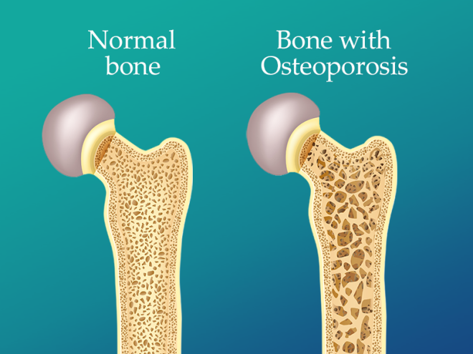

By Dylan Foxley
Student No. 2417047

Page of Contents:

Introduction Page 3

Case Study Page 4

Overview Page 6

Previous Approaches to the Condition Page 7

Current Approaches to the Condition Page 8

Co – Production Page 9

Clinical Governance and Supervision framework Page 10

Conclusion and recommendations Page 12

Reference list Page 14

Appendices Page 18

Introduction
This essay is a research report which looks at the condition known as Osteoporosis. In this report you will see how the work of the Therapy assistant practitioner (TAP) within the Community therapy team helps a patient cope with and manage the effects of living with this condition.
Osteoporosis is a condition which generally weakens the bones and makes the individual more vulnerable to fractures. The condition is fairly common within the United Kingdom. The Royal Osteoporosis society (2025) explains to us that more than 3.5 million people are currently known to be living with the condition in the UK.
This report will feature a case study of a patient who had a recent fall which resulted in a fragility fracture, which then coincided with the patient having a diagnosis of osteoporosis.
Within the report you will see a overview of osteoporosis as well as details on current and previous approaches to treatment for the condition within the health service.
The concepts of Co-Production and clinical governance will also be highlighted within the report. The conclusion of the report will highlight to you how the work of the Therapy assistant practitioner (TAP) can be effective in the treatment and support of patients with a diagnosis of Osteoporosis.

Case Study
In this case study we will see how the Therapy Assistant Practitioner (TAP) operates within the Community Therapy team.
The Community Therapy team is a service that provides patients with therapeutic interventions and treatment plans in their own homes with the aim of helping the patient to regain or maintain as much functional ability and independence as possible following a change in their medical status such as a new diagnosis or injury.
Within the departments allocation meeting The Therapy Assistant Practitioner (TAP) is delegated a suitable new Referral to take responsibility for Initial assessment and treatment plan.
The first visit to the patient by the Therapy Assistant Practitioner (TAP) following allocation sees them carry out an initial assessment with the patient to help develop a suitable treatment plan for the patient which supports them in working towards achieving their goals. In this case we will consider a gentleman who was discharged home from hospital with a fractured neck of femur and then referred to the Community Therapy Team from the local District general Hospital (DGH). The gentleman in the case study will be given the pseudo name of Frank to maintain his confidentiality.
Frank is a 72 year old male who lives alone in a privately owned bungalow. Frank has a long term diagnosis of Osteoporosis, Chronic Obstructive Pulmonary Disease (COPD) as well as more recent diagnosis of depression following the death of his wife. The COPD foundation (2024) explains to us that COPD is an incurable disease most commonly characterised by breathlessness and is a broad term used to cover several chronic lung conditions such as Emphysema and chronic Bronchitis.
Frank has recently had a fall at home in which he suffered a Left fractured neck of femur. Frank has surgery to repair the injury with a Dynamic hip screw (DHS). The Royal Cornwall Hospital (2025) explains to us that a Dynamic hip screw is a fixation screw and plate which holds your broken thigh bone together while it heals and will stay in place permanently even after the fracture has healed. Frank was able to give a very clear account of how the fall happened. He explained that shortly after lunchtime he became quite breathless whilst trying to move a pot in his garden and decided to go inside for a rest. Frank suffers with COPD and in recent times has found that he gets bouts of breathlessness more often as the condition has worsened. As he stepped into his conservatory Frank tripped on the step leading into it and fell onto the tiled floor.
Frank lives alone, does not have a pendent alarm and did not have any visitors that afternoon or evening so no help was summoned for him until the next morning when the postman arrived to deliver mail.
Franks overall social situation does have its challenges as he lives in a rural location with no near neighbours but he does have a very supportive son and a friend who both visit once a week. These visits help to boost his mood and give him a hand with practical tasks around the home as he was having difficulty before his fall with physically demanding tasks such as getting the groceries in and changing his bed linen. These difficulties coincided with regular back pain, a increasingly stooped posture, a decrease in his mobility and a growing feeling of weakness in both his upper and lower limbs. After talking to his GP about these problems Franks GP diagnosed him with Osteoporosis.
Osteoporosis is a condition known to lower our bone density over time and leave us more vulnerable to fractures as it gradually weakens our bones. The National Institute of Arthritis and Musculoskeletal and Skin Diseases (2022) explains to us that the condition can also be considered silent because a person may not even know they have the condition until they fracture a bone.

Overview of Condition
Osteoporosis is a condition which generally weakens the bones and makes the individual more vulnerable to fractures. It is a condition commonly found within the UK amongst people who are over the age of 50. Predominantly the condition is found in Women but also to a lesser extent affects the male population. It is explained to us by the Royal Osteoporosis Society (2025) that half of the female population over the age of 50 will break bones due to Osteoporosis and around one fifth of men.
This is a view supported by Gregson et al (2022) who report that Osteoporosis occurs predominantly in postmenopausal women and men over the age of fifty, he also continues to explain that “approximately one in two adult women and one in five men will sustain one or more fragility fractures”.
One of the most common fragility fractures linked to Osteoporosis is a hip fracture. Fractures such as this can have a major impact on the health service, between taking up bed space in hospitals and also the cost of fragility fractures per annum. The University of Bristol (2023) tells us that In the UK, the average hospital stay following a hip fracture is 32 days and Gregson (et al, 2022) point out that fragility fractures cost the NHS more than £4.7 billion ever year.
Once a patient returns home from Hospital it is family members who often have to deal with the strain of caring for individuals who have suffered an osteoporotic fracture, and this can cause a physical, emotional, and financial strain on them as they provide care to the patient.

Previous Approaches to the Condition:
Historically in health sciences it was often thought to be very difficult to differentiate the difference between osteoporosis and osteopenia. The normal attempts to diagnose the conditions included such methods as having a radiologist review a radiograph to identify the bone quality (Garn, Poznanski and Nagy, 1971), but as confirmed by Garn, Poznanski and Nagy (1971) there was no clear differences between osteoporosis and osteopenia when reviewing a radiograph making the diagnosis unreliable.
It is explained to us by Raisz (1997) that historically it has quite often been the case that the diagnosis of osteoporosis was made by either identifying that the bones were too thin, or when considering them following a fracture, which can lead to a inaccurate diagnosis or indeed one which is too late for many of the preventative measures to be put in place to help a patient avoid a fragility fracture.
In previous decades Calcium supplements and Vitamin D supplements were not as commonly available to people over the counter as they are today so to gain the benefits of these for bone health patients were usually referred to their GP for a prescription as they were not as easily accessible.
During these previous eras of healthcare The Therapy Assistant Practitioner (TAP) would have been working in the community in a much more reduced role with less responsibility when it came to providing treatment at home for a patient who was recovering from a recent fragility fracture. Typically, in these previous eras the initial subjective assessment of the patients needs would have been carried out by a fully Qualified therapist and the treatment plan with the recommended strengthening exercises would have also been decided by the qualified therapist.
The Therapy Assistant Practitioner (TAP) would have been very concerned with following closely the treatment plan set by the qualified therapist and feeding back to them details on how the patient was doing in progressing towards achieving their identified goals highlighting any issues as the treatment plan progressed.

Current Approaches to the Condition
In modern health sciences it is believed that as much early detection Of Osteoporosis as possible is key in treating the condition effectively. Osteoporosis Research Ltd (2024) tells us that there is a fracture risk assessment tool (FRAX) available which was produced by the University of Sheffield in recent years which helps to identify as early as possible a fracture risk using clinical risk factors and bone mineral density (BMD).
The modern day role of the Therapy Assistant Practitioner (TAP) sees them provide a broader service to the patient compared to what a generic Therapy assistant did in years gone by to a patient with a fragility fracture potentially caused by a fall and the diagnosis of osteoporosis. There would be some similarities between the current Therapy Assistant Practitioner (TAP) role and the previous Therapy assistant role in the community but the updated and current role of the modern day Therapy Assistant Practitioner (TAP) is more involved in the mobility assessments, outcome measures, setting the treatment plan and preventative measures to support the patient in reaching their goals, returning to baseline and prevent any falls in future which could result in any new fractures. All in all it is fair to say that the role today assumes much more responsibility for the treatment of a patient at home following a recent fragility fracture.
The guidelines set out for us by Powys Teaching Health Board (2024) give us a clear breakdown of the responsibilities and elements which make up the full scope of duties within the modern day Therapy Assistant Practitioner (TAP) role and these include.
- Handover of caseload/patient to another member of staff, providing all the necessary information
- To demonstrate the ability to jointly set functional, achievable, rehabilitation goals with patients.
- To be able to carry out HOMEFAST assessments and establish an appropriate treatment plan.
- To be able to carry out Total Hip Replacement Pre-operative assessments and establish an appropriate treatment plan.
- Complete an accurate subjective assessment.
- Carry out a mobility assessment including the relevant outcome measures to establish the correct treatment plan.
- Be able to provide a suitable and safe walking aid and/or recognise when a mobility problem is complex and requires an assessment with a registered therapist.
- To be competent in the correct selection and progression of exercises e.g. from the Otago balance and strengthening programme.
When considering the need to promote good bone health to patients it is quite common place that the Therapy Assistant Practitioner (TAP) will recommend to a patient and their family that they begin to take a Vitamin D or Calcium supplement as these can be easily obtained over the counter these days. If the TAP was concerned about the patients dietary intake in general and how this affects their bone health then they could also refer them to Dietetics for further advice.

Co-Production
NHS England (2025) explains to us that Co – Production is a system of working involving healthcare services, patients, carers and their communities which enables patients to be given access to the best possible support that is relevant to them, their needs and circumstances.
In Wales further legislation has been passed to help support this idea. The Social Services and Wellbeing Act (2014) takes into account the idea of Co – Production relating to patient services and explains to us all healthcare professionals working alongside a patient, their family and carers must endeavour to make sure that the care and support the patient receives is the best that it can be for meeting their needs.
It is explained to us by Duncan (2022) that the initial assessment stage is a vital part of the treatment process for a patient as it is when all of the details and information regarding a patients circumstances are collected which is vital for the Therapy Assistant Practitioner (TAP) to consider when trying to produce a effective treatment plan for the patient.
Within the Community therapy team before the initial assessment process begins the team receives a new referral for the patient into the department. There is a specific referral form for Community therapies which is shared with the wider aspect of the MDT which is involved in supporting patients living in the local community. The Harrogate and District NHS foundation trust (2025) explains to us that the MDT is a Multi-disciplinary team which is made of trained staff from all areas of Healthcare who have a joint focus of ensuring that the best possible care and treatment is provided for the patient. Any member of this MDT can refer someone to Community therapies. The MDT in the community involves GP`s, District Nurses, Social services, Dietetics, Pharmacists and the District General Hospital (DGH).
During the process of delivering a treatment plan many barriers can come up which the Therapy Assistant Practitioner (TAP) may not have been expecting. These can include:
Quite often after a recent illness or injury the patients prescribed medication list will have been updated or changed in Hospital as they prepare for Discharge. Once they are home there can be a delay in getting their prescription list updated accordingly with their local GP surgery or Pharmacy which can cause further complications such as high pain levels for the patient which prevent them from taking part in their treatment plan, issues cognition, confusion, or worsening of a newly diagnosed condition.
During a assessment and treatment process the Therapy Assistant Practitioner (TAP) may have identified that the patients rehab process would have benefitted from involvement with other services that for example complement a treatment plan aimed at improving mobility such as Podiatry or Chiropody but these services having long waiting lists can cause a long delay in the patient being seen thus leading to a negative impact on them achieving their goal.
Poor communication between healthcare services, which could result in not having the appropriate information about the patient, leading to a lengthier assessment process, unnecessary discussions and even poor therapy planning as the patient may have a condition that the Therapy Assistant Practitioner (TAP) is unaware of, which could cause discomfort or pain to the patient.
Even after a goal is identified with the patient and a treatment plan agreed on with them the patient could become non-compliant and then not practice their exercises as agreed in their own time. Perhaps this could be due to a psychiatric condition they have which the Therapy assistant Practitioner (TAP) was unaware of during assessment. A complication like this can lead to the patient not achieving their goal in the longer term of the treatment plan or the patient’s goals having to be reviewed and reduced.

Clinical Governance and Supervision Framework
The Powys Teaching Health Board (PTHB) (2024) state that “The importance of clinical supervision for all therapy, health science, nursing, midwifery, mental health and supporting clinical staff is recognised as being central to safe and effective practice within a clinical governance framework”. Some of the benefits to completing clinical supervision for staff according to the PTHB, inclusive of the ATP’s are;
- Development of reflective clinical practice and evaluation skills.
- Identification and understanding of own development needs and how to address them.
- Learning and developing improved working practices, skills, knowledge, and values.
- Support and encouragement.
Clinical Supervision for the Therapy assistant practitioner (TAP) allows them to raise any concerns to their supervisor of their clinical practice to ensure they receive support with their concerns or how to appropriately manage this in the next instance. Additionally, clinical supervision allows for a Therapy assistant practitioner (TAP) to reflect on their practice and to identify any areas of improvement which may be needed to provide the best possible care for patients. It is important that TAPs receive regular six weekly supervision sessions to cover all aspects of their role which covers, goals, training, concerns, well-being discussions amongst many others (See Appendix 2).
In Wales all NHS staff including the Therapy Assistant Practitioner (TAP) are required to complete statutory and mandatory training to help ensure that they are equipped with the skills and knowledge required to carry out their duties to the highest standards possible. These elements of training are often set out by Public Health Wales, The Welsh Government and NHS Wales.
Over the years in the NHS it has often been thought that several barriers exist which prevent effective workforce training. This is a issue mentioned by Ward and Wood (2001) who explain to us that factors such as time, limited financial resources and low staff motivation are the most substantial barriers for effective training in the NHS. This is a opinion partly shared by Sanders and McLaughlin (2018) as they tell us that cost and time are still existing barriers for the delivery of effective training but in contrast they feel that quality, relevance, access and inclusion are the most substantial current barriers to effective training in healthcare.
Risk management is an essential aspect covered within clinical governance, which helps to ensure the safety of patients and staff on a daily basis within the healthcare environment. The Therapy assistant practitioner (TAP) has a responsibility alongside all NHS staff to report any risk they find within the workplace using the Datix system as laid out by Public Health Wales (2024).
The Lone working policy of Powys teaching health board (2022) is very relevant to the role of the Therapy assistant practitioner (TAP) as they often work alone in the community setting. This policy sets out guidelines for all staff to follow on how to safeguard and minimise any risk to staff working alone in the community and explains to us that the health board has a responsibility to minimise any risk to its lone working staff in the community. This is a point of view matched by Public health wales (2024) which explains that there is a duty of care to lone working staff both in the community and on its property.
Brennan (2014) produced a risk assessment tool for individuals working alone to identify any risks (See Appendix 1), this system would be beneficial for the Therapy Assistant Practitioner (TAP) along with all other health care professionals to use to ensure safety when working alone and therefore to carry out an effective risk assessment prior to a visit.

Conclusion and Recommendations
The findings of this research project show us that the Therapy Assistant Practitioner (TAP) can and should effectively provide treatment plans for patients with Osteoporosis that help with the management of the condition, and reduce the risk of Falling and therefore the subsequent fragility related fractures which often happen to a Osteoporotic patient as a result of having a fall. The World health organisation (2025) explains to us that a fragility fracture is a fracture which occurs when a force or impact is put upon a bone which would not normally be enough to cause a fracture but does in this case because the bone is weaker than it would normally be. A Therapy Assistant Practitioner (TAP) can be very effective at introducing a patient to strength and balance exercises and ensuring the patient has the appropriate walking aid to help them be more stable when walking. Both of these methods often implemented by the Therapy assistant Practitioner (TAP) can be very effective in prevention of a fall which leads to a fragility fracture.
The evidence found during this research project shows us that from a Co-production point of view the management and treatment of a patient with Osteoporosis can benefit from a connection between the patients GP and the Therapy Assistant Practitioner (TAP). Medication can have a key role in the treatment and prevention of osteoporosis. NHS UK (2022) tells us that the medications used in the treatment of Osteoporosis are very often effective in strengthening the patients bones. Therefore, the co-production of the Therapy Assistant Practitioner (TAP) liaising with the GP would be beneficial by helping to make sure that the patient is on appropriate medication to manage other conditions that could increase their risk of falls and a subsequent fragility fracture. For example a patient with Osteoporosis who is currently been seen by the Therapy Assistant Practitioner (TAP) to help them address mobility issues may have been given medication by the GP to help them manage symptoms of Vertigo. NHS UK (2023) explains to us that a attack of Vertigo can be very bad for a persons balance, making them very dizzy to the point that they could well suffer a fall as a result of the attack. Whilst dealing with them the Therapy Assistant Practitioner (TAP) could notice changes in their condition and perhaps a worsening of their Vertigo symptoms and feed this back to the GP who then could adjust the patients medication accordingly in a timely manner which helps to prevent a subsequent fall due to the Vertigo symptoms getting worse.
During this research report we have seen that whilst working in the Community the Therapy Assistant Practitioner (TAP) is often in a position where they are a Lone worker. The Health and Safety Executive (2025) explains to us that a lone worker is anybody who performs duties on their own without contact with others from their workplace which makes them more vulnerable to injury or mishap.
Bearing this in mind it is sensible to recommend that they make sure a risk assessment is always completed prior to attending a patient’s home alone. A suitable risk assessment to follow is provided by Brennan (2014) with his Rapid Risk Assessment Tool (See Appendix 2). This should be used by the Therapy Assistant Practitioner (TAP) to identify any risks prior to completing a visit. Doing so will help ensure that their safety as a lone worker in the community is maintained at all times.

WORD COUNT: 3298

List of References
Overview of Osteoporosis by The National Institute of Arthritis and Musculoskeletal and Skin Diseases (2022).
Available at:
Osteoporosis Causes & Symptoms | NIAMS

What is COPD by The COPD Foundation (2024).
Available at:
What is COPD? - Chronic Obstructive Pulmonary Disease - COPD Foundation

Hip fractures explained by The Royal Cornwall Hospital (2025).
Available at:
Hip fractures | Fracture Clinic | Royal Cornwall Hospitals NHS Trust

CO – Production – using the always events quality improvement methodology NHS England (2025)
Available at:
NHS England » Co-production

The Social Services and Well being act (2014)
Social Services and Well-being (Wales) Act 2014 | Law Wales

Skills for Practice in Occupational Therapy by Edward A.S Duncan (2022).
Duncan, E. A. S. (2022) Skills for Practice in Occupational Therapy. 2nd Edition. Scotland: Bell and Pain LTD.

Andrews, N., Calder, G., Blanluet, N., and Baker, R. (2023) ‘Co-Production’, Research to support the Final Report of the Evaluation of the Social Services and Wellbeing (Wales) Act 2014. Cardiff: Welsh Government.
Available at:
Co-production Research to support the Final Report of the Evaluation of the Social Services and Well-being (Wales) Act 2014

Multidisciplinary Team (MDT) explained by Harrogate and District NHS Foundation Trust (2025)
Available at:
Multidisciplinary Team (MDT) - Harrogate and District NHS Foundation Trust

Royal Osteoporosis Society (2025) Osteoporosis and bone health. Available at:
Royal Osteoporosis Society - Better Bone Health for Everybody

Brennan, W. (2010) ‘Safer lone working: assessing the risk for professionals’, British Journals of Nursing, 19(22), pp. 1428 - 1430. Available at:
Safer lone working: assessing the risk to health professionals
Powys Teaching Health Board (2023) LINICAL SUPERVISION AND REFLECTIVE PRACTICE FOR THERAPY, HEALTH SCIENCES, MIDWIFERY, NURSING, SOCIAL WORK AND PSYCHOLOGY. Bronglais: PTHB. Available at:
Home - Powys Teaching Health Board

Ward, J. and Wood, C. (2000) ‘Education and training of healthcare staff: the barriers to its success’, European Journal of Cancer Care, 9(2), pp. 69-128. Available at:
Education and training of healthcare staff: the barriers to its success

Sanders, K. and McLaughlin, D. (2018) Improving Mandatory Training: How reps can play their part. 1st Edition. London: Royal College of Nursing. Available at:
Improving Mandatory Training Royal College of Nursing | Royal College of Nursing

Powys Teaching Health Board (2022) Lone Working and Policy & Procedures. Bronglais: PTHB. Available at:
pthb.nhs.wales/use-of-site/freedom-of-information/disclosure-log/foi-disclosure-log-2023/august/foi-23r276-attachment-2/

Public Health Wales Lone working policy (2024). Available at:
https://phw.nhs.wales/about-us/policies-and-procedures/policies-and-procedures-documents/risk-management-health-and-safety-and-estates-supporting-documents/lone-worker-procedure/

Public heath Wales incident reporting guidelines (2024). Available at:
phw.nhs.wales/about-us/policies-and-procedures/policies-and-procedures-documents/risk-management-health-and-safety-and-estates-supporting-documents/phw15-tp02-putting-things-right-incident-reporting-and-management-procedure/

NHS UK – Explanation on Vertigo (2023). Available at:
Vertigo - NHS
The Health and Safety Executive – Lone Working (2025). Available at:
Lone working: Protect those working alone - HSE
NHS UK – The treatment of Osteoporosis (2022). Available at:
Osteoporosis - Treatment - NHS
World Health Organization – Types of Fragility fractures (2025). Available at:
Fragility fractures
The University of Bristol – Hip fracture health costs (2023) Available at:
July: Hip fracture health costs and care | News and features | University of Bristol

The Royal Osteoporosis Society – Research (2025) Available at:
Royal Osteoporosis Society - Better Bone Health for Everybody

Raisz, L. (1997) ‘The Osteoporosis Revolution’, Annals of Internal Medicine, 126(6), pp. 458-462. Available at: https://oce.ovid.com/article/00000605-199703150-00007/HTML

Garn, S., Poznanski, A., and Nagy, J. (1971) ‘Bone Measurement in the Differential Diagnosis of Osteopenia and Osteoporosis’, Diagnostic Radiology, 100, pp. 509-518. Available at: https://pubs.rsna.org/doi/pdf/10.1148/100.3.509

Powys Teaching Health Board (2021). Powys Teaching Health Board Assistant Therapy Practitioner Support Worker Competencies. Bronglais: PTHB.

National institute of Arthritis and Musculoskeletal and skin diseases – Calcium and Vitamin D for Bone Health (2023). Available at:
Calcium and Vitamin D: Important for Bone Health | NIAMS

Appendices
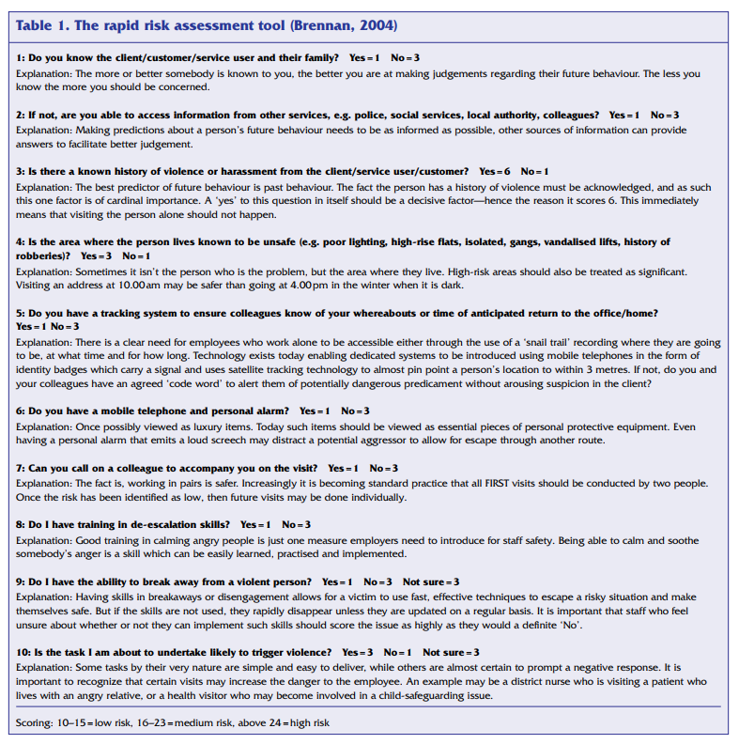
Appendix 1
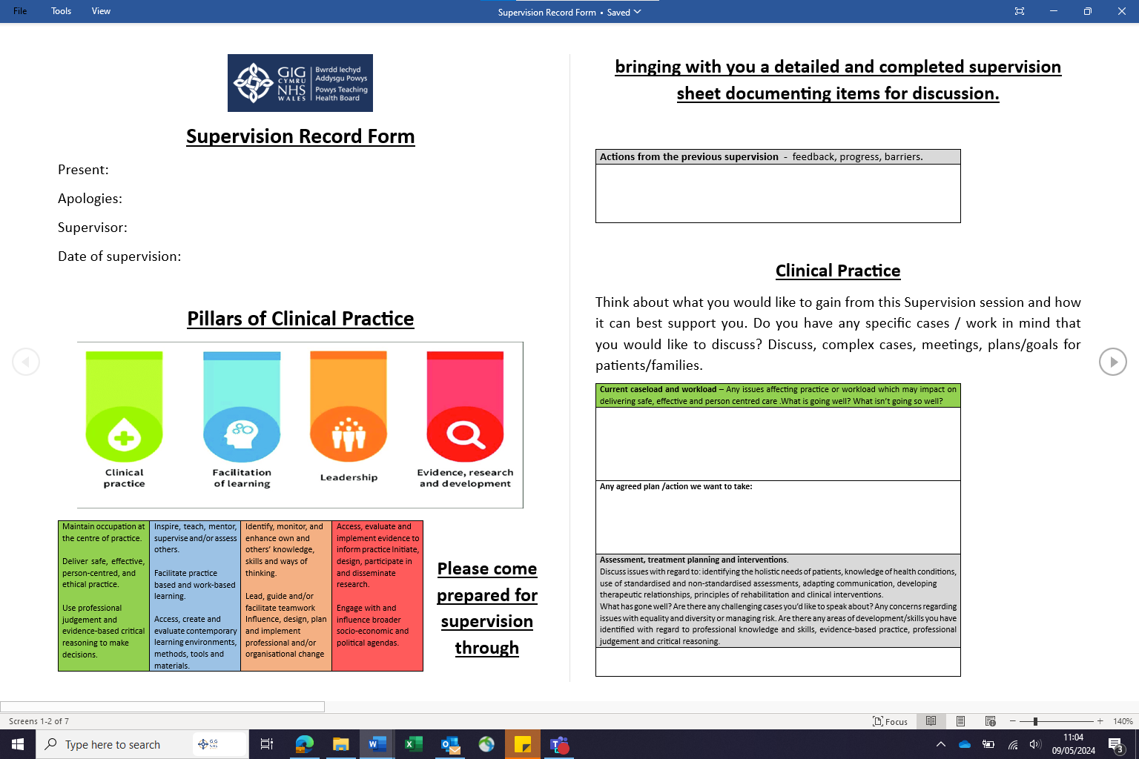
Appendix 2



