4/28/2026
Module Name: Software Solutions for Business

Module Code: ACCA4026

Student Name: Danuzia Aparecida Soares
Student ID: 2435233
Group: 3

Lecturer’s Name: Kwame Assa-Agei

Software Solutions for Business
Assignment 02
UNIVERSITY OF WALES TRINITY SAINT DAVIDLONDON CAMPUS)
LONDON CAMPUS

Table of Contents
Introduction 1
Task 1. e-Commerce Website builders/software solutions. 2
1.1 Wix: 2
1.2 Shopify: 3
Task 2. Mind-map of contemporary Software applications 4
2a. Describe mind mapping and explain the benefits of using mind mapping in business operations 4
2b. Create a mind map of contemporary software 6
Task 3. Office Applications 7
3a. Explain four office software solutions for business operations 7
3b. Test any two features 12
Task 4. Communication and Collaboration applications 17
4a. One (1) contemporary Communication and one (1) Online Collaboration 17
4b. Test one feature of a freely available Communication (1) and one feature of a Collaboration (1) application 19
Conclusion 26
References 27

Introduction

In today’s digital world, businesses depend heavily on software tools to improve productivity, manage operations, and support decision-making. As organisations become more technology-driven, it is important to understand how different digital solutions are used in real business situations.
This assessment explores a range of contemporary software applications used in modern organisations. It begins by analysing e-commerce platforms, focusing on their main features, benefits, and limitations. It then looks at mind mapping as a technique that supports planning, organisation, and problem-solving in business environments.
It also examines key Microsoft Office applications, including Word, PowerPoint, Excel, and Access, explaining how they are used for creating documents, presenting information, analysing data, and managing databases. In addition, practical tasks are included to demonstrate the use of specific features such as Mail Merge and the IF function.
Finally, the assessment evaluates communication and collaboration tools, specifically Gmail and Google Meet, showing how they support teamwork, communication, and remote working.
This assessment shows how these tools are applied in real business contexts and how they help improve efficiency and organisational performance.

Task 1. e-Commerce Website builders/software solutions.

E-commerce, also known as electronic commerce, is the process of buying and selling products or services over the internet. Nowadays, many businesses rely on e-commerce platforms, which are software applications that help users create, manage, and run an online store. These platforms usually provide tools for adding products, handling payments, and designing the website, which makes the whole process much easier, even for people without technical experience [1].

Wix:


Wix is well known for being very simple and easy to use, especially for beginners. One of its main advantages is that it does not require any coding skills, as users can build their website using a drag-and-drop system. This means you can just select elements like text, images, or buttons and place them wherever you want on the page.
In addition, Wix offers a variety of ready-made templates that can be customised depending on the type of business [2].
Another useful feature is that Wix allows users to set up an online store quite quickly, including adding products, setting prices, and choosing payment methods.
Limitations: However, there are also some limitations. Wix was originally created for basic websites, so even though it now supports e-commerce, it may not be the best option for very large or complex online stores.
Conclusion: In general, Wix is a good choice for small businesses or beginners who want a simple and practical solution to start selling online [3].

Shopify:


Shopify is a platform specifically designed for online store owners, providing a complete set of tools to create, manage, and grow an e-commerce business. One of its main strengths is scalability, as it allows entrepreneurs to start with basic features and gradually expand their store as their customer base increases. The platform focuses strongly on selling products rather than just presenting information, helping businesses meet customer needs more effectively [4].
Shopify offers a wide range of features that support daily business operations. Users can upload products, manage inventory, process customer orders, and track performance using built-in analytics and reporting tools. These features help business owners understand sales trends, identify popular products, and improve weaker areas of their website. In addition, Shopify includes a point-of-sale (POS) system, which is useful for businesses that also operate physical stores, allowing them to manage both online and in-person sales in one system.
Another important advantage is the flexibility in payment options. Shopify supports multiple payment gateways, making transactions easy and secure. Its own system, Shopify Payments, simplifies the checkout process by removing the need for third-party providers [5].
Limitations: However, there are also some limitations. One of the main drawbacks is the cost, as users must pay a monthly subscription and may face additional expenses for apps, themes, and transaction fees.
Customisation can also be limited without technical knowledge, especially when more advanced changes are required.
Additionally, many extra features depend on paid applications, which can increase both cost and complexity.
Shopify is a powerful platform, but it may not be ideal for all types of businesses.
Conclusion: Both Wix and Shopify are useful, but they suit different needs. Wix is better for beginners or small businesses looking for a simple solution, while Shopify is more suitable for businesses that want to grow and need more advanced features.

Task 2. Mind-map of contemporary Software applications

2a. Describe mind mapping and explain the benefits of using mind mapping in business operations

Mind Mapping is a visual thinking technique used to organise and develop ideas in a structured but flexible way. It usually starts with a central idea placed in the middle, and then related ideas are connected through branches. These branches can be expanded into smaller subtopics, creating a clear structure that shows how different ideas are linked. In many ways, a mind map looks like a tree, where each branch represents a different direction of thinking.
The concept of mind mapping was developed by Tony Buzan in the 1970s to improve notetaking and support more effective thinking. Unlike traditional linear notes, mind maps allow individuals to explore ideas more freely and visually. This approach can help engage both logical and creative thinking, which improves memory, focus, and understanding when dealing with complex information [6].

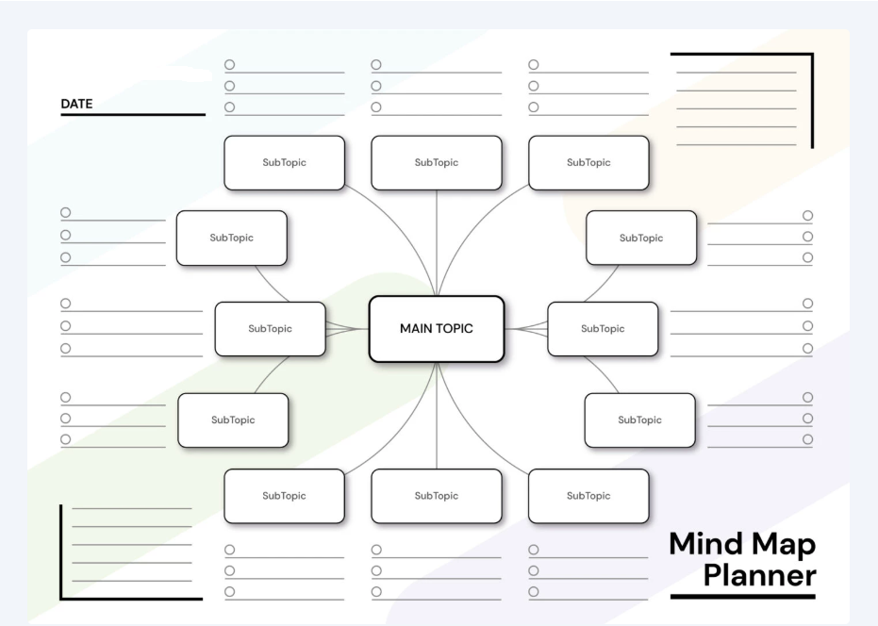
Image: Example of Mind Map Planner.
Benefits: One of the main benefits of mind mapping in business operations is its ability to support brainstorming and idea generation. During meetings or planning sessions, teams can use mind maps to quickly generate ideas and see how they are connected. This often leads to more creative and innovative solutions, as people feel more comfortable sharing ideas in a less structured format [7].
Another important advantage is improved organisation. Mind mapping helps break down complex problems into smaller and more manageable parts, making it easier to analyse tasks and plan activities. This is especially useful in project management, where it is important to clearly define responsibilities, deadlines, and priorities.
In addition, mind mapping can improve communication within teams. Because the information is presented visually, it becomes easier for team members to understand relationships between ideas and tasks. This can reduce the need for long explanations or meetings, as the key information is already organised in a clear and simple way [8].
Mind maps are also useful for decision-making and problem-solving. By organising information visually, businesses can compare different options, identify potential risks, and make more informed decisions. This helps organisations respond more effectively to challenges.
Furthermore, mind mapping supports knowledge management and continuous learning within organisations. It allows information to be stored and revisited in a structured but flexible way, which is important in fast-changing environments. As a result, teams can stay more organised, productive, and focused on their objectives.
Conclusion: Mind Mapping is a simple but powerful tool that supports creativity, organisation, communication, and decision-making in business operations.

Applications:
- Brainstorming
- Planning
- Organizing
- Keep time
- Requirements gathering
- Encourage original thoughts
- Track dependencies and responsibilities
- Management
- Presentations/meetings and interviews
- Analysis and problem solving
- Decision making

Best Practices for Mind Mapping:
Begin with a topic or image in the center and include visuals throughout.
Assign one main idea to each branch.
Place related sub-ideas on their own sub-branches.
Add pictures, symbols, or codes to make your map more visual.
Make each line the same length as its word or image.
Incorporate at least three different colours.
Use only one keyword per line.
Write all words clearly and legibly.
Leave room for additional ideas or new insights.
Allow your thoughts to flow freely.

2b. Create a mind map of contemporary software

LINK: https://mm.tt/map/3755785784?t=C84SUomSWa

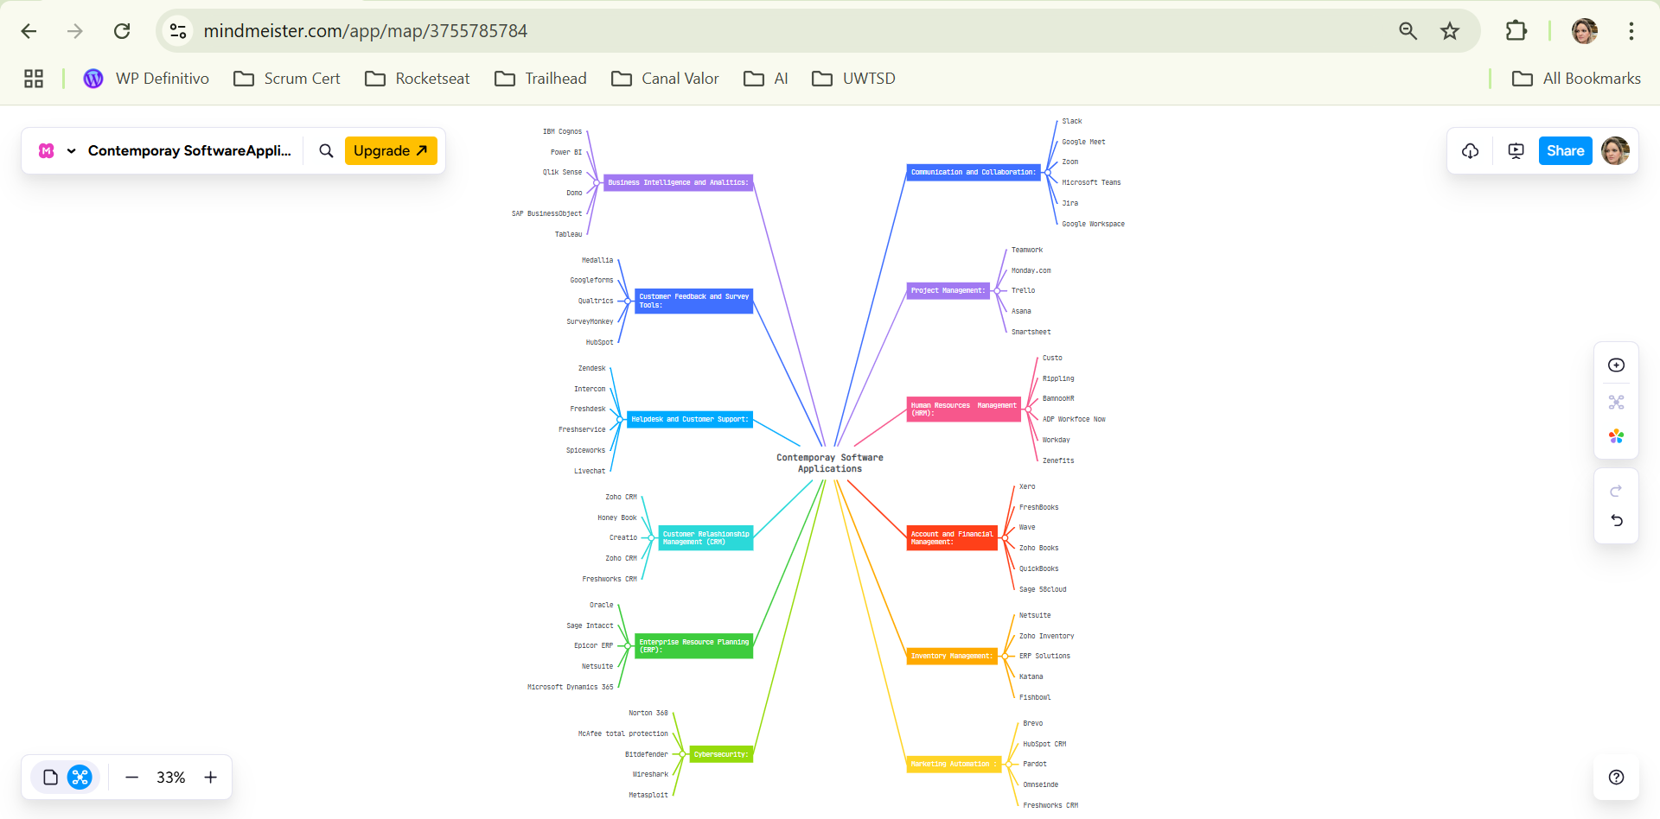

Task 3. Office Applications

3a. Explain four office software solutions for business operations

MS Word: Is a widely used word processing application developed by Microsoft and included in Microsoft Office 365. It is mainly used to create, edit, format, and share text-based documents, and it plays an important role in personal, academic, and professional environments [9]. In business operations, Microsoft Word is often used for writing reports, creating formal documents, and managing written communication.
Major Features: One of the main strengths of Microsoft Word is the wide range of features it offers for document creation. Users can type and format text using different fonts, sizes, and colours, which helps improve how the document looks. Tools like copy, cut, and paste also make it easier to edit content quickly. In addition, the software allows users to insert images, tables, and charts, which can help present information in a clearer and more engaging way.
Another useful feature is the ability to customise the document layout. Users can change margins, page size, spacing, and alignment depending on what they need. This is especially important in business environments where documents often need to follow a specific format. Microsoft Word also includes spelling and grammar checking tools, which help reduce mistakes and improve writing quality.
Collaboration is also an important benefit. Features such as comments and “track changes” allow multiple users to work on the same document and review edits. This is useful in organisations where teamwork is required. Research shows that digital word processing tools can improve productivity and make collaboration easier by allowing documents to be edited and shared more efficiently [10].
Benefits: Microsoft Word is quite easy to use, even for beginners, but it still offers advanced features when needed. It also provides templates for documents like reports, letters, and CVs, which can save time and help users create more professional work. Studies suggest that word processing software can also improve writing skills, as users can easily edit and reorganise their content [11].
Limitations: One issue is that Microsoft Word includes many features, which can sometimes feel confusing for users who only need basic tools. In some cases, this may reduce efficiency. Another limitation is that formatting can change when documents are opened on different versions of the software.
Conclusion: Microsoft Word is a powerful and flexible tool that supports many business activities. Even with some limitations, it is still one of the most important applications for document creation and communication in modern organisations.


MS PowerPoint: Is a widely used presentation application developed by Microsoft and included in Microsoft Office 365. It is mainly used to create visual slide-based presentations and is commonly applied in business environments for pitching ideas, presenting products, and delivering training sessions. Because of its visual nature, PowerPoint helps users communicate information in a more engaging and structured way.
Major Features: One of the main strengths of Microsoft PowerPoint is the variety of design tools it offers. The software includes a wide range of templates, themes, and layouts that allow users to create professional-looking presentations without requiring advanced design skills. These templates can be adapted depending on the purpose of the presentation, which makes the tool suitable for different business situations. Users can also customise colours, fonts, and layouts, which helps create a consistent and visually appealing style.
Another important feature is the use of animations and transitions. These tools allow users to add movement to slides, helping guide the audience through the content in a more dynamic way. When used carefully, animations can highlight key points and improve the flow of the presentation. At the same time, it is important to use these features in moderation, as too many effects can distract the audience instead of supporting the message.
PowerPoint also supports multimedia elements such as images, audio, and video. This makes it easier to explain complex ideas and keeps the audience more engaged. In addition, the Presenter View feature allows the speaker to see notes and upcoming slides while presenting, which can improve confidence and organisation during presentations. This is especially useful in professional environments where clear communication is essential.
Benefits: PowerPoint is effective for improving audience engagement. Visual elements such as charts, diagrams, and images can make information easier to understand compared to text-only formats. The software is also highly flexible, allowing presentations to be adapted for different audiences and purposes. Another advantage is that it supports collaboration, as multiple users can work on the same presentation using cloud-based tools such as OneDrive or Microsoft Teams. Research indicates that presentation tools can improve communication and knowledge sharing in organisations, particularly when visual elements are used effectively [12].
Limitations: However, there are also some limitations to consider. One common issue is the overuse of animations and multimedia, which can reduce the clarity of the presentation. Another limitation is that PowerPoint is not designed for complex data analysis. For this reason, it is often used together with Microsoft Excel when working with large datasets or detailed numerical information.
Conclusion: In general, Microsoft PowerPoint is a flexible and effective tool that supports business communication. Even with some limitations, it continues to be widely used to present information in a clear and visually structured way in modern organisations [13].


MS Excel: Is a spreadsheet application widely used to organise, analyse, and manage numerical data through spreadsheets, formulas, and functions. In business environments, Excel is commonly used for financial analysis, reporting, and handling large amounts of data [14].
Major Features: Microsoft Excel includes several features that support data organisation and analysis. One of the main features is the ability to structure data into rows and columns across multiple worksheets, which makes it easier to manage information in a clear and organised way. It also provides a wide range of built-in formulas and functions, such as SUM, IF, and VLOOKUP, allowing users to perform calculations quickly and accurately.
A feature that is also very useful is data visualisation. Excel allows users to create charts and graphs, including bar charts, line graphs, and pie charts, which help present data in a more understandable format. In addition, tools like PivotTables enable users to summarise large datasets and identify patterns more efficiently.
Excel also includes sorting and filtering tools, which help users focus on specific data, as well as conditional formatting, which highlights trends and important values. Data validation is another useful function, as it controls what type of data can be entered into cells, reducing the risk of mistakes.
Benefits: Excel is generally seen as a powerful tool for data analysis. It allows users to calculate, compare, and interpret data in a more efficient way, which supports better decision-making in business environments. The use of formulas helps reduce manual errors, while features like autofill and templates save time when dealing with repetitive tasks.
Another important benefit is flexibility. Excel can be adapted to suit different needs, whether for simple calculations or more complex analysis. It is also widely used across different industries, which makes it a valuable skill for both students and professionals. Research shows that spreadsheet tools like Excel support business performance by improving data analysis and decision-making processes [15].
Limitations: One common issue is that it can be prone to human error, especially when formulas are entered incorrectly. Even small mistakes can lead to inaccurate results, which may affect important decisions.
Excel is also not the best option for extremely large databases, where more advanced tools such as SQL or Power BI may be more suitable. Another limitation is that formatting issues can occur when files are shared between different versions. Although collaboration features have improved, they may still be less efficient compared to fully cloud-based tools like Google Sheets. Studies also highlight that visualisation tools, while useful, require careful use to avoid misinterpretation of data [16].
Conclusion: In general, Microsoft Excel plays an important role in business operations, especially in data analysis and reporting. It offers a wide range of features that help users work more efficiently and make better decisions, even though some limitations need to be considered.

MS Access: Is a database management system (DBMS) developed by Microsoft and included in Microsoft Office 365. It is designed to help users store, manage, and retrieve large amounts of structured data efficiently. In business environments, Microsoft Access is commonly used by small to medium-size organisations to manage customer information, inventory, project data, and other operational records [17].
Major Features: One of the main features of Microsoft Access is its use of tables to organise data. Information is stored in rows and columns, like spreadsheets, but with stronger data relationships. These relationships are created using primary and foreign keys, which help connect different tables and maintain data consistency. This structure allows users to avoid duplication and ensures that the data remains accurate and organised.
Another important feature is the use of queries. Queries allow users to search, filter, and manipulate data based on specific conditions. This makes it easier to extract relevant information from large datasets. Microsoft Access also supports Structured Query Language (SQL), which provides more advanced control over data operations for users with some technical knowledge.
Forms are also a key feature of Access. They provide a user-friendly interface for entering and viewing data, making the system easier to use, especially for non-technical users. Instead of interacting directly with tables, users can input information through forms, which reduces the risk of errors. In addition, Access includes reporting tools that allow users to generate formatted reports for analysis or printing, which is useful for business documentation and decision-making.
Another useful aspect of Microsoft Access is automation. Through macros, users can automate repetitive tasks without needing advanced programming skills. The software also supports data import and export, allowing users to transfer data between Access and other applications such as Excel or SharePoint. This integration makes it easier to work across different systems and improves workflow efficiency.
Benefits: Microsoft Access is considered an effective tool for managing structured data. It allows businesses to organise and track information more efficiently, which supports better decision-making. Compared to more advanced database systems, Access is relatively easy to use, making it suitable for beginners or smaller organisations. It also allows users to build simple database applications by combining forms, queries, and automation tools.
Another advantage is that Access supports multi-user environments, meaning that several users can work on the same database over a shared network. It is also more cost-effective than enterprise-level database systems, making it a practical option for organisations with limited resources. Research suggests that database management systems improve data organisation and help businesses maintain better control over their information [18].
Limitations: Microsoft Access is not ideal for very large databases, as performance may decrease when handling large datasets or high numbers of users. It can also be challenging for users without basic knowledge of database concepts. Another limitation is that Access has limited compatibility with web-based applications, making it less suitable for modern cloud-based systems. In addition, there is a risk of file corruption if multiple users try to edit the same database at the same time.
Conclusion: In general, Microsoft Access is a useful and practical tool for managing structured data in small to medium-size businesses. While it has some limitations, it provides a good balance between functionality and usability, especially for organisations that do not require more advanced database systems.

3b. Test any two features:

Mail Merge:

- This screenshot shows the data source used for the mail merge. This data will be used to automatically generate personalised letters.
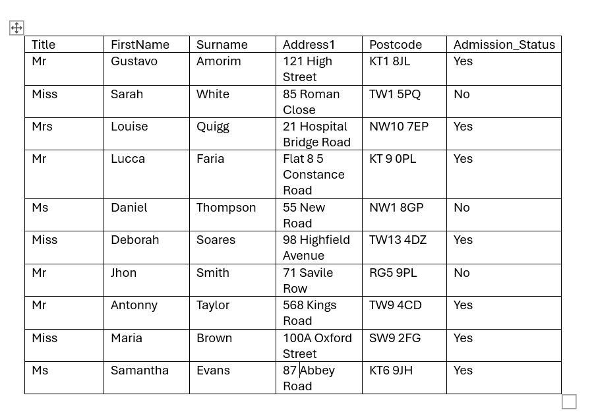
- Select “Start Mail Merge” in Microsoft Word and chooses the option “Letters”. This sets up the document to create multiple personalised letters instead of a single document.

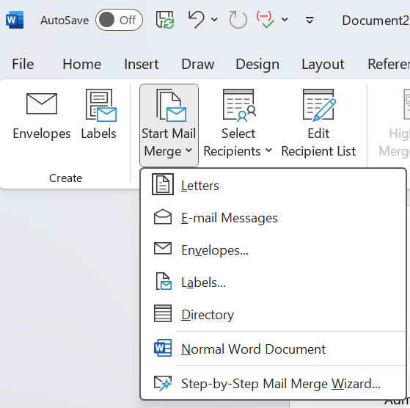

- Click on “Select Recipients” and choose “Use an Existing List”. This allows the system to connect the Word document to the Excel file that contains the data.
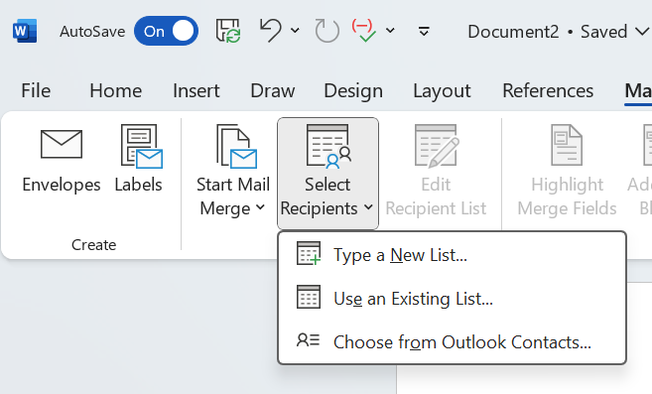

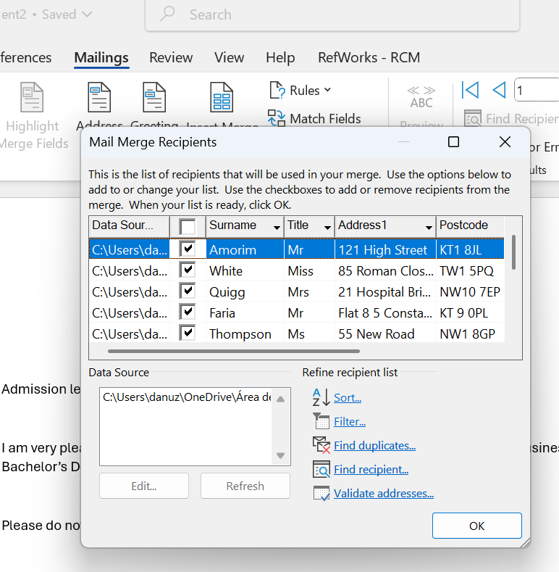
- This screenshot shows the list of recipients loaded from the Excel file. The user can review, sort, or filter the data to select which records will be included in the mail merge.

- In this step, the recipient list is confirmed and organised.
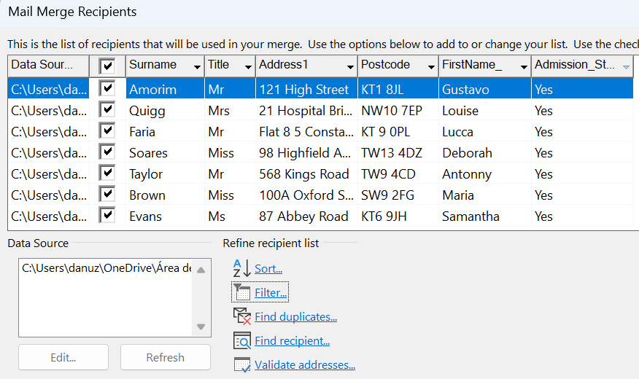


- This screenshot shows the Word document with merge fields inserted, such as «FirstName», «Surname», and «Address». These placeholders will automatically be replaced with the correct data for each recipient.

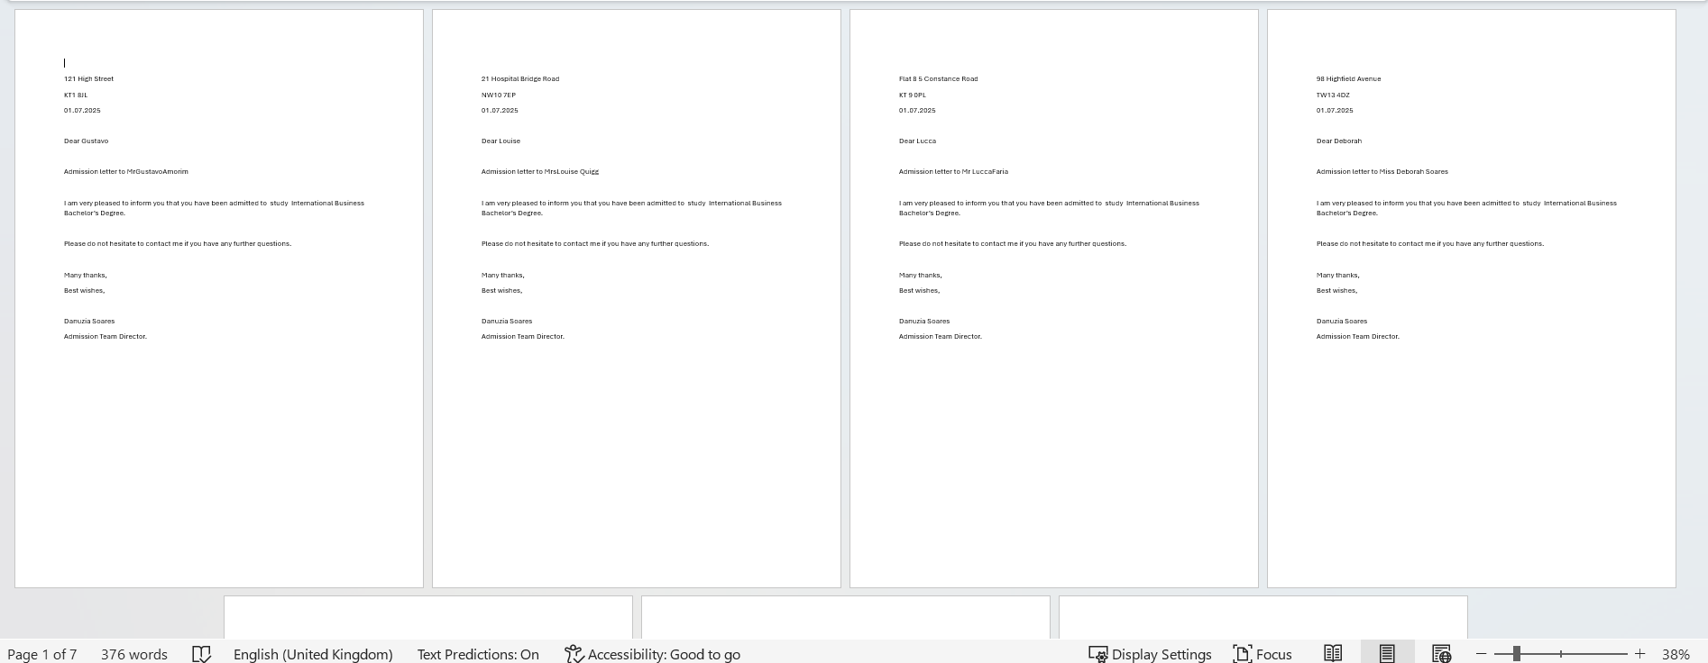
- This final screenshot shows the result of the mail merge. Multiple personalised letters are generated automatically, each containing different information based on the data source.

IF Statement:

- This screenshot shows the Excel spreadsheet with students’ marks and final results. The total mark is calculated, and the IF function is used in the “Remarks” column to display either “Congratulations” or “Try Again” based on the student’s performance.
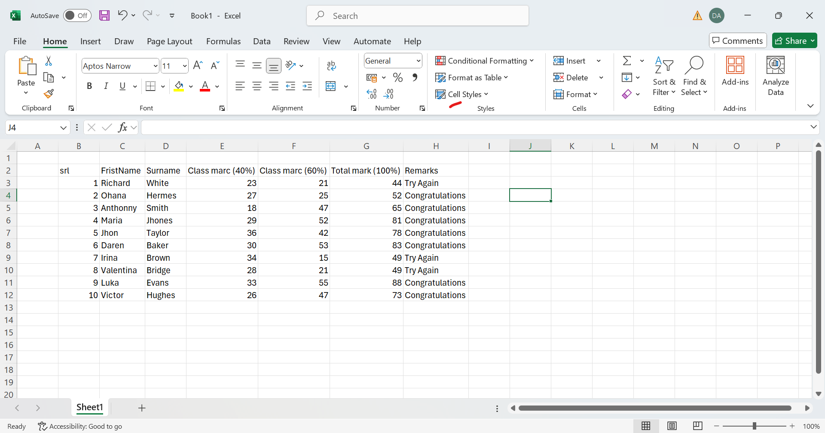

- In this step, the IF function is applied to automatically generate results. The formula checks if the total mark is greater than or equal to 50. If the condition is true, it displays “Congratulations”; otherwise, it shows “Try Again”. This demonstrates how Excel can be used to automate decision-making.
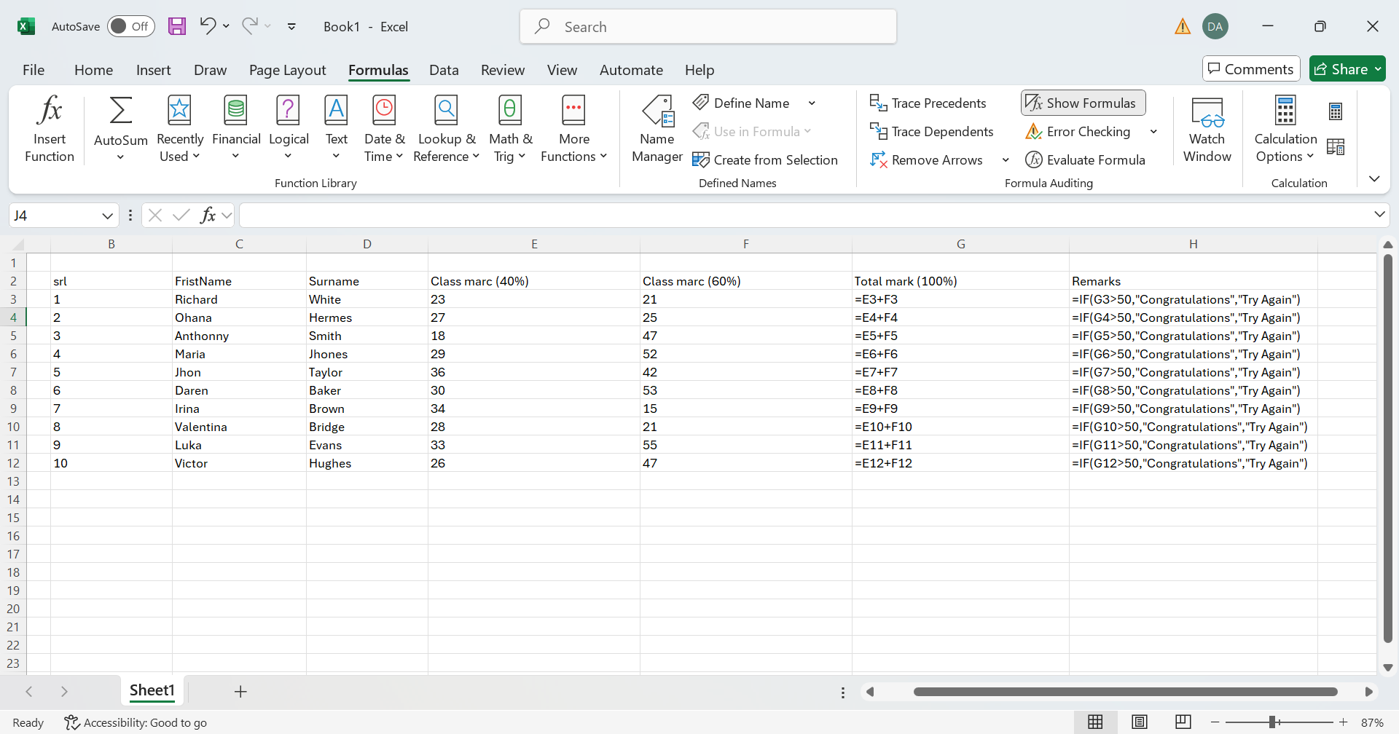

Task 4. Communication and Collaboration applications

4a. One (1) contemporary Communication and one (1) Online Collaboration

Gmail: Developed by Google is a widely used email platform in modern organisations. It plays an important role in supporting communication, collaboration, and productivity in the workplace [19]. As part of Google Workspace, Gmail offers more than basic email functions, as it integrates with other tools that help improve daily workflows.

One of the main advantages of Gmail is its user-friendly interface, which allows users to easily compose, read, and organise emails. It also includes a strong search function, making it easier to find messages, attachments, or previous conversations quickly. Features such as labels, filters, and categories help organise emails automatically, which reduces inbox clutter and makes it easier to prioritise important messages. In addition, threaded conversations group related emails together, helping users follow discussions more clearly.
Another important benefit is its integration with other Google Workspace tools, such as Google Drive, Google Docs, Google Sheets, Google Calendar, and Google Meet. This integration allows users to share files, schedule meetings, and collaborate in real time without needing to switch between different platforms.
Gmail also includes features that help improve productivity. For example, tools such as Smart Compose and Smart Reply provide suggestions when writing emails, which can save time. Mobile access is another advantage, as it allows users to stay connected even when they are not in the office.
In terms of security, Gmail provides strong protection through spam filtering, malware detection, phishing alerts, and multi-factor authentication. This is especially important in business environments where sensitive data needs to be protected. In addition, its cloud-based storage allows users to access past emails easily, which can support reporting and decision-making processes.
From a business perspective, Gmail is also cost-effective. It offers scalable storage and professional email services, making it suitable for both small businesses and larger organisations.
Conclusion: Gmail is a reliable and efficient communication tool that helps organisations improve internal and external communication, support teamwork, and increase overall productivity.

Google Meet: Is a video conferencing tool developed by Google and is widely used in modern organisations. It is mainly used for online meetings and helps teams communicate in real time, especially when people are working remotely or in different locations [20]. Because it is part of Google Workspace, it connects easily with other tools like Gmail and Google Calendar, which makes it more practical to use in everyday work.
One of the main features of Google Meet is that users can join meetings using a simple link, which makes the process quick and easy. Meetings can be scheduled in advance or started instantly, depending on what is needed. This flexibility is useful in business environments where plans can change quickly.

Another useful feature is screen sharing. This allows users to present documents, slides, or other content during a meeting, which is helpful when explaining ideas or showing information to others. There is also a chat option, where participants can send messages without interrupting the speaker. In addition, live captions can be turned on, which can help people understand better, especially if the audio is not very clear.
In terms of benefits, Google Meet helps improve communication because it allows face-to-face interaction, even when people are not in the same place. This makes teamwork easier and helps everyone stay connected [21]. It is also simple to use, which means users do not need a lot of technical knowledge to join or host a meeting.
Another advantage is how well it works with other Google tools. For example, meetings can be scheduled directly through Google Calendar, and files can be shared using Google Drive. This helps save time and makes the workflow smoother.
However, there are some limitations as it depends on a good internet connection, so if the connection is slow, the meeting quality may be affected. Also, some advanced features are only available in paid versions.
Conclusion: Google Meet is a simple and reliable tool that supports communication and teamwork in modern business environments.

4b. Test one feature of a freely available Communication (1) and one feature of a Collaboration (1) application

Gmail:
- Open a web browser and search for Gmail. After that just click on the Gmail link to access the platform.
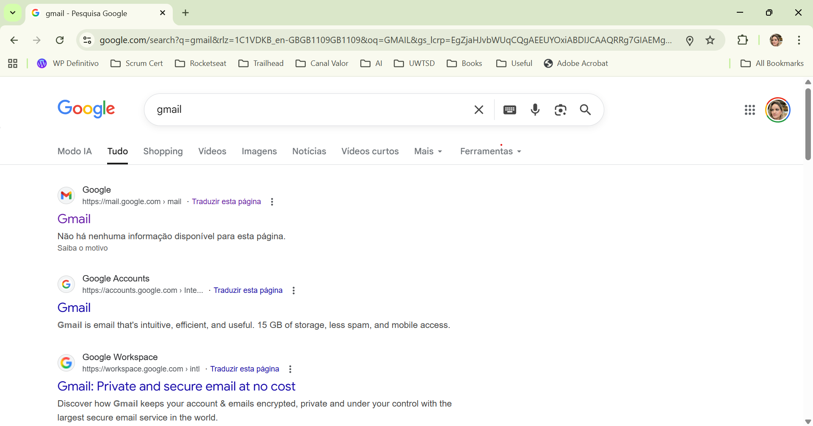

- The next step is to create an account if you don’t have one. It is a very simple process where you just need to follow the step by step.

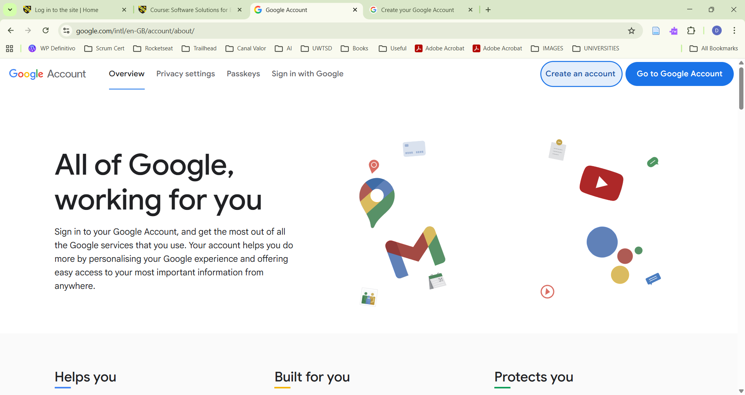

- Or if you have already a Google account, just select the Google account that will be used.
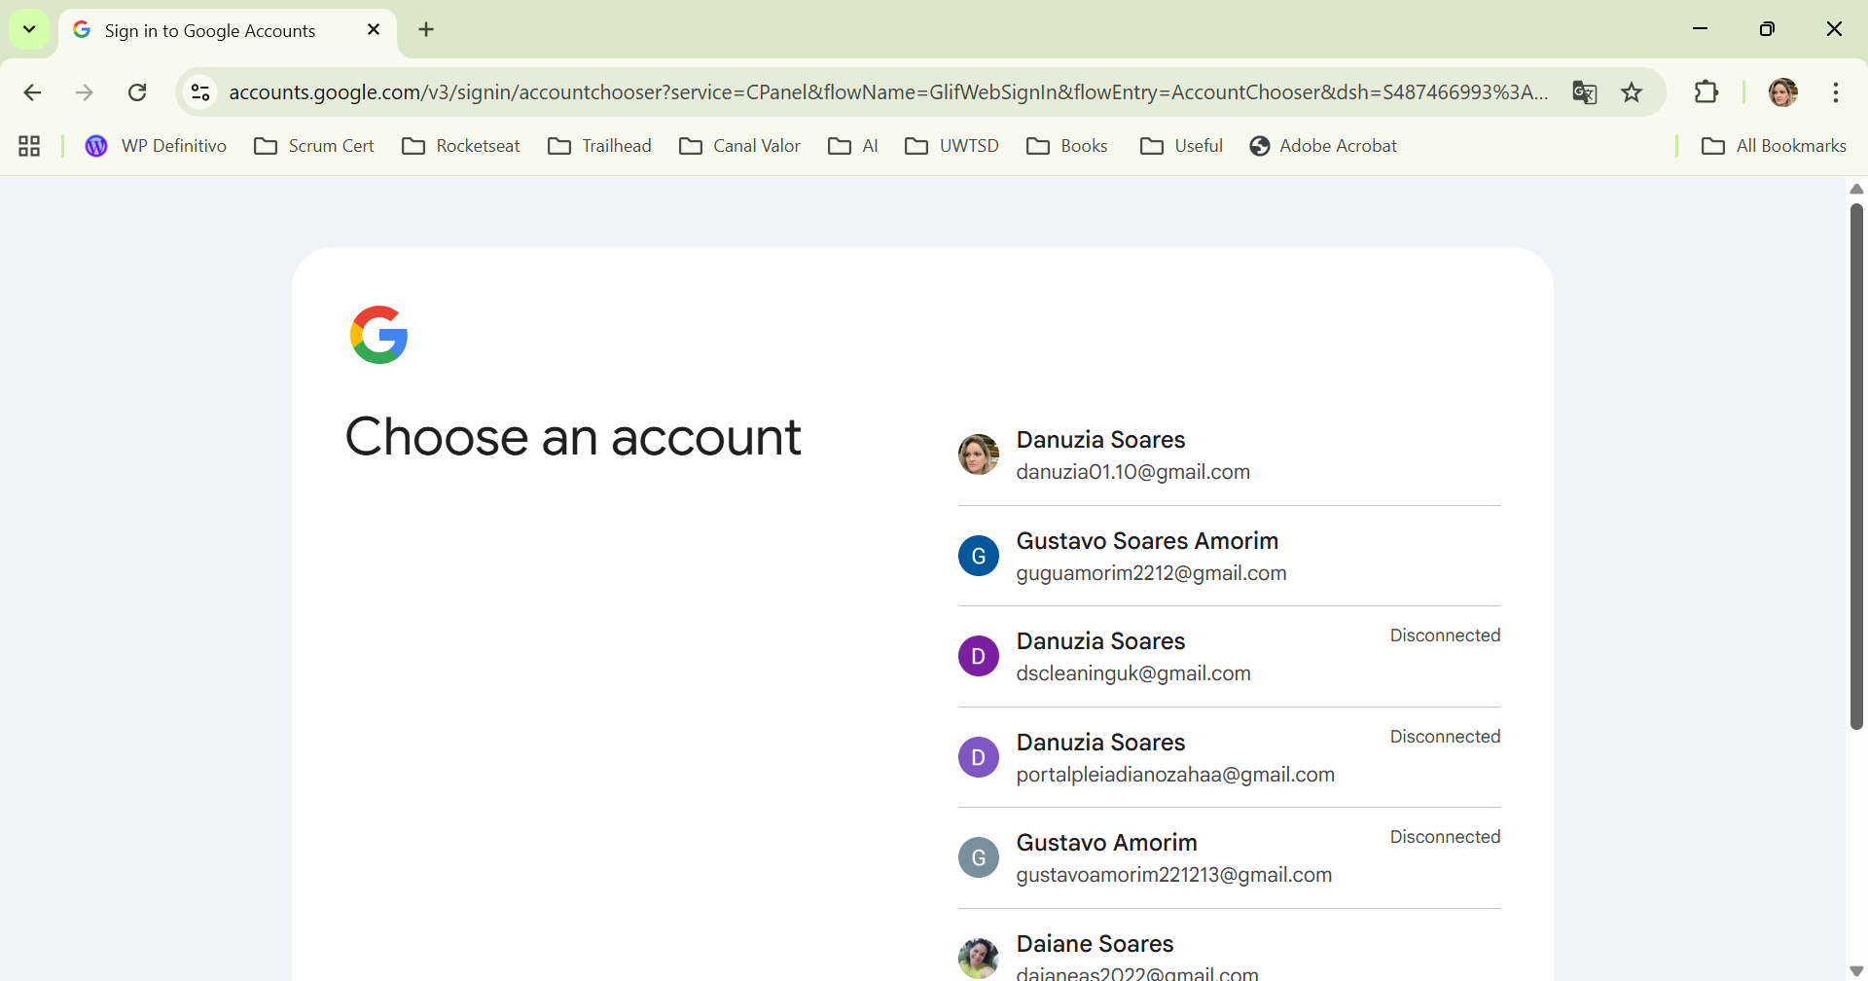

- Enter the user password.

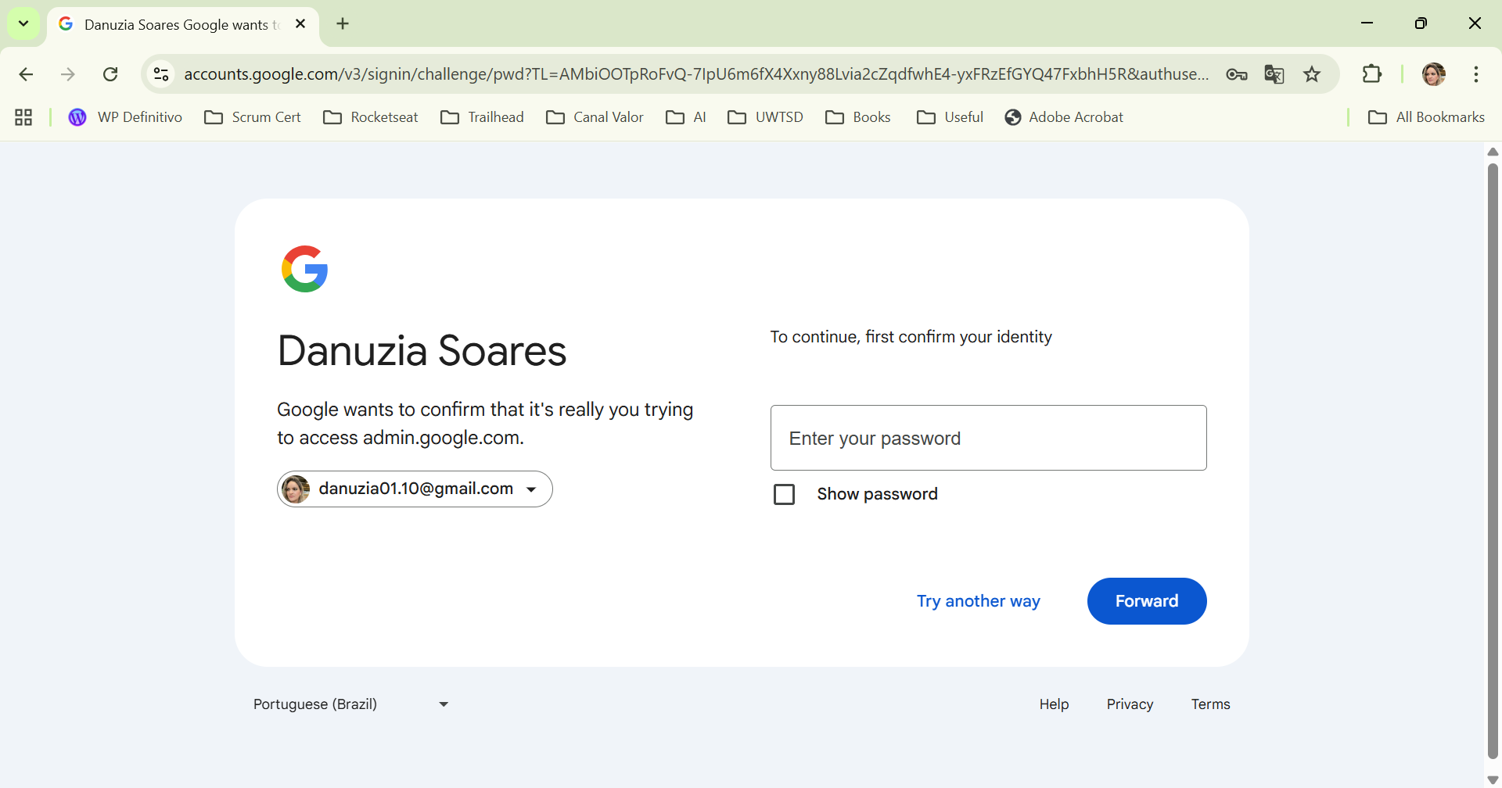

- To write a new email, the user just needs to click on the Compose button on the left side of the screen. This opens a new message window where the email can be created.

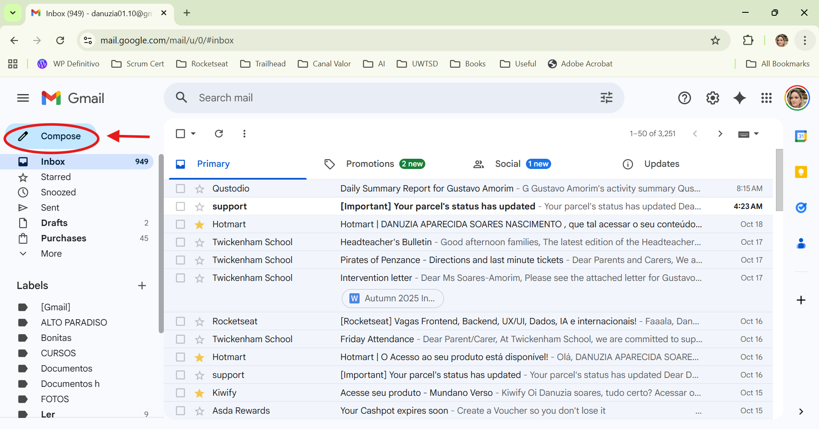
- In this step, the user types the recipient’s email address, adds the subject, and writes the message in the main text box.
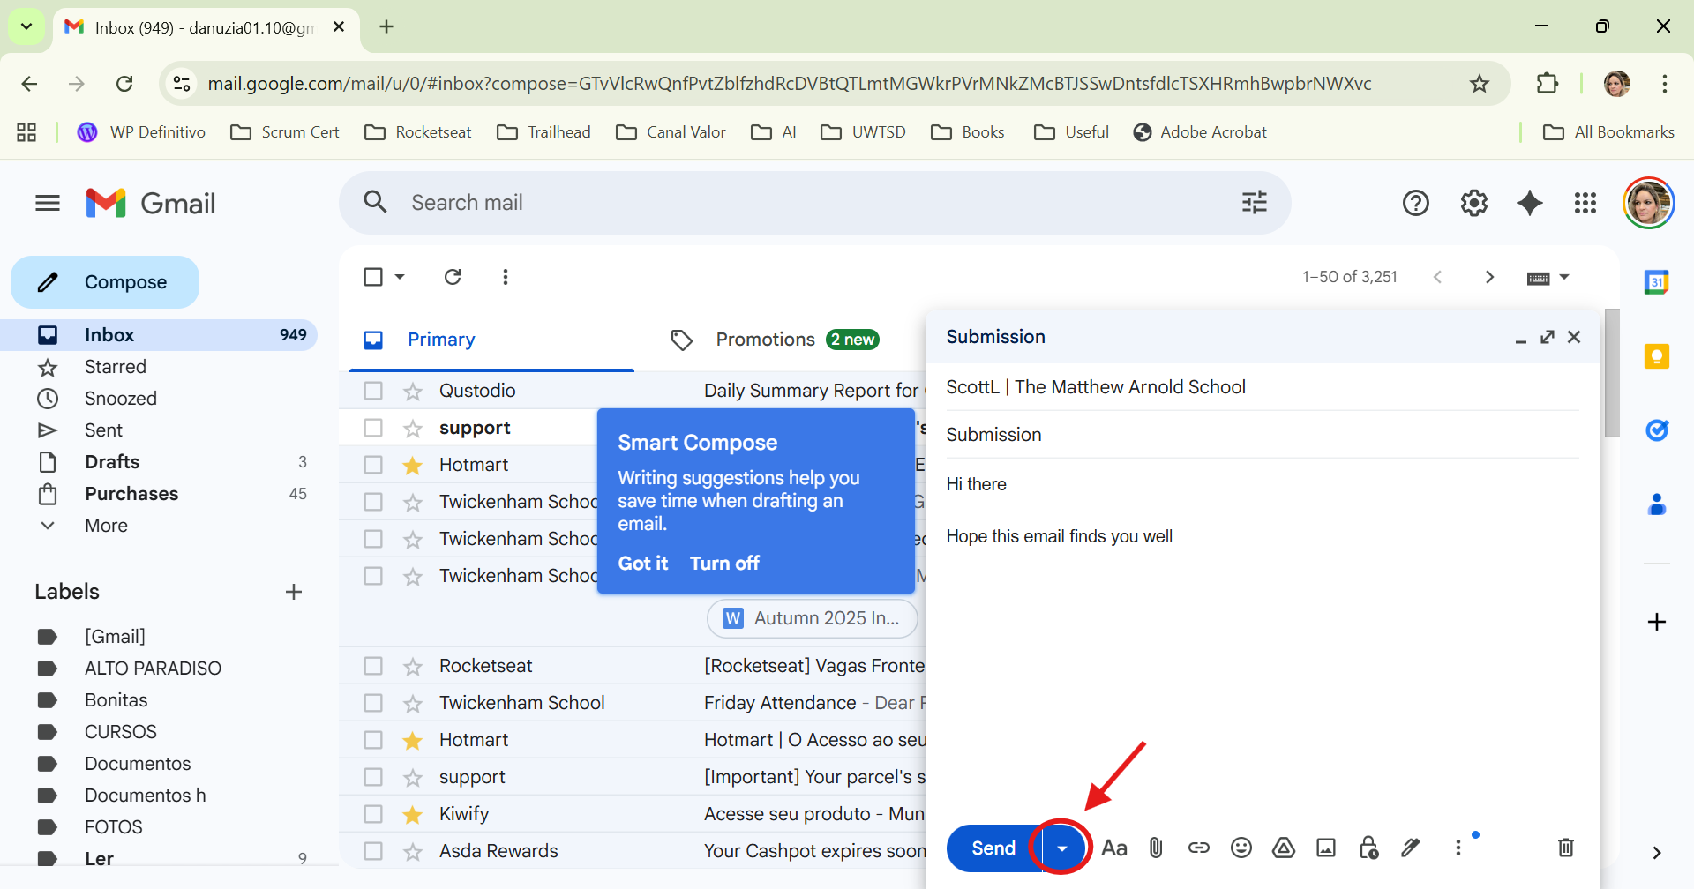
- Instead of sending the email immediately, the user can click the small arrow next to the Send button and choose Schedule send. Then, the user selects the preferred date and time for the email to be sent automatically later.

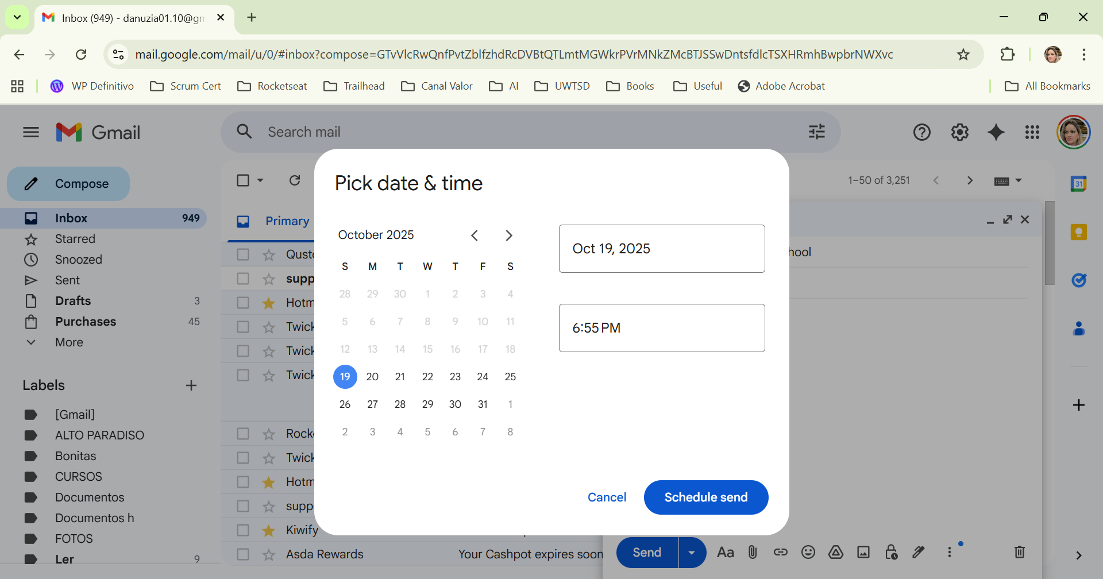

- After scheduling the message, the email is saved in the Scheduled folder. The user can open this folder to check the email details, confirm the sending time, or cancel the scheduled delivery if needed.
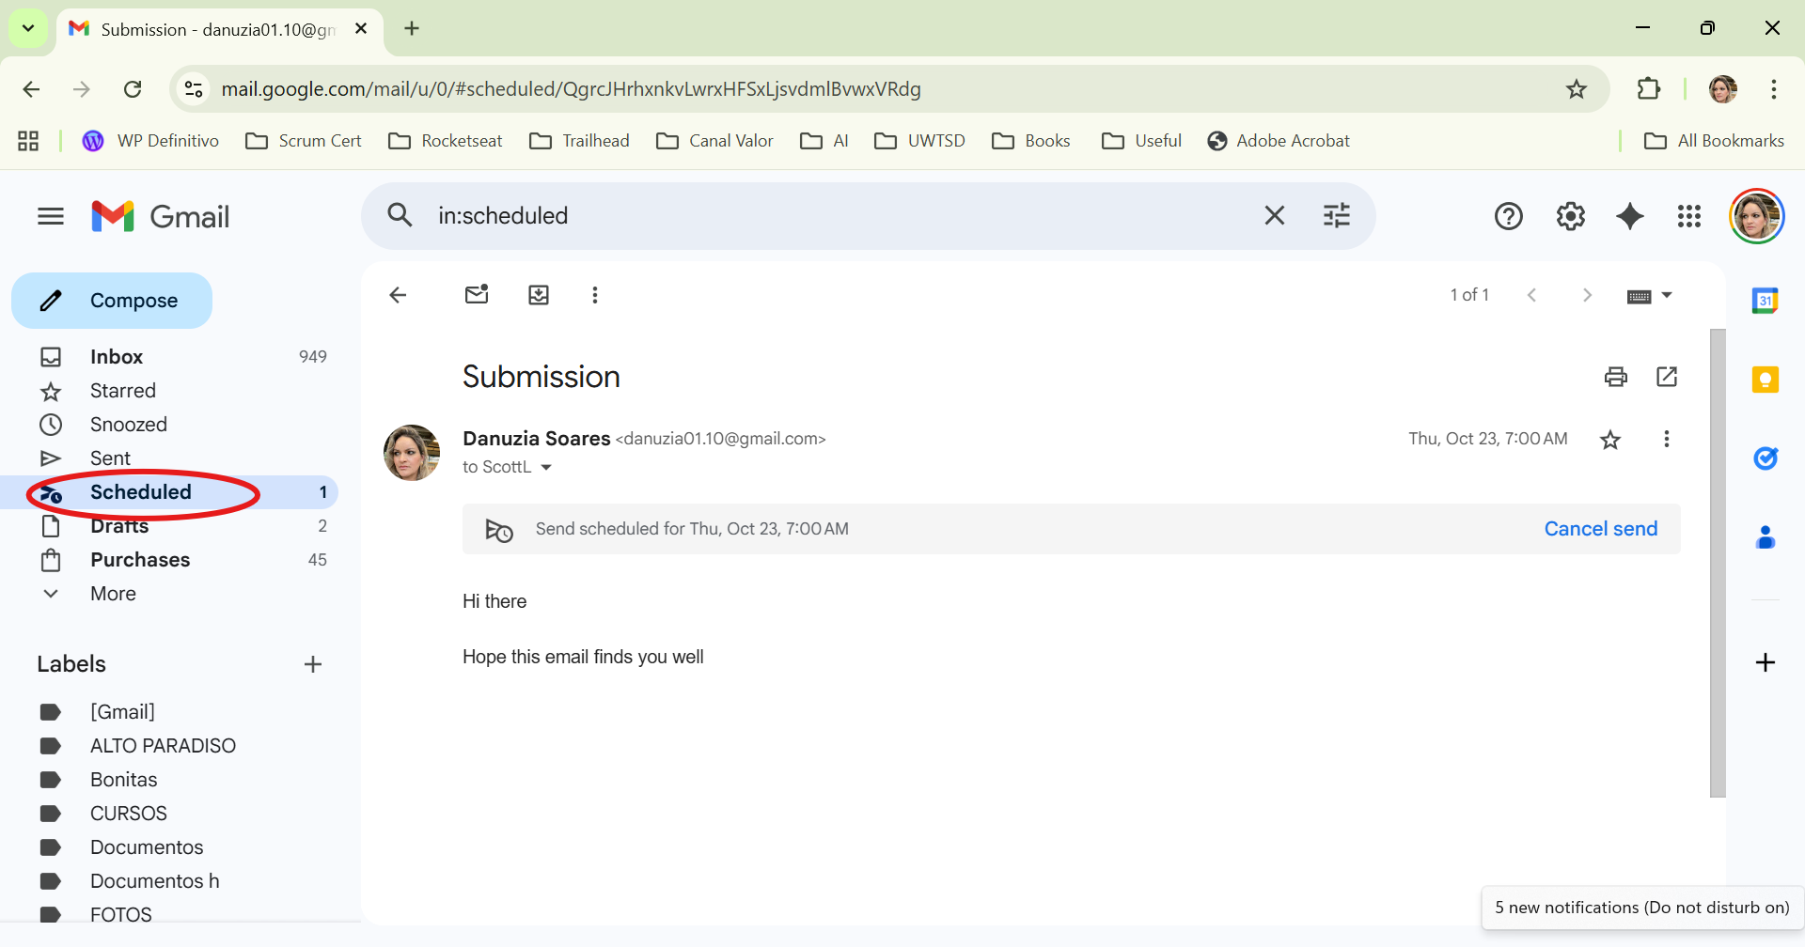

Google Meet:
- Open a web browser and access the Google Meet website and click Log in.

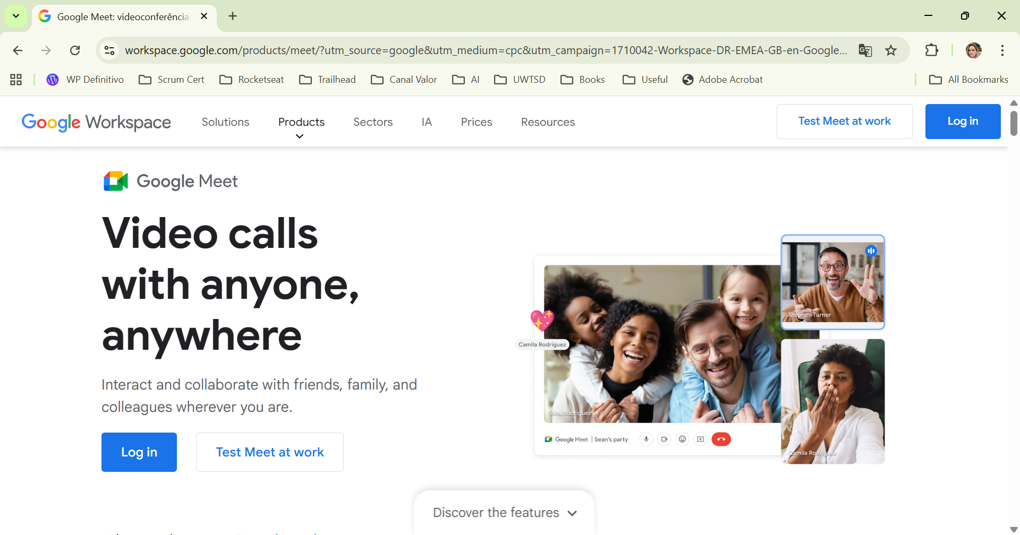
- After logging in, the main Google Meet page appears. On this page, the user can choose to start a new meeting or enter a meeting code or link. This is the main area used to join or create meetings.
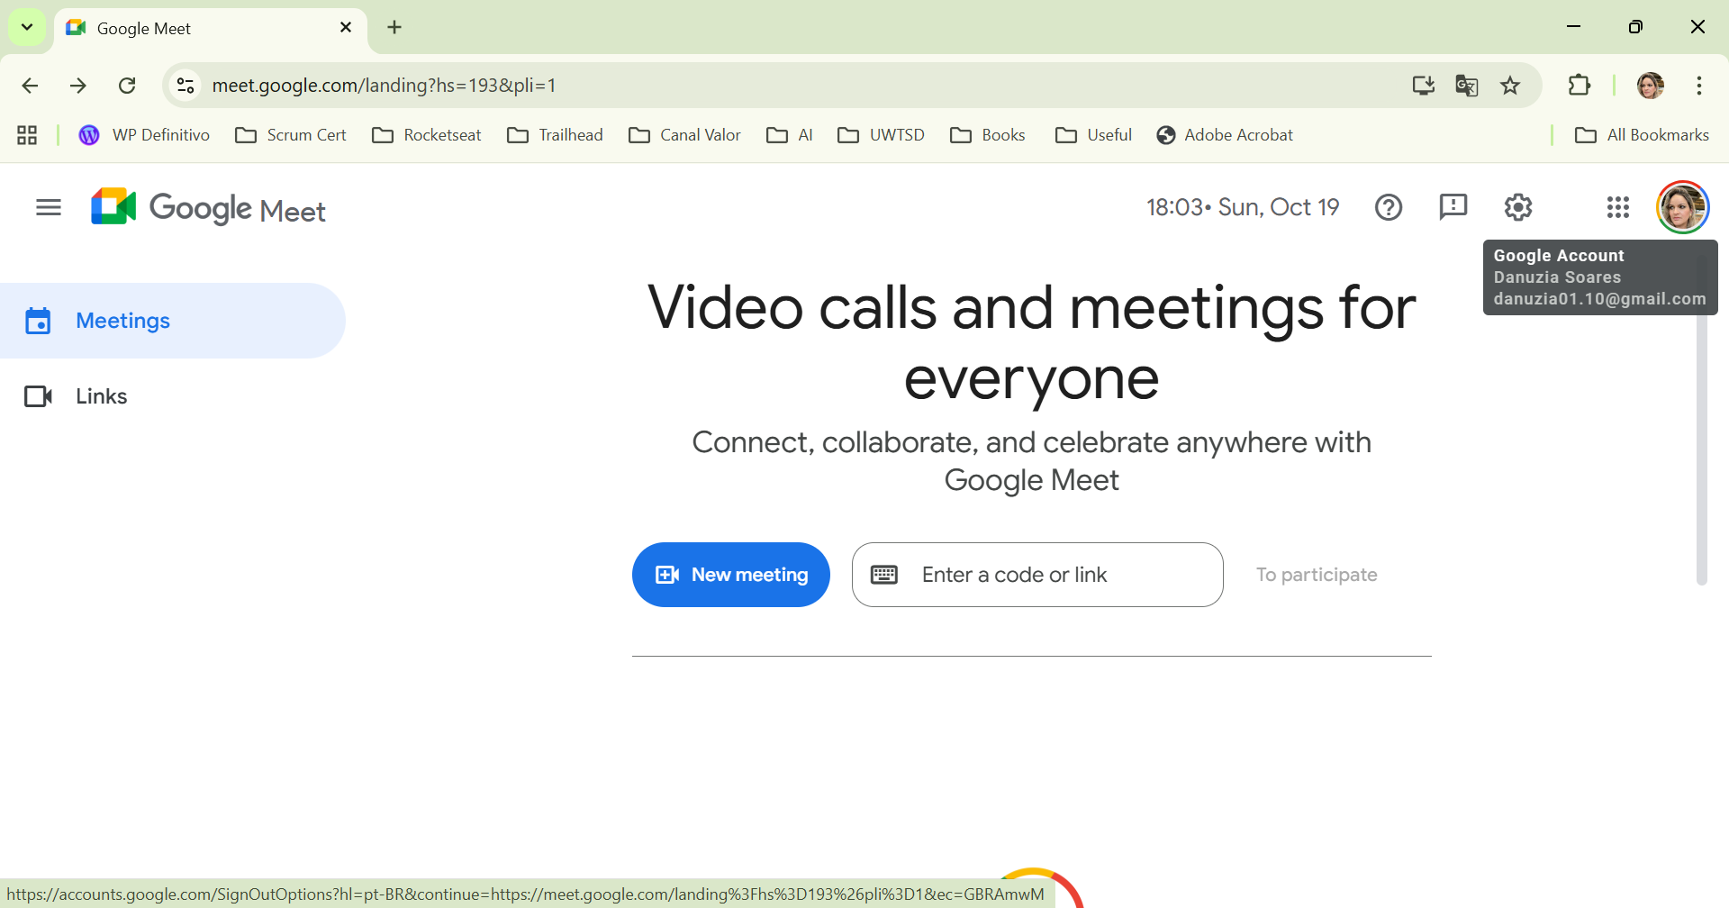
- In this step, the user clicks on “New meeting”. A small menu appears with different options, such as creating a meeting for later, starting an instant meeting, or scheduling a meeting on Google Calendar. This allows the user to choose the most suitable option depending on their needs.

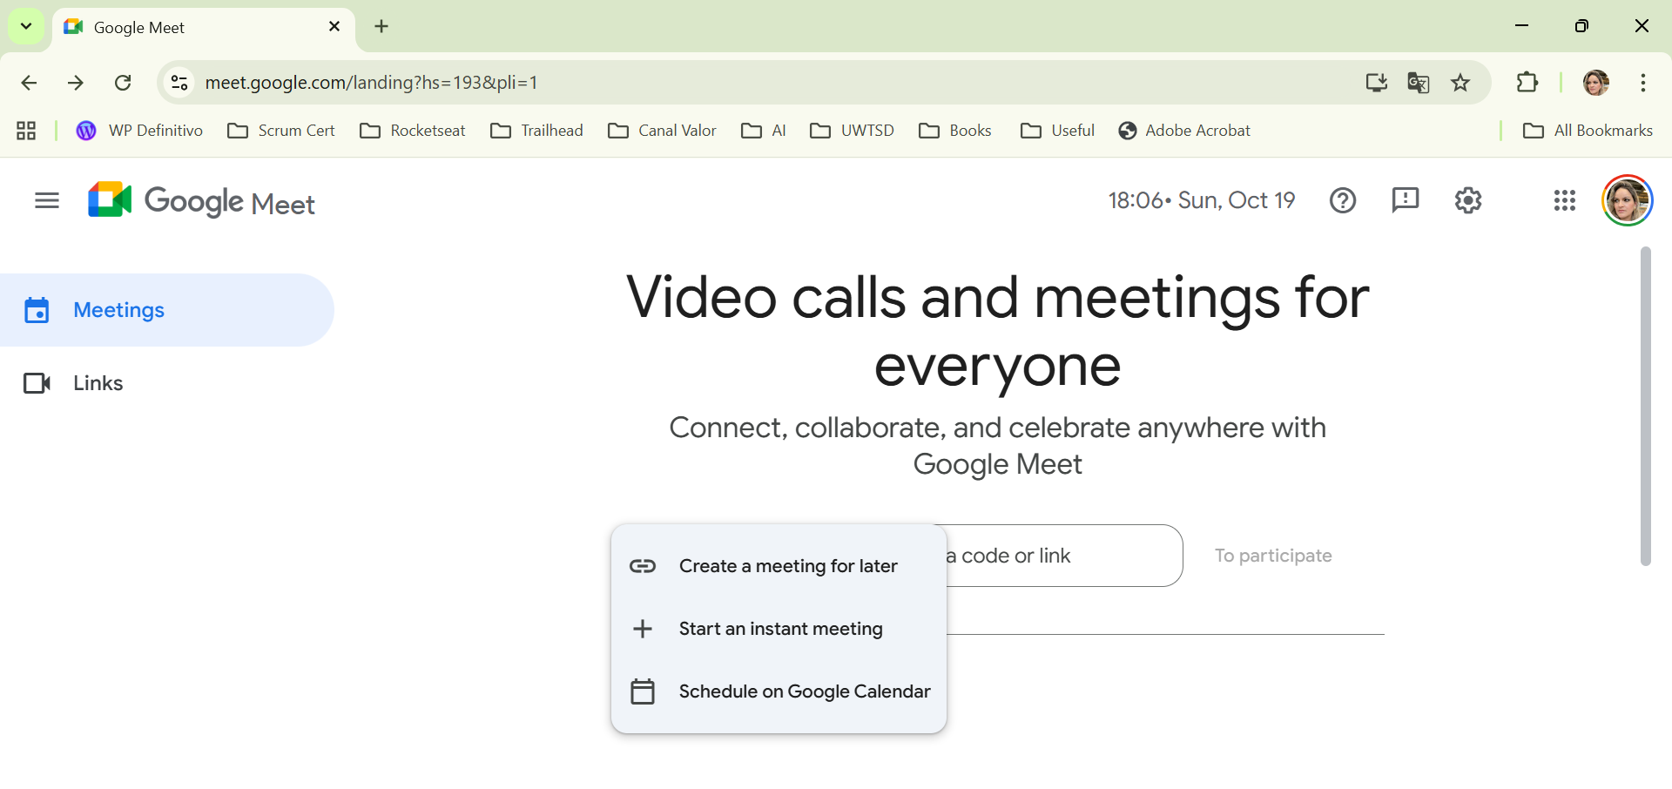

- To join an existing meeting, the user can type the meeting code or paste the meeting link into the box provided. After entering the code, the user clicks on “To participate” to continue. This step shows how easy it is to join a meeting using a shared code.
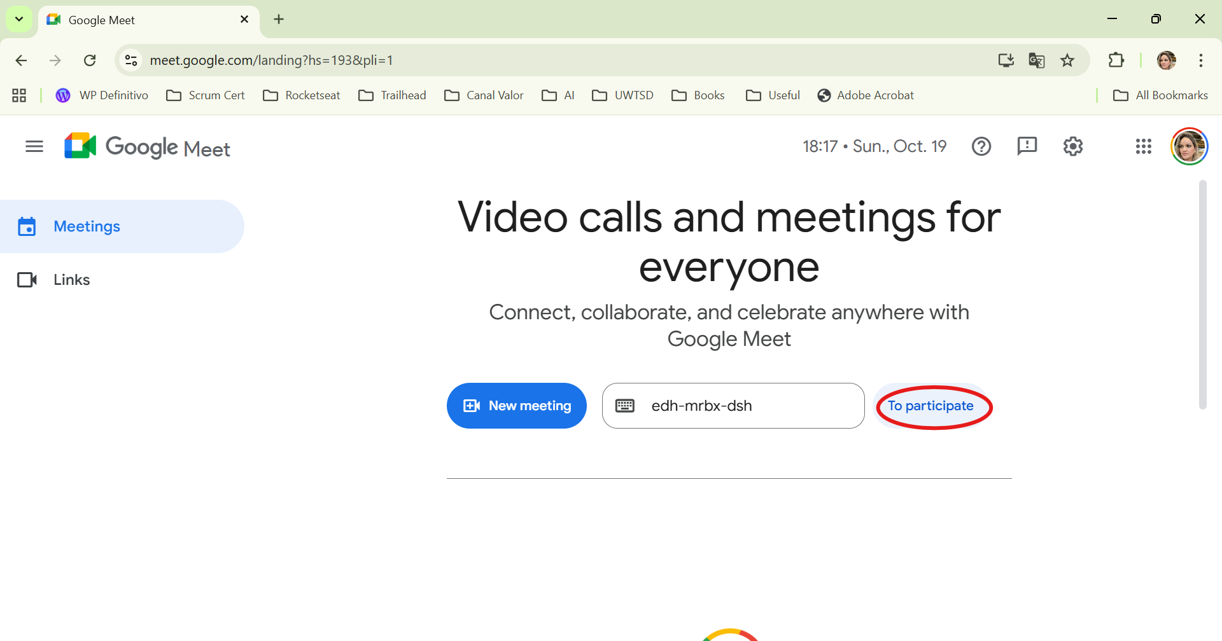
- This final screenshot shows the user successfully inside the Google Meet call. At this stage, participants can see and hear each other, use the microphone and camera controls, share their screen, send reactions, and communicate in real time. This demonstrates the practical use of Google Meet for online collaboration and meetings.



Conclusion

In conclusion, the software tools explored in this assessment highlight how important digital technologies are in supporting modern business operations. E-commerce platforms allow businesses to operate online and reach a wider audience, while mind mapping helps improve organisation, creativity, and problem-solving.
Microsoft Office applications, such as Word, PowerPoint, Excel, and Access, play a key role in everyday business activities, including document creation, presentations, data analysis, and database management. The practical tasks completed in this report, such as Mail Merge and the IF function, also demonstrate how these tools can be applied in real situations to improve efficiency and accuracy.
In addition, communication and collaboration tools like Gmail and Google Meet make it easier for teams to stay connected, share information, and work together, especially in remote or hybrid environments. These tools support better communication and help organisations respond more effectively to daily challenges.
The use of these software solutions helps businesses become more organised, productive, and adaptable. As technology continues to develop, understanding how to use these tools effectively will remain essential for success in modern organisations.

References

[1] | Kenneth C. Laudon and Carol Guercio Traver, E-commerce 2021: Business, Technology, Society, 16th ed. Harlow, UK: Pearson, 2021.
[2] | “WIX,” [Online]. Available: https://www.wix.com/ecommerce/website. [Accessed 5 July 2025].
[3] | D. Dumitriu, Popescu, Mirona and A. Maria, “SOFTWARE TECHNOLOGIES FOR THE MANAGEMENT OF MODERN E-COMMERCE BUSINESS SOLUTIONS,” in International Conference on Management and Industrial Engineering, Bucharest, 2019.
[4] | D. Steiner, “Shopify takes aim at Wix and WordPress for top dog in the ecommerce space,” Proquest, 2017.
[5] | C. M. Laudon and K. C. Laudon, Management Information Systems: Managing the Digital Firm, 16th ed. Harlow, UK: Pearson, 2020
[6] | A. Erdem, “Mind Maps as a Lifelong Learning Tool,” Universal Journal of Educational Research, pp. 1-7, 2017.
[7] | L. Kadagidze, “Mind Mapping as a Teaching Tool in Higher Education Language Learning Settings,” Kultura i Edukacja, vol. 114, pp. 78–88, 2016.
[8] | MindMaps.com, “What is Mind Mapping?,” [Online]. Available: https://www.mindmaps.com/what-is-mind-mapping/. [Accessed: 27-Sep-2025].
[9] | K. Wilson, “Essential Office 365,” in The Illustrated Guide to Using Microsoft Word , Elluminet Press, 2018, p. 59.
[10] | S. K. Sharma and J. Kaur, “Impact of word processing on productivity and collaboration,” International Journal of Computer Applications, vol. 182, no. 12, pp. 20–25, 2018.
[11] | R. A. Berk, “Using technology to improve writing skills,” Journal of Educational Technology Systems, vol. 41, no. 1, pp. 45–60, 2012.

[12] R. Mayer, Multimedia Learning. Cambridge: Cambridge University Press, 2009.
[13] S. Kosslyn, Clear and to the Point: 8 Psychological Principles for Compelling PowerPoint Presentations. Oxford: Oxford University Press, 2007.
[14] Microsoft, “Microsoft Excel – Overview,” Microsoft 365 Documentation, 2023.
[15] J. Baker, “The importance of spreadsheet skills in business,” Journal of Information Systems Education, vol. 18, no. 1, pp. 5–10, 2007.
[16] S. Few, Information Dashboard Design: The Effective Visual Communication of Data. Sebastopol: O’Reilly Media, 2013.
[17] Microsoft, “Microsoft Access – Overview,” Microsoft 365 Documentation, 2023.
[18] T. Connolly and C. Begg, Database Systems: A Practical Approach to Design, Implementation, and Management. Harlow: Pearson, 2015.
[19] A. B. Pahayahay, “Enhancing Collaboration Through Google Workspace: Assessing and Strengthening Current Practices,” International Journal of Computing Sciences Research, vol. 9, pp. 3602–3617, 2025.
[20] H. Chang, M. Varvello, F. Hao and S. Mukherjee, “Can You See Me Now? A Measurement Study of Zoom, Webex, and Meet,” arXiv preprint arXiv:2109.13113, 2021.
[21] N. Simpson, “Digital collaboration tools to support and enhance student engagement,” Studies in Technology Enhanced Learning, 2024.

