BA International Hotel Management
Operating Hotel Facilities presentation
Student name:Abul Fozol Oliullah
Student no:2226836
Module code: BMIH4006 Presentation
Tutor: Giulia Chifari
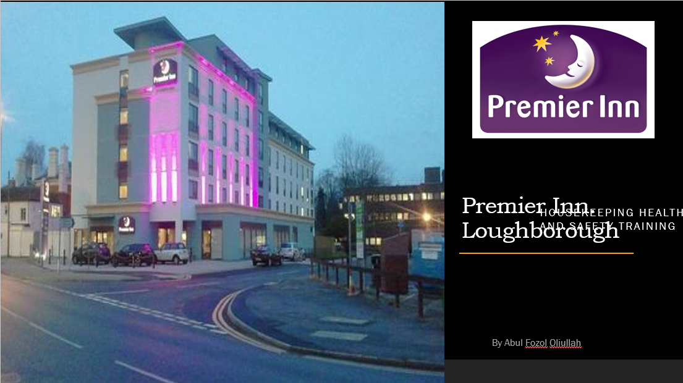

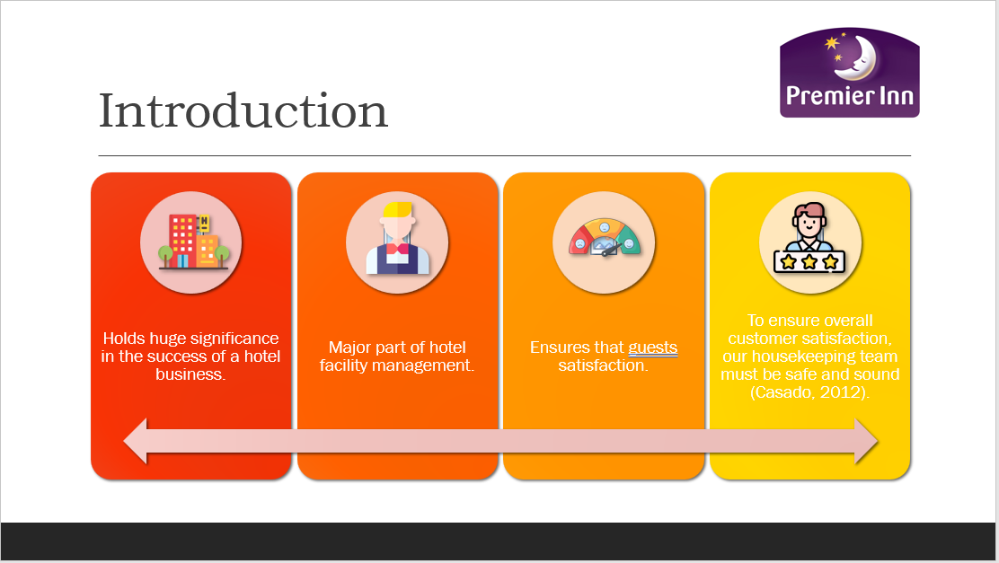
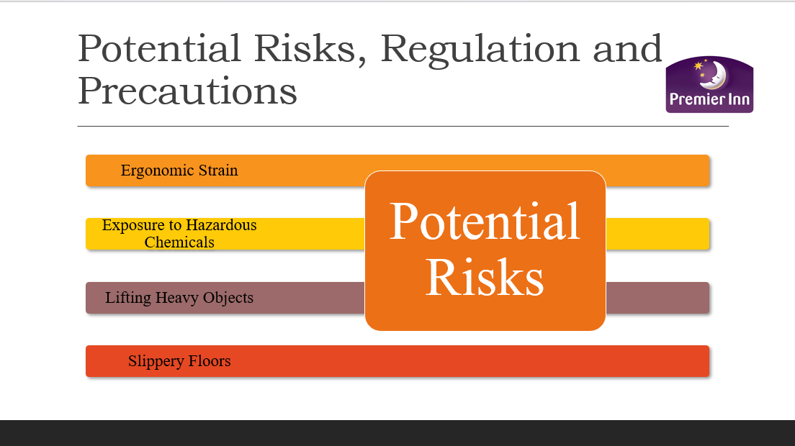

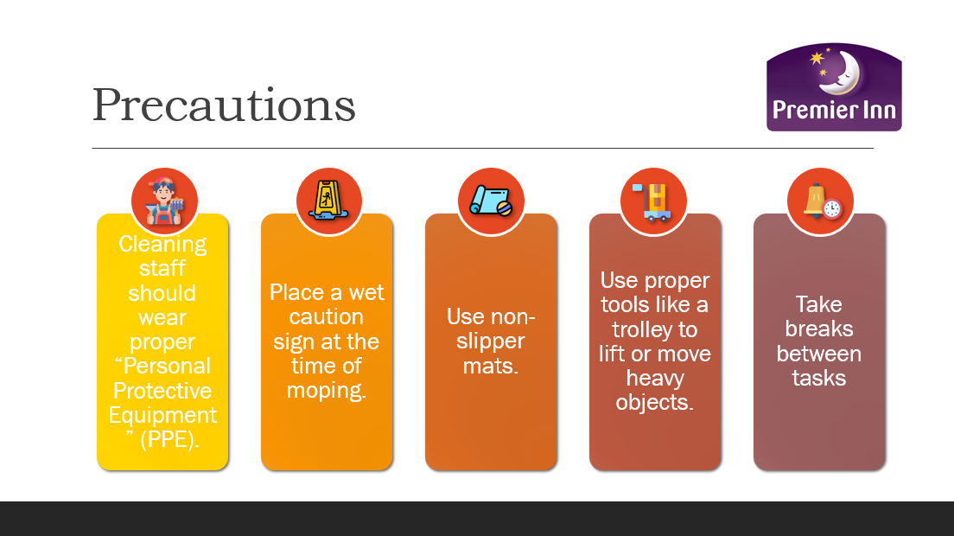
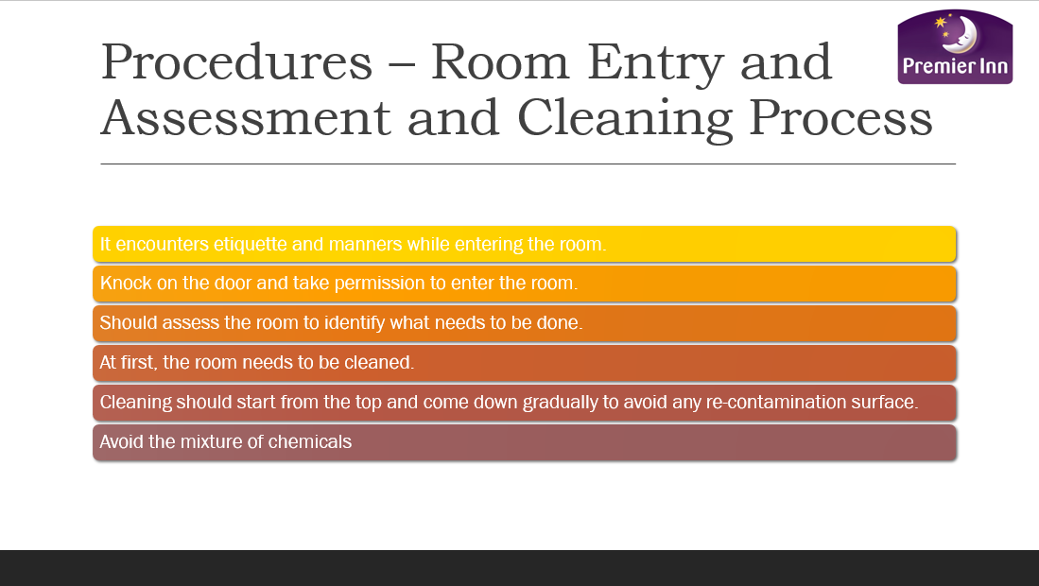
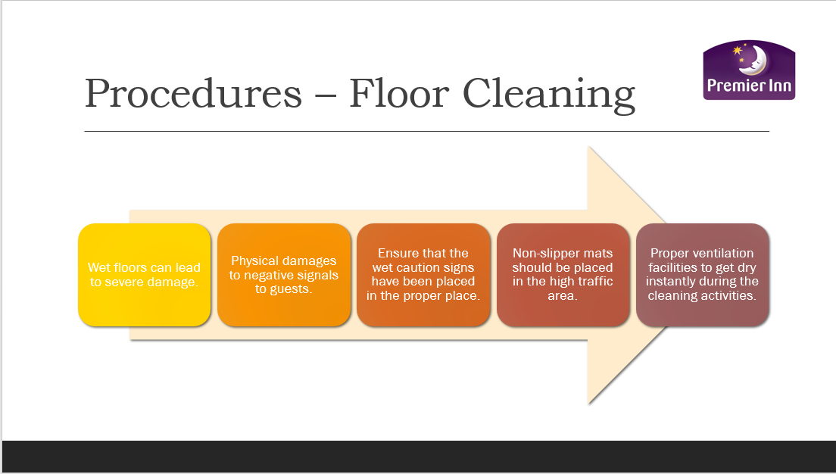
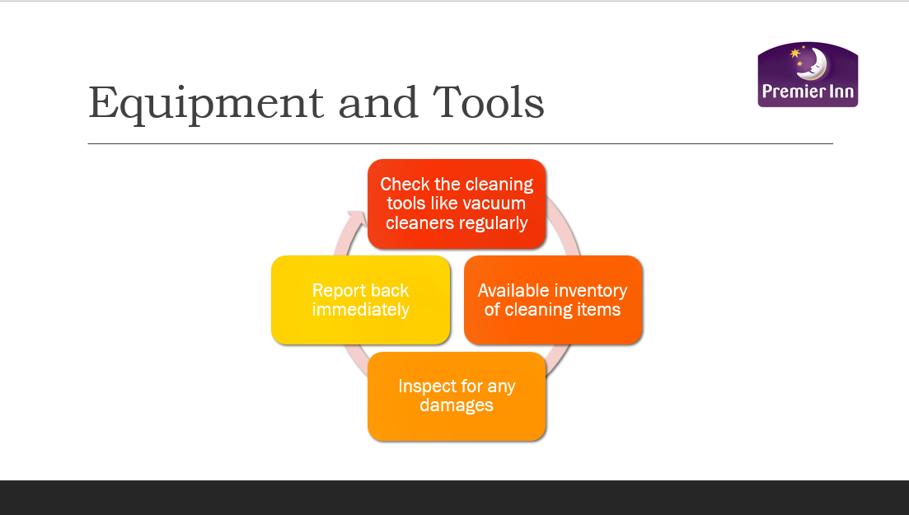
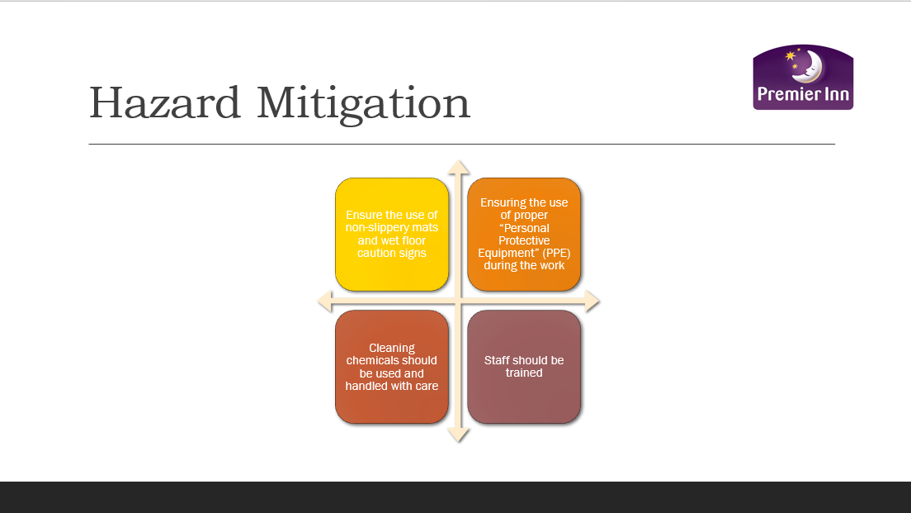

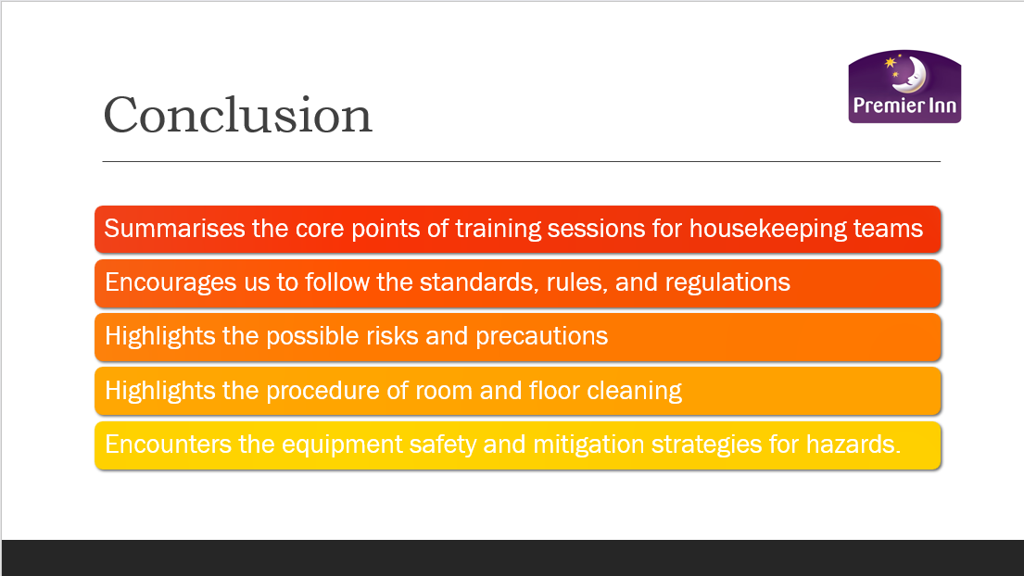
The presentation briefly summarises the core points of training sessions for housekeeping teams of hotel facility management. At first, it encourages us to follow the standards, rules, and regulations to develop a safe work environment. Later it highlights the possible risks and precautions that need to be considered.

