Heritage Impact Assessment and Maintenance Plan of the Alex building Swansea school of Arts
By Al David Ikete
Student Number:1902411

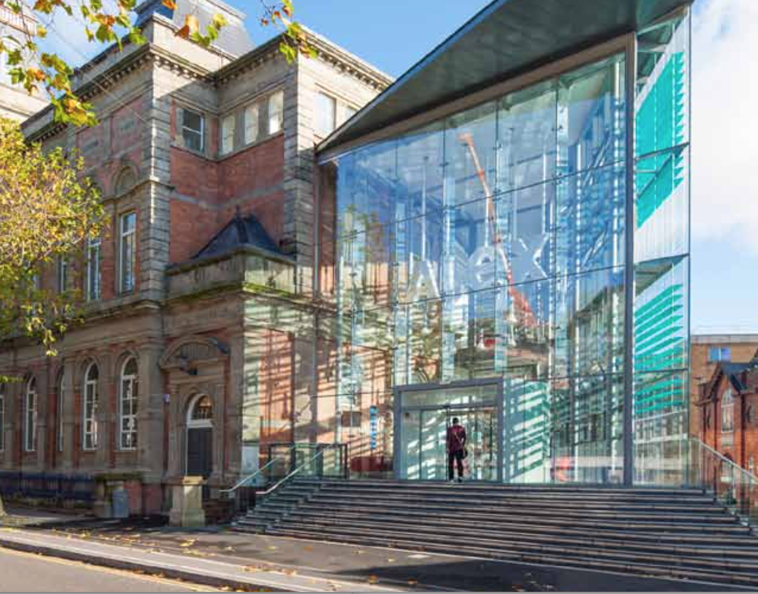

Table of Contents
Introduction 3
Location 4
Methodology 4
Designations 4
History and description of the Dynevor Building 5
Architectural Description 5
Heritage Significance of the Alex building 6
Relevant Planning Policy and Guidance 6
National Planning Guidance 7
Cadw’s Published Guidance 8
Introduction 9
Maintenance first 9
Cost risk 10
Impact of measure on each other 10
Heritage value 11
Estates and Facilities Management Plan 12
Conclusion 13

Introduction
This report provides a Heritage Impact Assessment in line with Cadw’s guidance for the Victorian School of Art structure and the extension of the modern contemporary Alex Building and provide direct recommendations to the process involved with the up upgrade and modification of both buildings and the potential for retrofitting in the future. The two buildings are situated within a conservation area in close proximity to the Swansea city centre.

The site boundary is marked in red around the satellite picture below

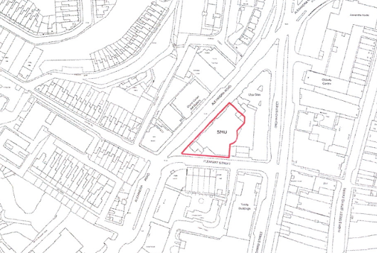

Location
The School of Art and the Alex Building is located on the outer boundaries of Swansea City centre situated near the A4118, as well as Alexandra Road, Pleasant Street, and backs orchard Street. The Alex Building sits within the Alexandra Road conservation area which covers a relatively small area and contains several listed buildings. The site is approximately 0.5miles away from the river Tawe and is approximately 0.2miles away from Swansea city centre.
The Alex building is a grade II listed building with another Grade II listing to the structure being under a different heading of Central library and classed as recreational building compared to the School of Art listing which states educational premises. The wall finish is predominantly exposed facing of red brick having a range of detailed arches, triangular pediments, quoining, and detailed Portland stone bands. The buildings consist of roof a blend between flat and pitched portions which contained slate coverings, the roof of the central tower with smaller towers adjacent and a domed roof over the library portion. The visible parts of the roof had man-made synthetic fibre slates laid onto the pitched roofs and lead covered flat portions with parapet details.
The proposed work is to evaluate the modern building which links into the original Central library building which remains relatively passive to the listed structure. Complementary to the assessment will be all necessary refurbishment works that were required for the listed structure.

Methodology
The purpose of this Heritage Impact Statement is to fully understand the historic asset and its vulnerabilities and to assess the current proposals. The assessment process follows the approach set out by Cadw in Conservation Principles1 and in best-practice guidance documents including Heritage Impact Assessment in Wales (2017) and Managing Change in Conservation Areas (2017). These documents contain the general principles to consider when planning changes to historic assets. In Wales, as from 1st September 2017, a proportionate Heritage Impact Statement is now mandatory for all applications for demolition within conservation areas.
This report is based upon a site survey on 22nd April 2022 and subsequent desk-based research.
The two names for the building are noted but hereinafter this report refers to it as the former Bottom Bridge Public House in line with the proposed planning application.

Designations
The Alex building is Grade II listed building with the Mount Pleasant conservation area and is south of the designated area, immediately adjacent to the Dynevor centre which is new development completed at the same as the building’s new extension. It was designated on the 30/03/1987.

The Alex building is one of twelve listed building within the Swansea city centre area and one three grade II listed buildings on Alexander Road, which include the BBC Wales building and the Gyn Vivian gallery.

History and description of the Dynevor Building
The building was built in 1886 and was designed by Henry of Dewsbury, however the name given to the building derived from the adjacent street names Dynevor Place, which was then known as Washing Lake Lane. The first tenants of the building were a school who moved into the new premises in 1894. The 1852 map, mentioned above, shows two semi-detached villas adjacent to Mount Pleasant chapel described as Russell place. However, there was another building on the north of the site which may have been Russell house. Its extensive grounds, and its northern edge which later formed De la Beche Street. The southern walls of the building bear the scars of the second world war where Swansea was blitzed, the scars consist of shrapnel wholes within its brick work.

Architectural Description
The 3 storey building stands on a road opposite the Glyn Vivian gallery and the BBC Wales building which have also receive renovation and new glass extensions. It has a redbrick elevation under a mixed slate roof and iron gutters. Free stone detailing compliment the redbrick and give the building character, an incision in the exterior wall is met by curtain mulling extension to the west wing of the building. The extension compromises of harsh triangular shapes that appear gigantic at face value and dwarf the original structure imposing an industrial element to the original buildings’ baroque architecture and Victorian architectural style. Banded quoins to upper floor, angle, and fluted pilasters below, tall sash window divided in 2-4-1-4-2 configuration, outer bays with fluted tympana and inscribed tablets that make up some the freestone detailing. Swagged and fluted aedicule flanked by niches and elaborate overthrow with reclining figures. Ached and key blocked ground floor windows basement window behind area railings. That are most T-framed glazing.

A sat back bay on the far right, similar style with glazed top storey and 2 bay return elevation. A street facing porch with segmental pedimented doorcase, with panelled plasters and carved tympanum. Main arched parapets to steps up. Smaller doorcase to far left with guilloche surround, inscribed over the door under a glazed lunette, with a flying platform leading to steps, 6-panel doors.

Interior

The interior entrance hallway has paired doorways leading up to steps, arched coffered celling to vestibule, elaborate timber pedimented doorcase with lunettes over them, arched pilastered treatment t lateral corridors. Aisled, circular classical reading room with copper dome roof. Cast iron detailed columns and radiating timber bookcases with guilloche ironwork balconies support.

Heritage Significance of the Alex building
The Central library building has retained a significant amount of its historic origins but has been substantially modified significantly to ensure sustainability and preservation of said historic origins. The setting has also been altered through the curtain mulling extension on the west wing of the building and the development of the nearby Dynevor centre which is a modern building extension that connects to an older building. The area in promotes special architectural and historic interests with several of the city’s most striking buildings situated on the Alexander Road which boast sleek hybrid structures such as the Gyn Vivian gallery, BBC Wales building and the Mount Pleasant conservation area. Given the modifications to the building and renovation works to the appearance it can be assessed as having high heritage significance and low capacity for change without adverse impact in the conservation area.

Assessing significance in accordance with Cadw’s Conservation Principle it is considered that the Dynevor building has high positive heritage values given the purpose it has served the community.

Evidential value is derived from its grand appearance and modernisation which shows that it is likely to have been built as an institutional building. Conversion to a building of higher education came in the early 21st century. However, the degree of remodification and preservation work that the building has undergone shows that is has high evidential value.

Historical value is derived from the link with the history of Mount pleasant area which is steeped with rich history for being the sight for educational advance with the late Swansea Metropolitan university site being located less than a mile away and the building itself housing several schools in its lifetime. The former secondary school for boys and girls directly plays a contributing role in the regional and national education system and so accordingly has high historical value.

Aesthetic value is well preserved to a degree as the old red brick buildings symmetrical appearance is broken by the striking structure of the curtain mulling extension. The redbrick elevations and freestone features provide a well formulate symmetrical buildings and with sharp angler extension work harmoniously in preserving the buildings history. Accordingly, the building has positive aesthetic value.

Communal value is potentially high given the past and present use of the building, however, the requirement for permission-based access lowers that value but it can be compensated because the building is used for community events. During the survey it was noticeable that the building had sentimental value to the local as passers-by would stop and admire the structure and stop by in the on-site coffee shop which can be referred to as a community hub. On balance it has medium communal value.

Relevant Planning Policy and Guidance
The statutory protection, under the terms of the Planning (Listed Buildings and Conservation Areas) Act 1990, as amended by the Historic Environment (Wales) Act 2016, means that demolition of a building within a conservation area requires consent. In this case this consent needs to be obtained from Swansea City and County Council.
Re Conservation Areas:
S.74 of the 1990 Act (Control of demolition in conservation areas) states
“A building in a conservation area shall not be demolished without the consent of the appropriate authority”

National Planning Guidance
National Policy on the historic environment and the development in the setting of listed buildings and conservation areas is set out in Planning Policy Wales (Edition 10, December 2018 - Chapter 6, Distinctive and Natural Places). This recognises that the historic environment is a finite resource and can only be maintained for future generations if the individual historic assets are protected and conserved.
Section 6.1.5 states that Cadw’s published Conservation Principles highlights the need to base decisions on an understanding of the impact a proposal may have on the significance of an historic asset.
- Section 6.1.6 sets out the Welsh Government’s specific objectives for the historic environment as being to:
- protect the Outstanding Universal Value of the World Heritage Sites
- conserve archaeological remains, both for their own sake and for their role in education, leisure and the economy
- safeguard the character of historic buildings and manage change so that their special architectural and historic interest is preserved.
- preserve or enhance the character or appearance of conservation areas, whilst the same time helping them remain vibrant and prosperous.
- preserve the special interest of sites on the register of historic parks and gardens; and protect areas on the register of historic landscapes in Wales.
5.3.2 Technical Advice Note 24 published in May 2017 sets out general guidance on the management of the historic environment, heritage impact and setting of historic assets.
Paragraph 1.15 states that:
“Heritage impact assessment is a structured process that enables the significance of a designated asset to be considered when considering proposals for change. Heritage impact assessments should be proportionate both to the significance of the historic asset and to the degree of change proposed and should include sufficient information to enable both the significance of the asset and the impact of change to be understood. The results of the heritage impact assessment should be summarised in a heritage impact statement which must form part of any listed building consent, conservation area consent and, when requested, scheduled monument consent applications.”
Paragraph 1.26:
“It is for the applicant to provide the local planning authority with sufficient information to allow the assessment of their proposals in respect of scheduled monuments, listed buildings, conservation areas, registered historic parks and gardens, World Heritage Sites, or other sites of national importance and their settings. These principles, however, are equally applicable to all historic assets, irrespective of their designation.”

Cadw’s Published Guidance
In May 2017 Cadw published a range of relevant guidance documents including one on Heritage Impact Assessment in Wales, and one on Managing Conservation Areas in Wales. These explain how vital it is to understand the implications of any proposed change before development is consented. It describes heritage impact assessment as a “structured process” to be summarised in the Heritage Impact Statement.
The publication on Heritage Impact Assessment in Wales sets out why the process of Heritage Impact Assessment can help make positive changes to historic assets. The guidance underlines that “Understanding the significance of your historic asset is the key to effective heritage impact assessment” and that “heritage impact assessment helps you to make changes to your historic asset that are in line with the principles of good design”. As well as being good practice, Heritage Impact Statements are now mandatory when applying for listed building consent and for demolition of buildings within conservation areas.
In accordance with the government policy and guidance summarised above, this report has set out the required understanding of the historic character and significance of the former Bottom Bridge Public House. It has concluded that there is nothing in the published policy and guidance that should prevent the proposed works, subject to their careful execution.

Task two –

Review the philosophies and processes involved in managing the care (conservation where appropriate) and potential retrofitting of both buildings.

Critically compare and evaluate the different asset management approaches and challenges the buildings face; formulating sustainable strategies to prevent deterioration of the condition of both buildings in changing times and use applications.

Introduction
Given the buildings age there are several factors that must be taken into consideration to ensure sustainability and cohesion between the old structure and the new structure. Retrofit of the old building is one of the ways that sustainability can be drawn from and used as a positive tool for energy efficiency. Retrofitting the building ensures that the buildings energy efficiency can be enhanced, associated Co2 savings can be made and building performance can be altered to achieve high energy efficiency. Retrofitting in building can be defined as the act of fitting new systems designed for high energy efficiency and low energy consumption to buildings previously without them (Ho & Celentano, 2017). These can range from small activities such as fitting energy -efficiency light bulbs to installing state of the art heating systems (Elmhurst energy , 2022). This section of the document will be giving aim to give a detailed asset management plan for the building, the plan will provide a strategy to prevent further deterioration of the university building.

Maintenance first
Through simple maintenance of the building interior comfort and fuel efficiency of the building can be increased, as it allows the building to work as effectively as possible. For example, rotten wooden pains like some of the ones found in the Dynevor building will be letting droughts in and heat out, whilst cracks in the guttering or render contribute to damp in the hallway spaces, which in turn makes the Dynevor building harder to heat to a comfortable temperature. Regular maintenance makes the Dynevor building retrofit ready and should be conducted before undertaking larger measures.
It would be prudent remember that regular maintenance can offer opportunities to think about energy efficiency. For instance, if wooden window frames need repairing or replacing as mentioned above, consideration for the installation of shutter or sash double glazing should be make at the same time. Conducting maintenance can also be a chance consider alterations that have been made to the building over the years and examine whether any might now be considered ‘detrimental’. There might be opportunities to ‘make good’ again through more sensitive refurbishment, which perhaps restores part of the building’s original appearance or uses more sensitive materials for the age and construction of the building such as the use of lime mortaring. For instance, if the external render is cracked, one consideration could be replacing a concrete render with a lime-based render, which returns the building to a more ‘breathable’ system. Also consider combining this with a breathable external wall insulation like wood fibre board, to increase the thermal performance of the walls.

Cost risk
When considering different energy efficiency measures, consideration should be made regarding any risk they could pose which might negatively affect the building. The risk is higher in older traditional construction like the Dynevor building because how they were originally designed to be used is very different to how we tend to use them now, so actions taken will have a more significant impact on the building than with more modern constructions.
The more complicated the measure the more consideration is needed about designing out any risk. Most measures will have an impact on the ‘common considerations’ listed later, and if the stakeholder does not think about them in advance, they may cause issues further down the line. Therefore, stakeholder must plan how to negate these potential issues then they will have reduced the risk, and are less likely to experience problems, whether that is trapping moisture in walls or causing condensation due to a lack of controlled ventilation.
A good approach is to start with installing lower risk measures, such as draught proofing, before considering higher risk measures, such as solid wall insulation. A benefit of this is that lower-risk measures are usually cheaper to install, meaning less financial risk too, and are usually easier to reverse if needed. One option is to install a low-risk measure, see if it improves comfort and the cost of stakeholder bills to the level they want, and if not, they can then consider the next measure.
Of course, it is not always as straight forward as this, especially if the stakeholder is planning a larger scale retrofit programme or if in practice the measures should be done in a certain order, but it is a good principle to follow.

Impact of measure on each other
Stakeholders should not think about measures in isolation, so if they have decided there are several measures, they want to install then they need to decide the order to do them in. Sometimes it might not make much difference, but in some instances, there might be a logical order.
They need to think about whether installing one measure will make another harder to do or will undo some of the work involved. One example is external wall insulation and replacing the windows. If the stakeholder wants to do both, they should do the windows first. If you do the external wall insulation first, there’s a risk it will be damaged when the old windows are taken out and replaced. Similarly, if they were considering a new heating system and significant new insulation measures, do the latter first. Otherwise, the stakeholder will risk installing an over-powered heating system before the heat requirements of the house drops due to the new insulation.
The other situation where measures impact each other is when two or more measures are more cost effective when installed together, as costs will be shared across the measures. For example, scaffolding is expensive to erect and if they have some for solid wall insulation then they could consider solar panels at the same time.

Heritage value
Where a building is considered to have historic significance (whether through its design, location, or previous occupants) the building may then be protected through classification. This can restrict what you are able to do, and they will need to apply for Listed Building Consent if you want to make any changes.
Planning Officers will base their decisions on various local policies and plans, and these decisions can vary significantly between different local authorities. This is another reason why it is a good idea to discuss the plans with a planning officer before applying for consent. Where there is ambiguity over whether a measure is suitable for a building, there may be options to reduce its impact by implementing the measures in a particular way or by carefully choosing an alternative mix of measures or materials.
Even if the work is not restricted the stakeholder might want to think about the impact of measures on the heritage value of the building, and how to reduce this. One way to do so is consider whether the measure is reversible, should that become necessary in the future. Examples include installing window shutters or laying loft insulation.
section reference: (energy, 2022) (May, 2012)

Estates and Facilities Management Plan
Directorate of Estates and Facilities (DOEF) Mission Statement
To contribute to the aims and objectives of the University Mission Statement by providing excellence through best professional practice in relation to the management, operation, and maintenance of the University estate, creating an environment which is fit for purpose.
Purpose of Document
The purpose of this Maintenance Strategy is to provide a clear statement of the objectives and methods to be employed by the University of Wales trinity St David’s to ensure its portfolio of buildings does support the institution’s strategic/service delivery objectives whilst also preserving asset value.
The Maintenance Strategy aims to ensure that, so far as is reasonably practicable, the built estate is fit for the purpose intended, complies with current legislation and is maintained, to provide a safe and secure environment. Revenue funded maintenance budgets are used for reactive and cyclical maintenance of existing building structure and fabric, core mechanical and electrical services, statutory inspections and testing of specialist installations and equipment, and grounds maintenance.
The strategy defines the framework on which all building maintenance, new capital works projects and management operations should be based to ensure a consistent approach in the planning, management, and reporting of building maintenance.
In addition to supporting university strategic and visionary aims, the maintenance strategy seeks to protect the asset value of the built estate by optimising the life of building components and to minimise disruption because of unforeseen major defects or component failures, which may adversely affect the operation of the University.
The University is committed to a process of risk management including identification and management of key risks, protecting, and making best use of assets, to ensure that the University can deliver its core business objectives.
In the context of the maintenance strategy, risk management involves minimising the risk of unforeseen major defects or failures, which may adversely affect the operation of the University, or cause harm to students, staff, or visitors. Correspondingly, an effective maintenance strategy mitigates the potential for claims against the University associated with negligence and statutory non- compliance matters.
Building Condition Survey
The University will arrange for condition surveys to be undertaken of the Dynevor building every 3 years to assess the physical condition of the asset, to inform strategy, planning, management, and funding of maintenance works. An internal assessment will be undertaken by the university’s DOEF Team to determine which parts of the building should receive full condition surveys taking into consideration estate strategy objectives.
To maximise the benefits to the Institution the condition survey will:
- Provide an informed and comprehensive assessment of the physical condition of the estate for all areas and elements
- Provide an estimate of how many years from the date of review repairs/replacement will be needed.
- Confirm the effectiveness of previous maintenance works undertaken.
- Provide an elemental analysis of individual buildings, use the following condition priority ratings, and provide costings for each element:

Condition Priority Ratings
Priority Rating | Definition
Priority 1 | Works cannot be deferred without breaking statutory obligations and health and safety regulations and, if not undertaken, will seriously affect the building occupants’ operations and functions
Priority 2 | Works that cannot be deferred without risk of serious penalties, in terms of dilapidation and increased cost
Priority 3 | Works that are highly desirable to maintain the value and functional utility of the estate
Priority 4 | Works that are necessary to maintain or improve current  standards or show a saving in running or operational costs.
Organisation
On completion of the above surveys, the DOEF will organise the University’s maintenance activities in accordance with the following maintenance work classifications:
Classification of Maintenance Work
Planned Preventative Legislative Compliance Maintenance Preventative & consequential
Cyclical Maintenance Statutory Testing
Scheduled Annual Maintenance
Reactive Maintenance Unplanned Corrective and Emergency Maintenance
Long Term Maintenance Elemental replacement of key building elements as per the 10-year LTM Plan
The Client Services Unit (CSU) will assess the criticality of repairs identified in the surveys and prepare a 5- and 10-year Long Term Maintenance Schedule which records all works identified for each building, ranked in order of importance/anticipated timescales with estimated costs attached to each repair element.
In prioritising and budgeting works CSU will particularly take account of the following and any other criteria which will ensure a value for money solution is achieved:
Legislative Compliance
Consideration will be given to whether maintenance identified is required to comply with H&S, Fire, EA, obligations under leases held and any other relevant legislation. If failure to carry out works places staff and students at risk then these works should be defined as Priority 1 works in undertaken as soon as is practicably possible. Student and Staff safety and health should be protected at all times.
In addition to the above the University is also required to comply with a wide range of statutes and regulations. The most relevant to maintenance are covered in EPM HS15 – Estates Ownership and Occupancy – Statutory Compliance Policy.
Other Activities
Account will be taken of other activities (such as Directorate Small Works Programmes, Environmental Sustainability Action Plans, Reactive Maintenance Requirements, and the main Capital Programme) in determining the most cost-effective delivery of the maintenance schedule.
Opportunities to Integrate Work Packages
Opportunities to collate property related work will include identifying opportunities for assembling several work schemes into one package to achieve greater value for money and minimise disruption to staff and students.
Estates Strategy/Faculty Objectives
Prior to implementing maintenance works a review of estate/faculty/environmental/other new objectives will be undertaken to confirm the requirement for repairs is appropriate.
Material Life Expectancy
Consideration will also be given to the types and quality of materials to be used. These will reflect the future expected life/use of the premises and costs applied accordingly.
Frequency of Maintenance Work
Planned and Cyclical Maintenance will be undertaken at frequencies determined by manufacturers recommendations, relevant British Standards and Codes of Practice etc. but adjusted in the light of local experience, survey observations, anticipated weather and seasonal implications when appropriate.
Reactive Maintenance will also be undertaken as soon as practicable having due regard for financial implications, risks which will arise from failure and the degree of disruption caused to university activities which will be caused by undertaking the work. Through proper planning and financing of works it is expected that reactive work will be kept to a minimum.
Non-Freehold Property
The University’s lease obligations as a tenant for maintenance, periodic refurbishment, redecoration and dilapidations will be assessed and included within the 5 years Planned and Cyclical Maintenance Schedule.

Redecoration Cycles
In developing a 5 year Planned and Cyclical Maintenance Schedule the Client Services Unit will have regard to the following policy on redecoration for the Academic/Non-Academic property portfolio, subject to funding availability:
External Redecoration Every 5 years
Internal Redecoration | Every 7 years in light use areas (such as conference rooms)  Every 5 years in medium use area (such as catering areas)  Every 3 years in heavy use areas (such as main receptions)
A programme will be prepared for residential accommodation properties and incorporated within the revenue Long Term Maintenance budget for residences.
All painting will be carried out by external contractors selected from an annual one-off tender basis.
Day to Day Maintenance
Day to day maintenance is defined as a sensible and practical repair on a like for like basis for the continuance of preservation, protection, repair to and upkeep, generally lasting no longer than one person day.
All day-to-day maintenance will be carried out with minimum disruption to the academic activities of the University.
Priority will always be given to statutory and other health and safety requirements and any work relating to emergencies such as major electrical failures; persons stuck in lifts; floods; gas escapes etc. and these will be responded to within one hour of reporting. On attendance an assessment will be carried out and actions put in place to make safe and prevent further damage.
All other breakdown/reactive work will be responded to in accordance to an agreed priority list.

Conclusion
Overall, the document has attempted to provide accurate heritage impact assessments and highlight the value of the building within the community. The document has also highlighted the importance of maintenance regarding retrofit and structural preservation. It has also provided a estates management plan that highlights the necessary steps to improve the buildings current condition and allow for necessary remodification to be undertaken by the university’s estate team over a prolonged time frame.

Bibliography
Elmhurst energy , 2022. What is retrofit in construction?. [Online]
Available at: https://www.elmhurstenergy.co.uk/what-is-retrofit-in-construction
energy, C. f. s., 2022. Low-carbon retrofitting. [Online]
Available at: https://www.cse.org.uk/advice/advice-and-support/low-carbon-retrofitting
Ho, J. & Celentano, S., 2017. Dartford Housing Retrofit Project Evaluation Report, Dartford: PRP.
May, N., 2012. Responsible Retrofit of Traditional Buildings, london: STBA Sustainable Traditional Buildings Allaince .

