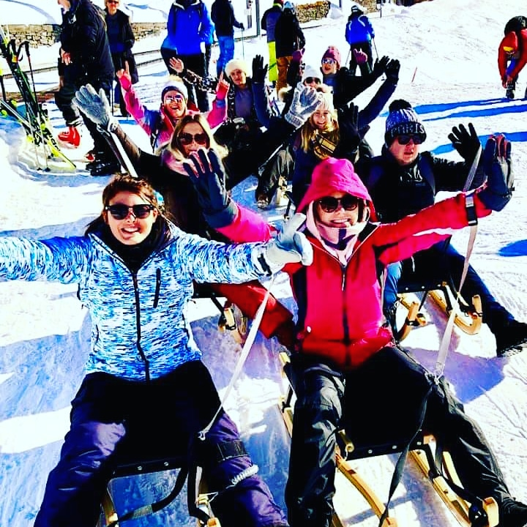  Travel review-Switzerland  By Chloe Carys Savory | #MamsAdventure  Travelling to Switzerland for the first time and getting to experience all aspect of its culture and by experiencing ski tourism at its finest during the winter snow.  Chloe Savory (1703177)  BA Tourism Management

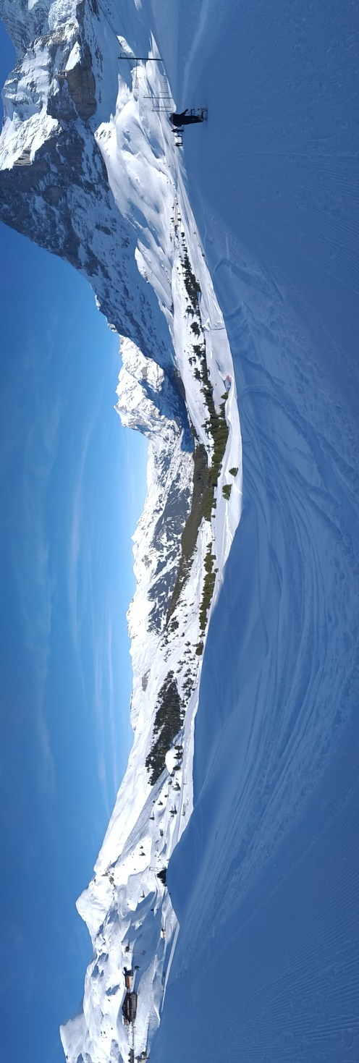

Introduction
Switzerland is a beautiful picturesque landscape, with much to offer. The winter sports and activities are one of the country’s main selling points, and the snowy landscape does not disappoint. it is also an expensive country, with many products being more than twice what you would pay in the UK. The cost of the whole holiday overall was £500, but it was 100% worth every penny. For the high price tag for a week away, we were able to do so much. In that week we travelled to France, stayed in Paris then travelled to Switzerland as a part of an education trip to experience their culture differences. The trip allowed us to gain a better understanding of the developments in Switzerland and how different it is to the UK. Travel systems in Switzerland are more efficient than in the UK, and because of the difference in infrastructure, the public transport is free. As part of the trip, we looked at how Brexit will affect UK tourist travelling to Switzerland. Also, how sustainable festivals are in Switzerland and what keeps tourist returning. We also discovered how technology is falling behind.

Main body

Travelling
We travelled to Switzerland by train to experience different types of travel and to see more of the scenery. It was also a way of saving money. To get to Switzerland from the UK, we first took the Eurostar from London to Paris. Travelling to Paris was very long especially when the Eurostar got delayed in London. The Eurostar is a very effective way to get UK residents to travel around Europe without having to catch a flight. The Eurostar is normally on time but as from past experience it has been known to have delays as was in our experience.
In Paris they have transport with rail journeys to get across the city. We discovered that the trains are very efficient compared to the UK, as they all ran at the scheduled times without delays. They are colour coordinated and maps at the stations. Citymapper and Trip Advisor are two different apps that can help you travel around Paris and other destinations like Switzerland. I found the easier one to use for going on trains and transport was Citymapper but Trip Advisor was good to find out how to get to destinations to go on our excursion days.
Organising a trip in Paris was straight forward I looked on comparison websites to see which ones would be cheaper to go to Disneyland Paris. I found out that the Disneyland Paris website itself was the most expensive. However, Attraction Tickets Direct was the cheapest to go to both parks.
Travel from Paris to Switzerland was by train. In Switzerland the public transport such as busses and trains left on time and arrived on time, like they did in Paris. The transport is free in Switzerland because there is no need for any building infrastructure apart from railway lines (Encyclopedia of the Nations, 2019). This is because all the buildings have to conform to the current style of chalets, so there is no need to invest in building large structures as other cities do.
In Switzerland I got the chance to look at ski tourism in Wengan with 8 other students to take part in some snow sports trying out tobogganing.
Organising an excursion for a day in Switzerland was also easy as a group of us wanted to go tobogganing in Wengan. Where we stayed at ‘Camping at Jungfrau’ we got some great hospitality from the staff and they helped us organise an excursion day at the reception desk. The train was also easy to get to Wengan.
The train journeys were good, although we had a few issues with conductors when we arrived at Switzerland. I am now aware for next time that they are not happy if you have not booked seats and they are not happy if you are late and holding the train up. They always like to leave on time.

Hospitality and Guest Service
‘Camping at Jungfrau’ is a site for ski tourists. At ‘Camping at Jungfrau’ they had the most amazing guest service and hospitality the staff were always welcoming and made us feel like one big family. They were always making sure we had enough food and checking that we were enjoying. They made sure that we had water when needed. I would definitely recommend ‘Camping at Junfrau’. They made our holiday by getting us to experience the culture of Switzerland I could not have asked for better. The food was so tasty not always to my pallet but I still had to try it because it was so presentable. I thought the hospitality at ‘Camping at Junfrau’ was truly amazing they made you feel at home and made the group connect better and enjoy the experience even more.

Culture
As ski tourists in Switzerland we were not made to feel as welcome by the locals as we did by the tourism hospitality staff. Compared with our experience in France, where the locals expect and welcome tourists, locals in Switzerland come across unwelcoming. This is backed up by Mowbray, (2018) who says that some locals would prefer if certain areas in Switzerland were not visited by tourists as they believe an influx of tourists would ruin the ‘peaceful ambience’. An example of our experience was where locals in Interlanken were rude to us on the streets while we were walking around enjoying the scenery and decided to scream at us and walk into us on purpose.
Switzerland keep their heritage and culture by maintaining chalets and their language they maintain snow sports and events to engage the community and country together. It’s a beautiful culture who keeps the tradition of music and arts (Milošević, 2016). It is an extremely wealthy country that still maintains the activity and living tradition (Milošević, 2016). Shoot the apple is another tradition they have from history of William Tell who shot with a bow and arrow, an apple of his sons head as punishment. To the swiss culture he is like their robin hood (Expatica, 2018). Along with other myths and legends.
One of the reasons locals are not keen on ski tourists is that Switzerland is an ethnocentric country. This means that they like their culture and they are not a multi-cultural community. To move here you have to fit in (Milošević, 2016). Speaking their language is very important to them because they like to keep their culture growing by speaking 4 different languages which are German, Italian, French and Romanish (Mowbrey, 2017). Speaking these languages can help you fit in (Milošević, 2016).

European developments
In order to sustain the landscape whilst accommodating ski tourism, Switzerland have developed a sustainable development plan. “In Switzerland, sustainable development is a constitutional obligation” (Dubas, 2016). Their sustainable development focuses on sustainable construction and developing a high standard of sustainable building. As part of their sustainable development, Switzerland have substantially improved their water and air quality without negatively impacting on the economy of the country. There are still some challenges to Switzerland’s sustainable development plan, such as climate change, transport infrastructure and social cohesion. This means that all the citizens of Switzerland must cooperate in order to allow the country to achieve their goals of sustainability (Dubas, 2016). This could be a problem when tourists visit for skiing as they may not be aware of ways to cooperate with the sustainability plan of the country.

In 2030 it is said by FDFA (2017) that its most likely to be more sustainable and the goals for 2030 is to have better decisions with the environment consumption and production. The locals in Zurich they have to pay for their black bags to dispose of rubbish that varies between 0.85 CHF to 5.70 CHF (Hirschi, 2019)
The main goals for Switzerland in 2030, is to make sure it is all an urban development, mobility and infrastructure in the towns and cities. The less energy used and to identify the climate change to clear more air and pollution. To use more natural resources by keeping it environmentally friendly and by being resilient towards the agricultural and food sector. The economic and financial systems. Education on a more sustainable development with more research and innovation to make Switzerland a sustainable country. The social security helps everyone in the country to have a more sociable and economic life. Looking at the social cohesion and gender equality issues they hope to be respected in professional and private life and women are able to make decisions in all economic and political public matters. They wish to reduce violence between women. They hope that migrants will quickly integrate to society and have equal opportunities. Switzerland like to remain the same cultural diversity in neighbourhoods. By speaking about health and mental conditions and by reducing early deaths by 2030 and they hope to get people more active active. The less people suffer from treatments with terminal illnesses, so they do not have to suffer. Also, by getting people with drugs and alcohol problems that help straight away to reduce the proportion of substance misuse issues in Switzerland (FDFA, 2016).

Brexit
There are many concerns about tourism from UK to European countries after Brexit, which include ski tourism. Relationships between the UK and Switzerland are currently strong as around 42,000 people live in Switzerland from the UK with around 140 flights a day travelling back and forth. They also have thousands of tourists visiting a year (GOV, 2018). Switzerland wants to keep relations with UK post to Brexit due to the number of British people living in Switzerland and the number of Swiss people living in the UK, which is about 34,000 (Swissinfo.ch, 2018).
Fahy, (2018) have said we have no idea of what will happen after Brexit but “working towards an agreement securing the status of our citizens” this means that the UK and Switzerland need to make an agreement as two nations to stand by one an other so that citizens of both countries can stay where they are, if not they may have to look at departing back home (Fahy, 2018).
The main things that can be affected by Brexit between the UK and Switzerland would be that the UK is and can remain the sixth most largest export markets worth 8.8 billion CHF and the eight most biggest source of the swiss imports worth 7.7 billion CHF (FDFA, 2019). The UK also is the sixth biggest direct investor as written by the FDFA (2019) and has roughly 50,000 – 60,000 flights a year connecting back and forth to Switzerland and the UK, partly due to ski tourism (FDFA, 2019).

Sustainable tourism
The Lauberhorn Festival that is held once a year in Switzerland is a Festival for worldwide tourists to join in with a snow sport race down the slopes. The amount of tourism this attracts has had an effect on the land in Switzerland because of damage the race is doing. Ski tourism could face a decline as the snow is not as much as it used to be, but by having festivals all over Switzerland it can help maintain tourism by bringing in tourists to the festivals (Rick Steves Europe, 2019). This is to sustain tourism in that area (House Of Switzerland, 2016).

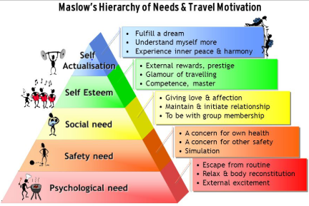
Ski tourism is a way of meeting the higher levels of the pyramid. Esteem can be met by having a sense of achievement after going on the slopes, and it can help gain self-respect. The basic needs are met in Switzerland because it is safe with less crime and less locals that suffer with alcohol issues or substance misuse.

(BINUS University, 2007).
Struggles with technology in Switzerland is that they promote their country well but not to the younger generation, why? I think its because its different to what young people think. Some like to party hard and some like to enjoy do some snow sports. Switzerland can seem expensive especially to the younger generation. What the younger generation don’t see is that Switzerland may have its culture, but they know how to have fun weather its partying or doing other activities. There’s so much to do and so little time and money but why go to other countries that are cheaper and end up somewhere that isn’t to your standard. Why not go to Switzerland! It will honestly be one of the best trips you will go on and you can honestly come back and say what an amazing holiday that was, with the experience you want.

Recommendations
Visitor strategies, tourism developments, new attractions, event management, national policies, funding and management styles
The trains leave dead on time which don’t give people who get off the other trains time to catch the other one I think it would be a good idea to try and give a 5 minute gap so people get the chance to run to catch the trains rather than leave the same time as one arrives.
I think that tobogganing in Wengan was amazing! However, I found that it was the most dangerous activities I had ever tried in my life. I had no sense of direction or how to turn the sledge I had no idea how steep the slopes would be. We all crashed so many times, it was just the most insane thing I had ever experienced especially for my first time. I would 100% do it again but I would recommend that when giving out the sleighs to maybe direct people on how to use them and warn them about the slopes advise maybe which ones to try out first.
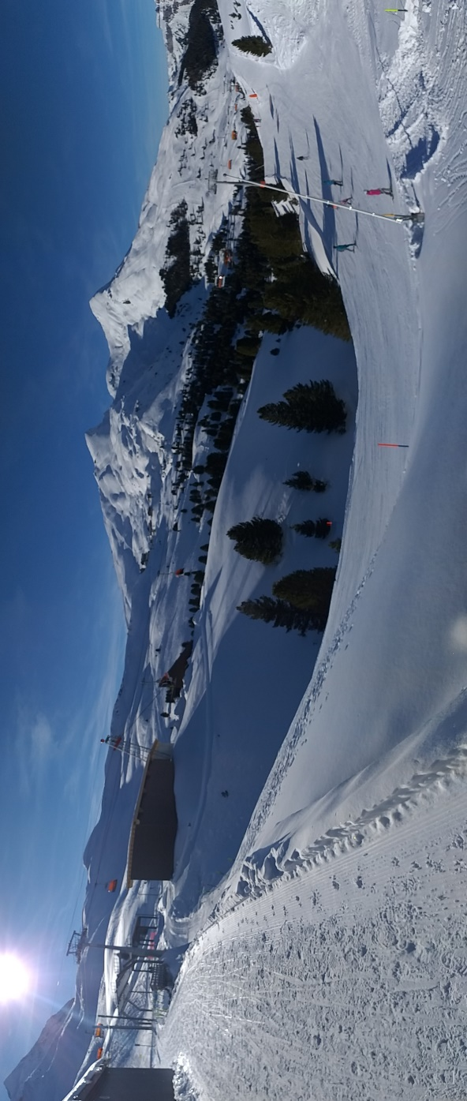

Conclusion
In conclusion the review looked at how Brexit could impact visitors living and travelling from the UK and Switzerland, vice versa could be effected to travelling back home. We have looked at how expensive Switzerland can be for a holiday and how the technology doesn’t reach out to the younger generation. Switzerland is very sustainable in events and with daily use of recycling by locals. Also, by organising a trip with ‘Camping at Jungfrau’ was easy to do and how the hospitality and guest service was really good and how they maintained their traditions and culture with ski tourist like ourselves.

References
Attraction Tickets Direct, 2019. Attraction Tickets Direct. [Online]
Available at: https://www.attraction-tickets-direct.co.uk/?gclid=CjwKCAjw-OHkBRBkEiwAoOZql7J8nhrTJkUo2aKRalgzq4SpLOqhVnLPwEyfrCg3KJeychCzqU1c5hoCmuUQAvD_BwE
[Accessed 20th January 2019].
BINUS University, 2007. Slide Player - Tourism Management and Planning. [Online]
Available at: https://slideplayer.com/slide/5168911/
[Accessed 30th March 2019].
Citymapper, 2019. Citymapper. [Online]
Available at: https://citymapper.com/london
[Accessed 1st February 2019].
Disneyland Paris, 2019. Disneyland Paris. [Online]
Available at: https://www.disneylandparis.com/en-gb//?ecid=SEM_IP_S_8126152771-c-56199388205-76584680-317924676216-Exact&mkwid=u5ENCT8F&gclid=CjwKCAjw-OHkBRBkEiwAoOZql2eIVpU9YmE3h-3llFeb881S-hAheaBKWm4CfbWRQE4QZ9sY_snAKRoC--0QAvD_BwE
[Accessed 20th January 2019].
Dubas, D., 2016. A new Sustainable Development Strategy for Switzerland. Open Access Government, June 10th.
Encyclopedia of the Nations, 2019. Switzerland - Infrastructure, power, and communications. [Online]
Available at: https://www.nationsencyclopedia.com/economies/Europe/Switzerland-INFRASTRUCTURE-POWER-AND-COMMUNICATIONS.html
[Accessed 20th March 2019].
Expatica, 2018. Myths, legends and folklore from Switzerland. [Online]
Available at: https://www.expatica.com/ch/about/culture-history/myths-legends-and-folklore-from-switzerland-512496/
[Accessed 30th March 2019].
Fahy, J., 2018. What would a no-deal Brexit mean for Brits in Switzerland?. Swissinfo.ch, 10th October.
FDFA, 2016. Switzerland Confederation. Bern: Didier Burkhalter.
FDFA, 2017. Strategy. [Online]
Available at: https://www.eda.admin.ch/deza/en/home/sdc/strategy.html
[Accessed 19th March 2019].
FDFA, 2019. Swiss–UK relations post Brexit. Federal Department of Foregin Affairs, 1st February, p. 1.
GOV, 2018. The UK-Swiss relationship. [Online]
Available at: https://www.gov.uk/government/news/the-uk-swiss-relationship
[Accessed 20th March 2019].
Hirschi, A., 2019. WASTE & RECYCLING IN ZURICH. Hello Switzerland, 24th January.
House Of Switzerland, 2016. Key aspects of environmental protection in Switzerland. [Online]
Available at: https://houseofswitzerland.org/swissstories/environment/key-aspects-environmental-protection-switzerland
[Accessed 16th Febuary 2019].
Milošević, Ž., 2016. The Customs and Culture of Switzerland: The Living Tradition, a Survived Past. Diplomacy & Commerce, September 17th.
Milošević, Ž., 2016. The Customs and Culture of Switzerland: The Living Tradition, a Survived Past. Dipmlomacy and Commerce, 17th Septermber.
Mowbray, S., 2018. 7 Places Locals in Switzerland Don't Want You to Know About. Culture Trip, 11th January, pp. https://theculturetrip.com/europe/switzerland/articles/7-places-locals-in-switzerland-dont-want-you-to-know-about/.
Mowbrey, S., 2017. Why Are There Four Languages Spoken in Switzerland?. Culture Trip, 19th June.
Rick Steves Europe, 2019. Upcoming Holidays and Festivals in Switzerland. [Online]
Available at: https://www.ricksteves.com/europe/switzerland/festivals
[Accessed 16th Febuary 2019].
Swissinfo.ch, 2018. Switzerland wants to intensify relations with UK after Brexit. [Online]
Available at: https://www.swissinfo.ch/eng/politics/bilateral-thinking_switzerland-wants-to-intensify-relations-with-uk-after-brexit/44498186
[Accessed 25th March 2019].
Trip Advisor , 2019. Trip Advisor. [Online]
Available at: https://www.tripadvisor.co.uk/
[Accessed 1st February 2019].

