MODULE TITLE: FRONT OFFICE OPERATIONS

M4X01920

ASSIGNMENT TITLE: FRONT-OFFICE SERVICE - THE "RECEPTION" FUNCTION

STUDENT NAME: IOSIF DANIEL STAN

STUDENT ID NUMBER: 1815337

LECTURER NAME: DR.JAHANZEEB QURASHI

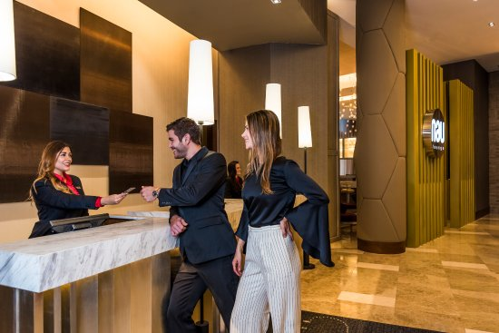

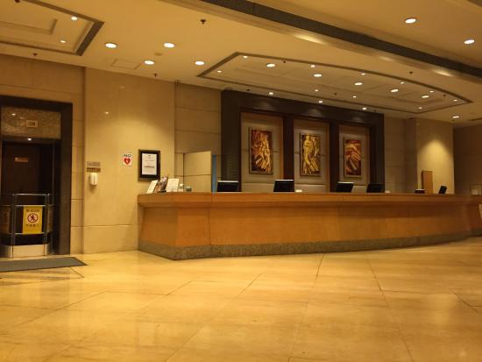

Table of Content

Introduction……………………………………………………………………page 3
Why is the Front-Office department Important…………………………….page 3
Conclusion………………………………………………..............................page 7
References………… …………………………………………………….…. page 8

The purpose in this assignment is to study, research and analyse the importance of the Front-Office Department, its efficiency hospitality industry.
Introduction:
Each multi-departmental physical business needs to have a front office or social event to get the visitors. Front Office Department is the face and similarly as the voice of a business. Despite the star rating of the hotel or the motel type, the cabin has a front office as its most undeniable office. For a business, for instance, neighbourliness, the front office division goes with a piece of bringing customer contribution up in the business. Front office is a commonplace association between the customers and the business.
Why is the Front- Office Department Important?
It is the one of the numerous branches of the inn business which straightforwardly interfaces with the clients when they initially land at the inn. The staff of this office is completely perceptible to the guests.
Front Office Department accept a central work in a motel, and it is the pith of a hotel or convenience establishment. It is the first and the last office where a guest interface. The Front Office Department is responsible for establish direct connections as to the level of organizations and workplaces gave. The Front work region is subject for taking note of enquiries, directing request to address staff/office.
Social capacities and individual appearance are huge and influencing components. An individual should be sure, warm, respectful, patient and real to deal with the inquiries of guests at the Front Office.
Front office manager
The Front Office Department is passing by Front Office Manager. The Front Office Manager is answerable for dealing with exercises, controlling the subordinates, enlisting and preparing, setting up quite far for front office division, execution assessment of workers and ensures that the entirety of the battles is tended to.
Front Office Manager is liable for booking the advancements of operators, cash, screen pay rates, room stores, limits, and so on. The Front Desk representative ought to be especially careful with the strategies and costs (commitment) of the associations gave and should be, brief to answer demand. He/she is at risk for the game plans, undertaking of rooms, keeping up visitor records, and so forth. Night expert is fit accounting, customary record the authorities, information area and restoring. The colleague is in danger for social event divides, charge age and dealing with equities.
Front office and various workplaces move toward a common target that is customer support and bliss. Keeping up guest relations is a noteworthy perspective. The regions are related, and all specialists ought to collaborate to ensure smooth working of the workplace with outrageous target of captivating the guests. The business is scanning for specialists with incredible correspondence and social capacities who can amass a similarity with the guests.
Front Office has an essential sway in Tourism and Hospitality Industry. This is an aftereffect of how the front office is the first and last point which team up with the client. Front office called so considering the way that they are masterminded at the front near the entry of the lodgings. Any information related to the customer can be gained from the front office of the cabin. The front work zone can help with offering help to the customers and direct to the correct individual for clarifying the complaints.
The activity of front office individual consistently incorporates regulating various divisions as well. Partner housekeeping division, accounts office and online reservation workplaces interface with front office to work in musicality with the methodologies of the hotel. Regardless, the route toward giving a warm welcome at the social affair is very noteworthiness. As early presentation is the best impression the customer should be satisfied by the welcome. A couple of individual characteristics like resilience and convenience should be a bit of the characters of people at front office.

Administering take a gander at in and check is moreover part of front office specialists nearby game plan of rundown if individuals to visit. Sending the information to various workplaces are in like manner part of the front office the board strategy. All levels of correspondences inside the hotel can be affected by the front office help. Fixing plans and organizing social occasions can in like manner be managed by front office specialists.

Lodging Front Office Sections
Front office director heads the group of staff dealing with different exercises and obligations in the front office. Barely any conspicuous exercises that the front office staff is engaged with are −
1-Reservation − It incorporates taking care of solicitations of clients for booking in facilities.
2-Reception − It incorporates accepting the visitors as per the best expectations and enrolling them suitably. It additionally incorporates seeing the visitors off.
3-Guest Services − They are otherwise called Uniformed Services. It incorporates customized visitor administrations, for example, −
1-Handling visitor baggage.
2-Handling visitor mail.
3-Delivering papers in lodging.
4-Paging the visitor inside the lodging (finding the visitor in the inn).
5-Arranging for a specialist in crisis.
6-Parking visitor's cars.

7-Arranging for reservations at the spots of preoccupation outside the lodging.4-Accounts − It basically incorporates a front office clerk and a Night Auditor. The clerk is liable for taking care of visitor instalments. He regularly reports to the record's chief instead of the front office administrator.
The night evaluator plays out the obligations of front work area gathering just as bookkeeping halfway during the night move. He needs to answer to the heads of the two offices, front office, and bookkeeping.

5-Communication − It includes dealing with correspondence among different offices and visitors of the lodging.

Night Audit Manager

A significant job that this administrator has during the night hours. The run of the mill duties of a night review administrator are:
1-Posting settlement charges, charges, and other paid administrations, for example, café, Internet charges to every visitor's record precisely.
2-Taking the obligation as an obligation director for night move.
3-Settling visitor accounts whenever required.
4-Authoring security of the inn during night move.

Front Office - Staff Qualities and Competencies
Being a piece of the administration business, the front office staff needs to have the accompanying characteristics and abilities. The front office staff individuals are required to
- Understand their particular jobs and obligations in the lodging and front office as an activity.
- Equip themselves with basic etiquettes and mannerism.
- Possess charming, considerate, and genial character.
- Wear spotless and slick uniform with same extras and shoes.
- Maintain demonstrable skill, inspirational frame of mind, and helpful nature.
- Have uncommon relational abilities.
- Be a cooperative person.
- Have the capacity to handle precarious circumstances

Conclusion:

In end the front office It's essentially the core of the lodging, the half and half between the visitor and the back-of-the-house.
Any not too bad lodging administration framework at the Front Office ought to be associated with Accounting, Housekeeping, Reservations, and different modules. Any solicitation that a visitor may have will go through/from the Front Office, therefore planning with different offices and staff individuals is a key highlight. All the more significantly, any objection will adhere to a similar procedure, and that is the reason the Front Office is answerable for taking care of visitors. Other than compromises, satisfying reservations, and guaranteeing lodging activities are smooth in any event, when the organization is shut is a crucial assignment without anyone else's input. At last, there are times where the inn divisions are on the whole recouping from days’ worth of effort, however the front office stays on obligation for 24-hours. They are the timekeepers that genuinely demonstrate that inns are the uncommon foundations that stay open throughout the entire year.

Reference:

1.

Virgil Balaure, Iacob Catoiu, Catalin Veghes - Marketing Turistic, Ed Uranus,
Bucuresti 2005

2. Philip Kotler 'Principiile marketingului', Editura Teora, Bucuresti, 2004
1.

Virgil Balaure, Iacob Catoiu, Catalin Veghes - Marketing Turistic, Ed Uranus,
Bucuresti 2005

2. Philip Kotler 'Principiile marketingului', Editura Teora, Bucuresti, 2004
1.

Virgil Balaure, Iacob Catoiu, Catalin Veghes - Marketing Turistic, Ed Uranus,
Bucuresti 2005

2. Philip Kotler 'Principiile marketingului', Editura Teora, Bucuresti, 2004
Kotler, P., Marketing Principles, Teora Publishing House, Bucharest 2004

Kotler, P., Marketing Management, Teora Publishing House, Bucharest, 2007

Lupu, N., Hotel-Economics and management, All Publishing House, Bucharest, 1999

Stancioiu, Aurelia Felicia, Marketing Strategies in tourism, Economic Publishing House, Bucharest, 2006

Stanciulescu, Gabriela, tourism Operations technique, Economic Publishing house, Bucharest, 1998
"What does front office staff do?" wise GEEK. Retrieved 14 October 2014. accessible @ https://www.wikipedia.org.Front_office (accessed 5/11/2019)

Reference:

1.

Virgil Balaure, Iacob Catoiu, Catalin Veghes - Marketing Turistic, Ed Uranus,
Bucuresti 2005

2. Philip Kotler 'Principiile marketingului', Editura Teora, Bucuresti, 2004
1.

Virgil Balaure, Iacob Catoiu, Catalin Veghes - Marketing Turistic, Ed Uranus,
Bucuresti 2005

2. Philip Kotler 'Principiile marketingului', Editura Teora, Bucuresti, 2004
1.

Virgil Balaure, Iacob Catoiu, Catalin Veghes - Marketing Turistic, Ed Uranus,
Bucuresti 2005

2. Philip Kotler 'Principiile marketingului', Editura Teora, Bucuresti, 2004
Kotler, P., Marketing Principles, Teora Publishing House, Bucharest 2004

Kotler, P., Marketing Management, Teora Publishing House, Bucharest, 2007

Lupu, N., Hotel-Economics and management, All Publishing House, Bucharest, 1999

Stancioiu, Aurelia Felicia, Marketing Strategies in tourism, Economic Publishing House, Bucharest, 2006

Stanciulescu, Gabriela, tourism Operations technique, Economic Publishing house, Bucharest, 1998
"What does front office staff do?" wise GEEK. Retrieved 14 October 2014. accessible @ https://www.wikipedia.org.Front_office (accessed 5/11/2019)

