Swansea Foreshore site investigation - case study
Fundamentals of construction technology

UWTSD
Produced by: Tobi Pratt 2519009

Table of Contents
Glossary of terms 1
Figure list 1
Introduction 2
Historical Background of the Site 2
Site Risks 3
Borehole Investigations 4
Foundation options 4
Raft Foundation 4
Pad foundations 5
Pile foundations 5
Elevated steel screw foundations 5
Building Control 5
Recommendations 6
Conclusion 6
Foundation Drawings 7
Bibliography 8
References 8

Glossary of terms
UXO, Unexploded Ordnance

Figure list
Figure 1 – Chosen site
Figure 2 & 3 - National Library of Scotland (2018). National Library of Scotland.
Figure 4 - naturalresourceswales.gov.uk. (n.d.). Natural Resources Wales / Check your flood risk on a map (Flood Risk Assessment Wales Map).
Figure 5 - Zetica UXO (2024). Risk Maps. [online] Zetica UXO.
Figure 6, 7 & 8 - British Geological Survey (2019). British Geological Survey (BGS).
Figure 9 - Hawthornthwaite, T. (2024). Quality Ground Screws from The Ground Screw Centre.
Figure 10 & 11 - Ideal Foundations. (2024). Screw Pier Technical Information - Ideal Foundations.

Introduction
This report will cover Swansea for shores proposed development of a two-story multi use building comprising both hospitality and residential facilities. Located between the county hall and the Marriott Hotel this site offers commercial advantages being close to the city as well as the waterfront. Although, the coastal location offers many challenging setbacks such as geotechnical variability, Environmental hazards, and previous historical land use implications. This is why it is important to carry out the site investigation to eliminate risks and enable a well calculated design is formed.
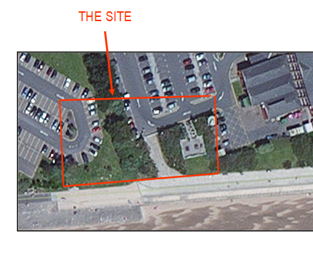
This report will contain a comprehensive analysis on historical site backgrounds, known site risks, bore hole investigation data, Foundation options, Building regulations, and further recommendations. There will be a heavy interest on unexploded ordnance and floods. These have been issues that have come to the attention during this desktop survey. We will also integrate information gathered from Swansea City archival research & geotechnical data from the site as well as the surrounding area.
We have been provided with a specific site location as we can see it will be sharing car parking areas with the adjacent facilities. The areas is flat land as per typical marina developments being in proximity to the sea with high public access. The building will be exposed to the coastal weather. This rises the chance of flood risks, or potential high groundwater levels. As we can see there is sand to the south end of the site potentially meaning well need to factor in a sand suitable foundation. This will be further discussed.
Figure 1

Historical Background of the Site
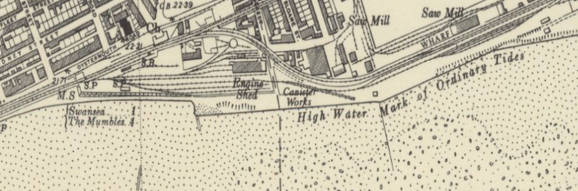
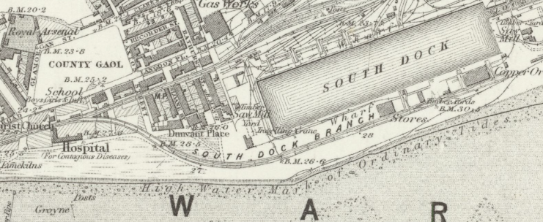
After researching historical information on the given site location, we can see that Swansea has had extensive development since the mid 19 century. We have gathered information from Ordinance survey maps using the national library of Scotland from 1888 this shows the area as an industrial site (National Library Of Scotland). This map reference details of a railway infrastructure which was used for the movement of coal and steel works during the initial development of Swansea foreshore. This was the first railway to hold passengers (BBC news). During the hight of the oil trade in the “1950s oil imports and exports were ran through the port of Swansea” (Swanseadocks). By the late 19th century, the area was utilised by sawmills and canister works. The presence of these productions introduces potential contaminates into the site and its surrounding area such as hydrocarbons, heavy metals, and timber preservatives in the soil (Kitunen and Salkinoja-Salonen, 1990). In figure two (map in 1947) we can see the evidence of the additional infrastructure built to provide these works.
Figure 3 (nationallibaryofscotland)
Figure 2 (nationallibaryofscotland)
Elaborating on this, Swansea docks was a main target area for bomb attacks in WW II. Its well-known knowledge that Swansea suffered from serious air attacks during the second world war. The docks and waterfront areas being one of the main strike areas “. It is believed around 1273 highly explosive devices along with 56,000 incendiary devices were dropped covering a total of forty-one acres” (Swansea Museum. 2025). As the site is in very close proximity to these areas there rises a high possibility of unexploded ordnance amongst the surface area. “The potential for UXOs poses a sever safety risk during the construction and could call for a specialist survey or clearance operations” (RICS. 2009).

Site Risks
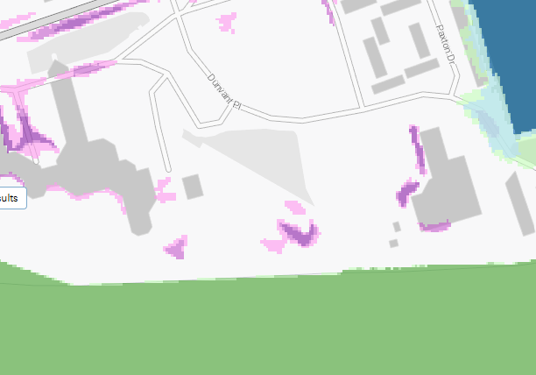
After researching through National Resources Wales flood risks map (Figure 4) we can see that the area of land is a high flood risk area from surface water. This offers a potential risk that could be seen to in the initial stages of design. The Welsh Governments circular 002/2025’ planning policy is as follows “in order to align requirements for referring applications in areas of flood risk to the Welsh Ministers with revised national planning policy and mapping on flooding. Technical Advice Note (TAN) 15: Development, flooding and coastal erosion1 and the Flood Map for Planning2” (Gov.wales) This informs us that a flood consequences assessment should take place for development in the given area at risk. This will include strategies like lifted floor levels, suitable/ adapted drainage systems to help manage surface water levels. By complying with TAN 15 the risk of damage to the structure can be eliminated.
Figure 4 (floodriskmaps)
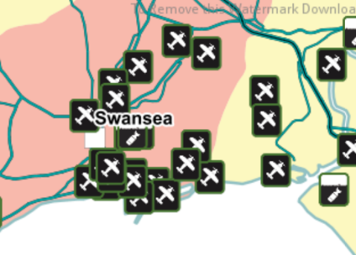
The risk of flood is the main risk we are aware of however, while the risk of UXO hazards is low probability UXO has the potential to be disastrous risk if not taken seriously. As we can see in Figure 5 there have been many plane parts & some UXOs discovered amongst Swansea in a broader picture. To help us understand the risk of the area an UXO survey can be organised using a magnetometer or the application of a ground penetrating radar survey these will offer direction for detecting metallic anomalies within the strata. Completing a survey such as this with an approved company such as IGNE, who have completed and discovered multiple UXO in Swansea previously will provide us with expert risk assessment, detection, and clearance, ensuring projects proceed safely and efficiently” (terratek)
Figure 5 (zeticauxo)

Borehole Investigations
Researching the area and using the borehole investigation records from the proposed new county hall we can see that the top layer is ground made from ashes, The overall investigation shows lots of clay and sand mixes, mostly consisting of fine medium sand, with some hints of gravel further down. A meter down hitting light grey fine-medium sand. At 2.56 Meters layers of soft clay is seen within the grey sand. 5.68 Shows us soft red brown sand clay with brick shale. Through out the investigation the primary material found is clay, the final material hit was boulder clay at 8M where the investigation was continued for 22 meters. (British Geological survey)
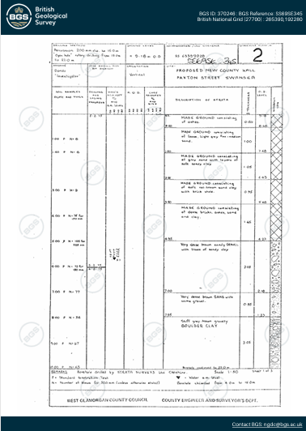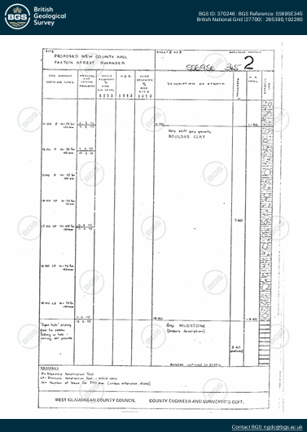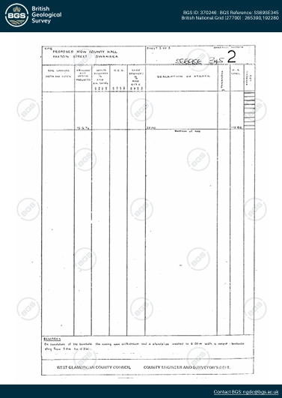
Figure 6 (bgs) Figure 7 (bgs) Figure 8 (bgs)
The lose materials such as fine sand or gravel yields a high permeability however offers low cohesion presenting issues such as low stability under load. From 8-22 meters there is a boulder clay stratum which offers a potential area to target for the foundation. While the Clay soil is made up from very fine mineral partials that hold water easily making it house poor drainage which can domino onto further issues. This stiffness the clay presents a higher weight bearing capacity. Clay soil is made up from very fine mineral partials that hold water easily. (hmstructures)

Foundation options

Raft Foundation
The first foundation we investigated is a raft foundation. This is a shallow foundation where the load is “imposed by a structure are low relative to the bearing capacity of the surface soils.” (designingbuildings). Raft foundations are used when floor areas are small with a low structural load. Or when the ground conditions are poor a strip and pad foundation requires extensive excavation therefore a raft foundation would be best to use in that scenario. Raft foundations are also ideal when settlement is likely to occur. With our site being built on a beach environment with sand being present in the borehole investigation settlement may be possible. As the load of our building will be significant looking at a strip and pad foundation may be more desirable than a raft. (designingbuildings).

Pad foundations
“Pad foundations are used to support individual or multiple columns, spreading the load to the ground below.” (concrete.org). This could be good for our build as the columns can reach the low strong clay while the load gets distributed across all the columns. These foundations can be constructed much deeper as long as the train / soil type is deemed suitable. Mainly, Strip Footings are installed around the perimeter outside of most houses, and Pad Footings are used to support heavy loads and beams within the household. (civilguidelines).

Pile foundations
Pile foundations, whether driven or bored, enable the transfer of structural loads to deeper soil layers, enhancing stability by reaching underlying clay strata. However, their installation poses challenges such as the use of heavy machinery, which generates significant ground vibrations that may risk disturbing UXOs. Furthermore, noise pollution and logistical constraints in a city waterfront location raise additional feasibility concerns. Despite their superior structural performance, the environmental impact and associated hazards reduce the suitability of pile foundations for this project (Chudley & Greeno, 2008).

Elevated steel screw foundations
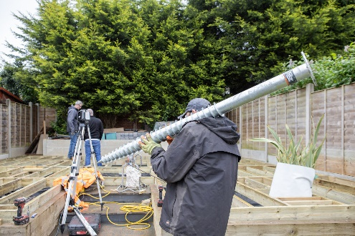
Elevated steel screw foundations can offer a modern solution that addresses many of the site constraints previously mentioned. This is in simple terms a giant corkscrew that is driven into the ground made from strong galvanised steel. When screwed into a ground it creates an anchor point for the foundation as its screwed into the soil. A screw pile has 3 parts: the shaft – main body of the screw that goes into the ground. The screw thread – The spiral part that helps drive into the soil to keep it firmly anchored. And finally, the bracket – top part that connects the building to the foundation. “Ground piles are screwed into the ground, penetrating deep below the surface, bypassing soft soil top layers to anchor into firm ground below. Each pile transfers the weight of your building safely into the ground.” (groundscrewcentre). The helical plane doesn’t just anchor the pile it spreads the load over a wide surface of soil this prevents any sort of sinking or movement over time. The building can sit securely on top of the piles using specific brackets, this creates a strong stable elevated foundation that protects it from ground moisture and movement. As our clay sits 8M deep this is more of a viable option as it sits deep into the ground and offers a great load to stability method. initial costs might be greater than that of which shallow foundations offer the stability, environmental and safety factors they offer could justify their use within this development. (groundscrewcentre). To further understand the way elevated steel screw foundations work, see figures 9 & 10 further below.
Figure 9 (groundscrewcentre)

Building Control
All parties involved in the construction project is held reliable if a UXO were to go off. “the roles and responsibilities of clients, principal designers, designers, principal contractors, contractors and workers are outlined in The Construction (Design and Management) Regulations 2015.” (allianz). The clients are responsible for providing all preconstruction necessary to each designer and contractor involved in the project. In the case where the client is unaware of an area where anticipated UXOs is concerned it is vital that they seek competent advice from suitably qualified specialists.
To meet TAN 15 requirements, it is essential to develop a strategic plan that addresses potential flooding issues. This should be complemented by early engagement with Swansea County Council prior to submitting the planning application. Such collaboration ensures that data and flood mapping align with the council's preferred approaches, thereby reducing the risk of project delays and minimizing flood-related risks.
The final foundation design of the project must comply with the government approved document A involving the structural integrity of the building. Approved document C involves the resistance to moisture of the building, while also aligning with Approved document L that addresses the carbon energy performance of the structure.

Recommendations
Firstly, I recommend a professional UXO specialist to carry out a desktop survey of the surrounding area. These specialists should have files of extensive data like historical archives, library resources maps and UXO databases. These specialists can also carry out a full intrusive survey if required. The chosen specialists can also provide each onsite operative with training / toolbox talks of an emergency response plan alongside additional training. (allianz).
Next, I would recommend carrying out another borehole investigation of the area. Although, the previous inspection is useful to for our report I feel it would give us a better in site as to what the ground is truly like on this current day.
For foundations, the use of steel screw foundations is recommended due to their advantages, including quick installation, minimal ground disturbance, and sustainability. A significant benefit of these foundations is their ability to elevate structures, effectively mitigating flood risks, which directly addresses key site concerns in line with TAN 15, and the approved documents mentioned. Combining these foundation solutions with coordinated collaboration with Swansea Council and environmental agencies will ensure full compliance with building regulations.

Conclusion
The proposed development site on Swansea Foreshore is situated within a historically industrial dockland area that has experienced significant redevelopment. Historical analysis suggests the presence of made ground and reclaimed land, which may result in variable ground conditions. Preliminary borehole data from the old county hall site indicates underlying soft clay and marine deposits, with groundwater expected at relatively shallow depths.
Given these conditions, a detailed geotechnical investigation is essential. This should include boreholes, groundwater monitoring, and UXO surveys. Based on the anticipated ground conditions, elevated steel screw foundations we deemed as the most suitable solution to ensure structural stability and minimize settlement. Further investigation will enable engineers to confirm soil properties and finalize the foundation design.

Foundation Drawings
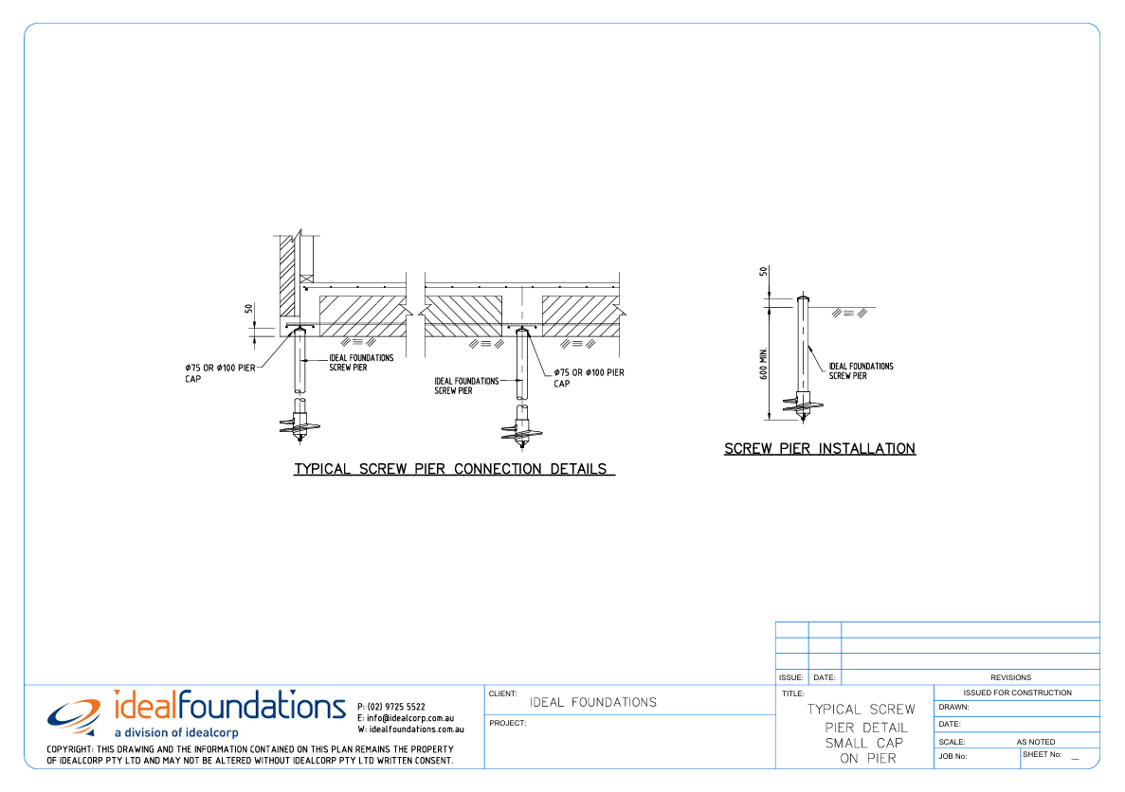
Figure 10 (idealcorb)

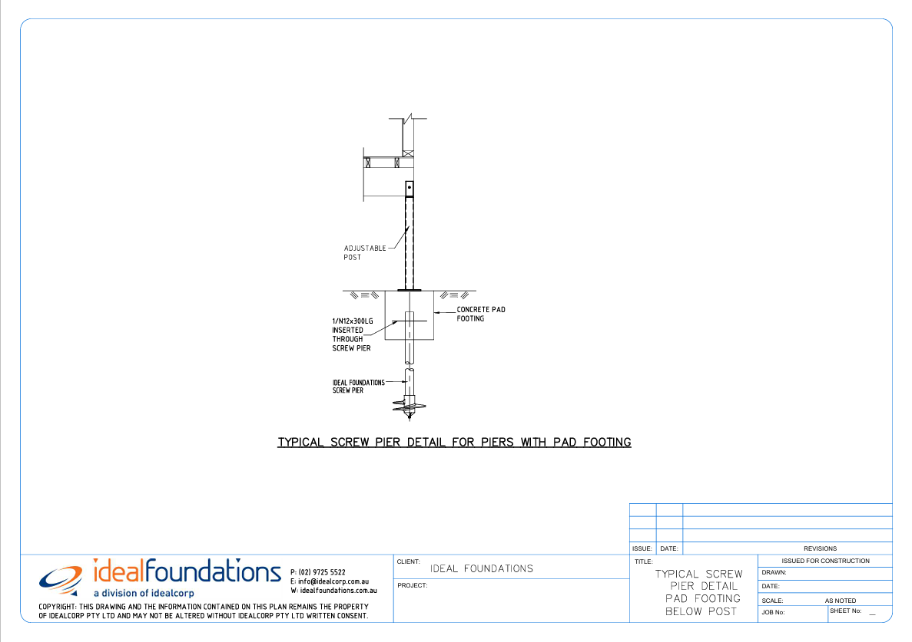
Figure 11 (idealcorb)

Bibliography
Allianz Insurance: Unexploded ordnance business risk support (UXO) (n.d.). Available at: Unexploded Ordnance (UXO) - business risk support [Accessed 9 Apr. 2026].
Chudley, R. and Greeno, R. (2008) Building Construction Handbook (7th ed.). London: Butterworth-Heinemann. P212 [Accessed 11 Jan. 2026].
Circular 002/2025 Guidance on The Town and Country Planning (Flood Risk Area Development) (Notification) (Wales) Direction 2025. (n.d.). Available at: guidance-on-the-town-and-country-planning-flood-risk-area-development-notification-wales-direction-2025-wgc-0022025.pdf [Accessed 4 Feb. 2026].
Kitunen, V.H. and Salkinoja-Salonen, M.S. (1990). Soil contamination at abandoned sawmill areas. Chemosphere, 20(10-12), pp.1671–1677. doi: https://doi.org/10.1016/0045-6535(90)90328-q. [Accessed 10 Jan. 2026].
SWANSEA Understanding Unexploded Ordnance (UXO) Risk in Swansea: Bombing History and Remaining Threats. (n.d.). Available at: a-guide-to-uxo-risk-in-swansea-2025-2-compressed.pdf [Accessed 9 Apr. 2026].

References
British Geological Survey (2023). Borehole Records. [online] British Geological Survey. Available at: Borehole records - British Geological Survey [Accessed 9 Apr. 2026].
GOV.UK (2024). Approved Documents. [online] GOV.UK. Available at: Approved Documents - GOV.UK [Accessed 9 Apr. 2026].
Hawthornthwaite, T. (2024). Services | Ground Screw Centre. [online] The Ground Screw Centre. Available at: Services | Ground Screw Centre [Accessed 9 Apr. 2026].
HM Structures. (2025). Building on Clay Soils in the UK: What Homeowners Need to Know About Foundations. [online] Available at: https://hmstructures.co.uk/2025/11/10/%F0%9F%A7%B1-building-on-clay-soils-in-the-uk-what-homeowners-need-to-know-about-foundations/ [Accessed 9 Apr. 2026].
National Library of Scotland (2018). National Library of Scotland. [online] Www.nls.uk. Available at: https://www.nls.uk/. [Accessed 10 Jan. 2026].
Natural Resources Wales (2020). Story Map Series. [online] flood-risk-maps.naturalresources.wales. Available at: Flood and Coastal Erosion Risk Maps [Accessed 15 Feb. 2026].
RICS. (2009). Surveyor’s guide to unexploded ordnance. [online] Available at: https://ww3.rics.org/uk/en/journals/land-journal/surveyors-guide-to-unexploded-ordnance.html. [Accessed 10 Jan. 2026].
Shuttleworth, P. and Owen, G. (2025). The old Swansea railway that was the world’s first passenger line. BBC News. [online] 20 Sep. Available at: https://www.bbc.co.uk/news/articles/c98e1pp6z7ro. [Accessed 10 Jan. 2026].
Swansea museum. (2025). The Blitz. [online] Available at: http://www.swanseamuseum.co.uk/swansea-a-brief-history/world-war-two/the-blitz/ [Accessed 10 JAN. 2026].
Zetica UXO (2024). Risk Maps. [online] Zetica UXO. Available at: https://zeticauxo.com/guidance/risk-maps/. [Accessed 2 Feb. 2026].

