Assessment

Portfolio Report on Contemporary Software Applications for Business
Student Name: Hamed Ahmed Elbadawi Huffi
Student ID: 2528907

26/04/2026

01/04/2026

Module NaMe: Software solutions for business
Module Code: ACCA 4026
Lecturer: Amitave Banik
Trinity saint david University of Wales (London Campus)

Module NaMe: Software solutions for business
Module Code: ACCA 4026
Lecturer: Amitave Banik
Trinity saint david University of Wales (London Campus)

Module NaMe: Software solutions for business
Module Code: ACCA 4026
Lecturer: Amitave Banik
Trinity saint david University of Wales (London Campus)

Module NaMe: Software solutions for business
Module Code: ACCA 4026
Lecturer: Amitave Banik
Trinity saint david University of Wales (London Campus)

Contents
Introduction 1
Task 1 2
E-COMMERCE WEBSITE FOR UNIQUE ELEMENTS 2
Task 2A 3
Mind mapping 3
Task 2B: 4
Fig 1: A mind map for my day-to-day operation. 4
Task 3A 4
Four Microsoft Platforms for Business Solutions 4
Task 3B: 8
Test any two features 8
Task 4A 13
One Contemporary Communication Application and One Online Collaboration Tool 13
Task 4B: 15
Test one feature of a communication and collaboration tool 15
Conclusion 17
References 17
Task 1 references: 17
Task 2A references: 17
Task 3A references: 18
Task 4A references: 18

Introduction:
In this portfolio, I created an e-commerce business and elaborated on which platform, between Wix and Shopify, would meet my business requirements. I also explained what mind mapping is and the benefits of creating one for a business. I also described four Microsoft software programs as business solutions. Lastly, I elaborated on one contemporary communication tool and one online collaboration platform, and I documented a few screenshots showing how to use them.

Task 1:

E-COMMERCE WEBSITE FOR UNIQUE ELEMENTS

Business idea:
The business I have chosen is an entrepreneur starting a handcrafted business called Unique Elements. It offers a wide range of distinctive, handcrafted products.

Business requirements:
As this unique business is highly original, its requirements are numerous. Such as green packaging and a need for a functional online platform. So, things like business trademark steadiness are crucial, as they will mirror the business's handcrafted products [1]. So, features like a prominent title, a catchy emblem, and a visually appealing design that engages viewers are also important aspects of an e-commerce website.

Attaining the correct consumer assembly is also essential, as your one-of-a-kind items can serve as a reference for any future blueprint formulas you may create. Evaluating the fees for your products can also be a big advantage, as it can differentiate you from other digital businesses and win over customers [1]. You’ll also need an easy-to-use, convenient online platform with high-resolution photos to provide a clear description of your products [1]. Secure payment options through gateways like PayPal are essential for building trust with your shoppers, making purchases hassle-free and secure, and implementing return and refund policies [1].

As this is a distinctive business providing one-of-a-kind products, maintaining a stock archive is also important, particularly if products are crafted in minute batches or in response to popular demand. As this is an operating electronic business, you must ensure you comply with applicable laws and tax regulations [2]. For example, meeting the artefact safety requirements and using adequate wrapping and transportation methods, such as green packaging and a recycling system, can be beneficial [2].

That said, selecting the right digital platform that meets your requirements is important. I’ve picked out two e-commerce platforms that will help shape your online business: Shopify and Wix.

E-commerce website business solutions:
Wix's e-commerce platform is a versatile and effective website that has gained a strong reputation among contractors/businessmen seeking to maintain an evolving digital shop [3]. Its digital trafficking proficiency enables its clients to build specialised platforms tailored to businesses needs without having to develop sophisticated algorithmic capabilities [3]. The platform includes a protected form of online payments through gateways such as PayPal and Alipay [3]. It also features an index-flagging tool to help you stay on top of your product records ahead of upcoming sales. To put it simply, Wix will contribute to enhancing your e-commerce platform immensely.

Shopify is an influential e-commerce digital platform that enables entrepreneurs and established brands to generate, personalise, and administer online stores without the need for enhanced technical skills [4]. It provides an easy way to tailor and adjust your platform, so shoppers can be guided more easily. The electronic platform has also enabled payments via gateways such as PayPal and Shopify Payments, making purchases hassle-free and secure for consumers. Entrepreneurs or new start-up businesses would benefit greatly from using Shopify, as it integrates with social platforms such as TikTok, Facebook, and Instagram, enabling them to reach a wide range of target markets, generate income, and build brand awareness [4].

Task 2A:

Mind mapping

The mind mapping method was created by Mr Tony Buzan in the mid-1960s [1]. It’s a robust, graphical, and intellectual technique that can convert your visions and concepts into a structured, graphic representation of your chosen topic, branching out to help you generate and develop numerous ideas. It was invented to boost human thinking, encompassing aspects such as inspiration, knowledge, and solutions [1]. It also enhances memory preservation and efficiency.
Mind map business advantage:
Enabling you to easily meet the requirements of your business, and ensure alignment with elements such as your focused market, unique selling points, stock management, costs, branding, planning and other distinguishing features. That lucidity will ensure that implementing a mind map contributes to building a distinctive, effective structure that gives you insight into the bigger picture you want to achieve [1].

For instance, my business is called Unique Elements, and it offers a wide range of items that are exclusive and handcrafted, so applying a mind map will allow me to brainstorm new suggestions and ideas with investors, developers and marketers without the need for technical jargon or being in the same room [2]. As a collective, using this methodology promotes new visualisations and allows the parties involved to share and improve previous products, leading to a better product and assisting in the formation of your mind map.

One of the key advantages of creating a mind map is that a user experience designer can create a user-friendly, enjoyable digital experience that meets the user’s needs while also meeting the business’s requirements [2]. Projecting a visual structure of the user’s journey through services or products from beginning to end also supports the business in identifying and improving pain points that hinder satisfaction.

Project management can also be simplified using a mind map, breaking down complicated missions into minute branches, allowing you to prioritise planning and execute them effectively, thus increasing productivity within your team [2]. Additionally, mind mapping fosters imaginative remediation by simplifying visual interactions and correspondence among various aspects of a network or a business objective. That visual lucidity regularly inspires creative plans that might not surface with sequential note-taking or in an ideation session [3]. Squads are capable of collectively broadening core ideas, recognising gaps in analysis or approach, and rapidly predicting individual contributions to the bigger picture.

Mind maps, moreover, are adaptable throughout the project's lifecycle, prompting them in a shifting business environment where importance and goals may change swiftly [3]. Furthermore, the implementation of colouration, visualisations, and main concepts in mind maps fulfils the need for adaptive learning and problem-solving strategies, enhancing the content to captivate and leave a lasting Impression on team members [3].

This comprehensive method can decrease misinterpretation and ensure all team members are synchronised. By frequently refining and returning to mind maps, companies can track growth, commemorate key achievements, and stay on track to meet their targets [3]. In the long run, merging this method into your strategic framework cultivates an environment that encourages teamwork, creative thinking, and continuous growth [3].

Task 2B:

Fig 1: A mind map for my day-to-day operation.
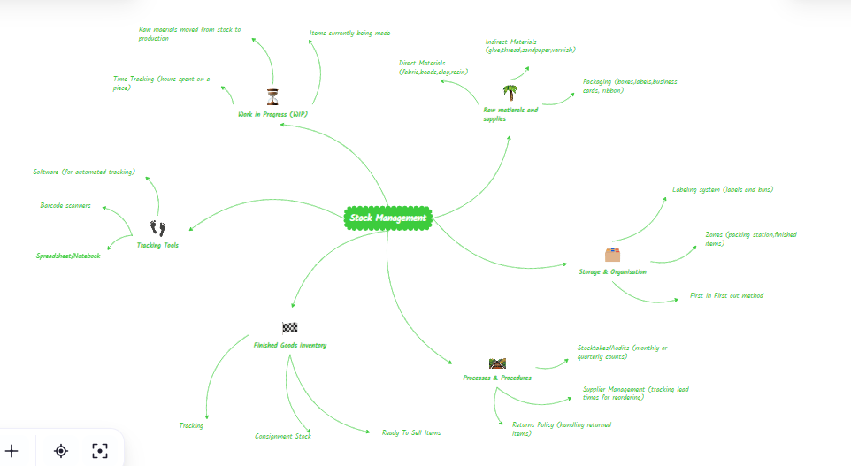
Source: https://mm.tt/map/3958766248?t=yao4jpN0Xu Created by Hamed Huffi

Task 3A:

Four Microsoft Platforms for Business Solutions

Amid the fast-moving, fiercely competitive commercial landscape, corporations are greatly reliant on software platforms [1]. These platforms improve business efficiency, strengthen communication, and improve performance. The most used platforms throughout daily operations include MS Word, MS PowerPoint, MS Excel, and MS Access [1]. This quartet forms part of the Microsoft Office Suite and functions as an important governance mechanism. They utilise and boost technological tools, skilled personnel, financial systems, administrative systems, and correspondence [1]. Each software supports many aspects of a company's operations and covers all areas. Together, the applications produce a robust all-in-one solution [1]. This helps companies adopt structured processes, leverage technology, and develop professional habits. As a result, they operate efficiently, make well-informed decisions, and maintain high professional standards [1]. In this task, I will investigate how each platform can serve as a key resource for organisations of all sizes.

Microsoft Word: The word-processing software known as MS Word was developed by Microsoft in 1983 and continues to be used by the majority as a platform solution for commercial use, and its durability was strategically planned [2]. Its working advantages provide a combination of dependability, adaptability, and high-performance software that has proven essential for institutions of all sizes [2]. In essence, MS Word delivers an effective tool for forming, amending, and administering records and files, nevertheless, the platform's prominence extends past standard document editing. In relation towards evolving organisations that rely on brief communication and well-crafted written materials, MS Word remains an essential tool [2].

Among MS Word’s key advantages is its consistent, user-friendly layout [2]. Work personnel can grasp the core concepts rapidly, cutting down the need to develop skills and helping teams to create well-crafted documents without needing a familiarisation period [2]. This level of accessibility is vital in rapid-paced workplaces where both lucidity and quick execution are priorities [2]. From preparing proposals and reports to drafting internal messages, MS Word provides a familiar workspace that assists in efficient, high-quality work [2].

Apart from its user-friendly nature, it offers sophisticated features created to strengthen professionalism and ensure uniform formatting [2]. Features such as formatting, layout, and content structure enable organisations to maintain a consistent trademark persona across every document they produce [2]. Cooperations can then develop consistent templates for documents, billing charges, conference times, and other document types, guaranteeing all communications present a consistent professional identity. Capabilities such as comments and track changes additionally improve teamwork, making it easy for team members to edit and enhance documents effectively, regardless of location [2].

Another notable advantage is its deep integration across Microsoft 365, enabling MS Word to interact easily with MS Excel, MS Outlook, MS Teams, and MS PowerPoint [2]. Such interconnectedness optimises processes, from incorporating data from MS Excel into a document, to sharing an MS Word file and working on it with other team members simultaneously [2]. As well as storing documents with confidentiality on SharePoint or OneDrive. With these connected systems, it can minimise strain and enable organisations to sustain a continuous and organised management system [2].

Given the heightened data protection demands of today’s tech-oriented world, MS Word offers advanced professional support for security solutions [2]. Built-in functions such as permission-based access, Microsoft Purview labels, and secured login information assist in preserving confidential information [2]. For sectors that manage highly sensitive information like legal and compliance services, financial services, or medical services, these attributes are fundamental to effective threat and risk mitigation [2].

MS Word’s versatility shows its lasting importance in the midst of contemporary business demands [2]. Its collaborative cloud tools, smart editing, and accessibility options support modern distributed teams [2]. The fact that it serves both small firms and multinational organisations highlights its adaptability and lasting relevance.

In conclusion, MS Word offers capabilities that go beyond simple file editing. It is an all-in-one operational platform built to strengthen teamwork, branding, information sharing and data protection [2]. Its mix of user-friendly design and sophisticated functionality establishes it as a key pillar of how professionals get work done today [2].

Microsoft PowerPoint: The presentation software known as MS PowerPoint has grown into a central, highly influential platform for delivering business presentations and communicating ideas in today’s professional world [3]. As well as MS Word, it is also part of the Microsoft 365 suite. It provides a flexible environment for designing visual presentations that aid decision-making, employee training, marketing efforts, and long-term strategic planning [3]. Its lasting importance originates from its ability to dismantle complex ideas, boost audience engagement, and integrate fluently with other business technologies [3].
Fundamentally, MS PowerPoint allows users to turn their ideas into engaging visual case studies. Organisations depend on it to showcase financial data, pitch new ideas, and map out projects. strategies, and conduct training programs [3]. The platform’s vast collection of layouts, concepts and digital creative tools enables even individuals who are not established in the design background to craft slides that appear clear and well-presented. Functions like charts, icons, SmartArt, and adaptable layouts help the platform users to present data with definition and continuity, which happens to be significant in professional domains where lucidity and a skilfully crafted presentation can have a direct impact on results [3].

Among PowerPoint's most notable advantages is its capacity to adapt, which allows it to manage visuals, media, written content, animations, and dynamic components, making it useful for both small presentations and large conferences [3]. This key versatility lets organisations modify their communication technique to serve different groups, for example, when addressing organisational groups, subscribers, and broader audiences. Using multiple media types empowers those delivering the presentation to create a more vibrant, enduring impression, which can improve how well the audience remembers the content and their involvement [3].

Joint creation for teams is an additional attribute where PowerPoint performs exceptionally well. As previously mentioned in the report above for MS Word, using Microsoft 365, team members can build reports together concurrently, share feedback, and audit every change as it happens [3]. This function is beneficial for groups spread across separate regions of the world or time zones. At times, unexpected issues may arise while working on a project, so thanks to SharePoint or OneDrive, your documents will be easy to access, kept up to date, and safely backed up in the cloud storage [3]. As long as you save your files on OneDrive or SharePoint, version history provides an additional level of protection, ensuring important changes are not lost or overwritten by mistake [3].

Another great trait of PowerPoint is its ability to boost on-stage performance. With Presenter View, performers can see their notes, track time, and preview the next slide, keeping them structured and in control [3]. Additionally, with Rehearsal Mode and embedded recording tools, it's easy to practice or record presentations whenever needed, ideal for sharing content on your own schedule. As digital sessions have become the norm, PowerPoint’s unification with Microsoft Teams supports smooth screen sharing and enhances collaborative deliberations [3]. Strategically, PowerPoint helps organisations drive normalisation and reinforce their brand identity. Custom pre-designed layouts allow businesses to embed their visual persona directly within their operations, promoting steadiness throughout the entire organisation [3]. This approach reinforces and enhances your trademark presence and visibility and improves administrative effectiveness by providing workers with established design templates.

Organisations depend on high-risk, security, as well as system reliability. Therefore, PowerPoint runs on Microsoft’s advanced security and compliance structure [3]. Security measures that are incorporated into PowerPoint, such as controlled access, password protection, and sensitivity labels, help ensure the safety of sensitive data in presentations that may contain financial records, privately held assets, or corporate strategies [3]. For instance, using Information Rights Management (IRM) lets you choose specific people or groups to view or edit materials, helping prevent forwarding, printing, or unauthorised distribution of presentations [3].

In conclusion, Microsoft PowerPoint continues to be an essential software solution for companies, as it helps organisations articulate clearly, innovatively, and effectively. Its blend of creative versatility, collaboration and alignment across the Microsoft platforms creates a vital necessity for businesses to share ideas and support decision-making [3].

Microsoft Excel: Companies rely on MS Excel because it brings together a powerful range of tools for data coordination, evaluation, and documenting in a format that is simple to work with [4]. The mesh-patterned skeleton enables businesses to easily archive and neatly arrange data for recording sales figures, overseeing stock levels, or compiling accounting reports. This adjustability enables MS Excel to support a wide range of business functions, such as human resources, marketing, finance, and operations [4].

Most of all, MS Excel is powerful because it can automate technical calculations using its formulas and functions [4]. Companies use these capabilities to lower manual tasks, prevent discrepancies, and accelerate workflows across financial planning, projections, and payroll evaluations. Formulas such as IF, IFS, VLOOKUP, and SUMIF equip operators to process data efficiently, whereas specialised tools like Pivot Table offer flexible, real-time data summaries [4]. These tools enable companies to convert core datasets into implementable intelligence that strengthens data-informed decisions [4].

Moreover, MS Excel is highly effective at visualising data. These illustration features help staff turn data into clear visual formats, such as dashboards, graphs, and data patterns, which provide key parties with clarity and accuracy [4]. Illustrated data briefs serve a crucial role in corporate domains, as decision-makers are required to analyse information swiftly and formulate long-term decisions [4].

MS Excel's capabilities are amplified when combined with the broader Microsoft 365 network. As mentioned above, with MS Word and MS PowerPoint, teams are able to work together, simultaneously distribute documents via OneDrive, and align spreadsheets directly with MS Word or MS PowerPoint [4]. This connected system increases productivity and maintains regularity throughout corporate documentation.

Despite the capacity limits of MS Excel, such as how well the software operates with exceptionally large data files, it continues to be widely relied upon in the corporate environment. The platform's combination of a user-friendly layout, logical strengths and flexible architecture equips businesses to manage day-to-day processes while also supporting strategic future planning [4].

Microsoft Access: The Windows database program known as MS Access was announced by Bill Gates in November 1992 [5]. It remains to provide an effective and efficient platform for organisations that need a unique software solution to differentiate themselves from competitors, without relying on comprehensive enterprise systems [6]. Its user-friendly design enables employees without specialised technical knowledge to develop and manage archives, while software engineers can make use of enhanced features like VBA automation, SQL queries, and customised configurations. Because it offers clarity as well as detail, MS Access works well for many operational requirements, such as stock control, Customer Relationship Management (CRM), Human Resources datasets, and finance [5].

One of its key strengths, most evident in the UK, where Microsoft platforms are widely used, is MS Access's effortless compatibility amid the broader Microsoft environment [5]. MS Access supports MS Excel imports, SharePoint-linked tables, and email-driven automation via Outlook, helping businesses simplify operations within their existing Microsoft environment [6].

The most recent update to MS Access 2024 brings new abilities that make the software even more beneficial for organisations [7]. With features like the Dataverse Connector, Large Address Aware memory improvements, and expanded table and connection capacity, it enables companies to expand their solutions and connect directly with cloud platforms such as Microsoft Teams and Power Apps [7]. Together, these enhancements elevate MS Access past traditional desktop software to a modern cloud-connected solution [7].

This shows that MS Access provides an appealing mix of affordability, flexibility, and fast development for small to mid-sized businesses [6]. It may not be suited for heavy-duty, advanced corporate settings, but it's still a great fit for companies that want a versatile, scalable, and affordable data-handling solution.

In conclusion, MS Word provides writers with effective tools to create organised documents that are effective for communication and documentation [1]. MS PowerPoint helps organisations create compelling presentations that support pitches and training sessions. MS Excel presents capable, systematic tools that assist in making data-driven decisions [1]. And finally, MS Access manages formatted data and gives custom database management systems built to support fundamental business processes [1].

Task 3B:

Test any two features
Mail Merage:
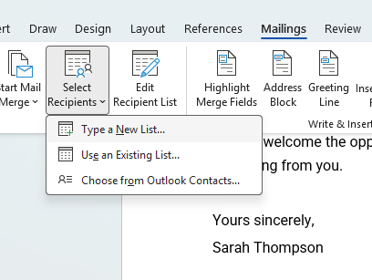
- After writing your letter, the first step is selecting the recipients. Click select recipients to choose existing contacts or create a new list.
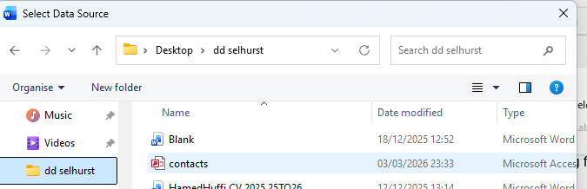
- I’ve selected use existing contacts.
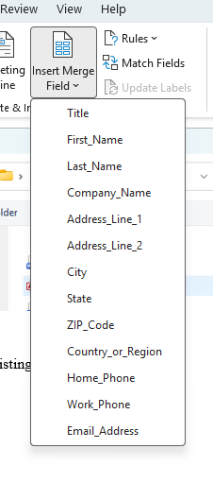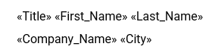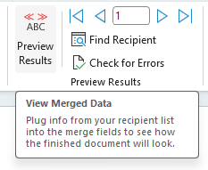
- Then click on insert merge field, and it will allow you to enter your recipients' details in the format you want. By clicking the preview results tab, you can see how it will look before sending.

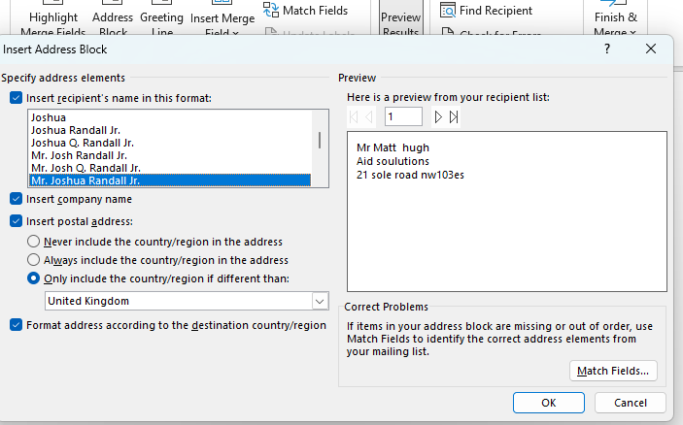
- You can also preview how your recipient's details will look by clicking address book, ensuring your format is correct for your country.
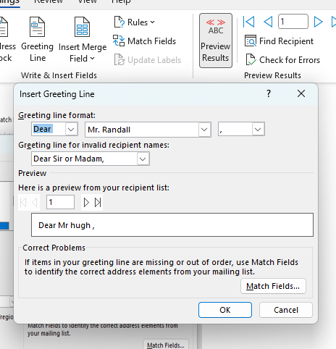
- Also, by selecting the Greeting line, you can edit how your salutation appears.

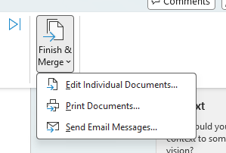
- Then, after you’ve completed editing your letter and merging, select finish & merge. It will give you the option to print your document or send it via email. You can also preview all letters (docs) by selecting edit individual documents.

If Function:
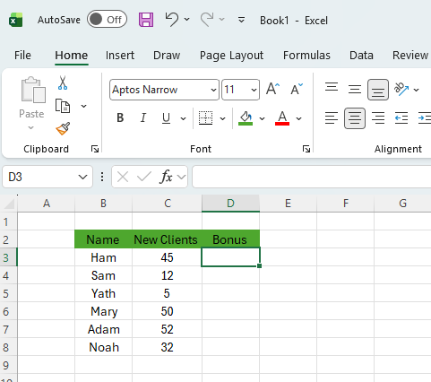
- Set up your data.
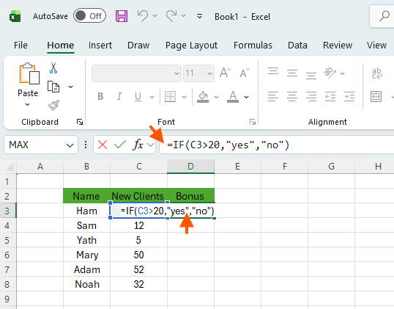
- Type the IF formula.
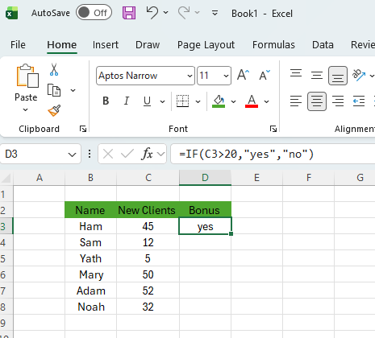
- Press Enter to see results.

Task 4A:

One Contemporary Communication Application and One Online Collaboration Tool

My chosen contemporary communication application is MS Teams.
As hybrid and fully remote setups become the common way of communicating with colleagues, MS Teams has evolved into a go-to platform for coordinated communication, helping businesses work better together, share information easily, and boost productivity across regional teams [1]. MS Teams brings together chats, virtual meetings, document sharing, and task management tools, creating a single gateway for workplace collaboration [1]. Its efficient utilisation across sectors shows a clear move toward flexible, effective and live interactive teamwork.

A major asset of MS Teams is its ability to bring communication portals together in one place. In the past, organisations had to manage communication through separate, unconnected tools, such as email, telephone, network-shared folders, or face-to-face meetings [1]. MS Teams brings these channels together in one digital solution, removing the hassle of switching between apps. The MS Teams chat feature can be used to communicate privately or in groups, helping groups make decisions rapidly and converse informally. Communicating portals in MS Teams enable departments to sort discussions by category, making documentation or subjects easy to find and neatly organised, instead of getting lost in endless email conversations [1].

Virtual meetings are now a fundamental part of current organisations, especially as hybrid and fully remote work arrangements become more common [2]. MS Teams brings together high-definition video conferencing, effortless display sharing, and a range of tools, including Transcription, Live Captions, Breakout Rooms, and Meeting Recordings. These features help mimic the experience of meeting in person while also offering the extra benefits that only digital environments can provide [2]. For international companies, connecting employees wherever they are helps maintain operational stability and lowers travel expenses.

MS Teams also stands out for how well it links with other Microsoft 365 platforms. Individuals can edit documents simultaneously on MS Word, MS Excel, and MS PowerPoint while remaining in MS Teams. Also, thanks to OneDrive and SharePoint, your documents stay protected, saved, and accessible to multiple users [2]. This unified process prevents repeated work, helps manage versions of the file more effectively, and enables groups to manage projects in a versatile way. The platform also supports external applications and custom add-ins, enabling organisations to tailor it to their precise business needs [2].

In today’s working conditions, safe and regulated communication is essential. MS Teams has established a proven corporate-level security defence, with features such as data protection, strong identity shielding, and compliance-ready infrastructure (including GDPR), which helps to make sure these measures meet the expectations of sectors handling sensitive data [2]. These defence features have made MS Teams a popular choice across industries such as finance, healthcare, and government.
Even with its strong advantages, MS Teams is not free from limitations [2]. Several users who use the platform have flagged that nonstop notifications leave them feeling swamped, and others say managing a high volume of streams and files can leave the screen flooded. So, getting the platform up and running effectively requires detailed company guidelines and system training to guarantee that the platform improves performance instead of slowing it down [2].
All things considered, MS Teams has positioned itself as a leading platform in contemporary business communication. By bringing together chat, meetings and teamwork tools into a single unified system, it adapts to what modern companies require and makes working together easier, more flexible, and more efficient [2]. As organisations become more digitally driven, MS Teams is expected to remain an essential platform in the evolution of workplace communication.

The tool I chose for online collaboration is Google Workspace.
Google Workspace is a suite of cloud tools that brings together a range of services to help companies and individuals work and collaborate effectively [3]. Tools such as Gmail, Google Drive, Google Meet, Google Chat, Google Docs, Google Sheets, Google Slides, Google Forms, Google Keep, Google Vids, Google Tasks, NotebookLM, AppSheet, and Gemini form a single combined system that enables collaboration, communication, storage, project management and security [3]. As contemporary work environments continue to adopt cloud-based collaboration, Google Workspace has become a primary platform for teams to work together from different locations and devices.

A distinguishing attribute of Google Workspace is how easily it lets people work together in real time. Tools such as Google Sheets, Google Docs, and Google Slides enable multiple collaborators to work on the same file concurrently, with instant updates visible to all participants [3]. Collaboration capabilities like suggestions, comments, version history and chat make teamwork faster and cut out the need for lengthy email exchanges. Working on a document together in real time helps remote teams to administer promptly and productively [3].

The Google Workspace suite also thrives when it comes to cloud storage capabilities, making documents accessible from any internet-connected device. This prevents your data from being lost if something goes wrong and allows all team members to access the most current document. You can alter access consents so that only chosen members can edit or view the file, making it safe to collaborate with coworkers as well as outside contributors [3].

Communication features in Google Workspace improve teamwork. For instance, Gmail continues to be the most popular email platform used internationally, and connects conveniently with Google Meet, Google Calendar, and Google Tasks [3]. Services such as Google Meet offer high-definition video calls with features like screen sharing, live captions, and breakout rooms, making online meetings more engaging and easier to navigate [3]. Features like Google Chat and Google Spaces assist in keeping teams organised and connected through communication, project deliberations, and document distribution [3].

A key part of Google Workspace’s proficiency is driven by security tools and system controls. Access control, security regulations, and data safety can all be managed by companies through features such as encryption, 2-step verification, and endpoint management [3]. These measures ensure the platform is fit for use by companies, educational institutes, and government departments that handle sensitive information [3].

To conclude, Google Workspace delivers a versatile, user-friendly suite for collaboration. By bringing together co-editing, cloud backup storage, integrated ways to communicate, and solid security measures, it establishes itself as an effective suite for contemporary teams to work together [3]. As versatile work models become the norm for most companies, demand for effective collaboration solutions is increasing. Google Workspace maintains its position for supporting efficient digital teamwork [3].

Task 4B:

Test one feature of a communication and collaboration tool
(MS Teams) Starting a new chat:
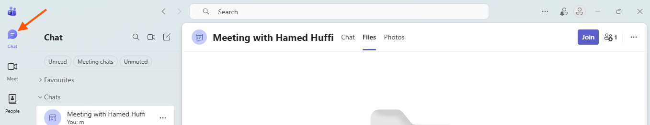
1) Open the chat section.

2) Click the new message button.
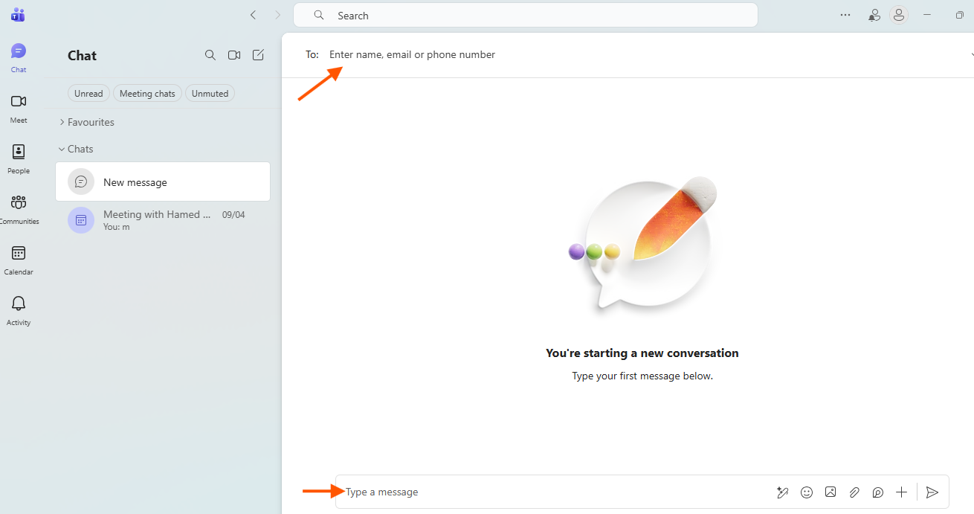
3) Add the person you want to chat with and type your message below.
(Google Workspace) Using comments on Google Docs for feedback:
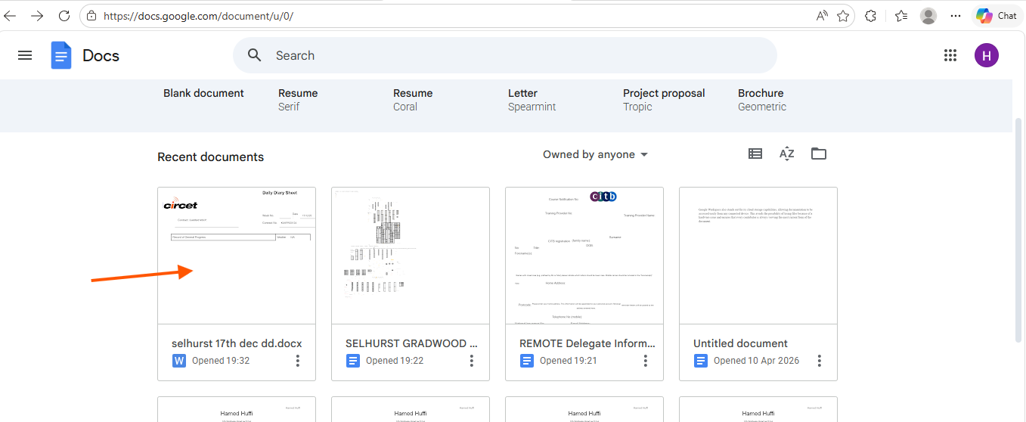
1) Open a document on Google Docs
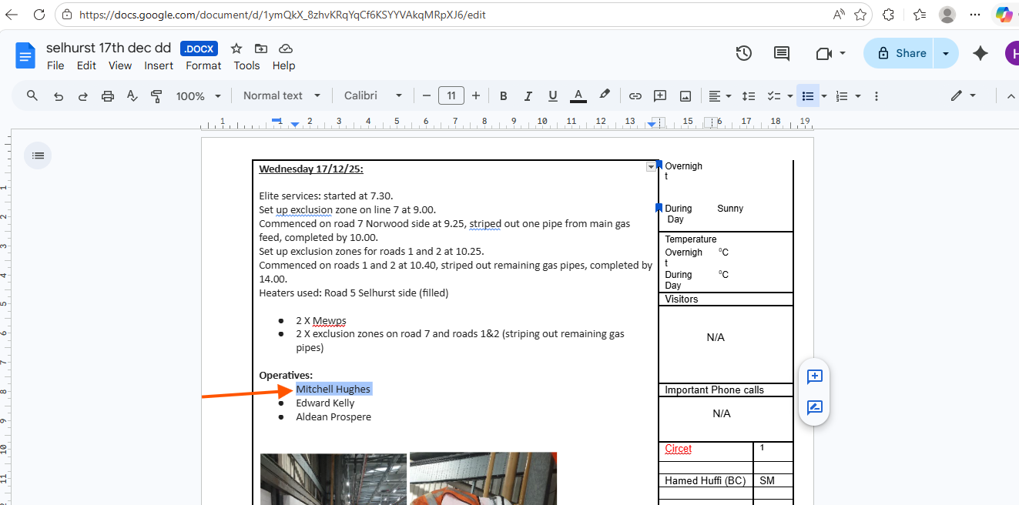
2) Highlight the text you want to comment on.
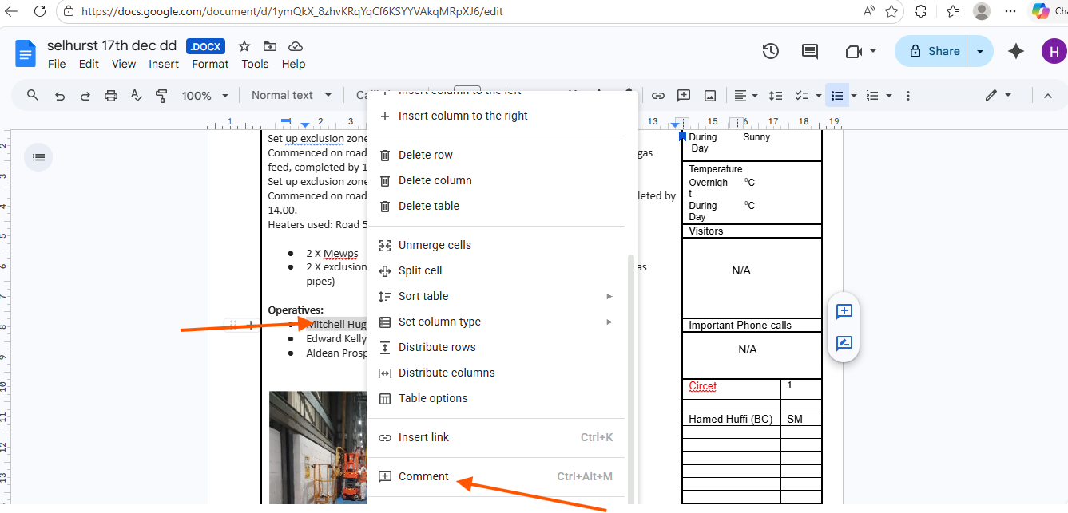
3) Right-click on the highlighted text and select comment (or use shortcut Ctrl+Alt+M)
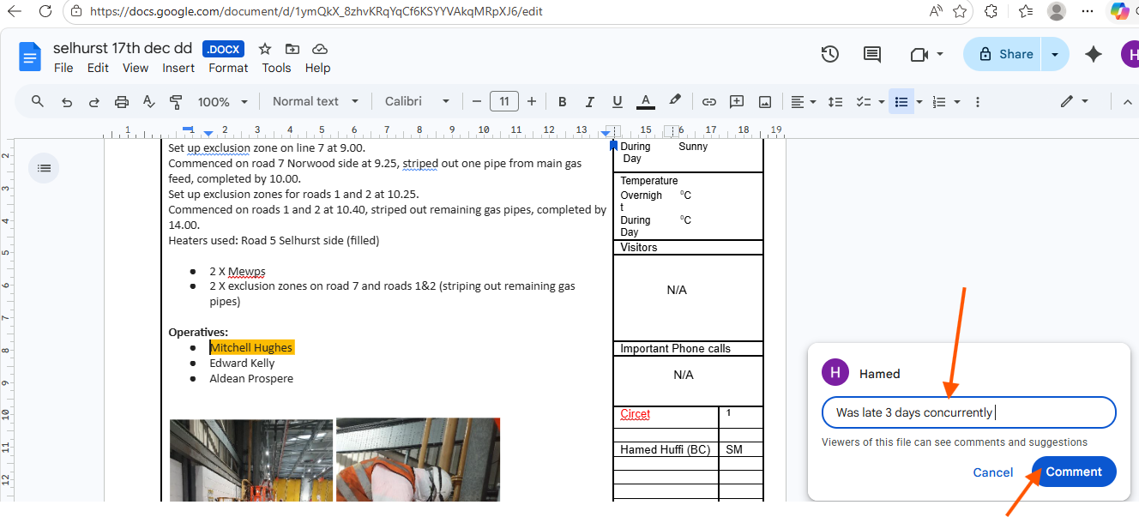
4) Type your comment in the box that appears on the right side of the document, then click the comment button to post.

Conclusion:
In conclusion, I have learned which skills, applications, and online platforms help achieve business success.

References:

Task 1 references:
[1] | L. A. L. Sandbrook, “Digitalization – How to implement a cost-effective digital platfrom,” Devlin Wholesale, 2024.
[2] | P. Costa and H. Rodrigues, “The ever-changing business of e-commerce-net benefits while designing a new platform for small companies,” Review of Managerial Science, vol. 18, no. 10.1007/s11846-023-00681-6, pp. 2507-2545, 2024.
[3] | C. Huriavi, “Obstacles and Attitudes that Small and Medium Businesses have Towards Website Development,” Radford University , Radford , 2025.
[4] | P. Waddy, Shopify for Dummies, New Jersey : Jhon Wiley and Sons, 2022.

Task 2A references:
[1] T. Buzan and B. Buzan,The mind map book, Pearson Education, 2006.
[2] T. Buzan, Mind map mastery: The complete guide to learning and using the most powerful thinking tool in the universe, Jaico Publishing House, 2024.
[3] M. X. Guo, Data Analysis for Business Students: A Mind-mapping Approach, Taylor & Francis, 2025.

Task 3A references:
[1] Open Stax, OpenStaOpenStax and OpenStaxOpenStax, "Workplace Software and Skills." Accessed: 6/04 2026. [Online]. Available: https://openstax.org/books/workplace-software-skills
[2] K. G. Isangula, S. Kelly and J. Wamoyi, "Manual qualitative data coding using MS word for students and early career researchers in resource-constrained settings," vol. 23, pp.16094069241299223, 2024,
[3] M. Hasanah, M. Rahmatullah and M. Fazrin, "The Influence of Using Microsoft PowerPoint Learning Media on Learning Outcomes in Business Law Courses," vol. 5, no. 1, pp.568761,
[4] B. M. Ojonugwa, O. K. Chima, O. J. Ezeilo, S. O. Ikponmwoba, A. Ochefu and M. O. Adesuyi, "Integrated Business Performance Monitoring Models Using Excel-Based Dashboards and Manual Controls,"
[5] Diana Miller. "Microsoft Access 2024: Is It Still Relevant for Databases?" Medium. Accessed: 5/04 2026. [Online]. Available: https://medium.com/@dianamiller574/microsoft-access-2024-is-it-still-relevant-for-databases-46c5dfbfd807
[6] H. Ihsan, F. Surya, E. Eliyanora and N. Hafizah, "A Digital Transformation in Waqf Management: Leveraging Microsoft Access for Financial Accountability," vol. 7, no. 11, pp.10.37502, 2024,
[7] "What’s new in Access for Microsoft 365
T2." Accessed: 5/04 2026. [Online]. Available: https://support.microsoft.com/en-gb/office/what-s-new-in-access-for-microsoft-365-76454345-f85d-47af-ace1-98a456cb3496

Task 4A references:
[1] M. Singh and R. Jangra,Digital Leadership: Integrating Technology for Organizational Success, CRC Press, 2025.
[2] B. A. Chaushi, M. Nastovska and T. Veseli-Kurtishi, "MS Teams for Virtual Collaboration-An Overview," 2024,
[3] A. Pahayahay, "Enhancing collaboration through Google Workspace: Assessing and strengthening current practices," 2025,

