Daniel Davies
2000224
Material Science and Building Services
Construction Materials

Contents
Chapter 1
  - Introduction……………………………………………………………………….……3
  - Methodology………………………………………………………………….……….3
Chapter 2 – Durability and climactic resistance
2.1- Forces……………………………………………………………………………………….4
2.2- Moisture……………………………………………………………………………………5
2.3- Safety………………………………………………………………………………………..5
Chapter 3 – Environmental impact
3.1- General……………………………………………………………………..………………6
3.2- Comparing the two material’s impact……………………..………………..6
Chapter 4 – Ease of assembly…………………………………………………………..8
Chapter 5- Conclusion…………………………………………….………………………10
Chapter 6- References…………………………………………………..……………….11

Chapter 1
Introduction
The concrete frame building I have chosen to study is the Rudolph Hall, located in New Haven, Connecticut. At seven stories high and 114,000 square feet, the building is one of the most famous concrete builds in the world. The Rudolph Hall building was designed by Paul Rudolph and completed in 1963. It was used as study hall for art/architecture students at Yale.
The Steel frame building I’ll be comparing It to is Taipei 101, found in Taipei, Taiwan. It stands at 1,667 feet high with 101 floors above ground making it currently the 10th biggest building in the world. After being designed by C.Y. Lee & Partners It was completed in 2004.
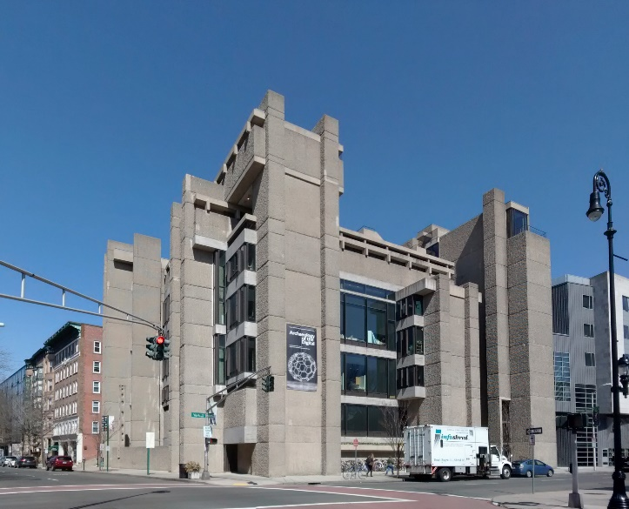

D.Deaeth (2019) J. Mairs (2014)
I will be comparing and contrasting the two different frame materials through looking at these two buildings and the impact that their frame has on the durability of the building, impact on the environment and the ease of construction.
Methodology
Both steel and concrete framed buildings a very popular in today’s construction industry. Steel is generally the more frequently used material so in this assignment where I compare and contrast the both materials properties and uses as building frames in order to see why that is. I believe I’ve chosen two buildings that accurately represent what each material is used best for in construction. Steel is a massively popular framing system for large builds such as the Taipei 101 tower and the Rudolph Hall is a typical concrete landmark with rich textures.
Chapter 2
Durability and climatic resistance
2.1- Forces
Rudolph Hall is located 2km away from the coast in Connecticut, which is prone to strong winds. Grey House publishing states, “coastal storms or “northeasters” are the most serious weather hazard in Connecticut. They generate very strong winds”. Reinforced concrete frames are an excellent way to combat this. J. Madsen says that Because of concrete’s weight and strength ”buildings constructed with cast-in-place reinforced concrete can resist winds of more than 200 miles per hour”.
Similarly to Connecticut, Taiwan also receives strong winds. These strong winds are produced by the typhoons that are present from June to October in Taiwan. Again this means that there are large horizontal forces acting on the massive building. The steel frame is more ductile to a reinforced concrete frame meaning the building can sway more in the winds without the frame giving way.
Furthermore, Taiwan sits close to the Eurasian/ Philippine sea plate boundary causing many earthquakes in the area. Earthquakes can make large buildings such as Taipei 101 sway massively meaning that the ductility of the structure is key.
Figure 1
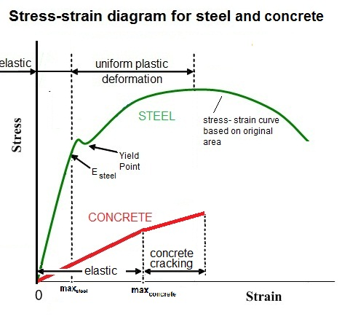
Figure 1 shows how steel can endure more force elastically and would take a lot more stress, in this case wind force before the material snaps. Concrete is a brittle material as is snaps before any real deformation is present. This means that for tall sky scrapers such as Taipei 101 steel is a lot more suitable in extreme winds as the top of the building can often sway away from the bottom. According to M. Higgins “about once a year, a 50-mile-per-hour wind comes up, moving a tower of this size about half a foot”.

2.2- Moisture
Taipei 101 is located in north Taiwan which has a subtropical climate and as mentioned, this brings typhoons to the area in the summer and early autumn. Typhoons cause a lot of rain to fall in a short period of time and so, while rain does not fall often during the year, during typhoon season large amounts of precipitation are present. Taiwan’s annual rainfall is around 2600mm. So although steel may be a suitable framing material for the forces acting on the structure, moisture wise steel isn’t the best option due to the corrosion of steel. When steel comes into contact with water, the iron in the steel is oxidised and produces rust, ultimately weakening the structure.
During January the average temperature in Connecticut is -3̊C this means frost can easily accumulate on the structure. As the water turns to ice, expanding around 10% the concrete can start cracking or spalling, this is called frost attack. With the ample of ice it is crucial that the concrete is impermeable to water so that water does not expand in the concrete and result in weakening of the structure and also so that the water does not reach the steel causing corrosion. Unlike the steel structure in the Taipei 101 tower, the concrete will not corrode.
2.3- Safety
In the case of a fire, concrete is the superior material. “It can endure very high temperatures from fire for a long time without loss of structural integrity,” says Alfred G.

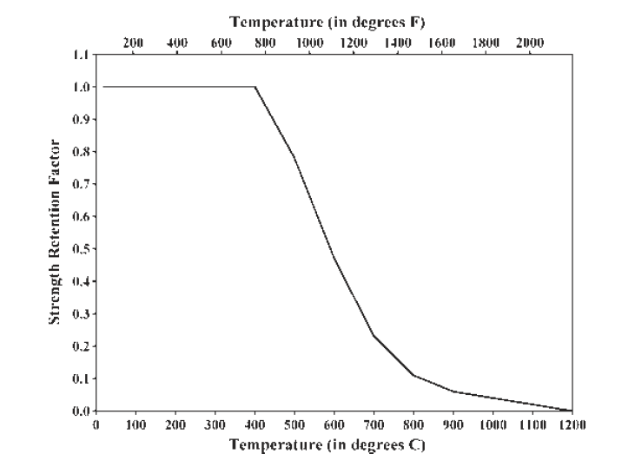
Figure 2
The average temperature of a building fire is around 600 degrees Celsius and as seen in figure 2, by the time this temperature is reached the steel has only retained roughly half it’s strength which would lead to serious structural damage.

Concrete on the other hand while at 600 degrees Celsius is not performing at its peak capacity does not loose nearly as much strength as steel.
None of the two environments are more prone to fires but concrete does preform better in extreme heat. A steel frame would require extra fire resistance which would add to the already expensive frame type.
Chapter 3
Environmental impact
3.1- General
The construction industry plays a massive role in global warming.
Generally, steel is considered “better” environmentally speaking because of the rate at which the steel used in construction is recycled although it very close and neither concrete or steel are very good for the environment.
3.2- Comparing the two material’s impact
Concrete is responsible for 8% of the worlds CO2 emissions. The production of cement is the reason for the high rate of CO2 produced in the production of concrete. When cement is made, the process of calcination produces CO2. 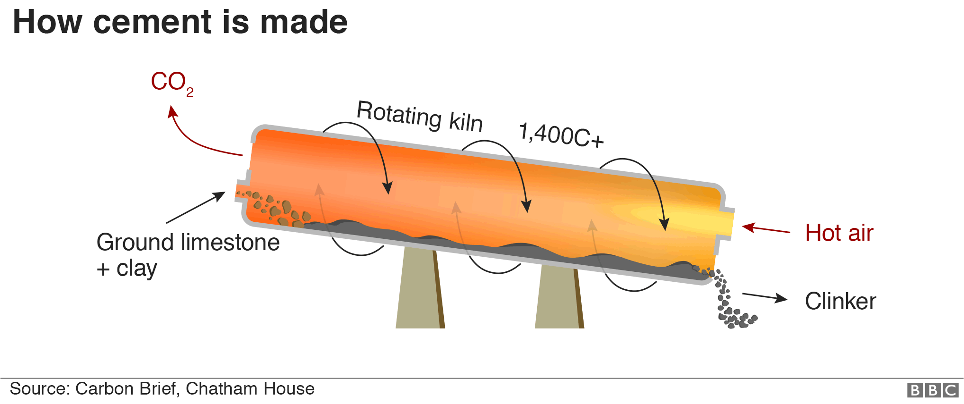

CO2 is produced in the production of steel when the interaction between carbon and iron ore in the blast furnace.

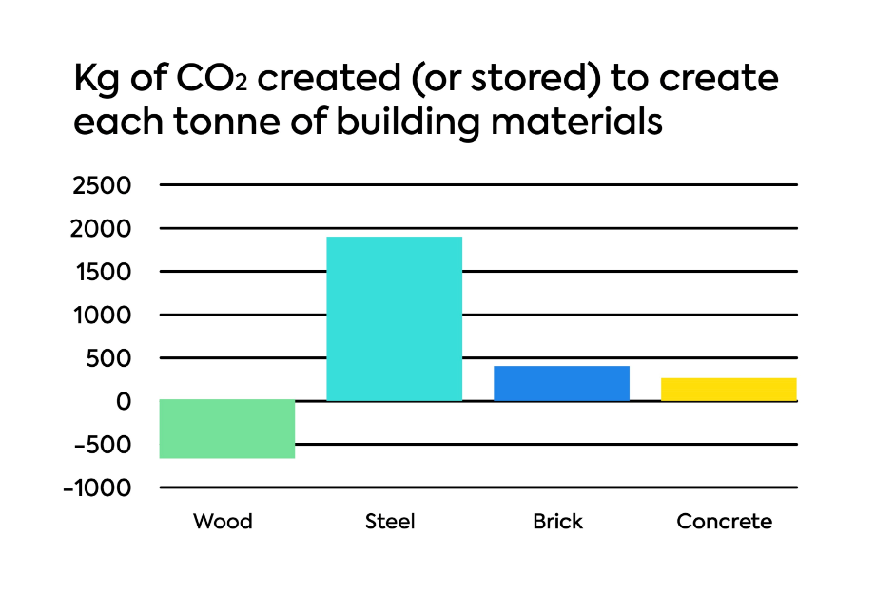
Figure 3

Figure 3 shows how much CO2 is created to create each tonne of building materials. It is clear to see that per tonne steel is by far creating more CO2 which is damaging to the environment because as proved in many case studies, CO2 has a direct correlation to the raise in the temperature of the earth, thus enabling global warming. While at first glance it seems that steel would be far inferior to concrete in helping reduce the carbon footprint produced by a large construction project such as the Rudolph Hall or Taipei 101 tower, when the weight of concrete compared to steel per m2 of the build is analysed it evens out as concrete is far heavier than steel and a larger volume of concrete is needed to steel.
So while concrete is often sourced locally, reducing travel miles. The overall production of CO2 is considered to be slightly more than that of steel.
Taipei 101 is located in China, the world’s largest producer of CO2. So despite steel being recyclable in construction, the question could be asked whether the material in this particular project would be recycled.

Chapter 4
Ease of Assembly
This is the area where steel is seen to have a large advantage over concrete.
While concrete framed buildings can be assembled faster because of the less complex frame designs, in some cases a as much as a whole story can go up in a day or two, steel does have it’s advantages. Steel is easier to plan around. When trying to work around a schedule, steel is the superior faring material. Because steel frames are prefabricated it means that a greater quality can be achieved with less time spent being made on site. In the case of a concrete framed building, the frame is not prefabricated but made on site meaning that any imperfections that are seen with the frame need to be sorted on site, thus costing time and therefore money as appose to steel frames that can be worked on for longer periods of time without sitting on site and costing a lot of money.
Steel frames are seen as the future of frames in construction as the amount of buildings being built out of steel frames are rising quickly. As advancements in building modelling have been made, the design of the steel frames have improved thus making for more reliable builds.
Steel is fairly simple to assemble because of the complex tools that can be used off site to weld the steel into the preferred structure. To contrast, concrete has many factors that effect the end product such as the amount of cement compared to that of water, the use of admixtures and the different aggregates.
When assembling a concrete frame a big problem in many cases is that concrete has a bad workability. Concrete is placed into a mould on site and then hardens. As mentioned concrete has many factors that effect the properties of that frame. One of these being the gradation of the aggregate. Aggregates come in different sizes and it’s important that the correct type of aggregate is used to ensure acceptable workability. An aggregate that is too coarse could lead to segregation and therefore disrupting the flow of concrete which weakens the structure as can be seen in figure 4.
Figure 4
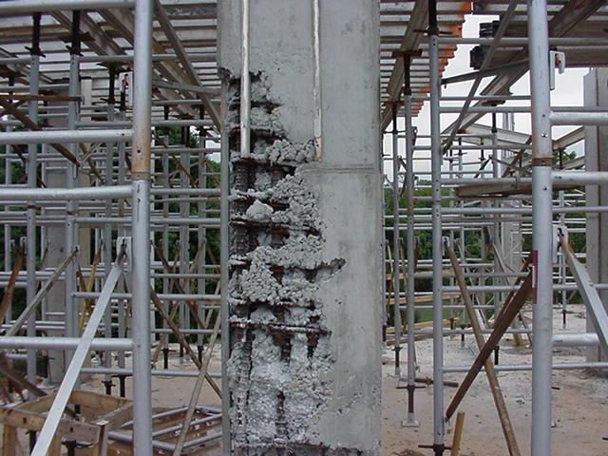

Green Spec claims, Coarse aggregates are particulates that are greater than 4.75mm. Coarse aggregates are a lot more common in construction with most construction projects using an aggregate of around 20mm. Although fine aggregates such as sand are important to lock the larger aggregates together.
Through my research I’ve also been able to gather that steel is preferred when working on unique designs. Because steel has a very good strength to weight ratio there are far less limitations when it comes to large heights and open spans.

Chapter 5
Conclusion
Through researching into concrete and steel frames in the construction industry I have read many arguments on the pros and cons of using either material.
While concrete seems to be the more safe material to build in, with it’s heavy resistance to fires and strong winds, It appears that steel is more advantages in areas such as strength and ease of assembly.
The most common point I kept coming back to through my research was that steel frames are the future of construction. C. Simmons claims “It is getting more and more common for steel to be used in construction, and people are preferring steel due to its various advantages” This could be because steel has a huge benefit of being able to be crafted off site which means it does not need to take up time and space on the site. Programming is a massive part for a building contractor to win work at the tender stage so reducing the time of construction would be seen as key element for the client. Thus meaning more and more steel framed buildings are rising across the world.
Being that steel framed buildings are becoming more popular, that could be a factor of why the concrete fame building is the older of the two that I’ve researched, being built in 1963 and Taipei 101 being built in 2004. That isn’t to say that concrete frame builds don’t have their purpose, as for in the case of the Rudolph hall where the winds can be very strong all year round, the solid and heavy nature of the building means that is less prone to any movement which could result in collapse.

Chapter 5
References
D.Deaeth (2019) Image of Taipei 101
J. Mairs (2014) Image of Rudolph Hall
Grey House Publishing (2001) Overview of climate in Connecticut.
J. Madsen (2005) Which is the better building material? Concrete or Steel?
O-lay. Stress-Strain diagram for steel and concrete (Figure 1)
Alfred G (2005) Which is the better building material? Concrete or Steel?
M. Higgins (2015) Keeping Skyscrapers from blowing in the wind
Vertex (2018) Steel strength retension diagram with respect to temperature ( Figure 2)
Citu. Kg of CO2 created to create each tonne of building materials (Fgure 3)
Green Spec. Aggregates for concrete
C. Simmons (2016) 3 common types of steel building constructions

