A Critical analysis of mental health within south wales police
The rise and fall of mental health absence throughout the pandemic

Author: 2005385

University of Wales Trinity Saint David
Date: 5th October 2021
Word Count: 7,359

Acknowledgements
I would like to thank South Wales Police for allowing this research project to take place and for the use of the data throughout the report. To Human Resources Business Partner, Lesley Davies, for all the advice and guidance provided during this time even up against an increasing workload. Sharon Atkins, who has gone through this report and helped with structuring, rewording and reminding me to complete the half sentences left. My friends and family for bearing with me whilst I went silent completing this project and to my partner who has encouraged me, picked me up when my confidence was down and when my motivation was lacking reminded me to keep going.
Thank you all for your support and guidance.

Contents
Acknowledgements 1
Abstract 4
1.0 Introduction 4
2.0 Literature Review 8
2.1 What is mental health 8
2.2 Impact of mental health at work 8
2.3 The impact that Covid-19 has had on Mental Health 9
2.4 How have companies tried to overcome mental health 10
2.5 Training and Management of Mental Health 11
2.6 Summary 11
3.0 Methodology 12
3.1 Research report aim and objectives 12
3.2 Research onion 12
3.3 Chosen research methodology 13
3.4 How your research participants were chosen 15
3.5 Reliability, validity and research limitations 16
3.5.1 Reliability 16
3.5.2 Validity 16
3.5.3 Research Limitations 17
3.6 How the research data was analysed 18
4.0 Results and analysis 19
4.1 Understanding mental health 19
4.2 Where to get advice 22
4.3 Themes found throughout the responses 23
4.3.1 Resourcing 24
4.3.2 Ways of working 24
4.3.3 Training 25
4.3.4 Support 25
4.4 Staff vs Officers 26
4.5 Review of Findings 28
5.0 Conclusion 28
6.0 Recommendations 29
Recommendation 1: Training for line managers and employees 29
Recommendation 2: Raising awareness and removing the stigma through accessible conversations with Occupational Health 29
Recommendation 3: Better promotion of the resources available 30
Recommendation 4: Additional resources – occupational specialist’s experts 30
7.0 Reference List 31
Bibliography 35
8.0 Review of personal learning 35
9.0 Appendices 36

Table of Figures
Figure 1 - Total Daily Sickness by Date from the 1st January 2019 to July 2021 for South Wales Police 5
Figure 2 - Absence rates across South Wales Police 5
Figure 3 - Total daily sickness by date for the whole of South Wales Police 6
Figure 4 - Total daily sickness by date for Operational Support Services 7
Figure 5 - CIPD Employee Outlook 2016, Work-life balance at work 9
Figure 6 - Research Onion, Mark Saunders, Philip Lewis and Adrian Thornhill., 2018 12
Figure 7 - What do you believe to be the top absence in SWP pre-covid? 18
Figure 8 - What do you believe to be the main reason for absence during the height of the Covid-19 pandemic? 19
Figure 9 - What do you believe to be the main reason for absence during the Covid-19 recovery? 19
Figure 10 - What conditions do you feel are considered under the umbrella term of mental health absence? 20
Figure 11 - Where do you find the advice? 21
Figure 12 - Themes that run through the questionnaire summarised in Q17 22

Table of Table
Table 1 - The advantages and disadvantages of data collection methods 12

Abstract
This research paper is a view into South Wales Police’s difficulties with absence rates especially within the category of mental health and how the coronavirus pandemic has impacted it. It looks at what other organisations have done to combat mental health and any themes that have emerged from the results found through the questionnaire that was sent to a specific area of South Wales Police (represented by both staff and officers). It reveals the common themes that line managers struggle with on a daily basis, such as training and support. With the intentions of how best to further improve the confidence of line managers and giving them the opportunity to manage their teams to the best of their ability. Lastly, is the exploration of recommendations that will look to enhance the mental health support within South Wales Police with the aim of decreasing the absence rates.

1.0 Introduction
“The people who together make up Team SWP have shown resilience, responsiveness and compassion; whether working from their homes or on the street, they have stepped-up.” (Matt Jukes, Centre for Army Leadership p33 2020)
These are the words from the Former Chief Constable of South Wales Police, it shows the dedication to the public and the support for each team. However, recent organisational data shows that absence has risen, this follows a dramatic fall at the start of the pandemic.
South Wales Police had 264 staff and officers absent at the start of January 2019, 269 on January 2020 and 283 in January 2021 with the cost of the lost amount of days worked potentially costing the force hundreds of thousands of pounds of public money, which could have been used for resourcing events and responding to calls in an adequate and efficient time. The Observer Special Reports (2011) published the Comparative tables for the 43 forces where South Wales Police came in at 43rd. It has been something that the Human Resources department has been working with the departments on, they have brought in further initiates for flexible and agile working and better signposting to support networks and training.
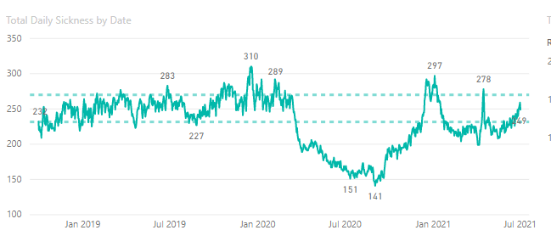
Figure 1 - Total Daily Sickness by Date from the 1st January 2019 to July 2021 for South Wales Police (screenshot from the BI Tool)
As can be seen from this graph there is a dramatic dip in the absence data that coincides with the start of the pandemic. Figure 2 reveals that the leading factor of absence rates across the whole of South Wales Police is Mental Health.
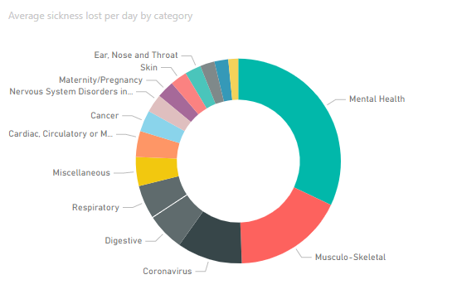
Figure 2 - Absence rates across South Wales Police (screenshot from the BI Tool)
Even with mental health absence there was a significant dip throughout the pandemic period which has started to rise to similar rates to pre-covid. Again, the question asked is why is there an increase? Figure 3 below reflects the whole of South Wales Police, with only the mental health absence category selected.
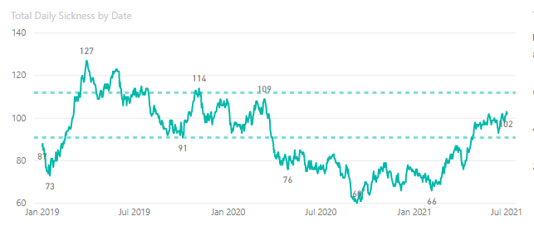
Figure 3 - Total daily mental health absence for the whole of South Wales Police (screenshot from the BI Tool)
South Wales Police has several different places to gain the information and guidance from. Occupational Health, which has its own mental health nurse and an FMA, counsellors and also a 24/7 counselling helpline which can be accessed by all staff and officers. There are hints and tips within the force intranet (BOB) which also provides guidance and adjustments ideas to those that are looking for assistance within their line managerial roles. The force also adopted the assistance of Blue Light Champions which were trained through the MIND charity campaign.
In order to build on this organisational data and the trends seen, this research project will look to concentrate on a specific area of South Wales Police, Operational Support Services (OSS). Chief Officers and Senior Management are aware of the trend but not the reasoning behind it or the learning that comes from it and so have consented to this report and the research that entails it to gain further knowledge and understanding.
This department is made up of 439 staff and 790 officers and has a current rate of just over 35% for mental health related absences and follows the trends of the whole force as can be seen in figure 4 below.
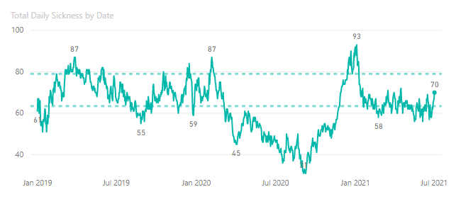
Figure 4 - Total daily sickness by date for Operational Support Services (screenshot from the BI Tool)
This aim of this report is to critically analyse the rise and fall of mental health absence throughout the pandemic within South Wales Police.
The objectives are as follows:
- Explore and critically analyse the literature around possible causes of absence rate changes pre and post Covid, including the impacts of line manager support and training around mental health.
- Design and implement an appropriate method of data collection to further enhance the resources that are already in place
- Collate and analyse results to reveal any themes felt by those that have responded
- Provide recommendations and an action plan on the best practice in managing mental health within South Wales Police
This report is structured into five chapters, chapter 1 is the introduction and an explanation of why this report is being undertaken. Chapter 2 is the literature review; this is an exploration of research that has been gathered by other author and organisations. The third chapter is the how and why the method of data gathering was decided. Chapter 4 is the reveal of the data gathered and analysed. With chapter 5 and 6 summarising the report with recommendations for South Wales Police.

2.0 Literature Review

2.1 What is mental health
Mental Health has been defined as a problem that has been experienced by individuals which affects their emotions, thoughts and behaviour causing a negative effect on their life or their families which is outside of the normal behaviour (Patel and Hanlon 2018). Which is in turn supported by MIND, a charity for those struggling with their mental health, who define it as how an individual feels, thinks and acts. However, MIND take their definition to a different level to Patel and Hanlon and follow the arguments from Keyes (2002; Westerhof and Keyes 2009) who states that this is a combination of emotional, psychological and social well-being which introduces mental health positivity, impacting on all individuals. Highlighting the need for all employers to understand their employee’s mental health.
As the TUC highlighted in their 2018 report for Mental Health and the workplace, there is now a differentiation of mental conditions, the common mental health issues such as, anxiety and depression and the more severe mental health conditions, relating to psychosis and bipolar disorder. It is to be noted that “work-related stress” is not a mental health condition but entwines individually or together with anxiety and depression (ACAS, 2021a). The World Health Organisation (2021a) recorded that the cost on the global economy is US $1 trillion each year in productivity.

2.2 Impact of mental health at work
CIPD in their collaborating work with MIND in 2018 found that many workers are suffering with their mental health in silence, with 48% out of 40,000 participants stated that they were experiencing some form of this (CIPD and MIND, 2018). Falling in the line with the CIPD’s Employee Outlook 2016, found that 53% of individuals suffered with poor mental health because of both home and work issues, with only 34% believing that they had the right work-life balance (figure 5).

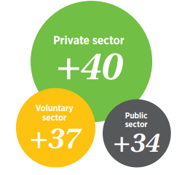
Figure 5 - CIPD Employee Outlook 2016, Work-life balance at work
Like so many things, mental health can be affected by areas such as social circumstances, environmental and also individual characteristics (TUC, 2018).
Within the paper by Johnson et al, they discovered through their own research using the ASSET stress questionnaire, that those within the public sector such as teachers, ambulance and police scored as most stressed under physical and psychological and for having the lowest job satisfaction. This is due to the untoward demand that the skills for these jobs involve the emotional lies and the physical toll of the safety of the communities around them. The world has certainly grown not only in population but also through the complications of protecting the communities, something that South Wales Police and all other emergency services have felt throughout the last decades, from 9/11, 7/7 to the increase of drugs and criminality (LaFree, 2012).
With ever increasing mental health illness, stresses and difficult work-life balance there is the question surrounding what more can South Wales Police do to assist in those in emergency services roles.

2.3 The impact that Covid-19 has had on Mental Health
The World Health Organisation (2021b) stated that fear, worry and stress is a common response to when individuals are faced with a perceived or real threat. The Government publications on Health and Wellbeing (2021) also found through a qualitative study that key workers have reported higher levels of depression and anxiety during the pandemic. However, based on the data above SWP has had the opposite effect especially during the times of the original lockdowns that were imposed on the country, mental health absences had fallen.
Early studies, prior to the pandemic, have found that presenteeism has an affect on professionals where the need to serve others outweighs their own (Crout, Chanh and Cioffo 2005, McKevitt, Morgan, Dundas and Holland 1997, Perkin, Higton and Witcomb 2003 and Hansson 2006), which does fall further in line with the data trends collated than with the information from WHO and The Government.
Betty Pfefferbaum (2020), as a reaction to the covid pandemic wrote a journal on mental health and the covid 19 pandemic. This highlighted that life threatening conditions from viral infections are not matching the requirement for trauma to meet the definition of PTSD but it does show that depression and anxiety disorders do come out of it and those that are in the profession such as health care workers are more susceptible to the emotional distresses that cause an increase in mental ill health. The statistics above for South Wales Police do support this action.

2.4 How have companies tried to overcome mental health
The Office for National Statistics (2021) show that absence rates decreased during 2020 with the public sector recording mental health absence of 15% and the private sector at 9.9%, there is potential for furlough having an impact on the figures for 2020 as less people being recorded in employment.
Ernest and Young (EY) have concentrated on the initiatives and the perks for the employees by encouraging discussions from all levels of staff about what has and is affecting their mental health as well as giving them additional perks to healthcare services and provisions once they reach the 3-to-5-year mark (Hoare, 2019).
The CDC listed several companies in their issue briefing (2019), that had created an opening for mental health to be discussed openly at work similar to that of EY, Prudential Financial and certified Angus Beef all try to create a transparent culture. They do this through open lunchtime sessions and senior management being open about their experiences.
Piloted in Iceland, Japan, Spain and New Zealand has been the four-day working week, enhancing the wellbeing and reducing the stresses placed on individual, results showing that productivity has increased, Japan for example found a 40% increase in their productivity when the four day working week was introduced, showing that not only did the wellbeing of their staff rise but also their productivity (Finery Report, 2021). Orocco in Scotland from May 2021 has started rolling this out across the organisation (2021) supported by the IPPR Scotland survey which revealed 80% of people that this would have a “positive effect on their wellbeing” (Buchan, 2021).

2.5 Training and Management of Mental Health
The Health and Safety Executives (2021) discuss throughout their guidance that talking to staff at the earliest opportunity or throughout appraisals could assist in the mental wellbeing of staff. However, to do this line managers need to have awareness and an understanding of mental health which will give them the confidence to approach this with individuals in the right manner.
As part of their guidance to work places, the World Health Organisation (2021a) suggested several methods for interventions and good practices to protect and promote mental health these include health and safety policies and practices being introduced and implemented, and providing resources to manage distress, illness and the harmful use of psychoactive substances; making staff aware of support that is available; allowing staff to be included or aware of the decision-making that affects their health work-life balance; career development initiatives and recognising and rewarding employee contribution (2021a).
Mind a charity raising awareness for mental health has developed two courses one for line managers and the other for all employers and employees this is through the median of e-learning and virtual (2021) thus allowing them to continue assisting through the pandemic.
Innocent have also introduced two training programmes, the first one is for all staff to increase their general awareness and the other is specifically for line managers to not only ensure they have the knowledge but also the skills for them to be equipped (Hoare, 2019).
Another company that has incorporated training into their work plans is Influence and Co, by partnering with mental health professionals to assist employees and managers in getting used to the new policy (Gingras, 2020).

2.6 Summary
Following Westerhof and Keyes (2009) definition, as explored above, through emotional, psychological and social well-being there is now an idea of how mental health has been impacted by the stresses of Covid-19 and how companies have tried to overcome the stigma and invisible nature of mental health. For South Wales Police that converts into an understanding of the behaviourial traits that those working for the force have, as explained by Crout, Chanh and Cioffo 2005, McKevitt, Morgan, Dundas and Holland 1997, Perkin, Higton and Witcomb 2003 and Hansson 2006 and as suggested by Betty Pfefferbaum (2020) an infectious disease would not have been considered as causing such states as PTSD but the emotional stresses caused by covid-19 such as anxiety and depression were not understood at this time. Maybe more could have been done to protect the mental health of those that were working throughout the pandemic if only the aftereffects had been known at the time. It will now be for the results and analysis to show how the force go forward.

3.0 Methodology

3.1 Research report aim and objectives
In order to understand the fall and rise of mental health absence throughout the pandemic within South Wales Police and to meet the objectives of why was there an increase post covid; any themes that may arise from the pre, during and post covid; the current resource tools and guidance that are already existing; the correlation between staff and officers and any best practice that will assist line managers, a questionnaire has been sent to line managers for their views and input. This chapter allows for an explanation of the build and why a questionnaire was decided as the research method.

3.2 Research onion
To describe the decision approach for the data collection techniques and analysis procedures, this chapter will follow Saunders “Research Onion” which is the diagram that they use in order to show the issues that and factors to consider when collecting and analysing data (2019).

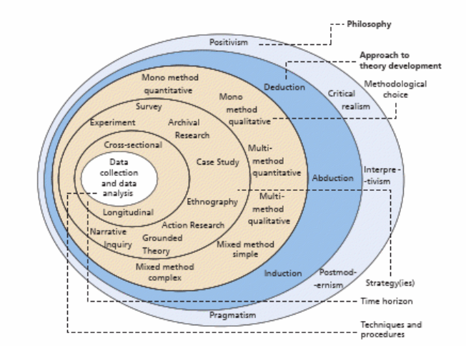
Figure 6 - Research Onion, Mark Saunders, Philip Lewis and Adrian Thornhill., 2018
Due to the limited timescales involved in this research, it will be a cross sectional study that will focus on the critical realism philosophy of explaining what is seen and experienced in the underlying structures of reality that shape the observable events (Saunders, 2019). This is why the survey will take on a mixed methods approach called “concurrent embedded design” (Saunders, p.172, 2019) where both the qualitative and quantitative gathering is completed in one single phase in order to support the data being collected, for example a questionnaire (Saunders, 2019) (Appendix 1).

3.3 Chosen research methodology
As this research is not attempting to prove a hypothesis, it is simply leading through an inductive approach to a hypothesis and a generalisation of the responses in order to achieve the aim. Thus, this research report can only be classed as the starting point for the research to be undertaken to fully understand the rise and fall of Mental Health across South Wales Police (Cohen, Manion and Morrison, 2018).
Table 1 outlines the advantages and disadvantages of other methods that could have been used and had been considered.
Table 1 - The advantages and disadvantages of data collection methods
Method | Advantages | Disadvantages
Interviews | Can be structured or unstructured to allow for freedom of conversation and an explanation around any misunderstood questions. Gains quality and in-depth information that are being sought when looking for opinions or impressions (Phellas, Bloch and Seale, 2011) | Time consuming and can be costly. Current legal requirements and covid policy could impact on whether this would be face to face or over the phone. Interviewer bias could impact on the answers that are found (Phellas, Bloch and Seale, 2011)
Focus Groups | Followed in consideration with other methods such as one to one interviews or surveys. Allow for group discussion and agreement when possible (Powell and Single, 1996) | Cost and timeliness. Geographical issues ((Powell and Single, 1996)
Surveys (email) | Can be completed through different medians, such as email, paper and web. Quicker access and less time consuming for both the respondent and the researcher (Toepoel, 2017). Bias throughout the questionnaire can be reflected on and removed prior to being sent to those selected. Cost-effective especially if conducted through email and can be reached across a large geographical area (Patten, 2016) | Questions need to be short and simple to minimise misunderstandings. Difficult to make sure the intended individual has completed the form. Poor or no internet access could impact on a survey. Unable to understand how those not responding could have impacted on the research results (Patten, 2016)
Observation | Allows for a deeper understanding of what is happening in the situation and the emotions being felt. Helpful if it is within the researchers organisation. (Saunders, 2019) | Time consuming and can lead to ethical dilemmas as well as observer bias (Saunders,2019)

With the above advantages and disadvantages explored the gathering of responses will be made through a questionnaire. Allowing for a full use of time and ability to reach the greatest numbers of individuals in the short space of time. The use of both paradigms of qualitative and quantitative questioning throughout the questionnaire, will allow the research gathered to be enriched and confirm the realities of the mental health situation within South Wales Police (Greener, 2008).

3.4 How your research participants were chosen
In order to gain the best data for the outcome of this aim, the survey has been sent to line managers within one of the largest areas of South Wales Police, Operational Support Services (OSS). It was chosen because of the ratio of staff to officers and operational to non-operational staff. Other areas such as Headquarters and Basic Command Units (BCU) consist mostly of staff or officers and therefore would not be able to reflect a fair understanding across the force and the different roles that have been impacted throughout the last few years.
110-line managers within OSS are being sent the questionnaire and although it cannot be classed as views respective across the whole of South Wales Police, the trade off is that be sending a questionnaire to those within OSS it will allow for a foundational understanding of both staff and officer views (Blackman and Rog, 2009).
The reason for the line managers being chosen is due to the need for understanding what the perception was prior to the start of the pandemic and where it was now, as well as the experiences that they had dealt with regarding mental health. It will allow for an idea of what the force are doing well, what they are could do better and where the gaps are in the knowledge provided to those dealing with the situations as they unfold.
The questions that have been written have therefore be aligned to gain the understanding of the targets above.

3.5 Reliability, validity and research limitations
Reliability and validity are key to the research and the results that it produces and although this is not a 100 percent achievement, minimisation of the discreditable elements is to be planned for. With reliability it looks at whether the data can be reproduced with similar outcomes (Anderson, 2013). Validity shows whether the answers provided are relevant to the study being conducted (Anderson, 2013).

3.5.1 Reliability
Chapman and McNeill (2005) compared reliability to a chemistry experiment if repeated it should always work and produce similar results regardless of who was doing it or the time that it was being done. By piloting the questionnaire, it allowed for a test of the questions asked and respondents interpretation of those questions so that if it was sent out again in the future it will allow for the same results to be obtained.
There will also be emphasis on the fact that this questionnaire will collect the data anonymously, assisting in the reliability of the honesty of responses (Saunders, 2019).

3.5.2 Validity
In order to test the validity of this research, a pilot of the questionnaire was undertaken with Human Resource Advisors and the Human Resources Helpdesk. The aim of this pilot was to make sure that the wording was clear, simple and had the theme running through clearly to gain the answers required. It would show how the responses are likely to return and whether it would need to be altered to a qualitative or quantitative question in order to gain the most honest and reliable information. Vanette (2019), explains the above in the terms of understanding what the respondent is expected to answer with and how to answer it based on the phrasing of the question. By conducting a pilot, the questions asked will assist in the validity of the responses returned.

3.5.3 Research Limitations
Throughout all research studies, there is the risk of complications which could impact on the outcome of research. The limitations for this study have been:
Timescales – this is due to the turnaround required for this data, it has unfortunately encountered the summer holiday where annual leave is heavily utilised and resourcing numbers are therefore low. Therefore, full potential in respondents may not be met.
Experience – some line managers may not have had first-hand experience of handling cases where mental health is involved, or could even be new managers whose knowledge would be limited. However, this could allow the department to understand the requirements of those new to the line management/leader role.
Completed online – due to the geographical locations across South Wales Police and the requirement for homeworking to remain regardless of the lifted restrictions, this survey has been conducted through an online Microsoft Form. Potentially causing difficulties with respondents participating due to the internet or technology know how. Several different forums had been trialled and Microsoft Forms has been discovered to be the easiest to answer and did not require respondents to sign up or create accounts in order to respond. The form could be completed online at work (without being blocked by the administrators), or with operational officers/staff it could be completed on their phones with ease.
Critical Incident – unfortunately the control room, one of the higher staffed departments, went into a critical incident at the start of the data collection period and therefore has potential to impact on the amount of line managers within this area that have responded to the survey.
Familiarity – As per Vanderstoep’s (2008) research, responses tend to be higher if the respondents are familiar with the individual sending out the survey, the email containing the link to the questionnaire will therefore be sent via the email address of the OSS HR Advisor.
Authorisation and awareness – Senior Management Teams have been made aware at meetings as well as re-emphasised at sickness meetings where other line managers attend, that this questionnaire is being sent out with the rationale explained. An email was originally sent to the Chief Inspectors and Head of Departments with detail included and a link to the survey, this allowed for them to review the questions and to encourage their teams to respond. After 24 hours all other line managers were emailed with the same detail contained (appendix 2).

3.6 How the research data was analysed
Microsoft Forms has been selected as this will allow for real-time analytical data providing an overview of what the responses are reflecting. Forms also has the ability to download the data into Microsoft excel which will allow for a further in-depth analysis to take place (Microsoft, 2021). Unlike other survey creators such as Survey Monkey and Gizmo who limit both questions and respondents, Microsoft Forms allows for a wide number of respondents and questions to be asked (Marrs, 2021).
As this questionnaire will have a mixed use of qualitative and quantitative questions being able to download the forms onto an excel spreadsheet allows for a further analysis to take place.
In regards to the qualitative data this will be analysed using a thematic networks analysis which means that the text a is categorised into common themes found throughout the responses that were received (Attride-Stirling, 2001). This is done via three stages, reading through the text to understand how it can be broken down; exploring what is contextualised within the text and the finally the interrogation of this into the themes (Attride-Stirling, 2001). This will then be able to provide a reliable understanding of the key themes for those that have responded and their views on mental health wellbeing within South Wales Police.
The quantitative data collected will be utilised from the Microsoft Forms analytical data but if required then excel will be used in order to discover a further in-depth understanding. Through the means of pivots and appropriate graph tools, it will allow for percentages and comparisons to be made that Microsoft Forms analysis may not be able to provide (Kirklees Council, unknown).

4.0 Results and analysis
With the critical analysis of the data gathered for the fall and rise of mental health absence throughout the pandemic within South Wales Police, it has raised some surprising and unexpected opinions via their experiences that are both of a positive and negative nature. So how does this assist in the objectives for this report?
With 59 out of 110 applicants and a split of 60/40 (%) between officers and police staff, there is the ability to understand any trends that may define the outcomes.

4.1 Understanding mental health
Throughout the questionnaire there was a hope to understand the respondent’s knowledge through their experience of managing their teams. 96% of the respondents stated that they knew someone who had suffered with mental health in the last 2 years within South Wales Police, so how is their knowledge?
Pre-covid 48 of the respondents believed that mental health was the main reason for absence within South Wales Police, Musculo-skeletal and digestive came second and third.

Figure 7 - What do you believe to be the top absence in SWP pre-covid?
31 stating that coronavirus was the main reason for absence during the covid pandemic (figure 8), with mental health coming a close second at 24. To note, respondents could only provide one answer, for the 24 that responded with mental health being the main reason during the height of the covid-19 pandemic, it shows that there were clear concerns for mental health wellbeing throughout this time.

Figure 8 - What do you believe to be the main reason for absence during the height of the Covid-19 pandemic?
Respondents have then chosen mental health as the main reason during the covid-19 recovery.

Figure 9 - What do you believe to be the main reason for absence during the Covid-19 recovery?
It is clear by the recovery, that 42 people thought that mental health absence had once again become the leading factor in the reason for absence within South Wales Police. The difference between the pre-covid and recovery responses is that there are two topics that respondents have chosen, “respiratory” which did not play a part in the pre-covid responses has arisen in both during and recovery. There is potential for this to be linked to “long covid” and therefore still coronavirus based. The second is “coronavirus”, as would be expected due to the influx of contagion that occur.
Of the 59 that responded, question 6 asked for their understanding of what they believed to come under the umbrella term of mental health absence.

Figure 10 - What conditions do you feel are considered under the umbrella term of mental health absence?
From the literature review already gathered above theoretically stress does not form part of mental health and yet is in the top three responses. There seems to be an indication that leave is miscategorised by line managers, and that further guidance and training may be required.
Depression and anxiety came through as the top factors for the key words in umbrella terms for understanding.
From the above the respondents understand the impact that mental health has on the force and absence rates, which has been further solidified with 78% of the respondents saying that they do believe that mental health issues have increased during the pandemic.

4.2 Where to get advice
As explained within the introduction South Wales Police, has several different places to gain information and guidance from when looking after staff or officers that are struggling with their mental health.
86% responded with “yes” they did know where to go for advice on behalf of those who they believe to be struggling with mental health, figure 11 reveals the qualitative responses to the supplement question where to find the advice.

Figure 11 - Where do you find the advice?
Occupational Health has the majority of the responses at almost 35%. Reflections from other qualitative data that has been analysed is that waiting times are causing concerns for those that are referred to Occupational Health services, “the response I had back was basically thanks for your e-mail, we are really busy, we'll triage this request but you may not hear from us.” (Q14, responder 38). It is therefore imperative that where the additional resources are placed is looked into and feedback is sought to understand why these are not the first stop for line managers to gain advice from.
Suggestions are then put forward with the scope of looking at what further could be provided with 30% of the responses wanting additional specialist resourcing provided, whether that be an increase in Occupational Health staff or the sickness team.

4.3 Themes found throughout the responses
Throughout the responses that were received the analysis revealed particular themes throughout. An overview of these is:
- Resourcing
- Ways of working
- Training
- Support
Resourcing will be covering, stress due to increased demand but not enough staff/officers to assist in the increase and additional assistance in solutions. Training as a solution to assist line managers in proactively looking after mental health of their teams, as well as there being a lack of for line managers. Ways of working, this will cover looking the working environment causes and solutions that have been raised. Support, a key factor that ties in with training however this has been raised throughout the responses as a cause for mental health absence and what the hope is across those that have responded to seek a resolution and what they would like to see implemented.

Figure 12 - Themes that run through the questionnaire summarised in Q17
The themes have been summarised in question 17, “From your experience as a line manager what do you believe would assist in mental wellbeing for all?”, this is due to the question lending itself to an understanding of what has been gathered throughout the questionnaire.

4.3.1 Resourcing
As the force is a public sector, it is highly scrutinised by the public and tightly monitored by the Government. Within the respondent’s answers there are several comments about the increasing demand and the lack of resourcing in order to sufficiently meet that demand, now understanding that there are difficulties in getting the resources, it will be difficult to get a solution to this but what can be looked at is the way that the resourcing is allocated.
For the 23% whose answer falls under the resourcing theme it also highlighted the need for additional resources within the specialist areas of mental health, looking at Occupational Health and increasing their resources could lower the demand on the unit as well as supporting and assisting those that need it prior to mental health absence and during.

4.3.2 Ways of working
As another trend that came through as a concern was the ways of working, remembering that these answers are from across the whole of OSS and not just one specific area.
36% mentioned something along the lines of ways of working, they included the environment that they worked within, understanding what employees need, managing breaks better and communication.
Here are some key responses that show the requirements for ways of working.
Respondent 22 said for example “breaks managed correctly and time off”, as found previously in this report the individuals are looking for a worklife balance. Studies explored above have shown that looking after the employees and giving them time and proper breaks (as should be expected) enhances their working life, positivity and increases their mental health.
“Senior leaders to recognise that staff are real people and that their attitude and decisions have real effects. Tick box processes and signposting to services do not resolve all anxieties”, as mentioned in the introduction there have been a lot of tools and resources highlighted through the South Wales Police, processes and guidance all relates to make sure everyone is offered the same thing, and although that may assist in a majority of cases some line managers may not be aware of the sensitivities and how each case may need something more than just following the process.
This brings us onto the understanding of the other two themes training and support.

4.3.3 Training
Throughout all of the questionnaire there has been a key theme for a greater understanding and training. South Wales Police at present does not have any training for looking after those struggling with mental wellbeing, apart from contacting Occupational Health or speaking with the Mental Health Nurse.
Several respondents on question 17 “from your experience as a line manager what do you believe would assist in mental wellbeing for all”, answered that they believe specific mental health training for supervisors would be of a benefit. Although the Police Force have Blue Light Champions who can assist or individuals can be signposted to, individuals are not always as comfortable talking to other colleagues from across the force.

4.3.4 Support
Support has been raised through some of the qualitative questions, but with two different perspectives. One is support from line management whereas the second is through the request of additional support that can be provided by South Wales Police.
54% of respondents when asked the question “do you feel SWP has done enough for those suffering with mental ill health?” stated that no they do not (5% chose not to answer and the other 41% believed they did). The follow up question reflecting answers such as additional resources within Occupational Health to assist in the demand and the retrospective delays caused by high demand and low resourcing. Better understanding of each case and to understand that not each one is a tick box exercise.
Other respondents within the 54% stated that there needed to be better signposting for the guidance, that the ideology with line management is pick yourself up and get on with it, that there is not enough preventative measures in place and that it depends on whether the line manager supports the individual or not.
However, with 41% believing that SWP are doing enough with comments that have been provided in the follow up suggesting that the documentation and guidance is suitable but there is an emphasis on the individual to help themselves also. With Pattern 1 and 3 (both coming in with 34% respondent choice) for question 17 showing that the individual is key to solutions.
Count of ID
Are you Police Staff or Police Officer | During the pandemic, do you think mental health absence has... | Total
Police Officer | Decreased | 5
 | Increased | 30
 | Stayed the same | 2
Police Officer Total |  | 37
Police Staff | Increased | 15
 | Stayed the same | 6
Police Staff Total |  | 21
Grand Total |  | 58

4.4 Staff vs Officers
What the results have revealed throughout the analysis is that staff and officers have experienced and are under the same understanding as one another as to the impacts that mental health has had on South Wales Police. There are three questions that have pulled out of the questionnaire to reveal the similarities between the two employee roles.
Firstly, during the pandemic do you think mental health absence has … with three multiple choice options.
As can be seen in the pivot above, the majority of staff and officers believe that mental health absence has increased, with the difference between the two being that some of the officers believe that mental health absence has decreased and staff thinking it has stayed the same. Officers believing that this has “decreased” does support Crout et al in their recognition of the need to serve others outweighs their own.
Secondly, is the question “do you feel that SWP has done enough those suffering with MH” this reveals the true difference in the opinions of those that have responded. With 26 officers selecting no, and believing that more could be done, whereas only 5 staff chose this option.
Row Labels | Count of ID
Police Officer | 37
No | 26
Yes | 10
(blank) | 1
Police Staff | 21
No | 5
Yes | 14
(blank) | 2
Grand Total | 58

Thirdly, the question “do you know anyone that has suffered with MH over the last 2 years”, and although the blanks are showing that some have chosen not to answer this question, those that answered in both arenas of officers and staff are at an equal level. Showing that mental health is impacting both roles across the force.
Row Labels | Count of ID
Police Officer | 37
No | 2
Yes | 31
(blank) | 4
Police Staff | 21
Yes | 19
(blank) | 2
(blank) | 1
Yes | 1
(blank)
Grand Total | 59

4.5 Review of Findings
The analysis of the findings has revealed that although the force has put the initiatives in place there needs to be further campaigns and training to assist line managers with how to have the conversations with individuals who experience these difficulties as well as how to prevent an absence occurring and a decline in an individual’s mental health.

5.0 Conclusion
As mentioned within the introduction and by WHO (2021a), poor mental health can have a costly impact on organisations as well on the individuals who are suffering with the impacts of this. To ignore the cries of help and not look to do anything further could have a reputational impact on the force and the family value that it holds itself too.
Having resources, tools and dedicated services within Occupational Health, could be an advantage to developing the support and understanding within South Wales Police. And although there is not a clear one reason factor as to why there has been an increase in Mental Health absence during the recovery phase of covid-19, there are themes from support to demand to working conditions that can all impact on the mental health of South Wales Police’s staff and officers. Presenteeism being a potential factor that carried South Wales Police through the pandemic but the emotional distresses (Pfefferbaum, 2020) that have been encountered are starting to appear, correlating to the fall and rise that has been shown through the initial figures.
Line managers, Senior Management teams and Chief Officers need to be aware that each individual has experienced mental health in different ways and have their own story, as explained by Westerhof and Keyes (2009) and their definition of mental health being impacted by emotional, psychological and social well-being. As identified through the results support is key to helping and developing the relationship with individuals who are experiencing difficulties in mental health.
The main way of doing this is to develop and relaunch the tools that are already in place, making guidance easier to find and to develop training to mirror other organisations who have a good reputation for supporting and looking after their employees and their mental wellbeing.
The aim is no longer to critically analyse the fall and rise of mental health absence within South Wales Police but how best to raise awareness of mental health, reduce the stigma that surrounds it and to prevent and support its staff and officers through their challenges with mental health.

6.0 Recommendations

Recommendation 1: Training for line managers and employees
As has been seen through the findings above there is a feeling from those that responded that additional training for mental health would be of a great benefit. This would follow suit of other organisations that are receiving a good reputation in the wellbeing of their staff, such as Innocent who has been explored above.
The recommendation would be two courses, one for line managers and the second for all staff and officers in order for them to not only understand their own mental health but also for those around them.
Cost: £12,136 per month based on the monthly salary of the four individuals that would be involved.
Time: These courses could be worked on at the same time as other projects

Recommendation 2: Raising awareness and removing the stigma through accessible conversations with Occupational Health
Although there are Blue Light Champions throughout the force, there is still a want for additional assistance from those that are qualified. The recommendation is to have Occupational Health sit within specific high demand areas and throughout the BCU’s for wellbeing hours or seminars to assist with those that are looking for help or even to bring a support group nature together in order to make them realise that they are not alone.
Cost: £74 a week for a Counsellor and a Mental Health Nurse for 2 hours a week to start with, if successful there is the potential for this to increase.

Recommendation 3: Better promotion of the resources available
Some of the feedback that has been received is showing that what South Wales Police already has in guidance and advice is not as easily accessible as it could be, especially in times of need. At present information is held on BOB (intranet) within the Human Resources page and within folders and contained within this is a toolkit that has been created specifically to hold information such as Mental Health and absence management guidance. However, none of which is easily accessible.
Solution: a dedicated space that will allow for contact details, useful links, guidance and toolkits to be all in one place and easily found from the home page of the intranet. Availability of an app to be on the work phones that are suitable for officers who are on the road or at other workstations without computer access, to contain the same data.
Cost: £4,243 per month
Resources: Human Resources Service Desk Agent and Communications Officer
Timescales: 1 month for the intranet and 3 months for the app

Recommendation 4: Additional resources – occupational specialist’s experts
To a force funded by public money this recommendation can cause concern due to the cost implications that this will have. However, waiting lists for the existing Counsellors and Mental Health Nurse are already long and causing difficulties for those that are waiting for their assistance. With additional resources to assist in this area not only would it help with the recommendations above, but it will allow for waiting times to be cut down and more staff and officers to be helped through the period of need, potentially cutting down on absence length.
Cost: £3,859 per month
Resources: Recruitment advisor and administrative assistant

7.0 Reference List
ACAS, 2021a. Supporting mental health at work. Available at: Supporting mental health at work - Acas. (Accessed on: 4th October 2021)
Anderson, V (2013) Research Methods in Human Resource Management. McGraw-Hill Education: Europe
Attride-Stirling, J. (2001) Thematic networks: an analytic tool for qualitative research. Qualitative research : QR. [Online] 1 (3), 385–405
Bickman, L. and Rog, D. J.2009. The SAGE Handbook of Applied Social Research Methods. 2nd ed, Thousand Oaks, CA: SAGE Publications, Inc. Available at: <http://www.doi.org.ezproxy.uwtsd.ac.uk/10.4135/9781483348858> [Accessed 2 Oct 2021]
British Army Leadership., 2020. Leading through Crisis: Cross-Sector Lessons from Covid-19. Centre for Army Leadership, Robertson House
Buchan, S. (2021) Scotland 4 day working week: will it happen and who is elgibile? Glasgow Live. Available at: Scotland 4 day working week: Will it happen and who is eligible? - Glasgow Live (Accessed on: 4th October 2021)
Centre for Disease Control and Prevention, (2019) Mental Health in the Workplace. Available at: Mental Health in the Workplace (cdc.gov) (Accessed on: 4th October 2021)
Chapman, S and McNeill,P., 2005. Research Methods 3rd Edition. London: Routledge
CIPD, 2021a. Employee Resilience: An evidence review. Available at: Employee resilience: an evidence review: Scientific Summary (cipd.co.uk) (Accessed on: 4th October 2021)
CIPD, 2021b. Mental Wellbeing and digital work. Available at: Mental wellbeing and digital work: an evidence review: Scientific Summary (cipd.co.uk) (Accessed on: 4th October 2021)
CIPD and MIND, 2018 mental-health-at-work-1_tcm18-10567.pdf (cipd.co.uk)
CIPD, 2016. Employee Outlook. Available at: employee-outlook_2016-autumn_tcm18-16797.pdf (cipd.co.uk) (Accessed on: 4th October 2021)
Cohen, L. Manion, L. Morrison, K. (2018) Research methods in education. 8th ed. London: Routledge.
Crout, L., Chang, E., and Cioffi, J. (2005) Why do registered nurses work when ill? Journal of Nurse Administration, 35 (1) (2005), pp. 23-28
Dewe et al., 2010. Coping with work stress a review and critique, Malden, Mass.: Wiley-Blackwell.
Gingras, A., (2020) 8 Companies that prioritize the mental health of their employees. Ripplematch. Available at: 8 Companies That Prioritize The Mental Health of Their Employees | Advice | RippleMatch
Government, 2021. Research and analysis: Important Findings. Available at: 2. Important findings - GOV.UK (www.gov.uk) (Available at: 4th October)
Greener, S (2008) Business Research Methods. Ventus Publishing
Hansson, M., Boström, C and Harms-Ringdah, K (2006) Sickness absence and sickness attendance—What people with neck or back pain think. Social Science & Medicine Volume 62, Issue 9, May 2006, Pages 2183-2195 https://doi.org/10.1016/j.socscimed.2005.10.002
Harvard questionnaire design PSRQuestionnaireTipSheet (harvard.edu)
Health and Safety Executive 2021. Stress at work – Advice for managers on mental ill health conditions. Available at: Stress at work - Advice for managers on mental ill health conditions - HSE (Accessed on: 4th October)
Johnson, S., Cooper, C., Cartwright, S., Donald, I., Taylor, P. and Millet, C., 2005. The experience of work‐related stress across occupations. Journal of managerial psychology. DOI: 133391 178..187 (lancaster.ac.uk)
Kirklees Council, (UNKNOWN). Analysing and reporting quantitative data. Available at: Analysing and reporting quantitative data (kirklees.gov.uk) (Accessed on: 4th October)
LaFree, G., 2012. Policing terrorism. Ideas in American Policing series, 15.
Maxwell, J.A., 2012. Qualitative research design: An interactive approach. Sage publications
Marrs, M (2021), 10 Best Survey Tools: Create Awesome Surveys for Free. Wordstream. Available at: 10 Best Survey Tools: Create Awesome Surveys For Free! | WordStream (Accessed on: 4th October)
McKevitt, C., Morgan, M., Dundas, R and Holland, W (1997) Sickness absence and ‘working through’illness: Comparison of two professional groups. Journal of Public Health Medicine, 19 (3) (1997), pp. 295-300
Microsoft Forms (2021), Check and share your form results. Available at: Check and share your form results (microsoft.com) (Accessed on: 4th October)
MIND, 2021a. Understanding mental health – for young people. Available at: Information for young people on mental health | Mind, the mental health charity - help for mental health problems (Accessed on: 4th October)
Mind Training courses (2021b) MIND Training. Available at: Mind Training | Mind, the mental health charity - help for mental health problems (Accessed on: 4th October)
Office for National Statistics (2021) Sickness absence in the UK labour market - Office for National Statistics (ons.gov.uk)
Orocco (2021) Orocco Moves to Four-Day Week. Available at: Orocco Moves to Four-Day Week - Orocco (Accessed on: 4th October)
Patel and Hanlon, 2018. Where there is no psychiatrist: A mental health care manual. RC Pysch Publications: London
Patten, M., 2016. Questionnaire research: A practical guide. Routledge.
Perkin, M., Higton, A., and Witcomb, M (2003) Do junior doctors take sick leave? Occupational and Environmental Medicine, 60 (9) (2003), pp. 699-700
Phellas, C.N., Bloch, A. and Seale, C., 2011. Structured methods: interviews, questionnaires and observation. Researching society and culture, 3(1),.Seale Final Proof.pdf (sagepub.com)
Pfefferbaum, B. and North, C,, 2020. Mental health and the Covid-19 pandemic. New England Journal of Medicine. DOI: 10.1056/NEJMp2008017

POWELL, R, SINGLE, H, Focus Groups, International Journal for Quality in Health Care, Volume 8, Issue 5, 1996, Pages 499–504, https://doi.org/10.1093/intqhc/8.5.499
Saunders, M. N. K., Lewis, P., & Thornhill, A. (2019). Research methods for business students (Eighth edition.). Pearson.
Sharland, L. (2019) ‘5 Companies Leading the Way in Mental Health Support at Work’ Anderson Hoare, [Blog] Available at: 5 Companies Leading The Way In Mental Health Support At Work - Anderson Hoare (Accessed on: 4th October)
The Finery Report (2021). Iceland, Japan, New Zealand propose 4-day workweek policy. Available at: Iceland, Japan, New Zealand propose 4-day workweek policy — The Finery Report (Accessed on: 4th October)
The Observer 2011 Police forces comparative table | Special reports | The Observer (theguardian.com)
Toepoel, V. 2017. Online Survey Design. In: 2017. The SAGE Handbook of Online Research Methods, 55 City Road, London: SAGE Publications Ltd. pp. 184-202 Available at: <http://www.doi.org.ezproxy.uwtsd.ac.uk/10.4135/9781473957992.n11> [Accessed 2 Oct 2021].
TUC, 2018. Mental health and the workplace. Available at: TUC-MENTAL_HEALTH_WORKPLACE.pdf (Accessed on: 4th October)
Vannette,D. (2019) The Qualtrics handbook of question design. Available at: Course: Investigating a Business Issue from a Human Resource Perspective (BMHR7006) (uwtsd.ac.uk) (Accessed on: 4th October)
Westerhof, G.J., Keyes, C.L.M. (2010). Mental Illness and Mental Health: The Two Continua Model Across the Lifespan. J Adult Dev 17, 110–119 https://doi.org/10.1007/s10804-009-9082-y
World Health Organsiation (2021a) Mental Health in the Workplace. Available at: Mental Health and Substance Use (who.int) (Accessed on: 4th October)
World Health Organisation, 2021b. Mental Health and psychosocial considerations during the Covid-19 outbreak. Available at: Mental health and COVID-19 (who.int) (Accessed: 4th October 2021)

Bibliography
El-Guebaly, N., 2007. Investigating the association between moderate drinking and mental health. Annals of Epidemiology, 17(5), pp.S55-S62.
McLaren, S. (2020) ‘5 Ways companies are supporting employees’ mental health and preventing burnout’ Linkedin [Blog] Available at: 5 Ways Companies Are Supporting Employees’ Mental Health and Preventing Burnout (linkedin.com) (Accessed: 4th October 2021)
Singh, D (2017) ‘The Ultimate Guide to Micrsoft Forms’ Collab 365. Available at: The Ultimate Guide to Microsoft Forms - Collab365(Accessed: 4th October 2021)
TuitionKit (2014) Questionnaire Design [Video]. Available at: Questionnaire Design - Bing video (Accessed: 4th October 2021)
Research Hub (2019) Survey questionnaire design using google forms [Video] Available at: Survey Questionnaire Design Using Google Forms - Bing video (Accessed: 4th October 2021)

8.0 Review of personal learning
Although the timeframe for this report does seem fairly small, it has definitely been made harder by my own difficulties in keeping to the deadlines that I set myself at the planning stages of this report. For future reports I would like at making sure my deadlines were updated with any changes that I had in work loads for example the critical incident that the control room went into at the start of August.
The summer is a time I would avoid completing a questionnaire as this does not allow for the best response rates to be achieved.

9.0 Appendices
Appendix 1 Questionnaire (printed version)
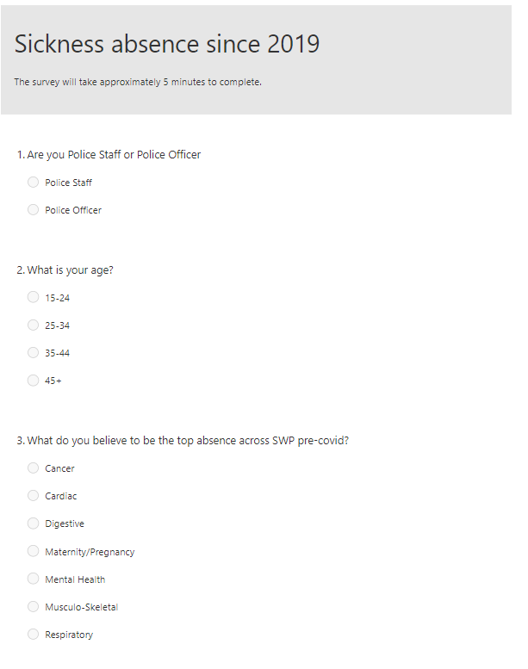
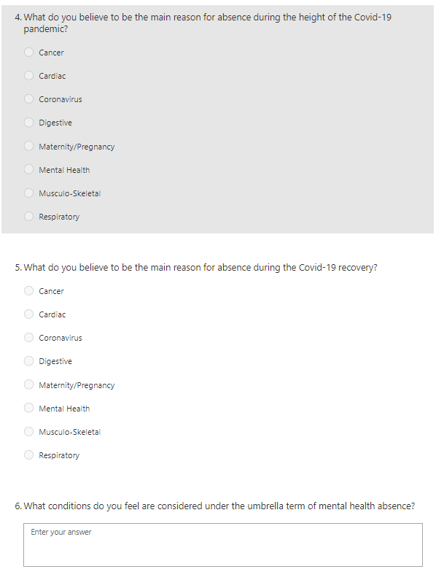
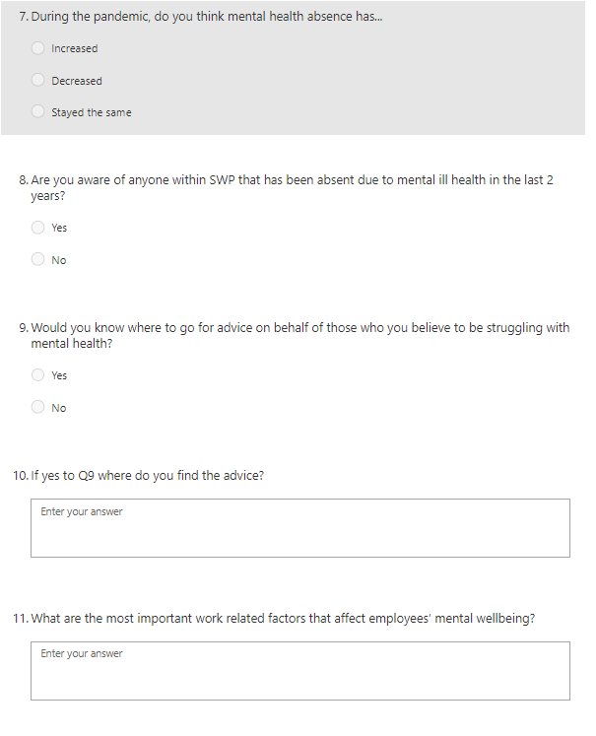
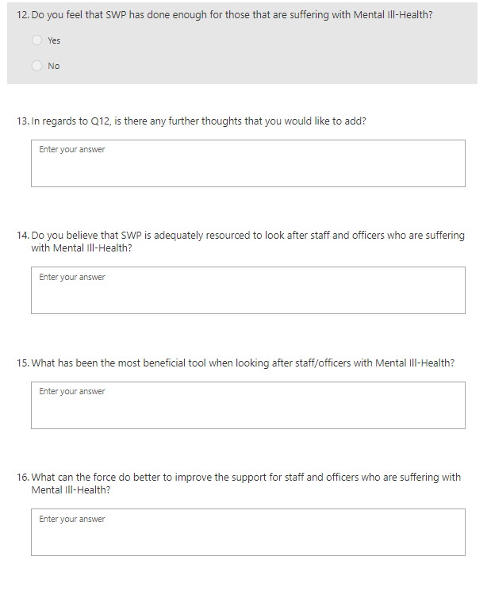
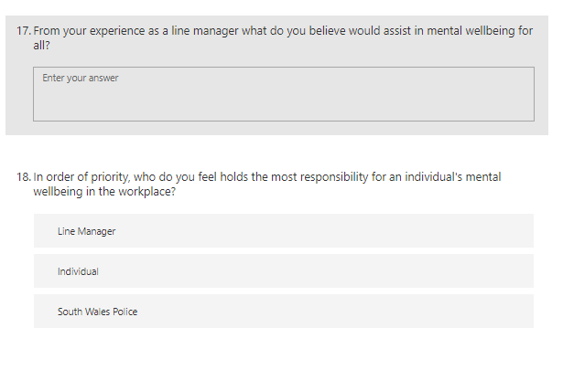
Appendix 2 Email introduction
Good Evening All,
I am currently undertaking research through a dissertation, based on the rise and fall in mental health absence that has taken place during the different stages of the Covid-19 pandemic.
As part of this research, I am looking for assistance from line managers such as yourselves, within the OSS arena, to understand and hear more of your experiences and ideas on the areas of Mental Health Wellbeing.
The report will be completed around October and any recommendations and understandings will be provided to South Wales Police. With a higher level of response it will allow for a more rounded and accurate reflection of experiences and understanding from across the OSS arena.
Please can I therefore ask for the questionnaire (found through the link below) to be completed. This has been set to close on the 18.08.2021 at 12pm.
https://forms.office.com/Pages/ResponsePage.aspx?id=-REPTm4EBUWcuNshUjEeIagMBZuUp1tJhuzg5kbEKVZURUVVNEtYVzZWVEpXTU0xTkdWNTBLM0RPOC4u
This questionnaire will take approximately 5 minutes to complete and can also be accessed via mobiles for ease of use whilst on the move. Please be assured that any information provided within the questionnaire, will be completely anonymous, as per the below screenshot.
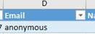

Any information provided will be held in a secure folder within the HR Drives, which has limited access, and will only be used by myself in the report as findings and statistical analysis.
Please do not hesitate to contact me if there are any further questions or information required. Please feel free to pass this email onto any other line managers within OSS.

Appendix 3 Action plan for the recommendations
Ref. | Recommendation | Key Action | Person Responsible | By When | Resources Required | Strategic Impact
1 | Training for line managers and employees | Developing two lots of training one for line managers and one for the employees | Learning and Development with content provided by Occupational Health | January 2022 | Project group made up of Performance and Organisational Manager, Learning and Development Advisor, Counsellor and Mental Health Nurse.  Assistance from MIND charity  Monthly cost based on individuals salary due to time spent (to note not a full time project): £12,136 | Two courses, one for line managers and the second for all staff and officers in order for them to not only understand their own mental health but also for those around them. Hopefully assist with decreasing absence numbers and increase the right conversations to support mental health
2 | Raising awareness and removing the stigma through accessible conversations with Occupational Health | Occupational Health to create workshops and a few hours a week to allow for group conversations to take place | Counsellor and Mental Health Nurse | November 2021 | 2 hours a week to start with:  £74 per week | Occupational Health sit within specific high demand areas and throughout the BCU’s for wellbeing hours or seminars to assist with those that are looking for help or even to bring a support group nature together in order to make them realise that they are not alone.
3 | Better promotion of the resources available | HR Helpdesk and Communications team to reinvigorate and advertise the resources already available | HR Helpdesk Support Assistant and Communications Officer | November 2021 | 1 month and 1 member from each team: £4,243 | Relaunching the tools that South Wales Police already have in place allows for a cost-effective approach to showing staff and officers what is already in place.
4 | Additional resources – occupational specialists experts | Recruitment team to gather information and create a campaign to attract further counsellors and mental health specialists | Recruitment team | December 2021 | Recruitment Advisor and Administrative Assistant: £3,859 per month  Additional cost will need to be accounted for when the number is known for the department | Assisting with the waiting times and ongoing demand that is currently being placed on the Occupational Health Department. In turn further assisting those that are in need of the help.

