AI is a hotly debated topic in Ancient History, with its use becoming increasingly prevalent as a tool for studying the past. As the technology develops it is being used to understand and analyse ancient texts and to generate entirely new content based on history. However, while some scholars see it as useful, others see it as harmful and damaging to both the research and the researchers due to how it is programmed and how that program operates.
Over Summer 2025, Google DeepMind, in collaboration with the University of Nottingham, unveiled a new generative AI model called Aeneas, designed to analyse and contextualise Latin texts as well as restoring damaged or missing parts in order to help historians. According to the University of Nottingham (Nottingham.ac.uk, 2025), Aeneas was trained on a digital collection of over 176,000 Latin inscriptions to act as a contextual interpreter by using its broad database to find parallels across texts in seconds. It is also capable of using a digital picture of a text to find out its geographical origin out of 62 Roman provinces with 72% accuracy and when it was written within 13 years of dates proposed by historians which it does using both the written content and layout, material and style (Google DeepMind, 2025). Furthermore, it has a generative ability to restore texts with 58% accuracy in gaps of unknown length and 73% accuracy in gaps of 10 or less characters. It restores them based off an image and the characters used which it compares to the database to find similarities in names, places and phrases to generate lost parts of texts.
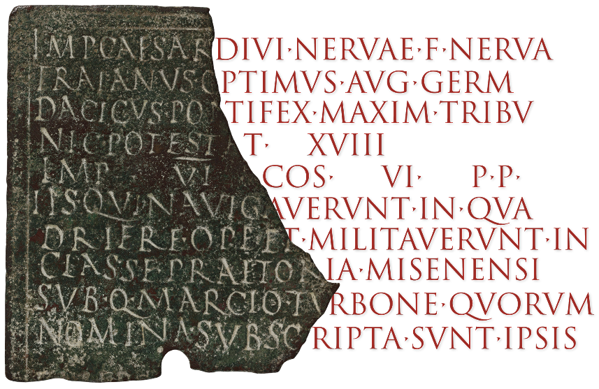
Restored bronze military diploma from Sardinia 113/14 C.E. (CIL XVI, 60) Credit: Deepmind
In ‘Ancient Historian and AI’ a study of Aeneas’ usefulness to historians with 23 participants working on 60 inscriptions, 90% of them rated it helpful and 44% said it gave them more confidence with the results showing that using the AI improved the historian’s accuracy. Supporters of this technology believe that it is useful because it allows historians to work faster and look across texts with a broader perspective using Aeneas’ database rather than just their own knowledge. Dr Thea Sommerschield a historian from the University of Nottingham and the co-leader of the research has stated that “that is the future value of this work, not just to do what we do faster and better but also to do things we didn't think to do before” (Ghosh, 2025). However, critics of this technology believe that Aeneas will hinder research as it could be distorting the past with inaccurate restorations or parallels since already established AI often makes errors analysing modern texts. The risk of misclassifying or misrepresenting history also means that using Aeneas could lead to biased or wrong understandings of history, especially since the inscriptions it uses are a key source for many of the different social groups in the ancient world which have more limited remaining documentation. Finally, over-reliance on Aeneas could lead to human research methods and study being seen as less important or inconvenient such as primary source study and critical analysis (AI, 2024).
AI generated historical images are also a topic of debate as more and more are made and reach a wider audience online with concerns due to their inaccuracy and risk of misleading people’s beliefs about the past. AI generated images work by fusing concepts, styles and attributes of contextually related images in its database so that it can create a digital image based on what a user has told it do, such as prompting it to make historically based images of people or places (GeeksforGeeks, 2024). Therefore because of the technology’s wide availability and popularity, it has become very common for people to generate whatever images they would like and present them to audiences as accurately historical. This has led to growing concerns that people will see AI historical content and think it is based in the truth, or even real, when it isn’t leading to growing historical biases and inaccurate knowledge among the public, especially if the images have been generated to serve and spread an agenda (MIT Management, 2024).
Due to these concerns Professor Felix K. Maier at the University of Zurich and computer linguist Philip Ströbel have collaborated to make a new AI platform called “Re-Experiencing History” with the goal of making more accurate historical images. The AI for this project was trained on academic literature and ancient sources to make images of Ancient Rome and Greece based on scholarly evidence with the goal of it being used in research, education and museums (SciTechDaily, 2025). This project could be beneficial to historians as it allows for deeper understanding of history through being able to visually explore it without being limited to Hollywood movies or illustrations, as well as drawing in new interest into the subject from people generating images for school or entertainment. In a press release the university of Zurich has stated that Re-Experiencing History “marks an important step in how we experience and convey history” (Hist.uzh.ch, 2023), with anyone being able to design and visualise whatever historical images they want with more truth and authenticity.
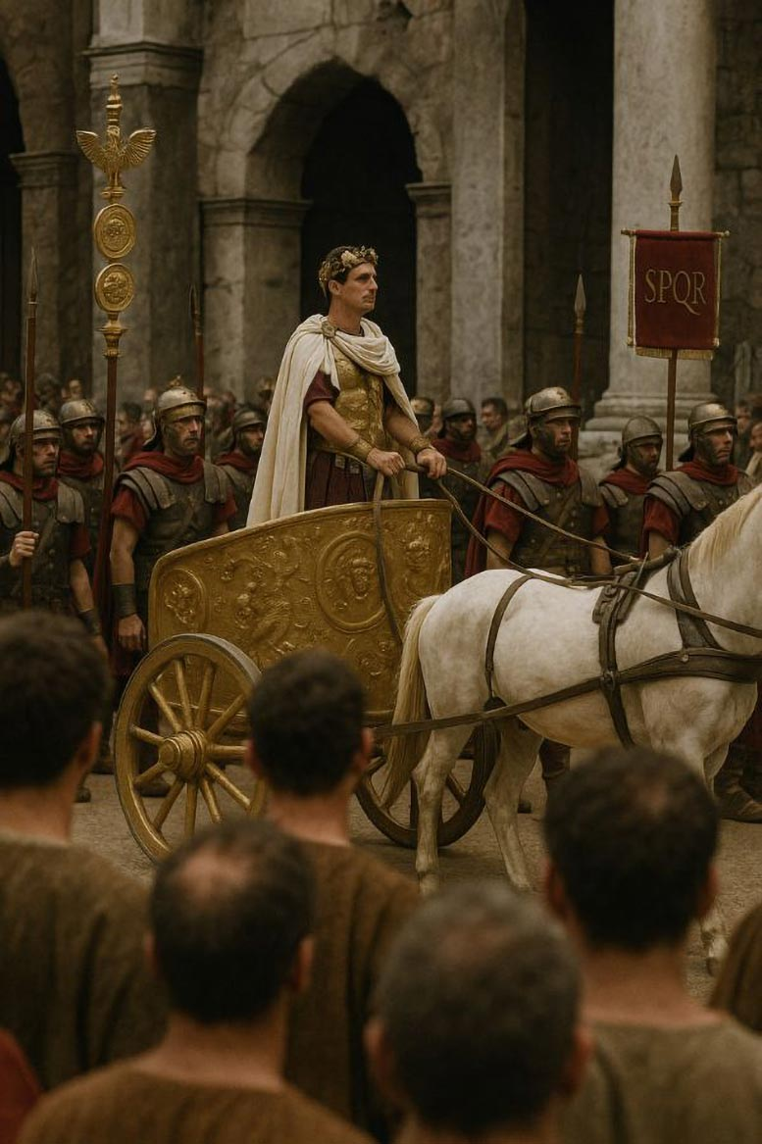
Re-Experiencing History generated image. Credit: University of Zurich
Therefore, while some believe that it is beneficial and opening new ways of studying the ancient world and making it more accessible, others are concerned that it is too inaccurate and capable of spreading misinformation to a large audience who don’t know much about the ancient world. With Aeneas it can help speed up research and fill gaps in inscriptions with its database but there is the risk that it misinterprets or fabricates information. Whereas Re-Experiencing History is designed to be a more historical image generator based on sources and research, its usefulness can vary on what the user wants to do and what prompts are put in with the potential for it to be misused. Overall, use of AI is disputed amongst ancient historians because while it is a useful tool due its large databases it can also be misleading and flawed.

References
Nottingham.ac.uk. (2025). News - First AI model for contextualising ancient inscriptions led by Nottingham researchers - University of Nottingham. [online] Available at: https://www.nottingham.ac.uk/news/aeneas-ai [Accessed 12 Oct. 2025].
Google DeepMind. (2025). Aeneas transforms how historians connect the past. [online] Available at: https://deepmind.google/discover/blog/aeneas-transforms-how-historians-connect-the-past/.
Ghosh, P. (2025). Gaps in what we know about ancient Romans could be filled by AI. BBC News. [online] 23 Jul. Available at: https://www.bbc.co.uk/news/articles/c04dwqr5lkvo.
AI (2024). The Archaeologist. [online] The Archaeologist. Available at: https://www.thearchaeologist.org/blog/pros-and-cons-of-ai-in-historical-representation.
GeeksforGeeks (2024). How does an AI Model generate Images? [online] GeeksforGeeks. Available at: https://www.geeksforgeeks.org/deep-learning/how-does-an-ai-model-generate-images/.
MIT Management (2024). When AI Gets It Wrong: Addressing AI Hallucinations and Bias. [online] MIT Sloan Teaching & Learning Technologies. Available at: https://mitsloanedtech.mit.edu/ai/basics/addressing-ai-hallucinations-and-bias/.
SciTechDaily. (2025). Is This the Future of the Past? AI Meets Ancient Rome. [online] Available at: https://scitechdaily.com/is-this-the-future-of-the-past-ai-meets-ancient-rome/.
Hist.uzh.ch. (2023). Re-Experiencing History. [online] Available at: https://hist.uzh.ch/de/fachbereiche/altegeschichte/lehrstuehle/maier/AIncient-Studies-Lab/Projects/Re-Experiencing-History.html [Accessed 12 Oct. 2025].
‌

‌

‌

