Student Name : Zlatko Nalbanski
Student ID : 2124047
Lechturer Name : Gasso Wilson Mwaluseke
London Campus

BLOGGING TO COMMUNICATE

Table of Contents
All about Flavoured Porridge, muesli, and granola making diet better, and tastier 3
Food Value of “Ready to eat Diet flattened Rice” 5
Collaboration with the UK Youtube community: an event to remember 6
Reshaping the marketing with innovation, and dedication 6
The audience, and Social media- the improved way of communication 7
Play games with MOMMA Foods, and earn more rewards! 8
Delivery at the Doorstep 8
Meet, and greet with Porridge lovers 9
References: 11

All about Flavoured Porridge, muesli, and granola making diet better, and tastier
MOMA foods have made oats better, and healthier for the new generation who are very conscious about their health. They are one of the best companies to provide diet foods like flavoured oats and muesli, making flavoured “ready-to-eat porridge” products (MOMA Foods, 2022). Eat healthily, and live in a better way should be the motto of every person’s life because in every day’s hectic life the generation is forgetting to look after their health. The company has brought an innovative type of product to increase the immunity level of people as well as reshape the body. Difficulty in maintaining a proper healthy lifestyle has become a challenge indeed. In this hectic lifestyle, if everyone consumes oily fast foods, severe effects can be observed on their skin and hair. There is a myth that oats are very bad in taste, but the company has changed every people’s thought by providing oats of various flavours.
Raisin cranberry, coconut milk, apple date with caramel, peanut butter with maple syrup, wildberry, and many other flavours are calling the health lovers to bite the healthy and tasty oats by MOMMA. Now, there is no need to eat regular boring oats because MOMMA has arrived with a diversified range of flavoured oats. Even one can use their oat milk t make tea, coffee, cold coffee, and ice tea. Flavoured oats are tastier than usual oats and give a kick to the taste pallet for starting a fresh morning.
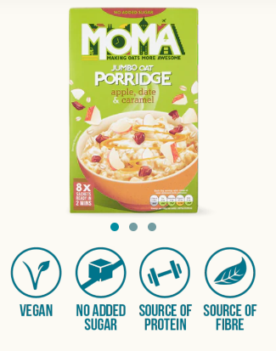
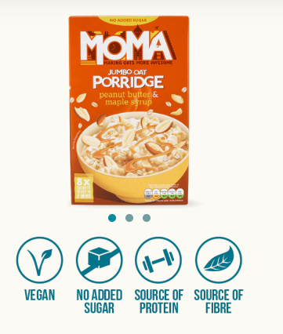
Figures 1 and 2: Flavoured Porridge at MOMMA Foods
(Source: MOMMA Foods, 2022)
The attractive packaging, easy-to-prepare quality, and interesting favours make porridges more vibrant, and classy. Not only porridge but muesli, granola- all the products have been restricted in the world of MOMMA.
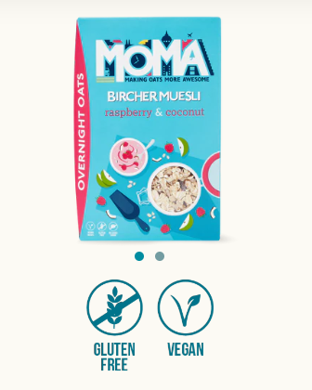
Figure 3: Flavoured Bircher Museli in MOMMA Foods
(Source: MOMMA Foods, 2022)
The raspberry and coconut flavoured bircher muesli is the bestselling item of the company because it is completely vegan and gluten-free.
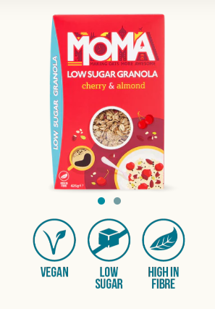
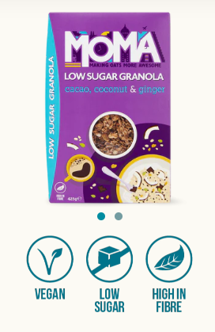
Figures 3, and 4: Flavoured Granola
(Source: MOMMA Foods, 2022)

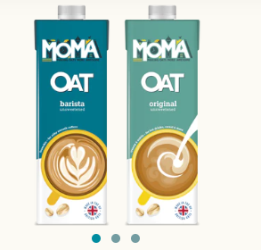
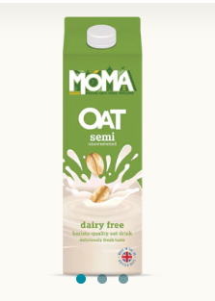
Figures 4 and 5: Different types of oat milk
(Source: MOMMA Foods, 2022)
Flavoured muesli and granola are very healthy to eat because the products are rich in fiber, and contain very less calories. The company is a very conscious weight watcher because they know healthy eating means healthy living. Different types of oat milk are used to prepare ice tea, Cappucino, latte, and many other types of teas, and coffees.

Food Value of “Ready to eat Diet flattened Rice”
Introducing the brand new product that MOMMA food is going to launch very soon which is "Ready-to-eat" flattened rice" with different flavours. Many people love poha which is also known as flattened rice, but earlier the product was not available in the company. Recently, they have decided to introduce “Diet flattened rice Porridge” which will be gluten-free, fat-free, and completely vegan. This is not the end; they have planned to bring a huge range of flavoured flattened rice porridge to the market in online markets, as well as offline markets. The decided flavours are mentioned below.
- Cranberry, and Raisin
- Almond, and Honey
- Peanut Butter
- Strawberry, and honey
- Almond, Pistachio, and date
- Apple, and almond
The flavours are quite interesting, and Mercer, the founder is very confident about this new project. Targeting the younger generation, office workers, and business professionals, Tom is trying to set a new trend of following a healthy and tasty diet for all. Pollution, hectic lifestyle, and the stress of work, increase the stress level of people. In order to maintain a healthy lifestyle, it is very important to maintain healthy food habits. Innovating diet semi-cooked flattened rice is a great approach by the company and the flavours that have been decided are very yummy!
Now, coming to the food value of the new product that is arriving in the market very soon, the value of this product is huge because the product is coming in a completely new version with new characteristics. Presently, the value of poha or flattened rice is rich in terms of nutrition and is quite healthy, but carbohydrate is high in normal flattened rice. However, this project will beat this resistance by introducing “diet, and ready-to-eat flattened rice” in different flavours

Collaboration with the UK Youtube community: an event to remember
The entire Youtube community was invited to yesterday’s event, and the event was grand because almost all the members of the Youtube community came to the promotion of the products. Renowned Youtube food channels have reviewed the product that is coming soon to the market. The channels which have reviewed the food are- The tasty, Rosanna Pansino’s channel, Mark Wien’s Channel, and Jamie Oliver’s channel. The content creators of these challenges were the brand ambassadors for the company’s food launch. After tasting the almond, and honey flavour of the “Diet flattened rice”, he was spellbound, and said, “OMG! This is amazing! I can’t believe that I am eating a porridge which is made with flat rice, and it tastes like a yummy dessert!!!! I am taking this entire pack home, and gonna use it for my breakfast daily!”.
This is a huge compliment given by him in an open seminar where thousands of people were invited. Moreover, the audience was very pleased to see the product, and many of them ordered the product immediately. Mark said, "I wish I could consume the almond, pistachio, and date-flavored flattened rice porridge on my lunch also! Damn! It is so bloody cool, and interesting too!"

Reshaping the marketing with innovation, and dedication
Marketing is incomplete with its 4 elements which are- Product, place, promotion, and price which are known as the “4Ps of marketing”. This is a very useful theory that should be used in this project because the product is new, and the approach is also unique.
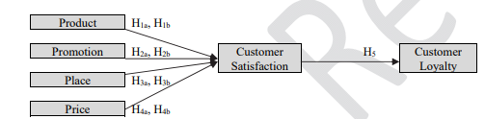
Figure 6: “4Ps Marketing Mix Theory”
(Source: Sudari et al. 2019)
The product that is going to launch in the market is - “Diet flattened rice”, and the marketing should be proper so that not a single scop of effective communication with the customers gets missed. The place where the company operates, and distributes its products is in London, UK, and presently the products are going to lunch in online also. This theory highlights the key elements of marketing by organisating the focus of all these elements to make an effective landscape of marketing (Sudari et al. 2019). The company is doing continued promotion by applying different interesting strategies online, and offline. Promotion is very important to let people know about the products. The big names are invited for the promotional purpose to increase the brand value in people’s eyes.
Most importantly, the products will be available at a very affordable price in spite of having these brilliant characteristics. It is hard to believe, but yes, it is not a dream anymore. This way the marketing strategy is getting changed, and reshaped by MOMMA Foods because they want to break the traditional way of marketing.

The audience, and Social media- the improved way of communication
Not only the Youtubers, but also several renowned facebook content creators, and Instagram content creators were also invited to that event and interacted with their fans. The creators were interacting with audiences and resolved all of their queries related to the product. Someone from the audience asked a female creator a question saying," Tell me truly, will you gonna use this meal as your breakfast? Please true answers only". She replied, "First of all, with all due respect, I am not a liar! Anyway, I am already using this product as my breakfast, and evening snack, even though I am carrying it with me because I love it! especially, the strawberry, and honey flavour!OMG! That is out of the world!".
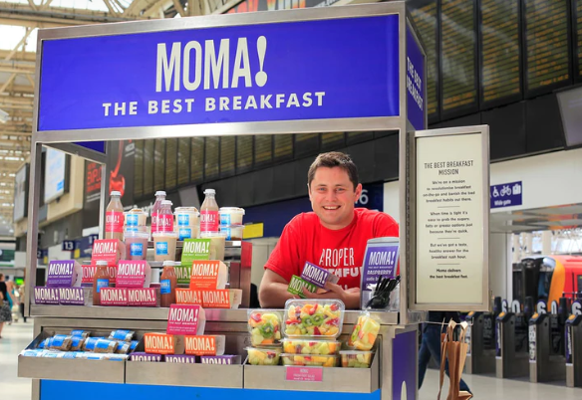
Figure 7: Selling MOMMA foods
(Source: MOMMA Foods, 2022)
Another customer asks the question to another male content creator, “Are these products natural, or artificial? I mean, is there any kind of preservatives available in these products? I mean I don’t want to waste my money.” As a reply, he said, “Dude, if you are a fan of me, mark my words, these are not diet foods, these are deserts without any calories”. The entire conversation was very nice, and people started to buy the products after their reviews.

Play games with MOMMA Foods, and earn more rewards!
The company has arranged different interactive games while promoting its products to make people more engaged in their industry. The event organiser gave a clue about a product, and people had to guess the name of the product. Every right guess will get 100 points in their MOMMA wallet, and at the end of 20 questions, whoever is left with the highest points will be the winner, and win exciting rewards. Through this event, the customers got the chance t to interact with the company’s representatives directly. The first question that was asked by the company’s executive was-
what is the product that is going to launch?
Options: a) Granola
b) Muesli
c) oats.
Customers became very confused, and the right option was not there, but some of them raise their hands, and said” Look, the right answer is ‘Diet flattened rice”, but you did not give us the option.” In reply, the executive said, “You gave the right answer, and that was the catch because right answers are not always available in the options.” the winner got an exciting hamper from the company and a voucher also. Many of the customers tried to answer, but they failed. The manager of the company said, “People who have participated in the quiz will be rewarded. No matter whether they won the game or not!” everyone was very happy and satisfied after the game. Some of them addressed the manager by saying,” Hope we will get the best product with the best services”. In a reply, he said, Of course, Sir, I am always at your service, and our company is always trying to do better. Please don’t forget to give your feedback, thank you”. The conversations were quite positive, and the customer response was also very good.

Delivery at the Doorstep
The company is not only launching new products but it will also be available online in different countries for supplying healthy and tasty foods. Through online orders, people can order their food, and the company will give delivery accordingly. After receiving the order, the company will prepare fresh porridge, and deliver the products to the address of the customers.
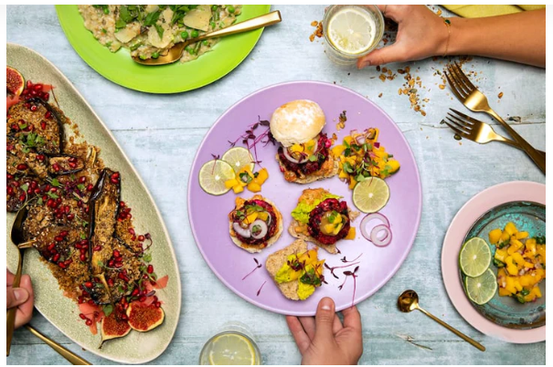
Figure 8: Delivering at home
(Source: MOMMA Foods, 2022)
Decorating the food palette with the amazing recipes of the company is a brilliant approach because the organisation also provides some healthy food recipes available online. Therefore, using an online market strategy will be very useful for the organisation to increase its overall profit.

Meet, and greet with Porridge lovers
The health lovers especially the porridge lovers were invited to another event where a meet and greet was organised to interact with the customers.
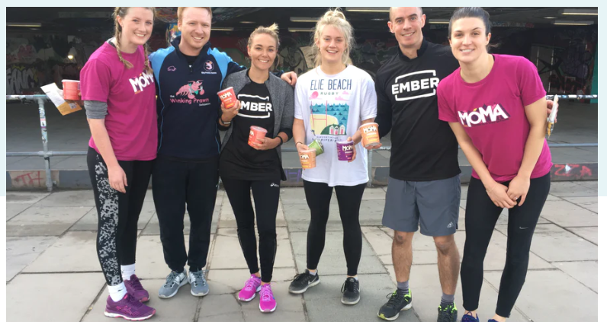
Figure 9: Meet, and greet customers
(Source: MOMMA Foods, 2022)
In this session, several questions were asked by the customers, and the company’s executives also asked some questions to them to understand their demands. One male customer asked the male executive, “How can you be so sure about the product?”As a reply he said,” I am very sure about this product because I have used the product, sir.” another question that was asked by a female customer to the female executive was- “Are the products natural, because I am very cautious about using these artificial products.” She replied,” Yes mam, these are natural products, and nothing artificial is used in the products. So you can be assured about this.” Some of the male executives asked the customers,” How much do you trust our company?” They replied, “We trust you, but the quality of the products should be premium.” After the interaction session, the motive of the organisation has become very clear, and they have tried their best to communicate with the customers by clearing their doubts as much as possible.

References:
MOMA Foods. 2022. Home. available at. https://www.momafoods.co.uk/pages/about-us. [Accessed: 25 August]
Sudari, S., Tarofder, A., Khatibi, A. and Tham, J., 2019. Measuring the critical effect of marketing mix on customer loyalty through customer satisfaction in food and beverage products. Management Science Letters, 9(9), pp.1385-1396.

