AI EFFECT IN HUMAN RESOURCE MANAGEMENT- OPERATIONS OF SHELL PLC

Student Name: S. Lakshmi Durga
Student I’D: 2228190

Contents
Chapter 1: Introduction 5
1.1 Introduction 5
1.2 Background of Study 5
1.3 Research Aim 5
1.4 Research Objective 6
1.5 Research Questions 6
1.6 Research Rationale 7
1.7 Problem Statement 7
1.8 Research Significance 8
1.8 Research Framework 8
1.9 Conclusion 9
Chapter 2: Literature Review 10
2.1 Introduction 10
2.2 Empirical Study 10
2.2 Artificial Intelligence in Talent Acquisition: A Productivity and Success Evaluation 13
2.3 Influence of Artificial Intelligence on Training, Career Advancement, and Performance Reviews 16
2.4 Employee Perspectives on Artificial Intelligence in Human Resource Management 17
2.4 Ethical Considerations: Use of Artificial Intelligence in HR Procedures 20
2.6 Literature Gap 21
2.4 Conceptual Framework 22
2.5 Summary 23
Chapter 3: Research Methodology 24
3.1 Introduction 24
3.2 Outline of Chosen Methods 24
3.3 Research Philosophy 25
3.3.1 Justification for Choosing this Philosophy 25
3.4 Research Approach 25
3.4.1 Justification for Choosing this Approach 26
3.5 Research Design 26
3.5.1 Justification for Choosing this Design 27
3.6 Data Collection 27
3.6.1 Sampling 28
3.6.2 Questionnaire Design 28
3.7 Data Analysis 29
3.8 Reliability and Validity 30
3.9 Ethical Consideration 30
3.10 Summary 30
Chapter 4: Data Analysis 32
4.1 Introduction 32
4.2 Quantitative Analysis (Survey Responses) 32
4.3 Qualitative Analysis (Thematic) 46
Theme 1: Assessing Association Utilization of artificial intelligence for upgrade enrollment proficiency robotics applicant screening and further Advance varieties efficiency and achievements rate. 46
Theme 2: Examine AIS role in personalized employee training career development and performance review to enhance overall HR operations. 48
Theme 3: Investigating how employees perceive and respond to AI implementation in HR processes, focusing on benefits, concerns, and potential impacts on job security. 50
Theme-4: Looking at the Moral Components of PC-based absolute intelligence Execution in Shell Plc's HR, Tending to Worries of Algorithmic Predisposition, Information Security, Straightforwardness, and Availability of Artificial Intelligence Driven HR Cycles. 52
4.4 Discussion 54
4.5 Summary 59
Chapter 5: Conclusion and Recommendations 61
5.1 Conclusion 61
5.2 Linking with Objectives 63
5.3 Future Scope of Research 64
5.4 Limitations of Research 65
5.5 Recommendations 65

Chapter 1: Introduction

1.1 Introduction
Shell plc, a multinational petroleum and petrochemical company headquartered in the United Kingdom, is committed to providing environmentally friendly energy solutions to fulfill the increasing demand for these solutions globally. To deliver energy sustainably for the economy, the environment, and society, Shell collaborates on hydrocarbons and works with upstream, downward, green energy and power arrangements, investments, and technology.

1.2 Background of Study
The demand for AI talent has increased as a result of organizations like Shell Petroleum Corporation realizing how important it is to have employees with experience in the field. According to a LinkedIn analysis, there is an increasing demand among consumers for artificial intelligence skills, indicating the growing importance of AI in the job market. That demand reflects the need for individuals who can leverage AI technologies to drive innovation and transform HR practices. AI in HR is becoming more and more common, especially in the wake of the COVID-19 pandemic. Numerous organizations have recognized the possibility of utilizing PC-based intelligence to get through the obstacles this pervasive problem presents.

1.3 Research Aim
The purpose of this research is to examine the use of artificial intelligence in digital information management systems used by companies such as Shell Plc. The research emphasizes how digital information management contributes to the understanding of the critical role that each service contributes with beneficial effects to business leadership in Human Resource Management, as well as how certain services, such as increasing productivity, improving decision-making processes, and improving HR practices, are more significant.

1.4 Research Objective
- To examine how Shell Plc uses artificial intelligence in talent acquisition, evaluating computer-driven hiring processes based on intelligence in terms of productivity, variation, and success levels.
- To investigate how training programs, career advancement, and representative performance reviews are influenced by artificial intelligence tools within Shell.
- To investigate how representatives of Shell plc view and respond to advancements in artificial intelligence-based human resource management.
- To look into the moral ramifications of Shell Plc's use of artificial intelligence in HR procedures. concentrating on certain issues, like a propensity for algorithmic advice, concerns regarding data security, and the ease of use of AI-driven HR processes.

1.5 Research Questions
- What impacts does artificial intelligence have on employing strategies in conditions of productivity, assortment, and achievement rates, and how in all actuality does Shell Plc utilize it to secure ability?
- How do artificial intelligence innovations influence Shell's agent execution appraisals, profession advancement, and training projects, and what quantifiable outcomes are there?
- What are the considerations and responses of Shell Plc agents on the most recent advancements in AI-driven HRM at the company?
- What ethical questions are raised by Shell Plc's utilization of AI in HR processes, explicitly about bias in the algorithm, data security, and accessibility?
- What specific disadvantages and benefits accompany Shell's AI-driven HR systems' tendency towards algorithmic guidance?

1.6 Research Rationale
In light of multiple factors, it is urgent to concentrate on how artificial intelligence (AI) affects "human resource management (HRM)" exercises for organizations, with a specific emphasis on Shell Plc. The developing acknowledgement of AI gifts and innovation by associations requires careful handling of their application in human resource management. The objective of the review is to reveal insight into Shell's utilization of AI in enrolling employees by examining how it affects recruiting process productivity, fluctuation, and achievement rates. Again, the review explores what AI advances mean for professional improvement, execution surveys, and training programs, giving a careful handle on quantifiable outcomes in these domains (Prenticeet al., 2020). The demand likewise envelops the perspectives and responses of Shell Plc's chiefs about advancements in AI-controlled HRM, gathering laborer encounters and mentalities considering mechanical changes. Another significant region that is inspected is morals, which covers subjects like algorithmic prejudice, data security, and the overall availability of AI-driven HR techniques at Shell. The examination reasoning aims to give huge experiences into the more extensive conversation on the effect of AI on current HR rehearses by investigating the advantages and disadvantages of Shell's fueled AI HR frameworks.
The research extensively reviews the different perspectives and views present within Shell, as the employees have different ideologies when the amalgamation of AI within the human resource practices is considered. As the employees are required to change their means of work post the inclusion of the technology which has impacted their experiences toward AI. The research has also effectively talked about how the ethical considerations along with how data security and algorithmic bias of the organization has taken a turn.
The following research provides a balanced analysis of the crucial insights as on how Ai has been impacting the HR practices.

1.7 Problem Statement
The appropriate implication of artificial intelligence in the existing practices of human resource management initiatives are greatly being overlooked within global organizations talking specifically about Shell Plc. There have been different issues and challenges being faced by the company, through this integration the company has been able to attain various opportunities as well. There has been a declination towards the human resource strategies as there has been a great call for the amalgamation of the AI talent sourcing. The report has helped in effectively addressing the urgent needs of the influence of AI within the domain of talent sourcing, training and development programs for the employees within the company. The prominent issues that have been encountered within Shell are the biases within the algorithms and the rising concerns of data security which has also impacted the organization’s access towards AI enabled human practices.

1.8 Research Significance
The meaning of examining the effect of artificial intelligence (AI) in human resource management (HRM) tasks, especially inside a global industry leader like Shell Plc, couldn't possibly be more significant. As associations around the world, including Shell, progressively perceive the basic job of AI in talent acquisition and management, understanding the implications becomes essential. The examination holds importance in a few aspects (Panet al., 2022). In this case, the review tends to the squeezing interest for AI talent, a pattern seen through platforms like LinkedIn, featuring the developing significance of AI abilities in the gig market. With regards to Shell, a global oil and petrochemical organization, the combination of AI in HRM tasks isn't just a reaction to showcase requests yet in addition an essential move towards effective talent acquisition and management. Researching how Shell uses AI in talent acquisition processes, for example, PC-driven recruiting gives bits of knowledge into the productivity, variety, and achievement levels of these systems.

1.8 Research Framework
The research framework aims to assess the utilization and effects of artificial intelligence in human resource management (HRM) undertakings at Shell Plc. It covers different dimensions of AI implementation, including talent acquisition, employee execution evaluations, career progression, training programs, and ethical contemplations. The essential research objective is to assess how AI is utilized in talent acquisition, evaluating its effect on productivity, enlistment variety, and accomplishment rates (Mohammed, 2021). The subsequent goal is to explore the effect of AI on training programs, career headway, and execution overviews inside Shell. The third goal is to comprehend employees' points of view on AI-driven HRM, gaining experiences in their discernments and regions for advancement. The fourth objective is to look at ethical worries connected with algorithmic inclination, data security, and the receptiveness of AI-driven HR processes. The last goal is to analyze the advantages and downsides of Shell's AI-driven HR systems, zeroing in on algorithmic courses. Generally speaking, the research framework gives a thorough and diverse way to deal with understanding the impacts of AI in HRM undertakings at Shell Plc.

1.9 Conclusion
Shell plc, a worldwide petrol and petrochemical organization settled in the Unified Realm, is focused on giving harmless to the ecosystem energy answers to satisfy the rising interest for these arrangements globally. To convey energy sustainably for the economy, the climate, and society, Shell collaborates on hydrocarbons and works with upstream, descending, environmentally friendly power energy and power courses of action, ventures, and technology.
The agenda of the project was to effectively comprise a study that helps in exploring the ways through which the organization has been able to onboard the employees with the help of artificial intelligence as the efficiency of the employees and the diversity is directly associated with the practices adopted by businesses.
Additionally, the business has been required to conduct thorough analysis that helps them in attaining the predetermined objectives and expectations of the business. The research has effectively talked about how a deep understanding of the subject provides the right path that determines the success of the organization. The research has talked about how crucially the roadmap toward implying AI in the business operations has helped Shell in attaining efficiency in terms of dealing with the present issues and challenges. The research has effectively comprised the peaceful and practical amalgamation of the fundamental principles of the productive human resource management.

Chapter 2: Literature Review

2.1 Introduction
Artificial intelligence (AI) has altered talent acquisition in different enterprises, including the foundry business. In any case, there is a critical literature gap concerning its implementation and effect on the foundry business. The foundry business, portrayed by Metal Anticipating, presents novel difficulties and necessities that require a particular spotlight on talent acquisition. Current literature features the advantages of AI in HRM, such as expanded capability and variety. Nonetheless, the complexities of talent acquisition in foundries, such as perceiving abilities applicable to metal anticipating, tending to somewhere safe worries, and tending to industry-explicit difficulties, remain unexplored. Tending to this literature gap is essential for future research, zeroing in on AI's viable applications in talent acquisition for foundries and exploring its potential to address sustainability concerns.

2.2 Empirical Study
Shell Plc has decisively consolidated artificial intelligence (AI) in its talent acquisition processes, revolutionizing traditional employing strategies. According to the writer, Dempere (2023), Leveraging the force of AI, Shell aims to upgrade productivity, introduce variety, and increment achievement levels in its talent acquisition attempts. The implementation of computer-driven employing processes, driven by intelligent algorithms and machine learning models, has altogether smoothed out and enhanced the enrollment cycle (Misraet al., 2020).
AI can make employing and choosing faculty simpler for human resources supervisors. AI-controlled innovations are utilized to find qualified contenders for an opportunity rapidly. Also, it could screen out up-and-comers who don't meet certain necessities, guaranteeing that Shell Plc and different organizations pick the best competitor. This sets aside time and cash by guaranteeing that simply the best applicants have been decided for each position (Dempereet al., 2023). Shell Plc, one of the notable makers of gas and oil, places a high value on having a shifted labor force to enhance the organization's development potential. For the reasons that were recently examined, it can find the top competitors quicker than Shell Plc's employing directors. One main angle where AI adds to productivity is in the effective screening of huge datasets of potential applicants. By using AI algorithms, Shell can rapidly break down huge measures of data, including resumes, profiles, and expert foundations, to recognize top-level up-and-comers that line up with the organization's particular necessities (Makariuset al., 2020). This facilitates the employing system as well as guarantees a more designated and compelling determination of competitors.
According to the writer, Shiohira, (2021), inside Shell plc, Recruiters can utilize AI to analyze future labor demands while considering market trends, business strategy, and performance metrics. AI may also assist in producing precise and realistic descriptions of jobs by taking into account the abilities and dispositions required for each occupation. By utilizing strategies and language handling procedures to examine educational plan vitae, continue covers, and portfolios, AI moreover helps Shell Plc streamline and robotize the enlistment cycle (Shiohira, 2021). AI could moreover assist the organization with conveying pre-evaluating tests and appraisals in used gaming for intelligent configurations, such as mental ability, character traits, and expert assessments. By utilizing AI while assessing its possibilities, Shell Plc might diminish inclinations and blunders while setting aside time and cash.
According to the writer, Manickam (2022), artificial intelligence can work with the headway of onboarding via mechanizing authoritative undertakings such as making accounts, completing administrative errands, and giving availability. This gives HR employees additional opportunity to zero in on the more urgent parts of the specialist onboarding reasoning, such as planning as of late recruited colleagues into the affiliation culture and consolidating them in. Repeated data could give modified onboarding encounters in light of all requirements and inclinations of each new enrollee, which can likewise advance fulfillment and backing (Manickamet al., 2022). This business implements AI to robotize techniques like employing, onboarding, and execution management. HR experts may now zero in a greater amount of their experience on significant obligations like creating talent and developing great associations with staff individuals. AI is moreover implemented to expand the exactness and productivity of HR processes.AI can likewise be utilized for execution appraisals and labor force planning, permitting Shell to expect future talent needs and distinguish potential abilities gaps. Artificial intelligence (AI) is a computer science-based method for managing tasks and algorithms that engage devices to intelligently and capably perform staff that ordinarily require gifted human intelligence. AI incorporates various subsets such as machine learning (ML), deep learning (DL), traditional brain organizations, cushioned reasoning, and talk affirmation, making novel ways of managing work on the show of current medicine.
The integration of AI can prompt more useful and informed choices, empowering Shell to pursue data-driven choices connected with labor force methods, variety, and talent maintenance (Raj and Seamans, 2019). In this condition, ethical worries, straightforwardness, and employee security are vital contemplations. Shell's employees are probably going to see AI in HRM as a pivotal power, encouraging a more agile, viable, and people-centric labor force.
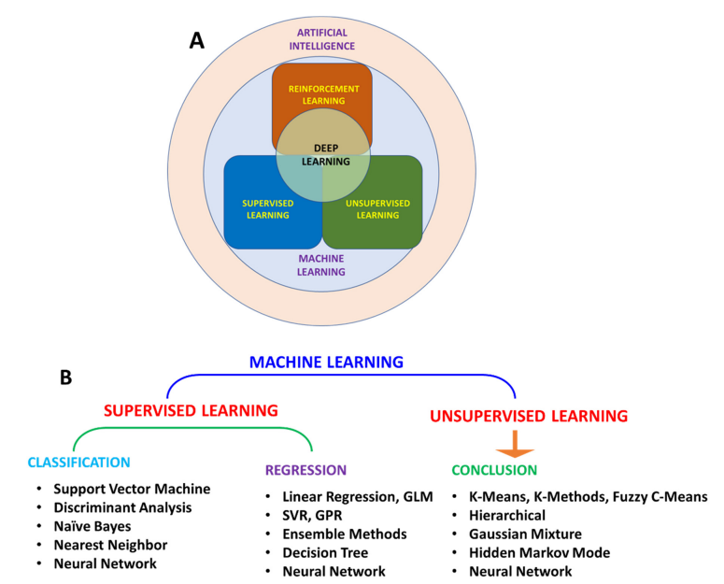
Figure 1: relation between AI, ML, and DL
(Source: Manickamet al., 2022)
According to the writer, Saliji (2022), Shell Plc's utilization of AI in HR systems raises ethical worries, especially regarding algorithmic inclination, data security concerns, and convenience. AI algorithms might reflect data inclinations, raising inquiries regarding fairness, equity, and potential discrimination (Saliji, 2022). Data security is pivotal, as the immense measure of delicate data handled by AI systems can be defenseless. Employees ought to feel open to teaming up with AI systems and have the chance to challenge choices. Ethical contemplations are expected to address algorithmic inclinations, guarantee data security, and work on the simplicity of AI-driven HR processes.

2.2 Artificial Intelligence in Talent Acquisition: A Productivity and Success Evaluation
Artificial Intelligence (AI) has converted numerous components of commercial enterprise operations, and one vicinity in which it has an effect on is especially noteworthy is in Human Resource Management, particularly inside knowledge acquisition. In this talk, we are able to delve into the impact of AI on knowledge acquisition, exploring its role in enhancing productivity and contributing to organizational fulfillment.
Streamlining Recruitment Processes:
One of the important advantages of integrating AI in talent acquisition is the capability to streamline and optimize recruitment procedures. Traditional recruitment strategies often include a large amount of manual attempt, from sifting via resumes to scheduling interviews. The AI era, which consists of applicant tracking systems (ATS), efficiently deal with these responsibilities, permitting HR specialists to recognize more strategic factors of capabilities acquisition (Arora, 2021).
Efficient Candidate Screening:
AI-powered gadgets excel in candidate screening, automating the initial tiers of the recruitment technique. These systems take a look at resumes, evaluate applicants based on predefined standards, and shortlist the most certified human beings. By automating this time-consuming challenge, AI now not most effectively hurries up the hiring process; however, moreover ensures an extra independent and steady screening way (Black et al., 2020).
Enhanced Candidate Matching:
Another noteworthy contribution of AI in expertise acquisition is its ability to facilitate precise candidate-undertaking matching. Advanced algorithms analyze candidate profiles, thinking about factors past just abilities and experience. This includes assessing cultural match, soft talents, and distinct intangible attributes. As a cease end result, corporations may want to make extra informed choices regarding candidate suitability, mainly to better prolonged-term hires.
Personalized Candidate Experience:
AI technology enables an extra personalized candidate to enjoy some unspecified time in the future of the recruitment journey. Chatbots and digital assistants, powered by means of using AI, engage with applicants, offering real-time updates on software program repute, answering queries, or even wearing out initial interviews. This now not best enhances the general candidate revel in but moreover presentations undoubtedly on the enterprise brand.
Data-Driven Decision Making:
The utilization of AI in knowledge acquisition generates big quantities of statistics that can be analyzed to derive meaningful insights. HR experts can leverage this data to pick out developments, diploma the effectiveness of recruitment strategies, and make knowledgeable decisions. Data-pushed tactics contribute to non-stop development inside the recruitment technique, mainly to better results and organizational achievement.
Reduced Bias and Increased Diversity:
AI systems have the potential to mitigate unconscious biases in the hiring manner. By counting on goal statistics and predefined standards, AI enables make sure truthful and constant reviews of applicants. This, in turn, contributes to extended range internal organizations, as hiring choices are primarily based on benefit in a region of subjective judgments (Carter et al., 2020).
Maximizing Resource Allocation:
AI's impact on know-how acquisition extends beyond the hiring system itself. The implementation of the AI era optimizes beneficial resource allocation inside HR departments. By automating ordinary duties, HR specialists can conserve strategic activities, which includes worker development and engagement. This reallocation of resources enhances common HR performance and ensures that human capital is utilized extra efficiently, contributing to the business enterprise's sustained success.
Continuous Learning and Adaptation:

Artificial Intelligence, with its capability to take a look at from data, helps non-stop development in expertise acquisition strategies. Machine studying algorithms analyze ancient hiring statistics to turn out to be aware about styles and inclinations. This information is priceless for refining recruitment techniques, adapting to market modifications, and staying earlier within the competition for top skills. The iterative nature of AI-pushed insights enables HR departments to stay agile in a dynamic technique marketplace.

Adherence to Compliance and Ethical Standards:
AI in talent acquisition also plays a vital characteristic in making sure adherence to compliance and moral standards. By relying on predefined standards and eliminating human biases, AI systems make a contribution to fair and apparent hiring practices. This no longer permits businesses to look at prison requirements but also fosters a moral art work environment (Lópezet al., 2021). The transparency supplied with the aid of AI technology builds agreement among applicants and stakeholders, similarly strengthening the agency's reputation.
Cost Efficiency and ROI:
Beyond its qualitative contributions, the combination of AI in talent acquisition brings about first-rate efficiencies. The discount in manual efforts, faster time-to-lease, and progressed desire-making methods together make contributions to a terrific cross lower back on investment (ROI). Organizations discover themselves saving whenever and sources, making AI a strategic investment with tangible blessings for the bottom line (Tulloch et al., 2020).

2.3 Influence of Artificial Intelligence on Training, Career Advancement, and Performance Reviews
In the ever-evolving landscape of Human Resource Management, the combination of Artificial Intelligence (AI) has brought approximately extensive adjustments in diverse components of employee development and assessment. This essay explores the impact of AI on schooling packages, professional development opportunities, and the overall performance evaluation procedure in the realm of Human Resource Operations.
Training Enhancement via AI:
Artificial Intelligence has revolutionized schooling methodologies, supplying a customized and green mastering revel in for employees. AI-driven systems analyze man or woman reading patterns and options, tailoring schooling content material to satisfy particular wishes. This no longer simplest guarantees a more enticing schooling technique but additionally maximizes understanding retention (Niyatoet al., 2024).
AI-powered simulations and digital truth tools have emerged as precious property in employee education. These technologies allow realistic and immersive situations, allowing personnel to exercise and refine their competencies in chance-loose surroundings. The end result is personnel that is better equipped to deal with actual-global demanding situations, enhancing simple usual performance and productivity.
Career Advancement Opportunities:
The integration of AI in Human Resource Management has extended career development opportunities for personnel. AI algorithms check individual abilities, universal performance facts, and professional achievements to pick out capability candidates for the profession boom. This facts-driven method minimizes biases and guarantees an honest evaluation method.
AI additionally performs a vital role in capabilities management via figuring out abilities gaps inside the business enterprise. This allows HR experts to design focused training packages and improvement responsibilities, aligning employee skill devices with the evolving wishes of the employer (Iheduru‐Anderson,2020). As a result, personnel are higher located for career development, contributing to a more dynamic and agile personnel.
Performance Reviews Streamlined by way of AI:
Traditional overall performance evaluations frequently are afflicted by subjectivity and inconsistency. AI has added a more statistics-pushed and intention approach to normal performance critiques. Automated systems analyze a multitude of performance metrics, which includes productiveness, undertaking crowning glory, and interpersonal abilities, presenting a comprehensive and impartial assessment.
AI-driven universal performance opinions aren't restrained to annual evaluations. Continuous monitoring and remarks mechanisms, facilitated through AI, allow for timely reputation of achievements and identification of regions for improvement.

2.4 Employee Perspectives on Artificial Intelligence in Human Resource Management
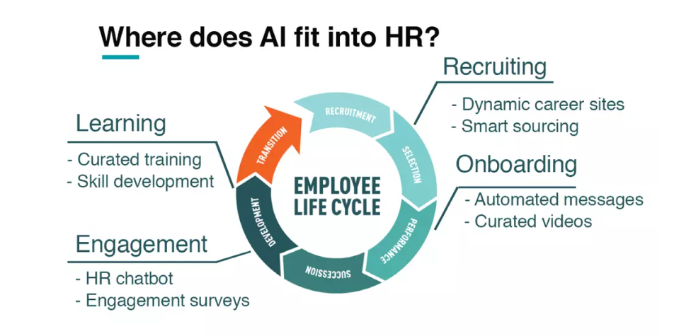
(Source: Biliavskaet al., 2022)
Tasks along with resume screening, candidate sourcing, or even preliminary interviews may be automated, saving treasured time for each HR professionals and activity candidates. This streamlined technique allows HR teams to pay attention to extra strategic elements of their roles, fostering a more dynamic and efficient painting environment.
Moreover, AI plays a pivotal role in fostering diversity and inclusion inside the place of business. By eliminating unconscious biases at some stage in the hiring system, AI structures make contributions to fairer recruitment decisions. Employees are increasingly spotting the nice effect of AI in selling an extra various and consultant team of workers, in the long run enriching the company lifestyle (Biliavskaet al., 2022).
Another thing that garners nice remarks is the role of AI in talent development. AI-driven tools can analyze employee performance data, figuring out skill gaps and recommending personalized training applications. This proactive technique to expert improvement is welcomed by personnel, because it helps continuous getting to know and growth, aligning character profession dreams with organizational objectives.
However, as with any technological advancement, concerns amongst personnel concerning process safety rise up. The fear of job displacement due to the automation of ordinary HR responsibilities is a winning sentiment. Employees fear the capability of downsizing HR teams, leading to extra impersonal painting surroundings. It is essential for groups to deal with these issues transparently, emphasizing the collaborative nature of AI and human efforts in achieving organizational goals (Biliavskaet al., 2022).
Moreover, the transparency and ethical use of AI are essential worries for personnel. The "black container" nature of some AI algorithms can result in skepticism and distrust. Employees choose readability on how AI is applied in decision-making techniques, mainly those related to performance critiques, promotions, and compensation. Open communication from HR departments about the moral suggestions and safeguards in the area can help alleviate those concerns.
Additionally, the problem of information privateness weighs heavily on the minds of personnel. AI systems regularly rely upon significant quantities of personal statistics to make knowledgeable decisions. Employees are rightly concerned about the safety in their touchy records and the potential misuse of records. Establishing strong data protection measures and communicating those measures to employees is critical in constructing accept as true with and making sure compliance with privacy policies.
Looking past the immediate impact on HR procedures, personnel are also spotting the ability for AI to enhance their universal painting experience. AI-pushed chatbots and virtual assistants, as an example, provide short and green responses to recurring HR queries, imparting personnel with timely statistics and guidance (Mich,2020). This accessibility complements communication channels between personnel and HR, fostering a more responsive and employee-friendly place of job.
Furthermore, the predictive analytics skills of AI make a contribution to an extra strategic technique in the body of workers planning. By analyzing historical information and figuring out traits, agencies could make knowledgeable choices about staffing ranges, talent requirements, and succession making plans. Employees respect the foresight verified by using AI in watching for organizational wishes, leading to an extra strong and forward-questioning painting environment.
On the turn aspect, the ability for algorithmic bias remains a massive situation. Employees fear that the algorithms utilized in HRM methods would possibly inadvertently perpetuate current biases or introduce new ones. It is vital for corporations to regularly audit and first-class-tune their AI systems to make certain equity and equity. This proactive technique allows self-assurance among personnel within the objectivity of AI-driven selections.
Moreover, the ongoing want for upskilling to evolve to AI-pushed processes is stated via employees. While AI can deal with ordinary obligations, human judgment, creativity, and emotional intelligence remain irreplaceable. Employees express a willingness to engage in continuous mastering to stay applicable in a more and more automated work landscape. Organizations, in turn, want to provide reachable and effective training applications to assist employees in obtaining the abilities to collaborate successfully with AI technologies.

2.4 Ethical Considerations: Use of Artificial Intelligence in HR Procedures
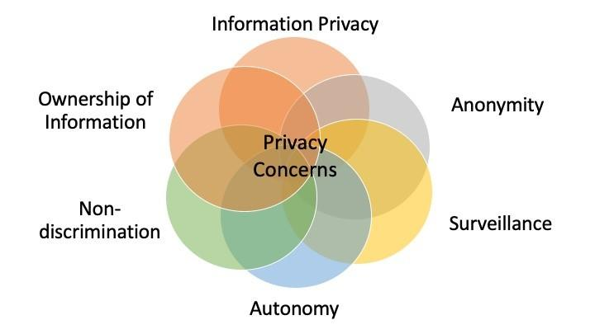
(Source: Mehrabiet al., 2021)
Fairness and Bias:
One crucial moral consideration in AI-driven HR operations is the potential for bias. AI algorithms are designed to research massive datasets and make selections based totally on styles. However, if the data used to educate these algorithms contains biases, it is able to lead to discriminatory results. For example, biased hiring algorithms ought to perpetuate current inequalities, favoring sure demographics over others (Mehrabiet al., 2021).
Transparency:
HR choices closely impact employees' lives, from hiring to overall performance critiques. It is essential for employees to apprehend the standards used by AI structures to make these choices. Transparent AI procedures foster acceptance as true within personnel, decreasing worries associated with opacity in choice-making (Sunny et al., 2020). Companies have to prioritize transparency, supplying clear verbal exchange approximately the use and implications of AI in HR processes.

Privacy:
AI in HRM regularly involves the collection and analysis of widespread amounts of private statistics. Protecting employee privacy is paramount in moral AI implementation. Organizations ought to set up strong records safety guidelines, ensuring that touchy statistics is treated securely and used most effectively for legitimate HR functions (Wang et al., 2022). Clear consent mechanisms must be in place to inform personnel approximately the collection and utilization of their information, reinforcing acceptance as true within the organization's commitment to privacy.
Job Displacement and Reskilling:
As AI technology automates positive HR responsibilities, worries about task displacement arise. Ethical issues demand that organizations prioritize the well-being in their body of workers. Initiatives for reskilling and upskilling employees whose roles may be suffering from AI implementations should be a core thing of HR strategies (Neffkeet al., 2024). This ensures that the introduction of AI into HRM does not result in useless hardships for personnel however rather supports their professional improvement.
Accountability and Decision-Making:
Ensuring responsibility for AI-driven selections is essential in maintaining ethical standards. Organizations ought to set up mechanisms to hint returned choices made via AI structures, taking into account scrutiny and rectification in case of mistakes or unintentional consequences. Human oversight stays vital, emphasizing that AI ought to augment human selection-making in place of updating it totally (Cobbeet al., 2021). This method guarantees that ethical concerns are not noted in the pursuit of efficiency.

2.6 Literature Gap
The literature on the integration of artificial intelligence (AI) in talent acquisition processes inside the foundry business has all the earmarks of being restricted, featuring a huge gap in the current research. While the more extensive applications of AI in HRM have been explored across different areas, there is a shortage of concentrates explicitly tending to its implementation and effect on foundries. The foundry business, portrayed by its extraordinary cycles of metal projecting and the development of metallic parts, presents particular difficulties and necessities in terms of talent acquisition (Sofiaet al., 2023). Existing literature overwhelmingly centers around the general advantages of AI in HRM, such as upgraded productivity, variety, and further developed direction. Be that as it may, the particular subtleties and complexities of talent acquisition inside foundries, including the ID of abilities significant for metal projecting, security contemplations, and the business' unmistakable work prerequisites, remain to a great extent unexplored. Besides, the literature needs bits of knowledge into how AI can address the business explicit difficulties, such as the requirement for a mix of large-scale manufacturing and quick creation of short series, as well as the effect of tough work regulations on the foundry labor force (Holm and Lorenz, 2022). Understanding the literature gap about the foundry business is urgent for propelling research in this domain. Future examinations ought to dive into the applications of AI in talent acquisition for foundries, taking into account the business' extraordinary prerequisites and difficulties.

2.4 Conceptual Framework

Independent Variable:
Implementation of AI in HRM Operations of Shell plc

Employee Performance Improvement

Operational Efficiency Enhancement
Figure 2: Conceptual Framework
(Source: Self-created)

2.5 Summary
To all the more likely to comprehend the outcome of AI-determined apparatuses on the proficient management of HR devices in an organization, the specific situation of Shell Plc was explicitly chosen for this research study. This report aims to see better the impact of artificial intelligence (AI) strategies on the productive administration of the human resources (HR) process in corporate settings. The explanation given above explains that involving AI innovations for the reason deals with a different labor force through robotization and AI supports benefits. Bringing AI apparatuses into Shell Plc's overseeing human resources process made recruiting simpler and more coordinated. The major subjective data set from the momentum study will be utilized to obtain valuable knowledge in the field of research. One more of the notable organizations that produces gas and oil is Shell Plc, which employs a shifted scope of skill. To make positive development inside the organization, it assists with giving viable direction in regards to the organization of changes and training process for implementation.

Chapter 3: Research Methodology

3.1 Introduction
The presentation makes way for a fastidious investigation into the effect of man-made reasoning (artificial intelligence) on human resources inside the useful machine of Shell PLC. In the contemporary company scene, the combination of man-made intelligence upgrades in HR obligations is reshaping normal practices. This exploration manners to unwind the intricacies of this convergence, using a diverse method. As institutions discover this first-rate tour, records the nuanced ramifications of simulated intelligence in HR turns into basic. This segment portrays the exploration gadget imagined to dig into the multifaceted factors, giving a guide to facts about the growing connection among simulated intelligence and HR rehearses at Shell PLC.

3.2 Outline of Chosen Methods
In the picked research system for inspecting the impact of artificial reasoning (laptop primarily based intelligence) on human resources at Shell PLC, the framed techniques count on a crucial aspect in directing the examination. The focal aspect of this factor is to offer an intensive outline of the selected studies techniques. In this research the systematic sampling method has been used by the researcher.
The framed strategies include unique features like exploration approach, method, plan, statistics assortment, and research. Every component contributes especially to the assessment's widespread shape. It fills in as a manual for disentangling the difficult connection amongst artificial intelligence and HR rehearses at Shell PLC. By depicting the system, the scientist lays out an organized place to begin for the examination, making sure an orderly and extensive research of the subject.
This part plans to clarify how the picked strategies line up with the exploration targets, making for an effective examination of the multi-layered factors associated with the becoming a member of pc based totally intelligence in HR responsibilities at Shell PLC.

3.3 Research Philosophy
In embracing a post-positivism research reasoning, the expert acknowledges the innate intricacy of investigating the effect of artificial awareness on human resources at Shell PLC. Post-positivism perceives that while right insights exist, they're looking to find out thoroughly because of the effect of diverse context-oriented elements. The legitimization for choosing this manner of questioning lies in its functionality to encompass a nuanced comprehension of the multifaceted connections amongst artificial intelligence and HR rehearses. This philosophical function permits the professional to recognize the subjectivity inborn in deciphering information, cultivating a first rate and basic exam. By choosing submit-positivism, the assessment approach contributes a more all-encompassing issue of view to the continuous talk on becoming a member of man-made intelligence inside the enterprise HR scene, particularly in the functional shape of Shell PLC.

3.3.1 Justification for Choosing this Philosophy
The selection of post-positivism because the exploration reasoning for inspecting the effect of artificial recognition on human resources at Shell PLC is valid by way of the use of its inborn capabilities. Post-positivism acknowledges that reality is trying to completely seize dispassionately, underscoring the requirement for a first-rate idea of different factors of view. The scientist's desire is grounded inside the acknowledgment that the multi-layered nature of artificial intelligence in HR obligations requests a method that obliges great views and recognizes the predicted restrictions in venture outright objectivity. This manner of thinking lines up with the evaluation's expectation to discover the numerous-sided landscape of man-made intelligence effect on HR rehearses at Shell PLC, taking into account a greater comprehension of the difficulty. The picked- up-positivist feature mirrors a pledge to primary an in depth and complete examination that perceives the intrinsic intricacies inside the inspected region.

3.4 Research Approach
The exploration technique took on to cope with the combination of artificial brain power into human resources at Shell PLC consolidating both inductive and rational strategies. This desire is valid by way of the use of the want to completely look at the mind-boggling factors amongst simulated intelligence and HR rehearses. The inductive perspective lets in the expert to get critiques from unique perceptions of interior Shell PLC, together with a greater extravagant comprehension of the peculiarity. At the identical time, the rational technique gives an organized structure to testing previous speculations or models in the placing of the affiliation. By embracing the two methodologies, the assessment plans to discern out a few types of concord amongst developing new information and approving present day hypothetical viewpoints. This systemic duality enhances the exploration's power, ensuring an exhaustive assessment of the multifaceted exchange among automated reasoning and human asset obligations at Shell PLC.

3.4.1 Justification for Choosing this Approach
The legitimization for taking up an inductive-rational examination method lies in its ability to offer a radical exam of the impact of computerized reasoning on human resources at Shell PLC. The inductive component takes into interest the research of unique occasions inside the affiliation, empowering the extraction of logically vital research. This technique lines up with the evaluation's plan to get new information from noticed peculiarities inside Shell PLC. Then once more, the logical mind-set gives a prepared machine, walking with the attempting out of laid out speculations or fashions within the precise hierarchical setting. This double method is crucial, the use of the developments of each inductive and rational questioning to assure a balanced examination. By consolidating the ones techniques, the evaluation appears to offer a nuanced comprehension of the transaction among man-made reasoning and HR works on, including to the extra full-size talk in hierarchical exam.

3.5 Research Design
The exam configuration picked for gaining knowledge of the coordination of artificial intelligence into human resource at Shell PLC is exploratory in nature. The choice to pick out an exploratory plan is valid by using the want to dive into the intricacies and subtleties encompassing the crossing factor of simulated intelligence and HR rehearses inside the affiliation. Exploratory examination is especially wholesome to occasions in which the peculiarity underneath observation isn't always definitely mentioned or needs clean barriers. Given the advancing scene of artificial intelligence in HR, an exploratory plan empowers the scientist to reveal new bits of expertise, examples, and predicted relationships. This technique gives the adaptability to modify the exam cycle powerfully as bobbing up subjects and complexities unfurl in some unspecified time in the future of the exam. The exploratory plan is, thusly, instrumental in running with careful research of the multi-layered connection among automatic reasoning and human resource at Shell PLC.

3.5.1 Justification for Choosing this Design
The legitimization for selecting an exploratory examination plan in the exam of automated reasoning's impact on human resource at Shell PLC is mounted inside the concept of the exploration objectives. An exploratory plan is taken into consideration because of the growing and difficult nature of the subject. Shell PLC's advent to coordinating guy-made brainpower into HR rehearses calls for an adaptable and flexible methodology that may oblige unanticipated intricacies. This plan lets the scientist investigate novel studies, examples, and expected connections without assumptions, cultivating an extra profound comprehension of the peculiarity. The dynamic and iterative nature of an exploratory plan lines up with the evaluation's intention to locate growing topics and subtleties, supplying a mile accomplishing thing of view on the developing connection among laptop based totally definitely intelligence and HR duties. Generally, the exploratory examination configuration fills in as a systemic device to explore the unusual vicinity of artificial intelligence's reconciliation into HR within the useful shape of Shell PLC.

3.6 Data Collection
Chasing entire bits of facts, the examination attempts to utilize a double-pronged way to cope with statistics collection, integrating each essential and non-compulsory resource. Actual data might be amassed through prepared conferences, research, or perceptions, straightforwardly captivating with people or topics pertinent to the exploration dreams. This firsthand information is expected to offer genuinely one of a type, putting express memories into the peculiarity being scrutinized.
At the same time, optionally available facts can be acquired from present writing, academic articles, information devices, and documented information (Agustina et al., 2023). This strengthening information improves the broadness and profundity of the concentrate by consolidating laid-out information, hypothetical systems, and precise discoveries. The reconciliation of crucial and non-compulsory information collection techniques guarantees a sturdy and balanced research technique, consolidating the extravagance of direct encounters with the profundity of previous statistics. This meticulous approach is ready to yield a whole dataset, working with nuanced research and know-how of the exploration inquiries.

3.6.1 Sampling
The evaluation ballot could be customized to encourage reviews into precise viewpoints pertinent to the exploration goals, like authoritative manner of existence, employee success, or assignment the board rehearses (Croitoru et al., 2023). By targeted on distinct segments of the industrial enterprise business agency, the researchers aim to capture a whole view of employee perspectives.
The determined-on people may be chosen through a systematic sampling method, making sure sincere example throughout exceptional organizational elements (Siregar et al., 2023). This approach allows in gathering several critiques and insights applicable to the research goals.
The survey questionnaire can be designed to find out particular factors along with organizational culture, worker delight, and project management practices. An aggregate of closed-ended and open-ended questions may be used to collect every quantitative and qualitative data.

3.6.2 Questionnaire Design
In developing the survey for the research, then nicely deliberate questions might be delivered to individuals through Google Structures. The ballot intends to determine a few kinds of concord among curtness and profundity, making sure member willpower and the collection of massive studies. The inquiries will cover remarkable viewpoints applicable to the exploration of dreams, investigating topics like consultant fulfillment, hierarchical lifestyle, and the challenge of the board.
The plan will integrate a mixture of near-finished inquiries, foreordained response options, and unassuming inquiries to recollect qualitative statistics (Ayers et al., 2023). This blend tries to provide quantitative information to prepare for exams at the same time as moreover uplifting people to speak nuanced feelings. Using Google Structures works with talented statistics series, ensuring explicitly of cooperation and smoothed-out records on board. Before execution, the survey will go through a pilot to refine clearness and importance in the mild of member complaints. This careful way to address ballot configuration plans to get exhaustive reactions, which includes a sturdy comprehension of the hierarchical factors indoors at Shell Plc.

3.7 Data Analysis
The exploration takes on an extensive records examination method, coordinating both qualitative thematic research and quantitative evaluation studies, encapsulating a combined strategies research method. Personal, thematic exams include recognizing examples, topics, and massive memories inside the unconditional reactions from the survey. This method empowers a nuanced study of emotional encounters and factors of view.
At the same time, the quantitative compare exam uses measurable techniques to break down close finished reactions, giving mathematical statistics to prepared examples and styles. The incorporation of each qualitative and quantitative examination improves the evaluation's discoveries by using a manner of imparting a complete comprehension of the exploration questions (Hendren et al., 2023).
The qualitative and quantitative discoveries can be positioned to verify or differentiate research, giving a more robust and more nuanced translation. These combined techniques method uses the tendencies of each insightful strategy, making top-notch intensive and balanced studies of the complexities in the information accumulated from the individuals at Shell Plc.

3.8 Reliability and Validity
Reliability the Validity and legitimacy of the exploration discoveries is principal to preserve evaluation believability. Reliability is maintained through a thorough exam plan and method consistency. Using normalized assessment gadgets and cautious execution of statistics assortment structures offers forestall result replicability.
Legitimacy is tended to through the affiliation of exploration measures with deliberate builds. The poll's substance legitimacy is confident via integrating draw-close surveys inside the direction of its flip of activities, ensuring that the inquiries lure the particular viewpoints inside the authoritative setting. Simultaneously, the triangulation of subjective and quantitative records assets improves to give more legitimacy, considering an extra and extended way of translating the examination peculiarity (Othman and Ainamo, 2023).
To further decorate dependability, the exploration uses rater dependability tests for subjective statistics exams, making positive consistency in mission recognizable proof. Also, the sincere documentation of the exam improves its suitability. This persistent manner of addressing unwavering extreme good and legitimacy protects the reliability of the evaluation's consequences, insisting on the electricity and respectability of the examination.

3.9 Ethical Consideration
Ethical Considerations are crucial to the examination, stressing the government assistance and freedoms of contributors. Informed consent might be searched for by all members, illustrating the examination's motivation, techniques, and likely ramifications. Privacy is centered on anonymizing facts and defending individuals' personalities. Members reserve the privilege to tug out without consequences.

3.10 Summary
The examination embraces a blended techniques technique, consolidating qualitative topical research and quantitative evaluation studies to research hierarchical factors wholly and thoroughly. With a defined inspecting procedure, the test uses ten painstakingly planned questions through Google Structures. Thorough dependability and legitimacy measures, alongside moral contemplations, spotlight the evaluated validity, and member authorities assist. By finding subjective and quantitative discoveries, the exam intends to present a nuanced comprehension of employee encounters, hierarchical tradition, and venture-the-board insights. This comprehensive method adequate effective willpower to information at the same time as keeping moral norms in the course of the exploration cycle (Dyczko, 2023). Legitimacy measures, alongside moral contemplations, highlight the evaluated validity and member government help. By locating qualitative and quantitative discoveries, the exam intends to provide a nuanced comprehension of employee encounters and hierarchical culture and challenge the board's insights. This complete approach is a dedication to records while preserving ethical norms for the exploration cycle.

Chapter 4: Data Analysis

4.1 Introduction
The aggregate of Man-made brainpower (artificial intelligence) in Human resource management (HRM) have changed ordinary practices, mainly in enrollment, consultant training, and execution audits. This qualitative assessment investigates imperative questions inside the artificial intelligence HRM courting, underscoring smoothed-out enrollment, tweaked employee development, and taking a look at simulated intelligence execution (Vrontis et al., 2022). Moral ramifications encompassing Shell Plc's usage of artificial intelligence in HR are analyzed, zeroing in on algorithmic predisposition, facts safety, straightforwardness, and openness. The appraisal competencies of how artificial intelligence improves fashionable execution, variety, and efficiency while divulging worker issues and moral contemplations on this speedy developing HR scene.

4.2 Quantitative Analysis (Survey Responses)
Question 1: How familiar are you with the use of artificial intelligence in HR practices at Shell PLC?
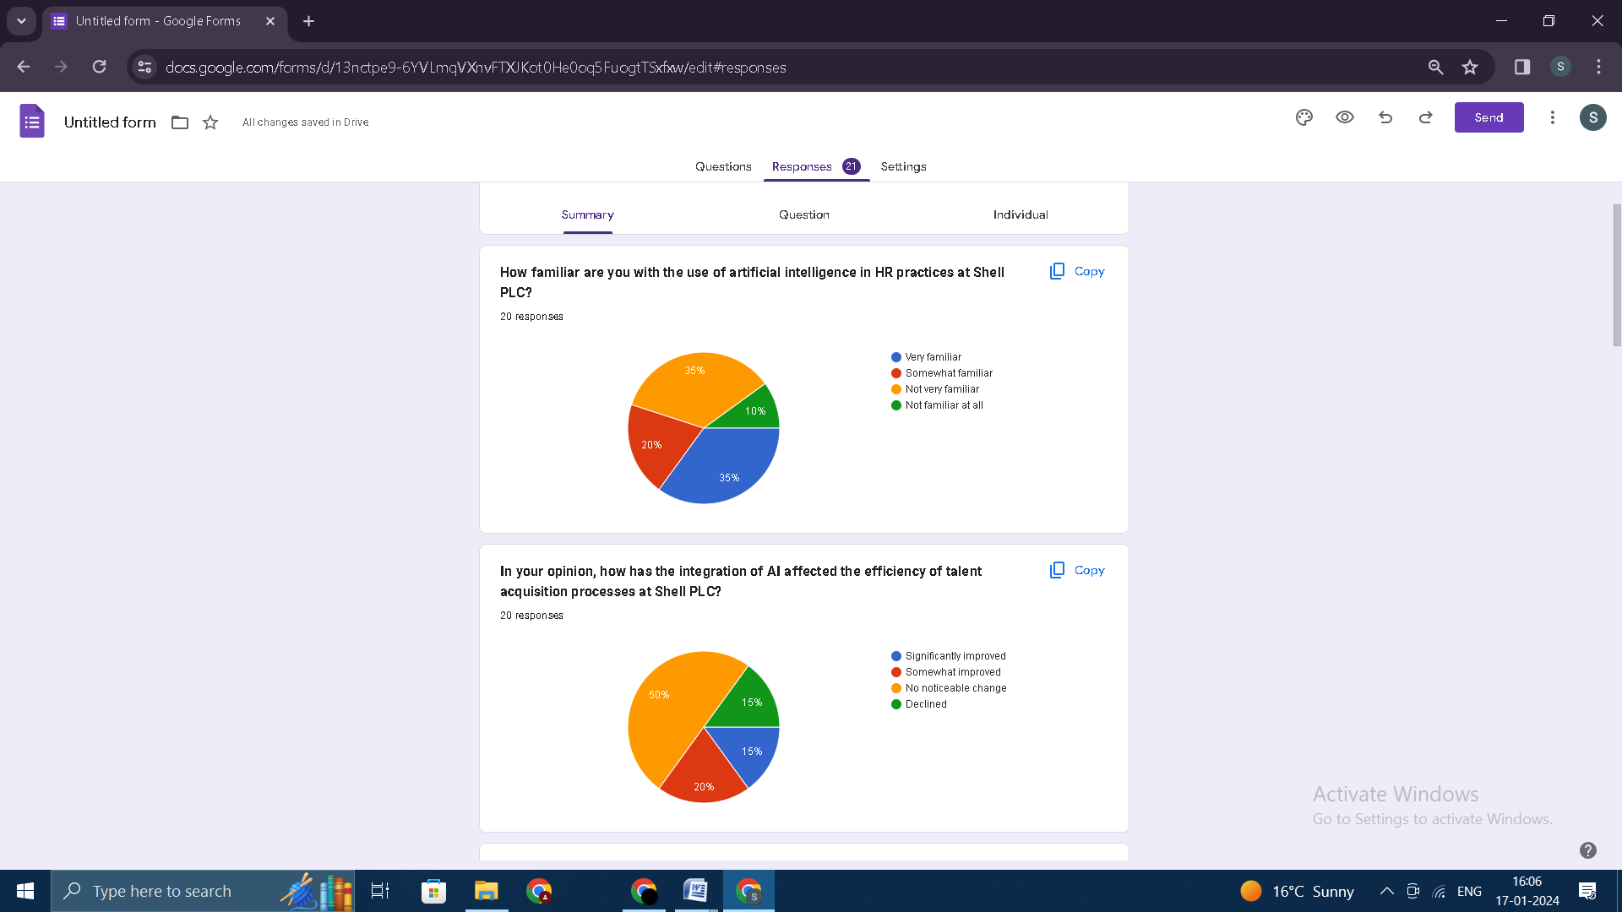
(Source: Google Forms)
Findings:
Based on the findings of the survey, it was discovered that employees working for Shell PLC have varying degrees of familiarity with the implementation of artificial intelligence (AI) in human resource practices. It is clear that there is a strong awareness of existing AI implementations and the possibility of having positive experiences with them, as indicated by the fact that a significant 35% of respondents stated that they were very familiar with the topic. While this was going on, 20% of respondents indicated that they had some familiarity with AI initiatives.
Analysis:
According to the findings, there's a want for targeted interventions which can be grounded within the numerous stages of familiarity that people have with the difficulty count number. As part of its human assets (HR) methods, Shell PLC is in a role to utilize the high-quality reviews of the very familiar institution to be able to further promote the adoption of artificial intelligence and innovation. It is vital to take a nuanced approach, which incorporates individualized conversation and education tasks, as a way to bridge the knowledge gaps that exist and to foster a more comprehensive information a member of the organization is extremely acquainted with. For the motive of addressing concerns raised via corporations which might be both not very familiar with artificial intelligence (AI) or aren't acquainted with it in any respect, it's far critical to enforce tasks that demystify AI technologies and demonstrate the benefits that they offer.
Question 2: In your opinion, how has the integration of AI affected the efficiency of talent acquisition processes at Shell PLC?
(Source: Google Forms)

Findings:
A wide variety of perspectives were expressed by those who participated in the survey regarding the influence that the implementation of artificial intelligence would have on the efficiency of talent acquisition at Shell PLC. The most significant group, which accounted 45% of the total, reported that they did not observe any discernible change, which is indicative of the prevalent belief that the implementation of AI had not significantly altered the effectiveness of talent acquisition procedures.
Analysis:
Furthermore, there is a need for this examination to be conducted. By gaining an understanding of the factors that contribute to this perception, it is possible to make modifications or enhancements to AI applications in order to better satisfy the specific requirements of talent acquisition procedures. This can be accomplished by leveraging the information gained from this understanding. It is of the utmost importance for the organizations that have reported improvements to be able to identify the specific aspects of the integration of AI that contributed to the perceived gains in efficiency. This is because the organizations need to be able to say that they have improved. However, the 15% of individuals who reported a decrease are deserving of consideration and call for a comprehensive investigation into the potential problems or obstacles that are preventing Shell PLC from successfully integrating AI in talent acquisition.
Question 3: To what extent do you believe AI contributes to diversity in the hiring process at Shell PLC?
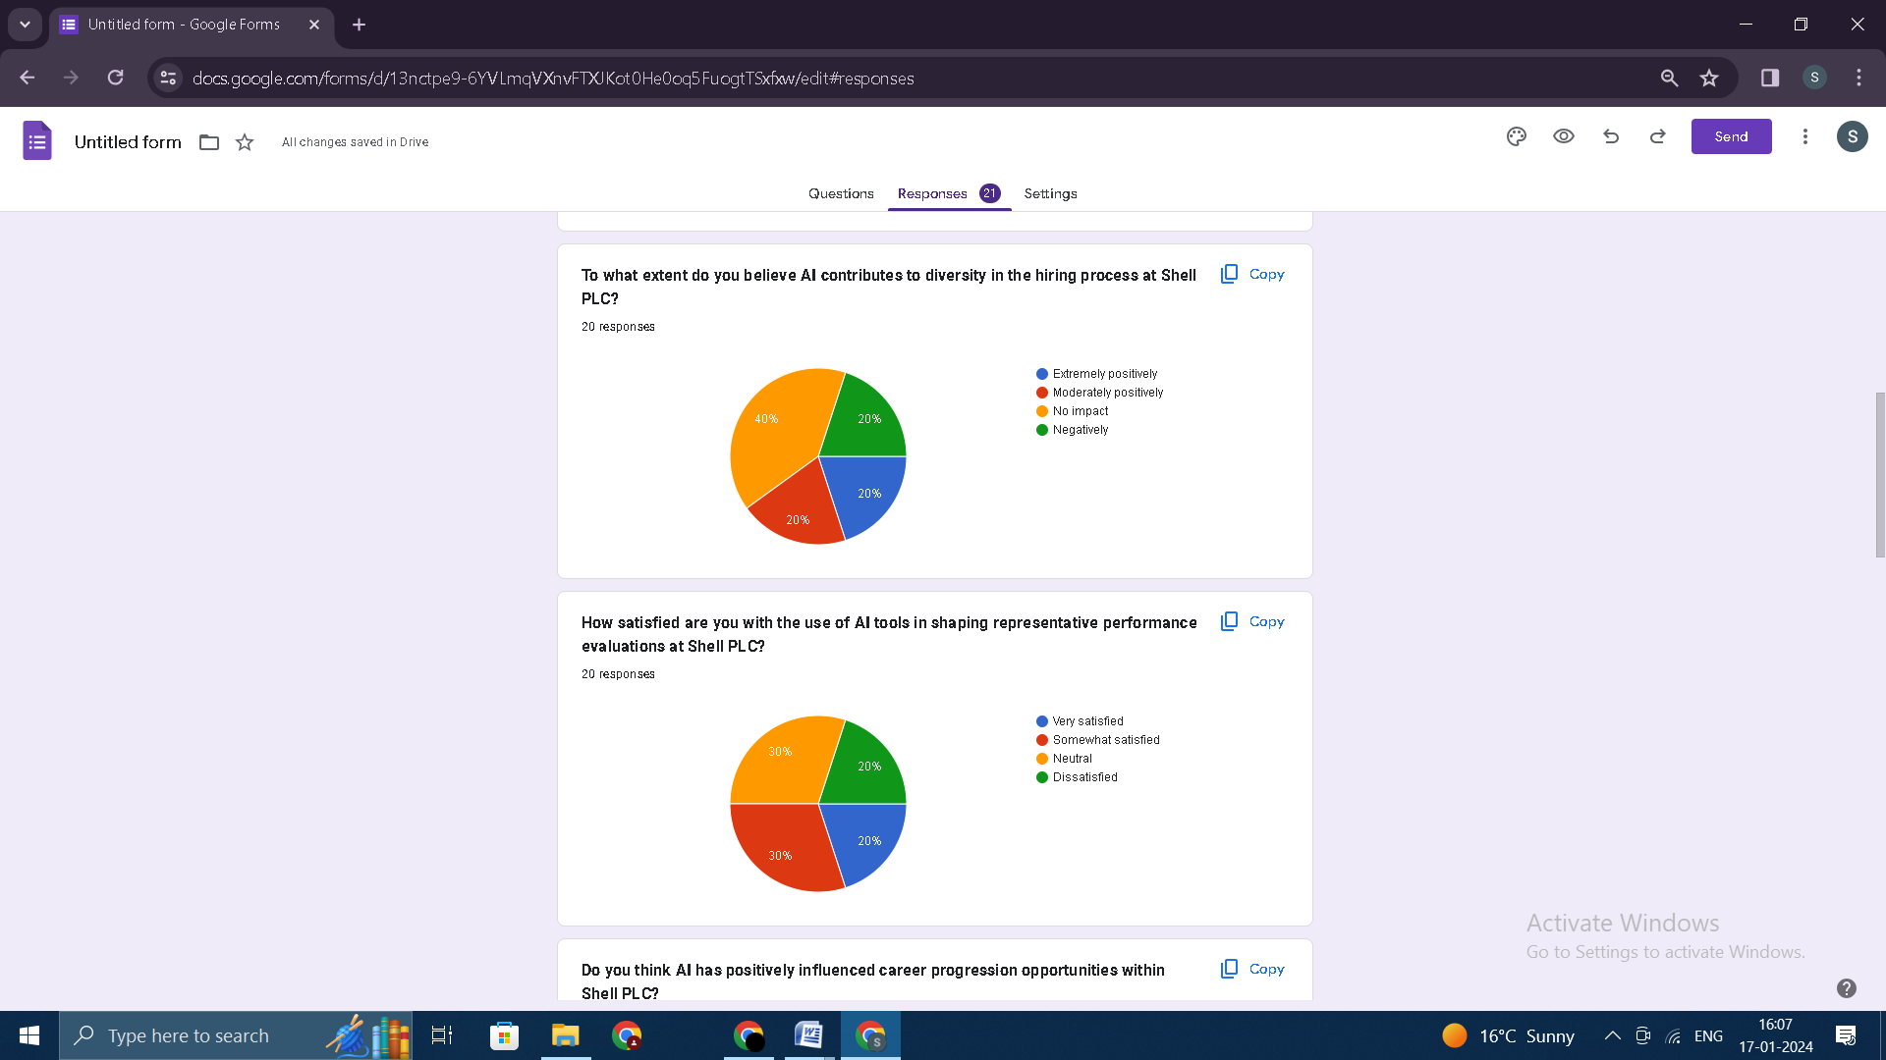
(Source: Google Forms)
Findings:
Participants within the survey have a spread of views, as evidenced via the responses they gave to the question of whether or no longer artificial intelligence (AI) contributes to range in the hiring system at Shell PLC. A huge 40% of respondents expressed the perception that artificial intelligence does no longer have any discernible effect on variety. This indicates that there can be a potential gap in the alignment of AI structures with the variety dreams of the company. This finding requires an important examination of the packages of artificial intelligence which are presently in use to make certain that they may be not accidentally contributing to the perpetuation of biases or impeding efforts to create a group of workers that is extra diverse. When it comes to addressing potential shortcomings and refining the position that AI plays in fostering inclusivity during the hiring procedure, it is important to have an intensive expertise of the precise motives that underlie this belief.
Analysis:
The diversity of evaluations amongst respondents, including the 20% of respondents who perceived a terrible impact, exemplifies the complexities and difficulties which might be associated with efficiently incorporating AI into hiring practices whilst concurrently keeping a focal point on variety. One of the most vital steps in refining applications of artificial intelligence and ensuring that they align with range goals and contribute to range dreams is to cope with the concerns raised with the aid of the minority that has a negative view of AI. In order to obtain this goal, it can be vital to reevaluate algorithms, enhance records sources, and put in force transparency measures so one can set up trust within the AI-driven hiring strategies concerned.
Question 4: How satisfied are you with the use of AI tools in shaping representative performance evaluations at Shell PLC?
(Source: Google Forms)
Findings:
Utilizing artificial intelligence tools for performance evaluations can be modified and improved in the future with the assistance of this information, which can be used to make adjustments and improvements. Shell Personal Limited employees are the target audience for this initiative, with the objective being to address their concerns and improve their overall satisfaction.
Analysis:
The difficulty of incorporating artificial intelligence into human-centered processes is highlighted by the fact that there is a wide range of opinions regarding the level of satisfaction with artificial intelligence tools that are used in performance evaluations. Positive responses highlight areas of success that can be further emphasized, whereas negative responses from the group that were dissatisfied signal areas that require improvement and refinement. Both sets of responses are important.
Question 5: Do you think AI has positively influenced career progression opportunities within Shell PLC?
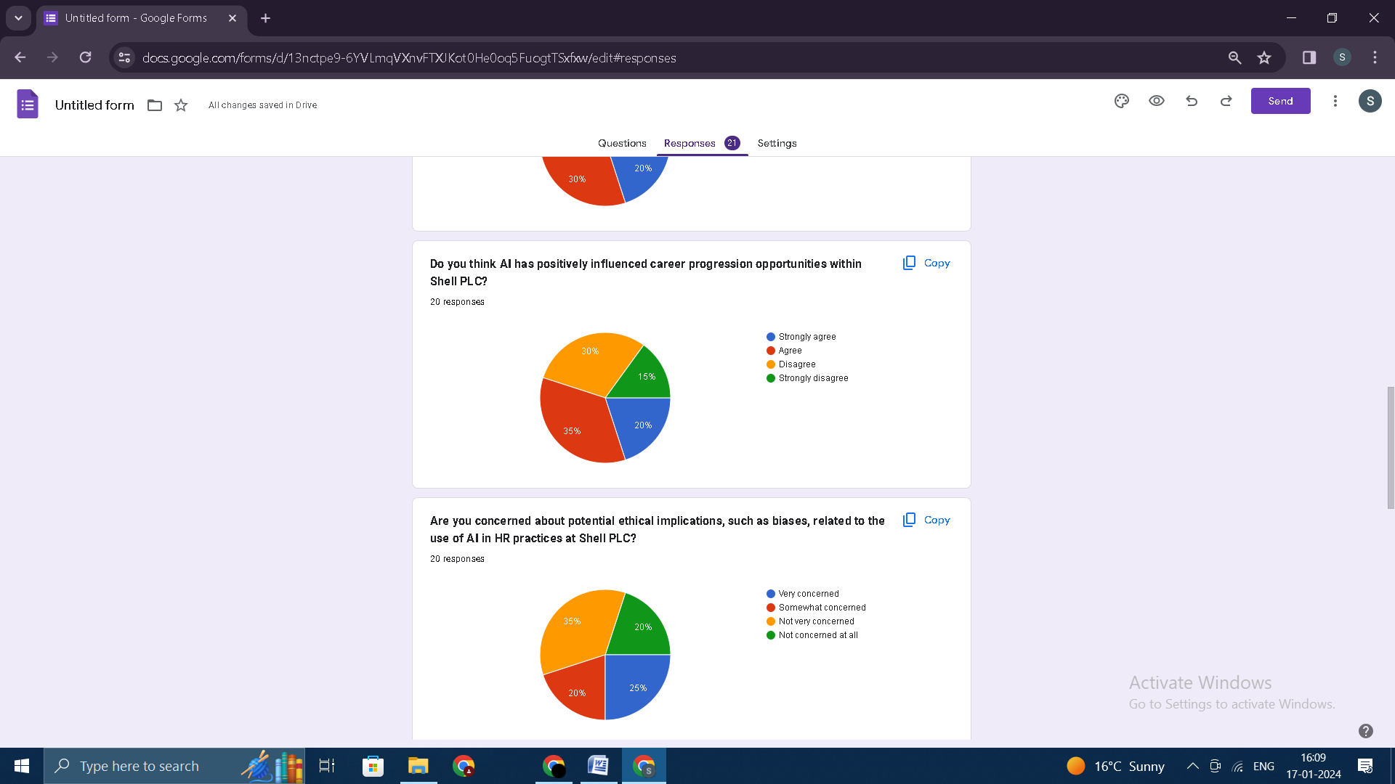
(Source: Google Forms)
Findings:
When it comes to the effect of artificial intelligence (AI) on professional advancement opportunities inside Shell PLC, the responses of the contributors to the survey screen a wide variety of opinions and points of view expressed by respondents. 55% of respondents agreed with the declaration that artificial intelligence has positively stimulated profession development. 20% of respondents strongly agreed with the announcement, and 35% of respondents agreed with the announcement. On the other hand, 45% of folks who participated in the survey had been against the proposition, with 30% expressing disagreement and 15% strongly disagreeing with it. It is essential to conduct a closer investigation into the perceptions of personnel that allows you to identify the specific components of the implementation of AI that make a contribution to perceptions which might be either positive or bad regarding the effect it has on professional development. This disparity highlights the necessity of accomplishing such an investigation.
Analyses:
Taking into consideration the positive responses, it is evident that a sizable proportion of workers consider artificial intelligence to be a driving force behind career advancement. The strategies that can be used to amplify the benefits of artificial intelligence in shaping career trajectories can be informed by an understanding of the factors that contribute to this positive perception. There are a number of factors that contribute to its positive perception. It is essential, on the other hand, to address the concerns that have been raised by those who disagree in order to identify potential challenges and refine AI applications in order to position them in a manner that is more closely aligned with the expectations and aspirations of employees for career advancement within Shell PLC.
Question 6: Are you concerned about potential ethical implications, such as biases, related to the use of AI in HR practices at Shell PLC?
(Source: Google Forms)
Findings:
These feelings are reflected in the responses to the survey that was asked about concerns regarding potential ethical implications related to the use of artificial intelligence in human resource practices at Shell PLC. There is a wide range of feelings that can be expressed in a variety of different ways, and these feelings are reflected in the responses.
Analysis:
It is important to address ethical considerations associated with artificial intelligence in human aid practices, and the existence of issues, especially those that had been categorized as "very concerned," highlights the importance of doing so. The reality that these issues deliver to mild the significance of addressing them makes it vital that they be addressed. To identify and address any ability biases that can be present within the artificial intelligence systems which can be currently being utilized, it is essential to carry out a complete analysis of these systems. This evaluation must be performed with the intention to identify and address any ability biases. This evaluation is something that needs to be achieved. Furthermore, this finding indicates that there may be a want for transparent communication and schooling applications on the way to alleviate concerns and foster a more expertise of the ethical frameworks which can be found in human resource practices that are pushed with the aid of artificial intelligence at Shell PLC. This is due to the fact the findings suggest that there may be a need for conversation and education programs which might be open and obvious.
Question 7: How well do you think Shell PLC communicates the ethical considerations associated with AI in HR to its employees?
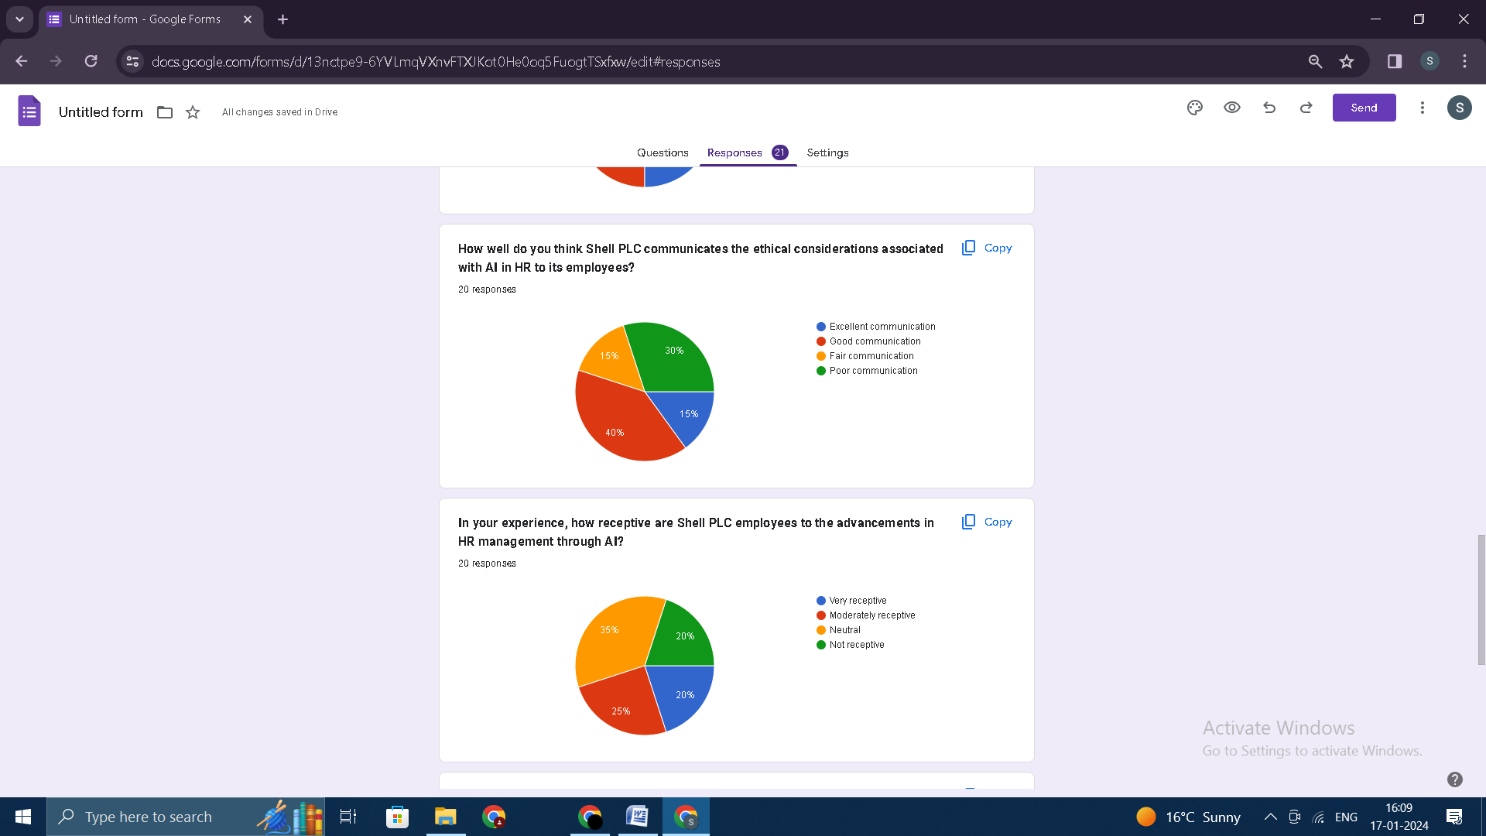
(Source: Google Forms)
Findings:
The responses to the survey that reflect the communication of moral issues connected to artificial intelligence with regards to human assets at Shell PLC reveal that contributors have a nuanced attitude via the responses that they supplied. It is noteworthy that 40% of respondents rated the communication as excellent, which indicates that there was a commendable degree of clarity and transparency within the dissemination of facts regarding the moral implications of using AI in HR practices. This is something that ought to be considered. The fact that a large percentage of employees have the belief that they're safely informed about the ethical considerations associated with artificial intelligence allows them to cultivate a sense of consideration and transparency in the communication practices of the business enterprise. The fact that this nice recognition is a gift is proof that this experience of information is going on.
On the other hand, 30% of individuals who participated inside the survey expressed their dissatisfaction and supplied remarks that the verbal exchange changed into insufficient. As a consequence of this, it could be deduced that an enormous proportion of employees are of the opinion that the records that are provided concerning the moral implications of artificial intelligence in human resource practices can be missing in either clarity or depth, respectively. It is of the utmost importance for Shell PLC to have a complete understanding of the precise issues or gaps that make a contribution to this perception in order for the company in an effort to efficiently cope with and refine its communique techniques.
Analysis:
When it comes to the manner in which ethical considerations ought to be communicated, employees have a variety of perspectives, which highlights the significance of making ongoing efforts to improve transparency and comprehension among workers. By identifying and reinforcing successful communication practices for the group that considers communication to be of adequate quality, it is possible to make a contribution to the maintenance of a positive representation of the organization. It is essential to address the concerns of those who have a negative perception of communication in order to refine strategies that will ensure that all employees are well-informed about the ethical dimensions of artificial intelligence in human resource practices. This is something that needs to be done while this is going on. The following are some examples of what this could entail: communication campaigns that are specifically targeted, interactive sessions, or documentation that comprehensively addresses employee concerns and aligns with the organization's commitment to ethical AI practices.
Question 8: In your experience, how receptive are Shell PLC employees to the advancements in HR management through AI?
(Source: Google Forms)
Findings
Responses to a survey that asked employees of Shell PLC about their openness to new developments in human resource management made possible by artificial intelligence reveal a wide range of perspectives. It is possible that a sizable portion of employees may be on the fence or uncertain about the incorporation of AI in HR practices, as indicated by the fact that a considerable 35% of employees expressed a neutral statement.
It is possible to contribute to a more inclusive and positive reception of AI advancements within the organization by proactively addressing concerns, providing clarity on the benefits of AI in human resources, and involving employees in the decision-making process.
Analysis:
As a result of the extensive type of responses, it is clear that Shell PLC needs to take a centered and nuanced technique to cope with the incorporation of AI into its human resources department. When it involves the neutral section, there is a possibility to engage in speaking, address uncertainties, and provide facts if you want to cultivate a group of workers that is extra informed and supportive. Using the positive reception that AI advancements receive from folks who are open to them as a basis for constructing a way of life of innovation and openness within the corporation is something that can be performed by leveraging the superb reception.
Question 9: To what extent do you believe AI has enhanced employee training initiatives at Shell PLC?
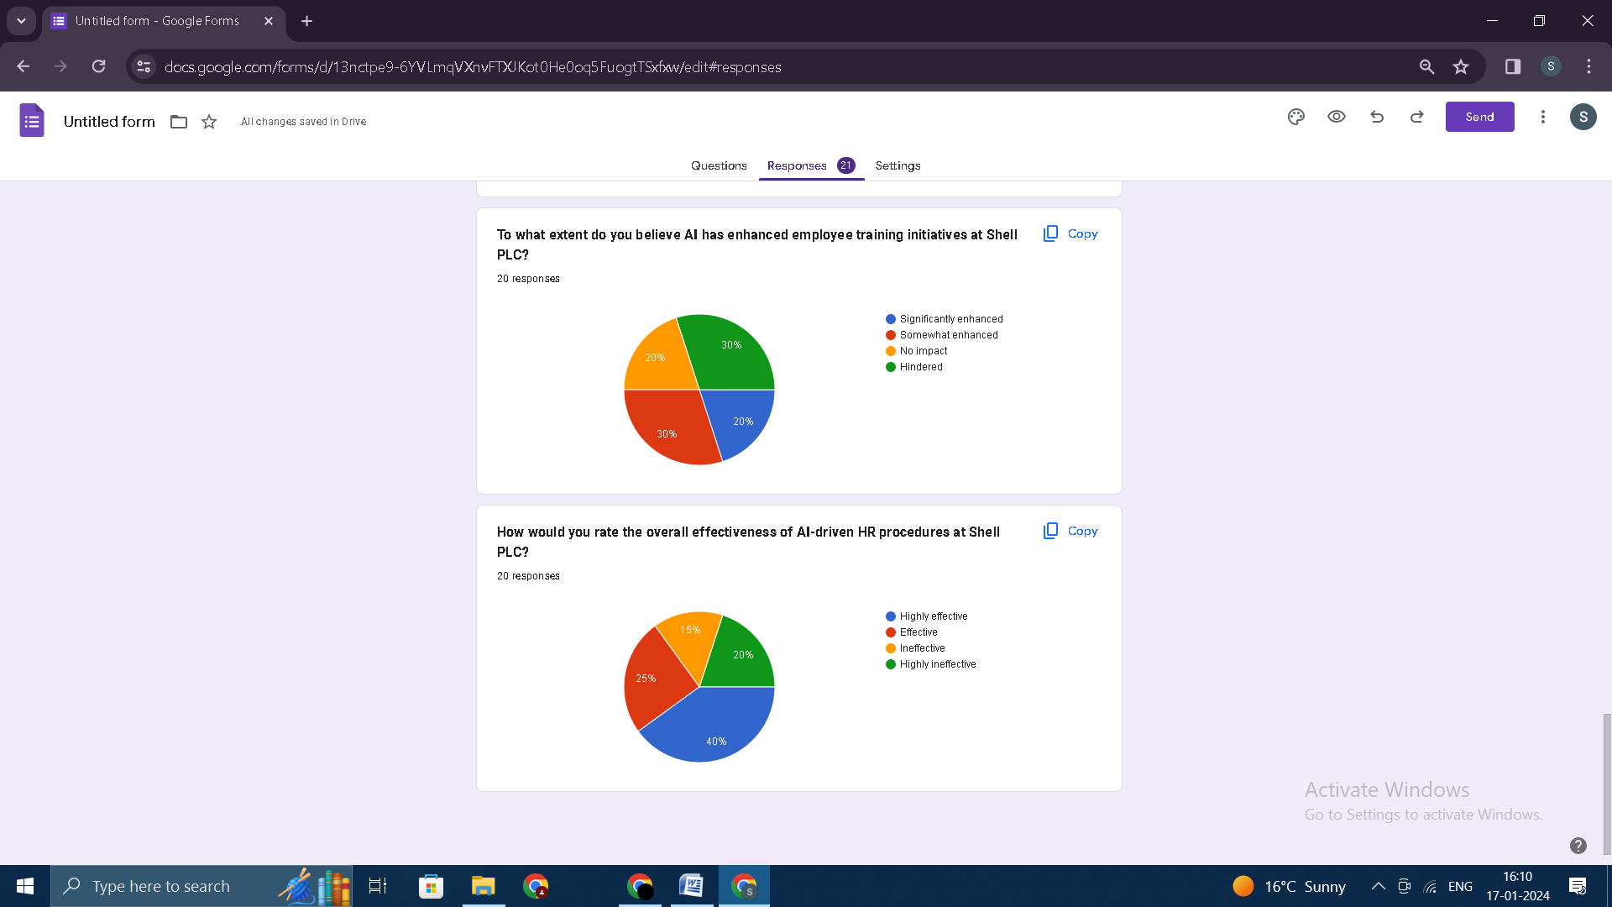
(Source: Google Forms)
Findings:
The responses to the survey that was carried out at Shell PLC regarding the influence that artificial intelligence has on the training initiatives that are being implemented for employees reveal a wide range of perspectives. These perspectives are revealed by the way in which the survey was constructed. In accordance with the findings of the survey, 50% of those who took part in the survey identified a positive influence. A total of 20% of those who participated in the survey stated that artificial intelligence has significantly improved training, while 30% stated that it has improved training somewhat. This fact indicates that there's a massive popularity of the capability benefits and efficiency of artificial intelligence in terms of optimizing worker schooling tasks within the company of the agency. This is usually recommended by using the truth that that is the case.
Analysis
In accordance with the advantageous sentiments expressed with the aid of individuals who accept as true that artificial intelligence (AI) has considerably or truly more advantageous worker schooling initiatives, it seems that the implementation of artificial intelligence (AI) in Shell PLC's schooling programs has resulted in fine outcomes. The truth that people have expressed high-quality feelings to one another is proof of this. Taking advantage of this opportunity, the business enterprise may be capable of in addition leverage technologies which might be powered with the aid of artificial intelligence in order to improve and increase the scope of its training projects. The employer will be able to capitalize at the strengths that have been identified even as concurrently addressing any regions that require improvement as a result of this. In addition, the 20% of those who trust that artificial intelligence has now not had any effect and the 30% of folks that believe that it has hampered schooling initiatives require more in-depth research so one can realize the factors which have caused those views. This statistic is vital for you to understand the elements that have led to these perspectives.
Question 10: How would you rate the overall effectiveness of AI-driven HR procedures at Shell PLC?
(Source: Google Forms)
Findings:
A blended but generally effective sentiment was expressed by means of the respondents within the survey that was conducted to decide the overall effectiveness of AI-driven HR approaches at Shell PLC. The results of the survey suggest that the evaluations of the respondents were blended. 65% of respondents rated the HR processes as both incredibly effective (40%) or effective (for 25%). This demonstrates that there is an extensive reputation of the big value and success of incorporating AI into HR tactics. This is evidenced by the fact that 65% of respondents rated the tactics as both effective or rather powerful. The fact that that is the case suggests that there is a widespread consensus concerning the effectiveness of the tactics.
Analyses
That AI-driven human resources procedures at Shell PLC have been given positive ratings of highly effective and effective indicates that there appears to be a general alignment between these procedures and the organizational goals of the company. This is indicated by the fact that these procedures have received positive ratings. The organization now has the opportunity to build on its previous accomplishments, identify the practices that have proven to be the most successful, and possibly expand the application of artificial intelligence to other HR functions. This potential opportunity is made possible by the positive perception that the organization has created. The 35% of respondents who rated the procedures as either ineffective or highly ineffective should be taken into consideration when thinking about the procedures. It is essential to pay attention to this group. Investigating the factors that led to these ratings is absolutely necessary in order to improve and perfect applications that are driven by artificial intelligence for human resource management. It is of utmost importance to ascertain whether these ratings are associated with the constraints of the system, issues with the user experience, or any other factors.

4.3 Qualitative Analysis (Thematic)

Theme 1: Assessing Association Utilization of artificial intelligence for upgrade enrollment proficiency robotics applicant screening and further Advance varieties efficiency and achievements rate.
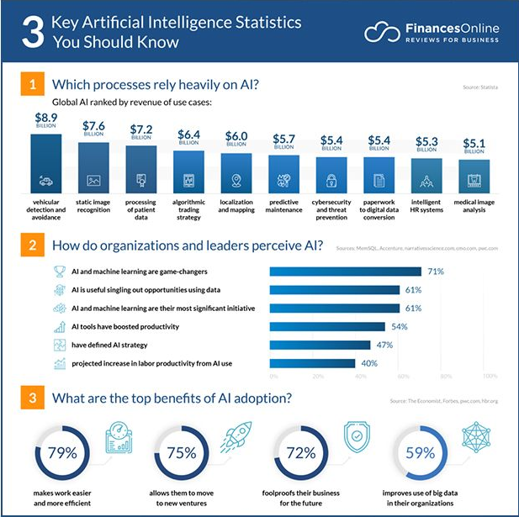
(Source: Kulkarni, 2023)
Inside Human Asset The board (HRM), coordinating Man-made brainpower (Artificial intelligence), has become super energy, reshaping trendy methodologies and cultivating greater powerful and compelling responsibilities.
Artificial intelligence's thing in enrollment is multi-layered, with its maximum unmistakable self-control mendacity inside the improvement of the recruiting gadget. Associations regularly embrace artificial intelligence-controlled devices to robotize redundant and tedious assignments, permitting HR specialists to zero in on more vital additives of the enlistment cycle. Automated resume screening, for instance, allows quick identification of certified candidates through studying their talents, memories, and qualifications, thereby expediting the preliminary degrees of the hiring manner.
Efficiency in candidate screening is another vital component of AI's impact on HR operations. Machine Learning algorithms, a subset of AI, can examine splendid datasets to emerge as aware about styles and are looking ahead to candidate achievement based totally on ancient facts (Kulkarni, 2023). This predictive capability assists HR groups in shortlisting applicants with a higher likelihood of achievement, contributing to better-informed hiring choices. Consequently, this now not simplest saves time however additionally complements the overall best of the knowledge pool.
Diversity and inclusion have come to be focal points for masses of corporations, and AI is gambling a pivotal function in fostering these values within recruitment techniques. By mitigating human biases in candidate assessment, AI structures make a contribution to fairer and additional objective preference-making (Mapes et al., 2020). This is completed through the elimination of identifiable information, together with names and pictures, within the path of the initial stages of candidate assessment. Consequently, businesses leveraging AI in recruitment are more likely to create several and inclusive painting environments, in the long run contributing to extra proper group dynamics and creativity.
Productivity profits are inherent in the adoption of AI in HR operations. Automation of ordinary duties, from scheduling interviews to sending observe-up emails, frees up treasured time for HR specialists. This allows them to focus on strategic elements of understanding management, such as worker engagement, improvement, and retention (Oluyisola, 2021). The symbiotic relationship amongst AI and human know-how guarantees a harmonious workflow wherein every element enhances the alternative, leading to extended normal productivity inside HR departments.
Success rates in recruitment are inherently tied to the splendidness of hires, and AI is proving to be a treasured best friend in this pursuit. The functionality to analyze full-size quantities of facts provides insights into the tendencies and characteristics that contribute to an employee's success within a specific position or organizational way of life. By leveraging these facts, businesses can refine their hiring standards and target candidates who align greater closely with the company's values and goals, in the long run developing the chance of long-time period success for every individual and the organization.

Theme 2: Examine AIS role in personalized employee training career development and performance review to enhance overall HR operations.
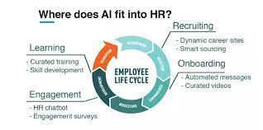
Source: Kulkarni, 2023

Personalized Employee Training:
Traditional one-length-fits-all schooling procedures are regularly being changed by way of AI-driven personalized studying stories (Wang et al., 2020). AI algorithms analyze individual employee overall performance facts, identifying strengths, weaknesses, and studying preferences. This enables HR departments to tailor schooling modules that cater to each employee's unique wishes.
The implementation of AI in training programs fosters a greater enticing and effective gaining knowledge of the environment. Adaptive studying structures, powered by AI, dynamically alter the content and tempo of training modules based on personal progress (Chen,2023). This now not handiest complements the overall studying experience but additionally guarantees that personnel acquire the particular skills and information required for his or her roles, contributing to accelerated activity satisfaction and productivity.
Career Development:
AI's effect extends to professional development, imparting valuable insights to each employee and HR professionals. AI-pushed career development equipment analyzes employee abilities, performance, and aspirations to provide customized profession direction suggestions. These insights help personnel make informed decisions about their career trajectories, fostering an experience of empowerment and engagement (Budhwaret al., 2023).
Moreover, AI assists HR in figuring out excessive-capacity personnel and developing targeted improvement plans. By leveraging predictive analytics, HR departments can forecast talent gaps and align education initiatives with the organization's destiny desires. This proactive approach now not only nurtures expertise internally however also ensures that the team of workers remains adaptable to evolving enterprise needs (Oluyisola, 2021).
Performance Reviews:
AI's impact on performance evaluations is transformative, making the process extra goal, timely, and insightful. Traditional annual performance opinions are often criticized for their subjectivity and bias. AI-pushed overall performance analytics deal with these concerns by way of imparting a facts-driven approach to evaluating employee overall performance.
Real-time performance monitoring, facilitated by means of AI, permits continuous evaluation of worker contributions. This ensures that remarks aren't always most effective, more accurate but additionally well timed, enabling personnel to make important changes right away. AI algorithms can examine a mess of information factors, together with challenge outcomes, collaboration styles, and personal achievements, presenting a complete and impartial view of a worker's overall performance (Namoun, 2020).
In conclusion, the combination of AI in HR operations, especially in the nation-states of customized worker education, career development, and overall performance evaluations, is reshaping the landscape of Human Resource Management. The shift toward tailor-made, information-pushed techniques now not only complements individual employee stories but also contributes to the overall performance and effectiveness of HR operations. As companies continue to include AI, the synergy between era and human knowledge in HRM is poised to redefine the team of workers management in the years to come.

Theme 3: Investigating how employees perceive and respond to AI implementation in HR processes, focusing on benefits, concerns, and potential impacts on job security.
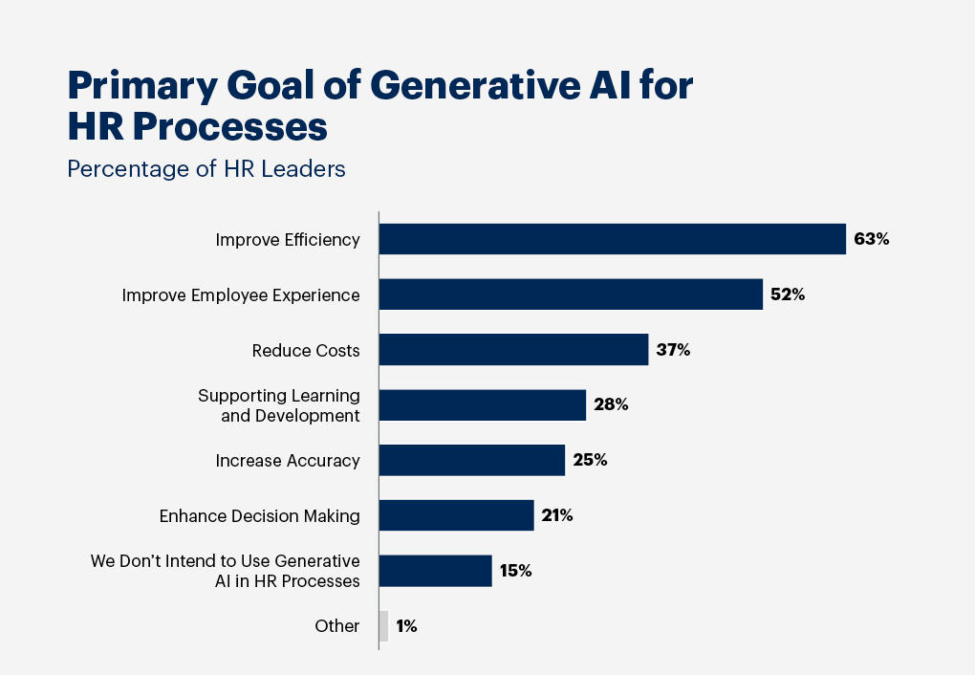
Source: (Harisantyet al., 2022)
As Artificial intelligence (AI) continues to reshape the panorama of human aid management, one critical factor that wishes attention is how employees understand and respond to the mixing of AI in HR methods. This thematic analysis explores the multifaceted dimensions of personnel' views, focusing on the advantages, issues, and functionality influences on job safety.
Benefits of AI Implementation:
One ordinary subject matter in personal perceptions of AI in HR approaches is the popularity of its advantages. Many personnel appreciate the performance and accuracy that AI brings to ordinary obligations which includes resume screening and initial candidate assessments. Envision HR professionals owning greater power for massive artwork and creating a effective artwork surroundings. On account of computerization, they could zero in on huge undertakings that enhance our workplace (McLennan et al., 2022).
In any case, it isn’t most effective for HR – we, as employees, recognize the decency that simulated intelligence brings to course. At the element at the same time as calculations manual alternatives, inclination is reduced, prompting extra notable tests and empowering variety and attention at artwork. This shift in the direction of involving information for alternatives is regarded as a amazing flow into, making the HR interplay greater honest and capable.
Concerns Surrounding AI Implementation:
Invigorating as new innovation may be, it brings a few concerns. Representatives are involved about dropping their duties to pc based totally intelligence, stressing that it is able to make some jobs pointless. The feeling of dread closer to computerization assuming manage over our assignments is actual, mainly when there's insufficient correspondence about how man-made intelligence will squeeze into our going for walks environment.
Another full-size problem is that simulated intelligence have to cast off the human touch in HR. We esteem human association, especially at the equal time as handling considerable such things as struggles at paintings, our interests, and our self-interest. The apprehension is that artificial intelligence ought to motive HR to experience much less non-public, and those are genuinely involved about that. Everything revolves spherical monitoring down the proper concord amongst innovation and the human side of our art work.
Potential Impacts on Job Security:
The overarching theme in employees' responses to AI implementation in HR approaches is the effect on activity security. While a few employees widely recognized that AI can streamline operations, they continue to be skeptical about its functionality to update the nuanced selection-making and emotional intelligence that humans carry to HR roles (Bhargava et al., 2021). The uncertainty surrounding the lengthy-time period results of AI on challenge safety activates personnel to impeach their professional trajectories and flexibility in an evolving administrative center.
Employees' perceptions of AI implementation in HR techniques are a complicated interaction of benefits, issues, and apprehensions about hobby protection (Harisantyet al., 2022). While the blessings, which include performance profits and extended objectivity, are stated, personnel harbor legitimate problems regarding task displacement and the potential erosion of the human touch in HR interactions. Effectively addressing those troubles requires obvious communication, emphasizing the complementary nature of AI and human competencies, and offering avenues for upskilling to ensure that employees stay relevant in an increasing number of AI-pushed HR landscapes.

Theme-4: Looking at the Moral Components of PC-based absolute intelligence Execution in Shell Plc's HR, Tending to Worries of Algorithmic Predisposition, Information Security, Straightforwardness, and Availability of Artificial Intelligence Driven HR Cycles.
As of late, the consolidation of Computerized reasoning (laptop-based intelligence) in Human Asset (HR) executives has changed into a commonplace exercise at some point in groups. Companies, including Shell Plc, have embraced artificial intelligence innovation to smooth out HR responsibilities, similarly, increase execution, and work with records pushed path. However, the growing reliance on AI in HR brings forth a number of moral issues that warrant cautious assessment. This thematic analysis delves into the ethical implications surrounding Shell Plc's use of AI in HR, specializing in algorithmic bias, information protection, transparency, and the accessibility of AI-driven HR methods.
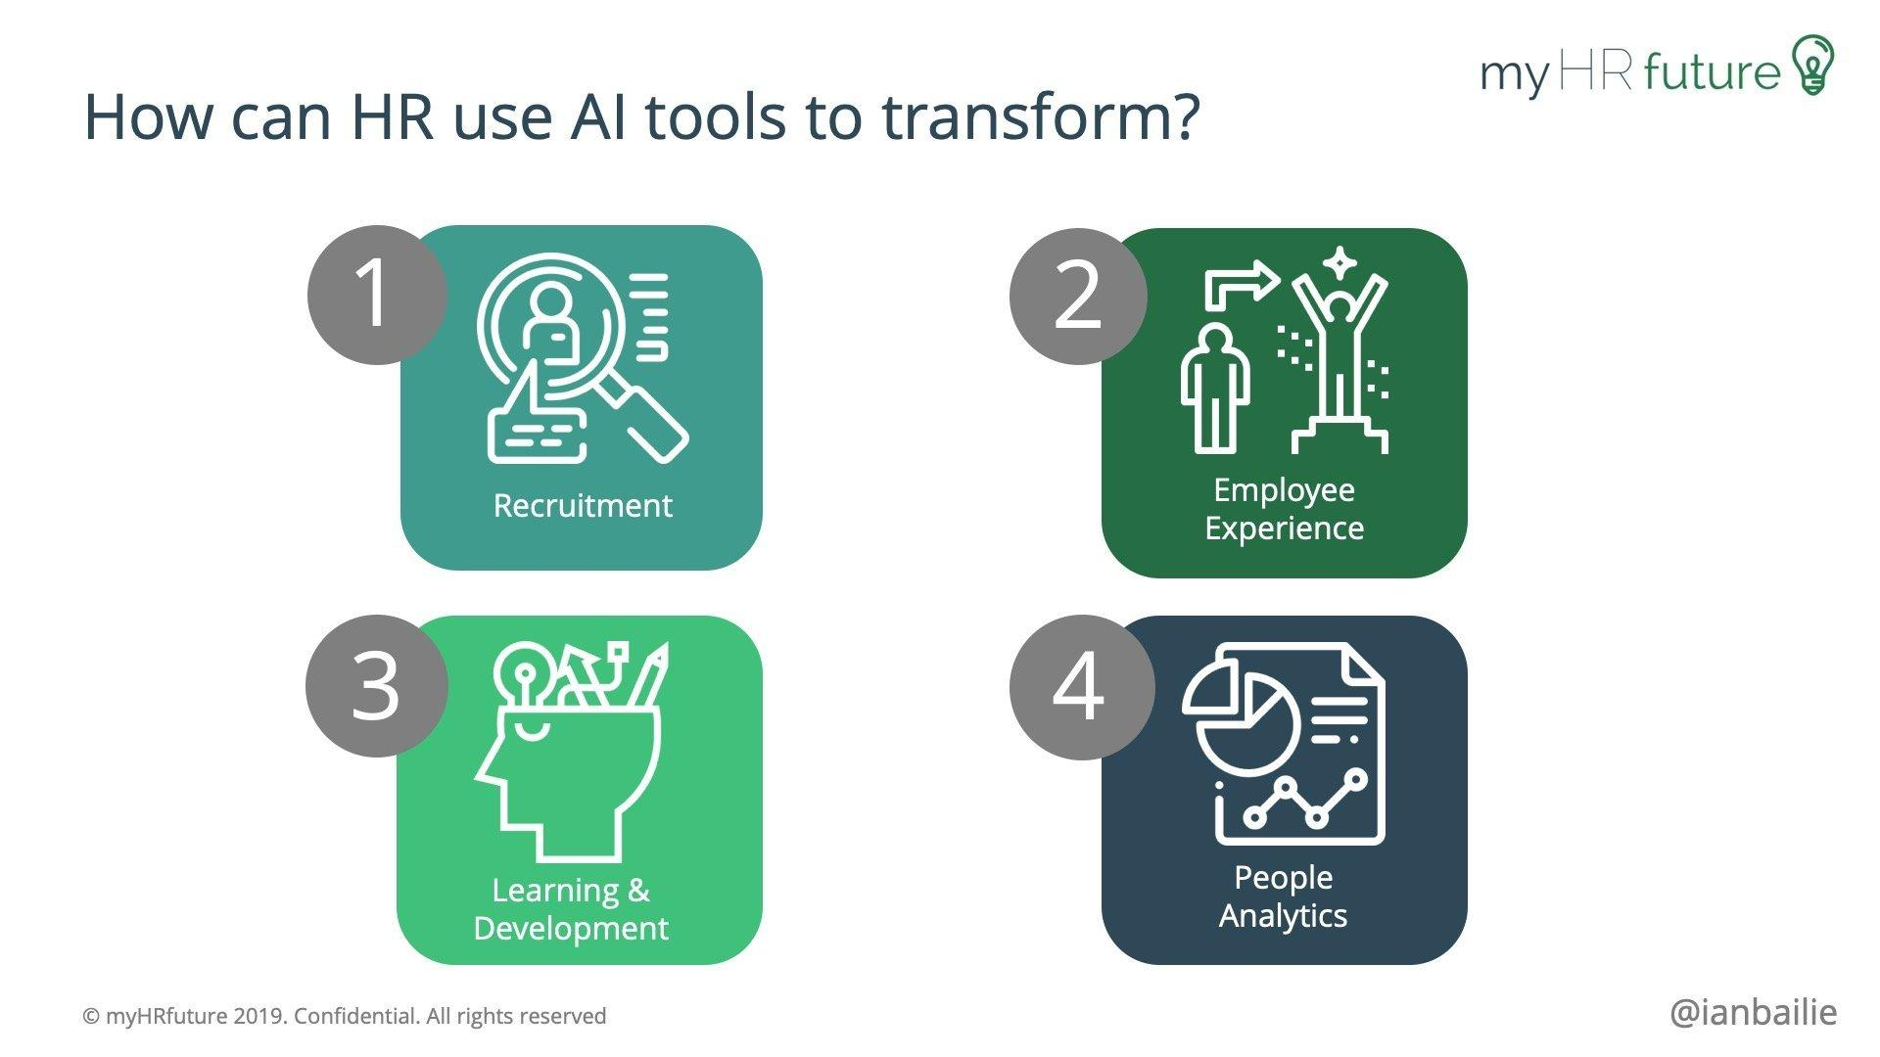
Source: (Mohamed et al., 2022)
Algorithmic bias is a pressing state of affairs within the application of AI in HR operations. The algorithms employed to assess resumes, select out applicants, and count on employee common performance can inadvertently perpetuate biases determined in ancient information. Shell Plc's use of AI in HR strategies will raise questions about the fairness of these algorithms. The thematic evaluation shows that careful scrutiny and ongoing monitoring of algorithms are critical to ensure a sincere and independent HR selection-making machine (Sienkiewicz, 2021).
Data safety emerges as every extraordinary moral interest. The large amount of touchy private records treated with the useful resource of AI systems in HR, which embody worker facts and performance information, requires sturdy security capabilities. In the context of Shell Plc, the evaluation underscores the importance of ensuring that AI packages adhere to stringent records safety requirements. This consists of imposing encryption, getting entry to controls, and normal audits to shield employee records and save you unauthorized admission to (McStay, 2020).

Transparency in AI-pushed HR strategies is an essential detail for constructing recall amongst employees. The thematic evaluation shows that Shell Plc ought to be able to approximate the usage of AI in HR selection-making to foster an open and accountable art work environment. Employees ought to be knowledgeable about the criteria used by AI algorithms for their critiques, and any picks recommended with the useful aid of AI want to be communicated honestly. Transparency helps mitigate issues related to equity and guarantees that personnel recognize the basis of HR alternatives (Mohamed et al., 2022).
Accessibility of AI-pushed HR processes is a moral hobby regularly overlooked. The evaluation shows that Shell Plc ought to ensure that its AI applications do not inadvertently exclude positive demographic agencies or people. Accessibility encompasses no longer handiest technological troubles however moreover the capacity effect of AI on the diverse body of workers. Shell Plc must actively work in the course of developing an inclusive environment in which AI supports variety and does not now make a contribution to the marginalization of any company.
In conclusion, the moral implications of Shell Plc's use of AI in HR operations are multifaceted and call for a nuanced technique. The thematic evaluation highlights the significance of addressing algorithmic bias, ensuring facts protection, selling transparency, and enhancing accessibility in AI-driven HR methods. By prioritizing those ethical worries, Shell Plc can navigate the evolving panorama of AI in HR, manage responsibly and make a contribution to a fair, at ease, and inclusive painting environment.

4.4 Discussion
This section covers the discussion based on the quantitative and qualitative analysis carried out in Chapter 4. The debate has been successful in helping to understand how the quantitative analysis was completed with the assistance of survey responses and how it has improved the project's reliability.
The field of human resources is highly diverse, dynamic, and ever-evolving. As such, organizations must leverage cutting-edge technological advancements like artificial intelligence to enhance the operations of human resource management in every way possible. Artificial intelligence has played a significant role in the recruitment process and improved workflow, making it more efficient and well-structured. The organization benefits from the efficiency of candidates, which is facilitated. By utilizing automated tools and applications to identify the most qualified candidates through thorough resume analysis and a 100% skill match closely related to the profile, I can improve both the product and success rate for companies that have incorporated artificial intelligence into their HR practices.
The analysis successfully discussed the percentage of people motivated by integrating artificial intelligence with HR practices carried out by Shell PLC. It has also successfully addressed the fact that 35% of the respondents need to be more familiar with the file containing the integration of AI with HR practices, while 10% of the participants are entirely unfamiliar with the integration of AI with HR practices. On the other hand, 20% of the responses are familiar with integrating AI and advanced technology with HR practices. Conversely, 35% of respondents are highly familiar with how advanced technology, like artificial intelligence, is incorporated into HR procedures within organizations and the benefits that the company is already reaping.
The analysis provided by the participants and the findings effectively discuss how employees within the organization have varying degrees of acknowledgement regarding implementing artificial intelligence within human resource practices. This indicates a knowledge gap among employees regarding their capabilities and how artificial intelligence has contributed to their varying levels of awareness.
The thoughts of the staff regarding how the incorporation of artificial intelligence has improved or impacted the effectiveness of the organization's talent acquisition procedures were covered in the second analysis question for Shell PLC. The following information has helped discuss a variety of viewpoints that were experienced and expanded upon with the use of the survey analysis and the analysis's readings. 15% of respondents believe that artificial intelligence has dramatically improved the organization's talent acquisition process, while 20% believe its incorporation has somewhat improved talent acquisition operations. Meanwhile, 50% of respondents think there have been no discernible changes to human resource practices, and 15% of respondents categorically state that there have been no benefits connected to the integration of heart-shaped facial intelligence and its relationship to improving talent.
The question of how and to what extent artificial intelligence has improved diversity within Shell PLC's hiding process is also covered in the analysis. Based on the participants' contributions to their opinions, the study of their responses reveals that they could offer a variety of viewpoints on this particular topic. 20% of participants believe artificial intelligence has improved diversity within the hiding process in a favorable way, and another twenty per cent believe it has improved diversity within the hiding process only somewhat. Forty per cent of the participants believe that diversity is unaffected. Twenty per cent of the attendees have negative opinions about how I have enhanced diversity within the organization's concealing process. Diversity and inclusion are essential components of Shell PLC, as they enable the firm to manage its commercial operations more efficiently. The presence of a creative workforce that can easily navigate complex events and circumstances is made possible by diversity and inclusivity.
The survey received 20 cooperative responses discussing how employees have reflected on their experiences, and the analysis has also addressed the level of employee satisfaction with the integration and application of artificial intelligence tools in efficiently evaluating employee performance within the organization. Regarding their experience with artificial intelligence rules, 30% of the employees are neutral, while 20% of the replies express great satisfaction with integrating and applying artificial intelligence tools—thirty per cent of participants are satisfied with using artificial intelligence tools for performance evaluation. However, 20% of participants expressed satisfaction with the firm and the use of artificial intelligence tools in efficiently assessing employees' performance at Shell PLC.
The impact of artificial intelligence on career progression opportunities for employees of Shell PLC has also been discussed quantitatively. Based on the responses of the 20 participants, the following points have been made clear: 30% strongly disagree with the idea that artificial intelligence positively impacts career progression, and 15% strongly agree with this idea. On the other hand, 35% of participant respondents and 15% of participant respondents agreed that artificial intelligence positively impacts career progression for Shell PLC employees. As we all know, artificial intelligence is a high-tech and practical technology with various implications in the contemporary business environment. It has affected people and organizations in many ways, allowing them to improve their skills and land high-paying positions quickly.
Additionally, the quantitative analysis effectively addresses the participants' concerns regarding the possible and significant ethical implications of discussing the biases in the current humidor practices and how AI can help resolve these issues or improve the following problems. Then, it clarified the following: 35% of the participants indicated that they were not particularly concerned about the unfair and unethical practices that the organization's Human Resource Department was currently engaged in, while 25% stated that they were not worried about such activities and practices. On the other hand, 25% of the participant's responses indicated that they were highly concerned about how artificial intelligence would aid in its eradication. Twenty per cent of the participants stated that they were worried about how these activities and the involvement of artificial intelligence would benefit them and improve their results. While the following replies demonstrate that some employees have respected current ethical and biased issues, human resource methods should not be subject to the same considerations.
As is apparent in a walking setting, it is essential to eradicate unethical activities and implement ethical practices. PLC is a multinational corporation that must place a high priority on human resource management because these are the practices that, in the end, define and shape their workplace. Therefore, the company must take reasonable consideration of and advantage of artificial intelligence in technology to address any ethical issues that may arise with the company's hiring and human resource policies. This will ensure transparency, efficiency, and a work environment that values employees.
The quantitative study also explored how Shell PLC has been conveying its ethical considerations, which are closely related to the implications of artificial intelligence for HR procedures and how those activities affect employees. A clear understanding of the situation at home has been aided by the 20 responses received for the qualitative analysis. Thirty per cent of the employees said that the organization sent out poor communication, while fifteen per cent of the participants said that Shell had a fair communication status with the company for a long time. On the other hand, thirty per cent and forty per cent of the participants noted that the communication shell PLC was imposing and was good. The majority of participants believe that the organization has been successful in communicating the ethical consideration with the implication of artificial intelligence within their human resource practices, which has proven to be actual evidence for the company in the sorting practices within that human resource management, according to the following responders who have given a cure.
Different people have different perspectives on ethical communication, and these perspectives have been emphasizing how crucial it is to improve transparency within the organization and for employees. By identifying these communication practices, the organization has improved the quality of those communication strategies, which has proven to be crucial for them in making well-informed decisions based on the ethical dimensions of artificial intelligence.
In order to understand how the employees of Shell PLC have responded to the advancements the HR management is making with the aid of artificial intelligence, a qualitative survey and analysis have also been conducted. The previous study revealed that 35% of the participants indicated that they are undoubtedly neutral because they believe and perceive that the employees are not inclined towards the advancements being made by the HR management with the assistance of AI. However, 25% of participant responses indicate that they have been moderately receptive to artificial intelligence advancements, and 20% of responses suggest that they are incredibly open-minded and much more inclined towards the advancements associated with artificial intelligence within the HRM department. Meanwhile, 20% of participant responses indicate they need to be more willing or receptive to the advantages of artificial intelligence within the HR department file.
Employee training is a practical component that should be included and has been supported by Shell PLC. A quantitative analysis of how artificial intelligence can help improve Shell PLC's employee training initiative with its services was conducted. The results showed that the following programs have benefited employees at varying rates: 20% of employees said the company's employee training programs have significantly enhanced them. In comparison, 30% of employees said that the organization has improved the employees' training. On the other hand, 20% of the respondents said that there had been no impact. Thirty percent of respondents think employee training has yet to make a difference for them.
The survey results have helped provide a blend of responses on how the participants and employees have been incorporating artificial intelligence into human resource practices while also being handled by human resource personnel. Artificial intelligence has undoubtedly helped improve the process by leveling up the ethical consideration of the process and providing more opportunities to a diverse and inclusive community, which has helped improve the HRM landscape for Shell PLC. The analysis of the artificial intelligence initiatives' overall effectiveness in human resource procedures with and shell has been done effectively with the assistance of the service conducted. According to the survey, 15% of participants believed that the HR practical had negatively impacted the entire process, and 20% of those who were responsible for the process said that the culture had proven to be highly infectious and that they had not experienced or analyzed any long-term effects from it. However, 40% of participant responses and 25% of past and responsive things indicated that the implementation improved the company's HRM efficiency.
The following trailer demonstrates how artificial intelligence has improved the organization's operations through AI algorithms that have improved human resource management by offering targeted training and development opportunities that have improved employees' job satisfaction and skill sets. Artificial intelligence has also proven to be a significant player in the theme of employee training, helping to transform the way it was implemented and make it more personalized.
In the third place, the team that discussed human interaction with technological advancements did an excellent job of assessing employees' perseverance and how they responded to introducing artificial intelligence into human resource processes. They also discussed how important it is to understand and analyze the following factors in order to properly understand the benefits of artificial intelligence and address any concerns about how it would affect their job security.

4.5 Summary
Computerized reasoning is assuming an crucial element in HRM, making enrollment smoother, similarly developing custom designed consultant path, and impacting how representatives see their art work. While we rate the blessings like decency and better execution, we furthermore have troubles approximately professional stability and human institutions. At the factor at the same time as we see how Shell Plc makes use of simulated intelligence, it is critical to contemplate what’s proper and honest – tending to predisposition, guarding our statistics, being open about how subjects art work, and making sure absolutely everyone may be essential for the running environment. As our fact transforms, we need to song down an awesome concord between attractive inside the blessings of artificial intelligence and making sure we are getting things carried out in a trustworthy and ethical manner. This exam resembles focusing a mild on the moral side of the manner Shell Plc includes simulated intelligence in HR, announcing we actually need decency, facts safety, straightforwardness, and everybody feeling blanketed. It’s tied in with finding the right blend amongst laptop-based intelligence and those in a bit surroundings that is pushing in advance with care and morals.

Chapter 5: Conclusion and Recommendations

5.1 Conclusion
All subjects considered; this evaluation tends to be an extensive exam of numerous elements inside the revolutionary putting of Shell Plc. The survey used a blended methodologies method, amalgamating emotional practical exam and quantitative review assessment, to procure nuanced facts of modern components. The accentuation on expert reviews, the valid existence of the agency, and the board met to contribute to massive encounters to the continuing collection of records.
The portrayed finding technique ensured the collecting of some of the 20 people, getting views from outstanding positions, divisions, and mild levels interior Shell Plc. This planned desire gives an in-depth problem of view on the relationships inside additives, perceiving the significance of moved research and observations.
The examination, which incorporates ten cleverly prepared questions controlled through Google Designs, hoped to type out a congruence between snappiness and si some type. The blend of closed finished requests for quantitative data and honest requests for emotional encounters with a cautious assessment of the study's desires.

Steadfastness and authenticity issues are crucial portions of this survey, underlining the watchfulness embedded in the study's plan. Exhaustive apportions had been conveyed to make sure the reliability of the revelations, from standardized outline units to amongst rater trustworthiness, without a doubt investigates precise records evaluation. At the same time, the survey around round authenticity via thrilled authenticity in survey improvement and the triangulation of summary and quantitative data assets.
Moral examinations feature the whole research tool. Informed consent, protection assertions, component withdrawal honors, and adherence to ethical standards recommend the dedication to safeguarding detailed government assistance and possibilities. The survey is direct, heading off terrorizing or deception, and researchers stay privy to a truthful nature, restricting hopeless conditions.
The mixed techniques technique taken in this evaluation works on the survey's significance and broadness. By merging emotional and quantitative assessments, the research manner to approve or separate disclosures, giving an all the more fantastic excellent and nuanced comprehension of the cutting-edge additives internal Shell Plc. This way of carrying out an approach traces up with the complexity feature in valid assessments, perceiving the numerous concepts of agent research and perceptions.
As the studies propel, the revelations are alleged to discover expertise into possible areas of development internal Shell Plc, whether it no longer concerns agent pride, valid way of life improvement, or challenge the board smoothing out. The portions of information that have been given from the survey also want to add to the knowledgeable route, developing a pleasant modern environment.
Nevertheless, perceiving the survey's constraints is critical. The modest version duration of 20 human beings should affect the generalizability of the disclosures to the more numerous leveled people. Besides, the pass-sectional nature of the survey offers a set of multiple leveled components, confining the capability to get longitudinal changes over an extended time.
Looking in advance, a mind for destiny research consolidates developing the model duration, incorporating longitudinal examinations, and getting to know more significant variables that would affect legitimate additives. Constant responsibility with Shell Plc and affiliations can upload to an extra recognition of the modern-day approach to performing and guide the development of frameworks for progressive replacement.
Considering the entirety, this study endeavors to contribute earnestly to the speech on leveled additives internal Shell Plc. Through a demandingly organized blended strategies method, the survey tries to discover massive encounters that can enlighten every instructional award and practical technique for contemporary-day development. The dedication to ethical requirements, reliability, and authenticity competencies of the evaluation's legitimacy, arranging it as a massive development to the area of numerous leveled examinations.

5.2 Linking with Objectives
- To examine how Shell Plc uses artificial intelligence in talent acquisition, evaluating computer-driven hiring processes based on intelligence in terms of productivity, variation, and success levels.
The exam goals align with an all-encompassing research of approaches Shell Plc consolidates artificial brainpower (simulated intelligence) in exceptional factors of human asset the board (HRM). The evaluation of laptop-based absolute intelligence usage in capability procurement, first and crucial, is ready inside the course of surveying PC-driven recruiting system evaluation includes factors of overall performance, variety, and success ranges, which means to apprehend the effect of artificial intelligence on the capabilities and fashion of the capability of securing processes indoors Shell.
- To investigate how training programs, career advancement, and representative performance reviews are influenced by artificial intelligence tools within Shell.
Furthermore, the exam concerning the impact of laptop-based intelligence apparatuses on getting geared-up programs, professional achievement, and execution audits dives into the greater good-sized variety of worker development. This goal seems to disclose what guy-made intelligence mixes manners for reading drives, vocation movement, and execution exams, revealing belief in the multi-layered way of artificial intelligence in molding the professional pointers of Shell's exertion strain.
- To investigate how representatives of Shell plc view and respond to advancements in artificial intelligence-based human resource management.
The purpose, zeroing in on the factors of view and reactions of Shell Plc's outlets to progressions in simulated intelligence based totally HRM technique to lure the human detail. Understanding how human beings see and collaborate with guy-made intelligence apparatuses in HR strategies gives massive expertise into the authoritative factors, probable issues, and regions for development.
- To examine the moral ramifications of Shell Plc's use of artificial intelligence in HR procedures. Come are concentrating on specific issues, like a propensity for algorithmic advice, concerns regarding data security, and the ease of use of AI-driven HR processes.
DIntog into the ethical implications of Shell's usage of simulated intelligence in HR strategies has a bent on moral contemplations. This intention examines algorithmic inclination, statistics safety issues, and the general ease of use of artificial intelligence-pushed HR procedures. By focusing on the ethical elements, the exam tries to be characteristic of moral communication encompassing intelligence execution in HRM and deliver guidelines to aware simulated intelligence using inner Shell Plc.

5.3 Future Scope of Research
Examining Plc's usage of computerized reasoning (PC based totally on intelligence) in human assets, the body (HRM) opens roads for destiny studies and headways. To decorate the review's broad Destiny examination, it needs to increase the instance length to comprise a more varied portrayal of Shell's hard work pressure, ensuring a way of reaching comprehension of artificial intelligence's effect sooner or later on diverse jobs and divisions.
A longitudinal method might be taken without delay to look at modifications in consultant encounters and hierarchical elements over the long haul as laptops are primarily based on intelligence gadgets growth. Investigating organization benchmarks and close examinations with precise businesses can deliver crucial information into excellent practices and areas for improvement in artificial intelligence-pushed HRM.
Moreover, a more profound leap into the moral issues recognized, like algorithmic predisposition and statistics safety, should form the purpose for unique research. Exploring worker discernments in more granular elements and statistics, the context-oriented elements impacting their reactions may add to a more extravagant comprehension of the human aspect of the artificial intelligence mixture.
In outline, the future extension lies in growing the exploration scope, consolidating longitudinal examinations of industry correlations, and digging further into explicit ethical components, encompassing the non-forestall communication on reliable PC-based totally intelligence execution in HRM rehearsals.

5.4 Limitations of Research
This examination, at the identical time in its research of Shell Plc's utilization of computerized reasoning (artificial intelligence) in human asset executives (HRM), isn't always without regulations. The unassuming example duration of 20 members may also affect the generalizability of the discoveries to Shell's complete difficult artwork strain. The look at its bypass-sectional nature offers a preview, restricting the capability to entice feasible adjustments in hierarchical factors after some time.
Besides, the dependence on self-discovered statistics from employees gives the chance of reaction inclination, as individuals may provide socially beneficial reactions. The assessment's emphasis on a solitary affiliation, but giving top-to-bottom evaluations into Shell's practices, confines the generalizability of discoveries to diverse organization settings.
Moral contemplations likewise give tips because the exploration essentially is based upon individuals' capability to show facts about their encounters with laptops based totally on intelligence in HRM, likely prompting deficient or one-sided facts.
Notwithstanding those guidelines, this exam is a fundamental investigation of simulated intelligence reconciliation in HRM inner Shell Plc, laying the steering for future investigations to grow upon and address those requirements.

5.5 Recommendations
- Given the same old example period of 20 humans, future exploration wants to reflect on consideration of a more excellent and numerous instance portrayal sooner or later of various jobs, divisions, and revolutionary tiers in Shell Plc. This extension would possibly decorate the assessment's outer legitimacy and deliver an extra and extended manner of comprehending artificial intelligence's impact on a more significant type of representative.
- Taking on a longitudinal technique would possibly allow scientists to conform with changes in hierarchical elements and employee encounters over the prolonged haul as simulated intelligence upgrades boom. This fleeting component of view wants to lure patterns, examples, and variations indoors Shell's labor strain, giving an extra nuanced comprehension of the drawn-out influences of simulated intelligence in HRM.
- Directing relative examinations with one-of-a-kind companies inside the business would likely provide huge benchmarks and bits of records into extraordinary practices. Investigating how establishments execute artificial intelligence in HRM can show the perception of specific methodologies, problems, and advancements, enhancing the comprehension of simulated intelligence's element within the extra great agency scene.
- Future exams want to dive in addition to expressing moral additives identified on this assessment, as an example, algorithmic predisposition and statistics safety troubles. This unique examination intends to teach the development of ethical policies and recommendations for capable artificial intelligence execution in HRM rehearsals.
- Utilizing more excellent granular methodologies, like targeted opinions or conferences, may also need to maintain more top-to-bottom bottom dies of consultant discernments and encounters with simulated intelligence in HRM. Understanding the relevant factors affecting employee reactions can provide nuanced critiques into the human issue of artificial intelligence reconciliation in the affiliation.

Reference list
Agustina, Y., Wijijayanti, T., Winarno, A. and Rahayu, W.P., 2023. The Economarketing Model: Development of Productive and Sustainable Tourism Area. International Journal of Professional Business Review: Int. J. Prof. Bus. Rev., 8(2), p.5.https://dialnet.unirioja.es/descarga/articulo/8955848.pdf
Ainamo, M., 2023. Developing resilient human capital to cope with environmental uncertainties.https://osuva.uwasa.fi/bitstream/handle/10024/15985/Thesis.pdf?sequence=2
Ali, J., 2023. Benefits and challenges of using ChatGPT: An exploratory study on English language program. University of Bisha Journal for Humanities, 2(2), pp.629-641.https://www.researchgate.net/profile/Jamal-Ali-10/publication/372310955_Benefits_and_Challenges_of_Using_ChatGPT_An_Exploratory_Study_on_English_Language_Program/links/6541f9390426ef6369f37e9c/Benefits-and-Challenges-of-Using-ChatGPT-An-Exploratory-Study-on-English-Language-Program.pdf
Arora, S. and Kumari, N., 2021. Recruitment search engines for screening resumes through AI by using boolean search functions. Journal of Asian Development, 7(2), pp.16-26.https://journalpro.org/index.php/jad/article/view/23
ASTERIA, E.P., 2023. THE COMPARISON BETWEEN BLENDED DEDUCTIVE INDUCTIVE AND INDUCTIVE DEDUCTIVE TECHNIQUES TO IMPROVE THE SECOND GRADE STUDENT’S ACHIEVEMENT OF TENSES AT MTS GUPPI NATAR (Doctoral dissertation, UNVERSITAS LAMPUNG).http://digilib.unila.ac.id/71680/3/TESIS%20TANPA%20BAB%20PEMBAHASAN.pdf
Ayers, J.W., Poliak, A., Dredze, M., Leas, E.C., Zhu, Z., Kelley, J.B., Faix, D.J., Goodman, A.M., Longhurst, C.A., Hogarth, M. and Smith, D.M., 2023. Comparing physician and artificial intelligence chatbot responses to patient questions posted to a public social media forum. JAMA internal medicine.https://www.researchgate.net/profile/Christopher-Longhurst-2/publication/370374478_Comparing_Physician_and_Artificial_Intelligence_Chatbot_Responses_to_Patient_Questions_Posted_to_a_Public_Social_Media_Forum/links/6461a8024353ba3b3b67947c/Comparing-Physician-and-Artificial-Intelligence-Chatbot-Responses-to-Patient-Questions-Posted-to-a-Public-Social-Media-Forum.pdf
Berschik, M.C., Schumacher, T., Laukotka, F.N., Krause, D. and Inkermann, D., 2023. MBSE WITHIN THE ENGINEERING DESIGN COMMUNITY–AN EXPLORATORY STUDY. Proceedings of the Design Society, 3, pp.2595-2604.https://www.cambridge.org/core/services/aop-cambridge-core/content/view/91B8F81566D39D6E006A9DD629456A20/S2732527X23002602a.pdf/div-class-title-mbse-within-the-engineering-design-community-an-exploratory-study-div.pdf
Bhargava, A., Bester, M. and Bolton, L., 2021. Employees’ perceptions of the implementation of robotics, artificial intelligence, and automation (RAIA) on job satisfaction, job security, and employability. Journal of Technology in Behavioral Science, 6(1), pp.106-113. https://link.springer.com/article/10.1007/s41347-020-00153-8
Biliavska, V., Castanho, R.A. and Vulevic, A., 2022. Analysis of the Impact of Artificial Intelligence in Enhancing the Human Resource Practices. J. Intell. Manag. Decis, 1, pp.128-136.https://library.acadlore.com/JIMD/2022/1/2/JIMD_01.02_06.pdf
Black, J.S. and van Esch, P., 2020. AI-enabled recruiting: What is it and how should a manager use it?. Business Horizons, 63(2), pp.215-226. https://www.sciencedirect.com/science/article/pii/S0007681319301612
Budhwar, P., Chowdhury, S., Wood, G., Aguinis, H., Bamber, G.J., Beltran, J.R., Boselie, P., Lee Cooke, F., Decker, S., DeNisi, A. and Dey, P.K., 2023. Human resource management in the age of generative artificial intelligence: Perspectives and research directions on ChatGPT. Human Resource Management Journal, 33(3), pp.606-659. https://onlinelibrary.wiley.com/doi/abs/10.1111/1748-8583.12524
Carter, E.R., Onyeador, I.N. and Lewis Jr, N.A., 2020. Developing & delivering effective anti-bias training: Challenges & recommendations. Behavioral Science & Policy, 6(1), pp.57-70. https://journals.sagepub.com/doi/abs/10.1177/237946152000600106
Chen, Z., 2023. Artificial intelligence-virtual trainer: Innovative didactics aimed at personalized training needs. Journal of the Knowledge Economy, 14(2), pp.2007-2025. https://link.springer.com/article/10.1007/s13132-022-00985-0
Cobbe, J., Lee, M.S.A. and Singh, J., 2021, March. Reviewable automated decision-making: A framework for accountable algorithmic systems. In Proceedings of the 2021 ACM conference on fairness, accountability, and transparency (pp. 598-609). https://dl.acm.org/doi/abs/10.1145/3442188.3445921
Croitoru, F.A., Hondru, V., Ionescu, R.T. and Shah, M., 2023. Diffusion models in vision: A survey. IEEE Transactions on Pattern Analysis and Machine Intelligence.https://arxiv.org/pdf/2209.04747
Dempere, J.M., Flores, P. and Allam, H., 2023, November. The Challenges Posed by National Artificial Intelligence Strategies and Policies on Higher Education Institutions. In Dempere, Juan, Flores, Pedro, &Allam, Hesham (2023). The Challenges Posed by National Artificial Intelligence Strategies and Policies on Higher Education Institutions. In Proceedings of the HCT International General Education Conference (HCT-IGEC 2023) (pp. 185-200). https://www.atlantis-press.com/article/125994475.pdf
Dyczko, A., 2023. Real-time forecasting of key coking coal quality parameters using neural networks and artificial intelligence. Rudarsko-geološko-naftnizbornik, 38(3), pp.105-117.https://hrcak.srce.hr/ojs/index.php/rgn/article/download/26545/14166
Grass, A., Backmann, J. and Hoegl, M., 2020. From empowerment dynamics to team adaptability: Exploring and conceptualizing the continuous agile team innovation process. Journal of Product Innovation Management, 37(4), pp.324-351.https://onlinelibrary.wiley.com/doi/abs/10.1111/jpim.12525
Harisanty, D., Anna, N.E.V., Putri, T.E., Firdaus, A.A. and Noor Azizi, N.A., 2022. Leaders, practitioners and scientists' awareness of artificial intelligence in libraries: a pilot study. Library Hi Tech. https://www.emerald.com/insight/content/doi/10.1108/LHT-10-2021-0356/full/html
Hendren, K., Newcomer, K., Pandey, S.K., Smith, M. and Sumner, N., 2023. How qualitative research methods can be leveraged to strengthen mixed methods research in public policy and public administration?. Public Administration Review, 83(3), pp.468-485.https://www.uece.br/ppgpp/wp-content/uploads/sites/109/2023/08/Hendren-et-al_2023_How-qualitative-research-methods-can-be-leveraged-to-strengthen-mixed-methods.pdf
Holm, J.R. and Lorenz, E., 2022. The impact of artificial intelligence on skills at work in Denmark. New Technology, Work and Employment, 37(1), pp.79-101. https://www.researchgate.net/profile/Jorge-Grenha-Teixeira/publication/338838117_Understanding_the_Impact_of_Artificial_Intelligence_on_Services/links/5ea0a04f458515ec3aff0bd4/Understanding-the-Impact-of-Artificial-Intelligence-on-Services.pdf
Iheduru‐Anderson, K., 2020, November. Barriers to career advancement in the nursing profession: Perceptions of Black nurses in the United States. In Nursing Forum (Vol. 55, No. 4, pp. 664-677).https://www.emerald.com/insight/content/doi/10.1108/EJTD-07-2020-0124/full/html
Journals
Kulkarni, S., 2023, November. Impact of Various Data Splitting Ratios on the Performance of Machine Learning Models in the Classification of Lung Cancer. In Proceedings of the Second International Conference on Emerging Trends in Engineering (ICETE 2023) (Vol. 223, p. 96). Springer Nature. https://books.google.com/books?hl=en&lr=&id=hVXiEAAAQBAJ&oi=fnd&pg=PA96&dq=Machine+Learning+algorithms,+a+subset+of+AI,+can+examine+splendid+datasets+to+emerge+as+aware+about+styles+and+are+looking+ahead+to+candidate+achievement+based+totally+on+ancient+facts.+&ots=cKTFfP33I7&sig=sqOklwj4R39lMuZDc9vWM-XsIos
López Jiménez, D., Dittmar, E.C. and Vargas Portillo, J.P., 2021. New directions in corporate social responsibility and ethics: codes of conduct in the digital environment. Journal of Business Ethics, pp.1-11.https://link.springer.com/article/10.1007/s10551-021-04753-z
Makarius, E.E., Mukherjee, D., Fox, J.D. and Fox, A.K., 2020. Rising with the machines: A sociotechnical framework for bringing artificial intelligence into the organization. Journal of Business Research, 120, pp.262-273. Available at: https://www.sciencedirect.com/science/article/pii/S0148296320305002
Maksimovic, J. and Evtimov, J., 2023. Positivism and post-positivism as the basis of quantitative research in pedagogy. Research in Pedagogy, 13(1), pp.208-218.https://search.informit.org/doi/pdf/10.3316/informit.193641116532656
Manickam, P., Mariappan, S.A., Murugesan, S.M., Hansda, S., Kaushik, A., Shinde, R. and Thipperudraswamy, S.P., 2022. Artificial intelligence (AI) and internet of medical things (IoMT) assisted biomedical systems for intelligent healthcare. Biosensors, 12(8), p.562. https://www.mdpi.com/2079-6374/12/8/562/pdf
Mapes, B.M., Foster, C.S., Kusnoor, S.V., Epelbaum, M.I., AuYoung, M., Jenkins, G., Lopez-Class, M., Richardson-Heron, D., Elmi, A., Surkan, K. and Cronin, R.M., 2020. Diversity and inclusion for the All of Us research program: a scoping review. PloS one, 15(7), p.e0234962. https://journals.plos.org/plosone/article?id=10.1371/journal.pone.0234962
McLennan, S., Fiske, A., Tigard, D., Müller, R., Haddadin, S. and Buyx, A., 2022. Embedded ethics: a proposal for integrating ethics into the development of medical AI. BMC Medical Ethics, 23(1), p.6. https://link.springer.com/article/10.1007/s43681-020-00002-7
McStay, A., 2020. Emotional AI, soft biometrics and the surveillance of emotional life: An unusual consensus on privacy. Big Data & Society, 7(1), p.2053951720904386. https://journals.sagepub.com/doi/abs/10.1177/2053951720904386
Mehrabi, N., Morstatter, F., Saxena, N., Lerman, K. and Galstyan, A., 2021. A survey on bias and fairness in machine learning. ACM computing surveys (CSUR), 54(6), pp.1-35. https://dl.acm.org/doi/abs/10.1145/3457607
Mich, L., 2020. Artificial intelligence and machine learning. Handbook of e-Tourism, pp.1-21. https://link.springer.com/content/pdf/10.1007/978-3-030-05324-6_25-1.pdf
Misra, N.N., Dixit, Y., Al-Mallahi, A., Bhullar, M.S., Upadhyay, R. and Martynenko, A., 2020. IoT, big data, and artificial intelligence in agriculture and food industry. IEEE Internet of things Journal, 9(9), pp.6305-6324. Available at: https://ksra.eu/wp-content/uploads/2020/08/10.1109@JIOT.2020.2998584.pdf
Mohamed, S.H.P., Thangam, M.M.N., Das, M.A. and Keshamma, E., 2022. Artificial Intelligence in the Field of Health: A New Paradigm Aspects: Clinical, Ethical and Legal. PriyaLokare.
Mohammed, I.A., 2021. The interaction between artificial intelligence and identity and access management: an empirical study. International Journal of Creative Research Thoughts (IJCRT), ISSN, 2320(2882), pp.668-671. Available at:https://www.researchgate.net/profile/Ishaq-Azhar-Mohammed/publication/353888035_The_Interaction_Between_Artificial_Intelligence_and_Identity_Access_Management_An_Empirical_study/links/6116a4731ca20f6f861e49df/The-Interaction-Between-Artificial-Intelligence-and-Identity-Access-Management-An-Empirical-study.pdf
Namoun, A. and Alshanqiti, A., 2020. Predicting student performance using data mining and learning analytics techniques: A systematic literature review. Applied Sciences, 11(1), p.237. https://www.mdpi.com/2076-3417/11/1/237
Neffke, F., Nedelkoska, L. and Wiederhold, S., 2024. Skill mismatch and the costs of job displacement. Research Policy, 53(2), p.104933. https://www.sciencedirect.com/science/article/pii/S0048733323002172
Okoli, C., 2023. Inductive, abductive and deductive theorising. International Journal of Management Concepts and Philosophy, 16(3), pp.302-316.https://www.researchgate.net/profile/Chitu-Okoli/publication/372054290_Inductive_abductive_and_deductive_theorising/links/6554de88b86a1d521be6d07a/Inductive-abductive-and-deductive-theorising.pdf
Oluyisola, O.E., 2021. Towards smart production planning and control: Frameworks and case studies investigating the enhancement of production planning and control using internet-of-things, data analytics and machine learning. https://ntnuopen.ntnu.no/ntnu-xmlui/bitstream/handle/11250/2760217/Olumide%20Emmanuel%20Oluyisola_PhD.pdf?sequence=1
Othman, O. and Ainamo, M., 2023. Developing resilient human capital to cope with environmental uncertainties.https://www.diva-portal.org/smash/get/diva2:1765069/FULLTEXT01.pdf
Pan, Y., Froese, F., Liu, N., Hu, Y. and Ye, M., 2022. Adopting artificial intelligence in employee recruitment: The influence of contextual factors. The International Journal of Human Resource Management, 33(6), pp.1125-1147.Available at:https://www.researchgate.net/profile/Hu-Yunyang/publication/349344117_The_adoption_of_artificial_intelligence_in_employee_recruitment_The_influence_of_contextual_factors/links/60629f3792851cd8ce762412/The-adoption-of-artificial-intelligence-in-employee-recruitment-The-influence-of-contextual-factors.pdf
Prentice, C., Dominique Lopes, S. and Wang, X., 2020. Emotional intelligence or artificial intelligence–an employee perspective. Journal of Hospitality Marketing &Management, 29(4), pp.377-403. Available at:https://www.tandfonline.com/doi/abs/10.1080/19368623.2019.1647124
Raj, M. and Seamans, R., 2019. Primer on artificial intelligence and robotics. Journal of Organization Design, 8, pp.1-14.Available at: https://link.springer.com/article/10.1186/s41469-019-0050-0
Ryan, G.S., 2023. Postpositivist critical realism: philosophy, methodology and method for nursing research. Nurse researcher, 31(3).https://oro.open.ac.uk/57453/1/Ryan%20%26%20Rutty%202018%20PPCR.pdf
Salas‐Vallina, A., Alegre, J. and López‐Cabrales, Á., 2021. The challenge of increasing employees' well‐being and performance: How human resource management practices and engaging leadership work together toward reaching this goal. Human Resource Management, 60(3), pp.333-347.https://onlinelibrary.wiley.com/doi/abs/10.1002/hrm.22021
Saliji, M., 2022. Perception and implementation of Zero Defect Manufacturing approach in foundries. https://www.diva-portal.org/smash/get/diva2:1664862/FULLTEXT01.pdf
Shiohira, K., 2021. Understanding the Impact of Artificial Intelligence on Skills Development. Education 2030. UNESCO-UNEVOC International Centre for Technical and Vocational Education and Training. https://files.eric.ed.gov/fulltext/ED612439.pdf
Sienkiewicz, Ł., 2021. Algorithmic Human Resources Management–Perspectives and Challenges. AnnalesUniversitatisMariae Curie-Skłodowska, Sectio H Oeconomia, 55(2), pp.95-105. https://www.ceeol.com/search/article-detail?id=997390
Siregar, F.P., Darmayanti, M., Putra, B.A., Nurrzai, A. and Ilham, R.N., 2023. ANALYSIS OF CAPITAL AND CREDIT ASSISTANCE FOR MICRO-BUSINESS GROUPS BY THE SHARIA EMPLOYEE COOPERATIVE OFFICE OF PT. ISKANDAR MUDA FERTILIZER LHOKSEUMAWE CITY. Journal of Accounting Research, Utility Finance and Digital Assets, 1(3), pp.279-284.http://jaruda.org/index.php/go/article/download/38/36
Sofia, M., Fraboni, F., De Angelis, M., Puzzo, G., Giusino, D. and Pietrantoni, L., 2023. The impact of artificial intelligence on workers’ skills: Upskilling and reskilling in organisations. Informing Science: The International Journal of an Emerging Transdiscipline, 26, pp.39-68. https://cris.unibo.it/bitstream/11585/917132/1/InfoSciV26p039-068Morandini8895.pdf
Sunny, J., Undralla, N. and Pillai, V.M., 2020. Supply chain transparency through blockchain-based traceability: An overview with demonstration. Computers & Industrial Engineering, 150, p.106895.https://www.sciencedirect.com/science/article/pii/S0360835220305829
Tulloch, V., Grech, A., Jonsen, I., Pirotta, V. and Harcourt, R., 2020. Cost‐effective mitigation strategies to reduce bycatch threats to cetaceans identified using return‐on‐investment analysis. Conservation Biology, 34(1), pp.168-179. https://conbio.onlinelibrary.wiley.com/doi/abs/10.1111/cobi.13418
Vu, H.M., 2020. Employee empowerment and empowering leadership: A literature review.http://techniumscience.com/index.php/technium/article/view/1653
Wang, C., Zhu, H., Zhu, C., Zhang, X., Chen, E. and Xiong, H., 2020, April. Personalized employee training course recommendation with career development awareness. In Proceedings of the Web Conference 2020 (pp. 1648-1659). https://dl.acm.org/doi/abs/10.1145/3366423.3380236
Wang, Y., Su, Z., Zhang, N., Xing, R., Liu, D., Luan, T.H. and Shen, X., 2022. A survey on metaverse: Fundamentals, security, and privacy. IEEE Communications Surveys &Tutorials.https://ieeexplore.ieee.org/abstract/document/9880528/
Xu, M., Du, H., Niyato, D., Kang, J., Xiong, Z., Mao, S., Han, Z., Jamalipour, A., Kim, D.I., Shen, X. and Leung, V.C., 2024. Unleashing the power of edge-cloud generative ai in mobile networks: A survey of aigc services. IEEE Communications Surveys & Tutorials.

