CertHE Skills for The Workplace

(BMSW4002_LON)

Effective Teamwork and
Communication Report

(BMSW4002_LON)

Lecturer: Saqib Shamim
Student: Judy Lee (2028008)

17th December 2021

Introduction
Our assignment is to write a report of 2000 words to demonstrate our understanding of the different types of communication, and communication skills in class, discussing case studies to support our understanding. We need to give examples of poor communication in our workplace scenarios and give suggestions to improve this referring to theories we have learnt and researched.

I will be implementing three theories of communication which is Berlo’s, Shannon and Weaver, and Schramm’s Model of Communication, all three models can be used to determine the varies ways of effective and non-effective communication styles whether verbal or non-verbal. I will be taking case studies from class; research reading materials and use personal experiences to support my report. Working with groups in class, towards presentations and discussions is a great way to help my understanding of different types of communication and what skills l need to use to improve this.

The report will also highlight types of communication used such a verbal over the phone, face to face speaking, nonverbal, such as email, letters texts and social media, and types of emails and letters used, therefore knowing the audience, such as formal letters or emails and informal types of communication, impacts the message the sender sends to the receiver. I will also give examples of good communication and examples of poor communication and ways to improve them.

Method

Understanding 3 models of communication

Shannon and Weaver Model
This theory was invented in 1948 and is designed to develop effective communication between the sender (source) to the receiver (decoder). It is also designed to find factors in distorted communication such a ‘noise’ which affects the decoding of the recipient. This includes noise from outside such as roadworks, sirens etc which can lead to in most cases misunderstanding and misinterpretation.
This model is one way communication and in the latter stages feedback loop was introduced to ensure and that the receiver and sender can clarify the subject of communication.

Shannon and Weaver Model, businesstopia, (2018),
How it works is any type of communication such as verbal or nonverbal, visual, or audio, is sent by the originator, the message is encoded, transmits the message into signals and converts to waves or binary data through cables or satellite. An example would be a telephone, the voice is converted into waves signals and transmits through cables.
Then the encoder is when the signal is converted into a message, the receiver converts the waves or data into a message which they perceive to understand. The receiver is the destination of the message from the sender. Then based on the understanding the receiving gives feedback to sender. If the message is distracted by noise, it will disrupt the flow of communication. Many attributes contribute to good and bad communication skills which lead to misunderstanding and barriers. From class case studies we have learnt that noise and distractions affect the perceived messages. By using the Shannon and Weaver theory it is crucial to get clarification, feedback, from the source. According to Drew J (2018), messages can be mixed up in the sending and receiving process which happened in my old workplace.
A bad communication scenario from experience at work was when one of the area managers was due to visit the store and asses the display with the Visual Merchandiser, they sent a very formal email to all store managers but incidentally called my store manager instead and explained that all staff needed to be in company’s full attire and well groomed. The area where the phone call took place was extremely noisy, unfortunately, our store manager at the time took the call negatively, as a personal attack thinking the area manager was criticising him for not doing his job allowing the store to be neglected and following standards. Unlucky for him he thought the call ended and he was cursing to everyone, it did cause slight awkwardness when the visitors arrived.
In this case my manager should have hang up the phone but email the area manager to clarify what was being instructed and explain it was very noisy and he could not hear. This would have saved him the embarrassment and in addition been seen as unprofessional. The Shannon and Weaver model reflects this type of communication as distraction of any kind can disrupt and transmit the misunderstanding of a message, therefore feedback and clarification is important.
Schramm Model of communication
This concept is based on the receiver encrypting the message meaning it can be passed onto the same person or a new person, and it is based on a circular line of communication therefore the sender and receiver can be the same.
From the diagram below the concept is three elements, the encoder, the sender (source) the recipient (decoder) and the message. P Juneja, (2018) states that this model is designed for the sender who knows the recipient and therefore the data sent is of understanding, knowledge, experience, and skills. The recipient will have expertise of the message received to decode, and it is a topic they understand. The message can be non-verbal, verbal, email, or texts or even gestures and eye contact.

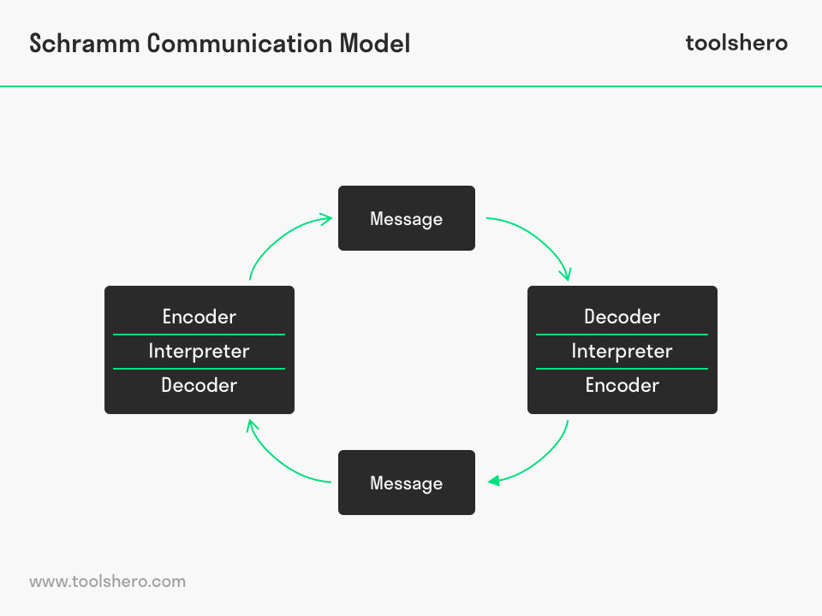

An example is grouping people together for assessment presentation, for some group members English is not their first language and the concept of expanding their ideas and research is not decoded, which is why sitting together face to face and showing examples, visual cues will assist and support them. Body language helps to identify if someone understands or not.
(See Appendix B), knowing your audience is essential, Case study, A Day with the Chief, Mark did not keep things professional and went into the meeting nervous and as he relaxed, his body language changed to being unprofessional and he started to speak negatively about his supervisor. In this instance, he did not identify in any professional circumstances you speak negatively about any past or current colleagues as this goes against your character. A personal example, I was team leader and explained that the slides needed to be just bullet points, but the members kept sending me long paragraphs with texts. Their understanding of the message was not complete, I decided to do an example of mine with short bullet points and showed them. It was apparent that visual communication was needed to explain and assist my instructions but knowing that my team, the audience, required a different type of tactful communication.
Berlo’s SMCR Communication Model
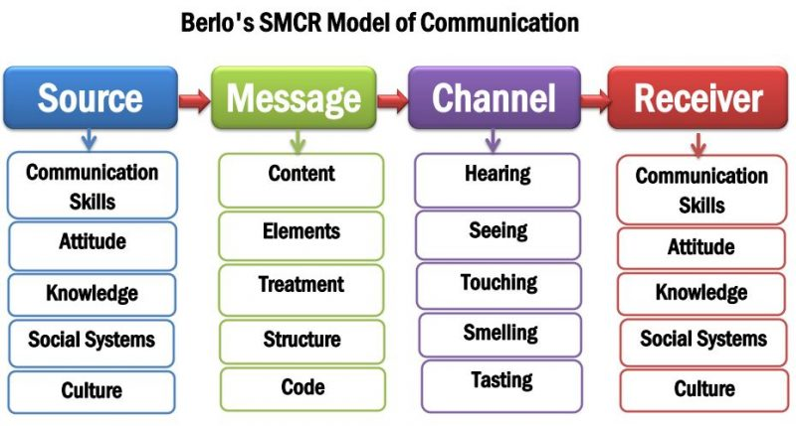
Berlo’s theory is a transfer of information, according to Kobiruzzaman (2021), these are the four elements of channelling messages, and the receiver is the audience. The diagram explains the source, which is encoded and the type of message, what is the line of communication? Then is it channelled, the route, can be audio or visual or both. The receiver decodes the message
In this instance the receiver can use feedback loop sending back the message to clarify. To understand the message there are factors that inhibits the understanding such as communication skills such as hearing, reading, listening etc the knowledge of the receiver, therefore familiarity is an advantage and effective, attitudes, such as the relationship of both parties and lastly the social setting such as religion, values, and beliefs.
From personal experiences I have encountered both good and bad experiences of communication. During my time working in Retail there have been many situations where bad communication was very challenging, due to language barriers. I had many clients who did not speak English and it affected the sales overall, I would have to use visual cues to assist in the line of communication. I would send pictures and pricing to my non-English speaking clients an if they liked the items, I would hold them for when they come to purchase.
A good example of good communication was teamwork, due to the nature of retail, staff worked shift patterns, we used WhatsApp and notes in our changeover briefs. Before each shift change, we would have a team briefing to voice any concerns or business to attend to. This is effective because problems arising in the morning needs to be relayed to the later shift staff, delays in stock, complaints etc. This also gives all staff a chance to clarify and give feedback on what works and what does not, working as a team effectively is very important and any issues needs to be addressed before any start to a shift pattern. I had a very difficult customer during my early shift, she needed shoes repaired but had no receipt luckily, we had her purchase history and called her to bring the shoes back in, but she could not return till late that afternoon. During shift change meeting I made sure I told my team the situation and that she was very difficult, she returned and was happy that the procedure was smooth and not stressful for her. She even text me to thank me for the service we provided for her. This instance was face to face verbal communication, even though it was a confrontational situation, briefing beforehand and making everyone aware of the difficult situation makes the transition smoother, and made the customer feel they have been listened to and that the customer is always right.
There have been many occasions where I misinterpret verbal and non-verbal communication, situations where you send someone an email regarding an issue and they reply not answering your question, frustrating as it is rewording your questions and asking if they understood can rectify this, in this instance Berlo’s theory helps us to understand that people have different barriers and decoding data whether it is through text, email or visual messages. (Kobiruzzaman M, 2021) according to Berlo’s model, written and read communication is one way communication and does not allow feedback, therefore clarification is important to re transmit the understanding backwards and forwards.
A case study (See Appendix A), in class of the Professor and the Village people, Lloyd B outlines Berlo’s model used whereby the professor used language that the village people did not understand, if he had used simple ‘my house was on fire!’, the Village people would have understood and helped him but he shouted, ‘The edifice is being consumed by a great conflagration!’ his context was not clear therefore everyone just looked at him and did nothing. Which supports that when we communicate, we need to know our audience and their body language.
Conclusion
The purpose of this report was to determine my understanding of different type of communication and how it impacts our understanding and how it can be misunderstood along the way. I have learnt that in all 3 models of communication feedback is crucial, this clarifies the sender’s message and the receiver, audience, double checks they have understood what the instruction or conversation is about. We know from all three models that when messages are sent, it is both parties’ responsibility to ensure that the message is decoded correctly. This is effective, good communication but in the real world we have distractions and challenges that affect this.
I find Schramm’s model simple to use because it has three functions, sender, message, and receiver. This is a two-way conversation which goes back and forth, for example I send a verbal message to my colleague they interpret it and feedbacks to me that they have understood, and vice versa. But this tends to happen when two individuals work together, know each other, it can not be effective for example in Shannon and Weaver’s model because, when there is distraction, the message is decoded incorrectly. My example I gave regarding good communication, the instance with a difficult client, I made sure I gave verbal and written communication to confirm the situation. This ensured that no further problems occurred as I identified the audience, difficult client, and my colleagues working different shift patterns, and made sure I verbally communicated this to my team and dealt with the client by written and verbal communication to confirm.
Therefore, the incident with noise interfering with my store Manager’s conversation was bad communication as he should have clarified the instructions whether by a follow up call or with email to make a concrete confirmation. In addition to improve effective and communication the area manager should have re confirmed the visit by email as this was an official visit.

References

Businesstopia 6th January 2018), businessstopia in communication, businesstopia “Shannon and Weaver model of communication”, https://businesstopia.net/communication/shannon-weaver-model-communication.

C Drew (29th September 2019), Shannon Weaver Model of Communication – 7 Key Concepts, https://helpfulprofessor.com/shannon-weaver-model/

P Juneja, (2018), Management Study Guide, https://www.managementstudyguide.com/schramm-model-of-communication.htm

Kobiruzzaman M M (12th February 2021), SMCR Model of Communication-David Berlo’s SMCR Model of Communication, https://newsmoor.com/smcr-model-of-communication-david-berlos-smcr-model-of-communication-example/

M M Kobiruzzaman (12th February 2021) Communication, https://newsmoor.com/theory-and-model-statement-process-explanation-reality/page/4/

Appendix A
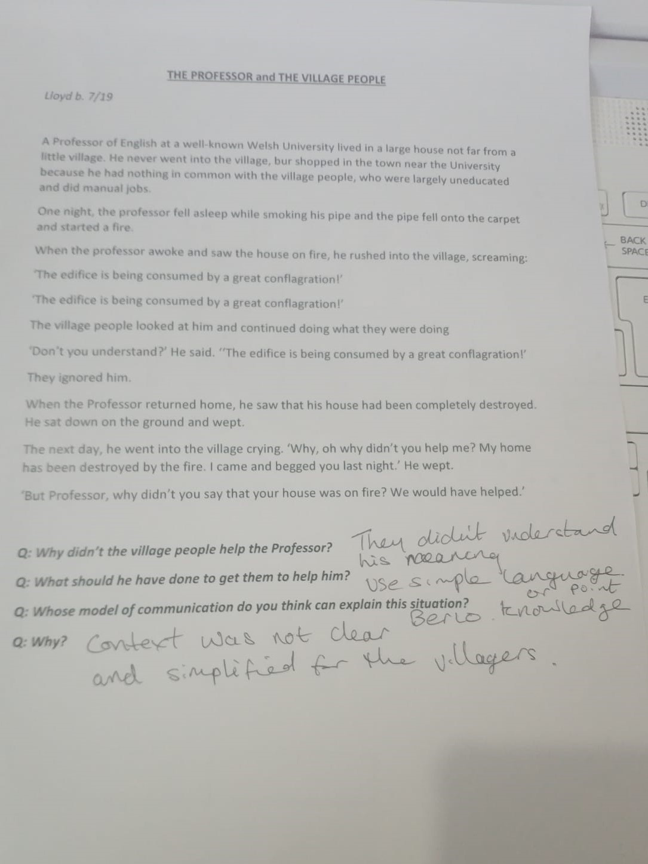

Appendix B


