Student Name: Bethany Curtis
P Number: 1700923
Programme of Study: Graphic Design
Module: M4X01559
Word Count: 1279

Introduction
Typography is everywhere. We rely on it every day. But it’s such a vital part of communication we often don’t always take it in. The imagined “What is it?” exhibition gives the audience a chance to experience a variation of typography in a way that is personal to them and their perception. In a busy age, where our minds are often running at high speeds, the exhibition allows you to step back and simply appreciate design. The exhibition will explore ideas of traditional Japanese aesthetics, which enable the mind to think differently about visuals. This is a good exercise in lateral thinking. Lateral thinking is about changing concepts and perception. According to De Bono “Lateral thinking is closely related to creativity, but whereas creativity is too often the description of a result, lateral thinking is the description of a process.” (1970, pg. 7). This allows us to think deeper about design and how we perceive it. A chance to challenge what your mind is viewing. The imagined exhibition showcases work of some of the best Graphic Designers and reveals Typography in it’s many different forms. A specific focus within the exhibition is order vs disorder. A perception that the viewer has to decide upon.
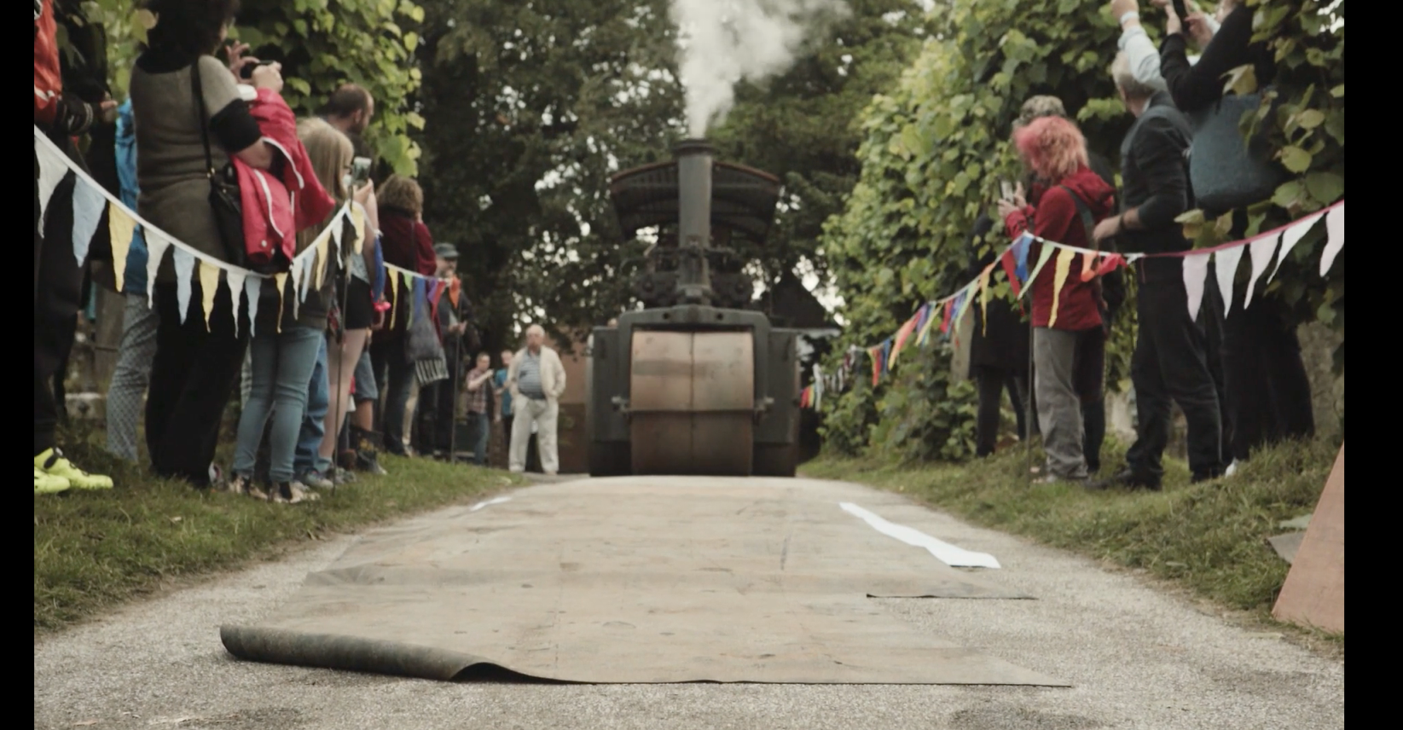
Antony Burrill, Persistence if Fruitful! 2016
Big Steam Print Event, 2016 (Video)
Within the context of my imagined exhibition, we can view this print by Antony Burrill in many different ways according to Japanese Zen aesthetic principles. According to Reynolds “The principles are interconnected and overlap; it’s not possible to simply put the ideas in separate boxes.” (2007)

The print was created in an unheard of, unique way; with a vintage steam roller at the Big Steam Print Event in 2016. This form of printing, brings attention to the traditional letterpress method and gives it glory in this digital age. Letterpress has made a comeback in recent years which is wonderful, as it is important to cherish this beautiful method of print. In an interview before making the print Burrill says “it will be the largest print I’ve ever made. I’m going to think very carefully about what I’m going to say!”. (2018) This makes it an iconic piece of design for Burrill, particularly because of the scale.

The work is very impactful with the use of bold dark typography. It addresses a feeling of force with the use of the exclamation mark. The Japanese principle “Shizen” describes an absence of artificiality. I think this is a fitting description for this print by Burrill, because of the traditional method used there is no digital manipulation created.

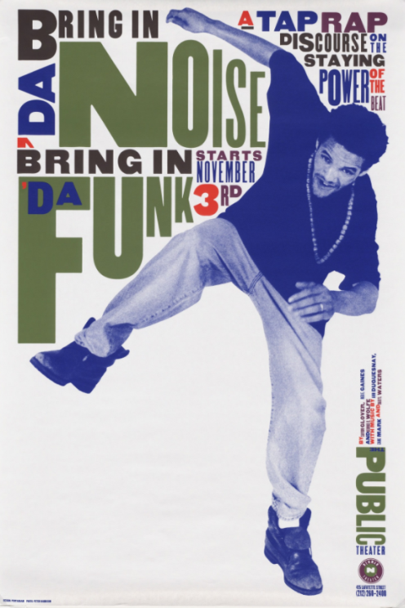
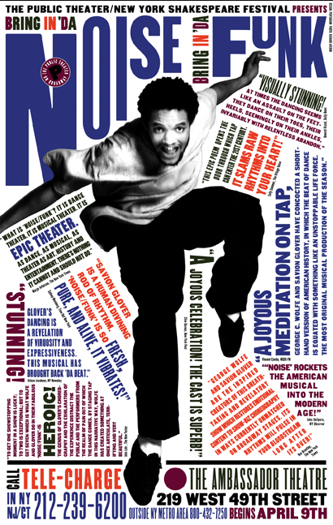
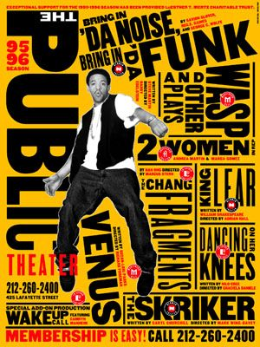
Paula Scher, Bring in ‘Da Noise, Bring in ‘Da Funk Triptych (1995)

We need to take into consideration that one’s perception may change because of the constant flux of reality. The fast pace of the world is likely to encourage and affect our senses within time. So, what someone perceives in 2018 may differ to what they perceive in the future. According to the BPS this goes in connection with the Buddhist expression of “impermanence”. (1981: 31) Nothing lasts forever.
The second work in the exhibition would be a triptych. Scher’s Bring in ‘Da Noise, Bring in ‘Da Funk posters designed for the Public Theatre in 1995 were massively influential and created a paradigm shift for design in New York – the city of signs. They were everywhere, and people began imitating this influential style. “In 3 – 5 years it became it became the standard.” (Paula Scher: Graphic Design, 2017). Scher took what she saw on stage and translated it typographically to communicate the perfect, urban, in your face design. It was iconic for her, and really put her on the map.
The type is arranged from top to bottom in an impactful way to create this movement and noise on paper. The Japanese principle “Fukinsei” describes a feeling of irregularity. “In graphic design too, asymmetrical balance is a dynamic, beautiful thing.” (2009) This reference is well suited to Scher’s communication in the posters and links the work in relation to the context of my imagined exhibition.

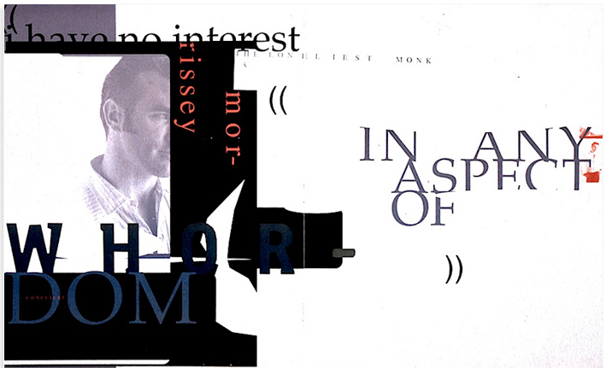
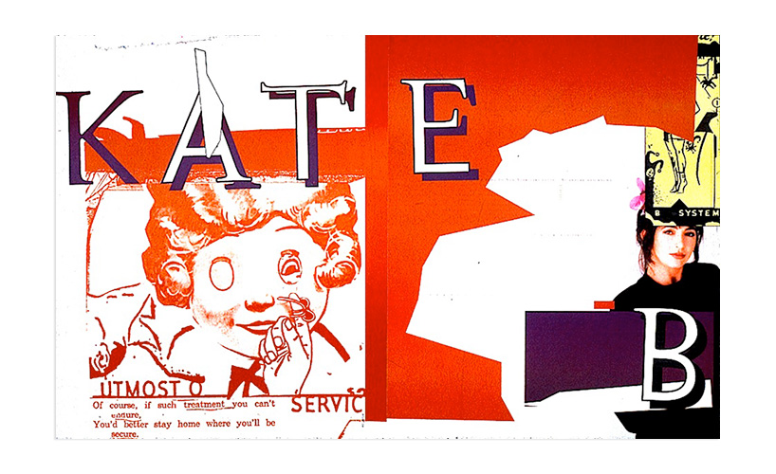
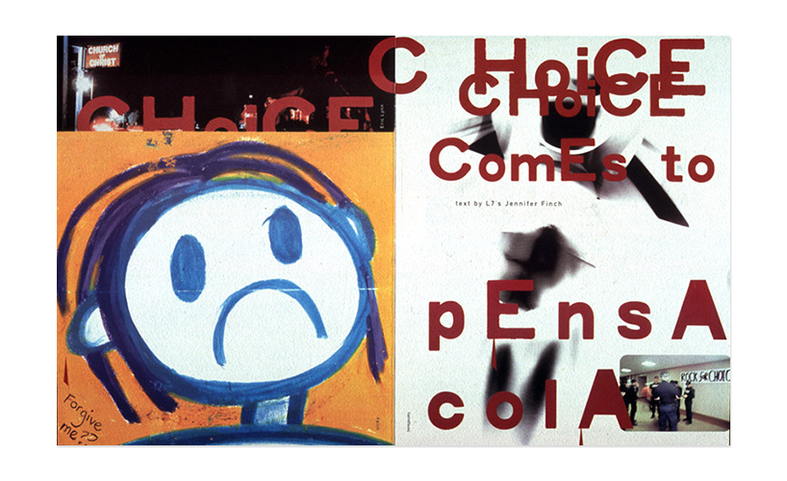
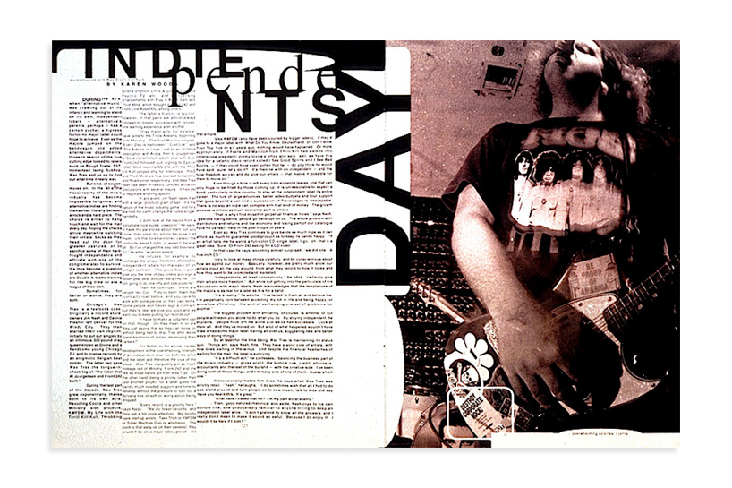
David Carson, Ray Gun Magazine Spreads, (1992-1995)
It was in the 90’s that David Carson created a revolution in typographic design. These spreads are a clear insight into why Carson is best known for his innovative magazine spreads and experimental typography. He broke rules. He has no formal training which obviously doesn’t put his design at fault, because of how iconic his signature grunge style is. He simply just “did what felt right- to reinforce visually what’s written, spoken or sung.” (Carson, 2014) He communicates the words effectively even with this unbalanced grungy style, that’s what makes it so iconic. The courage that Carson had to really push and challenge boundaries within typographic design when nobody else did at that time is influential. There is no wonder why he is considered to be one of the world’s most influential Graphic Designers.
Carson thoughtfully uses negative space effectively within his work and this puts more of a focus onto the communication of the words. This follows the Japanese principle of “Yugen”, to visually imply more by showing less. This is a strong tool to use in visual communication.
Another thing to take into consideration with perception is experience. How one has seen the world and their experiences may reflect upon their senses with a piece of work. According to Parkes within Japan “culture and the arts tend to be more closely connected with intellect and the life of the mind.” (2011) Age isn’t necessarily the factor, but personal experience is.

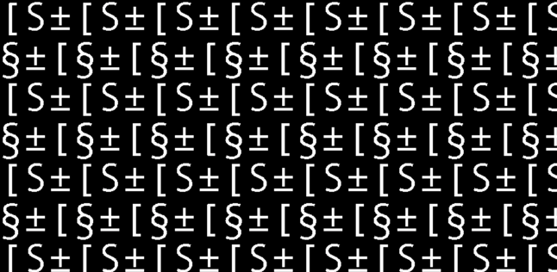
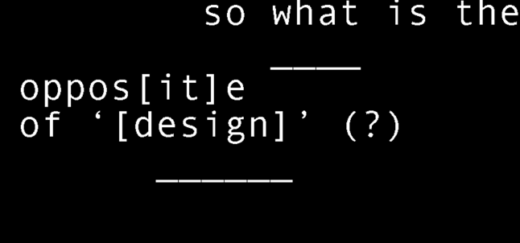
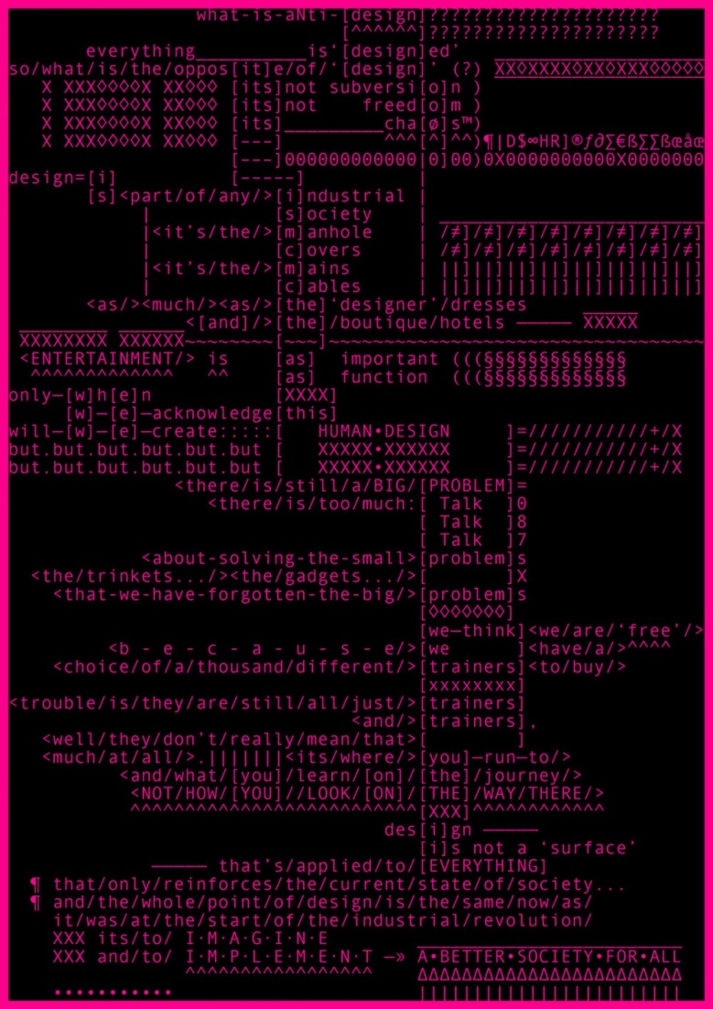
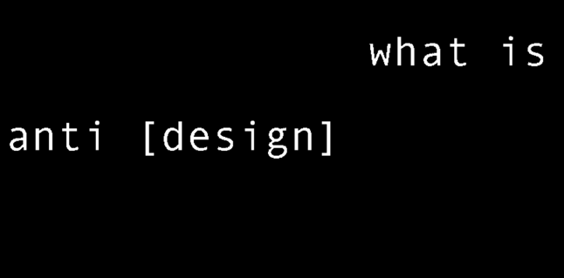
Johnathon Barnbrook, Anti Design Festival Animation and Poster (2010)
The fourth work within the exhibition would be an animation by Barnbrook with the transcript poster to accompany it. This animation by Barnbrook brings typography to life digitally within the imagined exhibition. This differs from the other works on show and represents more recent typographic design in this digital age. This is because animated and moving graphics are becoming the norm, to keep up with technology.
Barnbrook communicates in the animation how people are not present and are not focusing and documenting on the important things going on in the world to ‘make a better society for all’.
The work was made for the Anti Design Festival in London. Initiated by Neville Brody, the exhibition showcased art and design that challenged contemporary stereotypes. “The Anti Design Festival was born out of a need for change.” (Brody, 2010) It was a chance for work that was new, exciting and less mainstream.
“Datsuzoka” is another Japanese principle. According to Reynolds it’s a way of “transcending the conventional” (2007) This work by Barnbrook clearly links to this, he is preaching and being vocal with an opinion about society in a really interesting way. He clearly conveys the purpose of the Anti-Design Festival by breaking from the habit of design and creating work that shows his opinion and gives him a voice.

Ebon Heath, Push Me (2013)
The final work in the exhibition would be this sculptural hanging chandelier by Heath. This adds another form of typography to the exhibition, one that allows the viewer a new experience of depth. The words come alive when lit up whilst the chandelier rotates. Heath claims he has left behind the computer screen to get out of the virtual world, and instead of creating an illusion of depth, to actually do so with his sculptural and performance pieces. Heath (2017) says the focus in his work now is to “Make type scream and make type jump – physically not just metaphorically.”
The chandelier is made out of laser cut maple wood veneer and is inspired by the poetry found in the lyrics of “The Message” by Grandmaster Flash and the Furious Five. The composition of the work, shows off each word so beautifully whilst rotating. Within the context of my imagined exhibition, this work goes in relation with the principle “Shibui”. It’s simply elegant precisely as it is.

Bibliography
De Bono, Edward. (1970) Lateral Thinking: A Textbook of Creativity. Ward Lock Education, London
Reynolds, Garr. (2007) Presentation Zen: Simple Ideas on Presentation Design and Delivery (Voices That Matter). PeachPit, USA
Burrill, Antony (2018) Interview for Art Fund. [Online]. Available at: https://www.artfund.org/get-involved/art-happens/big-steam-print/interview-≠––with-anthony-burrill (Accessed: 02 April 2018)
BPS. (1981) The Three Basic Facts of Existence I: Impermanence (Anicca). Buddhist Publication Society, Sri Lanka
“Paula Scher: Graphic Design.” Abstract: The Art of Design. Episode 6. (2017) Netflix https://www.netflix.com/gb/title/80057883
Reynolds, Garr. (2009) 7 Japanese aesthetic principles to change your thinking. Available at: http://www.presentationzen.com/presentationzen/ (Accessed: 04 April 2018).
Carson, David (2014) Interviewed by Andy Butler for Design Boom, 22 September [Online]. Available at: https://www.designboom.com/design/interview-with-graphic-designer-david-carson-09-22-2013/ ( Accessed:10 April 2018)
Parkes, Graham. (2011) Stanford Encyclopedia of Philosophy [ Online ] Available at: https://plato.stanford.edu/entries/japanese-aesthetics/ ( Accessed: 04 April 2018).
Brody, Neville (2010) Interviewed by Alex Bec for It’s Nice That, 29 July [Online]. Available at: https://www.itsnicethat.com/articles/2931-neville-brody-the-anti-design-festival ( Accessed: 15 April 2018)
Ebon Heath (2017) Red Bull Profile: Ebon Heath. Available at: https://www.youtube.com/watch?time_continue=584&v=htVL-HTeT10 ( Accessed: 20 April 2018)

WHAT IS IT ? EXHIBITION


