Stephen Lawrence was a black teenager who lived in Eltham in South London. ... On 22 April 1993, Stephen was killed by a gang of white men in a racist attack. He had been waiting for a bus with a friend, when the gang attacked them. Stephen's friend escaped unhurt, but Stephen died from his injuries.

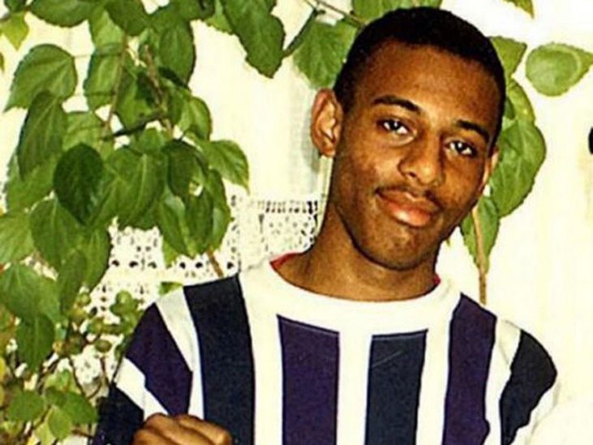

The MacPherson Report
How did it come about?
In July 1997, more than four years after Stephen Lawrence was murdered by a group of white youths, the then home secretary Jack Straw announced the establishment of an inquiry into his death.
It followed the dropping of charges against two youths, years of campaigning by the Lawrence family, the collapse of a private case by them and a subsequent announcement of an investigation into the case by the Police Complaints Authority.

What did they find?
A 350-page report concluded that the investigation into the killing had been “marred by a combination of professional incompetence, institutional racism and a failure of leadership”. Specific officers in the Metropolitan police were named and the entire force was criticised.

What were its recommendations?
A total of 70 recommendations designed to show “zero tolerance” for racism in society were made. They included measures not just to transform the attitude of the police towards race relations and improve accountability but also to get the civil service, NHS, judiciary and other public bodies to respond and change.
What was their impact?
Some 67 of the report’s recommendations led to specific changes in practice or the law within two years of its publication. They included the introduction of detailed targets for the recruitment, retention and promotion of black and Asian officers, as well as the creation of the Independent Police Complaints Commission with the power to appoint its own investigators.
The abolition of the “double jeopardy rule” – which stated that people could not be tried for the same crime twice – eventually led to the 2012 conviction of Gary Dobson and David Norris for Lawrence’s murder.


The Macpherson Report: Twenty Years On

The Home Affairs Select Committee is currently conducting an inquiry into progress in twenty years since the Macpherson Report, focussing in particular on performance against the following recommendations:

- That the Home Secretary and Police Authorities should seek to ensure that the membership of police authorities reflects so far as possible the cultural and ethnic mix of the communities which those authorities serve [this would now apply more appropriately to PCCs and their offices];
- That all possible steps should be taken by Police Services at local level in consultation with local Government and other agencies and local communities to encourage the reporting of racist incidents and crimes
- That Police Services and Victim Support Services ensure that their systems provide for the pro-active use of local contacts within minority ethnic communities to assist with family liaison where appropriate
- That police training and practical experience in the field of racism awareness and valuing cultural diversity should regularly be conducted at local level and that it should be recognised that local minority ethnic communities should be involved in such training and experience and
- That the Home Office and Police Services should facilitate the development of initiatives to increase the number of qualified minority ethnic recruits

The Lammy Review:

The Lammy Review, chaired by David Lammy MP, is an independent review of the treatment of, and outcomes for, Black, Asian and Minority Ethnic (BAME) individuals in the Criminal Justice System (CJS).
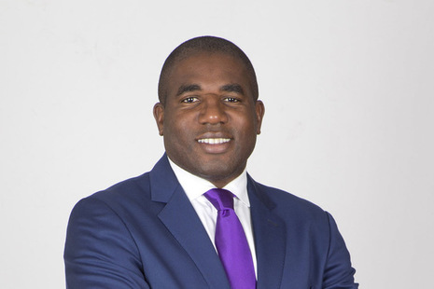
The report is online on the .gov website.

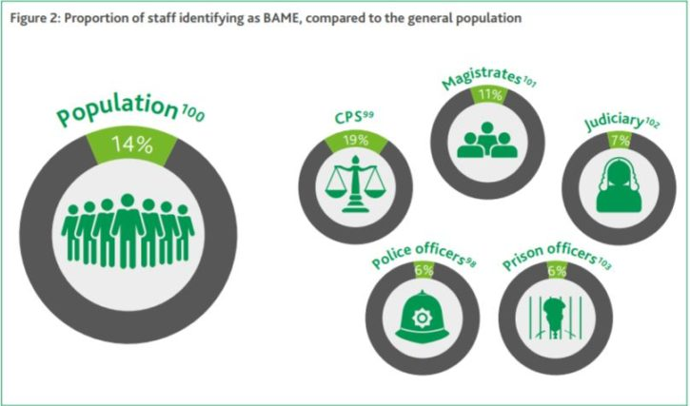

The Review:
This review has two distinctive features, the first of which is its breadth. The terms of reference span adults and children; women and men. It covers the role of the Crown
Prosecution Service (CPS), the courts system, our prisons and young offender institutions, the Parole Board, the
Probation Service and Youth Offending Teams (YOTS). A comprehensive look at both the adult and youth justice systems was overdue.

The review also addresses the position of other minorities who are overlooked too often. For example, Gypsies, Roma and Travellers (GRT) are often missing from published statistics about children in the CJS, but according to unofficial estimates, are substantially over-represented in youth custody, for example, making up 12% of children in Secure Training Centres (STC).17 Muslims, meanwhile, do not fall within one ethnic category, but the number of Muslim prisoners has increased from around 8,900 to 13,200 over the last decade.18 Both groups are considered within scope for this review

YOTs were established by the 1998 Crime and Disorder Act, with a view to reducing youth offending and reoffending and have been largely successful in fulfilling that remit. Yet despite this fall in the overall numbers, the BAME proportion on each of those measures has been rising significantly.31 Over the last ten years:
- The BAME proportion of young people offending for the first time rose from 11% year ending March 2006 to 19% year ending March 2016.32

- The BAME proportion of young people reoffending rose from 11% year ending March 2006 to 19% year ending March 2016.33

- The BAME proportion of youth prisoners has risen from 25% to 41% in the decade 2006-2016.34

- There are important gaps in what we know about the CJS. For example, prisons record inmates’ religion but the courts and the CPS do not. This obscures important questions, like why the number of Muslim prisoners has increased by nearly 50% in the last ten years. This lack of transparency undermines accountability.

- This review starts with decisions made by the Crown Prosecution Service (CPS), 60 but an individual’s journey through the criminal justice system (CJS) does not. Arrest rates determine the number of cases passed onto the CPS. This chapter looks both at the caseload that the CPS receives from the police, following arrests, and the decisions that the CPS itself then goes on to take

- Arrest rates are generally higher across minority ethnic groups in comparison to the white group. In particular, Black and Mixed ethnic groups are arrested at much higher rates. The disproportionate representation of Black, Asian and Minority Ethnic (BAME) individuals starts at the beginning of the CJS journey.

- Policing has a second, important legacy for the rest of the CJS: it affects how people view ‘the system’ as a whole. Grievances over policing tactics, particularly the disproportionate use of Stop and Search, drain trust in the CJS in BAME communities.

