Strategic Development and Implementation for SMEs

Student Name: Sinziana Madalina Chirvasa
Student’s ID: 2112859

Executive Summary
In the global economy, small and medium-sized enterprises (SMEs) are vital because they foster innovation, create jobs, and advance the economy. We shall concentrate on a particular SME that we are acquainted with, Brook and Wilde, for the sake of this academic report. The landscape of SMEs is heterogeneous, comprising a range of businesses and sectors, all of which confront distinct opportunities and problems. Our goal in writing this study is to offer Brook and Wilde important strategic recommendations that will direct its further development and application. SMEs work in dynamic situations where market trends, technology, and regulatory frameworks are always changing. To effectively navigate this complexity, one needs a strong strategic management framework. The first thing we'll do is evaluate Brook and Wilde's present strategic orientation critically, looking at its vision, purpose, values, goals, and objectives. Next, we'll use business environmental scanning techniques like PESTEL, VRIN, and SWOT to perform a thorough analysis of the internal and external surroundings. With the use of this analysis, the organization's position will be seen holistically, with opportunities, challenges, strengths, and weaknesses highlighted. Building on this framework, we will use models such as Bowman's Strategic Clock model, Ansoff Matrix, and Porter's Generic Strategies to examine the strategic growth options accessible to SMEs in the market. Our goal in assessing these expansion possibilities is to put out a fresh plan of action that is consistent with Brook and Wilde's long-term viability. Furthermore, a stakeholder analysis will be carried out in order to evaluate the relative power and comprehend the expectations of different stakeholders. The identification of strategic solutions that are appropriate, workable, and acceptable to important stakeholders will be guided by this research. This report will offer important strategic recommendations that are suited to the particular circumstances of Brook and Wilde, taking into account the inherent difficulties that SMEs encounter when putting strategic directions into practise. The main conclusions will be outlined in the conclusion, which will also stress how crucial it is for SMEs to have a clear, adaptable strategic plan in order to prosper in the always changing business environment. Our goal in producing this research is to provide insightful information on the strategic management of SMEs, promoting resilience and sustainable growth in a cutthroat market.

Table of Contents
Executive Summary 2
Introduction 4
The current strategic direction of Brook and Wilde 5
Business Environment Analysis 7
PESTEL Analysis 7
VRIN Analysis 9
SWOT Analysis 10
Strategic growth choices for SMEs in markets 12
Porter’s Generic Strategies 12
Ansoff Matrix 13
Bowman’s Strategic Clock model 14
Stakeholder analysis for Brook and Wilde 18
Recommendations considering challenges SMEs encounter to implement strategic direction 21
Conclusion 24
References 25

Introduction
Brook and Wilde is a company that specialises in high-quality sleep solutions. They are well-known for their dedication to bedroom comfort, innovation, and elegance. The company's goal is to develop items that provide a pleasant and rejuvenating sleep experience. Brook and Wilde sells a variety of sleep-related items, with a focus on mattresses and bed frames (Brook and Wilde, 2023). To give ideal support and comfort, their mattresses frequently incorporate innovative materials and technologies. The company may also provide pillows, sheets, and other accessories to improve the overall sleeping atmosphere. Brook and Wilde faces obstacles that many SMEs face, ranging from resource limits to technology issues, all of which have an impact on the design and execution of strategic directions. However, these challenges present a chance for strategic evolution and long-term prosperity. This research unveils a series of strategic recommendations adapted to Brook and Wilde's situation through an in-depth analysis. These ideas, which range from resource optimisation and innovation to change management and cybersecurity, offer a complete roadmap for the company's future advances. In the pages that follow, this report will look at how Brook and Wilde can not only overcome their obstacles, but also use them as drivers for strategic brilliance. This report provides a strategic narrative that is both nuanced and pragmatic, weaving together insights from market intelligence, change management, risk mitigation, and technological transformation—a guiding compass for Brook and Wilde's journey towards resilience, innovation, and long-term success in the realm of sleep solutions.

The current strategic direction of Brook and Wilde
Leading company in the sleep solutions market, Brook and Wilde, has set a strategic course that emphasises quality, innovation, and client happiness (Alharbi, 2015). Understanding the company's present strategy direction can be gained by analysing its strategic statement, which includes its vision, mission, values, goals, and objectives.

Vision: A well-defined vision sets the overarching aspirational goal for the company. For Brook and Wilde, the vision may revolve around becoming a market leader in providing premium and innovative sleep solutions. This could include an emphasis on redefining the standards of comfort and quality in the bedroom.
Mission: The mission statement outlines the company's purpose and how it aims to fulfil the vision. Brook and Wilde's mission might involve designing and manufacturing top-tier mattresses and sleep-related products, utilizing cutting-edge technologies and materials to enhance the sleep experience for customers.
Values: Core values guide the behaviour and decision-making within the organization. Brook and Wilde's values could include a commitment to quality craftsmanship, sustainability, customer-centricity, and continuous innovation. These values likely underpin the company's day-to-day operations and strategic choices.
Goals and Objectives: Concrete goals and objectives provide a roadmap for achieving the vision and mission. Brook and Wilde's goals might include expanding market share, introducing new product lines, enhancing customer satisfaction, and ensuring sustainable business practices. Objectives could be quantifiable targets aligned with these broader goals.
Analysis: Brook and Wilde's strategic direction appears to be aligned with the contemporary trends in the sleep solutions industry. Emphasizing premium quality, innovation, and customer satisfaction positions the company competitively (Brook and Wilde, 2023). The focus on sustainability and customer-centric values is likely a response to evolving consumer preferences and environmental consciousness.
However, to provide a more accurate and critical appraisal, it is essential to consider how well the strategic direction aligns with external market dynamics, potential challenges, and the company's internal capabilities.A critical study of Brook and Wilde's present strategic direction might be further strengthened by an assessment of the actual results obtained in respect to stated aims and objectives.

Business Environment Analysis
Analysing the internal and external elements that may have an impact on an organization's performance, operations, and strategic choices is the process of doing a business environment analysis (Eirini Apostolaki, 2018). This study aids organisations in navigating obstacles and seizing opportunities by offering insightful information for strategic planning. This paper aims to delineate the fundamental elements of business environment analysis, including PESTEL, VRIN, and SWOT analyses.

PESTEL Analysis
The PESTEL analysis, which stands for Political, Economic, Sociocultural, Technological, Environmental, and Legal elements, the analysis offers a thorough framework for assessing the macroenvironmental factors that can affect an organization's operations (Foss, 2019). In light of this, we examine Brook and Wilde, a significant participant in the sleep solutions market, using a PESTEL framework.
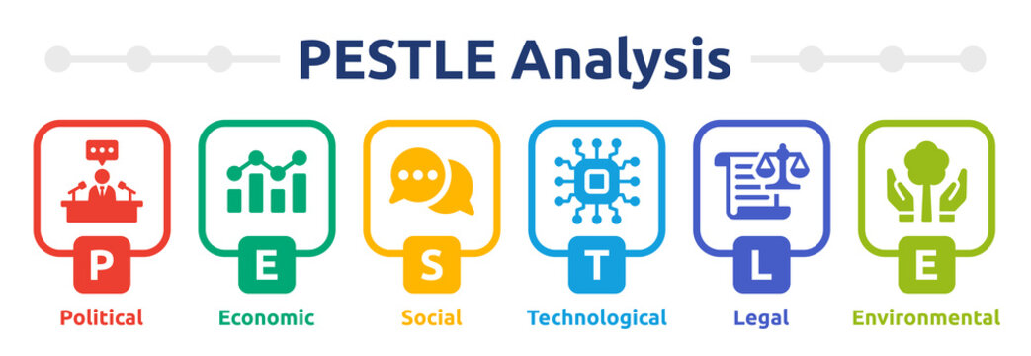
Political Factors: Trade agreements, safety laws, manufacturing standards, and other political aspects all have an impact on Brook and Wilde's business, which provides sleep solutions (Levy, 2014). Government policy changes may have an effect on the import/export of raw materials and completed goods, which may have an effect on the supply chain and general business operations.
Economic Factors: Brook and Wilde's business is greatly impacted by the state of the economy. Customers' purchasing power can be impacted by economic variables such as interest rates, inflation rates, and spending patterns of consumers. While economic upswings may offer prospects for expansion, economic downturns may have an impact on discretionary expenditure on upscale goods like high-end mattresses.
Sociocultural Factors: Brook and Wilde are greatly impacted by society trends and consumer preferences. The need for high-quality sleep solutions is growing as people place a greater priority on their health and fitness. Product design, materials, and marketing tactics may be impacted by societal movements towards ethical and sustainable consumption.
Technological Factors: Brook and Wilde's product development and production processes may be impacted by advancements in manufacturing and material technologies. Adopting cutting-edge digital innovations, like smart mattress integration or improved e-commerce, could provide businesses a competitive advantage.
Environmental Factors: Brook and Wilde need to take the environment into account, especially with the increased focus on sustainability. Reducing waste, using eco-friendly materials, and sourcing sustainably all meet legal and customer criteria. In addition to being expected by society, environmental stewardship can also serve as a point of differentiation.
Legal Factors: Compliance with legal requirements and industry standards is crucial for Brook and Wilde. This includes adherence to safety regulations for sleep products, employment laws, and any other relevant legal obligations. Staying informed about changes in legislation ensures that the company operates within the bounds of the law.
In summary, Brook and Wilde's success is influenced by the interplay of political, economic, sociocultural, technological, environmental, and legal factors. Understanding and proactively responding to these elements are essential for effective strategic planning and maintaining a competitive edge in the dynamic sleep solutions market.

VRIN Analysis
A VRIN analysis assesses an organization's resources to determine if they are Valuable, Rare, Inimitable, and Non-substitutable – factors critical for sustaining a competitive advantage (Levy, 2014). Applied to Brook and Wilde:

Valuable: Brook and Wilde's commitment to premium quality sleep solutions, innovative product design, and a customer-centric approach represents valuable resources. Their emphasis on providing a superior sleep experience aligns with evolving consumer preferences and positions the brand favourably in the market.
Rare: Certain resources possessed by Brook and Wilde, such as unique material innovations and perhaps exclusive collaborations with designers, could be considered rare. If the company has proprietary technologies or partnerships that competitors find challenging to replicate, it enhances their rarity.
Inimitable: The inimitability of Brook and Wilde's resources depends on the extent to which competitors can replicate their strategies and processes. If the company has proprietary manufacturing processes, patented designs, or exclusive supplier relationships, it could make their resources more difficult to imitate.
Non-substitutable: Resources that have no close alternatives contribute to sustained competitive advantage. If Brook and Wilde possess resources that customers highly value and for which there are no direct substitutes in the market, it strengthens their strategic position.
In summary, a VRIN analysis suggests that Brook and Wilde may have a foundation for sustained competitive advantage based on the uniqueness and value of their resources, provided these resources are rare, difficult to imitate, and lack close substitutes in the industry.

SWOT Analysis
SWOT analysis is a strategic planning tool used to evaluate and understand the internal Strengths and Weaknesses of an organization, as well as the external Opportunities and Threats it faces in its operating environment. The purpose of a SWOT analysis is to help Brook and Wilde develop a comprehensive understanding of their current strategic position.

Strengths: Brook and Wilde demonstrate a number of traits that support their competitive position in the sleep solutions market. The use of cutting-edge materials and technologies in the company's mattresses demonstrates its everlasting commitment to premium quality. Positive feedback and testimonials reflect their dedication to customer satisfaction, which boosts brand loyalty. They can also reach a big customer base thanks to a robust web presence and e-commerce infrastructure.
Weaknesses: Even with the presence of Brook and Wilde, there may still be some unresolved concerns. Due to the premium positioning of their products, buyers who are price concerned can have a harder time accessing the market. Vulnerabilities in the supply chain, such reliance on particular suppliers or difficulties with logistics, could be dangerous. Furthermore, the competitive environment in the sleep solutions sector necessitates constant innovation, so Brook and Wilde must remain ahead of changing consumer desires.
Opportunities: Brook and Wilde have opportunities to capitalize on emerging trends and market dynamics. The growing focus on health and wellness presents an opportunity to further market their products as contributors to overall well-being. Expansion into international markets and strategic collaborations with influencers or complementary brands could open new revenue streams. Leveraging technological advancements for smart sleep solutions aligns with the trend of integrating technology into everyday life.
Threats: External factors that pose threats to Brook and Wilde's business include intensifying competition within the industry. The emergence of new entrants or established competitors introducing similar premium products could erode market share. Economic uncertainties affecting consumer spending and potential shifts in consumer preferences pose additional threats. External shocks, such as global supply chain disruptions, could impact the availability of key materials.
In conclusion, Brook and Wilde's SWOT analysis highlights the need to leverage strengths and opportunities while addressing weaknesses and mitigating potential threats. Strategic initiatives aimed at maintaining product innovation, enhancing market accessibility, and ensuring supply chain resilience can position the company for sustained success in the competitive sleep solutions market.

Strategic growth choices for SMEs in markets
Continuing from the analysis of Brook and Wilde's current strategic direction, we can explore available strategic growth choices for SMEs in the sleep solutions market. Leveraging frameworks like Porter's Generic Strategies, Ansoff Matrix, and Bowman's Strategic Clock model can provide a structured approach to identifying growth options.

Porter’s Generic Strategies
Porter's Generic Strategies, developed by Michael Porter, offer a framework for organizations to gain a competitive advantage in their industry. The three generic strategies are Cost Leadership, Differentiation, and Focus. Let's examine how Brook and Wilde might use each of these tactics in the sleep solutions sector:
- Cost Leadership: Being the industry's lowest-cost producer entails taking on this role. The objectives of this strategy are price competitiveness, cost effectiveness, and economies of scale. Although a luxury brand such as Brook and Wilde might not prioritise cost leadership, aspects of this approach could be taken into account. Enhancing production procedures, logistics, and supply chain efficiency may assist lower costs and enable the business to provide competitive pricing without sacrificing product quality.
- Differentiation: Differentiation is the process of providing distinctive and one-of-a-kind goods and services that make a mark in the marketplace. Strong branding, excellent quality, and innovation are frequently used in this tactic. The differentiation strategy that Brook and Wilde have already adopted is based on their emphasis on high-end sleep solutions. By making investments in cutting-edge technologies, distinctive materials, or modifiable features that improve the entire sleep experience, the corporation may maintain its competitive edge.
- Focus: Concentrate on a single product category or market segment in order to maintain focus. This can be accomplished by differentiation emphasis (providing special products within a certain market segment) or cost focus (seeking the lowest cost within a niche). By focusing on a particular market segment within the larger sleep solutions industry, Brook and Wilde may implement a focused strategy.

Ansoff Matrix
The Ansoff Matrix, also known as the Product-Market Growth Matrix, is a strategic planning tool that helps businesses think through their growth options by comparing and contrasting potential outcomes based on the mix of new and existing goods and markets. To expand their business in the sleep solutions industry, companies like Brook and Wilde can choose one of four strategies from the Ansoff Matrix:
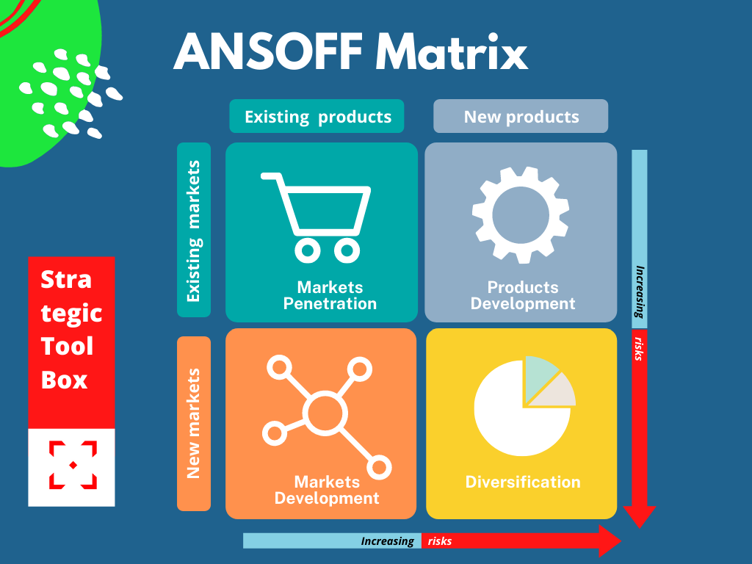
- Market Penetration: Increasing one's share of the market or selling more of one's existing products to one's existing customer base is an example of this strategy. Businesses can expand their reach into untapped markets by increasing their marketing efforts, launching new distribution channels, or implementing customer loyalty programmes that reward repeat business. Discounts and sales in the current market may also help bring in new customers.
- Product Development: The introduction of a new or improved product to the marketplace. One way to do this is to improve, extend, or introduce new products. By introducing new sleep solutions or enhancing their existing products with cutting-edge features, Brook and Wilde can test the waters of product development.
- Market Development: Market development involves expanding into new markets or reaching new customer segments while offering existing products. The company can explore market development by targeting new geographic regions or demographic segments. This might involve entering international markets, reaching untapped customer bases, or tailoring marketing strategies to address specific consumer needs in different regions.
- Diversification: Diversification is the riskiest strategy and involves introducing entirely new products to new markets. While diversification may present challenges, Brook and Wilde could consider related diversification by expanding into complementary product categories within the broader home and lifestyle market. For instance, introducing bedding accessories or sleep-related technology could represent a calculated form of diversification.
Rationale for Chosen Strategy: For Brook and Wilde, a combination of market penetration and product development may be particularly relevant. Intensifying efforts to penetrate the existing market while simultaneously introducing innovative sleep solutions aligns with the company's commitment to differentiation and premium quality. This approach allows for both expanding the customer base within the current market and catering to evolving consumer preferences, fostering sustained growth in the competitive sleep solutions industry.

Bowman’s Strategic Clock model
Bowman’s Strategic Clock is a model that offers different strategic options based on two key dimensions: perceived price and perceived value. It provides a visual representation of competitive positioning and helps organizations understand their strategic choices within the broader market. Let's discuss how Brook and Wilde might align with Bowman's Strategic Clock:
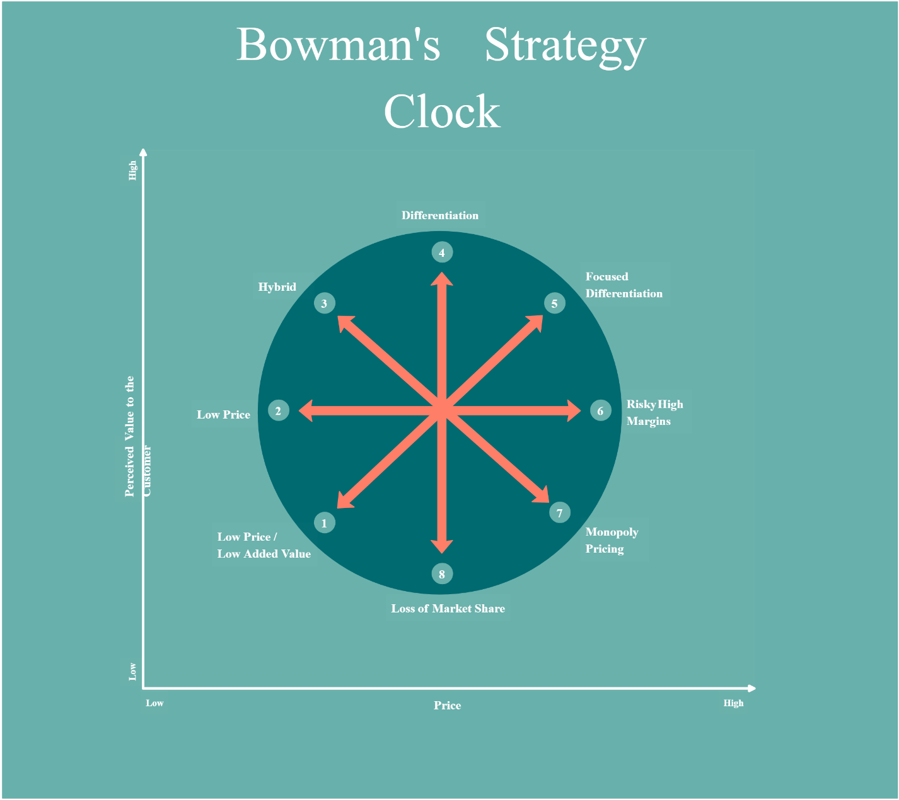
- Low Price/Low Value (Position 1): This position focuses on being the lowest-cost provider in the market, offering products at a lower price point but with perceived lower value. This position might not align well with Brook and Wilde's current strategy, as the company emphasizes premium quality and innovative sleep solutions, positioning itself as a provider of higher value.
- Low Price (Position 2): This position maintains a focus on low prices but aims to offer better value for money compared to competitors. Brook and Wilde may not directly pursue this position as it could compromise the premium quality perception of their products. However, the company could explore options to optimize costs without sacrificing quality to provide better value.
- Hybrid (Position 3): A hybrid strategy aims to achieve a balance between low prices and differentiation, offering reasonable prices for products perceived as having some unique features or higher quality. This position aligns well with Brook and Wilde's strategy, as the company already focuses on differentiation through premium quality and innovation. Balancing this with competitive pricing can attract a broader customer base.
- Differentiation (Position 4): This position emphasizes high value and premium pricing, focusing on delivering unique features or superior quality. This position strongly aligns with Brook and Wilde's current strategy. By consistently innovating and delivering top-quality sleep solutions, the company positions itself as a provider of high value, justifying premium pricing.
- Focused Differentiation (Position 5): Similar to Position 4 but with a narrower focus on a specific market segment. While Brook and Wilde primarily focuses on a premium market, they might explore opportunities for targeted differentiation within specific customer segments, such as luxury mattresses for high-end customers.
Rationale for Chosen Position: Position 3, the Hybrid strategy, appears to be the most suitable for Brook and Wilde. It allows the company to maintain its commitment to differentiation and premium quality while also considering cost competitiveness. This balanced approach ensures that Brook and Wilde can attract a wide customer base while delivering sleep solutions that are both innovative and reasonably priced, contributing to sustained growth and market resilience.

Proposed Strategy: Differentiation and Market Development
We propose a strategy that combines product differentiation and market development. Brook and Wilde can continue to differentiate themselves by investing in research and development to create cutting-edge sleep solutions. This might involve incorporating smart technologies, sustainable materials, or customizable features that align with evolving consumer preferences for personalized and technologically advanced sleep experiences.
Simultaneously, market development can be pursued by expanding into new geographic areas or demographic segments. This could involve targeted marketing campaigns to reach untapped audiences or introducing product variations to cater to different customer needs.
Rationale for Sustainability: This strategy aligns with the long-term sustainability of Brook and Wilde for several reasons. Firstly, differentiation fosters brand loyalty and allows for premium pricing, contributing to sustained profitability. Secondly, market development mitigates the risks associated with dependency on a specific market by diversifying the customer base. Finally, the focus on innovation positions Brook and Wilde as leaders in the industry, adapting to changing consumer demands and ensuring relevance in the competitive sleep solutions market. The combination of differentiation and market development creates a resilient and adaptable strategy for long-term success.

Stakeholder analysis for Brook and Wilde
Stakeholders, encompassing individuals, groups, or entities directly or indirectly affected by a company's actions, play a pivotal role in shaping its trajectory. This analysis delves into understanding the varying needs, concerns, and relative power dynamics of stakeholders to inform strategic decision-making.

- Customers: Customers expect high-quality, innovative sleep solutions that align with their preferences and contribute to a superior sleep experience. They may also expect transparent and ethical business practices, including sustainable sourcing. Customers hold significant power as their purchasing decisions directly impact Brook and Wilde's revenue and market reputation.
- Suppliers: Suppliers expect timely payments, fair business practices, and long-term partnerships. They may also anticipate sustainability initiatives in the supply chain. While suppliers are essential, Brook and Wilde's power in negotiations may be influenced by the availability of alternative suppliers in the market.
- Employees: Employees expect fair compensation, a positive work environment, opportunities for professional development, and alignment with the company's values. Employee morale and productivity significantly impact the company's success. Collective actions or talent retention challenges can affect operations.
- Investors/Shareholders: Investors seek a return on their investment through increased stock value or dividends. They also expect transparent financial reporting and sustainable business practices. Investors provide capital crucial for growth. Their influence extends through voting rights and the ability to impact the company's stock value.
- Competitors: Competitors expect fair competition and adherence to industry norms. They may anticipate responses to market dynamics that align with industry standards. While competitors don't have direct control, their actions influence market dynamics and can impact Brook and Wilde's market share.
- Regulatory Bodies: Regulatory bodies expect compliance with industry regulations, product safety standards, and ethical business practices. Non-compliance can lead to legal consequences, fines, or business restrictions, making regulatory bodies influential stakeholders.
- Environmental Advocacy Groups: These groups expect environmentally responsible practices, sustainable sourcing, and efforts to minimize the company's ecological footprint. While not direct decision-makers, their influence is growing, especially as consumer preferences shift towards eco-friendly products.
Identification of Strategic Options:
- Innovation and Quality Assurance: Continuously invest in research and development to introduce innovative sleep solutions, ensuring high quality and customer satisfaction. Addresses the expectations of customers, employees, and investors, enhancing the brand's reputation and competitiveness.
- Sustainable Practices: Embrace sustainable sourcing, eco-friendly manufacturing processes, and responsible waste management. Meets the expectations of environmental advocacy groups, customers, and regulatory bodies, contributing to ethical business practices.
- Employee Well-being Programs: Implement employee development programs, foster a positive work environment, and ensure fair compensation. Addresses the expectations of employees and contributes to enhanced productivity, job satisfaction, and talent retention.
- Transparency and Compliance: Ensure transparent communication with stakeholders, adhere to regulatory requirements, and maintain ethical business practices. Builds trust with customers, employees, investors, and regulatory bodies, mitigating risks associated with non-compliance.
In conclusion, strategic options that prioritize innovation, sustainability, employee well-being, and transparent business practices align with the expectations of key stakeholders. These options contribute to the long-term success, reputation, and resilience of Brook and Wilde in the competitive sleep solutions market.

Recommendations considering challenges SMEs encounter to implement strategic direction
Small and Medium-sized Enterprises (SMEs) encounter various challenges when implementing strategic directions. These challenges can impede the effective execution of planned strategies and hinder the achievement of organizational goals. Some common challenges and recommendations for SMEs in this context include:
- Limited Resources: SMEs often face limitations in financial resources, making it challenging to invest in research, development, and technology needed for strategic initiatives. A shortage of skilled personnel and expertise may hinder the effective execution of strategic plans.
Recommendation: It is recommended that resource allocation be prioritised by a comprehensive cost-benefit analysis. To get over financial obstacles, think about forming strategic alliances, contracting out non-core tasks, and looking into government grants or funding options. Invest in training initiatives to draw in qualified candidates and develop current talent.
- Market Dynamics and Competition: It can be challenging for SMEs to develop and put into practise strategies that stay relevant as a result of the market's and consumers' ever-changing preferences. Due to resource limitations, SMEs frequently operate in highly competitive contexts where maintaining a competitive advantage can be difficult.
Recommendation: To keep one step ahead of the competition, it is advised to regularly track industry trends and carry out market research. Make sure that the product line is in step with the changing needs of the market by using ongoing innovation to differentiate your offerings. Create a feedback system to determine consumer preferences and adjust items as necessary.
- Limited Access to Information: It may be more difficult for SMEs to make well-informed decisions and develop successful strategies if they lack the means to obtain thorough market knowledge. Inadequate data analytics skills can make it more difficult to glean insightful information for strategic planning.
Recommendation: Make effective use of technology and data analytics tools to collect and evaluate market data. To gain access to market research company information, think about forming alliances. Create channels for consumer feedback using social media and surveys to get up-to-date knowledge about their preferences.
- Resistance to Change: It might be difficult to adopt new tactics that call for adjustments to operations and attitude since SMEs sometimes have deeply ingrained cultures that are resistant to change. Employee resistance may arise from inadequate communication channels and engagement initiatives, leading to a lack of understanding or support for the strategic direction.
Recommendation: Encourage a culture of flexibility by openly conveying the strategic vision. To gain support, involve staff members in the strategic planning process. Employ change management techniques that highlight the advantages of the strategic direction and offer assistance and training throughout the shift.
- Risk Management: Because they frequently have low risk tolerance, SMEs may be afraid to try new things for fear of failing and suffering financial consequences. SME's capacity to recognise and reduce possible risks may be hampered by limited access to advanced risk assessment technologies.
Recommendation: It is advised that comprehensive risk assessments be carried out and that risk mitigation plans be created. Emphasise the calculated risks inherent in strategic endeavours while communicating the possible rewards. To reduce uncertainty, adopt a phased approach to strategic implementation.
- Strategic Planning and Execution: Undefined or impractical strategic aims and objectives may result from SMEs' lack of formalised strategic planning procedures. The inability to convert strategic plans into concrete actions could lead to gaps in implementation and prevent the attainment of strategic goals.
Recommendation: It is advised that a clear and comprehensive strategic plan be created, defining precise objectives, deadlines, and benchmarks. To gauge progress, set up key performance indicators (KPIs). Use project management tools to improve execution and make sure that everyone in the organisation is aware of the strategic strategy.
- External Factors: The execution of strategic goals may be impacted by external economic factors like recessions or downturns in the world economy. SME strategy adaptation may be required in response to swift regulatory changes, which could provide difficulties for operational and compliance modifications.
Recommendation: It is advised to develop scenarios in order to foresee future changes in the economy and in regulations. Organise backup plans so you can quickly adjust to unforeseen circumstances. Get involved in advocacy activities and remain up to date on regulatory developments by interacting with industry associations.
- Technology Constraints: The adoption of digital tools and platforms that are essential for strategic implementation may be hampered by low investments in technology infrastructure (Alick Mhizha, 2015). Because they might not have strong cybersecurity defences in place, SMEs are more susceptible to attacks that could jeopardise important plans.
Recommendation: In order to facilitate digital transformation, make investments in modernising IT infrastructure. Give cybersecurity precautions first priority to safeguard sensitive data. Instruct staff members on utilising novel technology and cultivate an IT-aware culture within the company.
A comprehensive strategy is needed to address these issues, one that includes developing an adaptable organisational culture, implementing strategic planning that is based on the organization's capabilities, and requesting outside assistance as necessary. By overcoming these challenges, SMEs can successfully adopt strategy directions and manage the ever-changing business landscape.

Conclusion
- Brook and Wilde encounter a variety of difficulties typical of small and medium-sized businesses as a SME in the cutthroat sleep solutions sector. These obstacles, which range from opposition to change and technological limitations to scarce resources and market dynamics, influence the strategic environment. Nonetheless, the offered strategic ideas present a comprehensive method for resolving these issues and promoting long-term development. Through resource optimisation, innovation adoption, and improved market information, Brook and Wilde are able to effectively handle industry difficulties. By addressing internal obstacles and encouraging employee participation, adaptable planning, and transparent communication, a culture of adaptability and resilience is fostered. Additionally, proactive risk management, technology change, and scenario preparation for outside variables guarantee readiness for unforeseen difficulties. Together, these suggestions provide a strategic roadmap for Brook and Wilde that takes into account the particular difficulties experienced by SMEs while also being in line with the organization's vision. By implementing these tactics, the business will be able to adapt to the intricacies of the industry while still thriving, innovating, and making a positive impact on the ever-changing landscape of sleep solutions.

References
Alharbi, A. (2015). Small and Medium-Sized Enterprises (SMEs) and Poverty Reduction in Africa. Cambridge Scholars Publishing.
Alick Mhizha (2015). Strategic Management Practices and Challenges. The Case of Small and Medium Scale Enterprises in Harare. GRIN Verlag.
Brook and Wilde (2023). Brook + Wilde Sleep | Award Winning Mattresses. [online] brookandwildesleep.com. Available at: https://brookandwildesleep.com/ [Accessed 20 Nov. 2023].
Dawes, J. (2021). The Ansoff Matrix: A Legendary Tool, But with Two Logical Problems. SSRN Electronic Journal, 1(1).
Eirini Apostolaki (2018). Strategy Development and Implementation Amongst SMEs in Construction.
Foss, N. (2019). How Strategic Entrepreneurship and The Institutional Context Drive Economic Growth. Strategic Entrepreneurship Journal, 7(1), pp.50–69.
Halim, H.A. (2020). Challenges and Opportunities for SMEs in Industry 4.0. IGI Global.
Kampanje, B.P. (2020). Pestel Analysis. SSRN Electronic Journal, 3(2).
Levy, M. (2014). Strategies for Growth in SMEs. Elsevier.
LIU, X. (2017). SWOT and PESTEL Analysis on the Coordinated Development of New Urbanization and Agricultural Modernization in Heilongjiang Reclamation Area. DEStech Transactions on Economics, Business and Management, (eced). doi:https://doi.org/10.12783/dtem/eced2017/9891.
Mazzarol, T. (2019). The Strategy of Small Firms. Edward Elgar Publishing.
Pehrsson, A. (2007). The Strategic States Model: strategies for business growth. Strategic Direction, 23(4). doi:https://doi.org/10.1108/sd.2007.05623dad.001.
Todorov, K. (2014). Handbook of research on strategic management in small and medium enterprises. Hershey, PA: Business Science Reference.
Udeme Usanga (2023). Effect of Strategic Management on the Performance of Small and Medium Scale Enterprises (SMEs) in South-east Region of Nigeria. GRIN Verlag.
VemićM.B. (2017). Optimal management strategies in small and medium enterprises. Hershey, PA: Business Science Reference.

