Programme:
BA (Hons) Leadership and Management Skills for the Workplace

Module:
Understanding and Engaging Stakeholders

Module code:
LCLM5001

Module Lecturer:
Eric Osei

Student Name:
James Masih

Student ID:
2420102

Executive Summary
This report evaluates the proposed implementation of the StaySmart+ service within Marriott International, analysing the organisational and strategic factors influencing its global rollout. It assesses Marriott’s organisational capabilities, including its international presence, diverse brand portfolio and technological innovation. A PESTLE analysis examines external opportunities such as technological advancements and changing consumer expectations, alongside challenges including regulatory compliance, cybersecurity risks and economic uncertainty. The report also identifies key internal and external stakeholders and explores stakeholder engagement through communication, collaboration, consultation and commitment. Overall, the analysis indicates that Marriott’s capabilities and effective stakeholder management support the successful global implementation of the StaySmart+ service.

Table of Contents

Introduction 3
Organisational Appraisal of Marriott International 4
Internal Stakeholders 6
External Stakeholders 6
Roles and Responsibilities of the key stakeholders 7
Frameworks, model, and theories to engage with stakeholders 9
Stakeholder Power - Interest Matrix 10
Stakeholder Engagement Plan 10
Communication Plan 11
RACI Matrix – StaySmart+ Implementation 11
Stakeholder Engagement and Business Performance at Marriott International 14
Conclusion 16
References 18

Introduction
In the hospitality industry today, service innovation plays an important role in helping organisations remain competitive and achieve long-term success. Many global hotel companies are using advanced technologies, personalised guest services and sustainable practices to meet the ever-changing customer expectations, whilst endeavouring to stay competitive in a fast-changing market (Sigala, 2018).
Marriott International is a multinational hotel company that operates thousands of hotels across the world. As travellers increasingly expect smarter, more personalised and environmentally friendly travel experiences, the hospitality team has developed innovative services that combine digital technology with prime guest services.
Marriott International is preparing to introduce StaySmart+, a premium service that integrates artificial intelligence–driven guest interactions, personalised travel planning and sustainability-focused amenities to enhance efficiency and guest satisfaction. The service is planned for global rollout within six months across selected domestic and international properties. However, its successful implementation requires effective coordination among diverse internal and external stakeholders whose interests and influence vary across regions.
Stakeholder management, therefore, becomes a central component in ensuring that the design, development and deployment of StaySmart+ are implemented effectively. Drawing on the principles of Stakeholder Theory (Freeman, 1984) organisations must identify, understand and engage individuals or groups who can affect or are affected by the project outcomes
Effective stakeholder engagement enables organisations to build trust, encourage collaboration and mitigate potential risks associated with global service implementation (Bryson, 2004).
This report critically examines the key stakeholders involved in the launch of StaySmart+ across Marriott’s global operations. It identifies and categorises relevant internal and external stakeholders, analyses appropriate stakeholder engagement strategies and evaluates the potential benefits, challenges and ethical considerations associated with managing stakeholder relationships during the introduction of a global hospitality service innovation (Johnson, Scholes and Whittington, 2017).

Organisational Appraisal of Marriott International
An appraisal of Marriott International is essential for identifying the group’s capability to implement the StaySmart+ service across global markets. Marriott is one of the largest hospitality companies in the world, operating thousands of hotels across more than 130 countries. The company manages a diverse portfolio of luxury, premium and mid-scale brands, allowing it to reach a wide range of customer segments.
Its global presence, well-established reputation and strong loyalty programme provide a substantial competitive advantage within the hospitality industry. However, the implementation of a technology-driven service such as StaySmart+ requires consideration of both internal capabilities and external environmental factors. Strategic frameworks such as SWOT and PESTLE analysis help evaluate these situations.
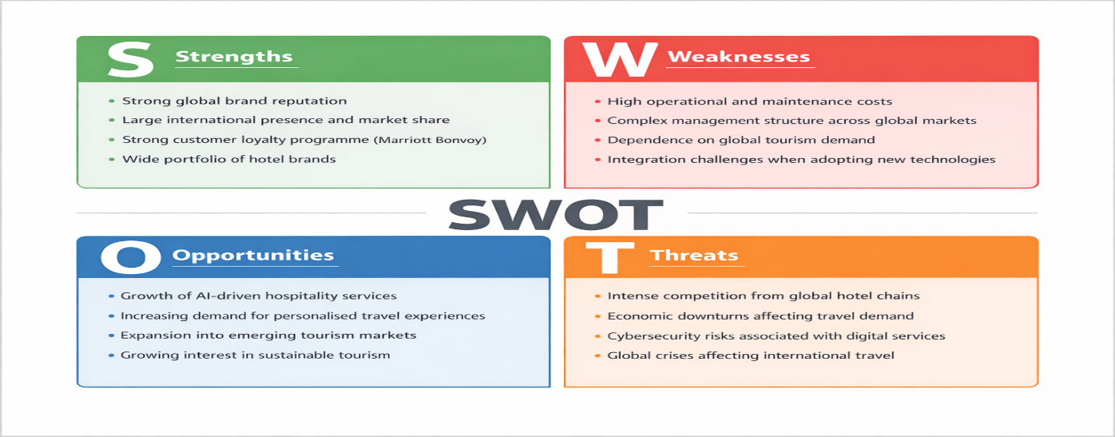
Figure 1

Figure1 shows that the SWOT analysis establishes that Marriott International has strong brand recognition, extensive market reach and established customer loyalty. These strengths create favourable conditions for introducing an innovative service such as StaySmart+. Nevertheless, technological (Bansal and DesJardine, 2014) integration challenges and global operational complexity may affect implementation.

PESTLE
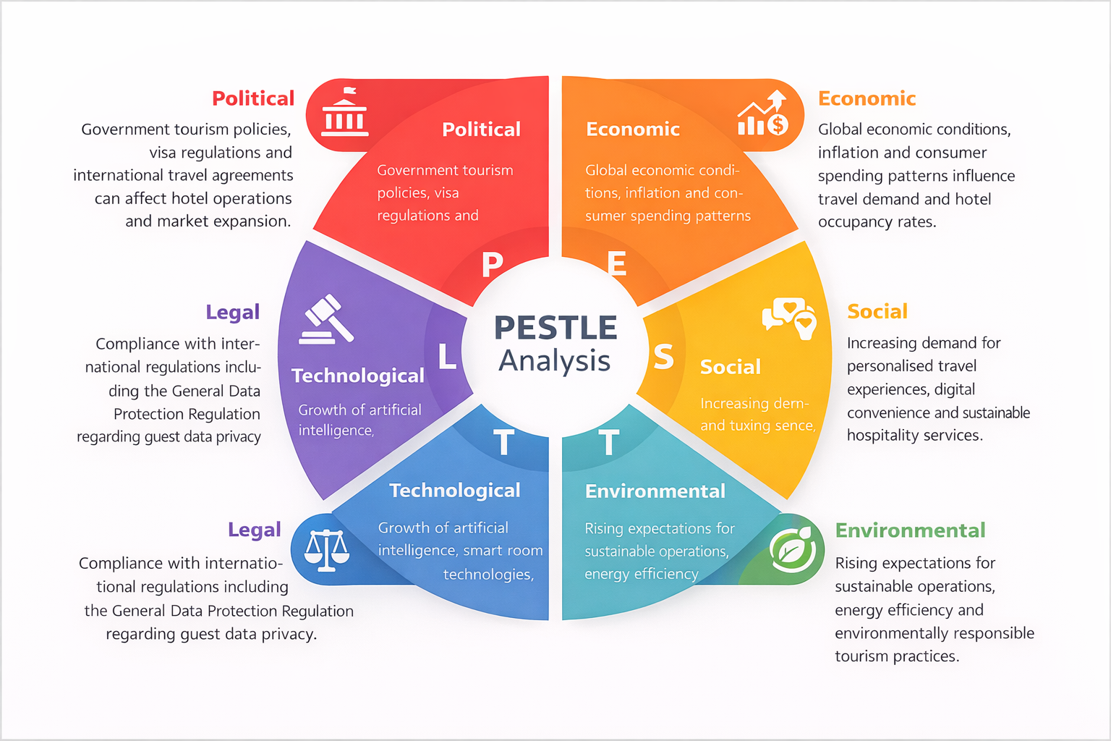
Figure 2
PESTLE analysis, as shown if Figure 2 is a strategic framework used to assess the external macro-environmental factors: political, economic, social, technological, legal and environmental - that may influence an organisation’s strategic decisions and operational environment (Law, Buhalis and Cobanoglu, 2019). Overall, the appraisal highlights that Marriott operates in a complex, rapidly evolving environment. Whilst technological developments and changing consumer preferences present strong opportunities for service innovation, (Law, Buhalis and Cobanoglu, 2019) the company must also readily address regulatory compliance, cybersecurity risks and economic uncertainty when introducing new global hospitality services such as StaySmart+

For the development and worldwide launch of the StaySmart+ service within Marriott International, a wide variety of stakeholders must be recognised. These stakeholders can be generally classified into internal and external groups based on their relationship with the organisation and their degree of influence on the project. Identifying these parties is crucial because their interests, resources, and decisions can greatly impact the planning, execution, and long-term success of the service (Clarkson, 1995).

Internal Stakeholders
Internal stakeholders are individuals or groups operating within the Marriott organisation who directly contribute to the design, delivery and management of the StaySmart+ initiative.
- Executive leadership and corporate strategy teams – Responsible for approving strategic investments, allocating resources and ensuring the service aligns with long-term organisational goals.
- Digital innovation and technology teams – Develop and integrate artificial intelligence tools, guest interaction systems and smart technologies required for the StaySmart+ platform.
- Operations and hotel management teams – Ensure the service is implemented effectively within individual properties and integrated into daily hotel operations.
- Customer experience and service design teams – Focus on improving guest journeys and ensuring the new service enhances comfort, convenience and personalisation.
- Human resource departments – Responsible for staff training, workforce readiness and ensuring employees understand how to deliver the new service effectively.
- Finance and investment teams – Evaluate project costs, budgeting requirements and financial feasibility.
- Sustainability and corporate responsibility teams – Oversee the environmental aspects of StaySmart+, ensuring eco-friendly amenities and sustainable practices are incorporated.

External Stakeholders
External stakeholders are individuals or organisations outside the Marriott organisation who influence or are influenced by the project outcomes.
- Hotel guests and loyalty programme members – The primary users of the StaySmart+ service whose feedback and satisfaction determine its success.
- Technology partners and software providers – Companies supplying AI systems, digital platforms and smart hotel infrastructure.

- Travel partners and booking platforms – Organisations that integrate travel planning services and promote hotel offerings to global travellers.
- Government authorities and regulatory bodies – Ensure compliance with tourism policies, safety regulations and data protection requirements such as the General Data Protection Regulation.
- Local communities and tourism organisations – Stakeholders affected by the sustainability initiatives and broader economic impact of hotel operations.
- Investors and shareholders – Interested in the financial performance and long-term profitability of the new service.
Together, these stakeholders form a complex (Reed, 2009) network of influence that must be effectively managed to ensure the successful development, launch and adoption of StaySmart+ across Marriott’s international hotel portfolio.

Roles and Responsibilities of the key stakeholders
The successful design and global implementation of the StaySmart+ service within Marriott International depends on the coordinated involvement of multiple stakeholders who contribute specialised knowledge, resources and strategic oversight throughout the project lifecycle. Each stakeholder group performs distinct roles and responsibilities that collectively ensure the service is effectively developed, delivered and adopted across international markets. At the same time, these stakeholders bring significant benefits to the project whilst also encountering operational, technological and organisational challenges (Mendelow, 1991).
Senior leadership and strategic management teams play a critical role in shaping the overall direction of the StaySmart+ initiative. Their primary responsibility is to provide strategic vision, approve investment decisions and ensure the project aligns with the organisation’s long-term innovation and competitive strategy.
By supporting digital transformation and sustainability initiatives, leadership enables Marriott to strengthen its position within the global hospitality sector. The main benefit these stakeholders bring is strong strategic governance and resource allocation, which are

essential for large-scale service innovation. However, they may face challenges in balancing financial risk, managing investment priorities and ensuring consistent implementation across diverse geographic regions.
Technology and digital innovation teams represent another key stakeholder group. These specialists are responsible for designing and integrating the artificial intelligence tools, personalised travel planning systems and smart hotel technologies that form the foundation of StaySmart+. Their role includes software development, cybersecurity management, system integration and continuous technological improvement. The contribution of this group is particularly valuable because it enables Marriott to deliver advanced digital guest experiences and improve operational efficiency. Despite these advantages, technology teams may face challenges such as complex system integration across existing hotel infrastructure, cybersecurity risks, and the need to comply with data protection regulations such as the General Data Protection Regulation (European Commission, 2016).
Hotel operations managers and frontline employees also play a central role in the delivery of the StaySmart+ service. These stakeholders are responsible for translating strategic plans into practical service experiences within individual hotels.
Their responsibilities include implementing new operational procedures, assisting guests with digital tools, and maintaining high service standards. Frontline staff provide the direct human interaction that remains essential even within technologically enhanced hospitality environments.
Their involvement benefits the project by ensuring that the service remains guest-focused and operationally practical. Nevertheless, employees may encounter challenges related to training requirements, adaptation to new technologies and concerns about the potential impact of automation on traditional hospitality roles.
External stakeholders also contribute significantly to the success of the project. Technology partners and digital solution providers support the development and maintenance of AI-driven systems, bringing specialised expertise and innovation capabilities that may not exist internally. Similarly, hotel guests and loyalty programme members provide critical feedback that helps refine the service and ensure it meets evolving customer expectations. These stakeholders contribute valuable insights into guest preferences, enabling Marriott to deliver

highly personalised travel experiences. However, managing guest expectations, ensuring data privacy and maintaining consistent service quality across global markets remain ongoing challenges.
Overall, effective collaboration between these internal and external stakeholders is essential for ensuring that StaySmart+ delivers its intended benefits. By combining strategic leadership, technological expertise, operational experience and customer insight, Marriott can successfully introduce an innovative hospitality service that enhances guest satisfaction while strengthening the organisation’s global competitive position.

Frameworks, model, and theories to engage with stakeholders
The successful delivery of the StaySmart+ service within Marriott International requires structured stakeholder engagement supported by established management frameworks and models. These tools allow project managers to identify stakeholder influence, clarify responsibilities, and ensure consistent communication throughout the project lifecycle. Using recognised stakeholder management frameworks also improves transparency, collaboration, and decision-making during complex global projects.
One of the most widely used models for analysing stakeholders is the Power–Interest Grid. This framework categorises stakeholders according to their level of power and interest in the project. It helps project managers prioritise engagement strategies and allocate resources effectively.

Stakeholder Power - Interest Matrix
Stakeholder | Power | Interest | Engagement Approach
Executive leadership | High | High | Manage closely and involve in strategic decisions
Hotel operations managers | High | High | Regular updates and active collaboration
Technology partners | Medium | High | Continuous coordination and technical meetings
Employees and frontline staff | Medium | High | Training and internal communication
Government and regulators | High | Low | Keep satisfied with compliance reporting
Hotel guests | Low | High | Engage through feedback and service testing
Figure 3
The model in Figure 3 helps the project team focus on stakeholders who have the greatest influence on the implementation of StaySmart+, particularly senior leadership, hotel management and technology partners. Another key framework is the stakeholder engagement plan (Figure 4), which outlines how stakeholders are involved at each stage of the project (PMI, 2021). It ensures communication and participation are tailored to the needs of each group.

Stakeholder Engagement Plan
Stakeholder | Engagement Method | Purpose | Frequency
Executive leadership | Strategy meetings | Project approval and direction | Monthly
Technology teams | Technical workshops | System development and integration | Weekly
Hotel managers | Implementation briefings | Operational preparation | Bi-weekly
Employees | Training sessions | Skills development | Before launch
Guests | Surveys and pilot testing | Service improvement | During testing phase
Figure 4
Effective stakeholder engagement also requires a clear communication plan (Figure 5) that ensures stakeholders receive the right information at the right time.

Communication Plan
Stakeholder | Communication Method | Key Information Shared
Senior management | Executive reports | Project progress and performance
Hotel management | Operational meetings | Implementation updates
Employees | Training platforms and emails | Service procedures
Technology partners | Technical documentation | System requirements
Customers | Mobile apps and feedback surveys | Service features and improvements
Figure 5
Finally, a RACI (Figure 6) matrix helps clarify roles and responsibilities within the project. The RACI model defines who is Responsible, Accountable, Consulted and Informed for each key task.

RACI Matrix – StaySmart+ Implementation
Task | Responsible | Accountable | Consulted | Informed
Service design | Innovation team | Senior leadership | Technology partners | Hotel managers
Technology integration | IT department | Project manager | External vendors | Staff
Staff training | HR department | Operations manager | Hotel managers | Employees
Service launch | Project team | Executive leadership | Marketing team | Customers
Figure 6
Together, these frameworks provide a structured approach for managing stakeholders during the rollout of StaySmart+. By clearly identifying stakeholder influence, defining communication processes and assigning responsibilities, Marriott can improve collaboration, reduce misunderstandings and ensure the successful global implementation of the new service.
Stakeholder Engagement and Conflict Management Using the 4C’s Model (Communication, Collaboration, Consultation, and Commitment)
The global implementation of the StaySmart+ service across Marriott International requires a structured and strategic stakeholder engagement process. Given the complexity of launching a technology-driven hospitality service across multiple international markets, the role of the project manager is not only to coordinate operational activities but also to foster strong stakeholder relationships. Effective engagement ensures that stakeholders remain informed, involved and supportive throughout the project lifecycle. One practical framework that can guide this process is the 4C’s stakeholder engagement model, which emphasises communication, collaboration, consultation and commitment. These four elements provide a structured approach for building trust, managing expectations and addressing potential conflicts among stakeholders. The importance of recognising and managing stakeholder interests has been widely discussed in stakeholder theory (Donaldson and Preston, 1995; Mitchell, Agle and Wood, 1997).

The first stage of the engagement process focuses on communication. Clear and consistent communication is fundamental to ensuring that stakeholders understand the objectives, scope and expected outcomes of the StaySmart+ initiative. As project manager, the initial step would involve establishing structured communication channels that enable information to flow efficiently between different stakeholder groups. This may include executive briefings for senior leadership, operational meetings with hotel managers, and digital communication platforms for frontline employees and technology teams. Communication also plays an essential role in aligning stakeholders with the strategic goals of the project, ensuring that each group understands how StaySmart+ contributes to improved guest experiences and organisational competitiveness. Effective communication can also reduce uncertainty and resistance to change, particularly among employees who may be adapting to new digital systems and operational procedures.Managing stakeholder expectations through transparent communication is considered a key aspect of successful stakeholder management (Hillman and Keim, 2001).

The second component of the 4C’s model is collaboration. Collaboration involves actively involving stakeholders in the development and implementation of the project rather than simply informing them of decisions. For a project such as StaySmart+, collaboration is particularly important because the service integrates multiple elements including artificial intelligence, personalised travel planning and sustainability initiatives. Technology specialists, hotel operations teams and customer experience experts must work together to ensure that the service functions effectively within real hotel environments. As project manager, fostering collaboration may involve cross-functional project workshops, innovation sessions and pilot testing programmes in selected hotels. These collaborative activities enable stakeholders to share expertise, identify operational challenges early and co-create solutions that improve the quality of the final service. In addition, collaboration strengthens stakeholder relationships by encouraging shared ownership of project outcomes.

The third element of the engagement process is consultation. Consultation ensures that stakeholders have opportunities to provide feedback and contribute insights that can improve decision-making. Within the hospitality sector, consultation is particularly valuable because service quality is closely linked to the experiences and expectations of guests as well as the operational knowledge of employees. For example, hotel staff may provide practical insights into how digital tools affect daily operations, while guests may offer feedback regarding usability and personalisation features. Consultation mechanisms may

include surveys, focus groups, pilot programme evaluations and feedback sessions with technology partners. Through these processes, the project manager can gather diverse perspectives and identify potential issues before full-scale implementation occurs. Consultation therefore reduces the risk of project failure by ensuring that stakeholder concerns are acknowledged and addressed during the planning and development stages. According to stakeholder identification theory, organisations must recognise stakeholders with legitimate interests and incorporate their perspectives into decision-making processes (Mitchell, Agle and Wood, 1997).

The final stage of the 4C’s model focuses on commitment. Commitment refers to the process of securing long-term stakeholder support and ensuring that all parties remain engaged throughout the project lifecycle. For StaySmart+, stakeholder commitment is essential because the successful adoption of the service depends on consistent implementation across multiple hotels and regions. As project manager, building commitment may involve establishing clear responsibilities, recognising stakeholder contributions and demonstrating the value that the service provides to both guests and employees. For instance, training programmes can empower staff to confidently deliver the new service, while performance monitoring systems can highlight improvements in guest satisfaction and operational efficiency. When stakeholders see tangible benefits from the project, they are more likely to remain committed to its success.

While the 4C’s framework supports effective stakeholder engagement, conflicts may still arise during complex projects. Conflicts can occur due to differences in priorities, resource allocation, technological challenges or resistance to organisational change. As project manager, conflict management requires a balanced and transparent approach. Open communication is often the first step in resolving disagreements, as it allows stakeholders to express concerns and clarify misunderstandings. Collaborative problem-solving techniques can also be used to identify mutually beneficial solutions that satisfy multiple stakeholder interests. In situations where conflicts involve strategic decisions or resource constraints, structured negotiation and mediation processes may be required to reach an agreement.

Ultimately, the effective application of the 4C’s model enables the project manager to create an inclusive and structured engagement process that supports cooperation among diverse stakeholder groups. By prioritising communication, encouraging collaboration, facilitating consultation and building commitment, the project manager can minimise conflict, strengthen

stakeholder relationships and ensure the successful implementation of the StaySmart+ service across Marriott’s global operations.

Stakeholder Engagement and Business Performance at Marriott International
Stakeholder engagement plays a key role in the success and long-term performance of innovative initiatives such as StaySmart+ at Marriott International. In the hospitality sector, where service quality, customer satisfaction and operational efficiency are closely linked, effective engagement with both internal and external stakeholders can directly improve organisational performance. Involving stakeholders throughout the planning, development and implementation stages strengthens collaboration, reduces operational risks and enhances the value delivered to customers.
One of the key impacts of stakeholder engagement on business performance is improved service quality and customer satisfaction. Involving hotel managers, frontline employees and guests in the development of StaySmart+ at Marriott International helps the organisation better understand operational needs and customer expectations. Employee participation supports effective service delivery, while guest feedback refines digital features and personalisation. This alignment between service design and user needs increases guest satisfaction, encourages positive reviews, strengthens brand loyalty and ultimately supports stronger financial performance.
Stakeholder engagement also strengthens organisational innovation and competitiveness. In the highly competitive hospitality industry, collaboration with technology partners, sustainability experts and customer experience teams enables Marriott International to access specialised knowledge that supports advanced service development. Partnerships with technology providers, for example, allow the integration of artificial intelligence to improve operational efficiency and personalise guest experiences. These innovations help differentiate Marriott from competitors such as Hilton Worldwide and Hyatt Hotels Corporation, strengthening market positioning, increasing potential market share and enhancing long-term brand reputation (Marketing for Hospitality and Tourism; Philip Kotler, John T. Bowen and James Makens, 2017).
Stakeholder engagement also improves risk management and organisational resilience. In large hospitality projects, involving regulators, investors and local communities helps organisations identify potential risks early and develop effective mitigation strategies. For example, when implementing AI-driven guest interaction systems that process personal data, engaging legal experts and regulatory authorities ensures compliance with international data protection laws such as the GDPR. This proactive approach reduces the risk of legal penalties and reputational damage while supporting sustainable business practices (Porter and Kramer, 2011; UNWTO, 2021).
Despite its benefits, stakeholder engagement can also create challenges if not managed effectively. Coordinating multiple stakeholder groups across different regions and organisational levels can be complex, particularly in a global organisation such as Marriott International, where stakeholders may have diverse cultural perspectives and operational priorities. Managing these differences requires strong leadership and structured engagement strategies. Furthermore, extensive stakeholder involvement can sometimes slow decision-making, as multiple viewpoints must be considered before reaching strategic agreements (Prahalad and Ramaswamy, 2004).
Another challenge relates to potential conflict between technological innovation and employee concerns. While AI-powered guest interaction systems can improve efficiency at Marriott International, some employees may fear automation replacing traditional hospitality roles. Without clear communication and training, this concern may lead to resistance and negatively affect service delivery. Therefore, stakeholder engagement must support both technological implementation and workforce adaptation (Ashcroft, 2017).
To maximise the positive impact of stakeholder engagement on business performance, several recommendations can be proposed for future initiatives.
To improve stakeholder engagement, organisations should implement structured frameworks that define stakeholder roles, responsibilities and communication channels throughout the project lifecycle. Tools such as stakeholder mapping and engagement plans help maintain active involvement while supporting efficient decision-making.
Organisations should also invest in employee training to support technological adoption, improving staff confidence, reducing resistance to change and enhancing service quality. In addition, transparency and ethical responsibility in handling guest data are essential to maintain customer trust through clear privacy policies and secure digital systems.
Finally, adopting continuous feedback mechanisms, such as guest surveys and employee consultations, enables organisations like Marriott International to evaluate and improve services such as StaySmart+, ensuring they remain responsive to evolving customer expectations and technological developments (Christopher, Payne and Ballantyne, 2013).

Conclusion
The successful introduction of the StaySmart+ service within Marriott International highlights the importance of effective stakeholder management in delivering innovative hospitality solutions across global markets. As the hospitality industry continues to evolve through digital transformation, personalisation and sustainability initiatives. Organisations must ensure that a wide range of stakeholders are actively involved throughout the project lifecycle. This report has demonstrated that identifying, analysing and engaging both internal and external stakeholders is essential for ensuring that complex service innovations are implemented efficiently and deliver meaningful value to customers and the organisation.
The analysis first identified the key stakeholders involved in the project, including internal groups such as senior leadership, technology teams, hotel operations managers and employees, as well as external stakeholders such as guests, technology partners, regulators and investors. Each of these stakeholders plays a distinct role in shaping the development, implementation and adoption of the StaySmart+ service. Their contributions provide important resources, expertise and feedback that support the successful execution of the project (Freeman, 1984).
The report also examined stakeholder engagement strategies using established management frameworks such as stakeholder mapping, communication plans and responsibility matrices. These tools provide structured approaches for managing stakeholder influence, clarifying responsibilities and ensuring consistent communication across the organisation. In addition, the application of the 4C’s model—communication, collaboration, consultation and commitment - demonstrated how project managers can build strong stakeholder relationships, manage conflicts and maintain alignment between different stakeholder groups.
Furthermore, the evaluation of stakeholder engagement highlighted its significant impact on business performance, innovation and customer satisfaction. Effective engagement enables organisations to improve service quality, strengthen brand reputation and enhance operational efficiency. However, the analysis also identified challenges such as stakeholder coordination, technological integration and employee adaptation to new systems.
Overall, the findings emphasise that successful hospitality innovation requires not only advanced technology but also strong stakeholder collaboration. By adopting structured engagement strategies and maintaining transparent communication, Marriott can effectively implement services such as StaySmart+ while strengthening its competitive position within the global hospitality industry.

References
Ashcroft, J. (2017) The relational lens: Understanding, measuring and managing stakeholder relationships. Cambridge: Cambridge University Press. Available at: https://www-cambridge-org.ezproxy.uwtsd.ac.uk/core/books/relational-lens/value-and-importance-of-relationships/718C31032061BDFA3F480BA2A53F45D4#CN-bp-1 (Accessed: 15 March 2026).
Bansal, P. and DesJardine, M.R. (2014) ‘Business sustainability: It is about time’, Strategic Organization, 12(1), pp. 70–78. https://doi.org/10.1177/1476127013520265
Bryson, J.M. (2004) ‘What to do when stakeholders matter: Stakeholder identification and analysis techniques’, Public Management Review.
Christopher, M., Payne, A. and Ballantyne, D. (2013) Relationship marketing: Creating stakeholder value. London: Routledge.
Clarkson, M.B.E. (1995) ‘A stakeholder framework for analysing and evaluating corporate social performance’, Academy of Management Review.
Donaldson, T. and Preston, L.E. (1995) ‘The stakeholder theory of the corporation: Concepts, evidence, and implications’, Academy of Management Review.
European Commission (2016) General Data Protection Regulation (EU) 2016/679. Brussels: European Commission.
Freeman, R.E. (1984) Strategic management: A stakeholder approach. Boston: Pitman.
Hillman, A.J. and Keim, G.D. (2001) ‘Shareholder value, stakeholder management, and social issues: What’s the bottom line?’, Strategic Management Journal.
Johnson, G., Scholes, K. and Whittington, R. (2017) Exploring strategy. 11th edn. Harlow: Pearson Education.
Kotler, P., Bowen, J.T. and Makens, J.C. (2017) Marketing for hospitality and tourism. 7th edn. Harlow: Pearson.
Law, R., Buhalis, D. and Cobanoglu, C. (2019) ‘Progress on information and communication technologies in hospitality and tourism’, International Journal of Contemporary Hospitality Management.
Mendelow, A. (1991) ‘Stakeholder mapping’, Proceedings of the International Conference on Information Systems.
Mitchell, R.K., Agle, B.R. and Wood, D.J. (1997) ‘Toward a theory of stakeholder identification and salience: Defining the principle of who and what really counts’, Academy of Management Review.
PMI (2021) A guide to the Project Management Body of Knowledge (PMBOK® Guide). 7th edn. Pennsylvania: Project Management Institute.
Porter, M.E. and Kramer, M.R. (2011) ‘Creating shared value’, Harvard Business Review, 89(1–2), pp. 62–77.
Prahalad, C.K. and Ramaswamy, V. (2004) The future of competition: Co-creating unique value with customers. Boston: Harvard Business School Press.
Reed, M.S. (2009) ‘Who’s in and why? A typology of stakeholder analysis methods for natural resource management’, Journal of Environmental Management.
Sigala, M. (2018) ‘New technologies in tourism and hospitality: Challenges and opportunities’, Tourism Management Perspectives.
UNWTO (2021) Global tourism trends. Madrid: World Tourism Organization

