Application Development (Web)
  - Lecture 10a Lab Tutorial Exercise

Making a Booking/Purchase

Objectives
The aim of this lab exercise is to show you how to make a change to the database and either:
- Purchase a Film
- Purchase tickets for a Film Showing
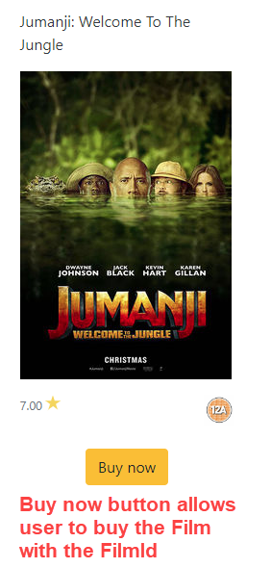
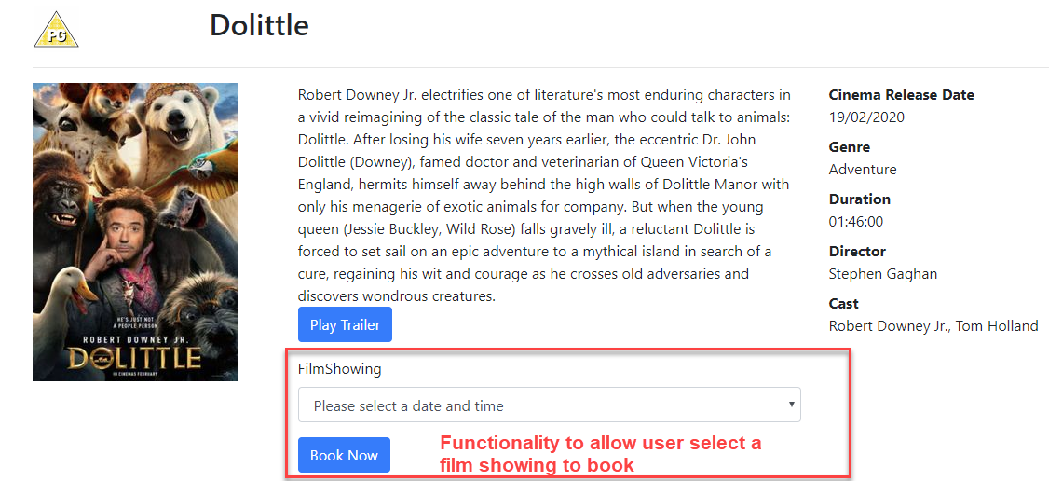

Making Changes to the Database
This exercise will show you how to make changes to your database (I am changing the database design as a quick solution to show you some techniques). We are going to change the booking table so that we can use it to either:
- Purchase a Film (whether for rental, streaming, etc.)
- Or purchase a FilmShowing with a specified number of tickets.
You will make changes to the Booking table:
- Change the FilmShowingID from required (NOT NULL) to not required (allow NULL).
- Add two new columns to the Booking table.
At the moment the table has the following columns. You can view in SQL Server (from the main menu, View SQL Server Object Explorer):
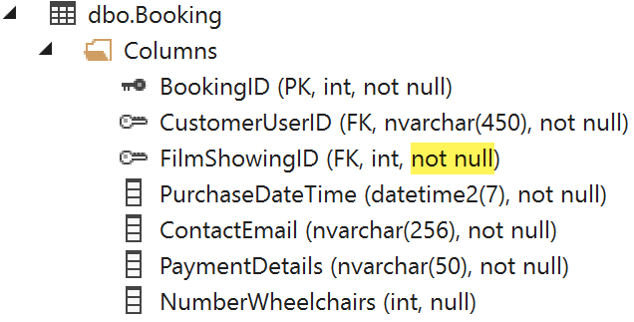

A Quick Fix First
- Go the GoMovies2020.Shared project.
- Go to the Models folder and open the GoMovies2020DbContext file.
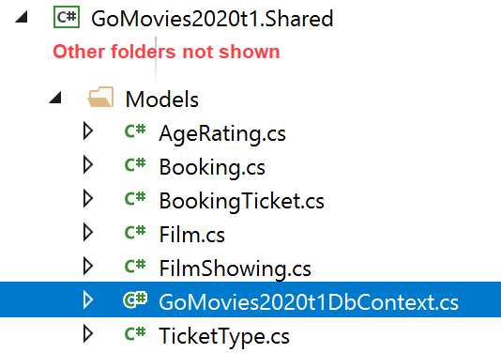
- Look for the OnConfiguring method and comment it out as shown below. If it is already commented out, you do not need to do anything.
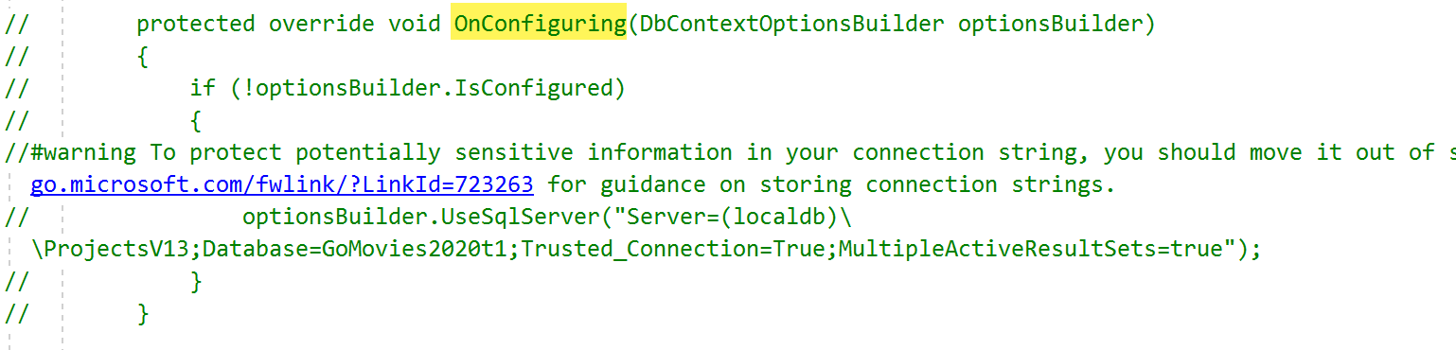
- Save and close the file.

Updating the Booking Table
Once you have created your database, you can simply make changes in the Model classes and these get migrated to the database use migrations.
- Go the GoMovies2020.Shared project.
- Go to the Models folder and open the Booking file.
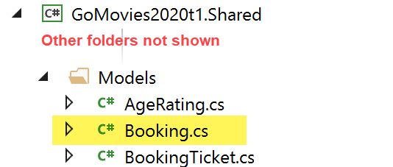

Changing FilmShowingId to Allow Nulls
- Locate the BookingId property.
- Add the question mark as shown below which indicates that a value is optional for this property, otherwise because it is an integer it will default to zero (0) if no value is specified which is not a valid ID or the same as NULL.
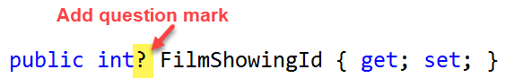

Add new column NumberTickets
Next, you will add a new property to store number of tickets purchased if booking a FilmShowing. This field will allow nulls (needs the question mark).
- Add the following property (you can add it after NumberWheelchairs)

Add new column FilmID
You will add a new column to store the Film being purchased for streaming, etc. This will be a foreign key to the Film table. It will allow also nulls (needs the question mark).
- Add the FilmID as shown below.
- Add the navigational property to the parent film record for the foreign key relationship as shown below (i.e. the FilmID links to a Film). Please see Lecture 5b: EF Relationships File on Moodle
- Save the file.

Migrating the changes to the Database
You migrate the changes to the database using the NuGet package manager.
- From the main menu, go to Tools NuGet Package Manager Pacakge Manager Console
- Copy and paste the following command (you have to give each migration, i.e. change to the database, a unique name to identify it. I have given this migration the name UpdateBooking as I am changing the Booking table).
add-migration UpdateBookingTable -StartupProject GoMovies2020.Web -Project GoMovies2020.Shared -Context GoMovies2020.Shared.Models.GoMovies2020DbContext
- Press the enter key. You should get the following screen/similar when done.
- The previous command automatically scripts the changes that need to be made.
- Important!
  - Check the code file that has automatically generated.
  - Locate the Up method (see screenshot).
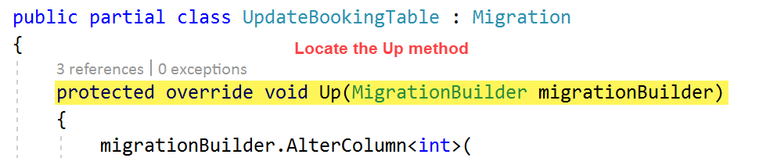
  - Comment out the following code as shown in the screenshot below if it exists (if it does not exist do not worry).
  - Email me if you have any problems.
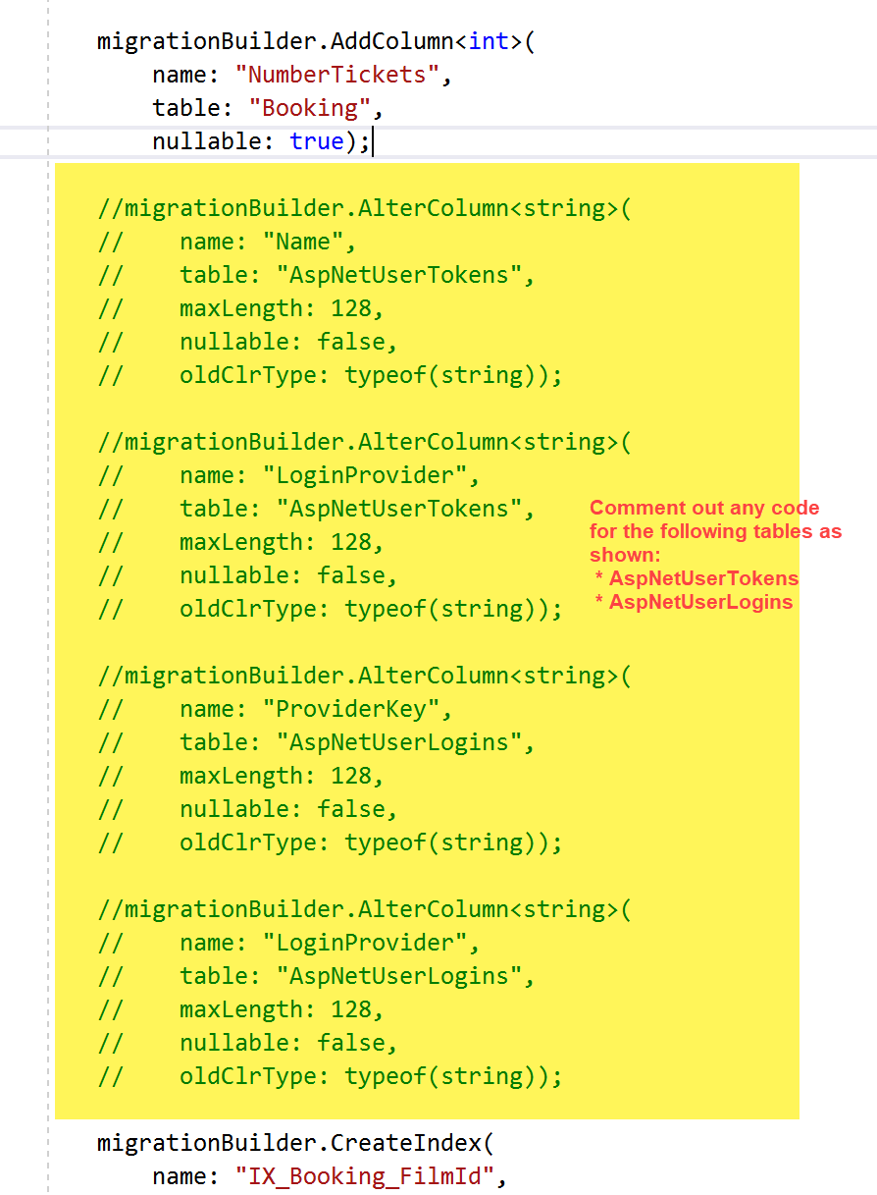
- Next run the following command to send the scripted changes to the database.
update-database -StartupProject GoMovies2020.Web -Project GoMovies2020.Shared -Context GoMovies2020.Shared.Models.GoMovies2020DbContext
- Press the enter key. You should see the word “Done” when it finishes.
- Note:
If you need to do the same in your assignment and you are using my template, you will need to replace GoMovies2020 with WebApp2020.
- Now go to SQL Server (from the main menu, View SQL Server Object Explorer).
  - Select your database and the Booking table.
  - Right-click and select Refresh. You should see the new columns.
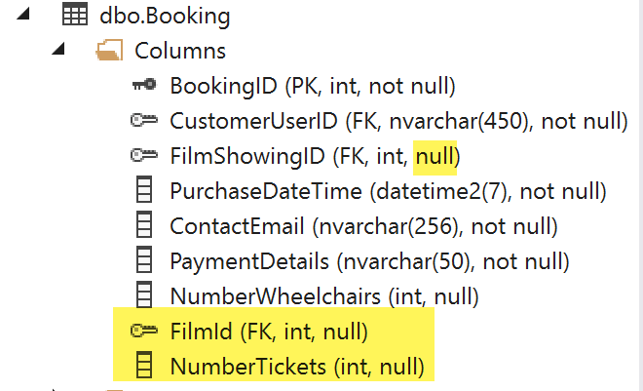
- That’s all for changing the model.

