Contemporary Themes in the Hotel and Hospitality Sector.
BMIH6001
Conference Presentation
The Role of AI in Improving Hospitality and Tourism Industry Services
Syeda Samia Begum
2130491
Ben Ka Po Chong

I confirm that I have not used any AI tools in the research and creation of this assignment. I confirm that I have not presented any AI generated materials as my own work. I confirm I have copies of my drafts, notes, and other resources I used, which I may be asked to provide in evidence.

Cover Page
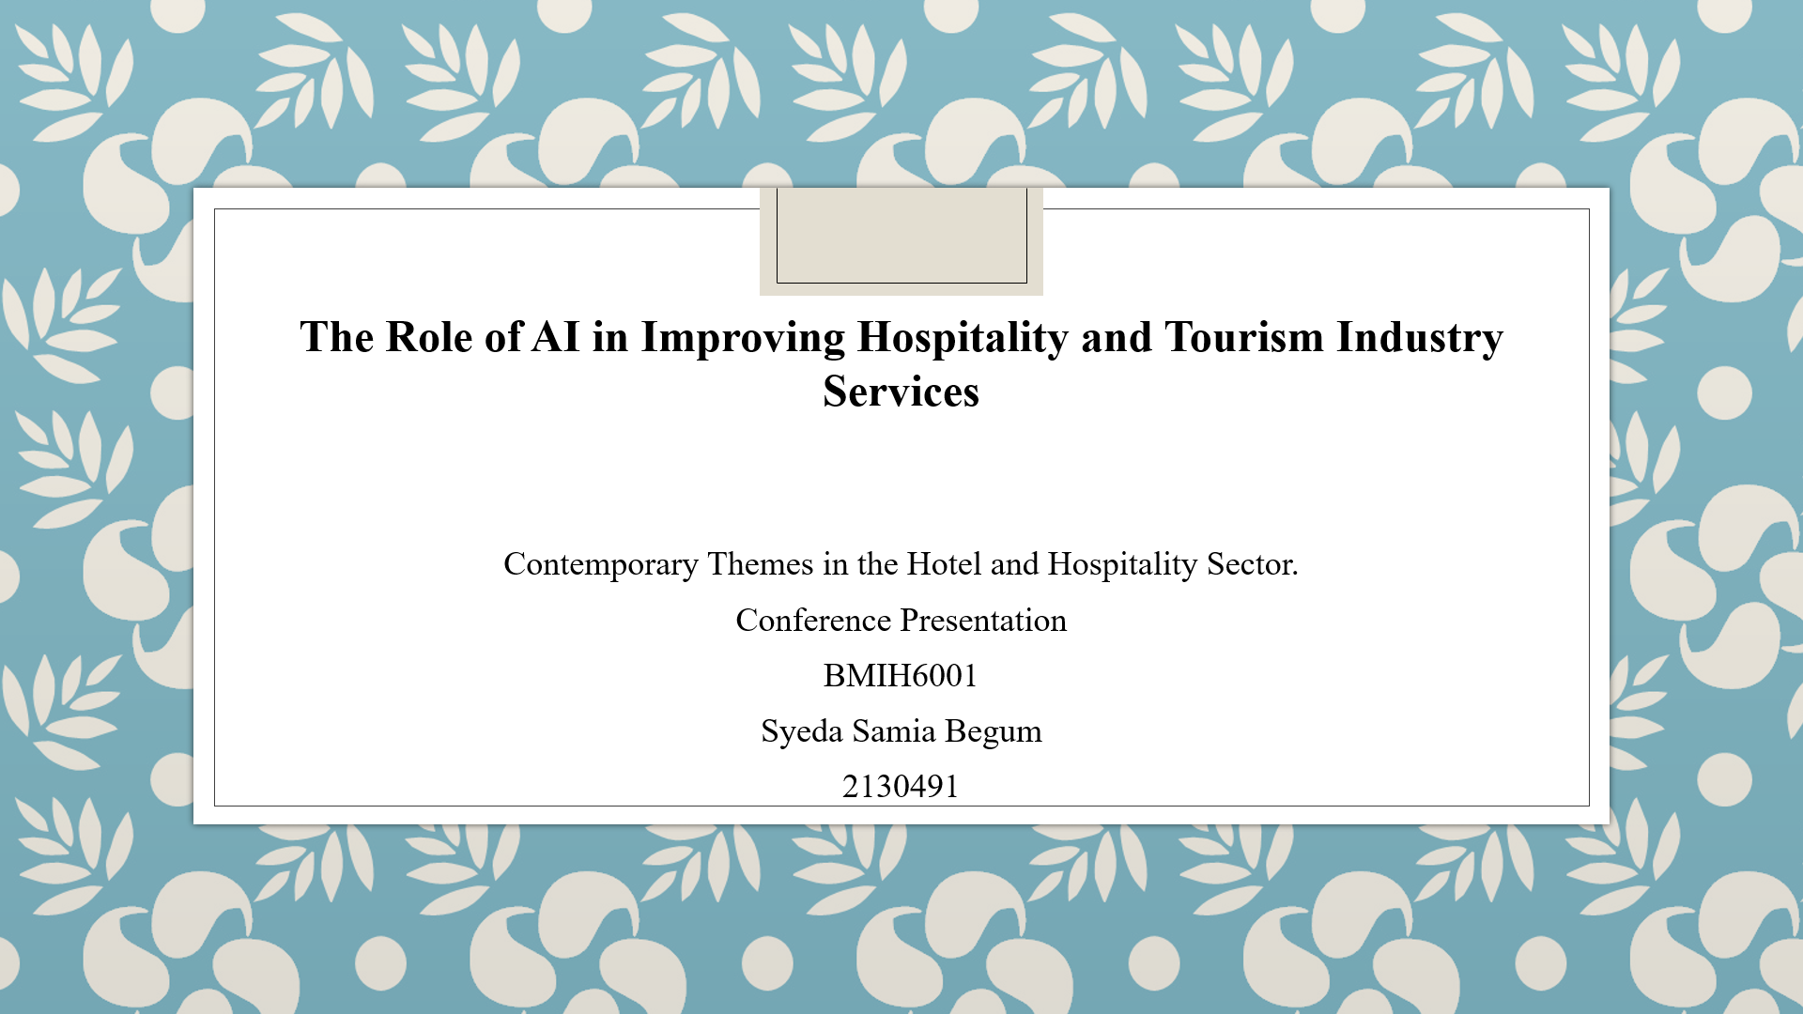
Slide 1: Introduction
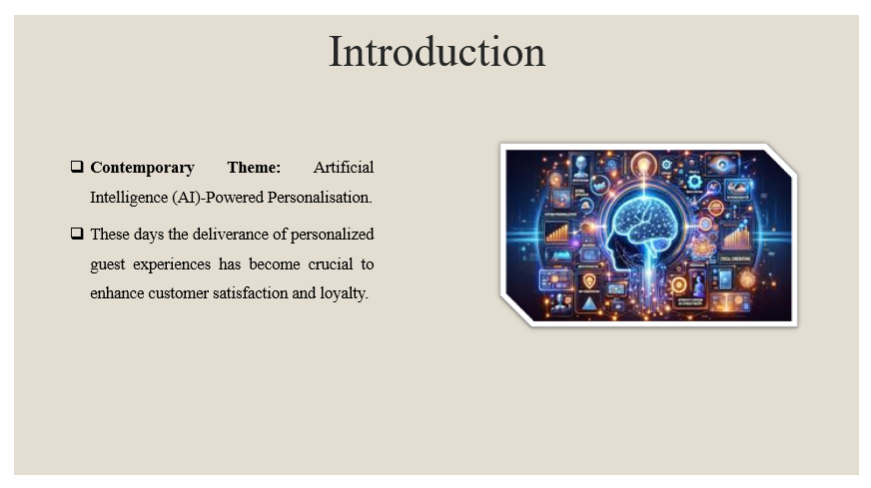

Slide 2 to 5: Literature Review
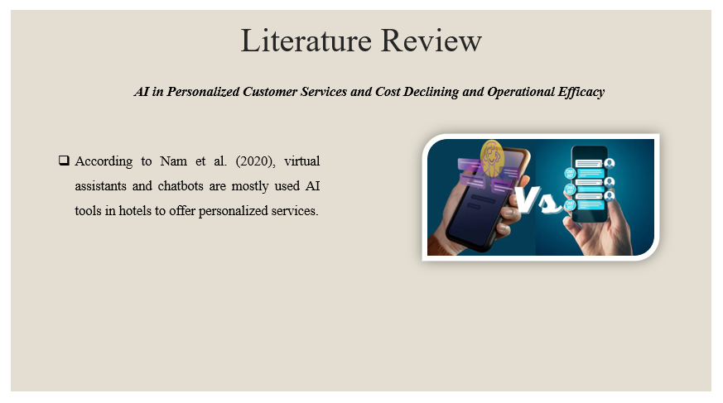
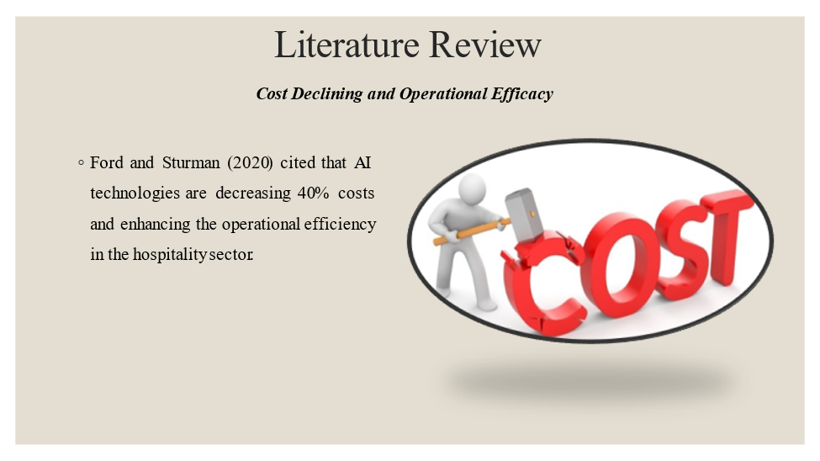

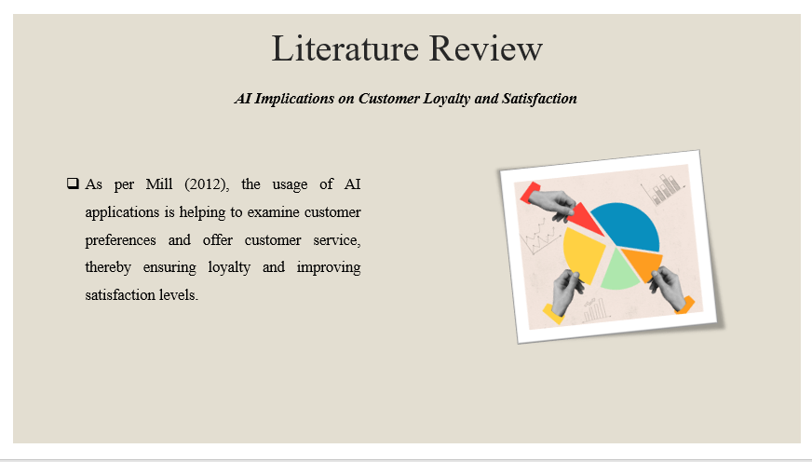
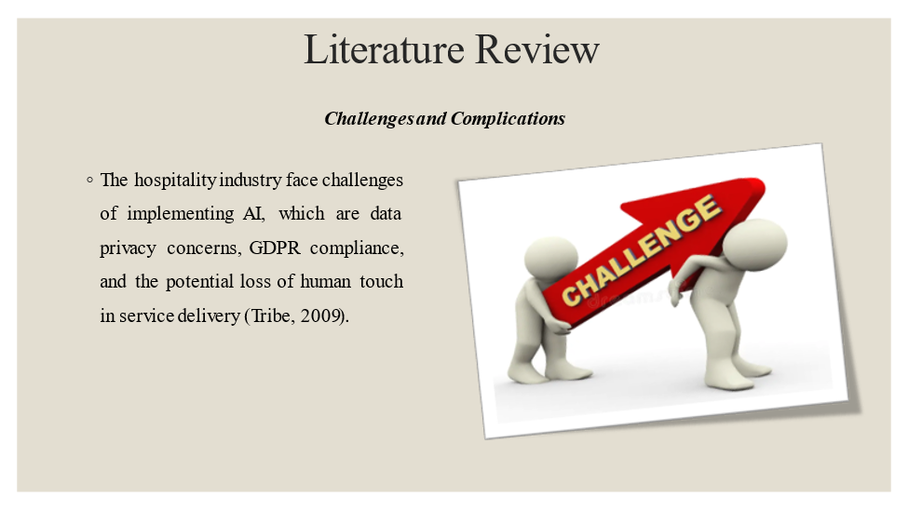

Slide 6 & 7: Method and Theme Impact Analysis
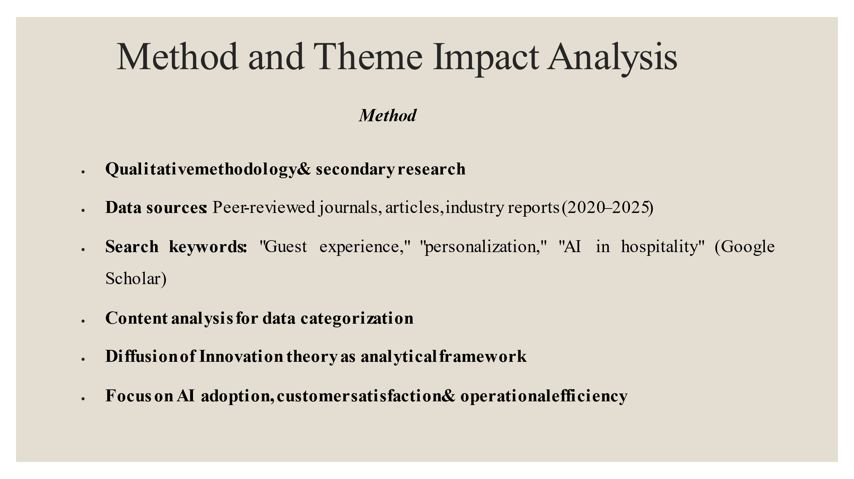
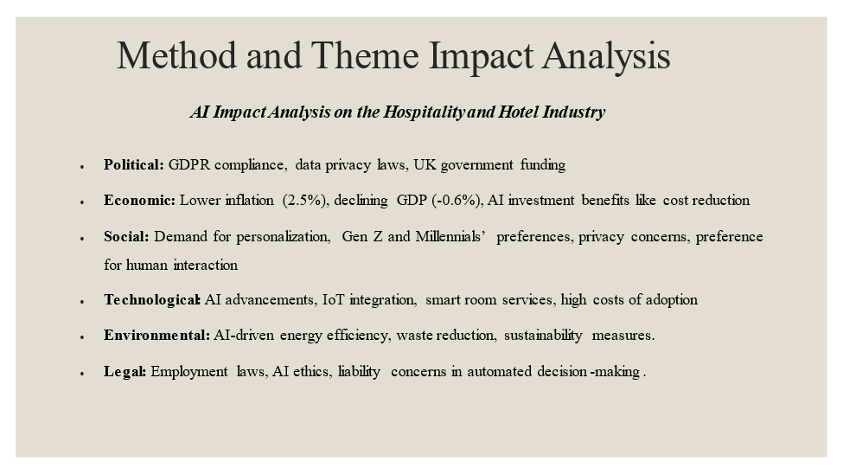
Slide 8: Conclusion
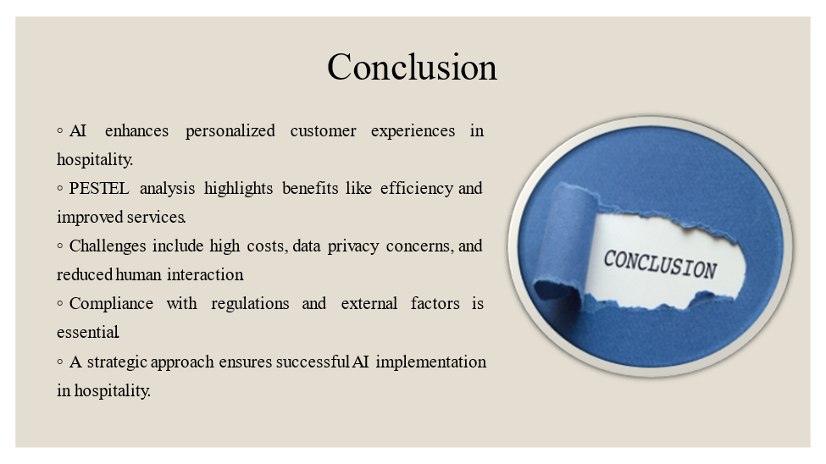
Slide 9: Recommendations
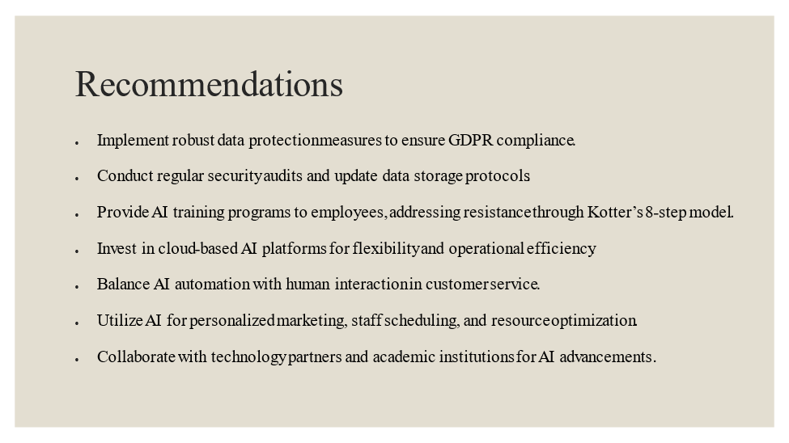
Slide 10: References
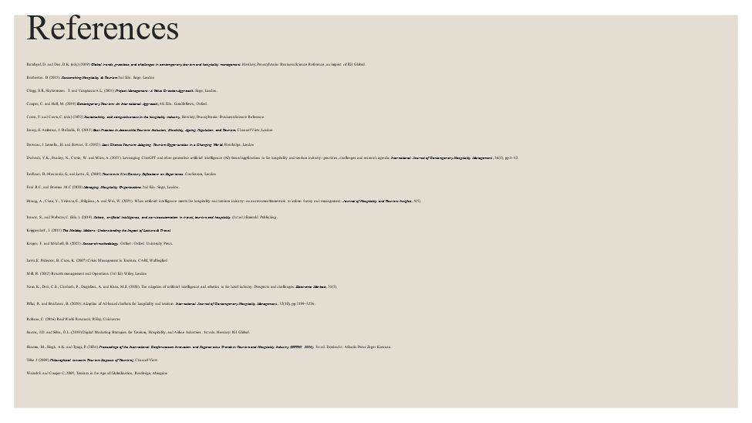
Batabyal, D. and Das, D.K. (eds) (2019). Global trends, practices, and challenges in contemporary tourism and hospitality management. Hershey, Pennsylvania: Business Science Reference, an imprint of IGI Global.
Brotherton, B. (2015). Researching Hospitality & Tourism 2 Edn. Sage. London
Clegg. S.R, Skyttermoen. T. and Vaagaasar. A.L, (2021). Project Management: A Value Creation Approach. Sage, London.
Cooper, C. and Hall, M. (2019). Contemporary Tourism: An International Approach, 4th Edn. Goodfellows, Oxford.
Costa, V. and Costa, C. (eds) (2022). Sustainability and competitiveness in the hospitality industry. Hershey, Pennsylvania: Business Science Reference.
Darcy, S. Ambrose, J. and Bulhalis, D. (2012). Best Practice in Accessible Tourism: Inclusion, Disability, Ageing Population and Tourism, Channel View, London.
Dawson, J. Lemelin, H. and Stewart, E. (2012). Last Chance Tourism: Adapting Tourism Opportunities in a Changing World, Routledge, London
Faulkner, B, Moscardo, G, and Laws, E, (2001). Tourism in 21st Century. Reflections on Experience. Continuum, London.
Ford, R. C, and Sturman.M.C (2020). Managing Hospitality Organizations 2nd Edn. Sage, London.
Ivanov, S., and Webster, C. (Eds.). (2019). Robots, artificial intelligence, and service automation in travel, tourism and hospitality (1st ed.). Emerald Publishing.
Koo, B., Curtis, C. and Ryan, B. (2021). Examining the impact of artificial intelligence on hotel employees through job insecurity perspectives. International Journal of Hospitality Management, [online] 95, p.102763.
Krippendorf, J, (2011). The Holiday Makers: Understanding the Impact of Leisure & Travel.
Laws, E. Prideaux, B. and Chon, K. (2007). Crisis Management in Tourism, CABI, Wallingford.
Mill, R. (2012). Resorts management and Operations (3rd Ed) Wiley, London.
Nam, K., Dutt, C.S., Chathoth, P., Daghfous, A. and Khan, M.S. (2020). The adoption of artificial intelligence and robotics in the hotel industry: Prospects and challenges. Electronic Markets, 31(3).
Pillai, R. and Sivathanu, B. (2020). Adoption of AI-based chatbots for hospitality and tourism. International Journal of Contemporary Hospitality Management, 32(10), pp.3199–3226.
Robson, C. (2016). Real World Research, Wiley, Chichester.
Santos, J.D. and Silva, O.L. (2019). Digital Marketing Strategies for Tourism, Hospitality, and AIline Industries. 1st edn. Hershey: IGI Global.
Sharma, M., Singh, A.K. and Tyagi, P. (2024). Proceedings of the International Conference on Innovation and Regenerative Trends in Tourism and Hospitality Industry (IRTTHI 2024). 1st ed. Dordrecht: Atlantis Press Zeger Karssen.
Tribe J (2009). Philosophical issues in Tourism (Aspects of Tourism), Channel View
Wahab S. and Cooper C, (2005). Tourism in the Age of Globalisation, Routledge, Abingdon.

