Developing Relationships and Workplace Achievement

STUDENT NAME: SHOPIK ALI
MODULE CODE: BMSK5002

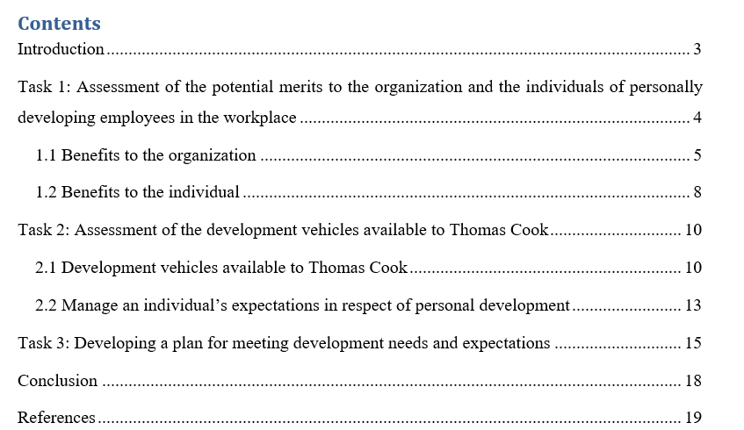

Introduction
Employees are the most valuable resource within the organization as the organizational performance depends on them. This ensures the proper utilization of the human resource the organization has to make sure the individual development within the organization. To complete this assignment three assessment criteria are followed and to complete the first criteria the importance and the benefits of the individual development to the Thomas Cook and its employee is discussed. Here we found that the organization is not only getting benefit from the individual development but also the individuals are also get benefited from the development. In the second task, the available development vehicles for the individual development within Thomas Cook are discussed. Along with this, the management of the individual expectation within the Thomas Cook in respect to their career development is also discussed. In the last task, a plan for the individual development and a plan to meet the identified development needs and expectations are described.

Task 1: Assessment of the potential merits to the organization and the individuals of personally developing employees in the workplace

Thomas cook Plc. is one of the biggest travel and tour Operator Company in the UK, they have almost 2700 employee working throughout the whole world. This company has to manage the employees for ensuring the employee performance within the organization. Thomas cook has to manage 2700 individuals every day (Anderson, 2003). Here the question arises, why is the organization of developing individuals? Is there any benefit to them? The answer to these questions can be found if we analyze the benefit of developing individuals within the organization. But before analyzing that we have to know, why the people are being managed within the organization? The answer is pretty much simple the people are managed and developed because_


- They are one of the most valuable assets of the organization
- The individuals are also a part of the organizational process
- If the organization does not manage their employee they have to face lots of problems such as_ project failure, decrease performance quality and rate etc.

So that’s some of the reason of managing the individual within the organization. Now we have to understand the factors that are related to the individual management and those factors are_

Consistency_ Each and every individual within the organization should treat equally regardless of any kind of discrimination
Respect_ each individual are different from each other in case of their skills and compatibility and their skills also should be respected.


Inclusion_ For any kind of participative work the organization should include their every employee.
Honesty_ In the case of the management of individual the manager or the delegated authority should be honest.
The development of the individuals within the organization is not only beneficial for the organization but also beneficial for the individuals themselves (Beausaert et al., 2013). The benefits of the individual development to the organization and to the individual are discussed below.

1.1 Benefits to the organization
Keep up with industry changes
There is a strong statement in the business world that each business organization should follow and that is_ if u wants to adapt with the continuously changing business world you have to prepare your organization and you have to keep your people up-to-date. For that, the organization like Thomas Cook has to manage their people continuously and this will help the organization to keep up the organization with the changes.

Be in touch with all the latest technology developments
All the time this world is going through the new development process and the technology is not an exception (Elias, 2007). The technology is changing and developed every day and to cope up with the latest technology the organization has to prepare their employee. For that reason, the organization develops their individual’s every day so that they can adapt to the latest technology.
Stay ahead of competitors
When the organization develops their individual it makes the organizational performance upgraded and in this competitive business world, this is essential. The development of individuals can help the organization to stay ahead of their competitors.
Be able to see weaknesses and skill gaps
For the development of the individual, Thomas Cook identifies the development needs of the people in the first place (Grant and Steadman, 2016). This identification of the development need will help the company to find out the individual’s weaknesses and skill gaps. This also helps Thomas Cook to develop the weakness into strength and also fill up the skill gap.
Increased employee motivation
To work within the organization and to provide the organization 100% of one’s own capability, the employee will need motivation. The motivation should regularly provide by the organization and the motivation can be delivered in many ways. A maximum organization like Thomas Cook they used Maslow’s hierarchy need theory in case of provides motivation to their employee.
Figure: Maslow’s hierarchy needs a theory
Source: (Anderson, 2003)
The need of the individuals is varied but the level of needs is the same, this need theory describes that the need of the individuals goes through stages. When the need of one stage is completed then certainly the need for the next level in showed up. By following these stages Thomas Cook motivates their employees and they provide development and training program to their employee and also used some other motivational tools.
Improved performance and productivity
The continuous development of the individuals makes sure that the organization will get the highest quality of the product (Healey, 2012). The development of individuals helps Thomas Cook to improve their organizational performance as well as productivity.
Increased efficiencies
When the organization developed individuals within the organization it ensures the organization efficiency in the organizational process and system. This efficiency also helps the organization to gain more financial benefits.
Increased innovation
As well already now that the development of individuals within the organization helps the individual to improve their knowledge and skills. This also helps the organization to get innovative ideas about the strategies and products to form the individuals.
Reduced employee turnover
If the organization provides the proper development to the employee, it improves the employee motivation as well as it also gives the employee job satisfaction (Hong, 2011). The employee relationship with the management is improved through the development programs. All the things help the employee to remain within the organization and that reduced the employee turnover.

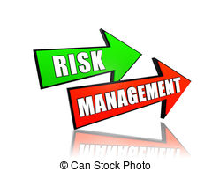
Risk management
To develop the individual the organization have to take several training sessions and on those training sessions, the organization trains the employee in managing the risks. The employer also clear about different types of things such as sexual harassment & discrimination, these training reduce the chances of risk and also help the organization to manage the risk by the diversity training.

1.2 Benefits to the individual
As it is a mention earlier that the development of the individuals within the organization is not only beneficial for the organization but also beneficial for the individuals themselves. The individual benefits from the development are described below_
Maximizing their individual strengths
When Thomas Cook develops the individuals within the organization, they identify the development needs of the people in the first place (Karami, Badsar and Ismail, 2012). This identification of the development need will help the company to find out the individual’s weaknesses and skill gaps. This also helps Individuals within Thomas Cook to develop their weakness into strength and also fill up their skill gaps. Along with these things the development also ensures the maximization of the individual’s strength within the company.
Overcoming personal challenges/obstacles
In case of working within an organization or within a business firm, the individuals may face lots of challenges as well as personal obstacles. The development program helps the individuals to find out their challenges and help them to overcome the challenges and obstacles they face.

Achieving new skills & competencies to become more effective
Throughout the whole training session and development program, the organization teaches the individual about lots of things (Laware, 2017). The individual can learn about new skills and competencies throughout the session and the practical workshops also help them to acquire those new skills and competencies. With the new skills and competencies, the individual can perform more effectively within the company.
Preparing for job responsibilities
Thomas Cook hires an employee for performing the job responsibilities within the organization. When the employee is started working for the company they have little knowledge about the job responsibilities (Mcnair and Rusch, 2010). The development & training session help them to gather the acquire knowledge about the job responsibilities and this will also help them in case of their future job life.
Improvement in managing themselves
The development helps the individual to manage themselves more effectively in the office as well as in their daily life. For example, development session taught about the time management and this help the individual to manage their time in the office work as well as this will also ensure a good & managed the life of the individual.

Clarifying and working toward goals
Each employee should have clear goals for their career; the development of individual ensures that the goals should be SMART (Mendelson, 2013). The individual gets benefited in their personal career by setting the SMART goal for themselves.


Increasing their job satisfaction and motivation
It is necessary to be satisfied and motivated in one’s life, this will help the person to give the best output. The organizational development motivated the individual toward their job and it gives them their desire for satisfaction (Michailakis and Schirmer, 2010). This also ensures a good mental health for the individual.
With all the discussion we can say that the developing individual has a high rate of potential benefit for the organization and the individuals also get benefited from that. That’s why the organization should develop their employee to gets the highest quality of performance and productivity by the proper utilization of human resources.

Task 2: Assessment of the development vehicles available to Thomas Cook

2.1 Development vehicles available to Thomas Cook
To meet up with the appropriate development needs of the individuals Thomas Cook has to go through with the appropriate development vehicles. Developing individuals within the organization refers to a document that state that, what an employee wants to achieve in the next days, months or year? These documents provide clear ideas about the employee goal and also help the organization to work with meeting up the individual goal (Simmonds, 2003). From the identification of the need to the meeting the need, this whole procedure has to go through by following a specific sequence and these methods of the sequence is known as a development vehicle.
Most of the organization manager knows that training and development program is necessary for the employee for the overall development of them, but they do not have the idea, what are the development needs? How to initiate the development? What method will be used for which type of development?

Figure: Development needs clipart
For this, the manager has to understand the individual development need within the organization. How will they understand it? Cause there are thousands of people working for Thomas Cook and everyone has their different capabilities and different type of needs (Temperley, 2013). The manager needs to apply the universal method of development for the general and specific method for the specific one.
American Society for Training and Development's recently invented a six-stage model for understanding the development needs and conduct the actions. We can call this initiative as the development vehicles for the Thomas Cook in case of understanding their individual's development needs and conducting the actual action to meet the development needs.
Stage 1: Review team members' job descriptions
Each employee has different job responsibilities within the organization and they have to exactly perform what their job responsibility says. The organization has documents for all employees about their job responsibilities and this is a great source by which the manager can find the development needs in general (Beausaert et al., 2013). According to the need of the job description, the development program can be carried out and this method can be conducted in general.
Stage 2: Meet with them
As the organization hires the employee, the employees are one of the great parts of the organization and the organization should have to take care of this valuable resource. The manager has to meet with the individual when they get time as part of the inspection process. In the meeting, the manager can ask them_
What type of challenges are you facing within the organization?
What is new for you here?
What are the things that made you frustrated about your job?
By this random questioning session, the manager can get the idea about the development needs of the individuals and the action can be taken.

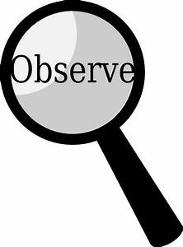

Stage 3: Observe them at work
By just observing the individual performance at work the manager can be determining the development need of the individual (Elias, 2007).

Stage 4: Gather additional data
The organization keeps a record of everything and the organization statistics and other data can give a clear idea about the development needs of the individual within the workplace.
Stage 5: Analyze and prepare data
When the manager will collect the appropriate data about the individual’s need within the company, the manager needs to analyze data to keep the best alternatives and to make decisions about the method of the development process (Grant and Steadman, 2016). It is not possible for the organization to target each employee specifically and develop each of them personally. That’s why they need to set some solutions that can be applied to a large number of populations. The data analysis is necessary for that reason.
Stage 6: Determine the action steps
In this stage, actual action is performed by the organization to train the employee to get the best output from them. In this stage, different types of training and development method are applied to the employee to train them and develop their needs. Some of the popular and common methods within Thomas Cook are described below_
There are several training and development options to consider:
- On-the-Job Training– This is one kind of practical experiencing methods of development within Thomas Cook to develop their individual’s practical experiences. For the organization, this is one of the cost-effective methods, by which they can make the employee train while they can also conduct their normal routine job.
- Instructor-Led Training– In this type of training, there is basically an instructor who is responsible for conducting the class or session and consults with the employee about their needs and provides them with the appropriate solutions (Healey, 2012).
- Cross-Training– In cross-training the teachers perform the task with the learner and this made an effective interaction and the development goal can be achieved at a high rate if the organization follows this method.
- Active Training– When the learner is taught by doing something interacting and interesting such as_ games, group work, and other practical exercises. It makes the individual involved with the situation and also helps the individual top learn effectively.
All of these things followed by the organization to ensure the proper understanding of the development needs and necessary proper steps to meet the needs (Hong, 2011).

2.2 Manage an individual’s expectations in respect of personal development
When the organization is involved with all the procedure like_ identification development needs and identify a proper solution and finally implement the solution, the organization have to consider the individual expectation from the development program in respect of personal development.

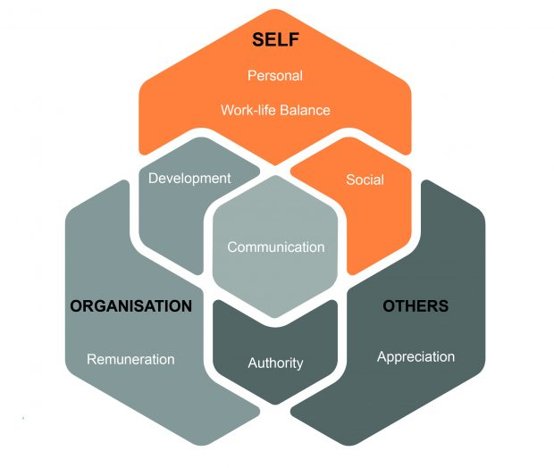
Development expectations are vary based on the point of view of the employee and the employer, many of the organization have to lose their employment because they do not give the opportunity for the career development of the employee. So at first place, the organization should understand the employee expectations from eth job and then they should conduct the further developing planning.

According to the statistics, 76% of the employee wants a career in their job and if they get the career in the job then they will stay otherwise they will search their career anywhere else. Because of that reason the organization should give an extra care in the career development opportunities for their employee so that they don’t have face high rate of employee turnover (Karami, Badsar and Ismail, 2012).
When the organization plan for managing the development expectations of individual they may get face
Is it group career development expectations? Or
Is it an individual’s career development expectations?
If it is individual career development expectation then the organization have to understand the individual’s expectations, their behavior as well as their full potential. Asking the right question, analyze the right things and by taking the right decision proper utilization of resources and skills is possible (Laware, 2017). Basically, people want to feel that they are recognized within the organization and t gives some people mental satisfaction as well as motivation. Dealing with group expectation is easy for the organization than the individual expectation, but individual expectation fulfillment is effective than the group expectation.
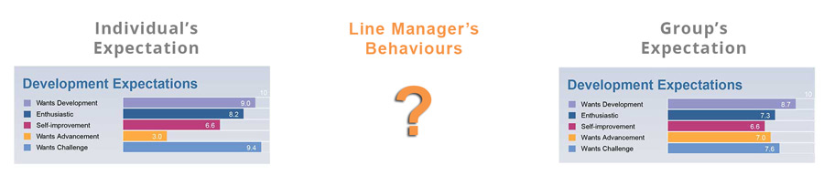
Figure: group expectation or individual expectation.
Source:
Basically, there are five key elements of the career development assessed by Harrison that the organization needs to consider in terms of managing individual’s expectations in respect of personal development.
Does the employee desire to have the work opportunities to prove their capabilities and skills?
Does the employee enthusiastic about their career goal?
Does the employee want their self-development?
Does the employee want advancement in case of their job responsibilities?
Do they want to take challenges?
By finding the appropriate answer to these questions the organization will take the necessary initiative to give the proper career opportunities to the employee according to their desire.

Task 3: Developing a plan for meeting development needs and expectations
For the individual development within the workplace, the organization needs to prepare the discussion session with the employee (Mendelson, 2013). The discussion will make the clear about the employer expectation from the employee as well as the employee expectation from the employers. Based on the discussion it will be possible to create an individual development plan.

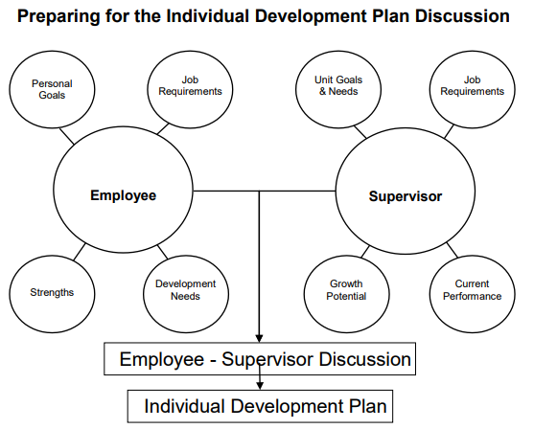
Figure: Individual development plan discussion
Source: (Healey, 2012)
In the discussion session, the employee discusses their personal goals and the job requirement as well as their employee’s strengths & their development needs. There must be a relationship between the job requirement and the employee personal goal, based on the employee personal assessment of the development needs should be identified (Mcnair and Rusch, 2010). The employer also discusses the potential growth of the employee, the current performance rate of the employee as well as employer’s performance demand. They also discuss the job requirements as well as the unit goals of the organization.
Based on all the discussion the organization finally decides about the individual development needs. According to the need of the job description, the development program can be carried out and this method can be conducted in general. When the manager will collect the appropriate data about the individual’s need within the company, the manager needs to analyze data to keep the best alternatives and to make decisions about the method of the development process. Different types of training and development method are applied to the employee to train them and develop their needs (Simmonds, 2003). Based on the discussion and by considering both sides the individual development plan is conducted which is an essential part of the organization overall development plan and very much essential towards the effective performance.
American Society for Training and Development's recently invented a six-stage model for understanding the development needs and conduct the actions.
Stage 1: Review team members' job descriptions: Each employee has different job responsibilities within the organization and they have to exactly perform what their job responsibility says. According to the need of the job description, the development program can be carried out and this method can be conducted in general.
Meet with them: As the organization hires the employee, the employees are one of the great parts of the organization and the organization should have to take care of this valuable resource (Temperley, 2013). The manager has to meet with the individual when they get time as part of the inspection process.
Observe them at work: By just observing the individual performance at work the manager can be determining the development need of the individual.
Gather additional data: The organization keeps a record of everything and the organization statistics and other data can give a clear idea about the development needs of the individual within the workplace.
Analyze and prepare data: When the manager will collect the appropriate data about the individual’s need within the company, the manager needs to analyze data to keep the best alternatives and to make decisions about the method of the development process.
Determine the action steps: In this stage, actual action is performed by the organization to train the employee to get the best output from them (Karami, Badsar and Ismail, 2012).
To give the proper respect to the individuals the organization has to consider the following model for the career development of the individual.

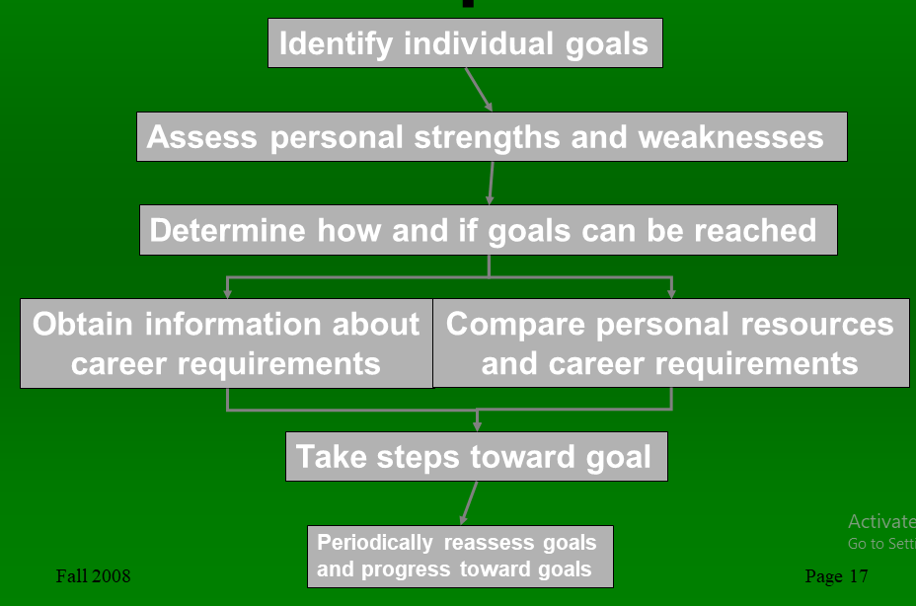
Figure: Career development model
According to this model, the organization has to identify the individual goals and they have to give the proper respect to the individual goal. When the goal is identified the personal assessment becomes necessary to set the further criteria. Here it is necessary to analyze personal strength, weaknesses, opportunities as well as threats.

After analyzing the goal the method or the process can be determined by which the individual goal will be achieved (Michailakis and Schirmer, 2010). Then the information should obtain regarding the career requirements of individual and then a comparison should take place between the resource available and the career requirements. Based on the analyses the individual take a step forward toward their goal, and a periodical progress assessment should conduct after a certain period of time.

Conclusion
For that, the organization like Thomas Cook has to manage their people continuously and this will help the organization to keep up the organization with the changes. The technology is changing and developed every day and to cope up with the latest technology the organization has to prepare their employee. For that reason, the organization develops their individual’s every day so that they can adapt to the latest technology. To work within the organization and to provide the organization 100% of one’s own capability, the employee will need motivation. The motivation should regularly provide by the organization and the motivation can be delivered in many ways. To develop the individual the organization have to take several training sessions and on those training sessions, the organization trains the employee in managing the risks. The development of the individuals within the organization is not only beneficial for the organization but also beneficial for the individuals themselves. The development program helps the individuals to find out their challenges and help them to overcome the challenges and obstacles they face. Along with these things the development also ensures the maximization of the individual’s strength within the company. To meet up with the appropriate development needs of the individuals Thomas Cook has to go through with the appropriate development vehicles. American Society for Training and Development's recently invented a six-stage model for understanding the development needs and conduct the actions. Development expectations are vary based on the point of view of the employee and the employer, many of the organization have to lose their employment because they do not give the opportunity for the career development of the employee. For the individual development within the workplace, the organization needs to prepare the discussion session with the employee. The discussion will make the clear about the employer expectation from the employee as well as the employee expectation from the employers.

References

- Anderson, G. (2003) AND ORGANIZATIONAL NEEDS. Industrial and Commercial Training, 25(4).
- Beausaert, S., Segers, M., Fouarge, D. and Gijselaers, W. (2013). Effect of using a personal development plan on learning and development. Journal of Workplace Learning, 25(3), pp.145-158.
- Elias, S. (2007). Positive Relationships in the Workplace. PsycCRITIQUES, 52(36).
- Grant, J. and Steadman, L. (2016). Barriers to Diabetes Self-Management Among Rural Individuals in the Workplace. Workplace Health & Safety, 64(6), pp.243-248.
- Laware, S. (2017). FORMULATION, DEVELOPEMNT AND EVALUATION OF ZIPRASIDONE HYDROCHLORIDE CAPSULES BY DRY GRANULATION METHOD. World Journal of Pharmaceutical Research, pp.1652-1665.
- Healey, M. (2012). Promoting the scholarship of academic development: tensions between institutional needs and individual practices. International Journal for Academic Development, 17(1), pp.1-3.
- Hong, Y. (2011). Developing a New Human Services Management Model Through Workplace Spirituality in Social Work. Journal of Workplace Behavioral Health, 26(2), pp.144-163.
- Hong, Y. (2011). Developing a New Human Services Management Model Through Workplace Spirituality in Social Work. Journal of Workplace Behavioral Health, 26(2), pp.144-163.
- Karami, R., Badsar, M. and Ismail, M. (2012). Moderating Effect of Achievement Values on the Relationships of Organizational Supports and Achievement Motivation in Leadership Role. The Social Sciences, 7(6), pp.866-874.
- Mcnair, J. and Rusch, F. (2010). The Co-worker Involvement Instrument: A Measure of Indigenous Workplace Support. Career Development for Exceptional Individuals, 15(1), pp.23-36.
- Mendelson, M. (2013). Introduction: Perspectives on the Contemporary Workplace. Journal of Intergenerational Relationships, 11(3), pp.329-329.
- Michailakis, D. and Schirmer, W. (2010). Agents of their health? How the Swedish welfare state introduces expectations of individual responsibility. Sociology of Health & Illness, 32(6), pp.930-947.
- Ongoing Training Benefits Volunteers and Organization. (2016). The Volunteer Management Report, 21(12), pp.6-6.
- Programme benefits science-based firms. (2001). Education + Training, 43(3).
- Simmonds, P. (2003). Continuing professional development and workplace learning 2: CPD and you – how CILIP is meeting the continuing professional development needs of its members. Library Management, 24(3), pp.169-170.
- Temperley, J. (2013). Identifying Management Development Needs. Executive Development, 7(2), pp.28-31.

