HPHI4003 Age of Empire: The Colonial Project and the Humanities
Week 1 Tuesday: SLAVERY AND EMPIRE
Researching Trans‐Atlantic Slave Trade Ship Voyages
In this lecture, we will think about, first, the scope of the Transatlantic trade,; second, research specific slave ship voyages; and, third, examine data about slaves themselves. You will be using The Transatlantic Trade Database, which has information on almost 35,000 individual slave ship voyages.
Exercise 1: Understanding the Geography and Scope of the Transatlantic Trade
From the homepage of The Transatlantic Trade Database (www.slavevoyages.org), select ‘Trans-Atlantic’ at top of page, and clock on ‘Estimates.’
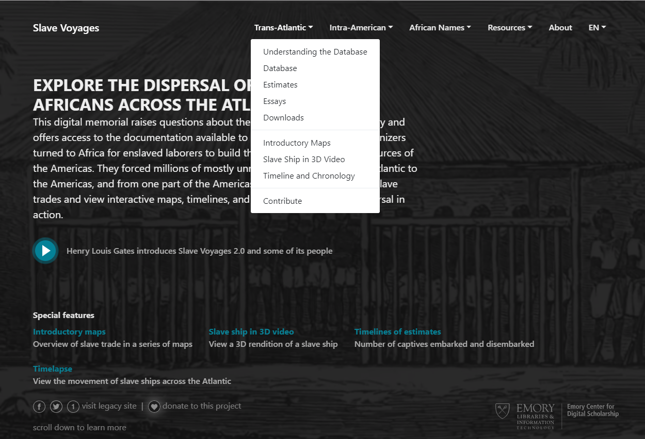
This brings you to this screen:
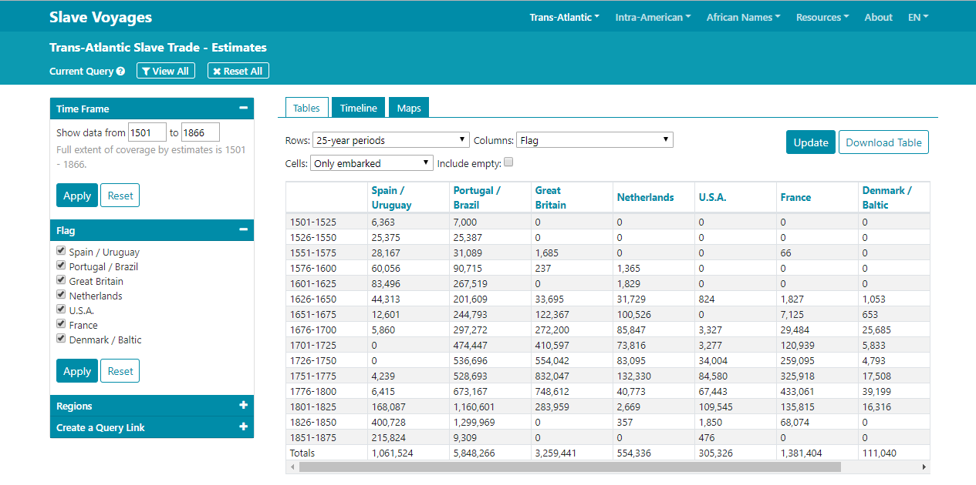
Using the data estimates, timeline and maps, try to answer the following questions:
- In total, how many slaves were transported from Africa to the Americas from the 1500s–1800s?

- How many Africans embarked?

- How many Africans disembarked?

- What might the differential between the above figures tell us about transatlantic slavery?

- Which 100-year-period saw the largest number of slaves transported to Africa? And which 25-year-period?

- What might the significance of the above be? Consult the timeline and compare/contrast it with the other data. What impact did the major events listed have on the transatlantic slave trade?

- What variations do the figures show in relation to a) the ‘nationality’ of ships, b) the destination of voyages?

- Which region of Africa saw the largest number of slaves transported from it?

- Which regions in West Africa saw the most slaves transported from them?

- How many slaves were transported from Southeast Africa and the Indian Ocean islands?

- The data also lists ‘Africans returning to Africa.’ What might be the significance of this data?

- Which region saw the largest number of slaves transported to it?

- How many slaves were transported into:
- the Spanish Americas

- the British Caribbean

- the French Caribbean

- mainland North America

- Brazil

- Europe?

- What might the significance of the above figures be?

- Can you make an estimate of how many slaves were transported into the Caribbean as a whole?

- What was the busiest European slave port? How many slave ship voyages began in the following ports? What percentage of the total slave ship voyages did each port account for? And how many slaves are estimated to have been aboard slave ship voyages that began in each port?
Port | Number of slave ship voyages | Est. total of slaves transported | Percentage of total number of slave voyages between Africa and Americas
Amsterdam
Bordeaux
Bristol
Cadiz
Cork
Glasgow
Hamburg
Hull
Lancaster
Lisbon
Liverpool
London
Marseilles
Nantes
Seville
Wales
Whitehaven

Exercise 2: Researching Specific Slave Ship Voyages
Consult the database and research the following ships’ voyages.
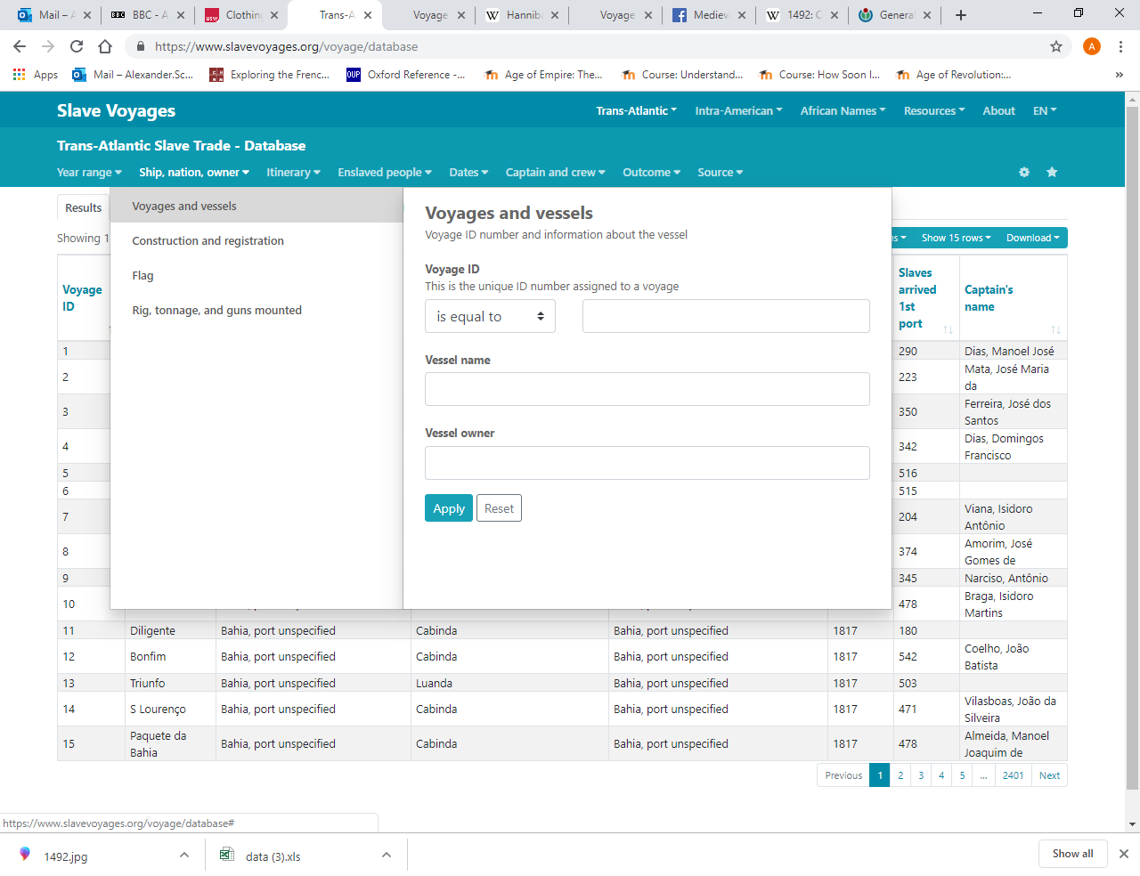
Working in pairs, tackle AT LEAST TWO of the following FIVE sets of questions about specific slave ship voyages.

- Thomas Phillips and the Hannibal (1693–1695).
Find the following data compare with the lecture reading. (see also https://www.slavevoyages.org/voyage/9714/variables),
- From which regions were the slaves aboard Hannibal purchased?

- What calling points did the Hannibal make en-route to the Americas?

- What was the destination of the Hannibal in the Americas?

- What was the length of the ‘Middle Passage’

- What was the demographical makeup of the African slaves aboard the Hannibal?

- How many slaves embarked from Africa?

- How many slaves disembarked in the Americas?

- Using the database, what other information can you glean about the ship’s captain, Thomas Phillips?

- Using the database, what other information can you glean about the ship’s owner?

- Captain Deane and the New Britannia
Interpret the below extract from the Gentleman’s Magazine, October 1773:
Part of a letter from the coast of Africa, gives a melancholy account of the New Britannia, Captain Deane, who, having 230 slaves on board, some of the black boys belonging to the ship found means to furnish them with carpenters tools, with which they ripped up the lower decks, and got at the guns and powder; being overpowered, however, by the crew, they then set fire to the magazine, and blew up the vessel, but which not less than 300 souls perished.
Using the database, find out more information about:
- The New Britannia and its voyage(s)

- The ship’s captain and his voyage(s)

- Venture Smith
Read and interpret the following extract from A Narrative of the Life and Adventures of Venture, a Native of Africa: But Resident above Sixty Years in the United States of America, Related by Himself (1798)
CHAPTER I. CONTAINING AN ACCOUNT OF HIS LIFE, FROM HIS BIRTH TO THE TIME OF HIS LEAVING HIS NATIVE COUNTRY
I was born in Dukandarra, in Guinea, about the year 1729. My father’s name was Saungin Furro, Prince of the tribe of Dukandarra. My father had three wives. Polygamy was not uncommon in that country, especially among the rich, as every man was allowed to keep as many wives as he could maintain. By his first wife he had three children. The eldest of them was myself, named by my father.
Invaders pinioned the prisoners of all ages and sexes indiscriminately, took their flocks and all of their effects, and moved their way toward the sea. On the march, the prisoners were treated with clemency, on account of being submissive and humble. Having come to the next tribe, the enemy laid siege and immediately took men, women, children, flocks, and all their valuable effects. They then went on to the next district, which was contiguous to the sea, called in Africa, Amamaboo [Anomabu]…. All of us were then put into the castle and kept for market.
On a certain time, I and other prisoners were put on board a canoe, under our master and rowed away to the vessel belonging to Rhode Island, commanded by Captain Collingwood and the mate, Thomas Mumford. While we were going to the vessel, our master told us to appear to the best possible advantage for sale. I was bought on board by one Robertson Mumford, steward of said vessel, for four gallons of rum and a piece of calico, and called VENTURE, on account of his having purchased me with his own private venture. Thus I came by my name.
Using the database, find out more information about:
- Venture Smith’s home region in Africa

- The ship Smith on which Smith was transported from Africa

- Captain Collingwood

- Other members of the ship’s crew

- Other slaves aboard the ship

- The Zong
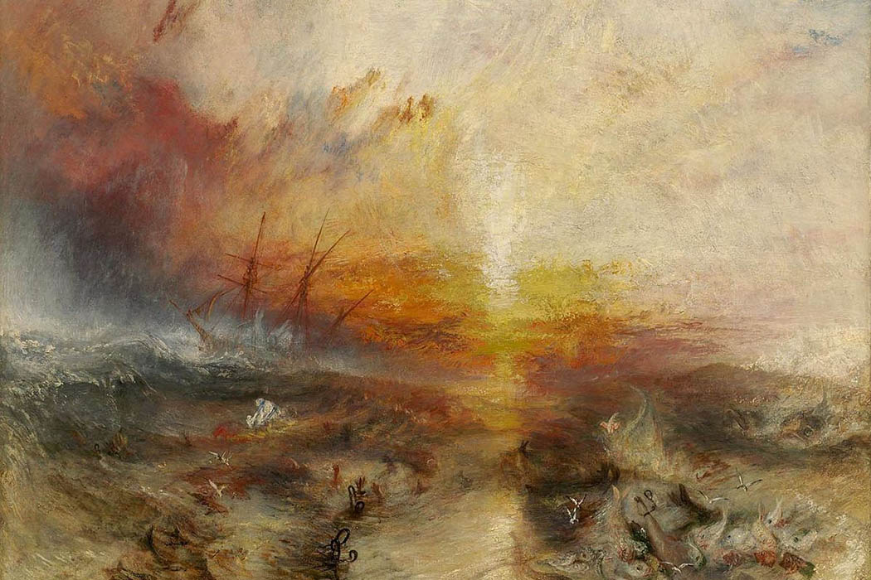
JMW Turner’s painting The Slave Ship (1840) is believed to depict the Zong. Use the database to find out more about the ship.

- How many voyages did the Zong sail, and when?

- Who was the Zong’s captain, and what further information can you glean about him?

- Who were the ship’s owners, and what further information can you glean about them>

- Hope Estate
Read and interpret the following letter from Robert Hibbard of Hope Estate, Jamaica to the Duke of Chandos.

Kingston, Jamaica 10 November 1787
Received, London 7 January 1788
My Lord,
I forward by this conveyance the duplicate of my letter to your Grace of the 27th of September, since which our Seasons have continued mild and noble, and, as no Hurricanes ever happened at so late a Period of the year as we are no arrived at we conceive ourselves perfectly secure.
A few days after the date of my last letter there arrived here to our address a very fine cargo of 600 slaves from the Gold Coast of Africa. As she brought us an account that no other could be expected from that part of the coast for a very considerable time, and as Provisions are remarkable cheap and in the greatest plenty, I thought it an opportunity not to be lost and (as our wants were rather pressing) I extended our purchase from ten to twenty. I was further encouraged to do this by having the opportunity of selecting previous to the day of the sale, the choicest Negroes in the Cargo. This is a privilege scarce ever permitted, and could not have been obtained but in a cargo of our own. The Negroes I chose are 20 prime young men all of whom are no settled in proper houses on the estate, and seem perfectly satisfied with their Situation.
The price was L69 Currency, each equal to L1,380 for the whole. The payment for Slaves is generally made the crop after the purchase, and the amount of interest after one month, but with respect to payment I shall await your Grace’s further discretion.
Your Grace’s most obedient servant, Robert Hibbard

- From the information provided, can you use the database establish which ship is referred to in the letter?

- What further information can you glean about the specific voyage listed?

- What information can you glean about the ship mentioned in the letter?

Exercise 3: Exploring the African Names Database
Slave ships kept accurate records of the number of enslaved people brought aboard the ship and disembarked later. However, ship records did not record information about individual slaves. The British abolished the slave trade in 1807 and then began patrolling the African coast to catch ships attempting to transport slaves illegally. More is known about individual slaves in the period after 1807. The African Names Database contains information on Africans liberated from slave ships captured by British cruisers between 1819 and 1845. There are over 67,000 African people documented in this database.
From the homepage of The Transatlantic Trade Database (www.slavevoyages.org), select “Explore the African Names Database”
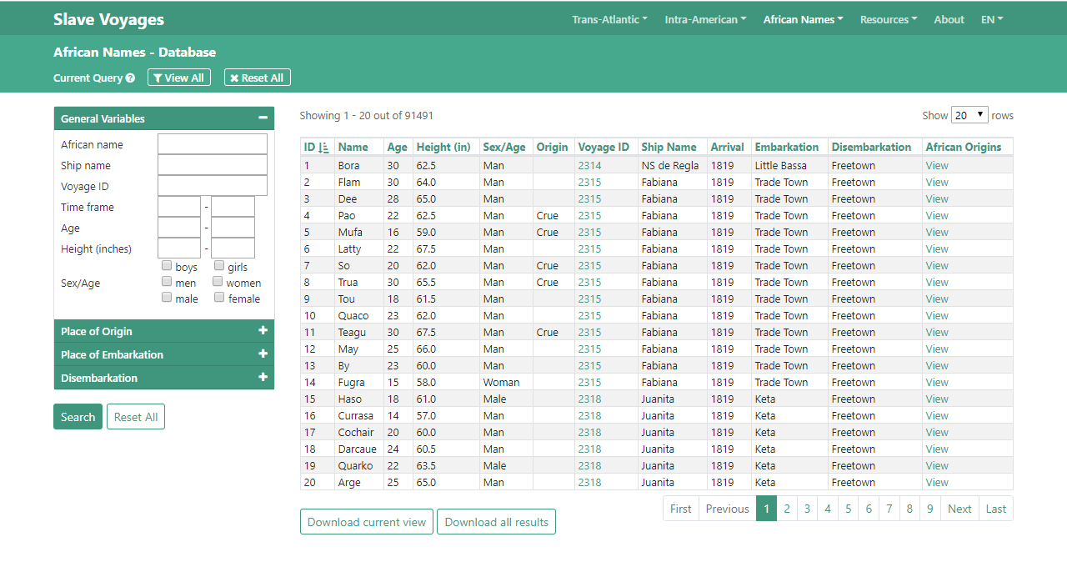

Fabiana.
- How many enslaved people were held on the ship Fabiana on its 1819 voyage?

- Click on the “Voyage ID 2315” to get more detailed information about the Fabiana voyage. Why were the enslaved people aboard the Fabiana disembarked in Africa and freed?

- What information can you find out about individual slaves aboard the Fabiana?

- What other information can you find about the Fabiana on the database?

If you have time, repeat the process with another ship

