AI and Machine Learning

Lecturer – Gordon Dickers
Scott Howells
Student P Number – 1701604

Table of Contents
Introduction 2
1.0 Task 1 2
1.1 AI Maze Application 2
2.0 Task 2 6
2.1 Hill Climbing 6
2.2 8-tiles Problem 9
2.3 8-tiles Puzzle Application 11
Bibliography 14
References 14
Appendix 15

Introduction
This report will highlight and discuss the implemented applications that were created on Visual Studio. The applications consist of an AI Agent searching for an object within a maze and an 8-tile puzzle game which can be played. There will also be a discussion into hill climbing and other functions relevant to the implemented code for the applications created.

Task 1
This section of the report will discuss the implementation of a program that uses an AI Agent to systematically search a maze for an object. Using different features, the program must function with a depth first search.

1.1 AI Maze Application
The application begins at a starting position on a maze whilst the AI Agent searches for the object that has been placed within the maze. The Agent continues to move to the right until there is a wall where it will back track and move downwards where there is no floor. If no movement to the right or down then the next move is upwards and if not right, down or up move then left would be taken. After creating the maze and testing the DFS and backtracking methods the application was unable to load the text file and so the maze was displayed in the c++ file where it functioned correctly. The use of depth first search (DFS) was implemented for the application to search for the object, it explores each branch before backtracking which is why it was useful to implement.

When the application is run it instantly portrays a maze where the is an Agent ‘*’ located at the start ‘S’ and automates it searching for the object ‘O’. When the Agent visits a location on the maze it implements a ‘V’ there as if to say it has been visited:
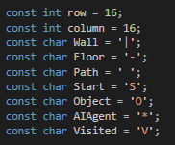
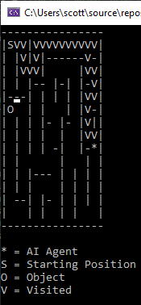

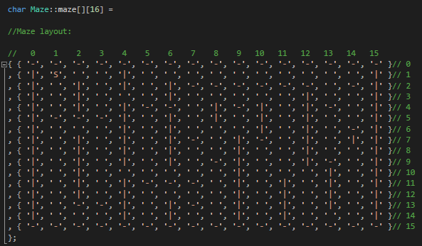

The above maze was implemented in the c++ file and consists of a 16 by 16 grid. The walls are implemented with the character ‘|’ and the floor is represented as ‘-‘.
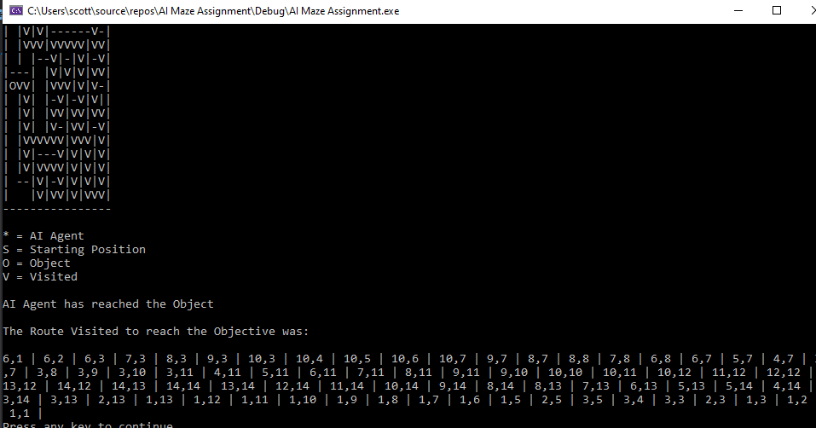
When the Agent has searched the maze and eventually found the object then the application will stop running and report that it has been found. The route that the Agent took was also displayed to allow the viewer to see what route was taken to achieve the objective.
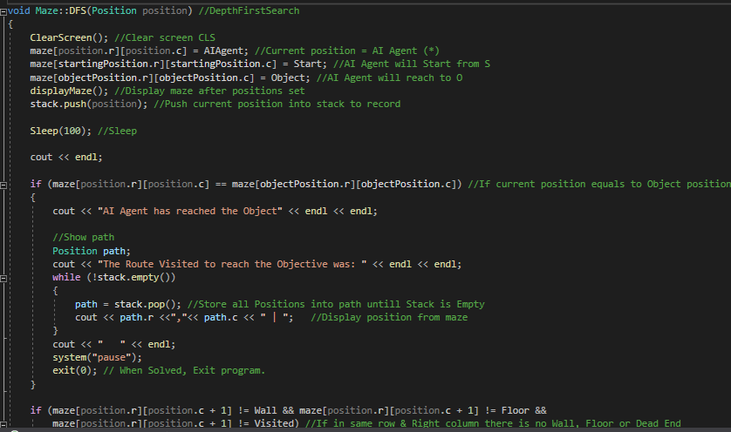
The DFS was implemented with the inclusion of stacks to enable it to acknowledge the current position of the agent and store it. The DFS variable was used with the position moved variable so it was enabled to search. With the use of stacks the backtracking method was able to function and go back over previous visited paths.
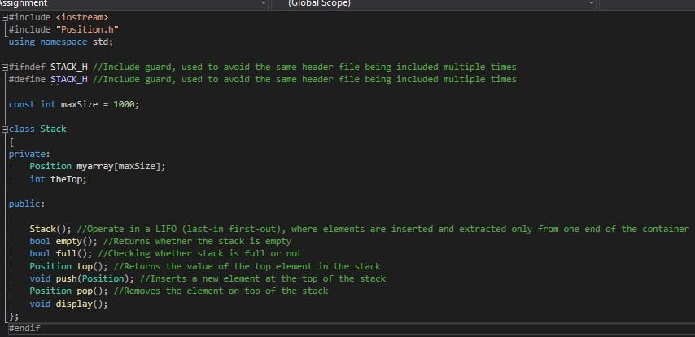
All of the code was commented on within the Visual Studio Application as to why the DFS linked. The use of ‘#ifndef STACK_H’ and ‘#define STACK_H’ were implemented as preprocessor techniques. They allowed for the prevention of a header file from being included multiple times. When compiling, all of the c++ files are compiled because of the use of #include and concatenates them into one major file. Errors began to appear throughout the application and thus the technique was included in the application. When compiled now the contents are processed however redefinition errors are cancelled.

The stack allowed to operate in a last-in-first-out method where the moves made where stored into the container, this also allowed for the functionality to backtrack when the Agent hits a dead-end. The push allowed for the new position to move to the top of the stack whereas the pop removes the position on top of the stack.
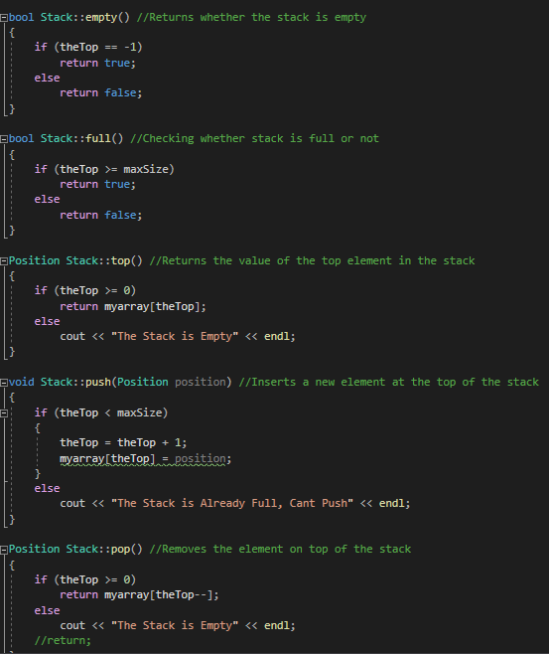

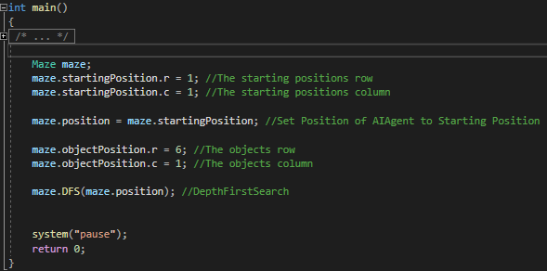
The main contained the starting position of the Agent with the columns and rows being able to differently portray where it starts. The objects position was also implemented and can be altered. Unfortunetly when using the ‘srand’ function, occasionally the object would display over a wall or floor and cause the application to function incorrectly. The random location that the object would be displayed had to be dropped to allow for a better performing application. The application includes many self-explanatory codes and the use of comments next to them should justify why and how they were used.

Test Plan:
Task No. | Expected Outcome | Did it work? | Actual Outcome
1 | AI Agent automates moving | Yes | The Agent can be seen to simulate moving
2 | AI Agent changes direction | Yes | The Agent will change direction if hitting a dead-end (wall/floor)
3 | AI Agent displays what path section has been visited | Yes | The Agent places a ‘V’ over the sections it has visited
4 | Maze read from a text file | No | The text file wouldn’t read the maze and so an alternative maze was created in the Maze.cpp
5 | Stop searching when object is found | Yes | When the Agent locates the object, it will systematically stop the animation and report success
6 | Display the route taken to achieve objective | Yes | The route taken to achieve the object is correctly displayed at the end of the search

2.0 Task 2
This section of the report is dedicated to the different methods that is used within AI and Machine learning. The discussion of Hill Climbing and the steps involved will be evaluated within this section. The topic of discussion will also go hand in hand with an 8-tiles problem. This problem is notorious within AI and Machine learning as it posses some of the most impressive methods of solving any given problem. This report will also contain a discussion on the heuristic function and how it is used in solving the tiles puzzle. Finally, this section will also contain a C++ application developed around the creation of an 8-tile puzzle. A short-written report on the created application will also follow, as details of the structure as well as algorithms will be identified and the reasoning behind the use of them.

2.1 Hill Climbing
Hill climbing is a method that is used in order to solve problems specifically in the area of Artificial Intelligence. The problems where hill climbing can easily be of use are in areas where the need to maximize or minimize a problems function by choosing values from the problems input. An example of this would be attempting to minimize the shortest route for a post man to travel, this is a well-known example simply known as “The Traveling salesman problem” [1]. Stating with an initial state is important as we aim to work towards achieving our Goal state. This can be seen as if we begin our journey at the bottom of the hill (initial state) and we aim to reach the summit (goal state). The hill climbing method is a different variation of the generate-and-test algorithm, this algorithm discards all the states that are unlikely to allow us to achieve the goal state [2]. In order for this to function correctly, the use of heuristics is used to indicate how close the current state is to achieving the goal state. The algorithm for the generate-and-test can be seen as followed:
- Generate the possible solutions
- Test to see expected outcome
- If solution found then quit, else go back to step 1
This is why hill climbing is a variation of the generate-and-test method as the feedback is taken under consideration from the test procedure and utilized for choosing the next move.
There are many types of hill climbing that can be used within AI and Machine learning. Simple hill climbing is as the name suggests the simplest way to implement a hill climbing algorithm. Simple hill climbing examines the other node “states and selects the first one which optimizes current cost and sets it as a current state” [3]. After analysing if the state it decides if it is better than the current state (if better move, else stay in the same state). The algorithm for simple hill climbing can be found as followed:
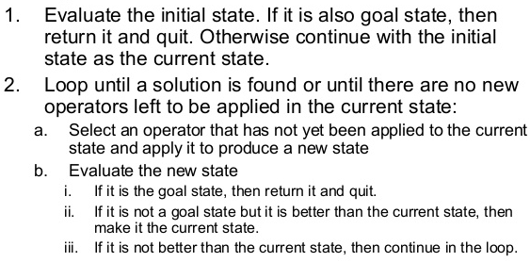 [4].
Steepest-Ascent Hill climbing is another variation on hill climbing. It works by examining the other nodes and selects the node that is closest to the goal state. The algorithm for the steepest-ascent hill climbing can be found below:
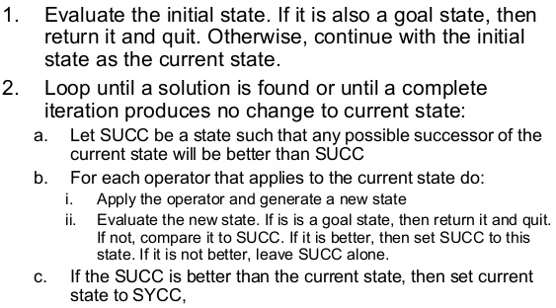 [5].
The final variation is stochastic hill climbing. This variation does not evaluate other nodes before moving. Instead, it selects one node at random and decides whether to select it as current state or examine another.
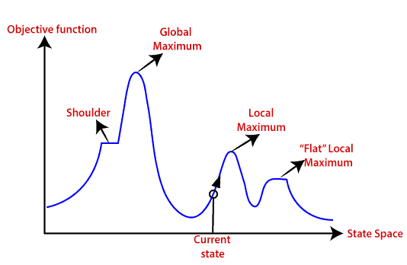(Hill Climbing Algorithm)
Above is a state space diagram for hill climbing. It is a graphical representation which shows the comparison of various stages of algorithm and objective functions/costs. The Y-axis is the objective or cost function whereas the X-axis is the state space. The goal of the search is to find the global maximum and local maximum.
The state space has different regions located within. The Shoulder is known as the “plateau” region which has an uphill edge. The Global Maximum is the best state as it has the highest value of objective function. The Current State is where the location when the search begins. Local Maximum is the state that is better than the others surrounding it however, it is not better than the global maximum despite it being a higher value than its surrounding states. “Flat” Local Maximum also which can be seen as a “plateau” is another flat region found within and has the same value as the others surrounding it.
Despite all of the positives and the usefulness of the hill climbing algorithm there are problems which occur. After conducting the research on hill climbing methods some of the problems that appeared were:
Local Maximum
The local maximum despite being the highest in its surrounding area, there is another state in the Global Maximum which would be better suited. The solution to this would be to use the backtracking technique. This technique would work by creating a list of the paths that can be used so that when it is time it can backtrack the search space and explore the other paths it can take.
Flat Local Maximum
The “plateau” also known as the flat area of the search space includes the same value as the other states surrounding. The issue is that the algorithm is unable to find the best direction to move. The hill climbing search has the potential to become lost in the plateau area. A solution to this could be to take greater steps in searching. It would be far better suited to randomly choose a state at a further location than its own to give the opportunity of finding a non-flat area when searching.
Ridges Local Maximum
The Ridge is a unique location within the local maximum. The areas within the ridge are higher than most however it does contain slopes and is not able to be reached within a single move. A possible solution to this problem would be to move in alternative directions.

2.2 8-tiles Problem
The 8-tile problem presents itself as a 9-section grid with 8 numbers filled at random locations. One tile must be moved at a single time into an adjacent free space until the puzzle is solved. Below is a randomly generated puzzle which must be solved:
1 | 2 | 3
 | 4 | 6
7 | 5 | 8
(Initial State)
1 | 2 | 3
4 | 5 | 6
7 | 8
(Goal State)
In order to complete this puzzle, the use of hill climbing and heuristic function must be used to find the potential valid moves and select the best one to solve this puzzle. The heuristic function of h() determines the number of tiles that are out of place after a move has been made.

1 | 2 | 3
 | 4 | 6
7 | 5 | 8

 | 2 | 3
1 | 4 | 6
7 | 5 | 8
1 | 2 | 3
4 |  | 6
7 | 5 | 8
1 | 2 | 3
7 | 4 | 6
 | 5 | 8

G = 1, h = (2), f = 3

G = 1, h = (4), f = 5

G = 1, h = 4, f = 5

1 | 2 | 3
 | 4 | 6
7 | 5 | 8
1 | 2 | 3
4 | 5 | 6
7 |  | 8
1 | 2 | 3
4 | 6
7 | 5 | 8
G = 2, h = (3), f = 5

1 |  | 3
4 | 2 | 6
7 | 5 | 8
G = 2, h = (3), f = 5

G = 2, h = (1), f = 3

G = 2, h = (3), f = 5

1 | 2 | 3
4 | 5 | 6
 | 7 | 8
1 | 2 | 3
4 | 5 | 6
7 | 8
1 | 2 | 3
4 |  | 6
7 | 5 | 8

G = 3, h = (2), f = 5

G = 3, h = (0), f = 3

The hill climbing that is represented in each move above assess the next possible move and decides which state is of shorter distance. For instance, the initial state begins with multiple numbers out of place and far away from the goal state. There are three possible moves to be made and each has been recorded with the heuristic function. State 1 had 4 tiles (h=4) out of place, state 2 had 2 tiles (h=2) out of place and finally the last state had another 4 tiles out of place. This means state 2 is the better state so it selects it. One major drawback that hill climbing can sometimes impose when attempting to solve such a puzzle is that it has the ability to get locked and unable to find the appropriate solution. This occurs because the vacant tile is only able to be attributed by its neighbours. Local optima [6] is another issue faced as the algorithm chooses the next viable state based on the distance also known as cost. It assumes that this is the bet path to reaching the goal however the path chosen has the ability to lead to higher costs (more steps) later on in the puzzle.
Using the depth-first approach when hill climbing can be extremely useful in order to overcome the issue stated above. The method to traverse a path for a certain number of steps (depth) to confirm it is the appropriate move to make. This approach will:
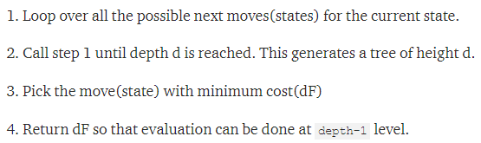 [7].
A method that goes into what was discussed above is the use of the A* Algorithm. This algorithm is perfect for pathfinding and traversal as the process is efficient and proves to be accurate when used. The most impressive feature of the A* Algorithm is that it can keep track of the nodes it has visited and thus saving a lot of time. The availability of saving a list of all the nodes yet to be explored also provides a useful functionality as it is able to choose the most optimal node from the list.
The formula that was used in solving the 8-tile problem above can be seen below:
f-score = h-score + g-score
The A* Algorithm uses a mixture of heuristic value in the h() function as well as the g-score meaning the number of nodes traversed from the current starting node. The A* Algorithm was used when solving the 8-tile problem as it correctly gave the solved puzzle.

2.3 8-tiles Puzzle Application
The 8-tiles puzzle game was created in order for users to play through a randomly generated board consisting of 8 numbers and 9 slots. The slot with no number holds the value of an empty space in which a number adjacent to it must go into. The application begins by loading the goal state, otherwise known to the player the final board layout the player must achieve. A screenshot of this can be found below:
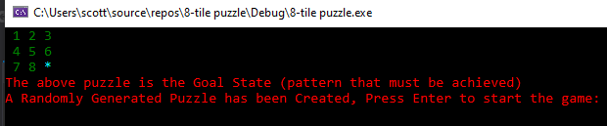
When the player hits the enter key the game will generate a random solvable puzzle to solve:
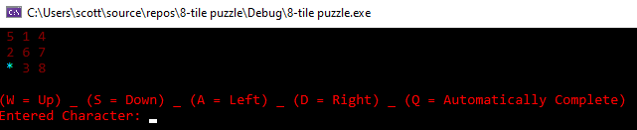
The instructions on how to play the game will appear, the player must use these characters to move the numbers into the correct place.

When the player correctly has a number in the correct section it will turn from the colour red to green:
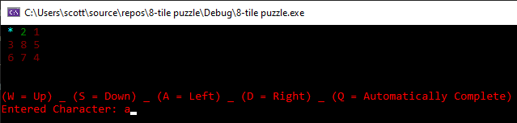
The previously entered character also appears to allow the player to remember what was chosen.
When all the numbers have been entered into their correct section then the game will stop and notify that the player has solved the puzzle. The number of moves were also recorded and displayed for the user to acknowledge.
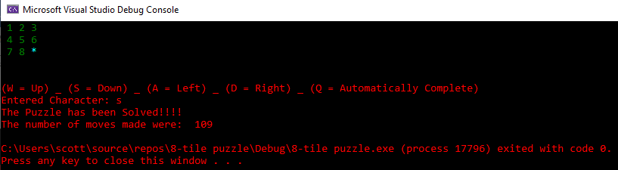
If the player is stuck then the option to automatically solve the puzzle can be triggered by selecting the character ‘q’. This automatically completes the puzzle however the functionality to animate the puzzle being solved would not work. This is also the same for the hill climbing method that was initially implemented, as further improvements to the code was made the hill climbing method used broke the game and thus removed from the files.
The structure of the program began with a main c++ file and multiple header files to retrieve what was appropriate. The header files mainly served it purpose for the hill climbing method that was used however, after difficulties they were removed in order for the main file to serve it purpose in being a fully function game. Multiple variables were used to create the game and sanctioned within void statements.
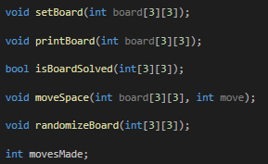
These methods were used to randomly generate the board, set the board, print the board to the console, move the tiles and check when the board was solved.

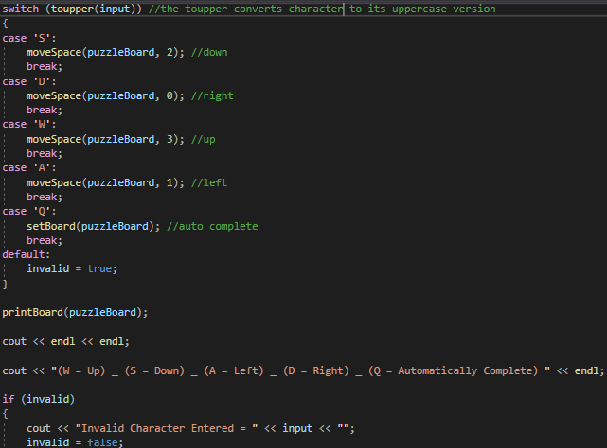
The main contained the printed-out text and the board where it was displayed on the console. A switch statement was used to allow the user to select characters on the keyboard to move the tiles. This made it easier for the program to function.

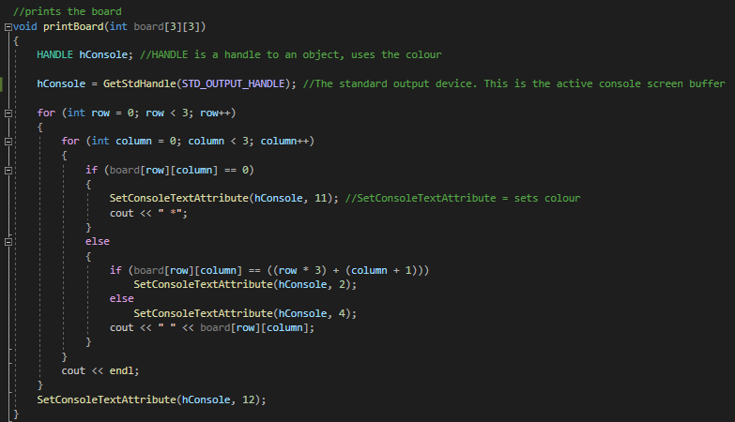
This structure was used to change the colours of the numbers. When the numbers were in the correct section it would turn to green to indicate that the player has it in the right place else it would remain red.

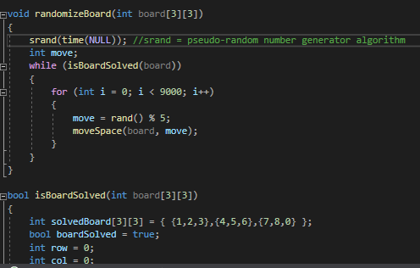
The other functions used are self-explanatory as they just set the board, print the board and allow for the movement of tiles. However, another important algorithm used was the srand which allowed for the boards being printed and set to be random each time the user would run the program.

Test Plan:
Task No. | Expected Outcome | Did it work? | Actual Outcome
1 | Display the goal state puzzle | Yes | Displayed the goal state puzzle
2 | Randomly generate a new puzzle board | Yes | It randomly generates a new puzzle
3 | Move the tiles using the keyboard | Yes | It moved the tiles using the keyboard
4 | Different colour text | Yes | Has different colour text displayed
5 | Animate the automatic solution | No | Does not animate, instead just shows the puzzle complete
6 | Solve the puzzle with hill climbing | No | Hill climbing method couldn’t be implemented
7 | Finish and display when the puzzle is solved | Yes | Displays when the puzzle is solved
8 | Display the number of moves | Yes | Displays the number of moves made

Bibliography
https://www.baeldung.com/java-hill-climbing-algorithm
https://stackoverflow.com/questions/14290026/linking-h-files-with-c-with-ifdef-header-guards
http://forums.codeguru.com/showthread.php?539241-RESOLVED-can-anyone-tell-me-all-colors-const-for-SetConsoleTextAttribute()-function
https://cpp.hotexamples.com/examples/-/-/SetConsoleTextAttribute/cpp-setconsoletextattribute-function-examples.html

References

[1] | T. Bektas, “The multiple traveling salesman problem: an overview of formulations and solution procedures,” Omega, pp. 209-219, 2006.
[2] | L. P. Kaelbling, “Associative reinforcement learning: A generate and test algorithm,” Machine Learning, pp. 299-319, 1994.
[3] | “Hill Climbing Algorithm in Artificial Intelligence,” [Online]. Available: https://www.javatpoint.com/hill-climbing-algorithm-in-ai. [Accessed 17 February 2020].
[4] | J. .K.Jose, “Heuristic Search Techniques,” 14 December 2016. [Online]. Available: https://www.slideshare.net/JismyKJose/heuristc-search-70129411. [Accessed 17 February 2020].
[5] | G. Bhowmik, Analytical Techniques in Biotechnology, Tata McGraw-Hill Education, 2011.
[6] | C. A. Tovey, “Hill Climbing with Multiple Local Optima,” SIAM Journal on Algebraic Discrete Methods, vol. 6, no. 3, pp. 384-393, 1985.
[7] | R. Aware, “Solve the Slide Puzzle with Hill Climbing Search Algorithm,” Towards Data Science, 20 March 2017. [Online]. Available: https://towardsdatascience.com/solve-slide-puzzle-with-hill-climbing-search-algorithm-d7fb93321325. [Accessed 17 February 2020].

Appendix
AI Agent Application code:
Source.cpp
#include <iostream>
#include <Windows.h>
#include "Maze.h"
#include "Stack.h"
using namespace std;

int main()
{
/* call for the maze from text files
Maze maze("test.txt");
Maze maze1("maze1.txt");
*/

Maze maze;
maze.startingPosition.r = 1; //The starting positions row
maze.startingPosition.c = 1; //The starting positions column

maze.position = maze.startingPosition; //Set Position of AIAgent to Starting Position

maze.objectPosition.r = 6; //The objects row
maze.objectPosition.c = 1; //The objects column

maze.DFS(maze.position); //DepthFirstSearch

system("pause");
return 0;
}

Stack.cpp
#include "Stack.h"

Stack::Stack() //Operate in a LIFO (last-in first-out), where elements are inserted and extracted only from one end of the container
{
theTop = -1;
}

bool Stack::empty() //Returns whether the stack is empty
{
if (theTop == -1)
return true;
else
return false;
}

bool Stack::full() //Checking whether stack is full or not
{
if (theTop >= maxSize)
return true;
else
return false;
}

Position Stack::top() //Returns the value of the top element in the stack
{
if (theTop >= 0)
return myarray[theTop];
else
cout << "The Stack is Empty" << endl;
}

void Stack::push(Position position) //Inserts a new element at the top of the stack
{
if (theTop < maxSize)
{
theTop = theTop + 1;
myarray[theTop] = position;
}
else
cout << "The Stack is Already Full, Cant Push" << endl;
}

Position Stack::pop() //Removes the element on top of the stack
{
if (theTop >= 0)
return myarray[theTop--];
else
cout << "The Stack is Empty" << endl;
//return;
}

void Stack::display()
{
top();
}

Stack.h
#include <iostream>
#include "Position.h"
using namespace std;

#ifndef STACK_H //Include guard, used to avoid the same header file being included multiple times
#define STACK_H //Include guard, used to avoid the same header file being included multiple times

const int maxSize = 1000;

class Stack
{
private:
Position myarray[maxSize];
int theTop;

public:

Stack(); //Operate in a LIFO (last-in first-out), where elements are inserted and extracted only from one end of the container
bool empty(); //Returns whether the stack is empty
bool full(); //Checking whether stack is full or not
Position top(); //Returns the value of the top element in the stack
void push(Position); //Inserts a new element at the top of the stack
Position pop(); //Removes the element on top of the stack
void display();
};
#endif
Position.cpp
#include "Position.h"

Position::Position() {}

Position::Position(int row, int col)
{
r = row; // Maze row
c = col; // Maze column
}

Position.h
#include <iostream>

#ifndef POSITION_H //Include guard, used to avoid the same header file being included multiple times
#define POSITION_H //Include guard, used to avoid the same header file being included multiple times

class Position
{
public:
int r; //row number in Maze
int c; //column number in Maze

Position(); //The position of the match in the sequence
Position(int, int);
};
#endif
Maze.h
#include <iostream>
#include <Windows.h>
#include "Stack.h"
#include "Position.h"

const int row = 16;
const int column = 16;
const char Wall = '|';
const char Floor = '-';
const char Path = ' ';
const char Start = 'S';
const char Object = 'O';
const char AIAgent = '*';
const char Visited = 'V';

class Maze
{
private:
/*
char** maze;

int rows = 16;
int cols = 16;

std::string file;
std::string dir = "mazes/";

Point end;
*/
public:

Position position; // Current Position
Position startingPosition; // Starting position in maze or S
Position objectPosition; // Object position in maze or O
Stack stack;

Maze();
static char maze[][16];
void displayMaze();
void moveUp(); //move Agent Up
void moveDown(); //move Agent Down
void moveLeft(); //move Agent Left
void moveRight(); //move Agent Right
void DFS(Position position); //DepthFirstSearch
void BackTrack(Position position); //Backtrack to record the route of the moves when you hit a wall
void ClearScreen();
};

Maze.cpp
#include "Maze.h"
using namespace std;

/*
Maze::Maze(const string& fileName) {
//Verify that the file provided is a valid text file
ifstream f(dir + fileName);
if (!f.good()) {
cout << "File: " << fileName << " is inaccessible or doesn't exist..." << endl << endl;
return;
}
// Set filename string property.
file = fileName;

//Build up the dynamic 2d char array using the newly determined rows and columns
displayMaze();
}
*/

Maze::Maze() {}

char Maze::maze[][16] =

//Maze layout:

// 0 1 2 3 4 5 6 7 8 9 10 11 12 13 14 15
{ { '-', '-', '-', '-', '-', '-', '-', '-', '-', '-', '-', '-', '-', '-', '-', '-' }// 0
, { '|', 'S', ' ', ' ', '|', ' ', ' ', ' ', ' ', ' ', ' ', ' ', ' ', ' ', ' ', '|' }// 1
, { '|', ' ', '|', ' ', '|', ' ', '|', '-', '-', '-', '-', '-', '-', ' ', '-', '|' }// 2
, { '|', ' ', '|', ' ', ' ', ' ', '|', ' ', ' ', ' ', ' ', ' ', '|', ' ', ' ', '|' }// 3
, { '|', ' ', '|', ' ', '|', '-', '-', ' ', '|', '-', '|', ' ', '|', '-', ' ', '|' }// 4
, { '|', '-', '-', '-', '|', ' ', '|', ' ', '|', ' ', '|', ' ', '|', ' ', ' ', '|' }// 5
, { '|', ' ', ' ', ' ', '|', ' ', '|', ' ', ' ', ' ', '|', ' ', '|', ' ', '-', '|' }// 6
, { '|', ' ', '|', ' ', '|', ' ', '|', '-', ' ', '|', '-', ' ', '|', ' ', '|', '|' }// 7
, { '|', ' ', '|', ' ', '|', ' ', '|', ' ', ' ', '|', ' ', ' ', '|', ' ', ' ', '|' }// 8
, { '|', ' ', '|', ' ', '|', ' ', '|', ' ', '-', '|', ' ', ' ', '|', '-', ' ', '|' }// 9
, { '|', ' ', '|', ' ', ' ', ' ', ' ', ' ', ' ', '|', ' ', ' ', ' ', '|', ' ', '|' }// 10
, { '|', ' ', '|', ' ', '|', '-', '-', '-', ' ', '|', ' ', '|', ' ', '|', ' ', '|' }// 11
, { '|', ' ', '|', ' ', '|', ' ', ' ', ' ', ' ', '|', ' ', '|', ' ', '|', ' ', '|' }// 12
, { '|', ' ', '-', '-', '|', ' ', '|', '-', ' ', '|', ' ', '|', ' ', '|', ' ', '|' }// 13
, { '|', ' ', ' ', ' ', '|', ' ', '|', ' ', ' ', '|', ' ', '|', ' ', ' ', ' ', '|' }// 14
, { '-', '-', '-', '-', '-', '-', '-', '-', '-', '-', '-', '-', '-', '-', '-', '-' }// 15
};

void Maze::displayMaze() //Display the Maze
{
for (int r = 0; r < row; r++)
{
for (int c = 0; c < column; c++)
cout << maze[r][c];
cout << endl;
}
cout << endl;
cout << "* = AI Agent" << endl;
cout << "S = Starting Position" << endl;
cout << "O = Object" << endl;
cout << "V = Visited" << endl;

}

void Maze::DFS(Position position) //DepthFirstSearch
{
ClearScreen(); //Clear screen CLS
maze[position.r][position.c] = AIAgent; //Current position = AI Agent (*)
maze[startingPosition.r][startingPosition.c] = Start; //AI Agent will Start from S
maze[objectPosition.r][objectPosition.c] = Object; //AI Agent will reach to O
displayMaze(); //Display maze after positions set
stack.push(position); //Push current position into stack to record

Sleep(100); //Sleep

cout << endl;

if (maze[position.r][position.c] == maze[objectPosition.r][objectPosition.c]) //If current position equals to Object position
{
cout << "AI Agent has reached the Object" << endl << endl;

//Show path
Position path;
cout << "The Route Visited to reach the Objective was: " << endl << endl;
while (!stack.empty())
{
path = stack.pop(); //Store all Positions into path untill Stack is Empty
cout << path.r <<","<< path.c << " | "; //Display position from maze
}
cout << " " << endl;
system("pause");
exit(0); // When Solved, Exit program.
}

if (maze[position.r][position.c + 1] != Wall && maze[position.r][position.c + 1] != Floor &&
maze[position.r][position.c + 1] != Visited) //If in same row & Right column there is no Wall, Floor or Dead End
{
maze[position.r][position.c] = Visited; //Set current position to Visited (V)
Position positionMoved(position.r, position.c + 1); //Decide to move Right and Store Next position in positionMoved
DFS(positionMoved); //Recall function with (new) positionMoved
}

if (maze[position.r + 1][position.c] != Wall && maze[position.r + 1][position.c] != Floor &&
maze[position.r + 1][position.c] != Visited) //If in down row & same column there is no Wall, Floor or Dead End
{
maze[position.r][position.c] = Visited; //Set current position to Visited (V)
Position positionMoved(position.r + 1, position.c); //Decide to move Down and Store Next position in positionMoved
DFS(positionMoved); //Recall function with (new) positionMoved
}

if (maze[position.r][position.c - 1] != Wall && maze[position.r][position.c - 1] != Floor &&
maze[position.r][position.c - 1] != Visited) //If in same row & Left column there is no Wall, Floor or Dead End
{
maze[position.r][position.c] = Visited; //Set current position to Visited (V)
Position positionMoved(position.r, position.c - 1); //Decide to move Left and Store Next position in positionMoved
DFS(positionMoved); //Recall function with (new) positionMoved
}

if (maze[position.r - 1][position.c] != Wall && maze[position.r - 1][position.c] != Floor &&
maze[position.r - 1][position.c] != Visited) //If in Up row & same column there is no Wall, Floor or Dead End
{
maze[position.r][position.c] = Visited; //Set current position to Visited (V)
Position positionMoved(position.r - 1, position.c); //Decide to move Up and Store Next position in positionMoved
DFS(positionMoved); //Recall function with (new) positionMoved
}

BackTrack(position); //Check Dead-End

}

void Maze::BackTrack(Position position)
{
if (!stack.empty())
{
maze[position.r][position.c] = Visited; //Set current position to Visited (V)
stack.pop(); //Pop current position
Position positionMoved = stack.pop(); //Pop last position and avoid Infinte loop
DFS(positionMoved); //Recall function with new position (last position)
}
}

void Maze :: ClearScreen()
{
HANDLE hOut; //Relocates your Console courser to the top left corner
COORD Position; //COORD pass multiple values

hOut = GetStdHandle(STD_OUTPUT_HANDLE);

Position.X = 0; //Top left corner of the display, but no text has been changed
Position.Y = 0; //Top left corner of the display, but no text has been changed
SetConsoleCursorPosition(hOut, Position);
}

8-tiles Puzzle Application code:
#include <iostream>
#include <Windows.h>
#include <conio.h>
#include <time.h>

using namespace std;

void setBoard(int puzzle[3][3]);

void printPuzzle(int puzzle[3][3]);

bool puzzleSolved(int[3][3]);

void moveSpace(int puzzle[3][3], int moveTile);

void randomizeBoard(int[3][3]);

int movesMade;

int main()
{
int puzzleGrid[3][3];

char input;

bool invalid = false;

setBoard(puzzleGrid);

printPuzzle(puzzleGrid);

cout << "The above puzzle is the Goal State (pattern that must be achieved) " << endl;

randomizeBoard(puzzleGrid);

cout << "A Randomly Generated Puzzle has been Created, Press Enter to start the game:" << endl;

cin.get();

system("CLS"); //clear the screen

printPuzzle(puzzleGrid);

cout << "'A' = Left" << endl;
cout << "'W' = Up" << endl;
cout << "'S' = Down" << endl;
cout << "'D' = Right" << endl;
cout << "'Q' = Automatically Complete" << endl;

cout << "Entered Character: ";

while (!puzzleSolved(puzzleGrid))
{
movesMade++;

input = _getch(); //uses <conio.h> to read the next character from keyboard

system("CLS");

switch (toupper(input)) //the toupper converts character to its uppercase version
{
case 'S':
moveSpace(puzzleGrid, 2); //down
break;
case 'D':
moveSpace(puzzleGrid, 0); //right
break;
case 'W':
moveSpace(puzzleGrid, 3); //up
break;
case 'A':
moveSpace(puzzleGrid, 1); //left
break;
case 'Q':
setBoard(puzzleGrid); //auto complete
break;
default:
invalid = true;
}

printPuzzle(puzzleGrid);

cout << endl << endl;

cout << "'A' = Left" << endl;
cout << "'W' = Up" << endl;
cout << "'S' = Down" << endl;
cout << "'D' = Right" << endl;
cout << "'Q' = Automatically Complete" << endl;

if (invalid)
{
cout << "Invalid Character Entered = " << input << "";
invalid = false;
}
else
cout << "Entered Character: " << input;
}

cout << endl;

cout << "The Puzzle has been Solved!!!!" << endl;

cout << "The number of moves made were: ";
cout << movesMade << endl;

exit(0); // When Solved, Exit program.

return 0;
}

//enter new code (missing from vs application)
if (blankRow + 1 > 2)
availableMove[2] = false;
else if (blankRow - 1 < 0)
availableMove[3] = false;
if (blankCol - 1 < 0)
availableMove[1] = false;
else if (blankCol + 1 > 2)
availableMove[0] = false;
switch (moveTile)
{
case 0:
if (availableMove[moveTile])
{
puzzle[blankRow][blankCol] = puzzle[blankRow][blankCol + 1];
puzzle[blankRow][blankCol + 1] = 0;
blankCol = blankCol + 1;
}
break;
case 1:
if (availableMove[moveTile])
{
puzzle[blankRow][blankCol] = puzzle[blankRow][blankCol - 1];
puzzle[blankRow][blankCol - 1] = 0;
blankCol = blankCol - 1;
}
break;
case 2:
if (availableMove[moveTile])
{
puzzle[blankRow][blankCol] = puzzle[blankRow + 1][blankCol];
puzzle[blankRow + 1][blankCol] = 0;
blankRow = blankRow + 1;
}
break;
case 3:
if (availableMove[moveTile])
{
puzzle[blankRow][blankCol] = puzzle[blankRow - 1][blankCol];
puzzle[blankRow - 1][blankCol] = 0;
blankRow = blankRow - 1;
}
break;
}
}

void randomizeBoard(int puzzle[3][3])
{
srand(time(NULL)); //srand = pseudo-random number generator algorithm
int move;
while (puzzleSolved(puzzle))
{
for (int i = 0; i < 9000; i++)
{
move = rand() % 5;
moveSpace(puzzle, move);
}
}
}

