Student name: Emanuel Cogalniceanu
Student ID number: 2243719
Program: BA International Hotel Management
Module: Financial Management for the Hotel Industry
Module code: BMIH5007
Assignment Title: Business Report - Comparison of Two Hospitality Organizations
Declaration
On 16th October 2024, I used the Grammarly app to check my material for spelling and grammatical mistakes. The tool worked independently, with no need for me to type specific queries; it was easy to determine which of the offered suggestions should be implemented or rejected. I declare that I did not employ the use of AI instruments in the search and writing of this assignment and have not submitted any AI-generated work as mine. Further, all drafts, notes, and all other materials used in the completion of this assignment have been retained by me and will be produced on request.

Executive Summary
This report provides an in-depth comparison of the financial management strategies of two prominent hotel groups: Shangri-La Hotels and Premier Inn Hotels. It evaluates their performance across four key areas including overall sales, market segmentation, growth rate, and financial capital invested in CSR. Marriott owns such brands as Shangri-La that is targeting the audience of high-income citizens and is expanding its hotels mainly in Asia whereas Premier Inn is targeting budget tourists and is mainly located in the UK. Moreover, this figure reveals the firm's concentration in the luxury class of operations, its growth in the growth regions of the globe, and its concern about eco-responsibility. In contrast, Premier Inn also prioritizes value, growth outside London, and operational productivity. Consequently, both organizations display efforts in CSR activity, although styles vary due to market positions take particulars of the recommendations based on the individual's opportunities for growth, generating new streams of revenue, as well as methods of contributing to the improvement of each individual's CSR plan.
Table of Contents
1. Introduction 4
2. Revenue Analysis 4
2.1 Shangri-La 4
2.2 Premier Inn Hotel 5
3. Market Positioning 7
4. Growth Expansion 10
5. Financial Commitment to CSR 11
6. Recommendations 12
7. Conclusion 13
8. References 14

Introduction
The following report aims to undertake a fundamental comparative analysis of the two leading hotel chains, namely Shangri-La Hotels and Premier Inn Hotels to evaluate the financial management strategies of both hotel chains. Moreover, Shangri-La Hotels, which is a luxury brand that provides a wide range of services on the international level, and another organization, namely Premier Inn, which offers cheap intermediate services, arrange financial information to support its development and sustain its revenue growth. The assessment covers four key areas: total sales, market segment, business development, and the firm's liability to CSR. The business of hospitality, which has seasonal tendencies as well, depends on consumer choices, the condition of the global economy, and competition. This report analyzes financial revenues, market position, techniques for growth, and CSR initiatives. The purpose of the report is to seek to compare and contrast these two companies' financial management strategies and their repercussions on sustainable financial management advancement.

Revenue Analysis

Shangri-La
Luxury sales and receipts from accommodation are the two main streams of revenue in this company followed by food and drink services, and luxury and wellness products, among others. Luxury is the brand and because of this, the organization can charge relatively high rates for the rooms and other services offered (Omondi-Ochieng, 2019). Subsequently, Shangri-La has directed its efforts on increasing the wellness and event offerings which are revenue-resulting acceleration effectively (Wang et al., 2020). Moreover, the new cases of the virus and the instabilities of the world economy resulted in low occupancy levels and revenue in 2020 and 2021. However, the revenue of Premier Inn UK in FY23, with statutory revenue of £2.508 billion was far better than in FY22. The company generated a pre-tax profit of £375 million which represents a stark departure from the losses posted for FY22. Total operating costs increased during FY 07 but the average room income per availability (AIPA), £59.45 showed an increasing Operating Margin due to an overall increase in the Room Stock Capacity (Uyar et al., 2020). The key performance indicators are also indicative of an improvement in occupancy rates and committed room growth pointing to the company’s expansion and operational success.
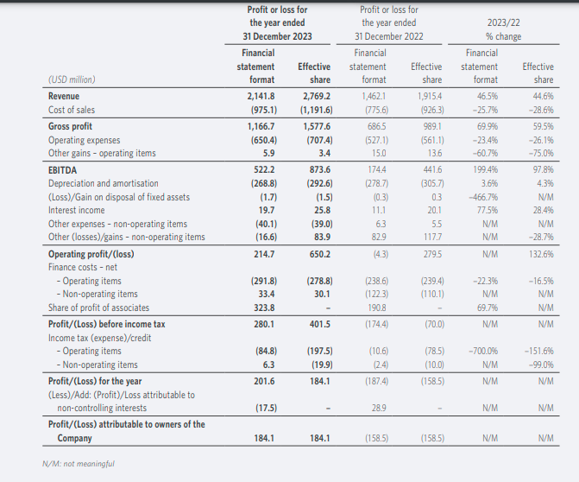
Figure 1: Shangri-La-annual Report 2023
Source: (Annual Report, 2023)

Premier Inn Hotel
Currently, revenue is mainly through room sales, and hotel guests also obtain meals from the restaurant, which is owned by Premier Inn. Meira and Hancer, (2021), focus on low-priced products, customers who search for cheap options, families, and businessmen who need comfortable accommodations but not super cheap. In contrast, Premier Inn had an advantage in domestic travel during the pandemic, though similar to Shangri-La, its revenue was more or less stable owing to the staycation economy in the UK. Panno, (2020), energy and labor costs have put considerable upward pressure on profitability in the bargain. Nonetheless, Premier Inn has formed a good level of solidity as it indicates high occupancy, and growth of properties in the UK and Europe that led to the constant growth of its revenues (Sakshi et al., 2020).
According to the data, the total asset figure by the end of December 2023 is USD 12.862 billion slightly higher than the figure for the year 2022 which is USD 12.633 billion. The non-current assets are worth USD 11.406 billion comprising property, plant, and equipment worth USD 3.998 billion, investment properties worth USD 1.803 billion, and right-of-use assets worth USD 1.051 billion (Ritchie and Jiang, 2021). The current assets are USD 1.455 billion and there are cash and cash equivalents of USD 870 million. Total non-controlling interests amount to USD 1.080 billion, following the principle of equity, by share capital and premium of USD 3.201 billion, and retained earnings of USD 1.629 billion. The revenue for the year, to December 31, 2023, is $2,141.8 million an increase of 46.5% from the year 2022. The gross profit increased by 70.1%, the operating profit by 132.6%. Its operating profit has enhanced greatly hitting $214.7M in contrast to a loss recorded the previous year. Profit before tax was $280.1 million (Martín-Rios and Ciobanu, 2019). The company achieved a net profit of $201.6M with profit for the owners of $184.1M as compared to losses in 2022.
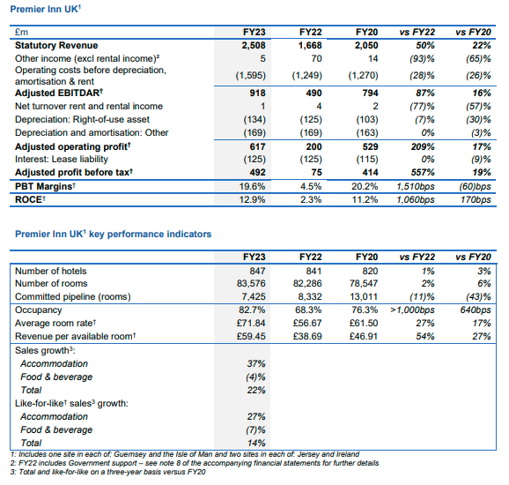
Figure 2: Annual report of Premier Inn
Source: (Whitbread UK, 2023)

Market Positioning
In considering the hotel namely Shangri-La in which the market segments implemented strategies are aimed at including enthusiastic and selective luxury travelers, business customers in addition to upper-income customers (Martín-Rios and Ciobanu, 2019). This comprises wealthy businesses, holidaymakers, politicians as well as other people who expect customized services, lavish rooms, and special facilities. Shangri-La is targeting those clients who will be interested not only in accommodation but also in an experience to enjoy the very essence of luxury and comfort. This business occupies a leadership position in the segment of luxury hotels, especially in the Asia-Pacific region and the Middle East market. Moreover, it currently has roughly 100 outlets globally to make it almost at par with premium brands such as Four Seasons, or Ritz-Carlton (Malagila et al., 2021). Currently, Shangri-La controls an estimated 5% of the luxury segment; The Company established a firm brand image that bases its operations on excellent services and quality products. In contrast, Shangri-La also has an advantage over rivals Four Seasons and Ritz-Carlton in places such as Asia given the organization’s strong established relationships and knowledge of those regions’ consumers (Gordon, 2020). Additionally, while Four Seasons targets serving modern luxury, the values of which are different from traditional luxury, Shangri-La targets a traditional hospitality-concept, making it a plus for its brand (Tam et al., 2022).
Moreover, in respective to the segment revenue of Premier Inn a large portion of revenue is from rooms then a lower towards foods and beverages significantly. Therefore, on average, the company primarily focuses on the economic segment, families, and business clientele in search of comfortable and cheap accommodations. People of all ages and various statuses visit the brand which includes families on vacations to corporate entities in search of cheap but comfortable lodging (Franco et al., 2020). Subsequently, Premier Inn's target consumer is the one with the utmost concern about the cost. Currently, Premier Inn is one of the largest players in the UK's budget hotel industry, the company controls about 20% of this market (Hayes et al., 2021). In considering the graph, which represents the revenue increases from the year 2020 by 4.95 and gradually increase with high propensity which reflects a positive side for the hotel industry.
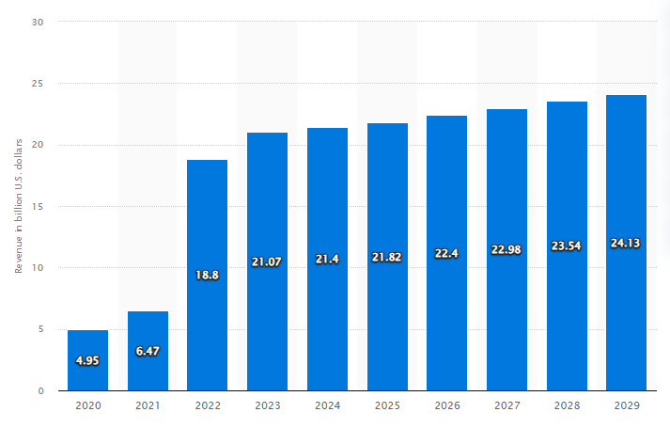
Figure 3: Revenue of the hotel industry in the UK from the year 2020 to 2029
Source: (Statista, 2024)
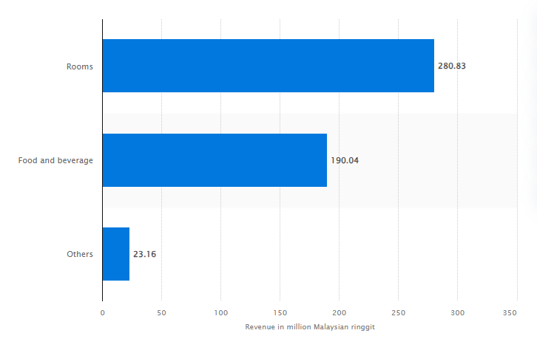
Figure 4: Hotels and resorts segment revenue of Shangri-La Hotels (Malaysia)
Source: (Statista, 2020)
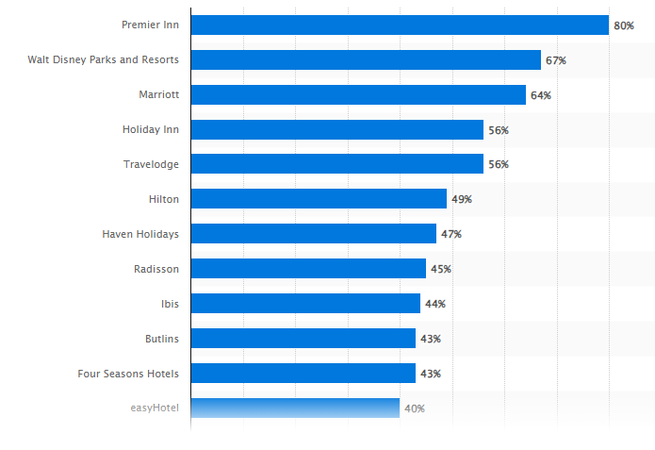
Figure 5: Most popular hotel brands among millennials in the UK
Source: (Statista, 2022)

Growth Expansion
Expansion Strategies Shangri-La has quite a strong emphasis on growth throughout the Asia-Pacific, or, more specifically, China, Southeast Asia, and the Middle East given the increasing popularity of luxury travel in those regions (Holzmayer and Schmidt, 2020). The brand focuses on early door-opening in strategic business and tourist cities and other attractive locations to lure many high-end customers. Also, increasingly with sustainability being incorporated into development plans, Shangri-La is effectively targeting high-end travelers' sustainability conscience (Eliakim et al., 2020). Market Opportunities include Middle-income markets, particularly in India and South East Asia have a great potential for growth, and luxury tourists are likely to increase with the improvement in their disposable income (Kee et al., 2020). Moreover, with the emerging world trends for wellness and ecotourism, there exist opportunities for Shangri-La to expand its service offering and appeal to a segment of the high-end market. In considering the barriers, which can be in terms of political instabilities in some parts of the world affecting its revenues concerning its operations in the Middle East as well as competition from other subsector luxury brands (Kusa et al., 2023). In addition, such as the effects of economic downturns and instabilities in the currency markets may affect expansion strategies (Dimitropoulos and Scafarto, 2021).
Subsequently, expansion strategies in the context of Premier Inn have a goal of enhancing its market position in the UK by expanding through the number of hotels and upgrading the present ones. Internationally, the brand needs expansion to Europe, especially the Germany area because business travel is increasing, and more people want cheap products. Market Opportunities operand of cheap travel accelerates Premier Inn with regards to growth possibility (Dorfleitner et al., 2019). Moreover, the expansion of the regional market across Europe particularly due to the need for value accommodation can strengthen its position as an international chain (Ann and Blum, 2020). Moreover, the prospect of resuming and recovering in traveling also gives novel development opportunities. Moreover, the barriers it creates with recognized low-cost hotel companies such as Travelodge and exposed to economic risks from inflation and changes in consumer expenditure (Díaz-Carrión et al., 2020). However, shifts in the consumption pattern can be noticed post-COVID-19 pandemic, a decrease in business travel which can affect the growth in specific areas.

Financial Commitment to CSR
In regard, to Shangri-La Hotels CSR and sustainability form an integral part of the operations of Shangri-La as a hotel chain (Alexakis and Jiang, 2019). Furthermore, this entail making positive changes in the local community and sanctuary whereby the hotel chain gets involved in specific activities of conservation of biodiversity. Subsequently, investment in energy-efficient technologies and carrying out sustainable strategies like cutting down on carbon emissions and wastes are clear long-term financial commitments to CSR (Babajee et al., 2022). On contradictory, bribery and corrupt practices are prohibited, and the group works with suppliers with high ethical standards (Anning-Dorson and Nyamekye, 2020). Thus, helping in reducing corporate environmental impact is not the only advantage that Shangri-La reaps, but also the positive change in the perception of their brand among luxury travelers who consider environmental issues important.
Premier Inn Hotels UK-based Premier Inn is already reckoned for its excellent standards in sustainability and CSR policies (Alexakis and Jiang, 2019). Premier Inn is a part of Whitbread Plc, which declares that the company will achieve net-zero carbon emissions within 2040. Moreover, it engages in all sorts of commonality, employment opportunity support, and charity partners and affiliations. Additionally, all these CSR activities are in line with the growing customer demands and help in the long-term cost management while improving the business efficiency for Premier Inn translating into a competitive advantage in the budget hospitality niche.

Recommendations
- Shangri-La should potentially look to increase its revenue streams by adding wellness and sustainability to its services. Given the increase of environmental conservation awareness worldwide and the focus on luxury wellness resort vacations that have sprouted across the world.
- The findings shows that wellness of the tourism industry is specifically rising with an appreciated rate of 7.5% every year, with the extra focus on sustainable development, it will be an opportunity for Shangri-La to capitalize on its revenue growth.
- Premier Inn needs to improve its digital platforms for bookings and offer business travel accommodation packages. With consumers becoming more cost-savvy and millennials more inclined to go with digital solutions they are likely to target, the company can improve on mobile and online ordering.
- Further appealing to a key growth segment, enhancing offers adapted for the business traveler such as check-in, meeting room, access to the business center flexible check-in check-out and loyalty cards would maintain added value.

Conclusion
This report was based on a comparative analysis of the two main hotels namely Shangri-La and Premier Inn in the hospitality industry context. Significantly, the evaluation shows that there are distinct dissimilarities between the two organizations regarding overall revenue, market segment, development prospects, and CSR passion. However, the outcomes show that Shangri-La aims at luxurious and worldwide hotel Chains while on the other hand, Premier Inn carries modest and local hotel chains. Moreover, the financial strategies applied refer correspond to achieve competitiveness advantages in the hospitality sector. Subsequently, the findings demonstrate that both hotels can improve their financial results by expanding the range of services and using the opportunities offered by digitalization.

References
Alexakis, G. and Jiang, L., 2019. Industry competencies and the optimal hospitality management curriculum: An empirical study. Journal of Hospitality & Tourism Education, 31(4), pp.210-220.
Ann, S. and Blum, S.C., 2020. Motivating senior employees in the hospitality industry. International Journal of Contemporary Hospitality Management, 32(1), pp.324-346.
Anning-Dorson, T. and Nyamekye, M.B., 2020. Be flexible: turning innovativeness into a competitive advantage in hospitality firms. International Journal of Contemporary Hospitality Management, 32(2), pp.605-624.
Annual Report, 2023. Online available at https://sitecore-cd.shangri-la.com/-/media/Project/Shangri-La-Group/Investor/Files/Public-Disclosures/Latest-Top-Publications/2023_Annual_Report_E.pdf [accessed on 16th October 2024].
Babajee, R.B., Seetanah, B., Nunkoo, R. and Gopy-Ramdhany, N., 2022. Corporate social responsibility and hotel financial performance. Journal of Hospitality Marketing & Management, 31(2), pp.226-246.
Díaz-Carrión, R., Navajas-Romero, V. and Casas-Rosal, J.C., 2020. Comparing working conditions and job satisfaction in hospitality workers across Europe. International Journal of Hospitality Management, 90, p.102631.
Dimitropoulos, P. and Scafarto, V., 2021. The impact of UEFA financial fair play on player expenditures, sporting success, and financial performance: Evidence from the Italian top league. European Sport Management Quarterly, 21(1), pp.20-38.
Dorfleitner, G., Rößle, F. and Lesser, K., 2019. The financial performance of the most valuable brands: A global empirical investigation. Heliyon, 5(4).
Eliakim, E., Morgulev, E., Lidor, R. and Meckel, Y., 2020. Estimation of injury costs: financial damage of English Premier League teams’ underachievement due to injuries. BMJ Open Sport & Exercise Medicine, 6(1), p.e000675.
Franco, S., Caroli, M.G., Cappa, F. and Del Chiappa, G., 2020. Are you good enough? CSR, quality management and corporate financial performance in the hospitality industry. International Journal of Hospitality Management, 88, p.102395.
Gordon, S., 2020. Organizational support versus supervisor support: The impact on hospitality managers’ psychological contract and work engagement. International Journal of Hospitality Management, 87, p.102374.
Hamzah, S.R., Azhar, A.S., Ishak, N. and Raseedee, A.F.N., 2022, August. Stock return volatility during SARS and COVID-19: Comparison between Malaysia and China's stock markets. In AIP Conference Proceedings (Vol. 2472, No. 1). AIP Publishing.
Hayes, D.K., Hayes, J.D. and Hayes, P.A., 2021. Revenue management for the hospitality industry. John Wiley & Sons.
Holzmayer, F. and Schmidt, S.L., 2020. Financial performance and corporate diversification strategies in professional football–evidence from the English Premier League. Sport, business, and management: An international journal, 10(3), pp.291-315.
Kee, D.M.H., Ang, Z.L., Woh, M.T., Soleimani, M., Jayant, J., Quttainah, M.A. and Pandey, R., 2020. Shangri-La Hotels and Resorts’ People and Culture Strategy in Deriving Employee Satisfaction. Advances in Global Economics and Business Journal, 1(1), pp.1-11.
Kusa, R., Suder, M. and Duda, J., 2023. Impact of greening on performance in the hospitality industry: The moderating effect of flexibility and inter-organizational cooperation. Technological Forecasting and Social Change, 190, p.122423.
London Stock Exchange. Online available at https://www.londonstockexchange.com/ [accessed on 16th October 2024].
Malagila, J.K., Zalata, A.M., Ntim, C.G. and Elamer, A.A., 2021. Corporate governance and performance in sports organizations: The case of UK premier leagues. International Journal of Finance & Economics, 26(2), pp.2517-2537.
Martín-Rios, C. and Ciobanu, T., 2019. Hospitality innovation strategies: An analysis of success factors and challenges. Tourism management, 70, pp.218-229.
Meira, J.V.D.S. and Hancer, M., 2021. Using the social exchange theory to explore the employee-organization relationship in the hospitality industry. International Journal of Contemporary Hospitality Management, 33(2), pp.670-692.
Omondi-Ochieng, P., 2019. Financial performance trends of United States Hockey Inc: a resource-dependency approach. Journal of Economics, Finance and Administrative Science, 24(48), pp.327-344.
Panno, A., 2020. Performance measurement and management in small companies of the service sector; evidence from a sample of Italian hotels. Measuring business excellence, 24(2), pp.133-160.
Ritchie, B.W. and Jiang, Y., 2021. Risk, crisis and disaster management in hospitality and tourism: a comparative review. International Journal of Contemporary Hospitality Management, 33(10), pp.3465-3493.
Sakshi, Shashi, Cerchione, R. and Bansal, H., 2020. Measuring the impact of sustainability policy and practices in tourism and hospitality industry. Business Strategy and the Environment, 29(3), pp.1109-1126.
Statista, 2024. Online available at https://www.statista.com/forecasts/515548/revenue-in-the-hotels-market-in-the-united-kingdom [accessed on 16th October 2024].
Tam, S.S., Fong, L.H.N. and Law, R., 2022. Management response to online review: The case of Hong Kong luxury hotels. In Information and Communication Technologies in Tourism 2022: Proceedings of the ENTER 2022 eTourism Conference, January 11–14, 2022 (pp. 123-133). Springer International Publishing.
Uyar, A., Kilic, M., Koseoglu, M.A., Kuzey, C. and Karaman, A.S., 2020. The link among board characteristics, corporate social responsibility performance, and financial performance: Evidence from the hospitality and tourism industry. Tourism Management Perspectives, 35, p.100714.
Wang, C., Hu, R. and Zhang, T.C., 2020. Corporate social responsibility in international hotel chains and its effects on local employees: Scale development and empirical testing in China. International Journal of Hospitality Management, 90, p.102598.
Whitbread UK, 2023. Online available at https://cdn.whitbread.co.uk/media/2023/04/Final-FY23-RNS-Final-Combined.pdf [accessed on 16th October 2024].

