Health and Social Care Career Portfolio
Chosen Job Vacancy (HCA)
Job Title: Healthcare Assistant (HCA)
Sector: NHS / Residential Care
Reason for Choice: This role aligns with my career goal of becoming a healthcare assistant and allows me to develop hands-on patient care experience.
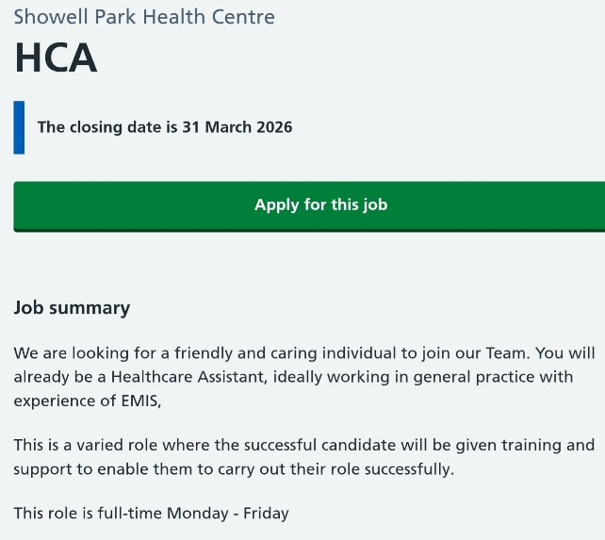
Task 1: Curriculum Vitae (CV)
Shellymae Mulcare
Flat 30 Ash House, Hailes park close, Wolverhampton, WV4 6EQ.
Phone: 07445145046
Email: maeshelly87@outlook.com
Personal Profile
A motivated and compassionate individual aspiring to build a career in health and social care. I possess strong communication skills, empathy, and a commitment to delivering person-centred care. I am seeking a Healthcare Assistant role to develop practical experience and contribute positively to patient wellbeing.
Education
[University of Wales] — [2024- ongoing]
Level 3 Health and Social Care
Key modules: Communication in Care, Safeguarding, Human Development
GCSEs: Walsall college
English: functional skills level 2
Maths: none taken
Science: none taken
Work Experience

Junior school volunteer — Bluecoat Junior School
[2010~2011]
Assisting with children in lessons and in the playground at break and lunch times.
Residential Care Assistant — [2011-2013]
Delivered personal care services, appointments, laundry, shopping and medication administration.
Developed teamwork and communication skills
Key Skills
- Communication and active listening
- Empathy and emotional intelligences
- Teamwork and collaboration
- Time management and organisation
- Understanding of safeguarding procedures

Achievements
- Completed First Aid Training
- Certificate in Safeguarding Awareness

Interests and Hobbies
- Volunteering in community settings
- Fitness and wellbeing
- Reading about healthcare practices
- References available upon request.

Task 2: Personal Statement
I am applying for the Healthcare Assistant role as it represents an important step toward achieving my long-term ambition of becoming a registered nurse. I am passionate about supporting individuals in maintaining their health, dignity, and independence, and I am committed to delivering high-quality, person-centred care.
My academic background in Health and Social Care has provided me with a strong theoretical understanding of key concepts such as communication, safeguarding, and equality. Effective communication is widely recognised as a fundamental component of quality care, enabling professionals to build trust and understand patient needs. Through my studies, I have developed both verbal and non-verbal communication skills, which I apply when interacting with others in a respectful and empathetic manner.
In addition to my education, I have gained valuable practical experience through volunteering in a care home setting. This experience allowed me to support residents with daily activities and observe how care professionals promote dignity and respect. I learned the importance of person-centred care, which involves tailoring support to meet individual needs and preferences. This experience strengthened my ability to remain patient, compassionate, and attentive in challenging situations.
My personal strengths include empathy, resilience, and strong interpersonal skills. Emotional intelligence plays a key role in healthcare, as it enables professionals to recognise and respond to the emotions of others effectively. I am able to remain calm under pressure and adapt to different situations, ensuring that individuals feel supported and valued.
I also possess strong teamwork skills, which are essential in healthcare environments. Collaborative working improves patient outcomes and enhances service quality. Through both my academic work and employment experience, I have learned how to contribute positively within a team, communicate clearly, and support colleagues.
I believe I would be a valuable asset to an employer because of my dedication, willingness to learn, and genuine passion for helping others. I am committed to continuous professional development and understand the importance of maintaining high standards of care. This role will allow me to further develop my skills and gain the experience necessary to progress within the health and social care sector.

SWOT Analysis
Strengths
Strong communication skills
Empathy and compassion
Basic knowledge of healthcare practices
Teamwork abilities
Weaknesses
Limited professional experience
Lack of advanced clinical skills
Confidence in unfamiliar environments
Opportunities
Training and development programmes
Career progression into nursing
Gaining hands-on experience
Threats
High competition for roles
Emotional demands of the job
Workplace stress and burnout

Task 3b: Personal Development Plan (PDP)

Goal 1: Improve Clinical Skills
Action: Attend training (e.g., first aid, manual handling)
Timeline: Within 12 months
Monitoring: Certificates and supervisor feedback

Goal 2: Enhance Communication Skills
Action: Practice active listening and attend workshops
Timeline: Ongoing over 2 years
Monitoring: Feedback from colleagues and reflective practice

Goal 3: Gain Employment in Healthcare
Action: Apply for HCA roles and volunteer regularly
Timeline: Within 6–12 months
Monitoring: Job applications and interview feedback
Evaluation
Progress will be reviewed every 6 months using reflective practice and feedback from supervisors. Reflective learning is essential for continuous improvement.

Task 4: Gibbs Reflective Cycle
This reflection is based on my LCHS4009 Component 1 presentation, which focused on communication in health and social care and explored its importance in delivering effective patient care. The presentation aimed to demonstrate my understanding of communication theories and their application in professional practice.
Feelings
Initially, I felt nervous about presenting in front of my tutor, as I lack confidence in public speaking. I often experience anxiety when speaking in formal settings, particularly when I know I am being assessed. However, alongside this nervousness, I also felt a sense of preparedness due to the research I had conducted prior to the presentation. I had spent time understanding key communication theories and ensuring my content was relevant and accurate. During the presentation, my nervousness increased, particularly because I struggle to maintain consistent eye contact with my audience. I also noticed that I tend to stutter when speaking aloud, which made me feel self-conscious and affected my confidence further. Despite these challenges, I remained focused on completing the presentation to the best of my ability.
Evaluation
One positive aspect of my presentation was the quality of the content I delivered. I used clear information and included relevant examples to support my points, which helped demonstrate my understanding of communication in health and social care. My lecturer also noted that my content reflected a good understanding of communication theories, which was encouraging. This suggests that my preparation and research were effective. However, there were also areas for improvement. Feedback highlighted that I needed to improve my eye contact with the audience and reduce my reliance on notes. I found myself looking away frequently, which limited my engagement with the audience and made my delivery appear less confident. This negatively impacted the overall effectiveness of my presentation.
Analysis
Effective communication is a crucial skill in both academic presentations and professional healthcare practice. In healthcare settings, clear communication ensures that patients feel understood, respected, and supported, which can directly impact the quality of care they receive. Similarly, in presentations, communication skills influence how well information is conveyed and understood by the audience. My reliance on notes may have reduced my ability to engage effectively with my audience, as it limited my use of non-verbal communication. Research into presentation skills highlights that non-verbal communication, such as maintaining eye contact, using facial expressions, and adopting confident body language, plays a significant role in audience engagement and understanding. My difficulty with eye contact may stem from a lack of confidence, which in turn affects my delivery. Additionally, my tendency to stutter when nervous suggests that I need to develop strategies to manage anxiety and improve fluency when speaking. This analysis shows that while my theoretical knowledge is strong, my communication delivery skills require further development.
Conclusion
Overall, the presentation was a valuable learning experience that allowed me to identify both strengths and areas for improvement. I demonstrated strong knowledge and understanding of communication in health and social care, which is essential for my future career. However, I also recognised that my presentation skills, particularly my confidence, eye contact, and reliance on notes, need to be improved. Developing these skills is important not only for academic success but also for effective professional practice in healthcare settings, where communication is a key component of patient care.
Action Plan
To improve my presentation and communication skills, I will take several practical steps. Firstly, I will practise presentations regularly to become more familiar and comfortable with speaking in front of others. Repetition will help build confidence and reduce anxiety. Secondly, I will record myself during practice sessions to evaluate my performance, focusing on areas such as eye contact, body language, and speech clarity. This will allow me to identify specific areas for improvement. Thirdly, I will seek feedback from peers and lecturers to gain different perspectives on my performance and receive constructive suggestions. Finally, I will work on building my confidence through continued experience and by gradually exposing myself to more speaking opportunities. Reflective practice will remain an important tool in my development, as it allows me to continuously evaluate and improve my performance over time.

Reference List
https://www.jobs.nhs.uk/candidate/jobadvert/A2805-26-0001?searchFormType=main&keyword=Health%20and%20social%20care%20support%20worker&location=Wolverhampton&language=en&page=2 [accessed 27.03.2026].
Gibbs, G. (1988) Learning by Doing: A Guide to Teaching and Learning Methods. Oxford: Further Education Unit, Oxford Polytechnic.

