
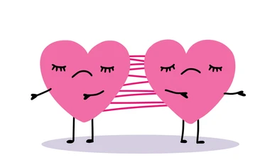

To what extent is co-dependency
influenced by trauma?

Lucy-Jo Evans (230573) BA MUSICAL THEATRE

CONTENTS PAGE:
* Research & Investigation * - Section 1:
* Introduction_________________________________________________Page 3
* Proposal____________________________________________________ Page 4
* Literary Review_______________________________________________Page 4-9
* Creation & Development * - Section 2:
* Initial Ideas & Storylines______________________________________ Page 9-10
* Character Work & Development______________________________ Page 11-12
* Musical Influences__________________________________________Page 12
* Script Work & Development_________________________________ Page 13-15
* Practical Development* - Section 3:
* Scheduling & Organisation_________________________________ Page 16-17
* Design Composition_______________________________________ Page 18-20
* Rehearsal Process________________________________________Page 21-22
* Performance _____________________________________________ Page 22
* Summary & Academic Contributions * - Section 4:
* Summary________________________________________________ Page 23
* Evidence & Materials___________________________________ Page 231
* Reference List___________________________________________ Page 24-25
* Bibliography/Reading List________________________________ Page 25

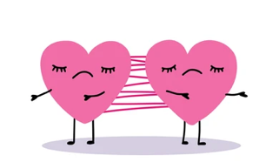

Research & Investigation - Section 1:
Introduction
Throughout my project, titled ‘The Chain’ I intend to explore and answer the question, ‘To what extent is cod-dependency influenced by trauma? This will be achieved through extensive research and development, followed by a performance piece, representing the research and analysis that I intend to collect to support my theory. This will be a piece of theatre, incorporating music, script, and movement, which will highlight all the skills that I have accumulated throughout my degree. My piece centred around my question explores the reality of what life can be like for someone struggling with PTSD, outlining how common it is for people to be suffering, and how it can go unnoticed by those around them. It explores themes of Trauma, co-dependency and hard truths for those who struggle in silence.
We see this story explored though the perspective of a girl who’s struggling with co-dependency as a result of childhood trauma, this eventually becomes her doom as she is faced with the reality of her struggles, realising she has rooted fears connected to her childhood and upbringing, and it isn’t until the end she realises that’s she’s been projecting her own problems on to her partner. Her thoughts and impulses are portrayed by ‘The voice. The completely true, but more vocally aggressive side of her that she has always tried to suppress. The boy in my piece serves as an alternative observation, a different point of view, highlighting how to spot signs of co-dependency, but also showing how it is hard to spot the difference between someone who is being intimate, and those who have deeper rooted issues enabling them to inhabit that behaviour.
Being able to research a theme as harsh and graphic as this, has really influenced my outlook on life, as having observed behaviour such as this, within my connection of people throughout my life, it has encouraged me to explore and educate myself and those around me about the influence that trauma can have on adulthood. My aim for this project is to leave an audience feeling both empathetic and conflicted. Not in a way that creates a negative energy within the space, but is rather more educational and eye opening to viewers, as for me, the exploration of this topic has deepened my knowledge and understating of what it’s like to experience trauma, and whilst I can’t put myself in a situation where I’ve experienced something this graphic first hand, I feel as though I am now more knowledgeable and appreciative of the struggles that the majority of people may go through in life. This is the same feeling I intend to leave my audience with, as believe it is important for us all to acknowledge the unseen battles others may face, and to carry that awareness into how we treat and understand one another.

Proposal
My piece, entitled ‘The Chain’, will explore the influence trauma can have on co-dependency. However, this is not with the aim to receive a definite answer or solution to this question, but rather an exploration and rooted understanding of these elements, and the potential outcomes that follow when these two subjects are crossed and linked. The context of this piece will be a heart wrenching romance, exploring themes of trauma, co-dependency, and love all of which will test the sustainability of the main couple's relationship, through challenging the mind of a trauma induced codependent, and their partner. Set in Modern day, my target audience for this piece is aimed towards young adults and onward. This is because the themes present within this piece will affect and educate anyone who is experiencing, having experienced, or even yet to experience the dynamics of a relationship, whether they resonate, disregard, or observe this piece of theatre, I intend to design my concept to leave an audience feeling something different, no matter what that feeling is. A mature audience is also a sensible target audience given its complex and potentially triggering themes of trauma and co-dependency within the piece.
What resonated most with me when choosing this topic, was the lack of knowledge and understanding that I had of these themes. Not only this, but the lack of awareness that is recognised online or within my community. What sparked my interest into this topic was, observing the relationship dynamic between my parents, noticing how one would always say ‘you wouldn’t get anything down without me’ or ‘you couldn’t live on your own’. These quotes stuck out to me as my first thoughts were negative, assuming the worst, however, this was not always the case. Learning that there is a drastic switch between having responsibilities and duties within a relationship, and those who simply build their livelihood around the relationship they share with their significant other has affected my outlook on life, and I intended to hopefully, shed light on this topic to others.

Literary Review
Trauma, Emotional Intimacy, and support are desirable traits within most relationships, as it allows a sense of connection, deepness, and trust, which can be nurtured within a relationship. It can also create a safe space between couples to share and receive, thoughts, feelings, and experiences. According to Beverly Engel, a therapist who specialises in relationship issues, it is known that emotional intimacy can also stretch to having a mutual understanding of each other’s wants and desires, building connections to reveal your true self. (Engel, 2023) Research by scientists working with Science Direct, shows that individuals with complex trauma often struggle with forming and maintaining intimate relationships, due to symptoms such as emotional dysregulation, dissociation, or fear of abandonment. (Dorahy, 2012) Co-dependency, however, is a pattern of behaviour where one may come reliant on another person, often pushing their own boundaries, and sacrificing their needs for others, stemming from a range of different reasons. For my project and focus more specifically, those that are trauma-based incidents, fears, or insecurities that one person may carry. Childhood abuse, for example, has been shown to disrupt healthy emotional development and interfere with relationship satisfaction in adulthood according to an article produced by Sage Journals. (Finzi-Dottan, 2023) Whilst trauma can vary for person to person, it is suggested by the vast majority of healthcare professionals and mental health specialists across the UK and beyond, that trauma from a young age can consciously or even uncontrollably effect and influence adulthood. In relation to my piece, my research is intended to explore the depths of emotional intimacy and its coexistence with co-dependency. Also looking into whether they can coincide with each other, exploring to what extent co-dependency is influenced by trauma, as per my question.
When creating and developing my main character, I wanted to embed these outlooks and observations of the human mind, exploring how trauma can have a long-term effect on one’s ability to function normally, and the contributions it can have to someone’s mental health state. As published by The Centre for Addiction and Mental Health (CAMH), Trauma is an emotional response that can extend to prolonged periods of times resulting from experiencing or living through a distressing event. (CAHM, N/A) Whilst this validates my question that trauma can influence and have an impact adulthood, I still wish to explore what effects trauma from an early age can influence romantic relationships specifically, post-trauma. Additionally, a study by Hogan (2019) found that childhood emotional abuse is positively correlated with insecure attachment styles—both anxious and avoidant—and negatively correlated with relationship satisfaction, highlighting the enduring impact of early trauma on adult romantic relationships. (Hogan, 2019) I investigated signs of trauma that can be recognisable in adulthood, and I also investigated the consequences associated with different trauma enhanced events arisen from an early age, looking into these common traits found in those who suffer long term from trauma associated with their youth.
Firstly, I investigated different forms of childhood trauma which could commonly lead to struggles within a relationship later down the line. When exploring themes such as abuse, neglect, natural disasters, violence, or any event leading to fear, helplessness or a sense of being overwhelmed, I was focused on establishing the importance of each event and understanding how they are all different and can affect the way a story is told greatly. Whilst all themes can be linked to the broad term ‘Co-dependency’ it is important to understand that anyone who has experienced trauma in some form or another, will have a different level of response and severity to the situation. And whilst it is possible to collect data and create an average outcome for someone suffering from some form of trauma, it is still impossible to confirm that certain forms of trauma are responsible for the actions both conscious and subconscious, that someone may experience or embody moving forward. The seminal Adverse Childhood Experiences (ACE) Study by Felitti et al IN 1998, explores the wide-ranging impact of different childhood traumas, emphasizing that individual responses vary greatly and that the long-term effects can influence emotional health and interpersonal relationships. This understanding has broadened my perspective of the characters I am writing for my piece, allowing me to put myself into the shoes of someone burdened by trauma. (Felitti, 1998) Furthermore, a page written by journalist Hilary L. Lebow and reviewed medically by Clinical Phycologist Dr. Lori Lawrenz, goes into the depths and layers of childhood trauma, touching upon co-dependency and its effects on adult relationships. What I found fascinating about this article was the take on the perception of trauma, and how a situation which may feel traumatic for one, would not necessarily gain the same response from someone else. (Lebow, 2021) This for me was quite an eye-opening take on trauma, as it has broadened my perspective of the characters I am writing for my piece, allowing me to put myself into the shoes of someone who is a burdened by a trauma carrier.
On the contrary, explored some of the ways that trauma can create and influence a co-dependent state. It is clear to note, that any form of trauma can lead to a relationship that becomes co-dependent. This is information that I retrieved from Bright Quest, a Residential Treatment centre for adults with complex psychiatric disorders. A subsection of their article, attacking the questions trauma and co-dependency talks about how many who have experienced or lived through damaged relationships can develop a need for co-dependency. (Ellis, 2024) This inspired me as I was intrigued to see how, flawed attachments throughout childhood, can create a feeling of uncertainty in adulthood, especially if an incident related to the lack of attachment to a parent, or having to live with one parent causes one to be used to the notion of their loved ones leaving. This, as brushed upon earlier on, is a common ‘symptom’ of a co-dependent, as this can feed a need to overcompensate and attend to their partners to prevent them from leaving. It is a common phenomenon for a female co-dependent for example, who has maybe had a flawed relationship with their father, to transfer those feelings and experiences onto a male partner. This can also translate to the understanding that trauma can influence stereotypes and those who may have suffered with a traumatic event, can then only associate all similar situations to their experiences. I think this is a focal point in my research as I believe that exploring this effect of trauma can help to educate and explore within my piece the effects and influences trauma can have.
Linking back to the article from Bright Quest, they also state that an individual’s effect of trauma can rub off onto a partner or loved one, as the effect can ripple and cause secondary trauma which causes a receiving individual to experience some of those fears later down the line, or develop issues due to an unhealthy attachment to someone who is severely struggling with co-dependency as a result of trauma. Again, I am fascinated by this, as I believe it’s important to focus and explore the effects of trauma not just on the victim but also those around them and the effects it has. This aligns with Beattie’s foundational work on co-dependency, which emphasizes how early trauma and dysfunctional family attachments contribute to co-dependent behaviours and unhealthy relationship patterns. (Beattie, 2010) Additionally supporting this, a study by Cermak in 1986, delves into the psychological foundations of co-dependency, highlighting how early childhood trauma and dysfunctional family environments often underlie co-dependent behaviours. Cermak emphasizes that co-dependency can manifest as an excessive emotional reliance on others for approval and identity, often stemming from unresolved trauma, and notes the secondary impact on relationships when trauma is unaddressed, supporting the ripple effect described by Bright Quest. (Cermak, 1986)

When creating the two characters for my piece, I wanted to give them each standout personalities and traits, allowing an audience to understand their dynamic within a romantic relationship. It’s important to me that the female within my piece was the trauma carrier, and the one who was codependent. This meant that many other habits or traits found in co-dependents can be explored from a viewpoint where it’s stereotyped for women to take on roles such as providing for a man or being attentive to them so they can ‘provide for your family’. I intend to broad stroke this topic of gender stereotypes within relationships as I feel it would take away from the premise of my piece, however by taking this factor into consideration means I can ensure that I fully understand different forms of co-dependency and the different signs and habits to look out for.
There are many archetypes found within both old and modern-day literature, culture, and the tv/film world, this often pushes stereotypes and can often educate the masses incorrectly. It is extremely common in older movies, plays etc… to carry out gender stereotypes, where women are labelled to be caregivers, doing housework or providing a selfless service to others. According to an article written by PH. D Shawn M. burn, it is common for women who follow this stereotype to sub consciously form devotion to another partner, and go overboard when taking care of others, often unable to understand or tell the difference between being emotionally available and overcompensating to ensure they are meeting the needs of their significant other. However, this study also explores statistics which show that Men are more likely to be a co-dependent in a relationship, which from an academic viewpoint is interesting as it allows for a whole different approach to the outlook oft piece. (PH.D, N/A)And whilst this would not have a huge effect on the premise of my question, it is still interesting to explore common misunderstands in society and delve into the different stereo types found within both men and woman within intimate relationships. This aligns with research by Robin Norwood, who in her book Women Who Love Too Much explores how traditional gender roles often pressure women into caretaking roles that can fuel co-dependent behaviours, while also highlighting that co-dependency transcends gender and affects men as well, offering a more nuanced understanding of co-dependency dynamics in romantic relationships. (Norwood, 1985)
Furthermore, another interesting to note about this, is that there are a vast variety of different dynamics and dynamics experiences for couples who are involved in co-dependent relationships, this includes having a singular co-dependent, or even couples who are reliant on each other. What I found most intriguing is that whilst it’s common that you can have two co depends within a relationship, or just one or even none, it’s interesting to note, that whilst one partner may harbour many signs of co-dependency, it’s common for the receiver to absorb these habits and tendencies. Independents within a co-dependent relationship may, overtime start to become reliant and used to the attention and commitment that their codependent partner is giving them, this can easily become unhealthy and unbalanced, as whilst it’s never in someone’s original motives to act this way, it is common for a codependent receiver to become overwhelmed and controlled. This then manifests into outbursts and a lack of independence in life. This is what creates a conflict within codependent relationships as you often have one trying to please and protect the security of a relationship and the other who is carrying the burden and unlocking ‘ugly’ traits which only occur because of stress and overbearing. However, according to Helpguide.org it’s highly likely that signs of co-dependency can go unnoticed, as often the behavioural traits associated with co-dependency can be mistaken for intimacy and excessive attachments to your partner. Whilst there are many articles highlighting, they key signs of co-dependency it’s important to note that it’s not always easy to spot, and what I find interesting is that within a codependent and independent relationship, it often goes unnoticed when someone is struggling, unless it reaches an extreme state. (Reid & , 2025)
On the contrary, I wanted to investigate how far someone can survive within a codependent relationship before it reaches its breaking point, I wanted to explore this from the perspective of both a codependent and independent. This would be a huge contributing factor to my piece as I intend to delve into the downfall of a codependent relationship and explore its journey and conclusion. Anna Runkle, an author who shares her experiences and leads a movement to help people worldwide recover from trauma symptoms, states that codependents are more likely to want to take care and assume a dominating role where they can become the ‘fixer’ allowing them to throw their energy into another person. (Runkle, N/A) To me, this suggests that a lot of behavioural traits found in codependents, stem from the fact that they are forcing themselves to inherit a role within a relationship where they are the caregiver, looking after and constantly protecting their partner, often making themselves feel powerful and in control, however, it’s not all cases where the co-dependent is fighting to find fault in their partner to maintain control by ‘helping them’. According to an article from, Breathe Life Healing Centres, it is common for someone who is ‘dysfunctional’ within a relationship to be showered with kindness from their partner, seen as the ‘enabler as it doesn’t benefit or help their other half to recover and change and other just allows it to happen and encourage bad behaviour. (Centre, N/A)
Contrastingly, to support the idea that there are a variety of different forms of co-dependency, Author, Anna Runkle says in her book Re-Regulated, that it’s common for a codependent whose issues have resulted from a trauma infused incident, to have a lack of ability to create natural connections, leaving them feeling estranged. This can often lead to the codependent feeling the need to seek validation and overcompensate creating and maintaining relationships as they believe it shields them from the fear of being alone/unwanted. (Runkle, 2024) I found this very intriguing as I am wowed by the notion that those who fear most about loneliness, seek out relationships the most, but often sabotaging themselves, and making things worse. The sad irony that comes with these actions, for me, outlines some of the sad truths that are associated with the term ‘co-dependency’ and considering how lots of people who struggle with co-dependency are often outlined and shaped to be a villain or a bad person, and some of the deep truths found within their motives can lead to guilt and sympathy from n observer.
On the contrary to this, being a receiver within a relationship with a codependent, it can be difficult to spot that someone is struggling or ever overcompensating, however this lack of acknowledgment can feed a sense of delusion for codependent as often it’s hard for them to establish the state of the ‘receiver’ in the relationship. From what I have gathered, as a co-dependent you are caught up in the needs of others and your fears, not allowing you time to focus on your own wellbeing. This can create a rut within a relationship, and this can be the start of a long cycle, where a codependent is overworking to provide and protect their relationship. Within my piece I intend to explore the dynamic of someone, the codependent, who is constantly overthinking and overstimulated, fighting and working to protect something that did not need protecting in the first place. Exploring how fears can take over your emotions and the effect it has on the long run, focusing on the effects of self-sabotage, and eventual downfalls and consequences associates with being codependent. Janet G. Woititz explores the long-lasting effects of growing up in dysfunctional families, highlighting how such early experiences contribute to patterns of codependent behaviours. (Woititz, 1989) I also want to brush upon the effects that trauma can have and the influence it provides to someone who has fallen deep into a codependent state. Furthermore, I want to explore the alternative perspective of someone within the relationship who is a receiver of this behaviour. Pia Mellody describes, how trauma disrupts healthy emotional boundaries and fuels cycles of anxiety and self-sacrifice, which are common in codependent relationships. (Mellody, 1989)
Furthermore, I wish to explore a situation where it highlights the fears and supports of a codependent, and how the ‘receiver’ isn’t always enabling this behaviour. I think it is important to explore this perspective as despite my research delving into the notion that co-dependents feed of those with their own issues, but to rather highlight the symptoms and pressures that they, the codependent go through, showing that it is possible to have a functional/dysfunctional relationship. To truly portray this idea, I intend to link back to all the research I have explored and analysed, using this to decide how I want to structure and end the piece, taking all the different perspectives and outcomes of the struggles of codependents. Within my piece, I want to focus specifically on the effects that a damaged relationship ship/upbringing can have on someone who has experienced this trauma. Exploring the impacts it can have on one’s mental health state, looking into the life of someone recovering from trauma stemmed from childhood. Continuing to educate, I intend to implement the research I’ve accessed in relation to the effects that an individual’s trauma can have on the people around them, and repercussions it can have both on themselves and those around them.

Creation & Development - Section 2:
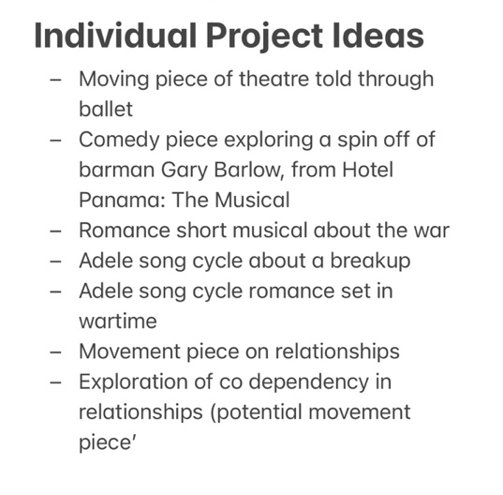
Initial Ideas & Storylines
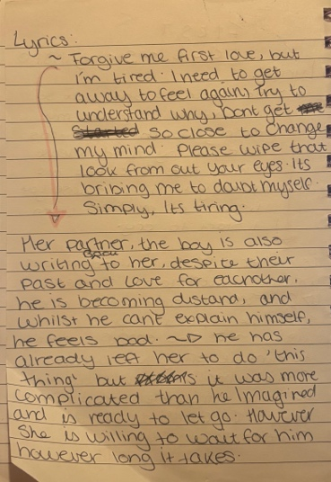
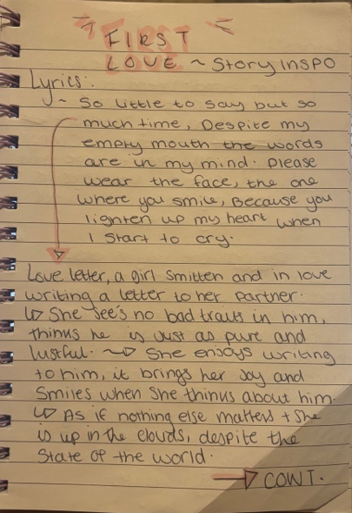
When we were first introduced to this project, we were advised to explore themes, potential topics and areas of interest that we would like to work on for our pieces. As the introduction to this module was amidst our collaborative project, I collated any ideas or sparks of inspiration that had come to me over the Christmas period, this then benefited me when we began working with this module, as I was able to narrow down my choices through trial and error.
Initially, I chose to write an Adele themed jukebox musical exploring themes of love and relationships set in the war, however after exploring and developing a base storyline, I felt that I struggled to find a question to explore key themes related to this idea. However, by exploring some of her music in depth I was able to create narratives and ideas just by doing a stream of consciousness upon first listening to her songs. This was a technique that was picked up and explored through our performance classes and our acting classes and has proved beneficial to me over the years as I often find myself generating and unlocking more ideas through this method. To summarise a book written by Jenifer Moon, whose an academic educator influenced using learning journals, reflective and exploratory techniques such as journaling and free writing, including stream of consciousness, are effective tools for deepening creative understanding and developing personal insight. This aligns with my experience, as these methods allow me to access a more honest and emotionally connected version of my ideas, which has been vital in shaping my creative process. (Moon, 2006)
So, after lots of exploration and discussion with Elen on what themes and questions I could work with, I eventually chose to write a musical theatre piece centred around co-dependency and trauma. I knew that I wanted my piece to explore the struggles within a relationship when these key themes are intertwined, so I began extensive research to explore the full depths of these themes. Once I was educated on the subject, I was then able to begin structing my storyline and piece, something which was much easier than my original idea as I felt that I had enough knowledge to create an in-depth story, also exploring education through theatre. According to Neelands and Dobson, respected figures in drama and theatre education, in their book they encourage the integration of critical reflection, creativity, and research into practice, as it helps students to develop work that is both meaningful and grounded in theoretical understanding. (Needlands, 2008)
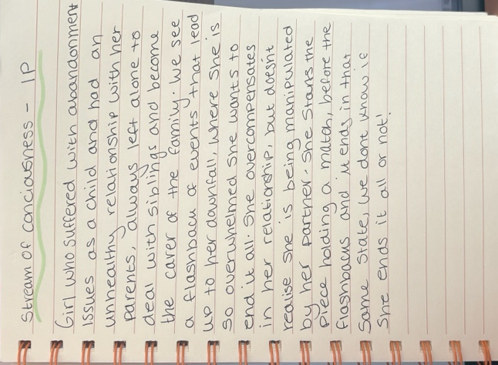
So, following this, I then re-introduced the stream of consciousness exercise to help navigate my storyline. This proved successful as I was able to pick out bits that I liked and keep other parts on the back burner. I liked the idea of the main girl having a traumatic childhood relationship with her parents, so I knew that I wanted to incorporate that as part of her story and using this as the ammunition to fuel her struggles and inevitable struggles in her relationship. To help finalise a storyline structure, I created a story board to better expand and develop my ideas.
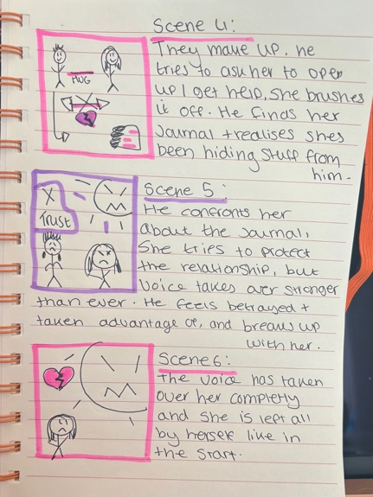
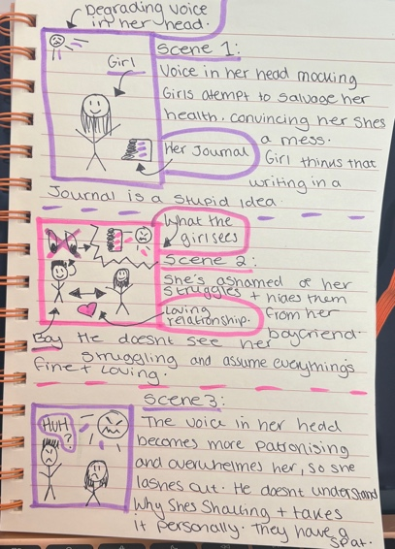
This was beneficial for me as it created an organised structure for me to follow when writing my script. If I were to brainstorm and structure storylines and ideas again, I would take into consideration the educational application of the process. As researched proved key when attacking a topic through theatre, and the more educated I am within a chosen subject, means it will pay off in the final product, as my storyline will have depth and true meaning in relation to my question. As drama educator Dorothy Heathcote suggests, drama is not only a form of expression but also a means of inquiry and learning, where understanding the context enhances both performance and impact. (Heathcote, 1985)

Character Work & Development
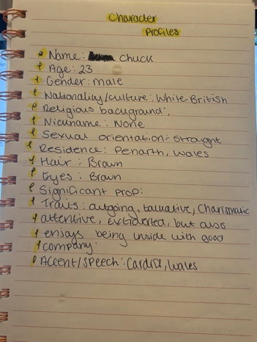
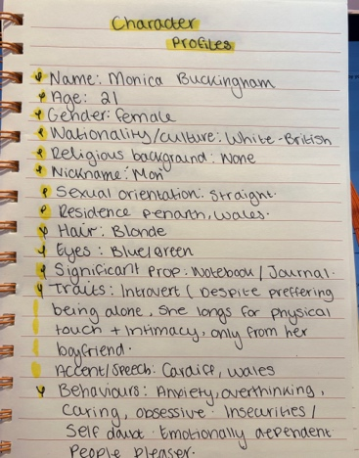
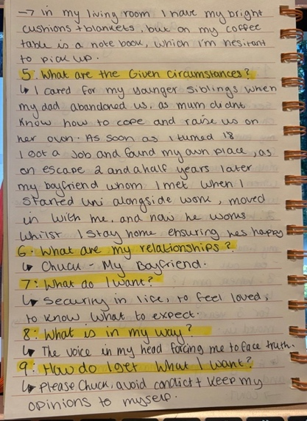
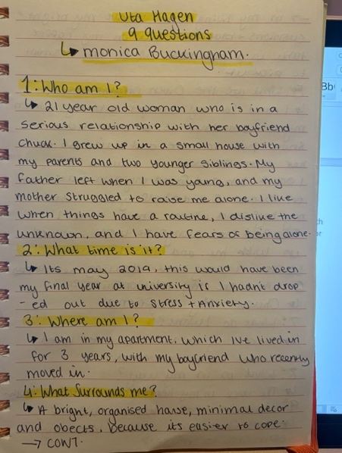
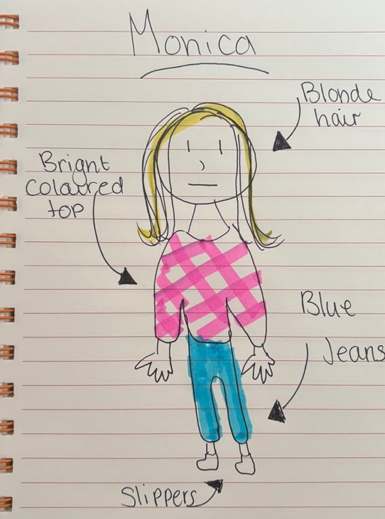
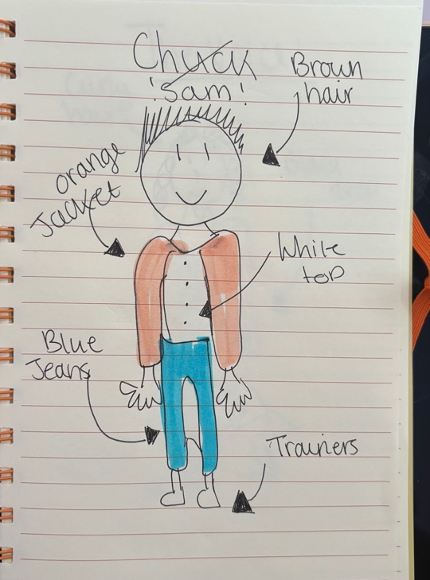
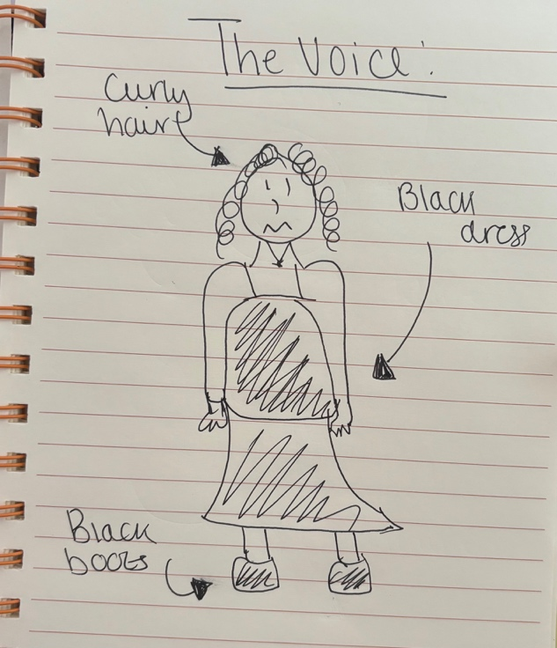
I knew when creating my piece, that I had to take into consideration the availability of students to partake in my piece. I intentionally picked a theme which could be focused on two individuals, as this also reflects on my theme and having an intimate cast meant that the focus would be entirely on their relationship dynamic, ensuring that audience were able to follow their journey from start to finish. When creating the leading male and female ‘Monica’ and ‘Sam’ I took inspiration from some of the techniques that we had explored in acting class, I started by answering a set of questions for both my characters, exploring in detail what they are and how I could form their personalities. From this I was then able to approach a more detailed method called the Uta Hagen 9 questions, or the Uta Hagen technique. Uta Hagen was a German/American actor who refined her techniques to pass onto thriving actors, she was focused on finding the truth on stage and explored how every detail can impact a performance. Uta Hagens 9 questions is a technique designed to make a writer or actor create and develop the most accurate and thoroughly understood characters, exploring all aspects of their personalities and traits. (Windsor, 2024) I found this fascinating and explored this method within my own work, as I felt due to the nature of my piece that it would be beneficial for myself and my actors to explore these questions and apply more depth to my piece. To achieve this, I put myself in the shoes of the main character Monica, which also contributed to my overall development of the piece as I felt I better understood her motives within the piece which helps drive both the story and the narrative as she is a key visualisation of my extensive research.
I didn’t intend on having ‘The Voice’ in my piece, however through exploration of the main girl ‘Monica’, it felt instinctive to explore the depths of her thoughts and emotions through a third-party narrative. This was played by Menna, who was an offstage cast member. I wanted to use ‘The Voice’ as a narrative to combine the journey of the story and bring the audience into the perspective of Monica and her struggles. This made ‘The Voice’ a pivotal part of my piece, as vocalising Monicas thoughts meant that I was able to explore her limits and boundaries, and tying the audience to both perspectives within the relationship. According to Jean Benedetti, a British theatre scholar, director ,author and known for his history theatre and acting techniques, this narrative device helps to “bridge the gap between the internal experience of characters and the external presentation, creating deeper empathy and understanding” This technique proved particularly effective for my piece in exploring the complex mental and emotional struggles of trauma and co-dependency, by giving voice to what might otherwise remain unspoken. (Bendetti, 2015) This came as a challenge as I was unsure whether the concept of her thoughts being brought to life would come across to an audience, however by ensuring that I linked my research on the struggles of a codependent and what it’s like living with trauma, it meant that this would help drive the narrative of the story and allow room for a kick in the storyline raising the stakes.

Musical Influences
Since changing the concept of my piece, I became more open to see what music would fit, knowing I wanted it to be a jukebox piece of theatre. When discussing my concepts and storyline ideas, it was brought to my attention that ‘The chain’ by Fleetwood Mac would fit nicely with the themes and topics that were being explored with my piece. I followed this up with research to explore its potential place in my piece. The song references the breakup between band members Stevie Nicks and Lindsey Buckingham, implying that if they can’t mend the relationship at this stage then they should just stop trying, therefore breaking their chain. (Benitez-Eves, 2023)The lyrics in this song fit perfectly within my ideas, adding onto this, implying that Monica is stuck in her how cycle chain, and that her mental state and issues just keep repeating and looming over her head until she makes a change.
I was intrigued by the relationship between the two, through extensive research into their discography, I came across a whole plethora of songs that were written to each other about their relationship. This inspired me to keep my piece solely focused on the band’s music as the narrative between the band members was something which I fuelled into my narrative. At the end of the piece chose to add Landslide, as suggested by Elen, as it explores and summarises the struggles that Monica went through in her relationship, but also just her life thus far.
In comparison to my original method on the Adele theme, letting the music organically take its place within my narrative rather that creating a story to fit the music, worked to my advantage as I was then able to develop my characters narratives and drive the plots forward through song. This aligns with theories of musical dramaturgy that highlight how existing music can shape and deepen character development and storytelling in jukebox musicals. (Citron, 2010)

Script Work & Development
Throughout this process, my script went through many changes and alterations. In total I had 5 drafts, the fifth being my final version. (See evidence and Materials, section 2, E.) My original draft of the script, (Section 2, A.) explores the relationship dynamic between Monica and ‘The voice.’ As this draft wasn’t a complete script and more of a workshop of how I wanted to play out my ideas, I was able to perceive the relationships present within the scene and figure out what I needed to prioritise in terms of character, plot and overall message development.
The first few drafts were mainly just developments of the storyline, exploring where I can add music, build tension and hold back for tender moments to break away from the tension. To keep track of my developments I colour codes all changes made and marked where things needed to be added or changed, so that when I looked back on my drafts, I was able to work efficiently to reach my final product. Here is an example from my second draft. (Section 2, B.)
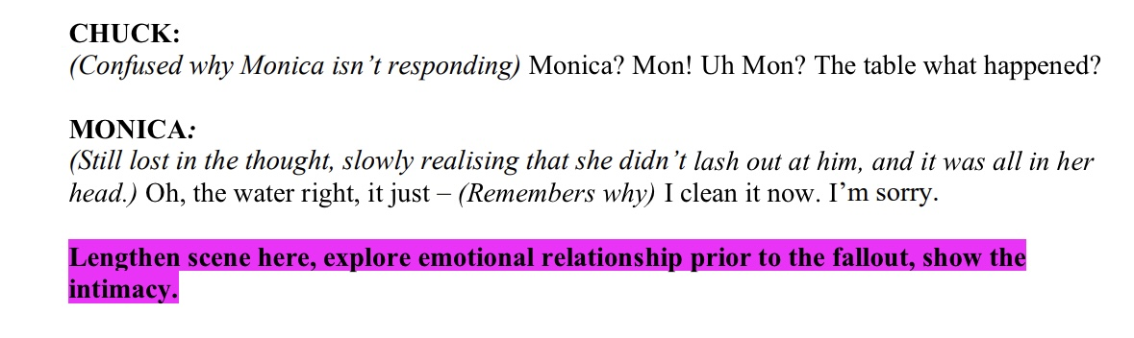
When I began to delve into some of the details of the relationship of Monica and ‘The Voice, I relationship for example, in the first scene we see Monica battling with her thoughts and becoming overly defensive to what ‘The Voice’ is saying to her. I liked this as it shows how Monica as already been struggling mentally and that her PTSD and fears have been brewing inside for a longer period, and that she’s been fighting and learning to cope with these negative thoughts for an excessive amount of time, hence her immediate frustration. 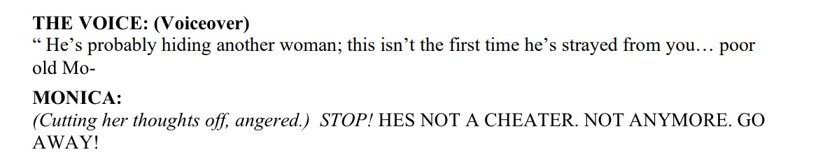
Whilst this clues the audience into the perspective of how she’s feeling, it felt more abstract and unrealistic to have her vocalising a conversation with herself. I didn’t want to confuse that she was showing signs of sci schizophrenia as that’s not the direction I was intending to take the piece. To problem solve this issue, I was then able to experiment a world where she’s embarrassed of these thoughts and tries desperately to ignore them, acting like they don’t exist to convince herself she is fine, as this resembles a more truthful world in which people can resonate with more and connect more intimately with the storyline. Here is an example of where this has been applied in draft 4 (Section 2, D.)
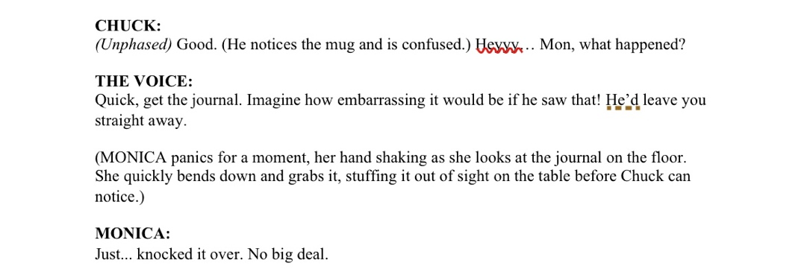
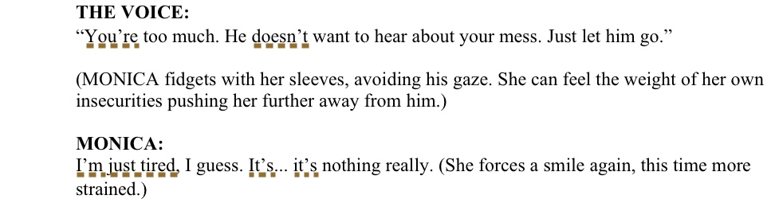
Through re-reading my drafts and edits, it soon appeared to me that I was neglecting Monica’s past, which is a vital component as it not only creates a backstory for the audience, as to what Monicas life has been like leading up to these events, but it also has an educational purpose, showing the audience what the effects of trauma can be like and what it’s like to have to live with it and attempt to recover. In my second draft, it was more focused on ‘The Voice; observing and mocking her as she waits for Chuck, I felt that this lacked emotional depth, and within a short time space its vital that everything has a meaning and purpose within each scene, so I needed to make sure that going forward I was prioritising how her feelings are being perceived externally as it then helps to drive the narrative.
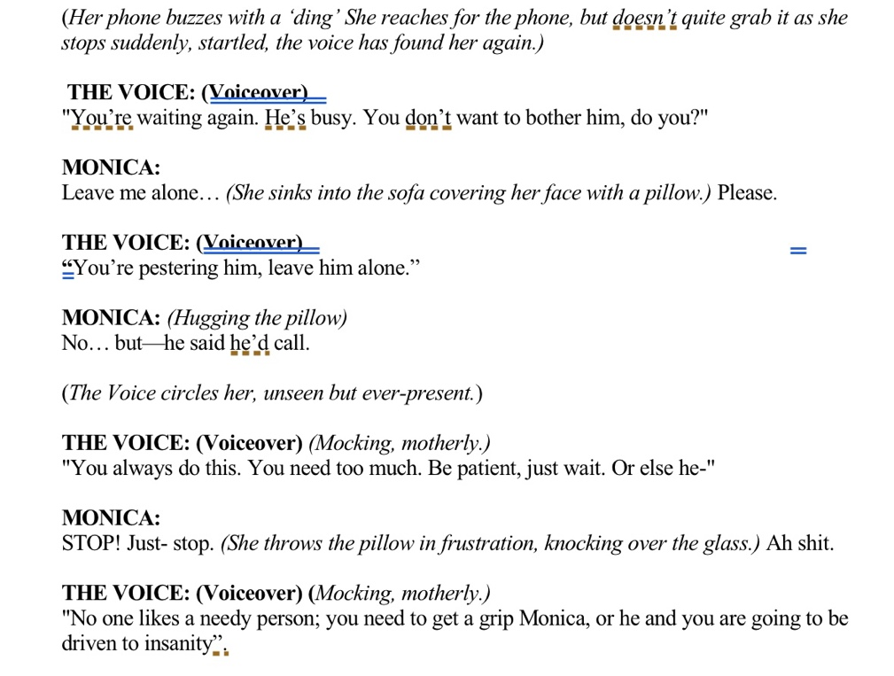

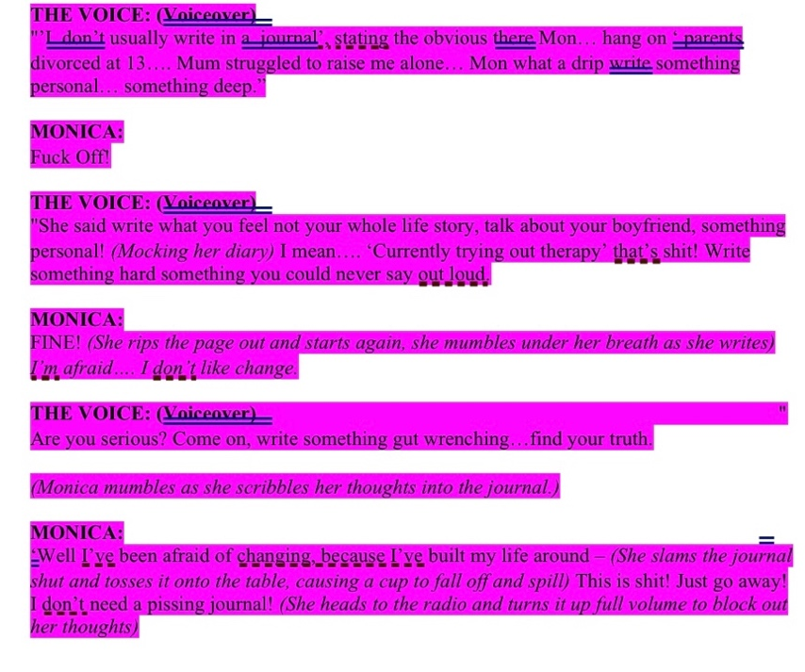
In my third draft (Section 2, C.) I reviewed these problems and tried to make sure I was capturing what forms a major part of Monicas personality, which is her trauma. As you can see in this updated version below, there is more depth to her backstory, and it’s clear from the start that she isn’t comfortable with expressing her feelings or facing the harsh reality that she has fears and issues that remain unresolve. By adding harsher, more patronising responses from ‘The Voice’ it was easier to establish and build the tension between herself and her thoughts allowing for an audience to understand and experience her heightened emotions more organically.

Practical Development- Section 3:
Scheduling & Organisation
When preparing my project, it was vital for me to set goals and deadlines to ensure I was staying on track with my work. I began with a production schedule which was edited and updated throughout the entire process. (Section 3, A.)
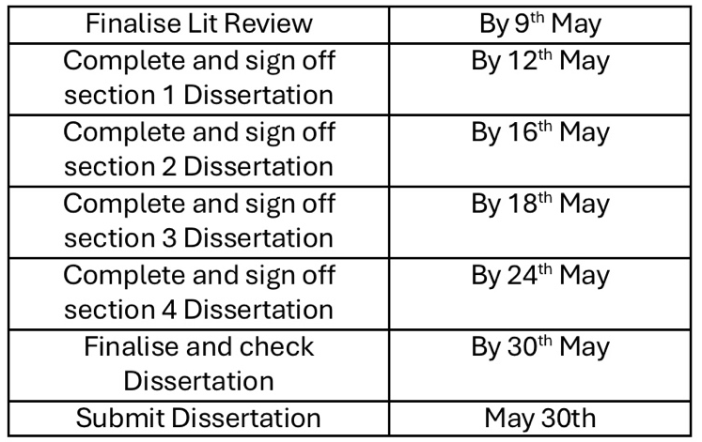
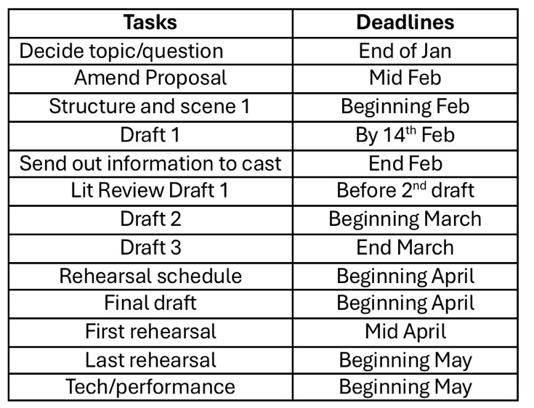
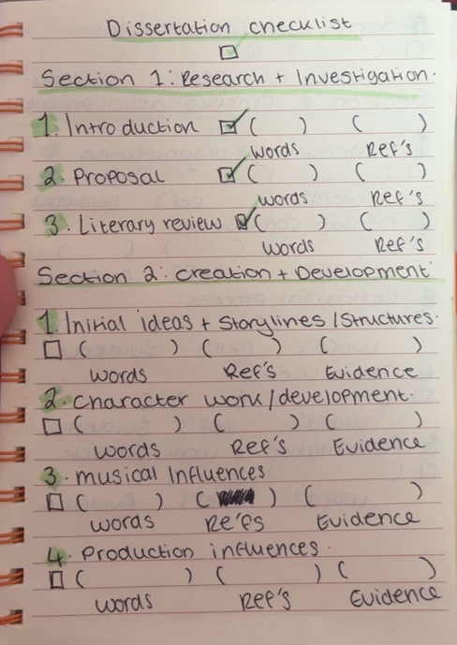
To assist with the writing of the portfolio/dissertation, I made myself a checklist, which I wrote based off the criteria supplied on Moodle for this project. By doing this I was then able to work effectively and ensure that I was including all the required material into my project. Additionally, by splitting my workload into sections, I was then able to better organise the structure my portfolio, allowing these who read it to be able to clearly understand all aspects of my work.

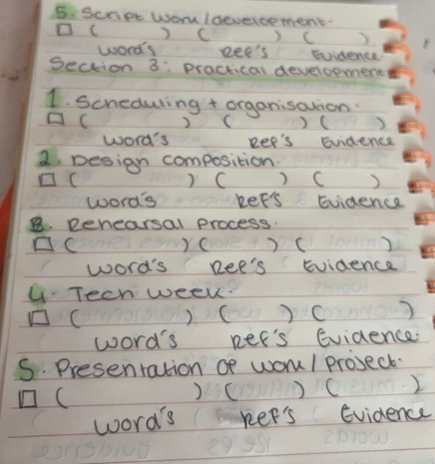
This process aligns with self-regulated learning strategies, which stress the importance of setting goals and using tools such as checklists to monitor progress. (Zimmerman, 2002)
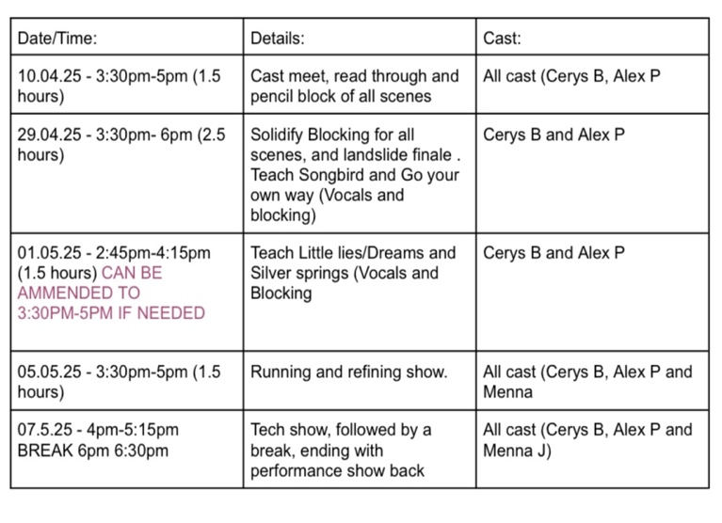
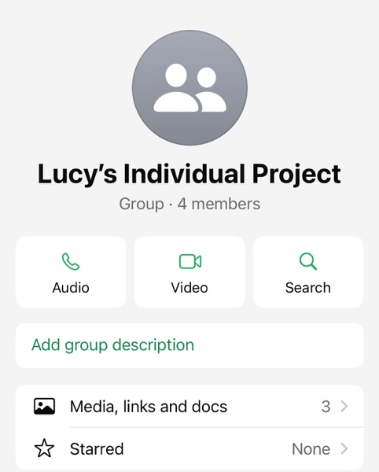
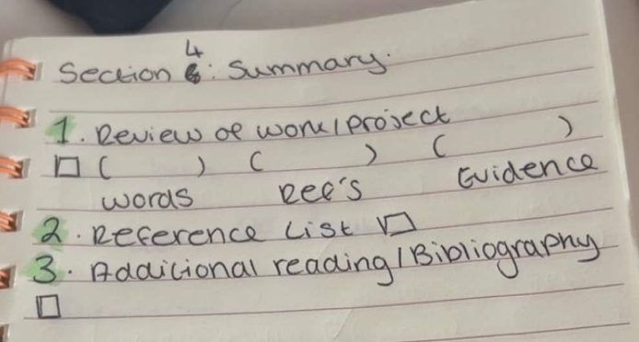
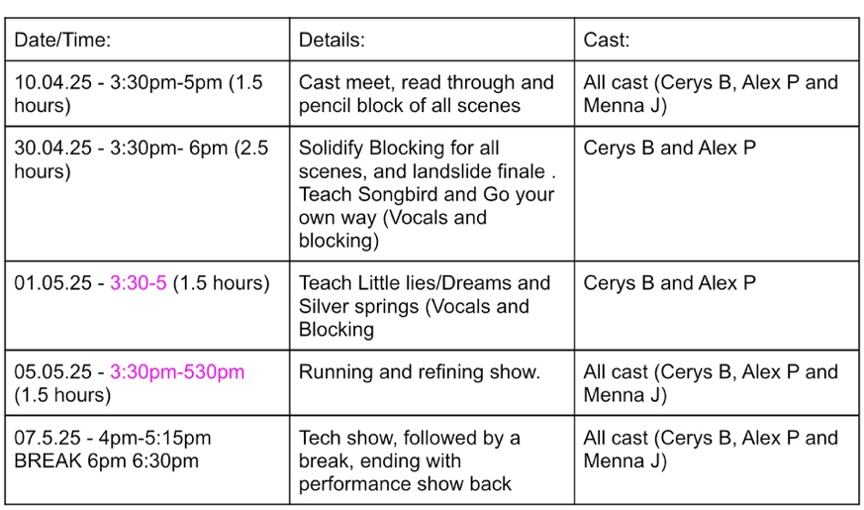
When casting for my piece, unlike many others I didn’t opt to use those in the year below. I had contacted a few friends that I had worked on shows with previously who were eager to get involved. Despite my ideas not being finalised at this point, I created a WhatsApp for me to communicate with my cast. This proved extremely helpful to both me and my cast, as we were able keep up to date on scripts, progress and rehearsals. When creating my rehearsal schedule, I first asked my cast for their full availability, ensuring that I was working entirely around them as they gave up their time to contribute to this project.
By doing this I was able to assess what was achievable from a director’s perspective, making sure that I have enough time to fully stage my project, leaving me prepared for tech week. I had two drafts of my script as I amended it to fit my cast, all amendments were highlighted in pink. In these schedules, I included details of what I was aiming to achieve, allowing my cast to prepare for each session, I also clearly marked who was needed each session to avoid confusion and make everything easier for my cast.

Design Composition
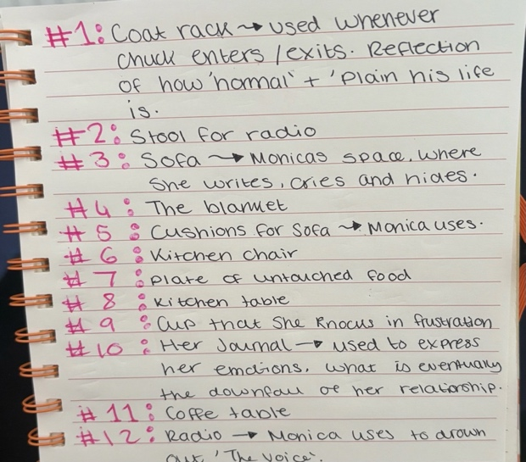
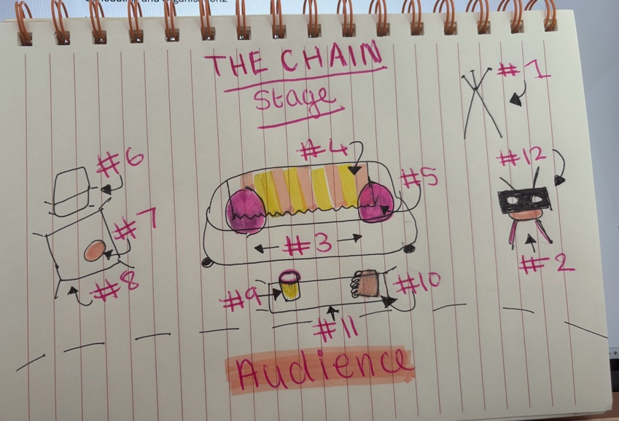
When designing the set and props for my piece, there was a thought process behind my choices. As you can see in the photo below, most of my props and set pieces are bright coloured. I chose this as a juxtaposition to themes explored within my piece. Not only does it contrast from the energy of the piece, but it serves as a message supporting the exploration of my question. It shows how just because things may look happy and bright on the outside, it doesn’t mean that it translates into what happens in people’s lives. This message is explored through Monicas constant dismissal of her fears and pretending she’s fine in front of her boyfriend. I also incorporated this message into costume design, I knew that at home I owned lots of brightly coloured tops and jackets, so I knew exactly what would work for my piece. I designed these concepts so that my actors knew what direction to take when brining in material, whilst also accommodating what they can bring in and what I can source for them. If I were to redo this project with a larger budget, I would have liked to experiment with more abstract costumes as I feel it would create a sense of uncertainty in the space, leaving an audience confused by powerful in your face costumes, as opposed to the dark storyline, which would further push the themes of my question. When designing costume for ‘The Voice’ I knew straight away I wanted her in all black, like funeral clothes, as it’s a reflection of the darkness she brings upon Monica, and how her thoughts are what’s darkening her world. And at the end when ‘The Voice’ leaves with Sam, it’s as if her fractured life has now been left with him.

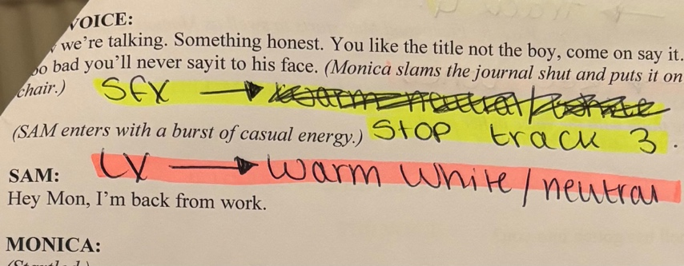
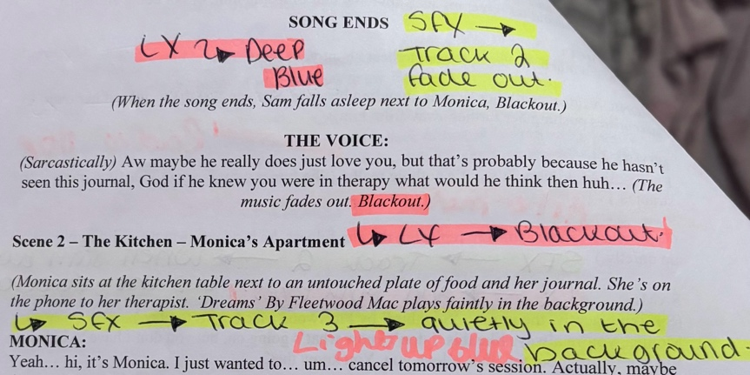
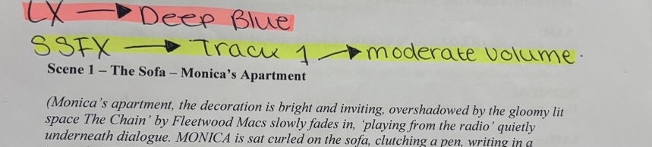
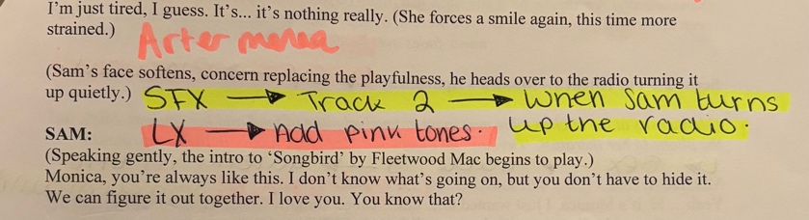
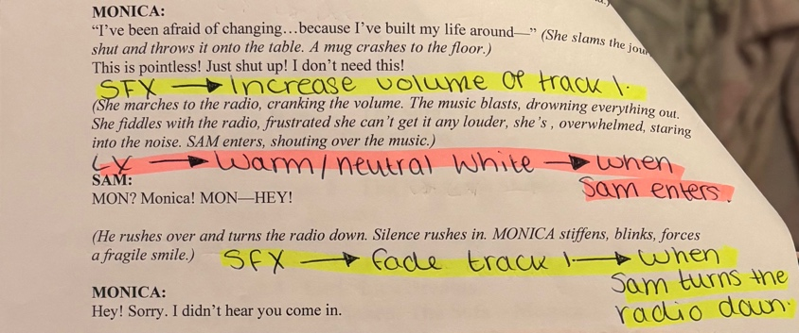
When preparing for tech week, I made sure that I knew what I wanted when in the space with nick. I spent time deciding what lights and effects I wanted prior and marked them on my script so Holly and Nick could follow as they were in control of my technical needs. To ensure that all my music cues were easy and understandable, I created a google drive with all my songs listed in number order of when they appear in the script. (Section 3, Having previous experience with using music cues for teaching shows, I found this part rather quick and easy as I already understood the mechanics of it.
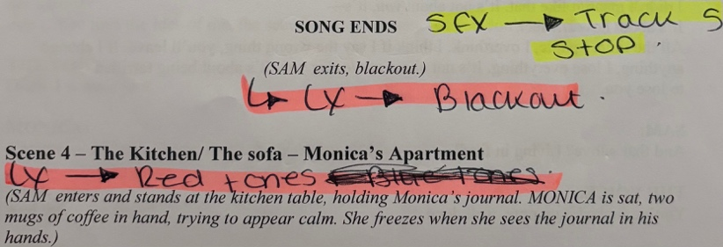
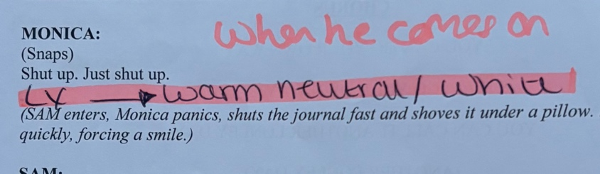
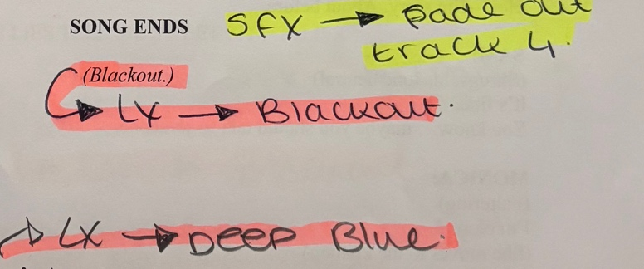
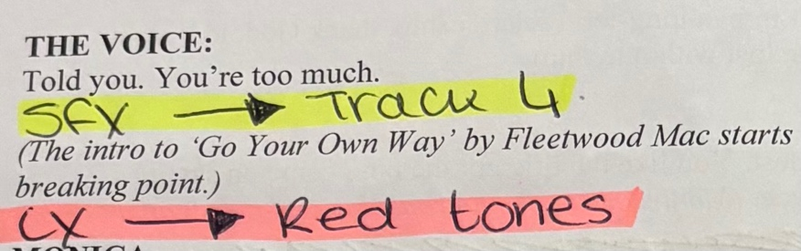
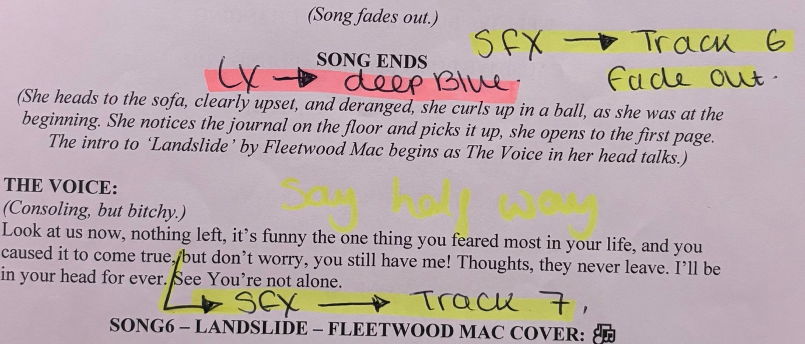
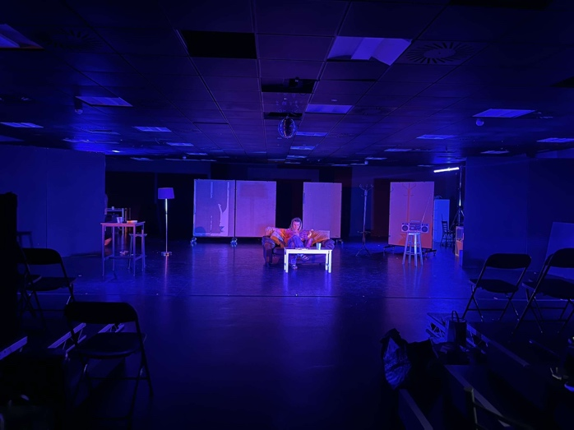
As you can see here, most of my piece was staged in this dark blue lighting, this reflected ‘The Voice’, and how it made Monica feel, so whenever Monica was alone or being controlled by ‘The Voice’ , this would be the colour of the stage. When it was just her and Sam, on stage the lights would be a warm neutral tone, as to her Sam is the light in her life and when he enters the space, he brings brightness. However, during the heated moments within the piece, the lights would fade to a strong red to signify the tension and anger present in the space.

Rehearsal Process
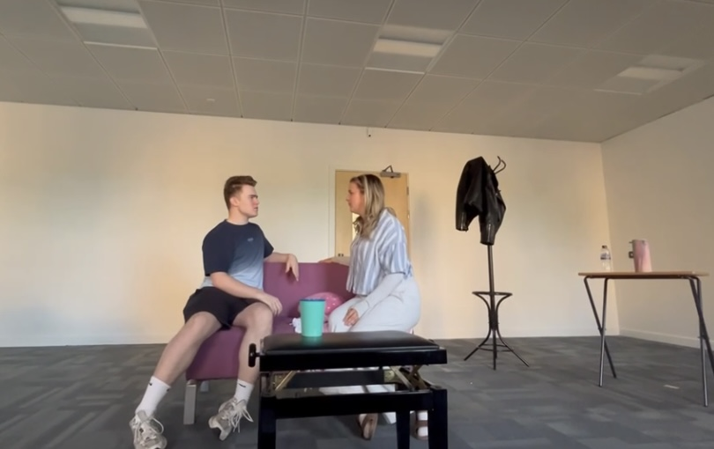
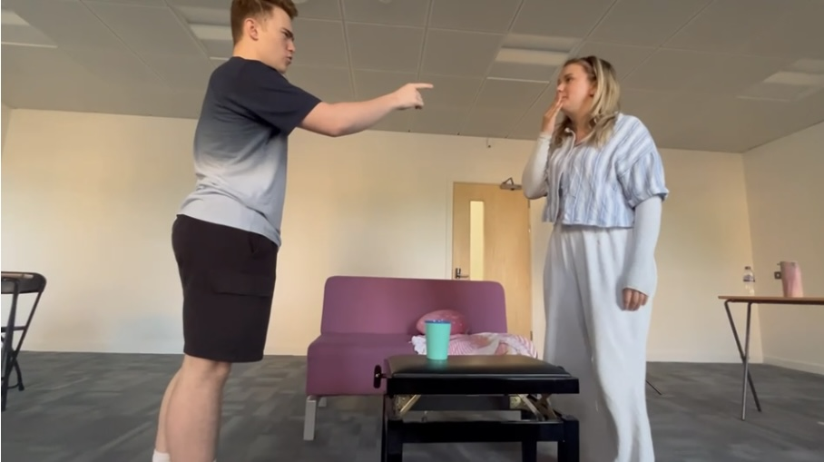
We used our first rehearsal as a chance to get to know another and the script. We started by introducing ourselves, however as the cast had all met before it made the process allot easier. We used this time to get to know the script and pencil block the show, which was a technique I picked up from our director during rocky. By pencil blocking it gave my cast a chance to understand the vision of my script, it also meant that over Easter they could learn their lines with an idea of how the staging is, which potentially makes it easier as they can correlate the two. I didn’t rush into detail during this first session as I just wanted us to gel as a creative team and explore the potentials of my piece. Each rehearsal that followed, had a similar structure, which allowed my actors to come feeling prepared and ready to work. A technique that I picked up in acting class, called the Alexander technique unique. At the start of each rehearsal, we would to this as a way of relaxing and preparing to work productively in the space. As the majority of my rehearsals were in the evenings, it was vital that I prioritised the wellbeing.
After our first read session, we followed each session by blocking and detailing scenes and songs. As a main part of my project explored the intimacy and depths of loving relationships, it was important for me to focus on strengthening and developing the intimacy between my actors. As both of my actors had known each other a long time it was a lot easier to move forward in this process. We did an exercise I picked up from Tonya, during our first year. For this, participants must stare into their partners eyes and just relax into it, this resonated quite well my Cerys and Alex, the two actors playing the couple in my piece, as they took it seriously and approached the art of doing nothing. I followed this up by asking them questions of their experience and what they were thinking about, from this I was then able to establish the relationship they share with each other, knowing what I am working with when staging the piece. Here are some rehearsal photos, from our third rehearsal.
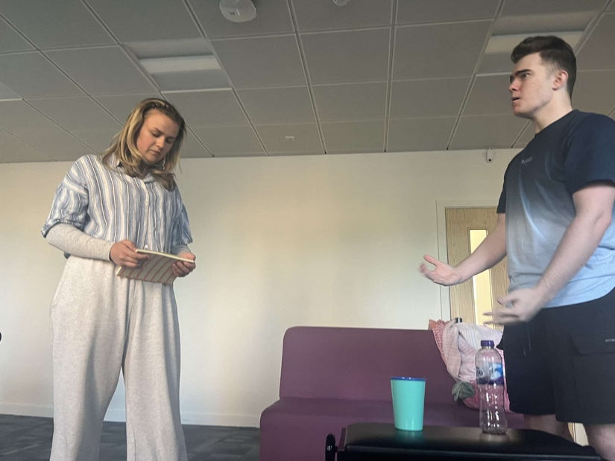
When directing my piece, I took inspiration from the ways that I have been guided and directed in my past, including throughout my university experience. It was interesting as this was the first time I had directed a piece, and having the extensive range of directors to pick from to influence my piece was helpful. It was interesting to see how different forms of directing can gel with each other to explore something new. I approached a style in which, I would let my actors make their own decisions and then if I did not like it I would then suggest something new. This is something that we’ve explored with Angharad a lot and it translated well in my rehearsal room. It felt more freeing to give my actors a chance to explore their characters before I navigated them to what I wanted.

Performance
When it came to the performance, I felt extremely prepared, alongside my actors and stage help. Prior to the performance we focused use of space, as we had an idea of who was going to be in the audience and where, I was able to factor in sight lines, and ensure that my actors were performing out to an audience and not making the piece to closed off, which was difficult as the piece itself is quite intimate, so it’s easy to feel as if you’re the moment and forgetting that you’re telling a story. We conquered this by moving the space in ever so slightly, which allowed for a more intimate setting, which was a feeling I wanted to resonate within the audience, so that they felt as though they were a part of the experience. What worked particularly well within the performance was the elevation of the text, despite successful rehearsals, it was as if the piece what brought to life when observed by an audience. Alongside watching my actors perform my piece, I also focused on what was going on around me, observing my audience. The energy that I picked up from this was a sense of dedication and concentration to what was happening on stage. It felt as if everyone was hooked into the story, exploring the depths of the text. Whilst I could t justify exactly how the audience were feeling though my piece, I felt the energy from my performers was reflected into the audience and it was as if we were all a part of the same story. If I were to do this project again, I would like to explore the depths of Sam’s character, showing the perspective of someone who is feeling the effects of a codependent, looking more into what it’s like to have to deal with other people’s trauma and the effects it has.

Summary & Academic Contributions- Section 4:

Summary
Throughout this entire project, I have explored a range of techniques and skills which I can bring with me into my adventures post-graduation and utilise in my future. I have gained an extensive understanding of how to conduct in depth research, and the importance of research and understanding when explore themes within theatre. Alongside this I have been able to hone and nurture my skills as a performer and creative. Being able to direct, design, write and research as an independent has been extremely educational, allowing me to develop as a self-employer and providing me with the necessary skills needed for the future, alongside being able to work collaboratively with friends and professionals within the creative industry.

Evidence & Materials

(In order to view images, please download from the files attached, thankyou.)

Section 2:
File of all photographic material used in Section 2: Photographic Evidence Section 2

Section 2, A - Draft 1 of Script
Section 2, B - Draft 2 of Script
Section 2, C - Draft 3 of Script
Section 2, D - Draft 4 of Script
Section 2, E - Final Draft of Script

Section 3:
File of all photographic material used in Section 3: Photographic Evidence Section 2

Reference List

Beattie, M. (2010) How to Stop Controlling Others and Start Caring for Yourself. Hazelden Publishing. pp. unknown
Bendetti, J. (2015) Theatre & Emotion: The Heart of Performance. Routledge. pp. 132.
Benitez-Eves, T. (2023) The fractured meaning behind Fleetwood Mac’s ‘Rumours’ classic ‘The Chain’. American Songwriter. Available at: https://americansongwriter.com/the-fractured-meaning-behind-fleetwood-macs-rumours-classic-the-chain/ (Accessed: May 2025).
Breathe Life Healing Centre (n.d.) This is what toxic co-dependency looks like. BLHC. Available at: https://breathelifehealingcenters.com/toxic-codependency-looks-like. (Accessed: April 2025).
Burn, S.M., Ph.D. (n.d.) Are women more co-dependent than men? Psychology Today. Available at: https://www.psychologytoday.com/gb/blog/presence-of-mind/201709/are-women-more-codependent-than-men(Accessed: April 2025).
CAHM (n.d.) Trauma. CAMH.ca. Available at: https://www.camh.ca/en/health-info/mental-illness-and-addiction-index/trauma (Accessed: March 2025).
Cermak, T.L. (1986) Diagnosing and Treating Co-dependence: A guide for professionals who work with chemical dependents, their spouses, and children. Johnson Institute Books. pp. 10-30.
Citron, S. Songwriting and Narrative in Musical Theatre. Routledge. pp. 42.
Dorahy, M.J. (2012) Complex trauma and intimate relationships: The impact of shame, guilt and disassociation. Science Direct. Available at: https://www.sciencedirect.com/science/article/abs/pii/S0165032712006878?utm_source=chatgpt.com (Accessed: March 2025).
Ellis, M.E. (2024) How trauma can result in co-dependency. Bright Quest. Available at: https://www.brightquest.com/blog/how-trauma-can-result-in-codependency/ (Accessed: April 2025).
Engel, B., LMFT (2023) Emotional intimacy: What is it and how to build more of it. Choosing Therapy. Available at: https://www.choosingtherapy.com/emotional-intimacy (Accessed: March 2025).
Felitti, V.J (1998) Relationship of Childhood Abuse and Household Dysfunction to Many of the Leading Causes of Death in Adults. American Journal of Preventive medicine. Available at: https://www.ajpmonline.org/article/S0749-3797(98)00017-8/fulltext (Acessed: March 2025).
Finzi-Dottan, R. &Gewirtz-Meydan, A. (2023) In Love With a Trauma Survivor: When a History of Childhood Abuse Interferes With Relationship Satisfaction Among Couples. Sage Journals. Available at: https://journals.sagepub.com/doi/10.1177/08862605231198009?utm_source=chatgpt.com (Accessed: March 2025).
Heathcote, D. (1985) Drama as a Learning medium: Hutchinson. pp. Unkown
Hogan, K. (2019) Childhood trauma and adult romantic relationships. Scholar Works. Available at: https://scholarworks.calstate.edu/concern/theses/dv13zv08v (Accessed: March 2025).
Lebow, H. and Lawrenz, L., PsyD (2021) How childhood trauma may affect adult relationships. Psych Central. Available at: https://psychcentral.com/blog/how-childhood-trauma-affects-adult-relationships (Accessed: March 2025).
Mellody, P. (1989) What is it, where It Comes from, How It Sabotages Our Lives. Harper & Row. pp. chapters 2 & 5.
Moon, J.A. (2006) Learning journals: A Handbook for Reflective Practice and Professional Development. Routledge. pp. Uknown.
Needlands, J. & Dobson, W. (2008) Theatre Education and Applied Theatre: Divisions and Disconnections, Research in Drama Education: The Journal of Applied Theatre and Performance. Taylor & Francis. pp. 39-51.
Norwood, R. (1985) Women Love Too Much: When You Keep Wishing and Hoping He’ll Change. Pocket Books/Arrow Books. pp. Unknown.
Reid, S. and Riviera, T. (2025) Co-dependency: Signs, causes and help for a codependent relationship. Help Guide. Available at: https://www.helpguide.org/relationships/social-connection/codependency (Accessed: April 2025).
Runkle, A. (2024) Re-regulated. Hay House, pp. 101+ (Chapter 7). (Accessed: April 2025).
Runkle, A. (n.d.) The brutal reality of co-dependent relationships. The Crappy Childhood Fairy. Available at: https://crappychildhoodfairy.com/2022/04/29/the-brutal-reality-of-codependent-relationships/ (Accessed: April 2025).
Windsor, A. (2024) What Is Uta Hagens Acting Technique? Starnow. Available: https://www.starnow.com/uk/magazine/article/what-is-uta-hagens-acting-technique-77742/
Woititz, J.G. (1989) Adult Children of Alcoholics: Health Communications. pp. 30-50.
Zimmerman, B.J. (2002) Becoming a Self-Regulated Learner. Taylor & Francis. pp. 64-70.

Bibliography/Reading List
https://www.helpguide.org/relationships/social-connection/codependency

https://www.merriam-webster.com/dictionary/codependency

https://shalvacares.org/are-abuse-survivors-co-dependent/

https://www.webmd.com/mental-health/signs-codependency

https://freefromcodependency.com/2020/05/13/victimhood-a-tool-in-the-codependent-armoury/

https://www.quora.com/What-are-some-signs-that-someone-is-taking-advantage-of-your-codependency

https://www.reddit.com/r/Codependency/comments/7saf6k/manipulative_codependent/

https:/ /www.psychologytoday.com/gb/basics/codependency#:~:text=Codependency%20is%20a%20dysfunctional%20relationship,%2C%20friends%2C%20and%20family%20members.

https://www.medicalnewstoday.com/articles/319873#codependence-vs-dependence

https://hopeandsafety.org/learn-more/co-dependent-or-abused/

https://www.talkspace.com/blog/what-causes-codependency/

The Effects of Divorce on Children - Khiron Clinics

Can Divorce Lead to Trauma Symptoms? - Psych Central

https://mediate.com/the-long-term-psychological-effects-of-divorce-on-children/

#:~:text=Possible%20Consequences%20for%20Kids%20Whose,earlier%20age%20than%20their%20peers.

https://pmc.ncbi.nlm.nih.gov/articles/PMC9360253/#:~:text=Data%20from%20a%20recent%20study,of%20traumatic%20experiences%20in%20childhood.

The Long Term Psychological Effects of Divorce on Children

Parental Conflicts and Posttraumatic Stress of Children in ...

I would Like to thank, all my tutors over the past two years who have influenced and inspired my work, I would also like to thank my creative team who assisted with lighting and sound, and my actors who dedicated time to this project.

