Apostol Constantin Cosmin (1918998)
Lemos Alexander (1917608)
Apostol Maria Cristina (1918999)

Date:28/08/2020
Lecture: Paul Jenkins

DIGITAL SKILLS AND RESEARCH METODS

Term 1
EQUIPMENT
APPLICATIONS
DEVICES
PLATFORMS
SUPPLY/TRANSPORT
THE TECHNOLOGY IN AND OUT OF OUR RESTAURANT
TILLS
COMPUTER
PDQ
KEYS
IPOD
DEVICES
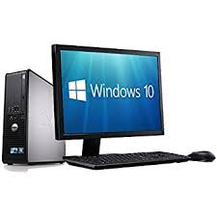
Computer
- The restaurant manager is a busy person. He or she is responsible for the overall operation of the restaurant from the front of the house to the kitchen, and must try to maintain the bookkeeping end of the business as well. Office computers are a must for restaurant managers. They are used to order supplies, track inventory, process payroll, and track sales trends.

Self-Service Ordering
- While it isn't commonplace in the restaurant industry yet, self-ordering programs may soon be more frequently used in large restaurants to speed service and cut down on labor costs. Some fast-food restaurants already have kiosks where the customer can punch in what he wants to eat. An electronic message is sent to the cook, obviating the need for an order-taker or waitress.

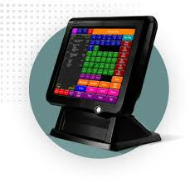
Tills
- Streamline your order management
- Take control of your entire business at the touch of a button
- Increase efficiency and productivity
- Improve accuracy and reduce mistakes common in handwritten orders
- Reduce hours spent on paperwork
- Instantly produce bills at one touch
- Keep records of every order
- Project a professional image towards your customers

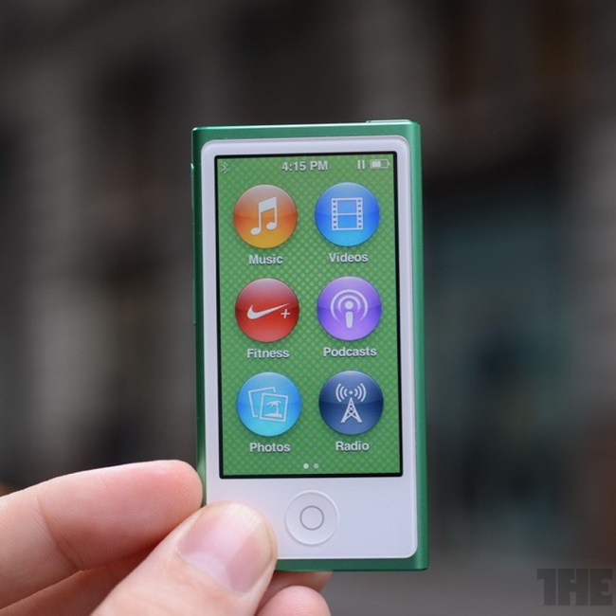
iPod
iPod Restaurant POS systems come equipped with robust sales, inventory, and employee performance reporting capabilities.
- Want to see how many tables each of your waiters serve per shift or the average value of each table they serve? An iPad Restaurant POS can do that.
- Want to see which menu items have the highest profit margins, or which are your actual best-sellers? Just click a button to run a daily, monthly, or annual sales report and get informed.
An iPod Restaurant POS’ reports enable you to make decisions based on facts, not instincts. The result is that you maximize each of your dishes’ profit margins, invest only in inventory you know will sell, and plan employee work schedules that maximize both your table turnover rate and sales per table.

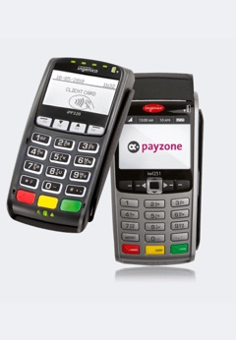
PDQ

With consumers increasing moving away from cash and towards cards, businesses must accept card payments if they want to stay competitive. To do that, you need what is called a PDQ machine.



Keys

Every employee can access the till with the help of the keys, every member of staff has a personalised key with different access on the system.
FINGERPRINT EMPLOYEE
AIR
CONDITIONER
DISHWASHER
FRIDGES
EQUIPMENT
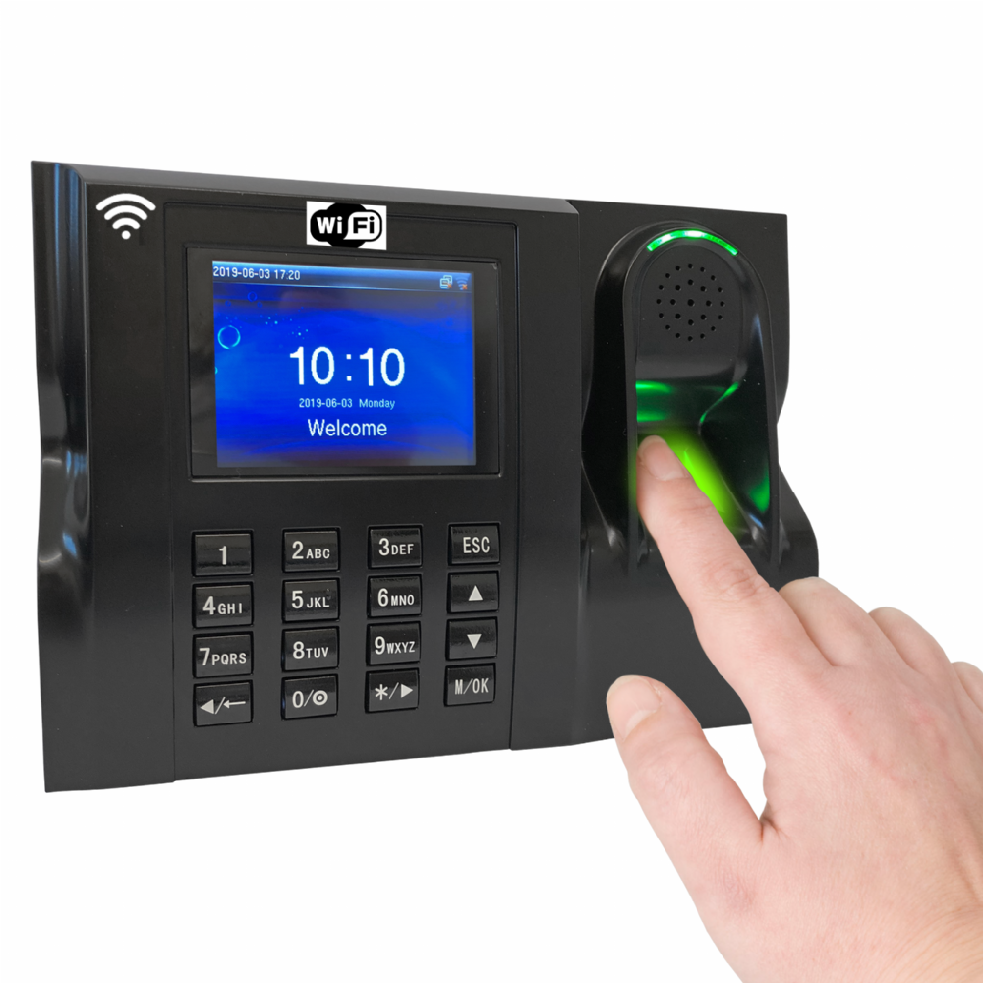
Fingerprint employee
Biometric time and attendance systems use the fingerprints of employees to verify who is actually clocking in and clocking out of work each day. The system scans the finger of the employee, coordinates are determined and then the system maps the endpoints and intersections of the fingerprint.

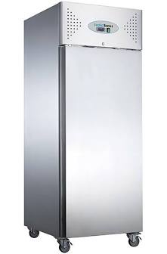

Fridges

The fundamental reason for having a refrigerator is to keep food cold. Cold temperatures help food stay fresh longer. The basic idea behind refrigeration is to slow down the activity of bacteria (which all food contains) so that it takes longer for the bacteria to spoil the food.

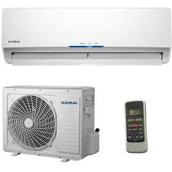

Air conditioner
To ensure the proper ambiance, restaurant owners select Daikin air conditioningsystems for their quiet operation and stylish appearance that complements any décor.

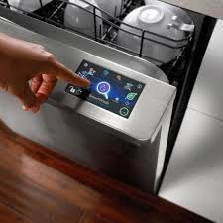

Dishwasher
Dishwashers, also known as Kitchen Helpers, work in the kitchen of any kind of restaurant. Their main role is to clean dishes, utensils, and all kitchen appliances.

AZTEC
FOURTH
APPLICATIONS

Aztec
Aztec is an application which is connected with the tills, the keys, the iPod and the PDQ machine.



Fourth hospitality

Fourth is the platform on the hospitality which shows you the details of the employers, the forecast, the sales, the rota and the holidays.

HARRI
LOOOP
RESDIARY
PROCUREWIZARD
PLATFORMS

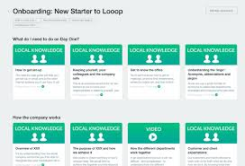

Looop
Looop is a platform which welcome a new member staff. In this platform we are able to find all the traning which we need for new starters, but also you can fine all the details, stories and values about our company.



Harri
Through the Harry platform managers can hire people and train them.

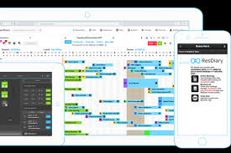

ResDiary
ResDiary is a smart platform which helps you to manage the bookings, set the time and pax for each request of booking.

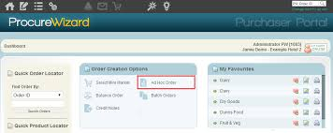

ProcureWizard

Through this application you can make orders, you have the stock control and you can check the wastage.

RESTAURANT/STORE
DELIVERIES
ORDERING SYSTEM
COMPETITIVE SERVICE
DELIVERING
PROCEDURE
TAKING CARE
OF ORDERS
SUPPLY/TRANSPORT
Introduction

This report is about how a restaurant gets its products from its supplier, I will explain the ordering system, when the restaurant knows when to order and how the process is done in a smooth and safe way. Also, show how the restaurant has coped with this pandemic. Finally, show what the restaurant have learned from this traumatic experience that is affecting the entire planet, the infamous COVID-19.

What is a supplier (food & drink)?
According to the dictionary (dictionary.cambridge.org. 2020) it clearly estates that is a person or company that provides goods that a company or someone needs. In addition is a person or company that keeps a company or business strong and reputable. In other words, the business is as good as the supplier because if you have little or nothing to sell, you will go out of business.
The importance of choosing an excellent supplier is no small task. (Eymard, D., 2009). Choosing a reputable or reliable supplier should meet certain criteria, such as:
- Experience- Meet current food and drink standards, check their reliability, check internet forums about their opinion regarding this or other suppliers. Research how long supplier has been in the business.

- Company history- Research history of supplier and see if it meets your food and health standards.

- Reliability- See how reliable the supplier is with deadlines and quality of food. This is a must in most if not all restaurants.

Technological aspects of the restaurant/supplier- The company that was chosen to supply the restaurant is Booker Retail. This company (bookergroupjobs.co.uk/booker-retail-partners) was chosen because of its vast experience in the sectors of food and alcoholic beverages (140 years). They have an easy web to browse, make orders 24/7 which is a plus in the restaurant business. Apart from adding or deleting items, they have an app and newsletter where you can get all the new food items and discounts to loyal customers.
Booker Retail uses a scanner to scan all products from all of its customers to be allocated in a cage (slide presentation) along with a label containing all of the restaurant’s data such as:
- Name of restaurant
- Address, city, etc.
- Items to be delivered
- Time of approximate delivery etc.
The restaurant uses the app procure wizard which enables the chefs what items must be ordered, it also helps keeping track of all of the food supply, on top of that, Booker Retail has its own app for all clients as well as a newsletter and a web page that can be easily accessed. Once you are a client, you are assigned a client number and you could order all the items you need to run your business, as previously explained the supplier will take care of the order as soon as possible. If order is done within the ordering time-frame. Order times are from 8am until 6pm, anything beyond that time-frame will carry for the next day. Booker retail has its own lorries which is a plus, since they don’t have to rely on other transportation companies to deliver their goods. Finally, once goods are delivered to the restaurant, the owner or the chef signs an electronic pad which sends a message to the supplier that the goods arrived to its final destination.
As we all know the COVID-19 pandemic has taken the world by surprise. In one way or another all businesses have changed their normal day-to-day habits and the way they function. For instance, 58 Gin, a London-based distillery, has started to make sanitiser in response to the pandemic (Miller, N., 2020). This action shows how businesses have to adapt to difficult periods, otherwise they will either be absorbed by another company or be out of business. Meanwhile, Booker Retail has made few changes, one of them is that they have suspended guided visits to their warehouse. This guided visit enables visitors to see how their products are handled and delivered to their establishments.

Conclusion

Nowadays, most restaurants have to cope with this pandemic. Now more than ever all establishments have to adapt to this especial time in human mankind. Technology has been a great ally to deal with the new times. All available apps are an excellent tool to keep track of inventory as well as, of all your food and beverages orders with just a few clicks on your phone or computer.
Having a reliable supplier is a plus to keep the business going, this is a key point to take into account. That’s why choosing a reliable supplier is no easy task. To conclude, the management of a restaurant is no easy job as my team is going to explain in a PowerPoint presentation showing the following:
- Inside of a restaurant
- Apps used in a restaurant
- Supply and transportation of goods into the restaurant.

References
- https://www.cardswitcher.co.uk/ultimate-pdq-machine-guide/
- https://sevenrooms.com/en/blog/ipad-restaurant-pos-system-benefits/
- https://orbititech.com/restaurant-till-system/
- https://itstillworks.com/computers-used-restaurants-8130791.html
- (Cambridge dictionary, 2020)
Cambridge dictionary (2020)
Available at https://dictionary.cambridge.org/dictionary/english/supplier
(Accessed: 12 August, 2020).
- Eymard (2009)
Eymard, E, (2009) How to choose a reputable ingredient supplier.
Available at: https://www.foodsafetymagazine.com/magazine-archive1/junejuly-2009/how-to-choose-a-reputable-ingredient-supplier/
(Accessed: 13 August, 2020).
- (Bookergroupjobs, 2020)
Bookergroupjobs, (2020)
Available at: https://www.bookergroupjobs.co.uk/booker-retail-partners
(Accessed: 18 August, 2020).
- Miller (2020)
Miller, N., (2020) How factories change production to quickly fight corona virus.
Available at: https://www.bbc.com/worklife/article/20200413-how-factories-change-production-to-quickly-fight-coronavirus
(Accessed: 10 August, 2020).

