Owl pellets assignment

Introduction
This experiment aims to figure out what owls eat from their pellets in two different locations: Pare le Breos in Swansea from a barn owl nest box and Newport Wetlands, a stand of trees in Newport. When owls eat animals they eat the whole and they do not chew them. Some of the prey is then digested but the owl can not digest parts of it like the fur, feathers, bones and teeth (All About Birds 2009). So after the prey is eaten it is then processed in a part of the owl called a gizzard which is a special part of an owl's stomach that helps to hold the bones, fur and feathers of its prey after 6-8 hours the indigestible stuff is then formed into a pellet and regurgitated (Lewis. D 2015). This process can happen 1-2 times a night when the owl is hunting its prey. These pellets are then collected and stored in bags for people to do this experiment and figure out what can be found in these sites. The experiment will figure out what species can be found in these areas using the owl pellets, this will allow for an estimate of how many of each species might be found in the different locations. Information from the site can be then used back up the information that was found from the pellets for example if habitats such as grasslands are at these sites it is known that field voles (Microtus agrestis) or pigmy shrews (Sorex minutus) may have a habitat there. It will also explain what species is making it so owls might stay at these locations. It can show what species are not in those areas for example it will be less likely that a water shrew (Neomys fodiens) would be in the Parc le Breos site than in the Newport Wetlands site and the owl pellets will be able to tell us that.

Methodology
The first step of the experiment is to collect an owl pellet from one of the sites owl pellets usually weigh 2.45-10.89g (Doerksen, G.P. 1969). The next step is to start to look through the pellet and pull out any skulls or jaws that can be seen in the pellet, these should be put aside to look at later. Once the pellets have been looked through then the skulls and jawbones must be identified. Different species will have different teeth shapes and patterns as well as the skulls and jaws will be different sizes as well. There are different ways to identify skulls and jaws; one of the main ways is to look at the pattern of the teeth which will show if it is a vole (Microtus) or not (Ecott.B. 2024). Another way to identify a skull or jaw is to take out the teeth and look at the tooth sockets that they leave at the root as different species have different-looking sockets. Also, a good way to figure out if a skull or jaw is a shrew is to look if it has red on the tooth this is an indication of the species however, shrews are hard to identify so you must measure the jaw or skull to figure out the species. There will be various sheets to help identify the different species and once a species is identified then it must be recorded into a database. Once the first pellet is done it is a good idea to look at a pellet from the other site and then you must continue this method for 5 pellets for each site. This method is the best method to use as it is easier to identify skulls and jawbones than having to identify a species that is moving around or already being eaten by the owl (International Owl Centre n.d.). This method allows you to have a closer inspection with a microscope to have a reliable identification of the species found in the owl pellet so this makes the method more credible and reliable than other methods. However, some methods could be more suitable to find different species in these sites but this method would be the best to find small animals like voles shrews and mice which are all a part of an owl's diet. Because the experiment size is quite small it could make it more unreliable as there will be species that may not be found in different pellets but they may be found in different ones that were not analysed.
Results
The results in the database for each site are shown below: (change this so the means are all in graphs)
Parc le Breos owl pellet data-
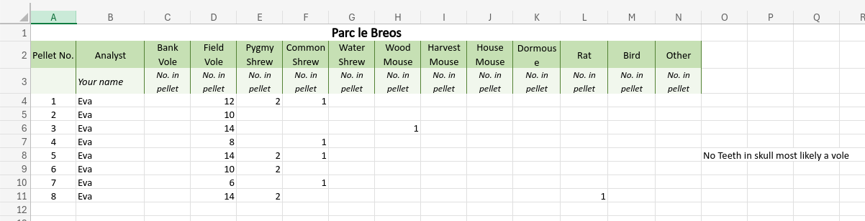

Newport Wetlands owl pellet data-
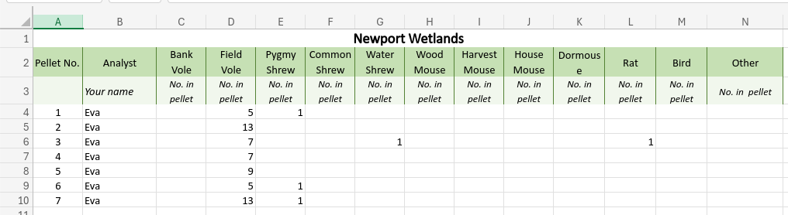

We will now figure out the mean average of each species from each site starting with- Park le Breos.
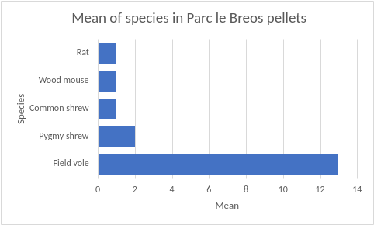

Newport Wetlands
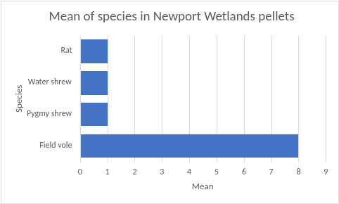

The results of the experiment would be that there are more field voles in both sites than any other species this is because both sites are ideal habitats for the field voles. In total, there were 147 field voles found in both sites which is a much greater amount than any other species. The second-highest species found in the owl pellets at both sites were pygmy shrews with a total of 12 from both the sites. However, there were a few skulls that were hard to identify so therefore they could not be counted as they either had no teeth or they were unidentifiable this can affect the results as there could be species that are not counted. And finally, there was one of a water shrew, a wood mouse Apodemus sylvaticus) and a rat (Rattus spp) on each site.

Discussion
The results show that owls' diets mostly consist of field voles as it was the highest number in each site. This is because field voles can be found at both Parc le Breos and Newport Wetlands as they both have grassland and woodland which field voles like to live in (Mammal Society n.d.). In the site Parc le Breos there was a higher number of pygmy shrews than Newport Wetlands. This might be because pygmy shrews are more common in grassland than in woodland (Pygmy shrew — Mammal Society n.d.). Or the owls at Parc le Breos have found more pygmy shrews on this site rather than the owls in Newport Wetland who might have found it more difficult to hunt pygmy shrews. It was also found that a water shrew can be found in an owl pellet in Newport Wetlands this is because water shrews can be found near water such as streams, ponds, lakes and rivers (The Wildlife Trusts n.d.) and the site is a wetland which has most of these habitats for a water shrew to live in. Also, a wood mouse was found in the Parc le Breos owl pellet this is because this site has more woodland areas which is a large habitat for wood mice (Woodland Trust n.d.). A reason why there might be a high population of field voles could be because they are a main source of food for a range of predators such as owls, and kestrals and mammals they are a good source of food for foxes, weasels and stoats. (Woodland Trusts n.d.) Stoats and weasels can be found in farmland, moorland, marshes and woodland which are all habitats that field voles can be found in therefore they are a good food source for these animals.
The Parc le Breos site has characteristics such as low oak/birch/willow woodland in the south and east, to drier ash, sweet chestnut, sycamore and beech woodland in the north and west (Parc le Breos 2021). The Newport Wetlands site has habitats such as wetlands, reedbeds and estuary habitats. (RSPB 2024) Sometimes it can be difficult to identify skulls and jaws if some of their teeth are disintegrated or species might be wrongly identified because it can be hard to see the difference between bank voles and field voles so this could make the experiment unreliable as species might be wrongly identified. Even though there were only these few species found in the owl pellets it does not mean that other species can not be found in those sites. So, other species could be there at the site but did not show up in the owl pellets because owls have not eaten them. Also, some species could not have come up in the owl pellets used because they might have been in different owl pellets that were not examined.
Rats can be found on both sites this would be because rats are common in open fields which are easy to find for owls as they are particularly big and easy to see. However, the reason why there might not be as many rats in both sites could be because of different factors. One factor in Parc le Breos that might reduce the number of rats on that site would be that rats need water areas to survive and it does not have any water areas. To fix this reduction in rats they should try and create a pond or a lake to help increase the amount of rats on the site to allow owls to have a larger mammal prey to eat. A factor that might reduce rats in Newport Wetlands might be that there are no areas or covers to help rats breed on the site. If Newport Wetlands has cover for rats to breed in this may increase the amount of rats on their site. If the experiment was done again it would be a good idea to look at more owl pellets for example 20 from each site to produce a bigger range of species from each site this will allow more understanding of the species found in each site. Another experiment can be done to find more species in each site for example going to each site and counting each species that can be seen on the site this could be birds, mice or even rats. It is important to know that owls like to stay in one place as it helps them with their mental map of their homes so it is unlikely that the owls would be getting food from somewhere else so the pellets should all be from the two sites that the pellets should be from. Due to each site having its habitats, there could be a range of different species that owls do not eat so we do not know if they are present. There would be different experiments and surveys that can be done to find these different species and organisms. There are a few websites and lists that back up my findings such as a list of species that can be found near Newport Wetlands from Gwent Wildlife Trust. This website shows mammals such as field voles, pygmy shrews and water shrews. (Gwentwildlife,2024) Finally, if there were different habitats in the sites then maybe different species would be present on the site such as doormice or even bats.

Some management suggestions for Parc le Breos would be to ensure that there are open areas so predators can easily find their prey in the open grass areas and that different bird species will stay in Parc le Breos. It is also good to keep an open area as it allows for species to create their homes for example pygmy shrews like grassland habitats. Another management suggestion for Parc le Breos would be to do assessments of their site for example they should be doing studies and surveys of their site to then share the results with other people who are interested in the site and its species. It will also help them understand what they should add or remove for example they might find out that they need to add more shelters for smaller mammals. The final management suggestion would be that they should leave dead wood around the woodlands, this will give a food source for lots of different animals in the woodland it can provide homes for bats which might be a reason why there were no bats present in the owl pellets because they might not have the right conditions to live there. (The Wildlife Trusts n.d.) Also, some management suggestions for Newport Wetlands would be to ensure that birds have covered feeding places to make it more likely for owls to stay on the site. The next management suggestion would be to have cover for voles and shrews, even though they are a predator of owls they still need to have a few remaining to make sure there is a healthy breeding system in the area and cover for them can help with that. The final management suggestion would be to ensure that there are water tables and birdhouses to help with the breeding system this will ensure that the biodiversity on the site will stay level and normal.

Conclusion
In conclusion, the experiment shows that in both sites owl pellets have a high amount of field voles this is because field voles are the main diet of owls. Also, different species can be found in different sites for example wood mouse was only found in Parc le Breos because it has a woodland habitat and water shrew was only found in Newport Wetlands because the site has water habitats. Also, it is good to take into account that not all species will be found in a few pellets due to the amount that was examined for this experiment. So, it is a good idea to redo the experiment but with more pellets to get a more reliable result with more species identified. Also, another important note would be that owls generally stay in one place rather than flying off someplace else to find food if they have already made a nest at the site this means that the species found in the pellets will most likely be within the site rather than from a different place. Furthermore, this makes the experiment more reliable because the results will not be too big a range which allows us to figure out what species can be found in the sites. Finally, the most interesting part of this experiment was when rats were found in one pellet from each site as rats can be hard to catch for owls as they are bigger than shrews or voles. Owls find it easier to eat mice, shrews and voles but rats and also birds can be found too in owl pellets however these are more uncommon.
References

Gwentwildlife.org. (2024). Mammals | Gwent Wildlife Trust. [online] Available at: https://www.gwentwildlife.org/wildlife-explorer/mammals?page=1 [Accessed 7 Nov. 2024].

All about birds (2009). What are owl pellets? [online] All About Birds. Available at: https://www.allaboutbirds.org/news/what-are-owl-pellets/ [Accessed 16 Nov. 2024].

Lewis, D. (2015). Digestion in Owls - The Owl Pages. [online] The Owl Pages. Available at: https://www.owlpages.com/owls/articles.php?a=4 [Accessed 16 Nov. 2024].

Doerksen, G.P. (1969). An Analysis of Barn Owl Pellets from Pitt Meadows, British Columbia. The Murrelet, [online] 50(1), p.4. doi:https://doi.org/10.2307/3534473.

Scott, B. (2024). Hainault Forest Website. [online] Hainaultforest.co.uk. Available at: https://www.hainaultforest.co.uk/11Nature%20Detective%20Mammals.htm [Accessed 16 Nov. 2024].

International Owl Centre (n.d.). Dissecting Owl Pellets. [online] International Owl Center. Available at: https://www.internationalowlcenter.org/owlpellets.html [Accessed 16 Nov. 2024].

Mammal Society (n.d.). Mammal Society. [online] Mammal Society. Available at: https://mammal.org.uk/british-mammals/field-vole [Accessed 16 Nov. 2024].

Pygmy shrew — Mammal Society (n.d.). Mammal Society. [online] Mammal Society. Available at: https://mammal.org.uk/british-mammals/pygmy-shrew [Accessed 16 Nov. 2024].

The Wildlife Trusts (n.d.). Water shrew | The Wildlife Trusts. [online] www.wildlifetrusts.org. Available at: https://www.wildlifetrusts.org/wildlife-explorer/mammals/water-shrew [Accessed 16 Nov. 2024].

Woodland Trust (n.d.). Wood mouse (Apodemus sylvaticus) – British Mammals. [online] Woodland Trust. Available at: https://www.woodlandtrust.org.uk/trees-woods-and-wildlife/animals/mammals/wood-mouse/ [Accessed 16 Nov. 2024].

The Wildlife Trusts (n.d.). How to manage a woodland for wildlife | The Wildlife Trusts. [online] www.wildlifetrusts.org. Available at: https://www.wildlifetrusts.org/wildlife/managing-land-wildlife/how-manage-woodland-wildlife [Accessed 16 Nov. 2024].

Parc le Breos (2021). Nature Reserves in Gower - Parc Le Breos. [online] Parc Le Breos. Available at: https://parc-le-breos.co.uk/the-gower-peninsula/nature-reserves-gower/ [Accessed 16 Nov. 2024].

RSPB (2024). Newport Wetlands Nature Reserve, Gwent - The RSPB. [online] Rspb.org.uk. Available at: https://www.rspb.org.uk/days-out/reserves/newport-wetlands [Accessed 16 Nov. 2024].

Woodland Trusts (n.d.). Field Vole (Microtus agrestis). [online] Woodland Trust. Available at: https://www.woodlandtrust.org.uk/trees-woods-and-wildlife/animals/mammals/field-vole/ [Accessed 16 Nov. 2024].

