BA Business management
Data Handling and Business Intelligence
LCBB5000
Assessment 2

Lecturer: Joy Botu

Paulina Kostova
Student N 2008000
Date: 13th May 2022

What is Excel, and how is it used?
Microsoft Excel is a spreadsheet program on a computer that provides users with the platform to record data in table form. The data tabulation in Microsoft excel comes in specific cell spaces in either rows or columns in horizontal and vertical arrangements, respectively (Becker & Gould, 2019). The excel program forms part of the Microsoft Office suite, productivity software, and is always known for its ability to organize data in rows and columns, unlike Microsoft Word. With the classification or the arrangement order in which the excel spreadsheet provides for the data analysis, data analysis becomes so easy to analyze for whoever is concerned, making the information easy to interpret and very useful to capture for the users (Mayes, 2020). Other features available in this program include calculations and computation capabilities, graphic tools, pivot tables, and macro programming, all for working out the data for analysis.
Data analysis, statistics calculation pivot table, and data representations such as the use of charts are some of the most important uses of the excel spreadsheet. Other additional uses include making calendars and schedules, goal planning worksheets, task lists, and project management. The best use of the excel sheet is the calculation. It can always help calculate anything and more, so one can program a formula that automatically fills the correct answers at the right time as the data tabulation adds on.
Accounting using the excel sheet also comes easier and in the best way as it is one of the easiest and most appropriate ways to perform accounting. Financial analysis and other accountabilities are also essential for software, especially in modern business (Anderson, Camm & Cochran, 2020). With this Microsoft, it is easier to make a budget, plan the expenses, and later track the proceedings of the natural progression for accountability. With the data adequately tabulated, all the activities, including the financial reports, easily comes in place and make the accountability process very clear in one way or the other.
The calendars and schedules form better functions for organizing an individual or an organization as they can be attached to other uses such as the goal planning worksheets. One can make short-term and long-term goal projections using the Microsoft Excel sheet through the platform.
IF formula
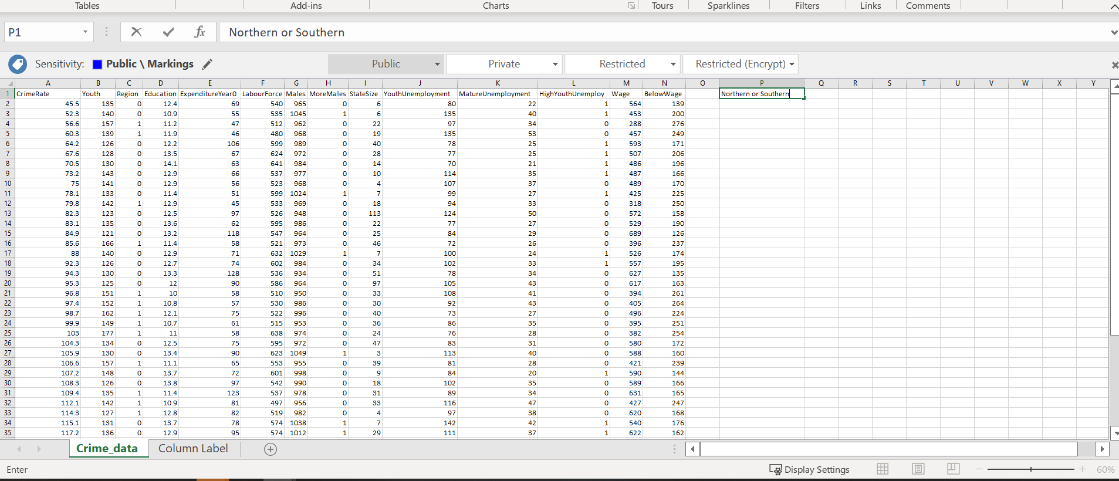
In Excel, it is a must to work in the easiest way possible. In this example, the IF formula will be shown. Due to the figures 0 and 1 to divide the regions between Southern and Northern did not help me at all. Therefore, I used the formula to divide the regions into names. But the question is why we do not just put the writing manually. Remember the first step. In Excel, it a must to work in the easiest way possible. So, the first step of the practical work is writing up a title at the top of row 1. In the case I wrote it on position P1.

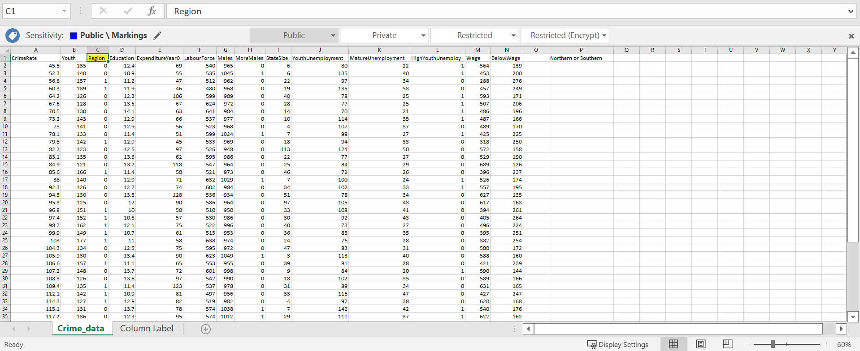
Secondly, to make sure everything is correct and does make a result at the end; marking out the column an individual wants to work on is a clue that many professionals use. To do this just use the highlighter colour in the home section. As we can see, the word Region and bellow are all the figures that we will be working on.

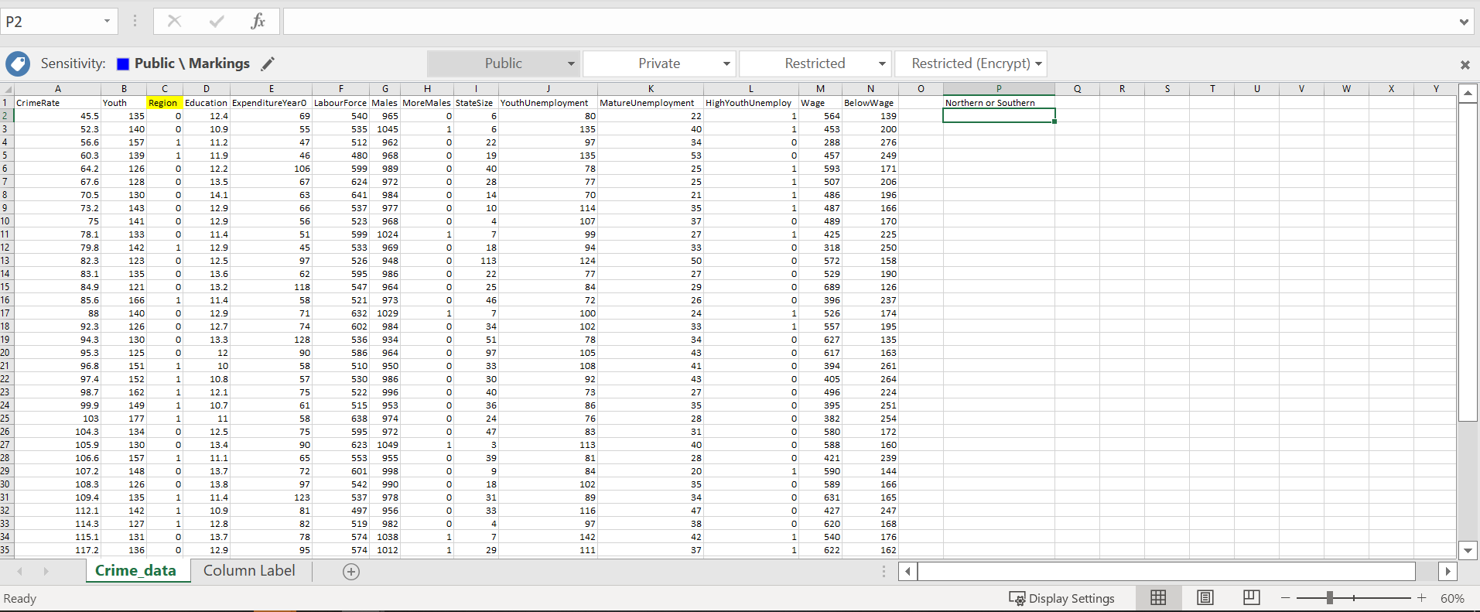
Next step is clicking on P2 row/column, making sure it is the right one because the result will end up with result FALSE.
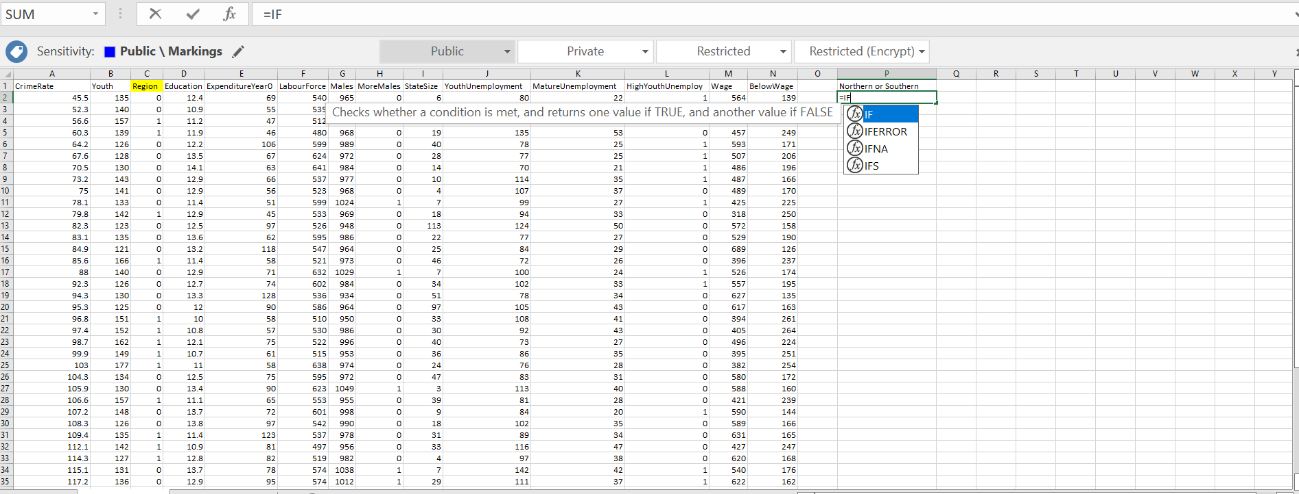
After this we start with the command. In Excel when someone wants to show a command, they must start with the sign equals. This tells Excel that a user is willing the software to undergo a specific task for them. After the equal sign, we type ‘’IF’’ and the underneath the sign comes up with all the relevant commands.
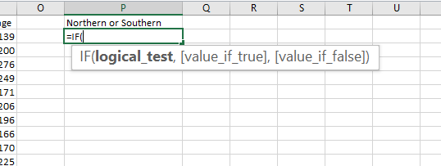
The next step after clicking the ‘’IF formula, it should automatically open a bracket.
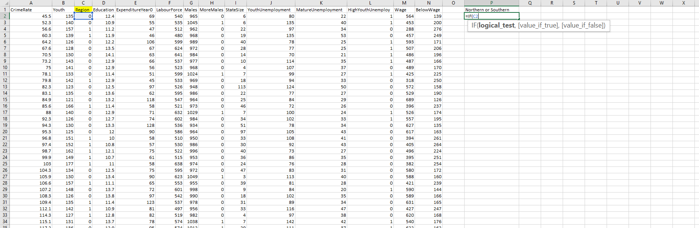
After the bracket, the first equation that needs to be inserted is the logical test, which is the first number that is in the table. In this instance, the first column number under region is 0.
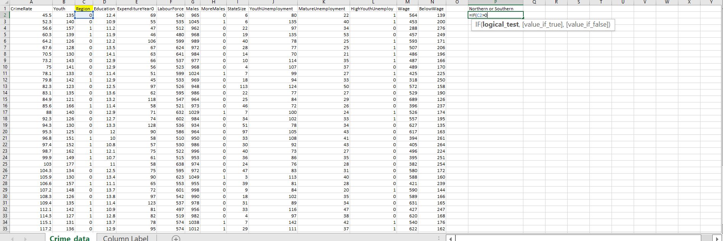
To make this section work, the concentration needs to be in its best. Due to 1 being Southern, we need to make sure that anything bigger than 0 turns into Southern and anything bellow 0 or actual 0 is Northern. As we can see from the screenshot, we have inserted C2 which is the first column ‘’IF’’ to be bigger than 0.

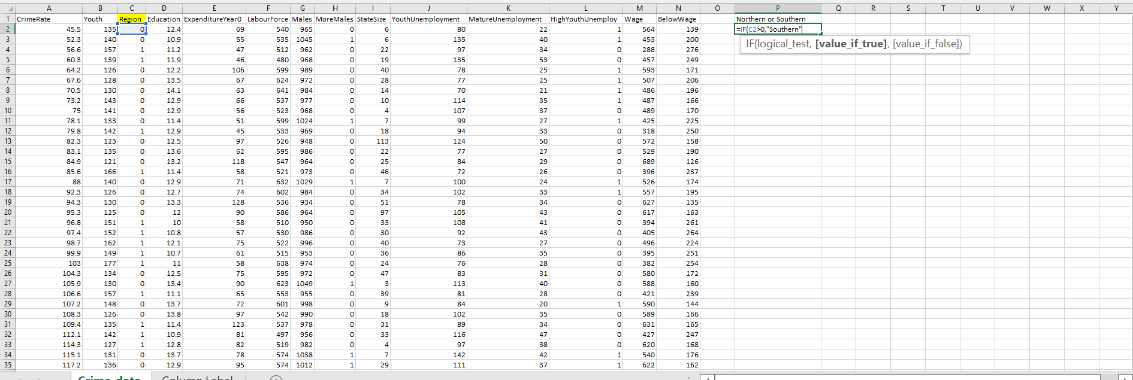
Next step is to put a comma, which makes excel to put us to the next stage, which for this instance ‘’value if true’’. We must write Southern as we examine whatever is bigger than 0 in the region section to turn to the right specified answer. The value is specified as true so any true value is turned to Southern.
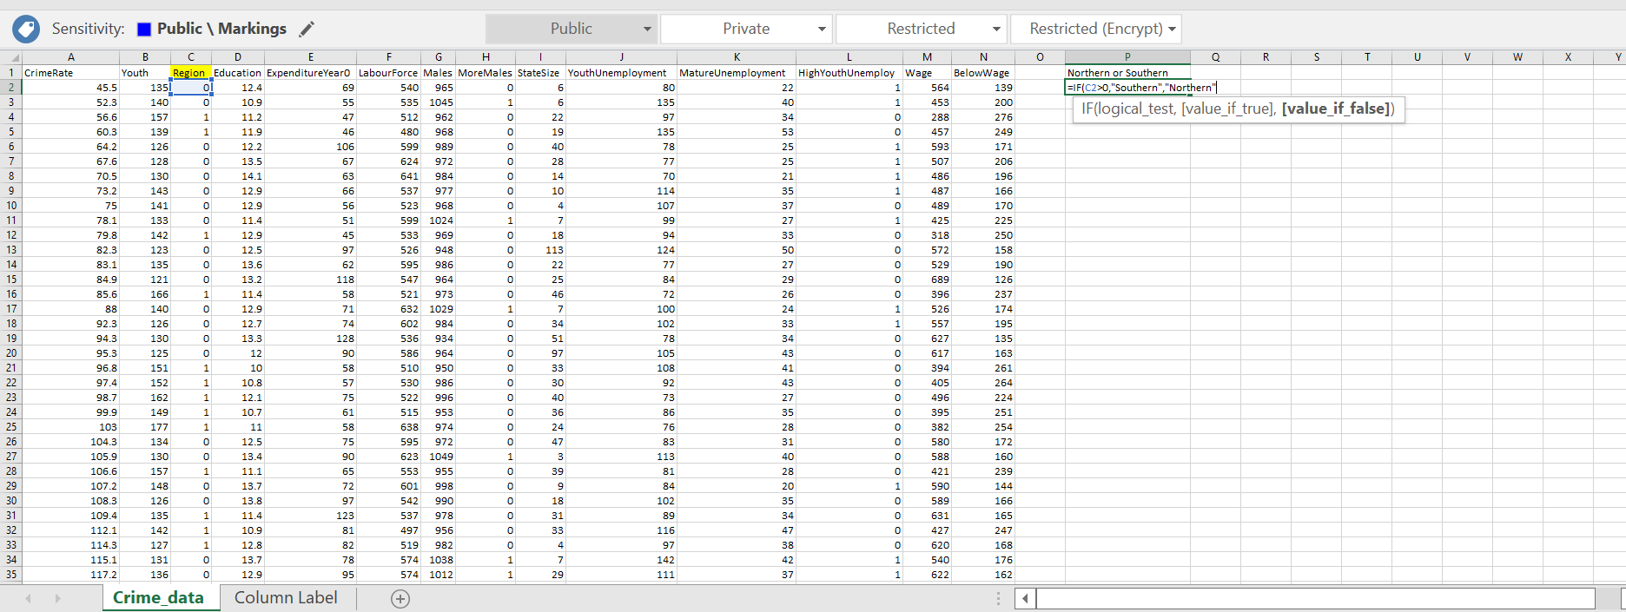
Again, we cannot forget the comma! As Southern is written to be true, the final chapter is false. Which just suggests that anything below 0 or actual 0 needs to be false. To change the name we have to put Northern. So, in this instance the Northern is the False.
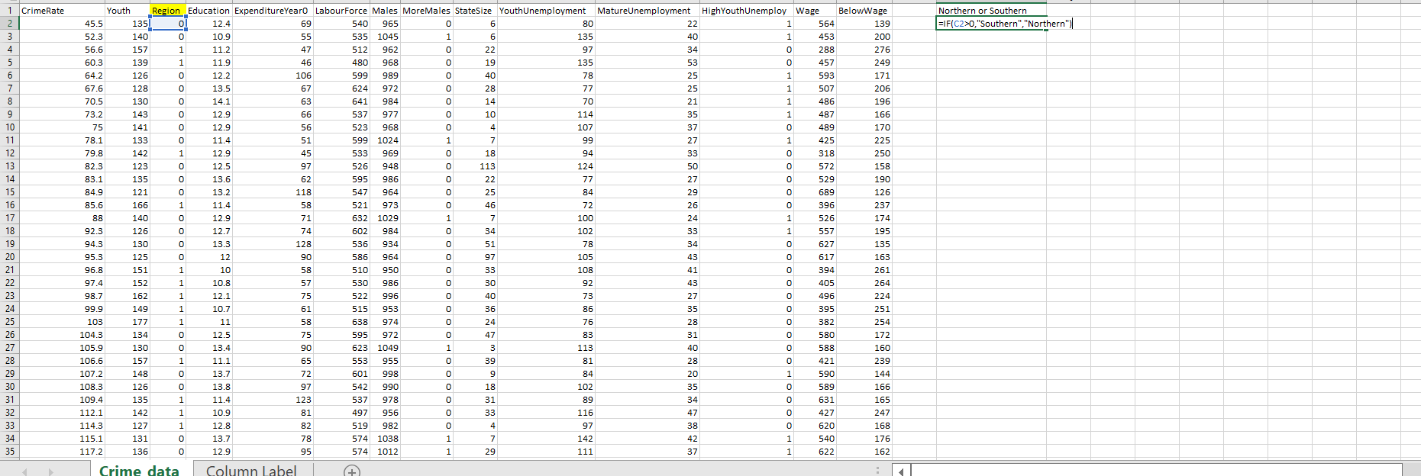
To close out everything we need to put a bracket at the end, is simple like mathematics when doing multiplying.
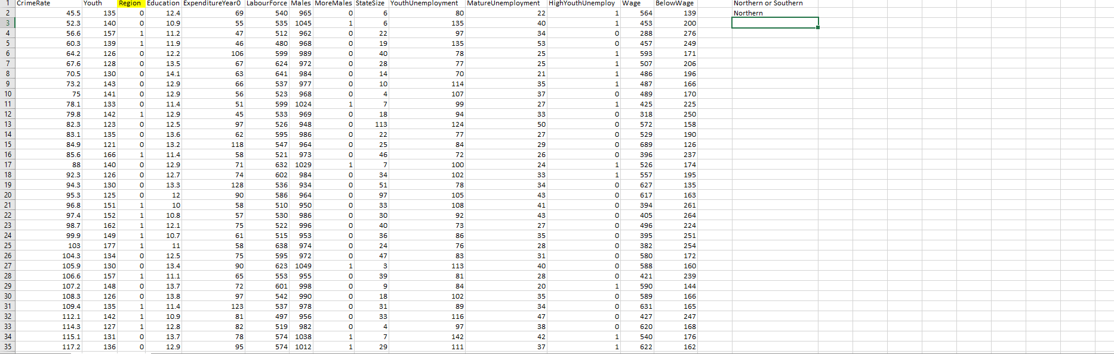
As we can see the first column, the answer is Northern. This is due to the first Region in C2 to be 0, so Excel automatically changes the equation to Northern.
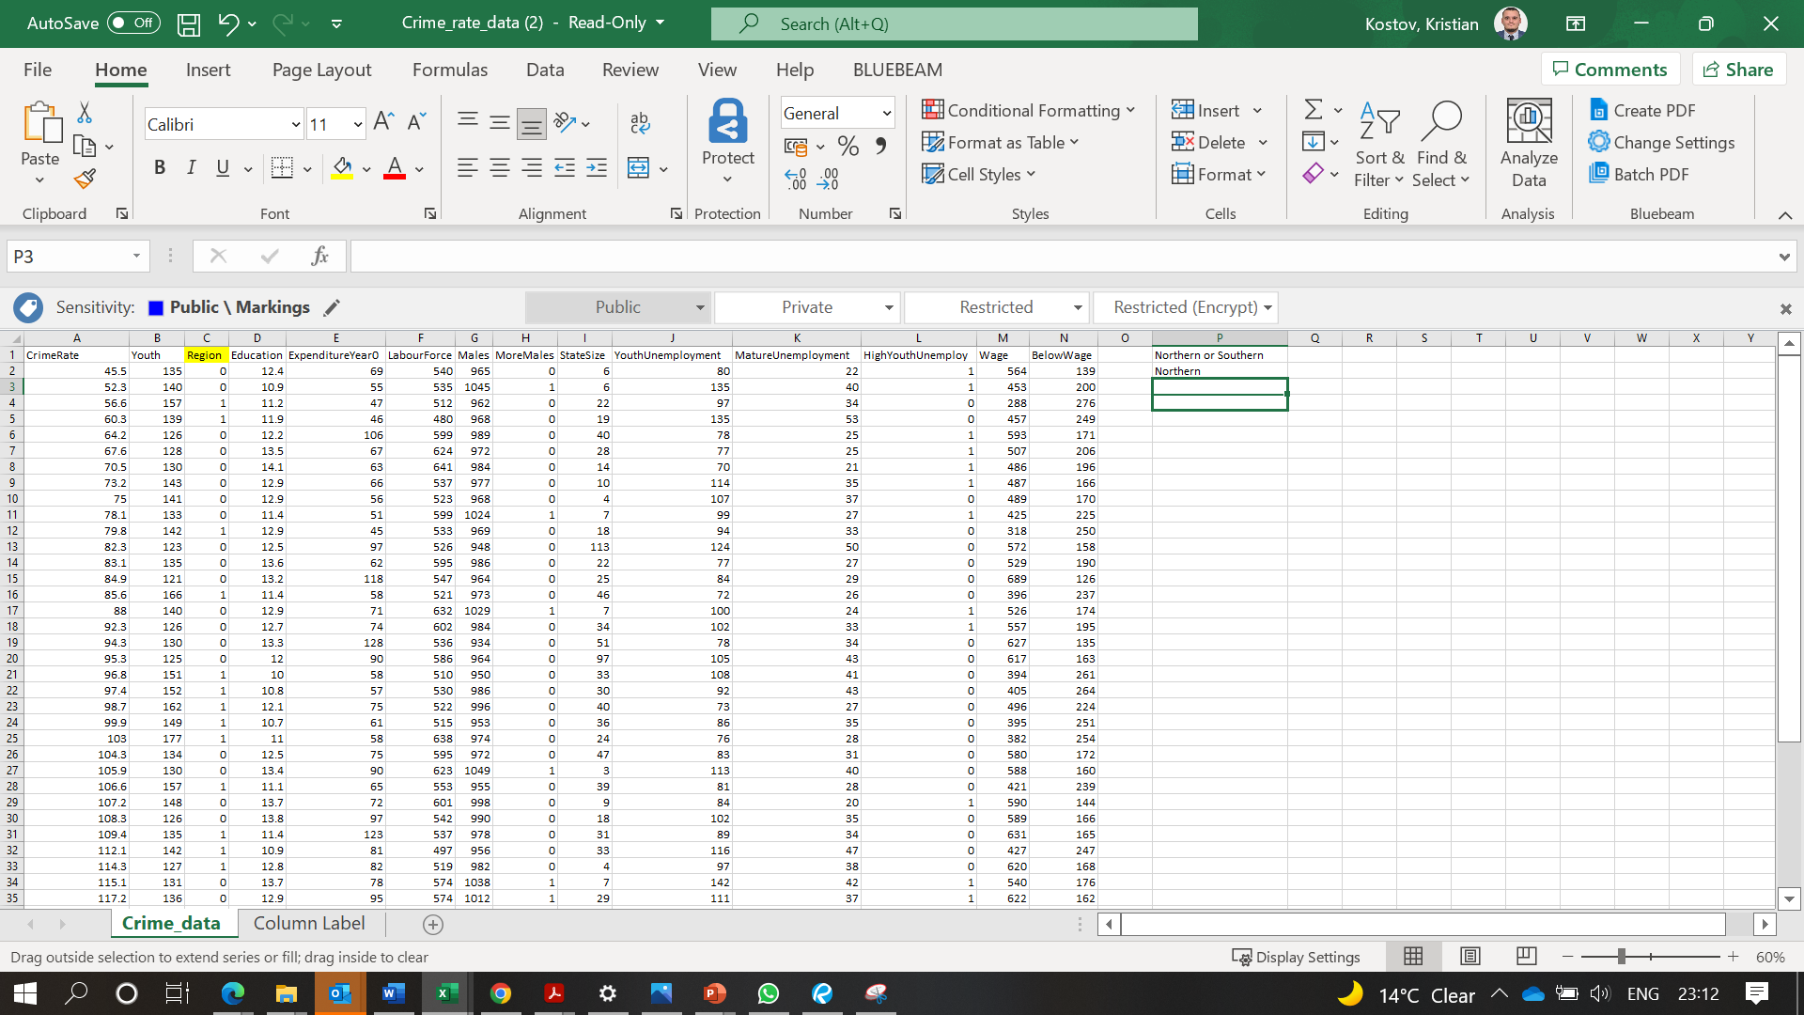
Making sure that we do not do formula for each of the grids, we just click on Northern on column/row P2. Then with the right-hand side we can see something like a plus sign. With the mice, start to drug it down all the way until the table finishes and the last column is market in green.
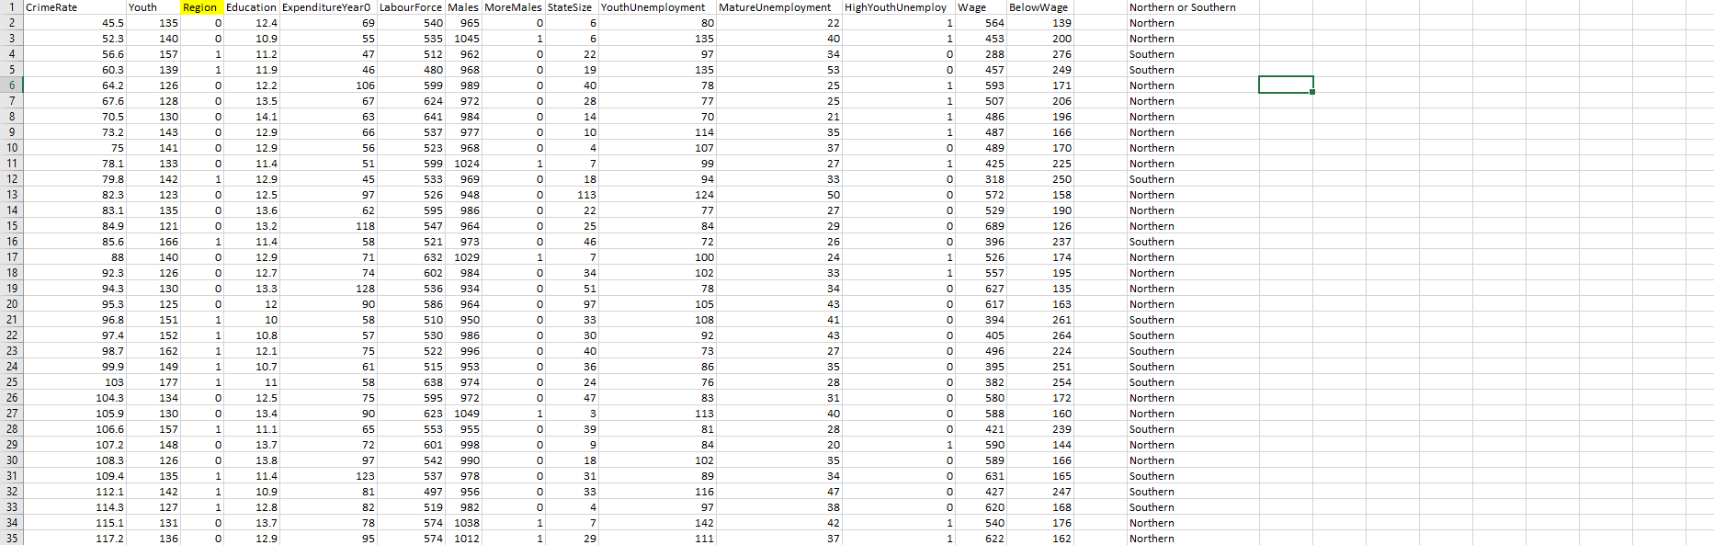
After realising the button of the mice, the whole table will come away with all the calculations of either the region is Northern or Southern.

Pivot Table

Now we will give an example of how to use a Pivot Table.
- First point will obviously be opening the Excel application with the table of numbers and different categories.

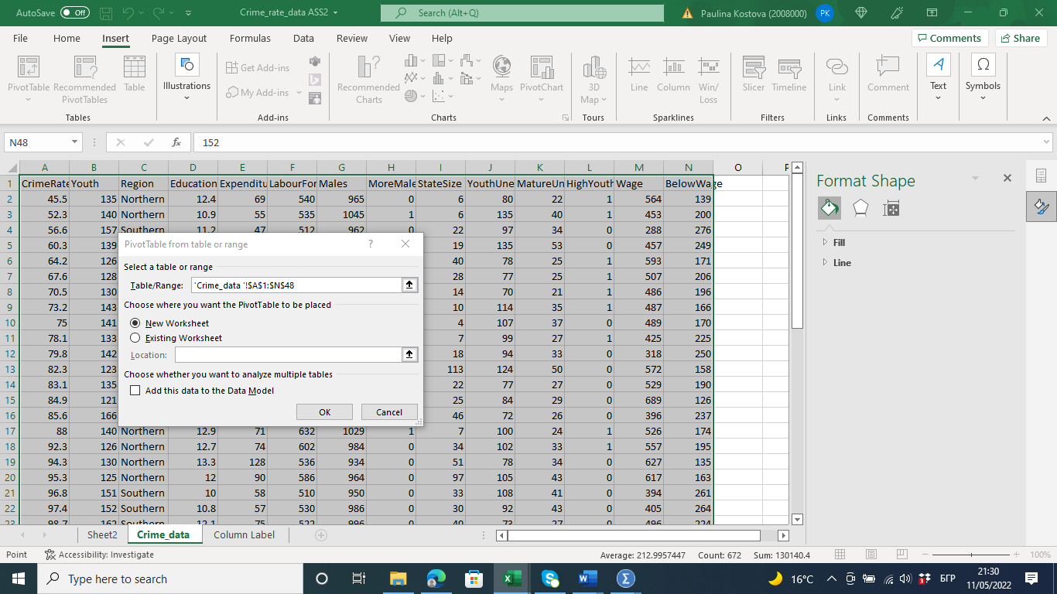
Picture 1: From the main menu, we must click on the insert button. Secondly, we press tables section, then pivot tables. Finally, click on from table range. From the menu that pops up, we must click on select a table or range and we mark out the whole table of content from column A1 to column N48. Then we click new worksheet.

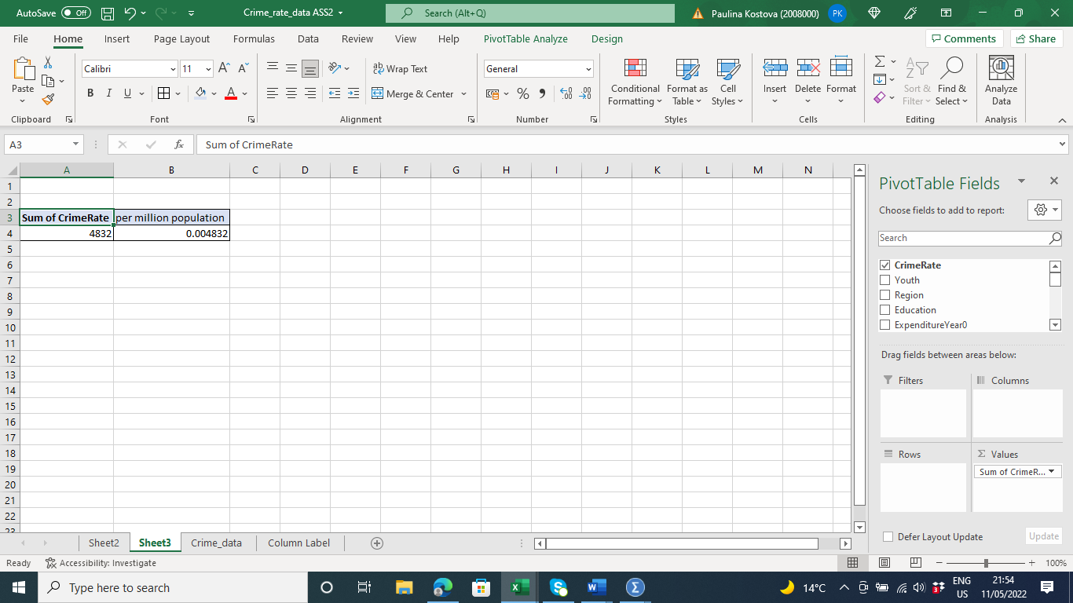

Picture 2: In the new worksheet, to work out the whole sum of Crime rate, we must move Crime rate into the right-hand side table where it mentions values. The result that we can see is 4832 and that is the overall sum. However, as we need to record it to a population of 1,000,000, we must divide 4832 by the population amount. We receive 0,004832.

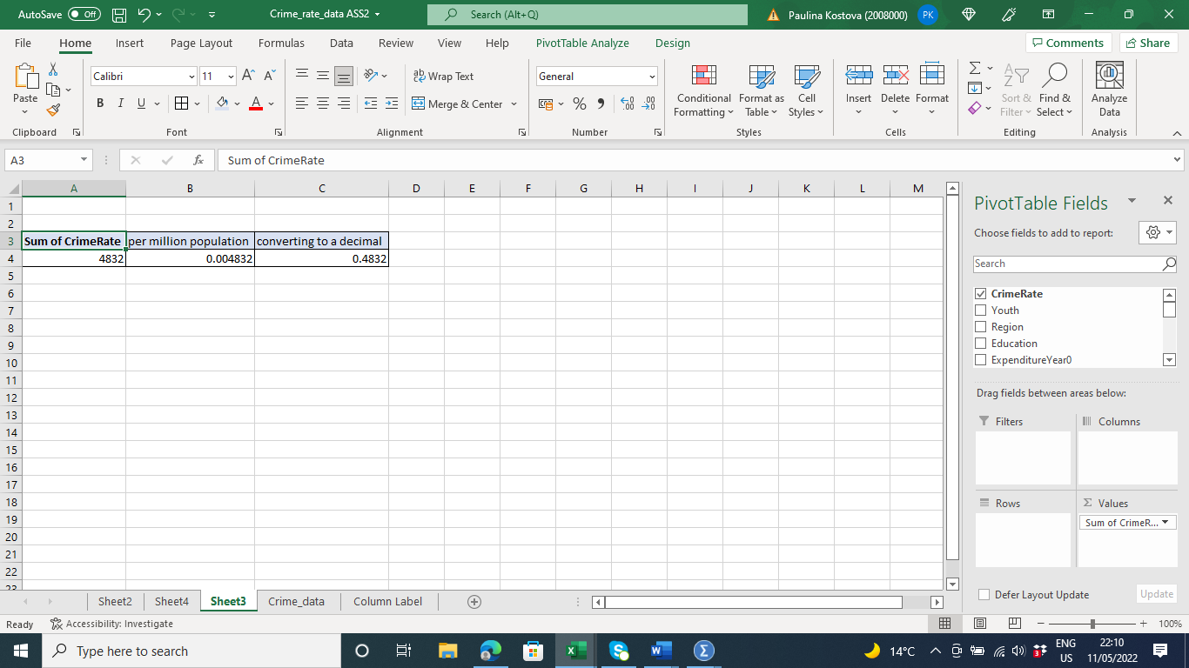
Picture 3: In order to get the percentage, of course we have to divide the result of 0,004832 by 100% to receive a final result of 0.48% approximately.

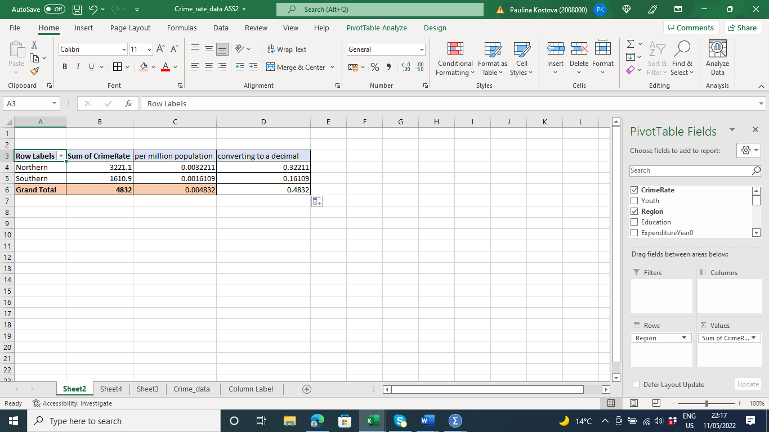

Picture 4 -With the same steps to find out the results of region southern and northern, we use the table on the right, but before this as mentioned we used the easiest version of ‘’IF’’, to work out how many Souths and North is there. We add the new equation, although this time we move Region to Rows instead of Values. Again, we have to compare all the results to the population number in cells C4 and C5 and D4 and D5 we work out the percentage final calculation.

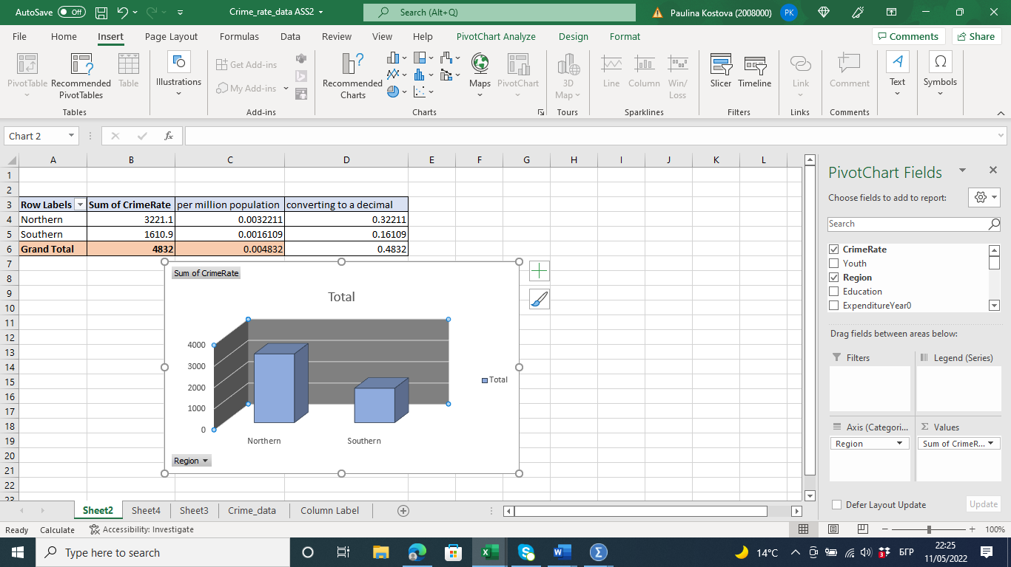
Picture 5: In Excel, when we want the work to look more accurate, we apply graphics and tables. To do this, firstly go to the main menu. Press Insert, Charts, insert column or Bar chart and finish off with 3D columns. The software does everything automatically from the equations and formulas provided. An individual, always can set up a different colour to illustrate the difference. For both on the graph is blue.

What is the IF function in Excel?
The IF function is a popular key in excel that enables comparing a value and what one expects in their calculations (Hossain, 2021). The function provides the logical expression of a value and what one could have probably been expecting in their workouts in an excel sheet. The statement provides a result in either possible outcome. The first result is when the comparison in place is accurate and when the comparison in place is never true or false.
What is a Pivot table in Excel?
A pivot table is a tool in an excel spreadsheet that allows for data extraction in the dashboard or report forms and is always contained in a large worksheet format (Cosma, 2019). The tool is capable of summarizing data from the complex into simpler forms. Equally, the tool can sort or group the data from their complex form for the proper extraction process of the information material in the data. The reorganization ability of the tool in the excel spreadsheet makes it outstanding in one way or the other and very purposeful in the data analysis process. The tool is always in the table section of the excel spreadsheet for accessibility purposes and is easily accessible. As the changes in the data source change happen, the pivot table's content or format will be equally changing as it is subject and dynamic to the source content.

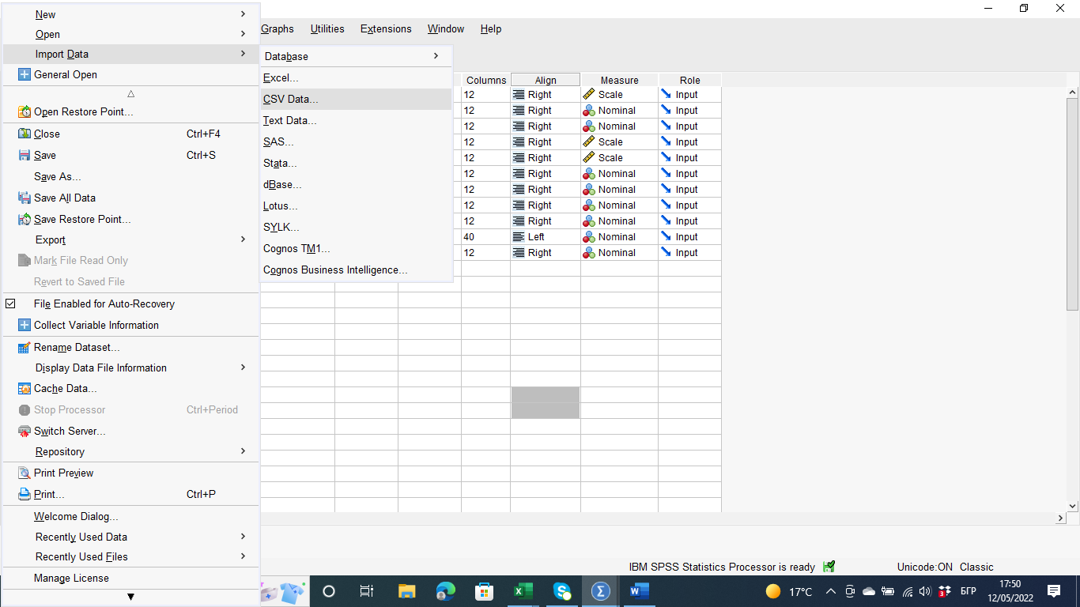
Start the programmed SPSS, from the main menu, click File, import data, CSV data with these steps we activate the document Ice_cream which we will analyze.

To answer the first question: How many students like Vanilla flavor we must do these steps:

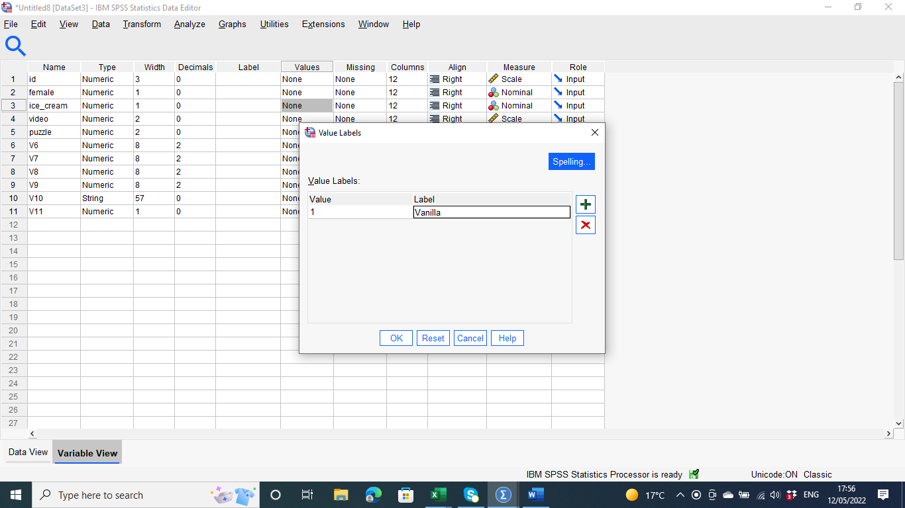

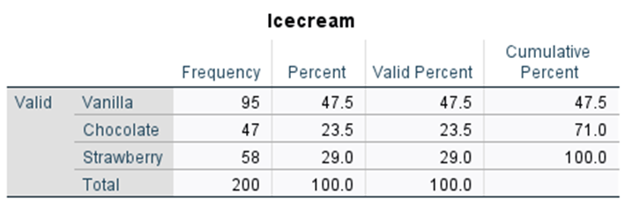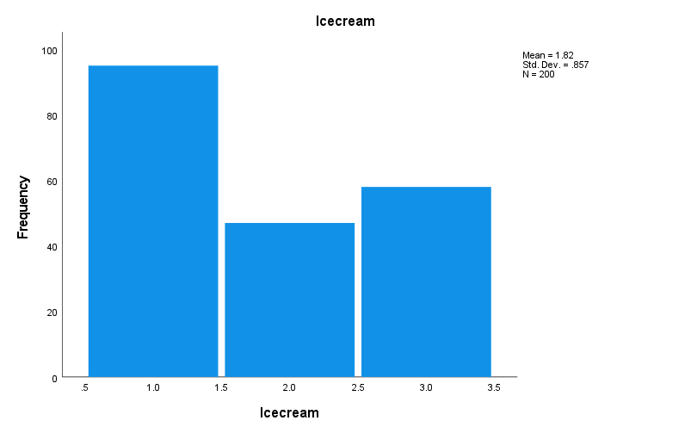
Firstly, we go to row Ice cream column Value and the software opens a window Value Labels which we add with the sign plus in section value 1 and section Labels- Vanilla. In this case, we go a result 95 students like Vanilla flavor. On the page Data view from the main menu, we click on Analyze, Descriptive statistics, Frequencies. In Variables we put Vanilla.

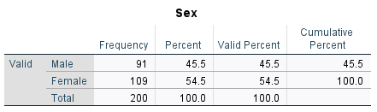
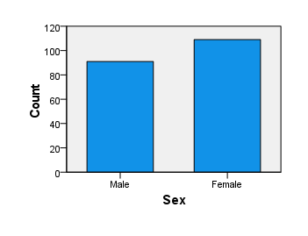
To answer the question two: How many students are Male and Female we must follow the steps:
For a better calculation for the specific gender, we must change the wording with Female with Sex. On page Variable View in front of Sex column Values opens the window Value Labels, which again we use the sign + in section Value 0 and section Labels- Male, Value 1, and section Labels-Femaile. On page Data View from the main menu, we click on analyze, descriptive statistics, frequencies. In variables we swap sex and then we collect the result the female are 109 and male are 91.
For the last question: What are the mean and median of participants who likes chocolate and strawberry flavour?
From the page Variable view row Ice cream column Values opens the window Value Labels. We again use the sign + to add in section Value 2 and section Labels- Chocolate, Value 3, and section Labels- Strawberry. On page Data view from the main menu, we click on analyse, descriptive statistics, frequencies. In Variables we change Ice cream, and we click statistics. From the opened window of Central Tendency, we check in Mean and Medium. The results are shown on the graph bellow.

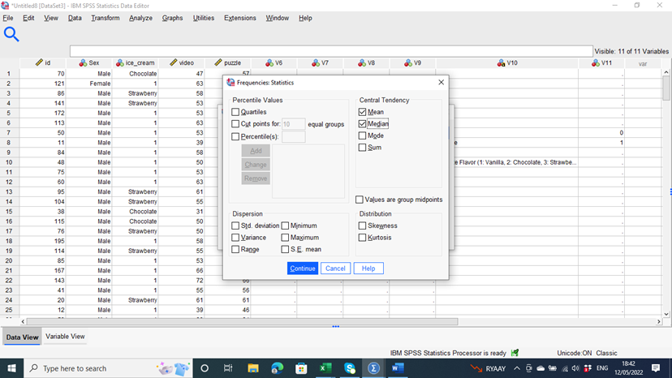
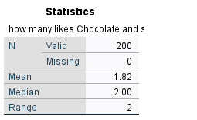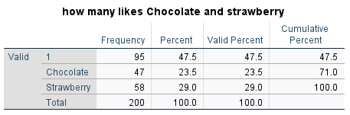
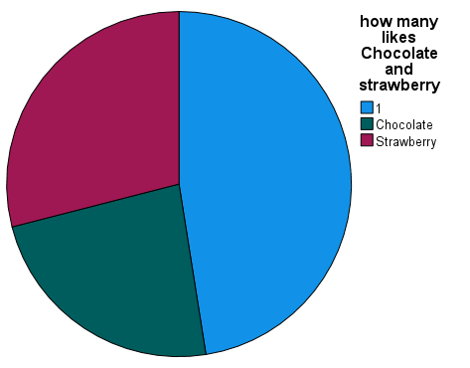
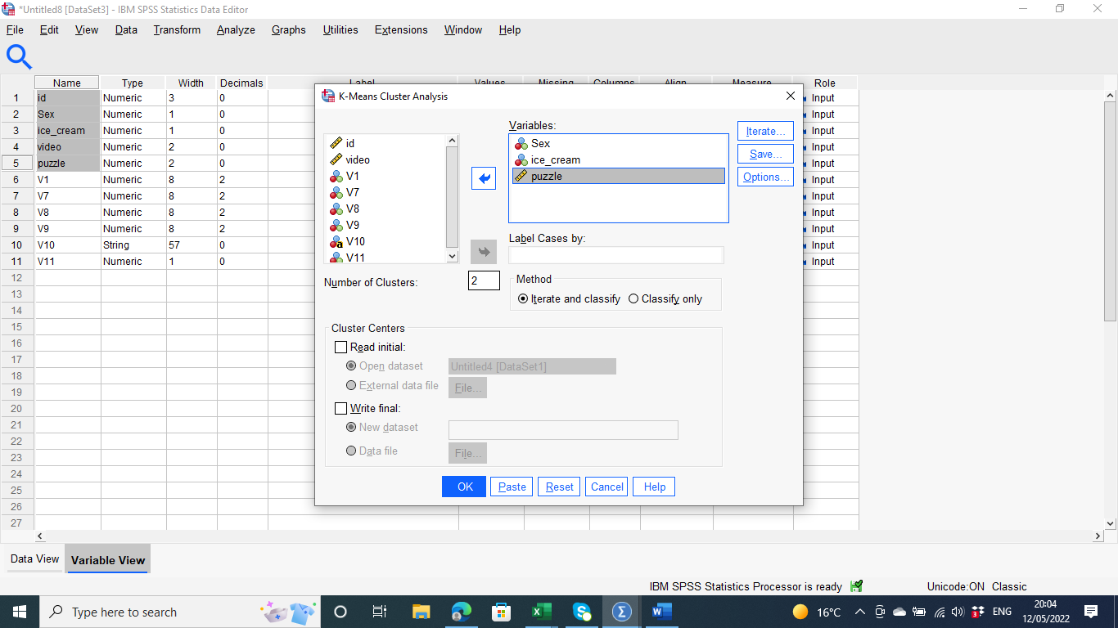
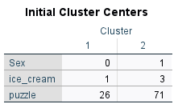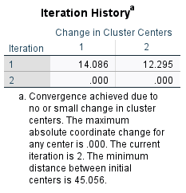

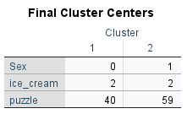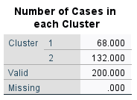

Explain the most common data mining and text mining methods used in business with real-world examples?
Data mining is when organizations use certain data sets to determine trends, patterns, and valuable data that can help the business and its management forge through in either the market or productivity purposes (Mughal, 2018). One of the most common data mining methods that businesses have been using to extract information and determine the right trend in their way forward is the artificial intelligence method. Artificial intelligence is one of the most common senses. It has more appropriate ways and best suits the current use of the internet of things that the world has adopted.
Artificial intelligence and machine learning have been a major example in the real-life application used by businesses as a method of extracting information (Finlay, 2021). Businesses use this kind of method to extract information and learn what they are more likely to like in the buying list and therefore get to know the correct suggestion to make for the clients and increase their chances to make purchases. Businesses that operate on the online platform have their clients' information through artificial intelligence by predicting what the client is more likely to buy and a process called the beloved recommendation system. Through this system, after the client purchases, let's say, Amazon, they are listed with more goods that they are more likely to like and buy. The machine has already extracted the information concerning the client and their trends in purchasing, which makes it easier to predict what they are more likely to buy again out of love and preference. Amazon carries out a thorough search and analysis of the customers' behaviors which it contains, and releases them at the right time or immediately does so using the available information and behavior the customer has been using concerning their shopping patterns to establish their attests and preferences. The machine, after that, categorizes the products depending on the client's probability of buying them and makes the correct display for them to hit.
Additionally, artificial intelligence has been used by videos and music platforms such as Spotify and Netflix to predict the right playlist for their customers. After a proper analysis of the behavior and the preferences of the songs and movie genres that a viewer loves, the streaming platform provides them with a prediction of a playlist that they are more likely to click and watch after the play in action. The extraction method in this kind of information is vital for such businesses as it helps them in boosting their outreach and helps generate more like it through increased sales. The prediction or information extraction also helps in the accurate production of good quality products and services that helps to increase sales and services to generate more income for the business.
Business organizations such as mobile service providers have also used the available information to retain their customers and prevent them from moving to other vendors or providers. Through the available information, such as the high number of messages that these businesses have concerning their clients, they can predict through the churn strategy and come up with the customers who are less likely to renew their contract with the organization. By analyzing the weak points of the customers, the organization comes up with an incentive strategy where they map out the best incentives that are more likely to relieve the vulnerable customer and attract them more to prevent them from transferring to other customer providers. The organization uses the data mining tool to access the billing information, the text messages, the web data transmission, and the customer services to help in containing such significant clients of the organization. The organization generates a probability score and establishes the churning strategy to encounter the situation out of such information.
Data mining methods such as artificial intelligence have also been vital in other fields such as crime prevention. By applying the proper technique and establishing appropriate information to establish a pattern of crime in an area, it is always easier to come up with a counter-prevention method that can help boost the security of an area in one way or another. Through the available data, the right programs, such as linear regression, can also help come up with the correct pattern to predict the more likely scenario or happening of a crime in an area (Zhao & Tang, 2018). With the availability of all the information about crimes in the area before, data mining comes up with a future predictions in the most accurate ways. It allows for the security team's execution of the right strategy to contain any possible situation in the area. Factors to key in during this counteraction to this security issue, such as the correct police to add in certain areas and which areas are more prone to crime, are some of the steps to take by the agency. Additionally, more details such as the age group target and the vehicle numbers to scrutinize by the agency become clear when such a data mining method is in place for an effective security prevention process.
Advantages and Disadvantages of using SPSS and Excel
The advantages of excel include;
The excel spreadsheet offers the best data storage tool on the computer. The simplicity of this tool and the way in
which is designed to provide the best way in which one can ever need to store their data even when they don't use any option or tool that excel provides.
The ability to perform calculations makes excel the best spreadsheet application in the computing world. The spreadsheet is designed to perform calculations of the data keyed in and provide simple and accurate results for the best analysis process.
Advantages of SPSS and the disadvantages of Excel
Even though there are similarities in terms of the built-up of Microsoft Excel and the SPSS, the latter is a winner and better when it comes to statistical ways of doing things which makes it better than excel in most ways (Mekhrinigor, 2021). Excel has a popularity for use in making calculations even though it is always a tedious way of analyzing compared to the SPSS, which has more simplicity and better ways of doing things. Some of the advantages that the SPSS has included;
Microsoft has more accessible access to the purely statistical aspects because it is designed to perform statistical duties and calculations on the computer. The software contains built-in keys, allowing it to perform analysis processes in the most efficient and accessible ways for the interpretation process (Sallis & Silkoset, 2021). The functions are also designed to work more speedily and efficiently to deliver the outcome at the convenience of the performer at the right time. All of these make it a better distinction from MS Excel, which is more likely to perform poorly or slowly.
The package also makes the statistical tests easier because the equipment has the complete set, making the running process very easy and much more convenient and practical.
Even though the pivot tables are perceived to be good in the MS Excel spreadsheet, they are excellent for the SPSS. The character makes them stronger in function and an additional tool for the data analysis process in this software.
Additionally, creating tables is easier for the SPSS with a different report generation for data and makes the whole analysis and presentation process easier. The functions that the program contains are helpful in the report generation process. With easier tables, the data interpretation becomes easy and the whole information becomes usable to serve its purpose.
Disadvantages of using SPSS
Some of the disadvantages of the software is the fact that it can be expensive for the students to purchase which make its uses to be limited to certain economic class of the society.
The software can also be complicated to learn and would need skills which calls for the users to add more training to be in the right position to exploit all the features available.
As compared to the MS Excel, the graph features in SPSS are never simple and so can be difficult to interpret to the user.

References
Anderson, D. R., Sweeney, D. J., Williams, T. A., Camm, J. D., & Cochran, J. J. (2020). Modern business statistics with Microsoft Excel. Cengage Learning.
Becker, L. T., & Gould, E. M. (2019). Microsoft power BI: extending excel to manipulate, analyze, and visualize diverse data. Serials Review, 45(3), 184-188.
Cosma, E. (2019). Pivot Table: A Tool to Calculate, Summarize, and Analyze Data. Ovidius University Annals, Economic Sciences Series, 19(1), 161-166.
Finlay, S. (2021). Artificial intelligence and machine learning for business: A no-nonsense guide to data driven technologies (No. 4th ed). Relativistic.
Hossain, E. (2021). MS Excel Functions and Formulae. In Excel Crash Course for Engineers (pp. 117-141). Springer, Cham.
Mayes, T. R. (2020). Financial analysis with microsoft excel. Cengage Learning.
Mekhrinigor, Y. (2021). Statistical Programs In The Teaching Of Physical Education Classes. Turkish Journal of Computer and Mathematics Education (TURCOMAT), 12(7), 354-356.
Mughal, M. J. H. (2018). Data mining: Web data mining techniques, tools and algorithms: An overview. International Journal of Advanced Computer Science and Applications, 9(6).
Sallis, J. E., Gripsrud, G., Olsson, U. H., & Silkoset, R. (2021). Simple Analysis Techniques. In Research Methods and Data Analysis for Business Decisions (pp. 111-146). Springer, Cham.
Zhao, X., & Tang, J. (2018). Crime in urban areas: A data mining perspective. Acm Sigkdd Explorations Newsletter, 20(1), 1-12.

